Customer Satisfaction Survey Form for Soliciting Feedback About the National Institutes of Health (NIH), Office of the Director (OD), Office of Research Services (ORS), Division of Occupational Health and Safety (DOHS) Website
Section 0: All Respondents
Burden Disclosure
Public reporting burden for this collection of information is estimated to average five minutes per response, including the time for reviewing instructions, searching existing data sources, gathering and maintaining the data needed, and completing and reviewing the collection of information. An agency may not conduct or sponsor, and a person is not required to respond to, a collection of information unless it displays a currently valid OMB control number. Send comments regarding this burden estimate or any other aspect of this collection of information, including suggestions for reducing this burden, to: NIH, Project Clearance Branch, 6705 Rockledge Drive, MSC 7974, Bethesda, MD 20892-7974, ATTN: PRA (0925-0648). Do not return the completed form to this address.
Introduction:
This survey asks a series of questions about your perception of the NIH, OD, ORS, DOHS website. Your feedback is valuable and will be used to evaluate and improve your experience on our website. This survey should take 1 minute to complete. We are committed to providing excellent customer-service to you and your candid feedback is critical to our focus on continuous improvement. The survey provides NIH employees and contractors an opportunity to submit comments and/or ideas about our website anonymously to DOHS.
Instructions:
Please see the attached survey for your reference and use. The survey will be digital, however, a hard copy of the survey questions is included to assist in the evaluation process. In addition, please note the following below:
• Survey responses reside behind the NIH firewall and are secure to the extent permitted by law.
• For each question, select the option that best represents your view.
• The survey will take approximately five minutes to complete.
• Try to answer each question as honestly and accurately as possible.
• At any point, you may exit the survey and return to complete the survey at a later time. Your answers will be saved.
Questions about this survey may be sent to larry.johnson at@nih.gov.

Survey Form For Soliciting Feedback About The National Institutes of Health (NIH), Office of the Director (OD), Office of Research Services (ORS), Division of Occupational Health and Safety (DOHS) Website

Data Collection Instrument

Home Page
The ORS/DOHS will have an active URL link located on every page of the website called “Website Feedback.”
The following screenshot presents where the “Website Feedback” link will be located on the home page.
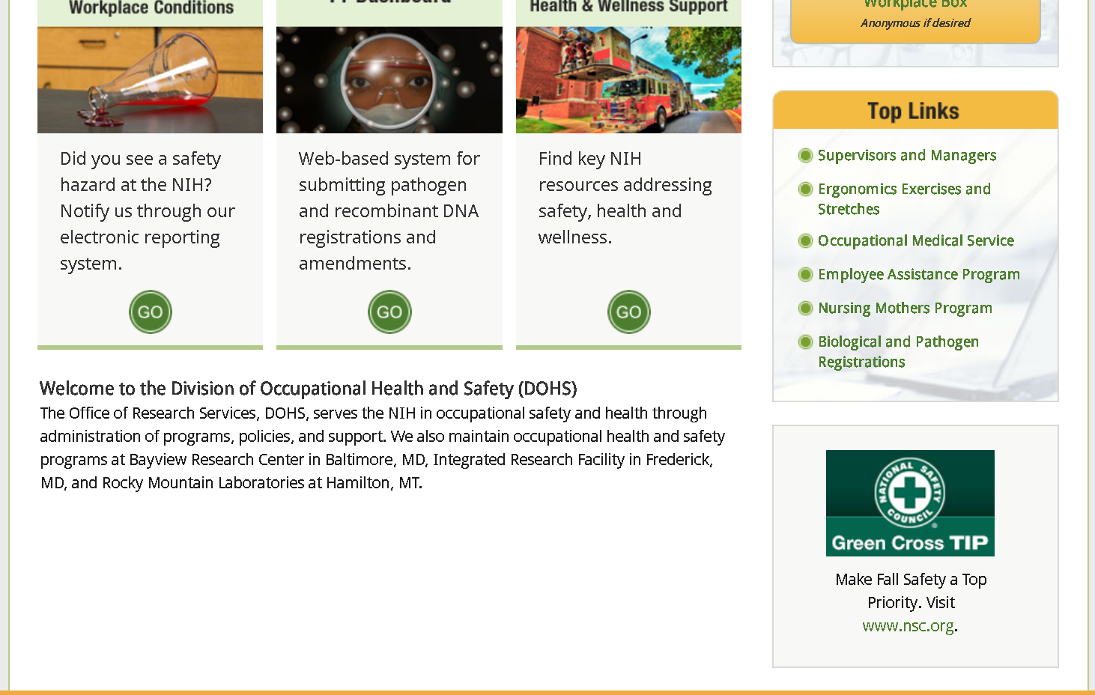
Website Feedback

DOHS Subsite Webpage
The following screenshot presents where the “Website Feedback” link will be located on a subsite webpage.
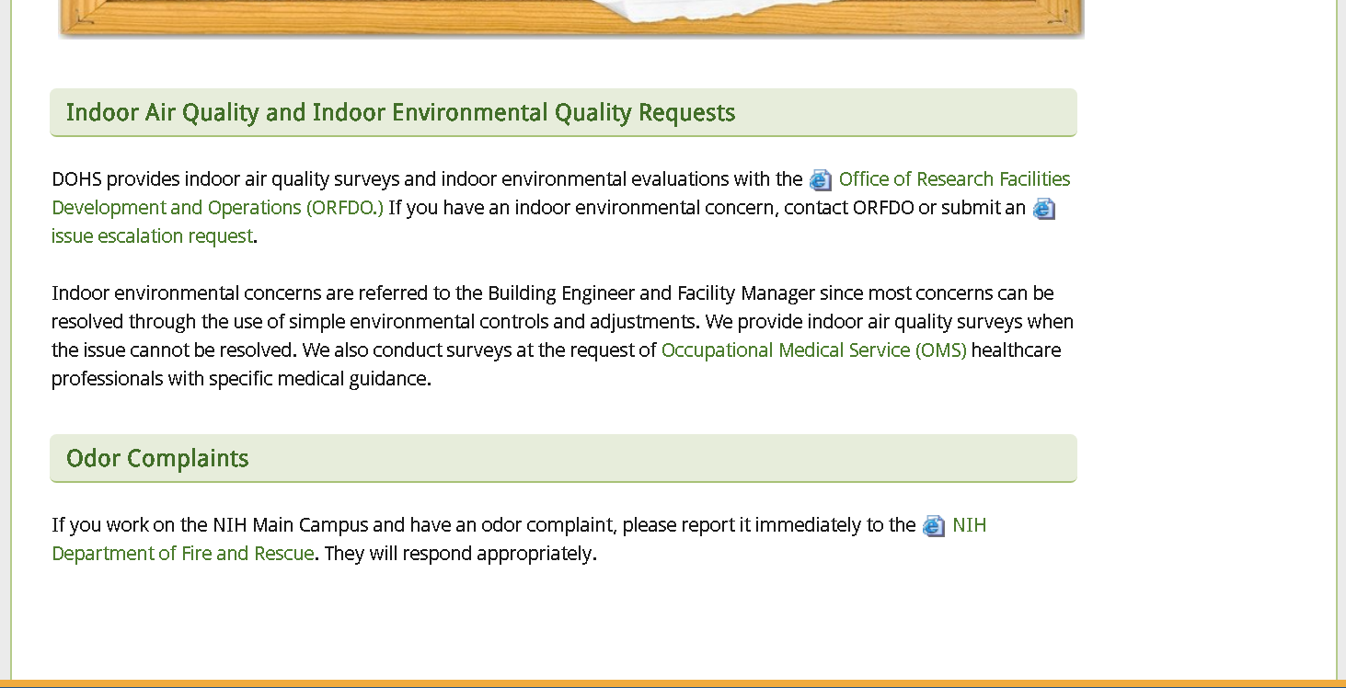
Website Feedback

Survey Webpage
The “Website Feedback” survey is developed as follows. Form fields and checkboxes will be added if this project is approved.
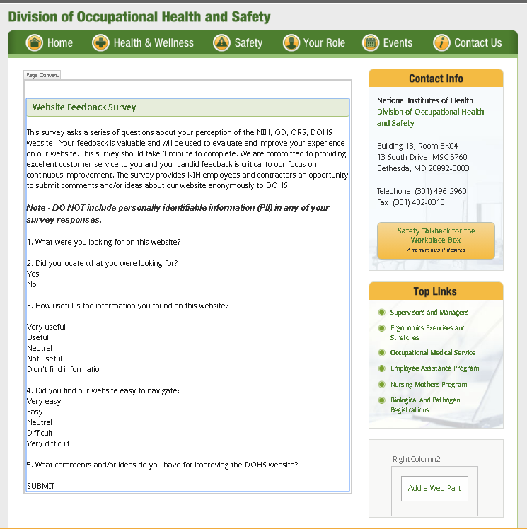
The actually content of the Website Feedback page is as follows:

Website Feedback Survey
This survey asks a series of questions about your perception of the NIH, OD, ORS, DOHS website. Your feedback is valuable and will be used to evaluate and improve your experience on our website. This survey should take 1 minute to complete. We are committed to providing excellent customer-service to you and your candid feedback is critical to our focus on continuous improvement. The survey provides NIH employees and contractors an opportunity to submit comments and/or ideas about our website anonymously to DOHS.

Note - DO NOT include personally identifiable information (PII) in any of your survey responses.

1. What were you looking for on this website?
2. Did you locate what you were looking for?
☐Yes
☐No

3. How useful is the information you found on this website?
☐Very useful
☐Useful
☐Neutral
☐Not useful
☐Didn't find information I was looking for

4. Did you find our website easy to navigate?
☐Very easy
☐Easy
☐Neutral
☐Difficult
☐Very difficult
5. What comments and/or ideas do you have for improving the DOHS website?
SUBMIT
Submit

Thank You Page
Upon submitting the survey, the customer will see the following page:
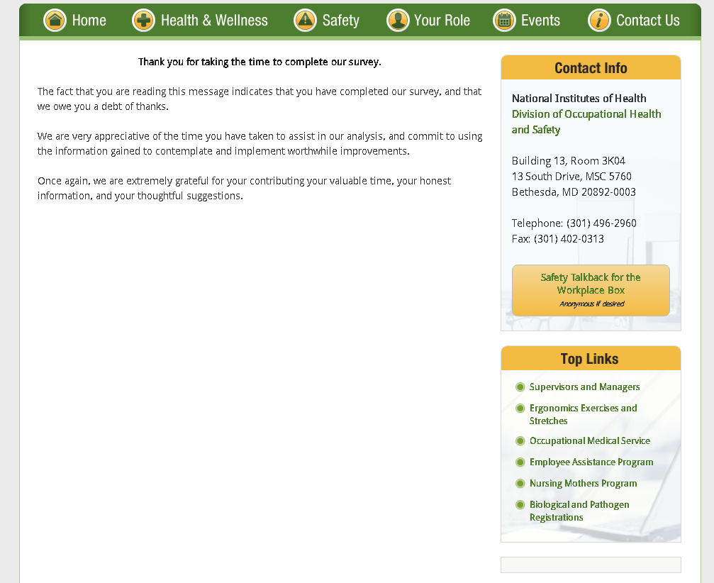
The content on this page is as follows:
Thank you for taking the time to complete our survey.​

The fact that you are reading this message indicates that you have completed our survey, and that we owe you a debt of thanks.

We are very appreciative of the time you have taken to assist in our analysis, and commit to using the information gained to contemplate and implement worthwhile improvements.

Once again, we are extremely grateful for your contributing your valuable time, your honest information, and your thoughtful suggestions.

-End of Document-

