FIC CareerTrac Screenshots

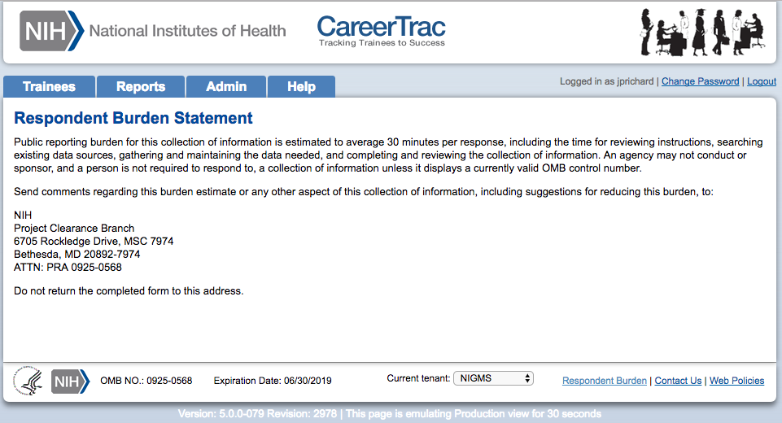
Burden Statement Page

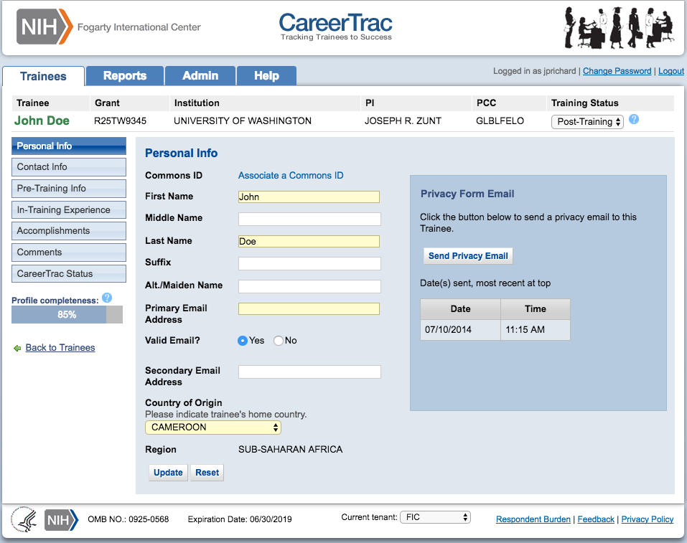
Personal Info Page

Personal Info Page – Associating a Commons ID (Search)
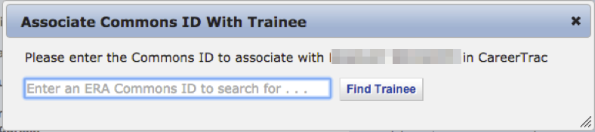

Personal Info Page – Associating a Commons ID (Preview)
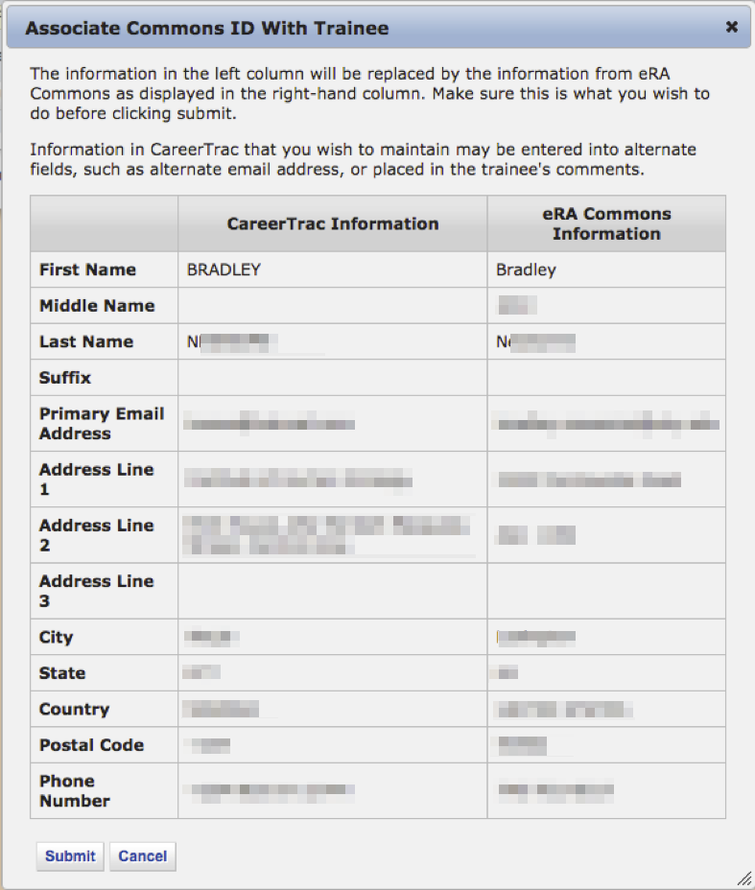

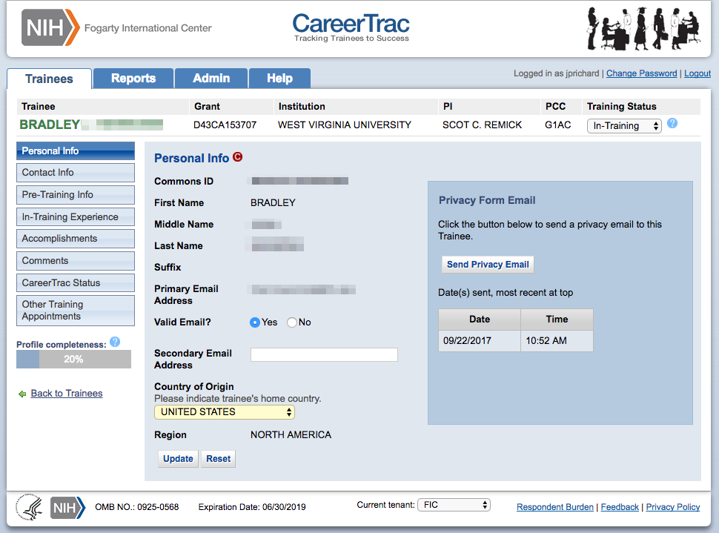
Personal Info Page – Commons Trainee

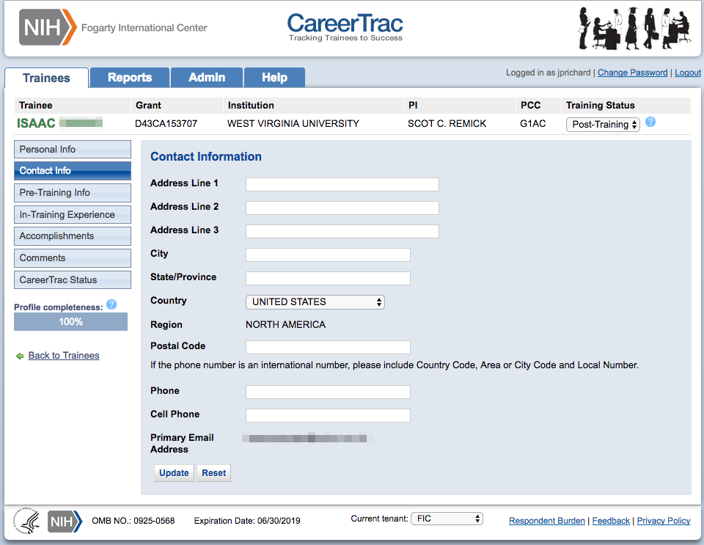
Contact Info Page
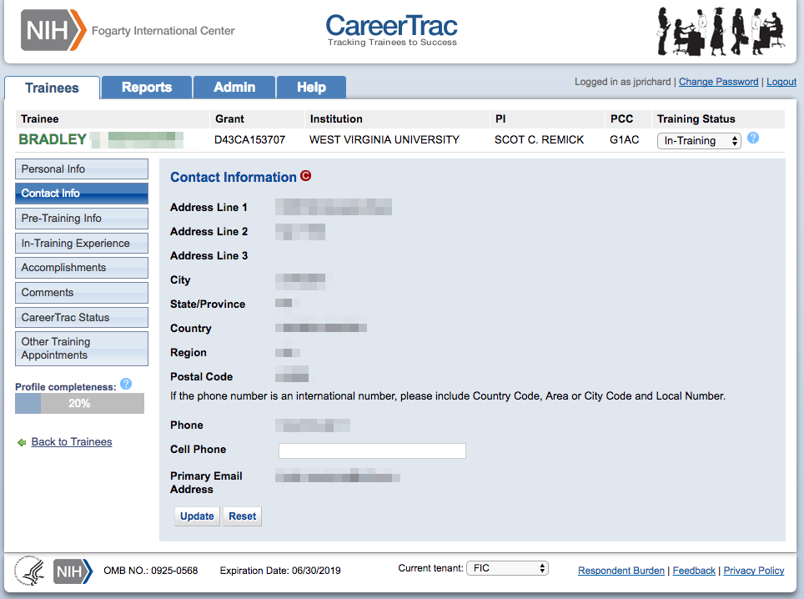
Contact Info Page – Commons Trainee
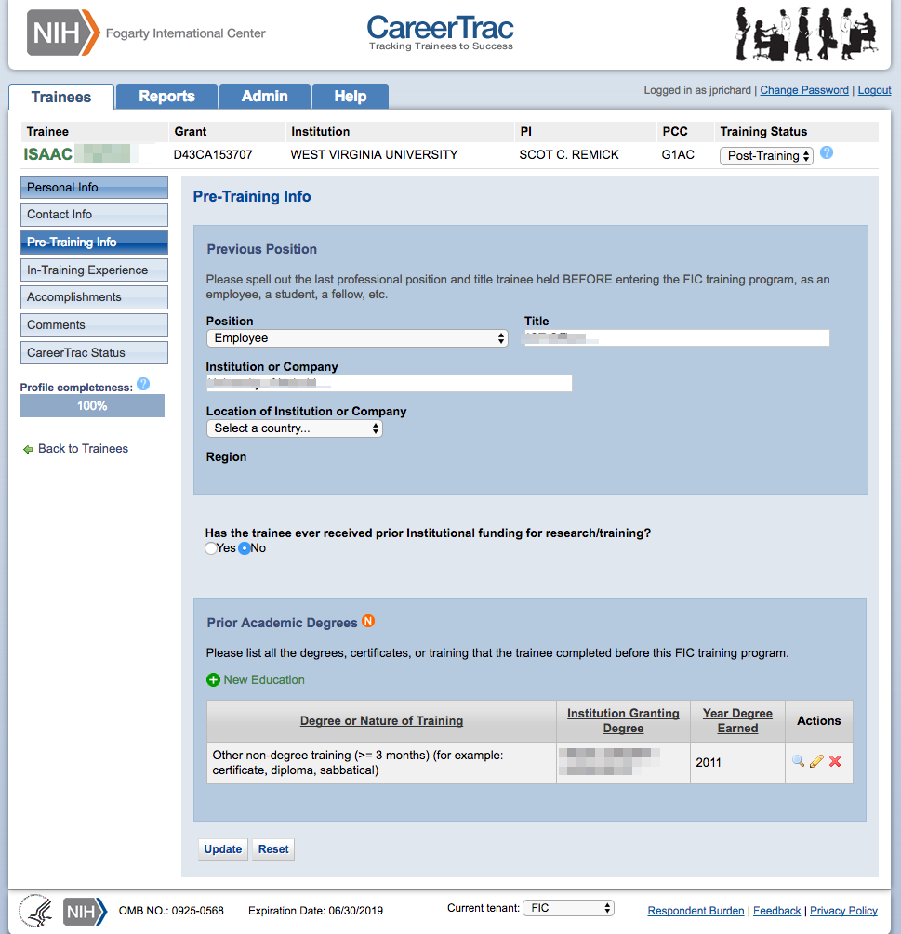
Pre-Training Info Page

Pre-Training Info Page – Create Prior Academic Degree (Commons Trainee)
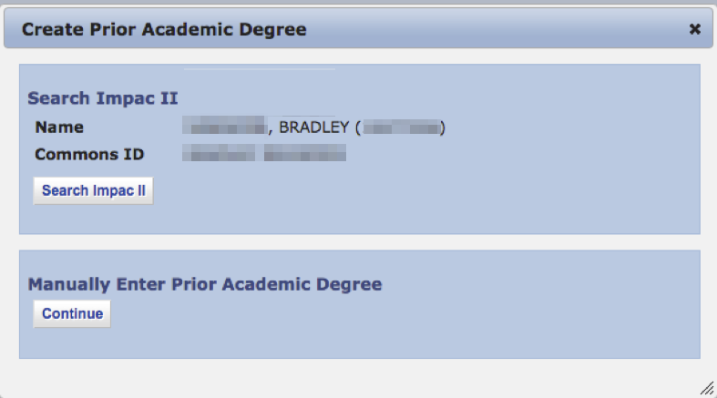

Pre-Training Info Page – Create Prior Academic Degree (Manually Enter)
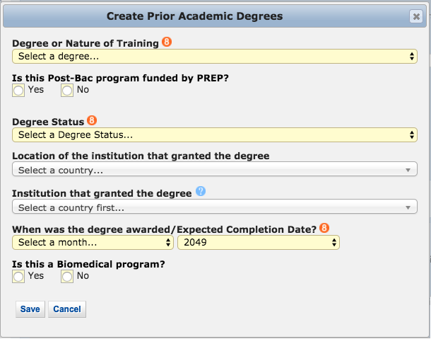

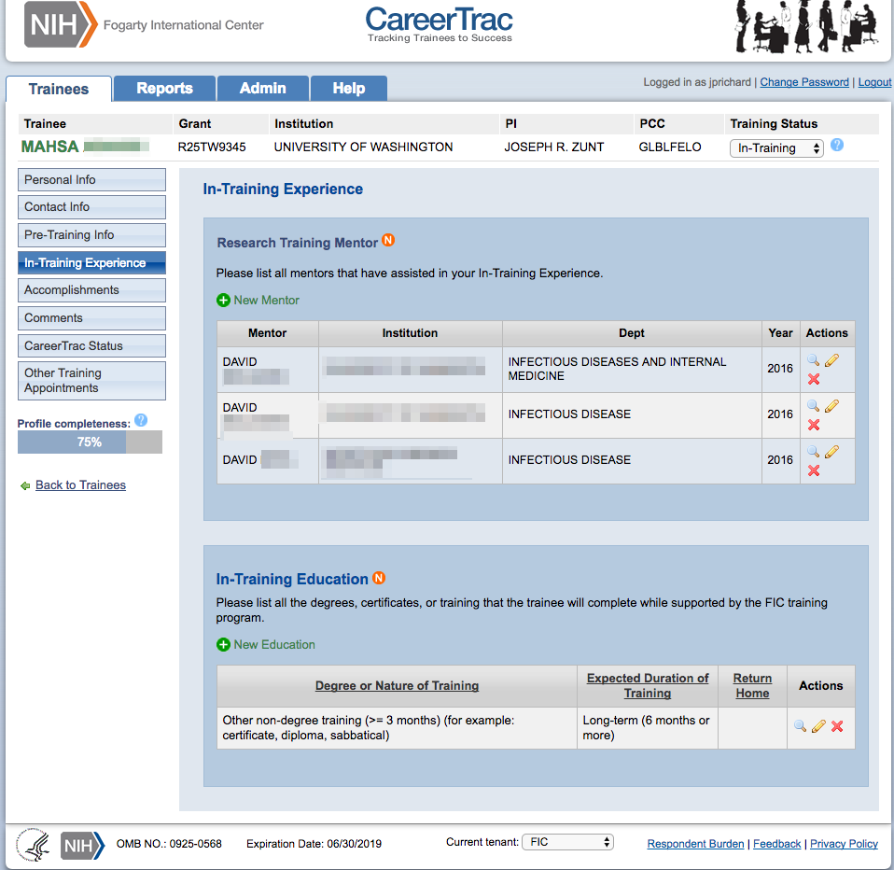
In-Training Info Page

In-Training Info Page – New Mentor (Search)
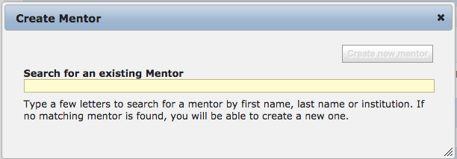

In-Training Info Page – New Mentor (Manually Enter)
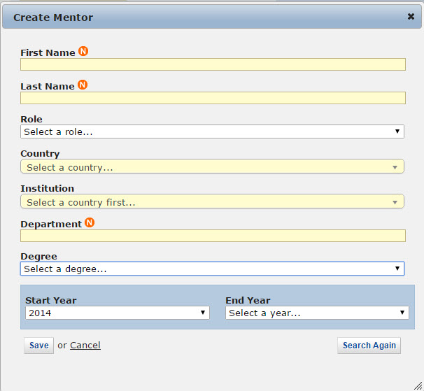

In-Training Info Page – Create Education (Commons Trainee)
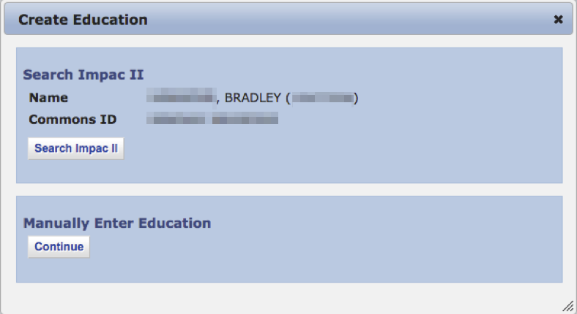

In-Training Info Page – Create Education (Manually Enter)
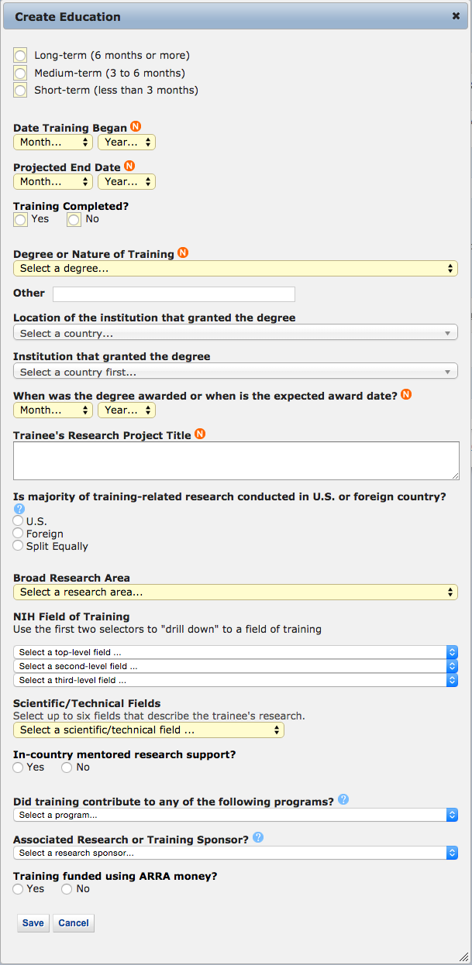
Accomplishments Page
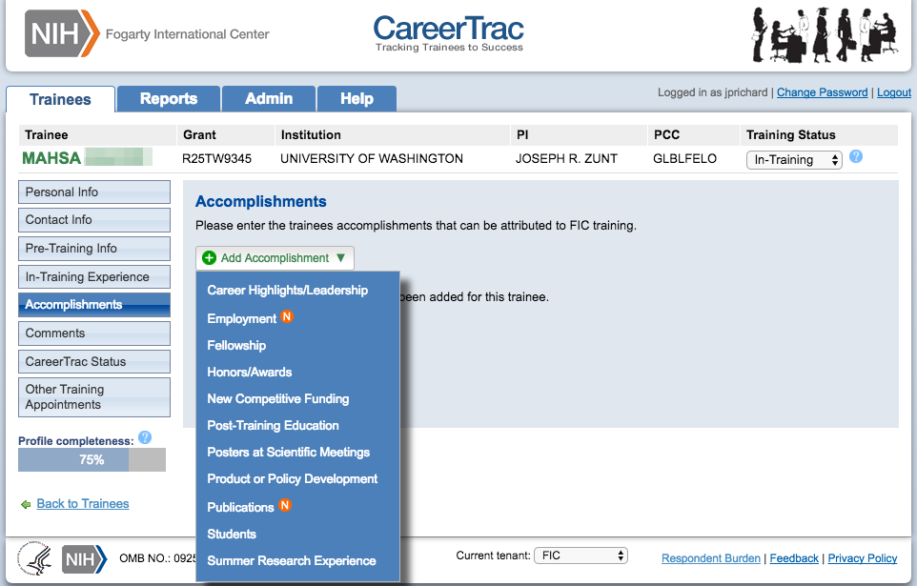

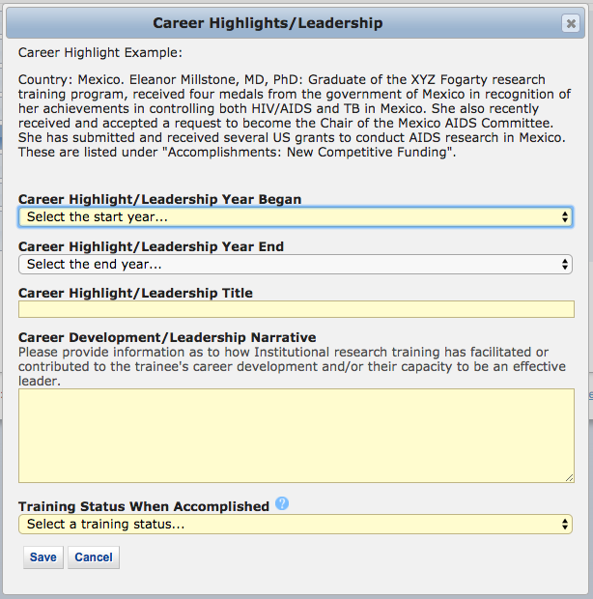
Accomplishments – Career Highlights/Leadership

Accomplishments – Employment (Commons Trainee)
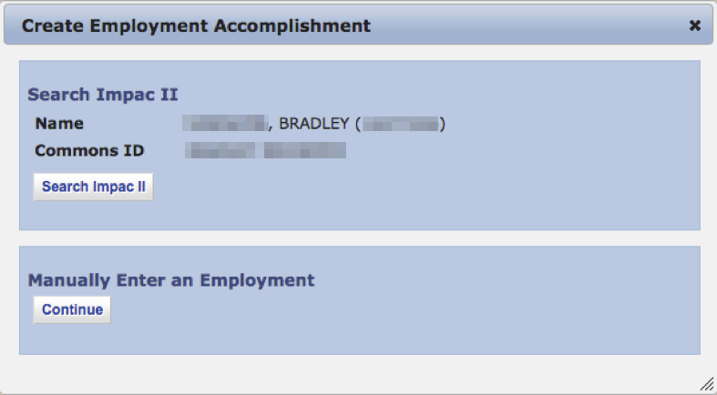

Accomplishments – Employment (Manually Enter)
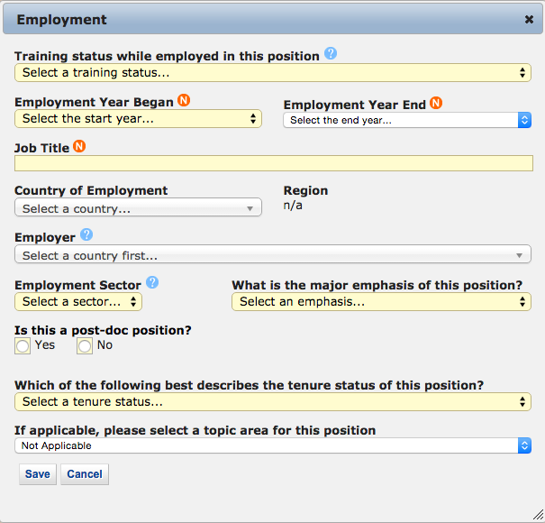

Accomplishment – Fellowship
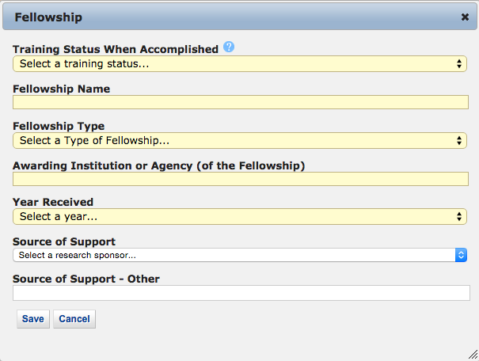

Accomplishments – Honors/Awards
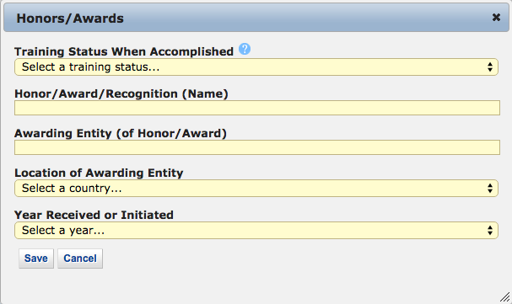

Accomplishments – New Competitive Funding
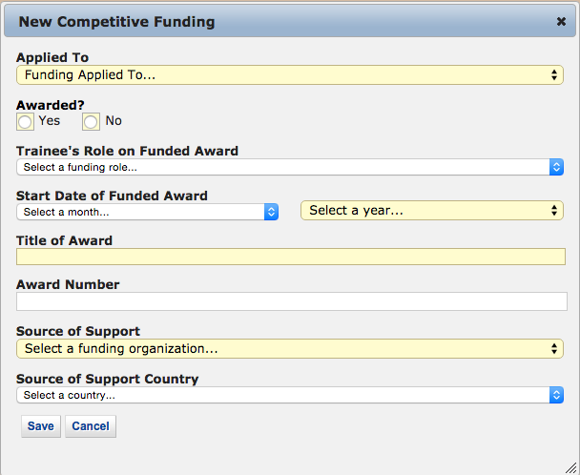

Accomplishments – Post-Training Education (Commons Trainee)
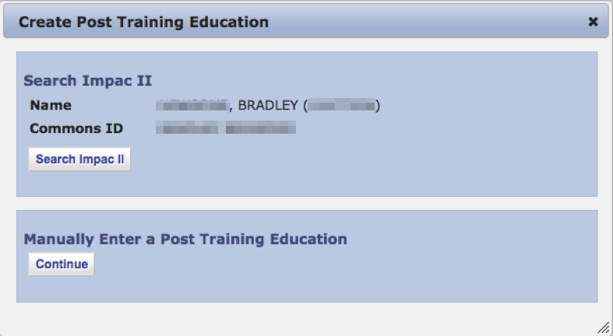

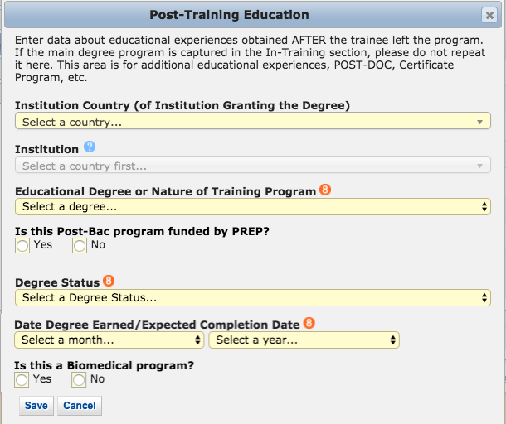
Accomplishments – Post-Training Education (Manually Enter)

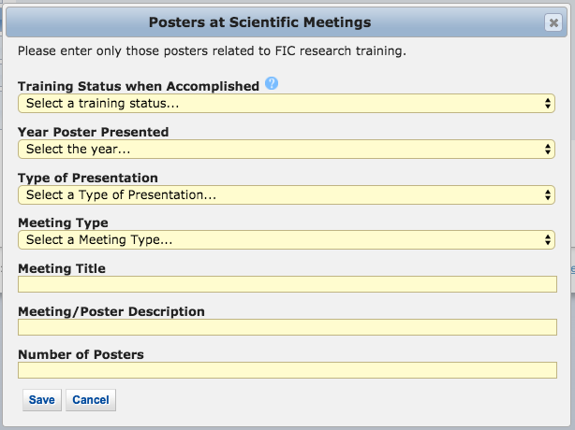
Accomplishments – Posters at Scientific Meetings
Accomplishments – Product or Policy Development
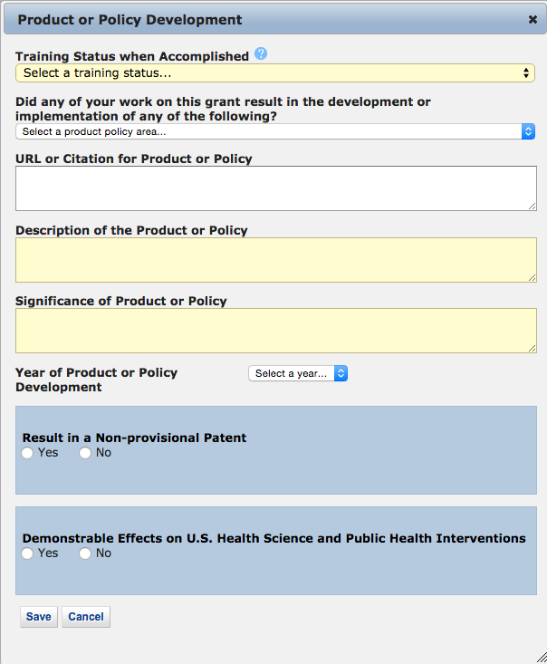

Accomplishments – Publications (Search)
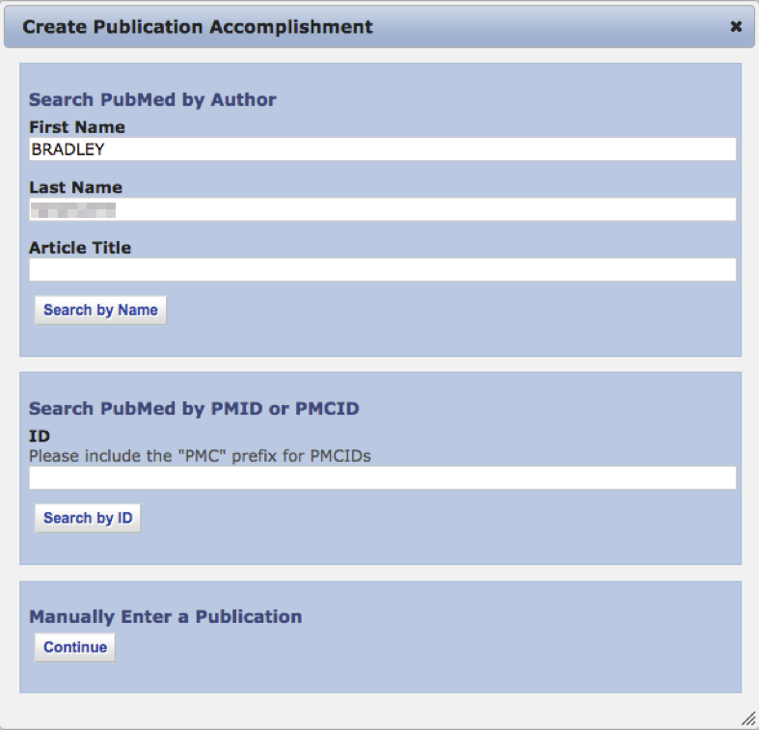

Accomplishments – Publications (Manually Enter)
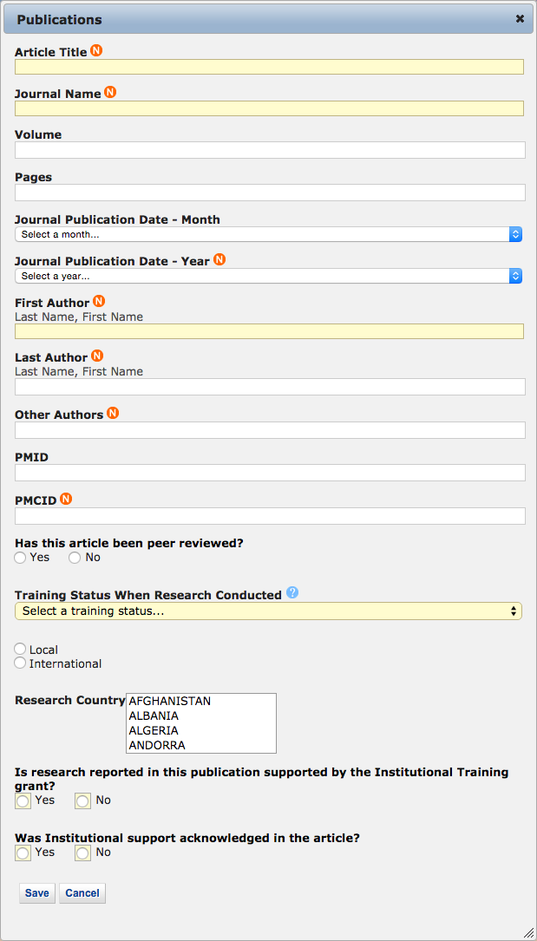

Accomplishments – Students
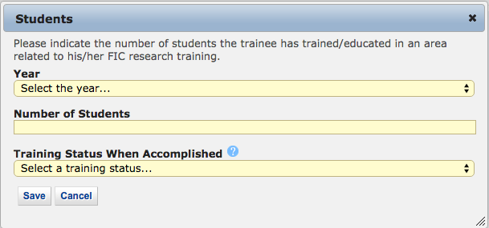

Accomplishments – Summer Research Experience
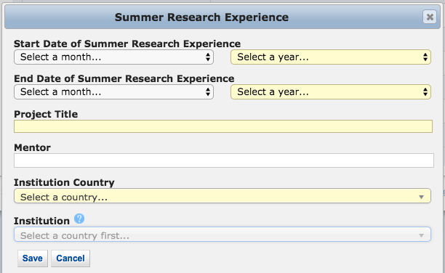

Comments
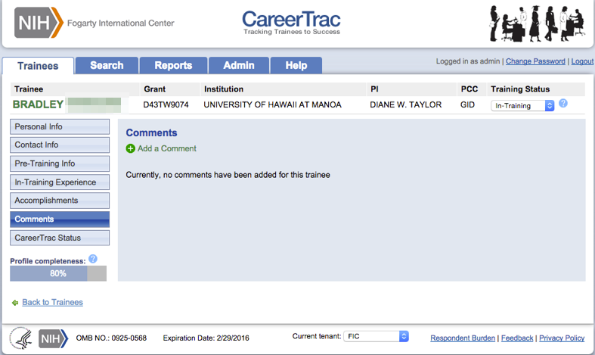

Comments – Add Comments
