NIGMS CareerTrac Screenshots

Burden Statement Page

Personal Info Page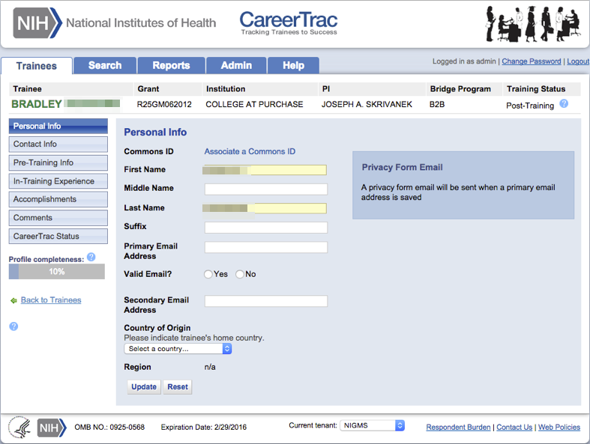

Personal Info Page – Associating a Commons ID (Search)
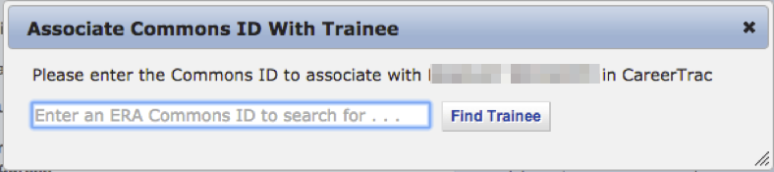

Personal Info Page – Associating a Commons ID (Review) 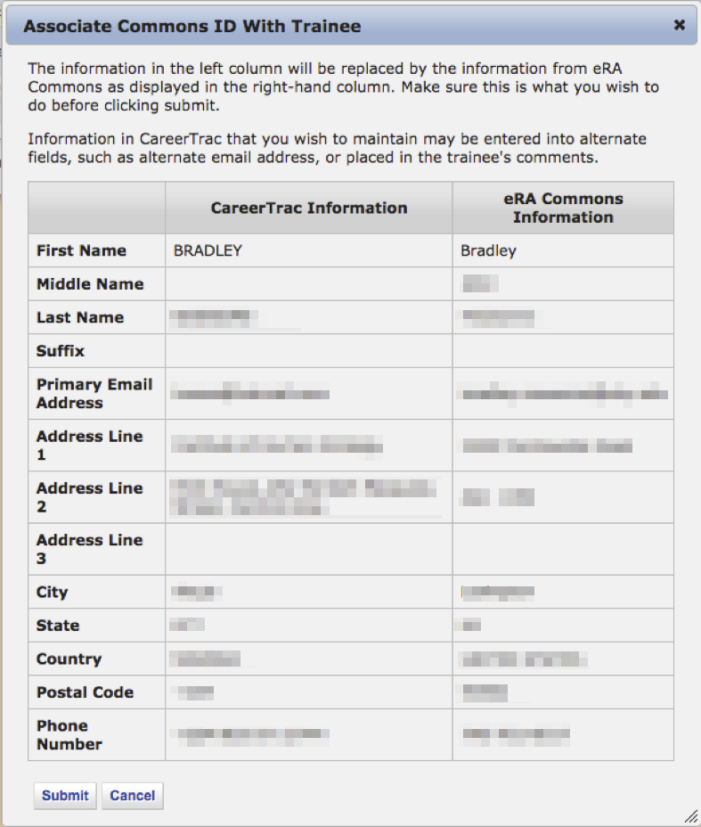

Personal Info Page – Commons Trainee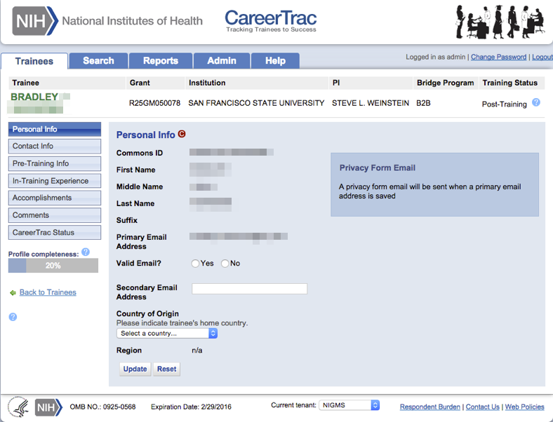

Contact Info Page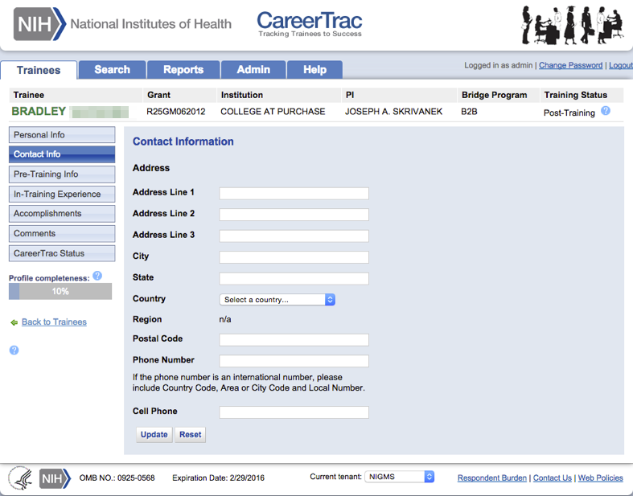

Contact Info Page – IMPAC II Trainee 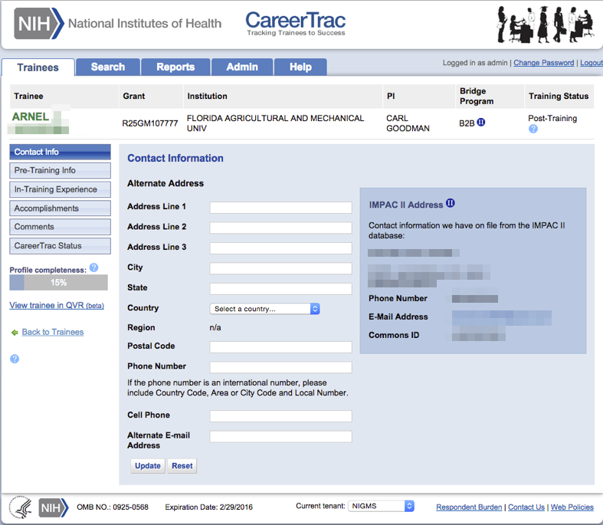

Contact Info Page – Commons Trainee 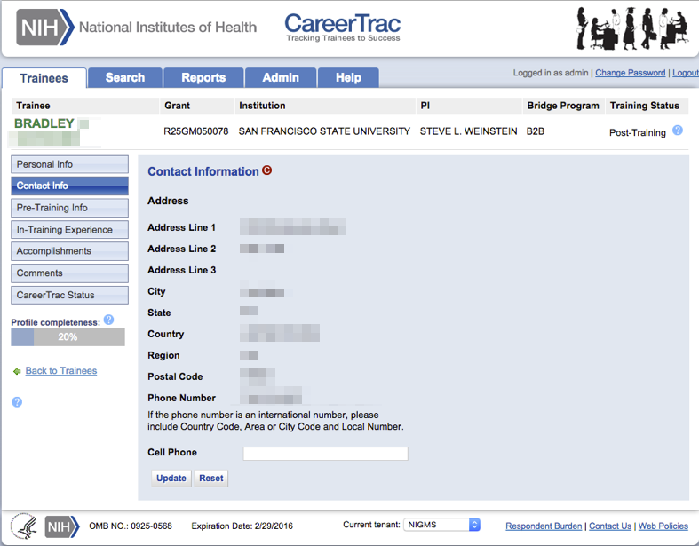

Prior Academic Degree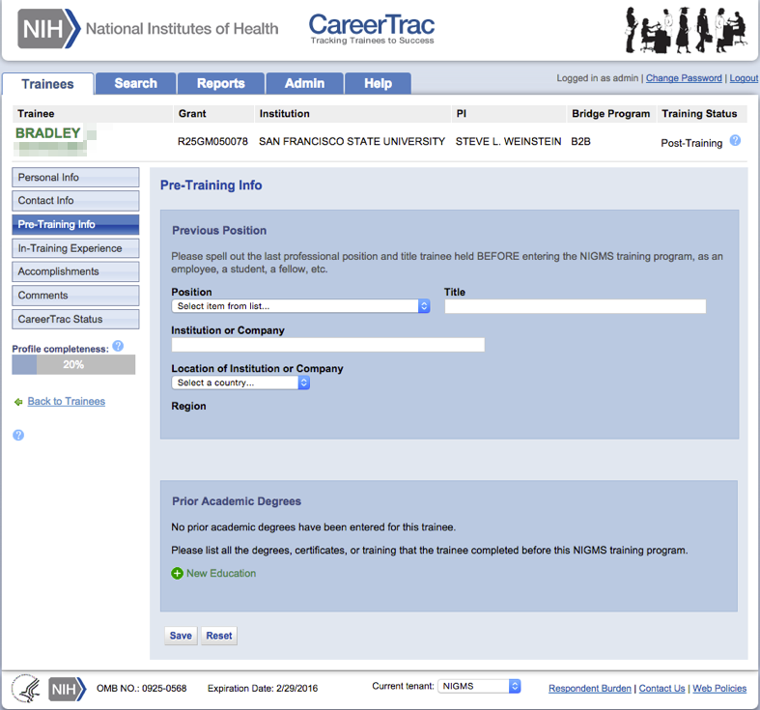

Prior Academic Degree – IMPAC II Trainee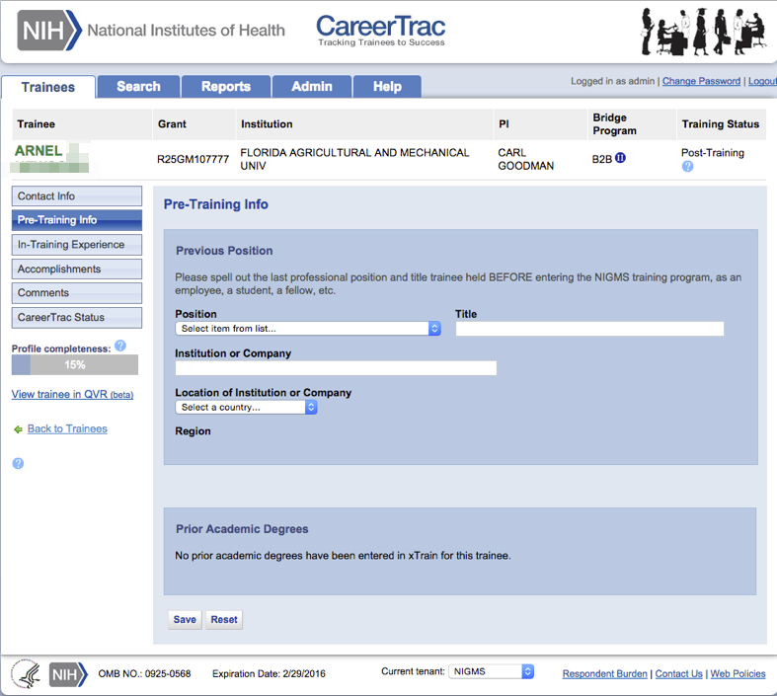

Pre-Training Info Page - Create Prior Academic Degree (Commons Trainee)
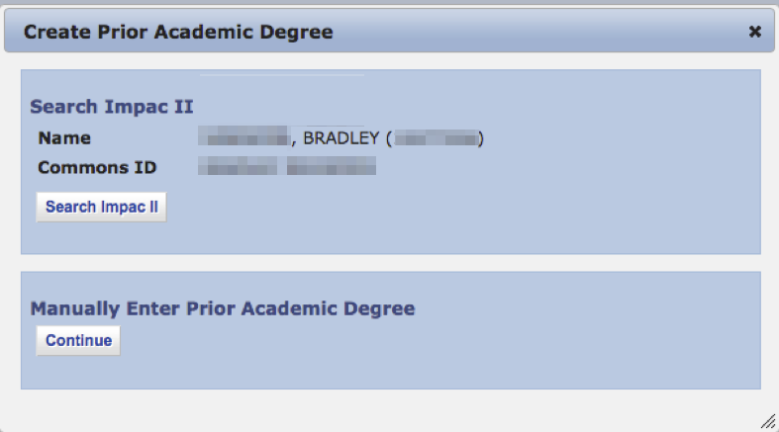

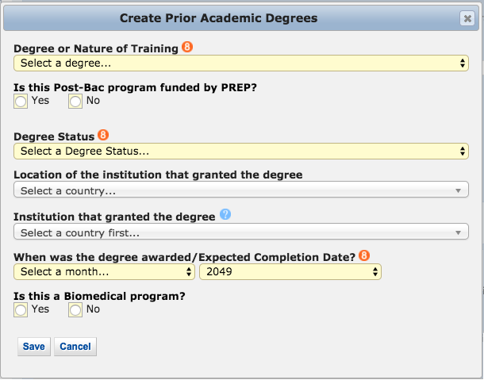
Pre-Training Info Page - Create Prior Academic Degree (Manually Enter)

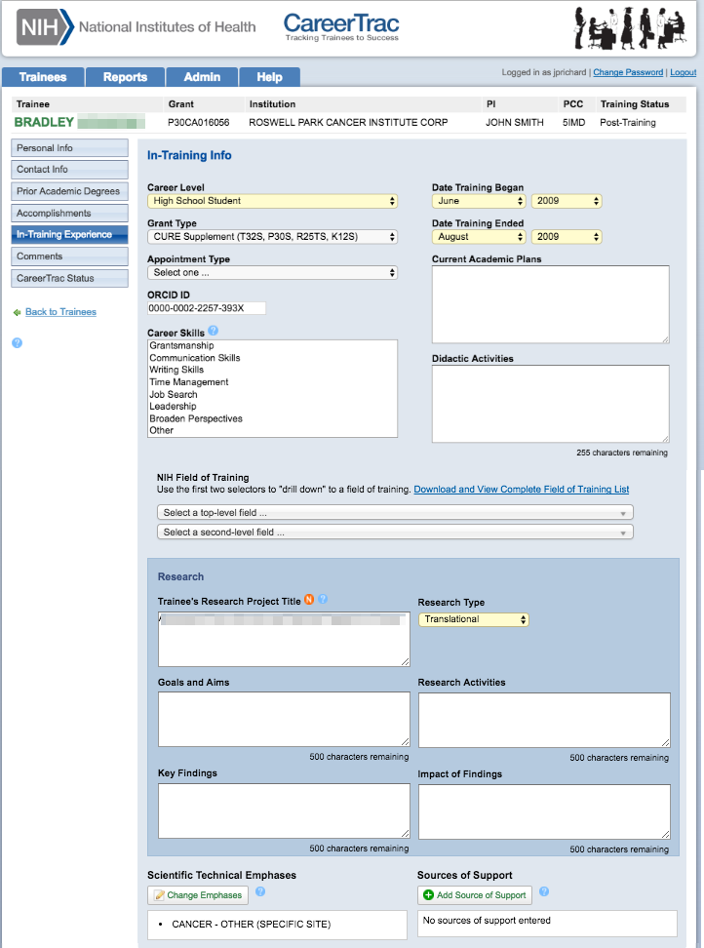
In-Training Experience page (Part 1)
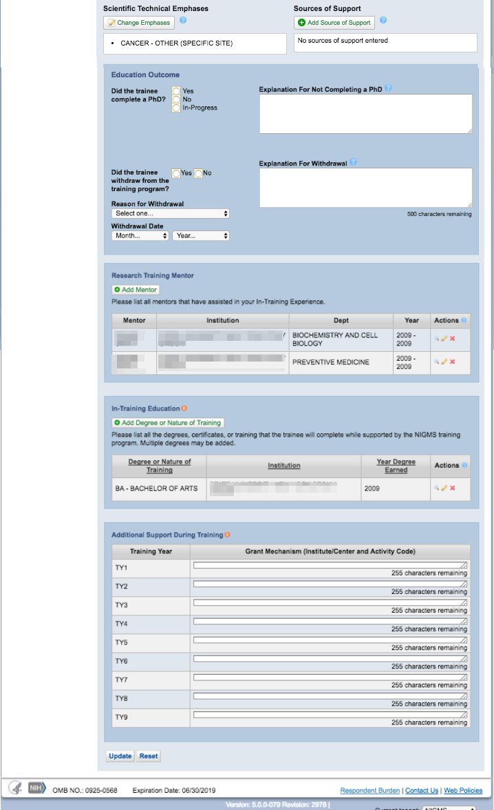
In-Training Experience page (Part 2)
In-Training Experience – Scientific Technical Emphases 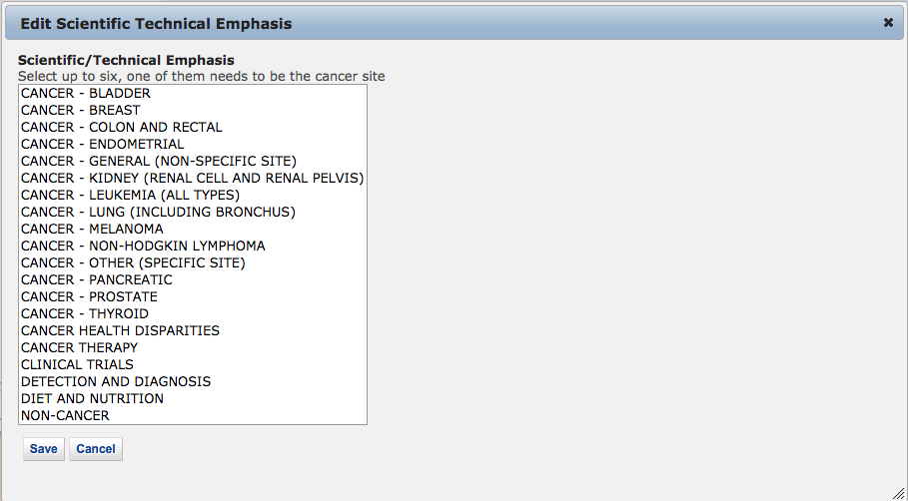

In-Training Experience – Source of Support 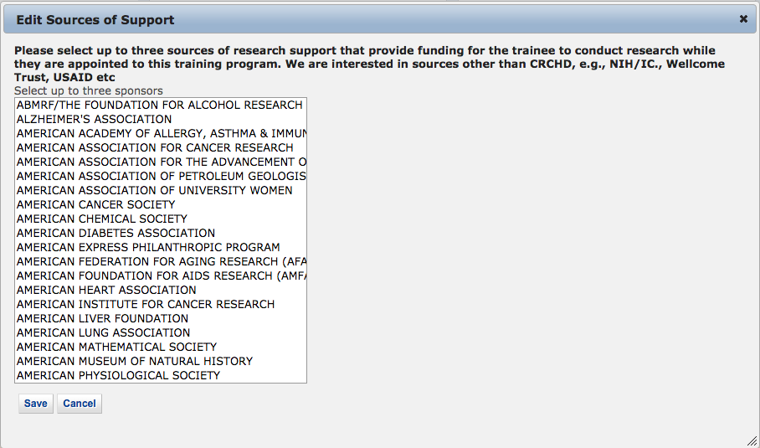

In-Training Info Page – New Mentor (Search)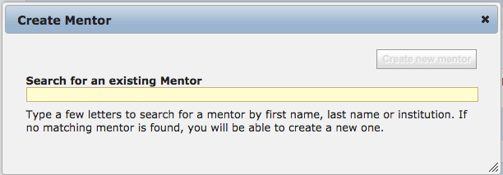

In-Training Info Page – New Mentor (Maunally Enter)
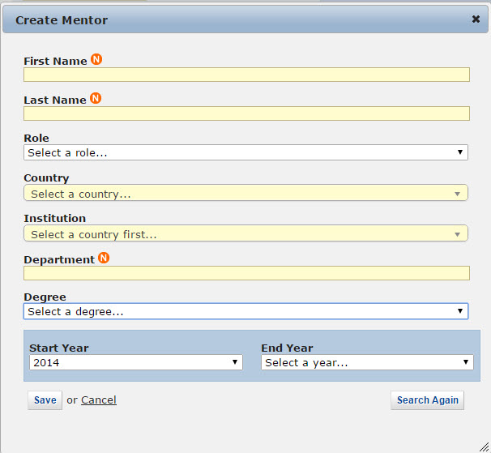

In-Training Info Page – Create Education (Commons/ IMPAC II Trainee)
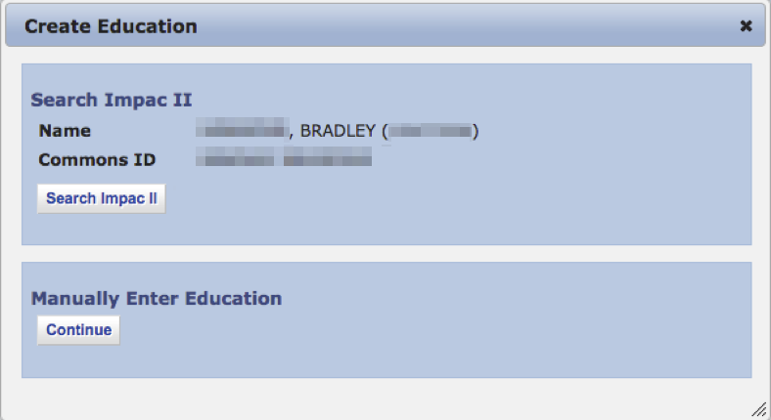

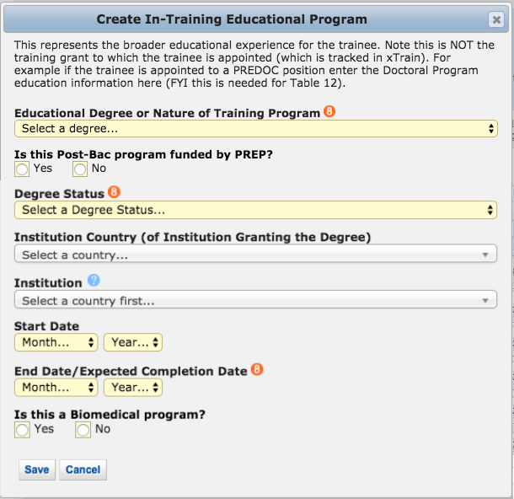
In-Training Info Page – Create Education (Manually Enter)

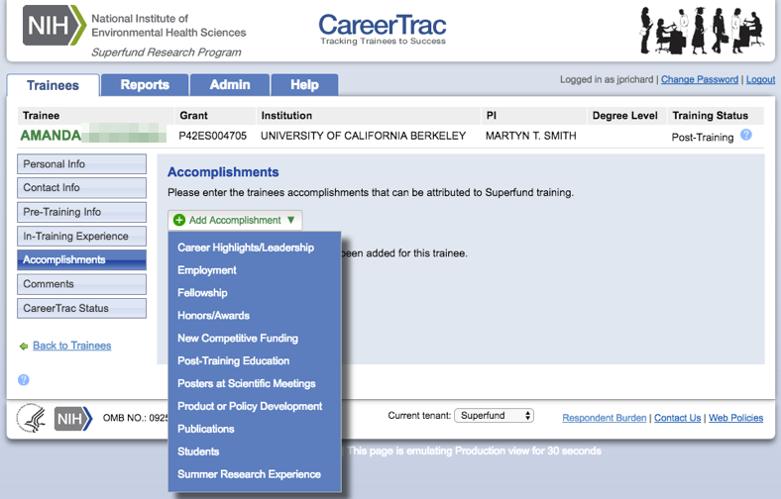
Accomplishments page

Accomplishments – Career Highlights/Leadership 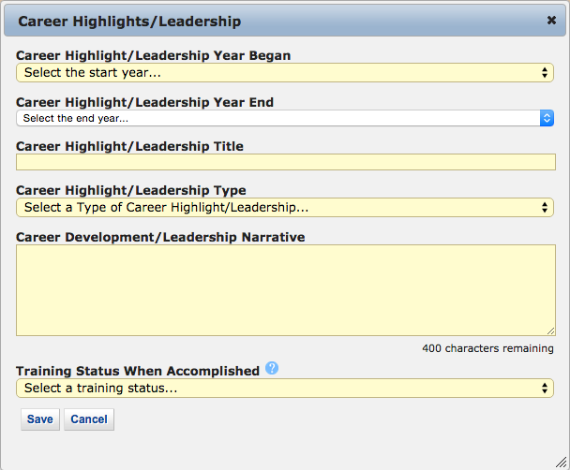

Accomplishments – Employment (Commons Trainee) 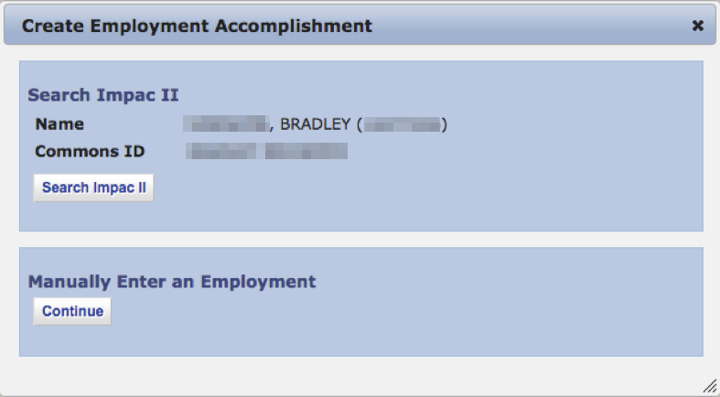

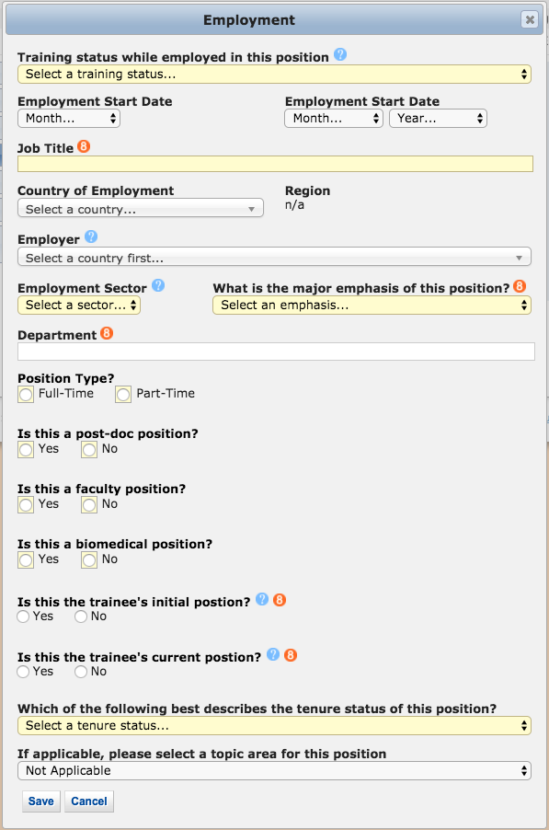
Accomplishments – Employment (Manually Enter)

Accomplishments – Fellowship 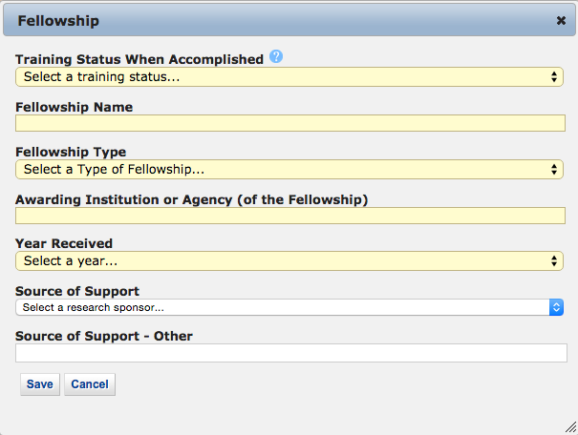

Accomplishments – Honors/Awards 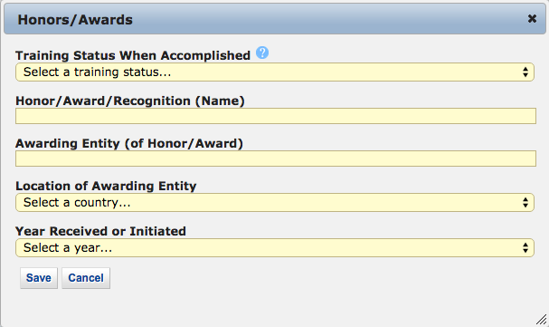

Accomplishments – New Competitive Funding 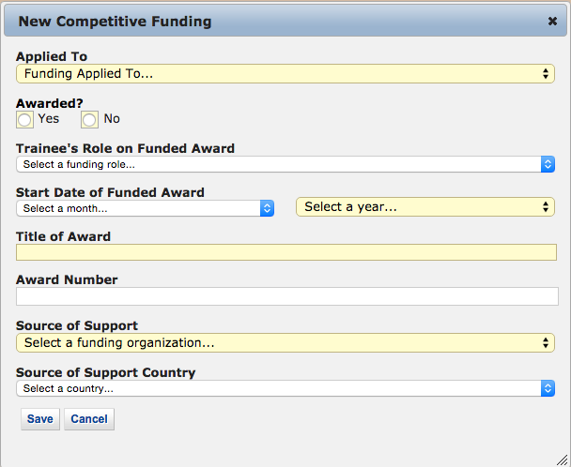

Accomplishments – Post Training Education (Commons Trainees)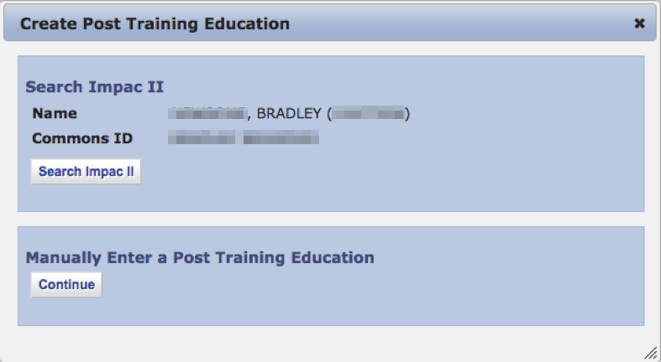

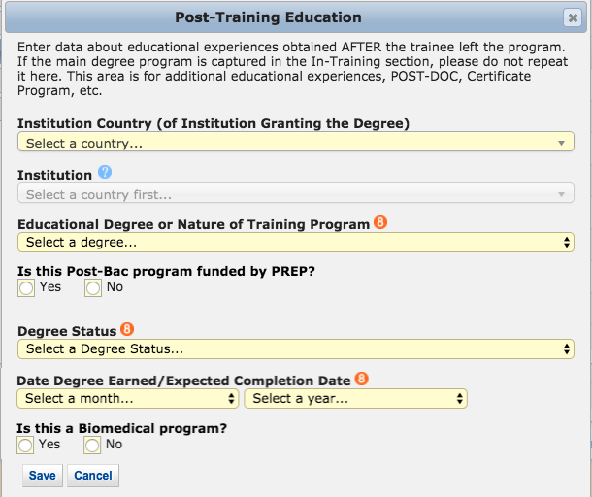
Accomplishments - Post Training Education (Manually Enter)

Accomplishments – Posters at Scientific Meetings 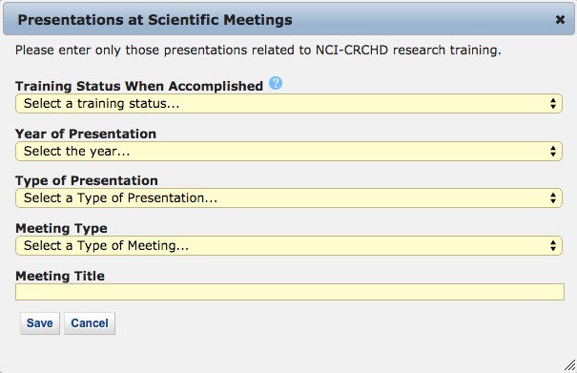

Accomplishments – Product or Policy Development 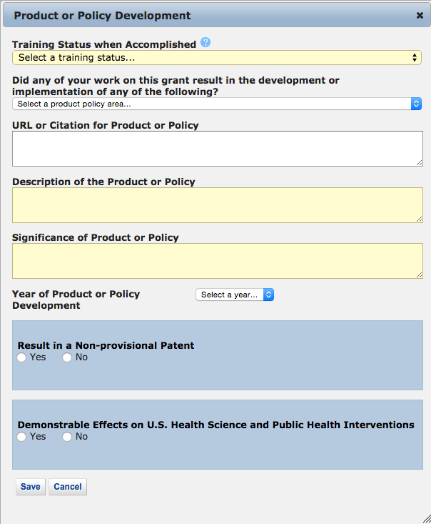

Accomplishments – Publications (Search)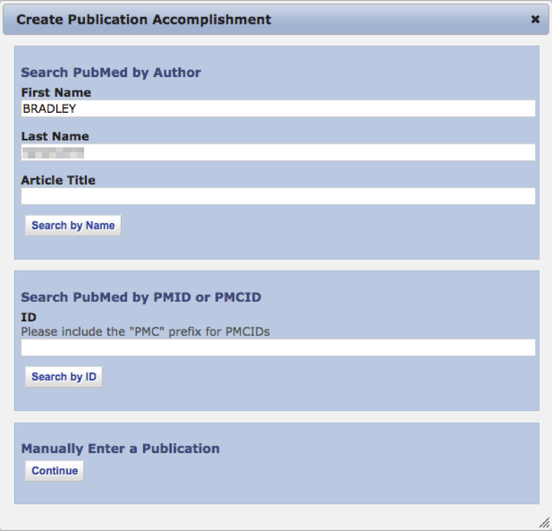

Accomplishments – Publications (Maunally Enter)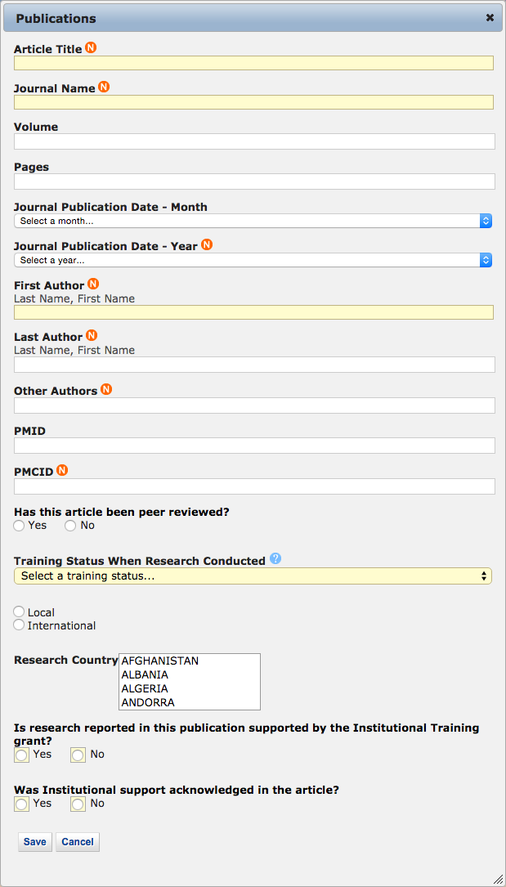

Accomplishments – Students 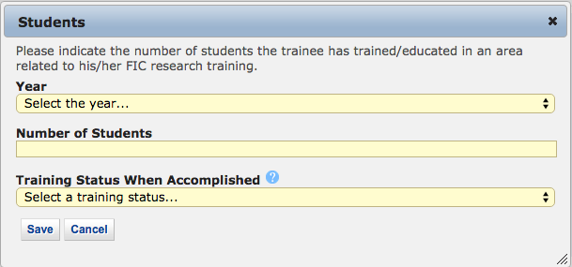

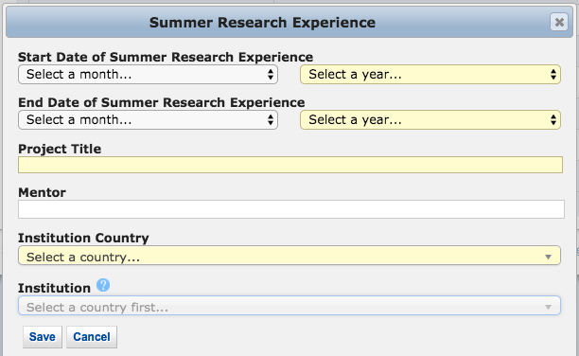
Accomplishments – Summer Research Experience

Comments
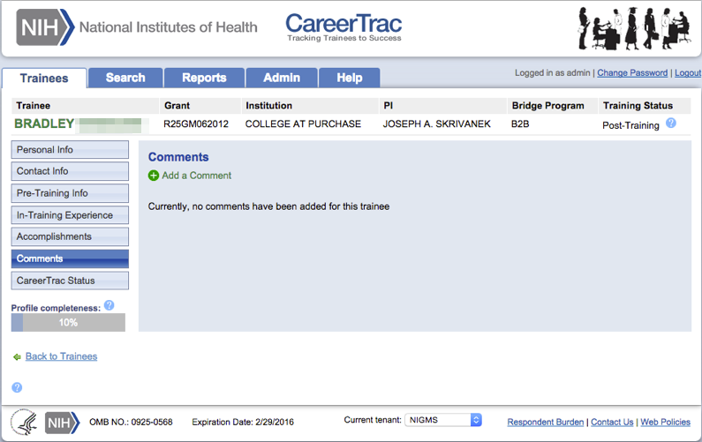

Comments – Add Comments 