SRP CareerTrac Screenshots

Burden Statement Page

Personal Info Page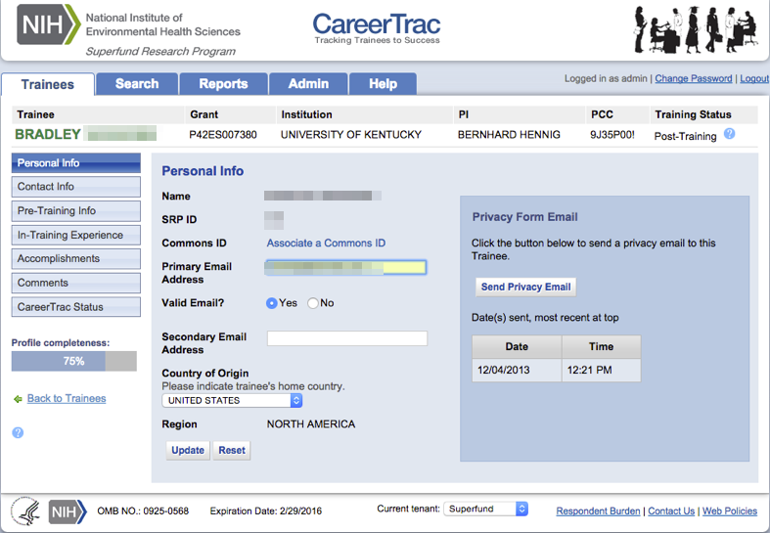

Personal Info Page – Associating a Commons ID (Search)
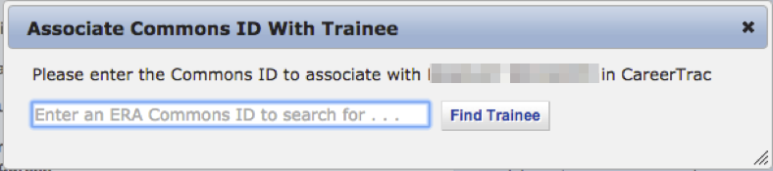

Personal Info Page – Associating a Commons ID (Review) 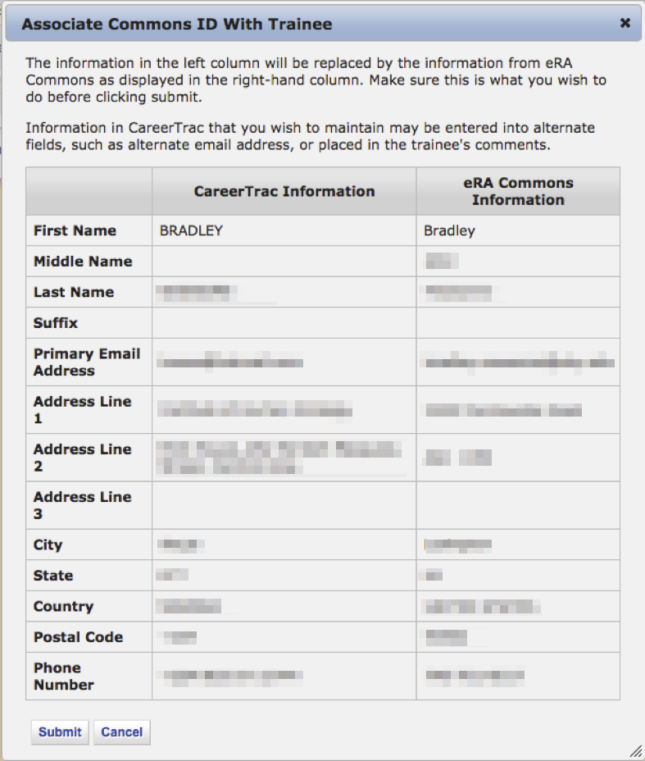

Personal Info Page – Commons Trainee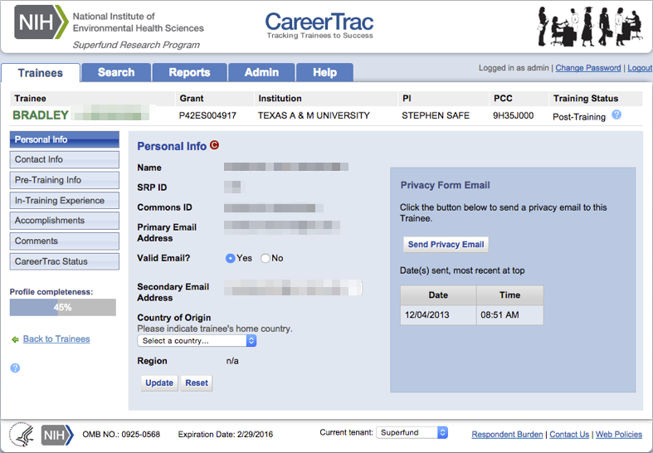

Contact Info Page 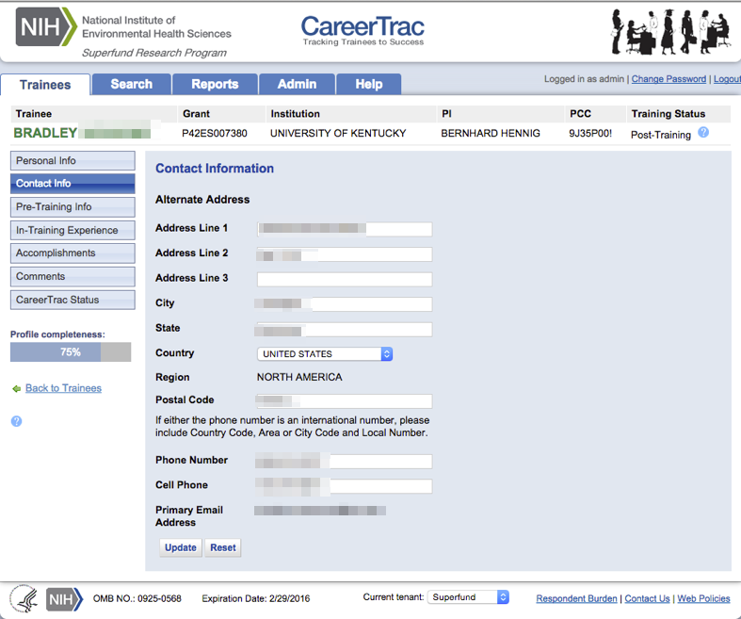

Contact Info Page – Commons Trainee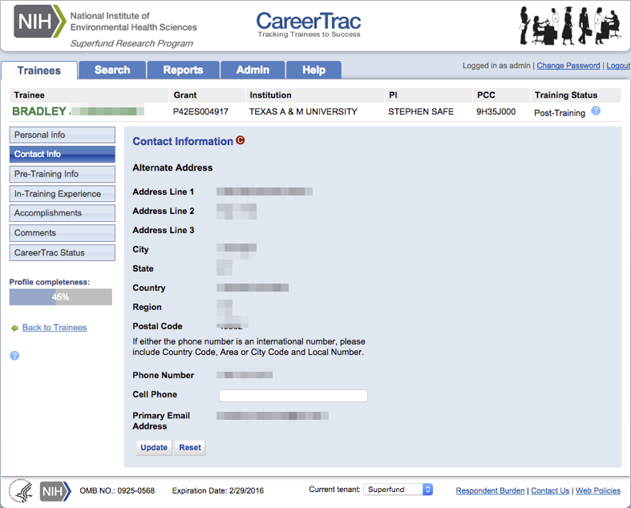

Pre-Training Info Page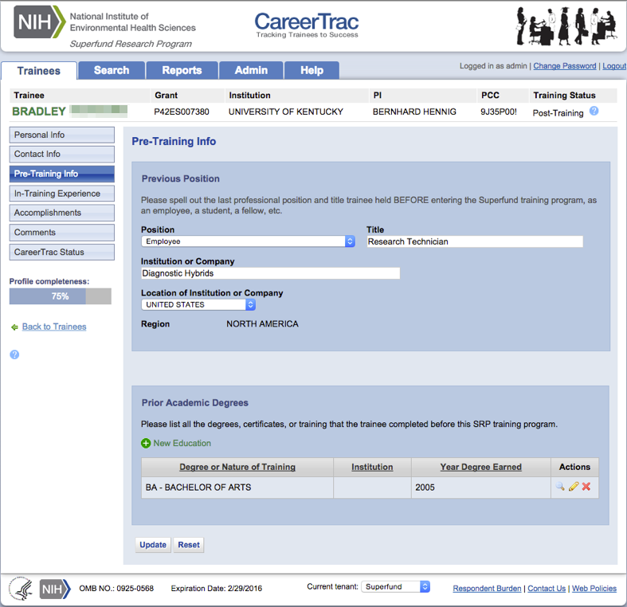

Pre-Training Info Page - Create Prior Academic Degree (Commons Trainee)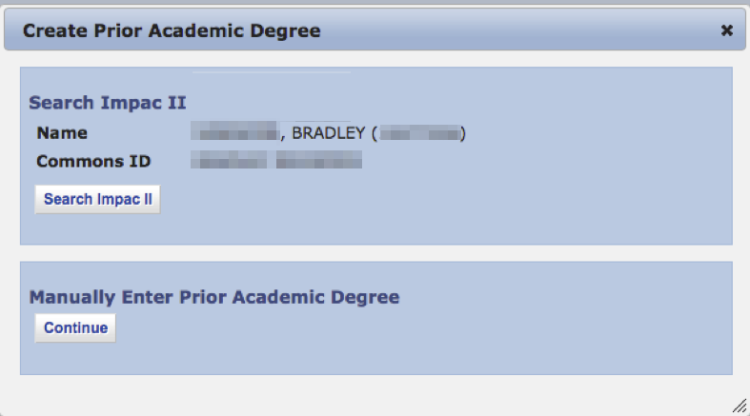

Pre-Training Info Page - Create Prior Academic Degree (Manually Enter)
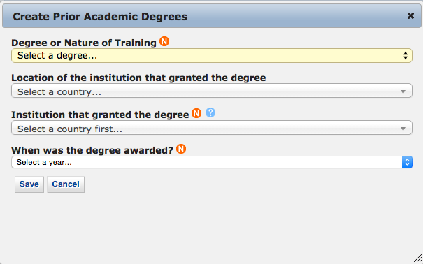

In-Training Info Page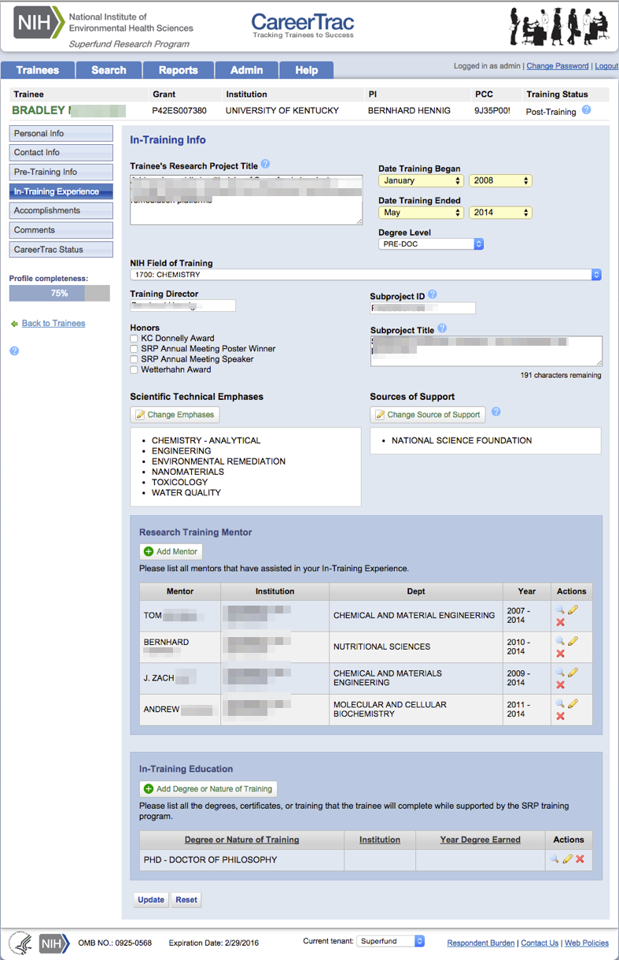

In-Training Experience – Scientific Technical Emphases 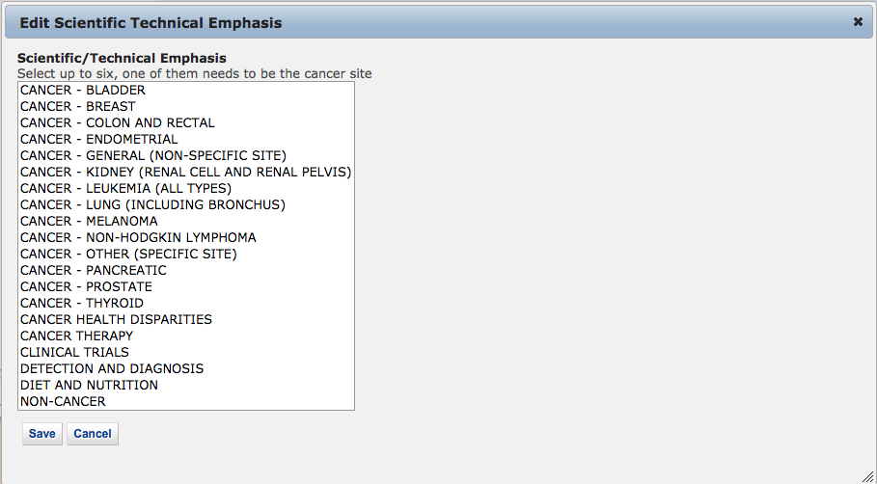

In-Training Experience – Source of Support 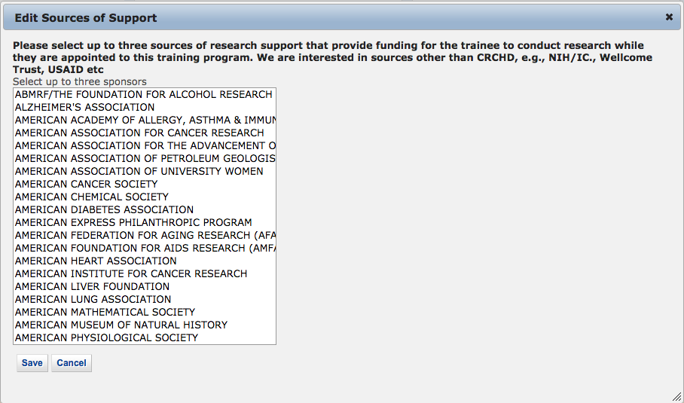

In-Training Info Page – New Mentor (Search)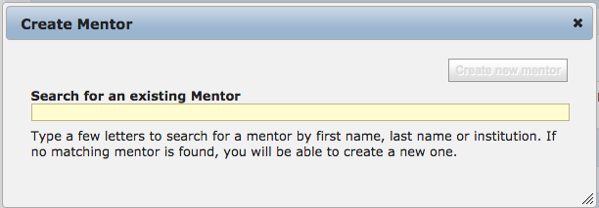

In-Training Info Page – New Mentor (Maunally Enter)
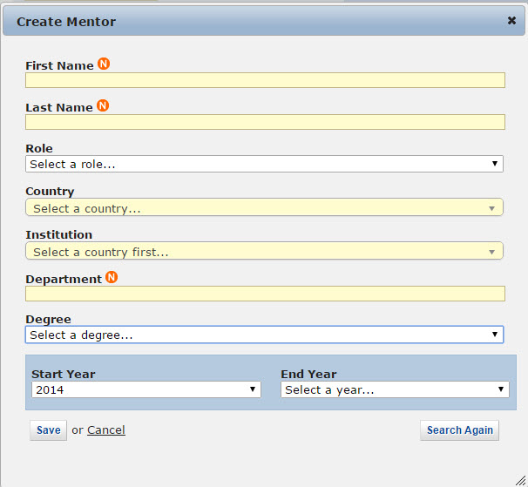

In-Training Info Page – Create Education (Commons Trainee)
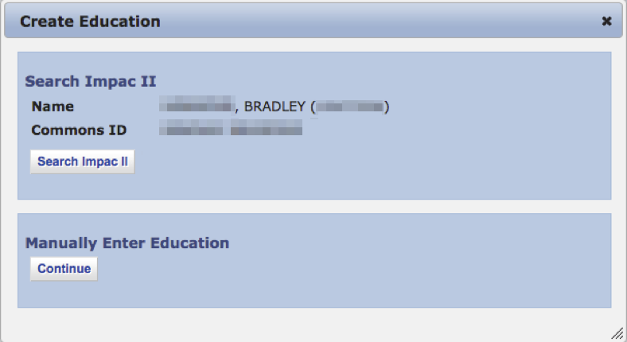

In-Training Info Page – Create Education (Manually Enter)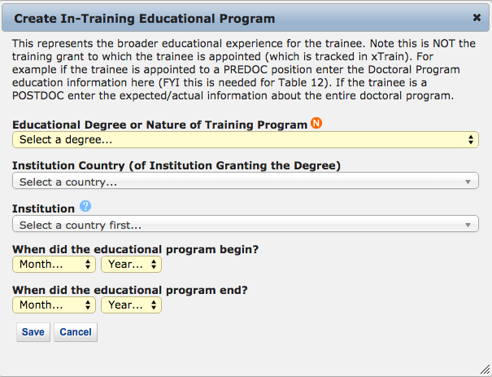

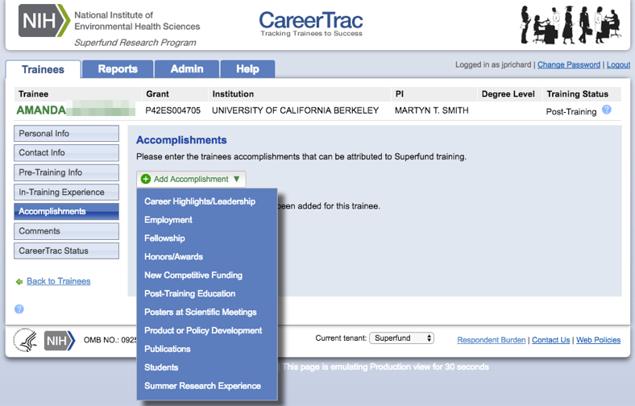
Accomplishments page

Accomplishments – Career Highlights/Leadership 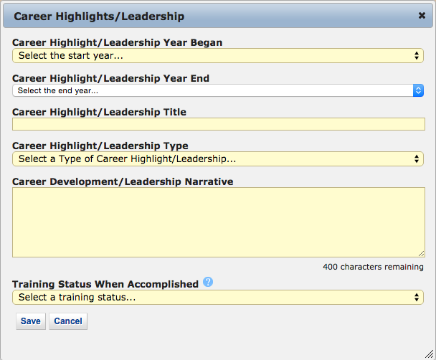

Accomplishments – Employment (Commons Trainee) 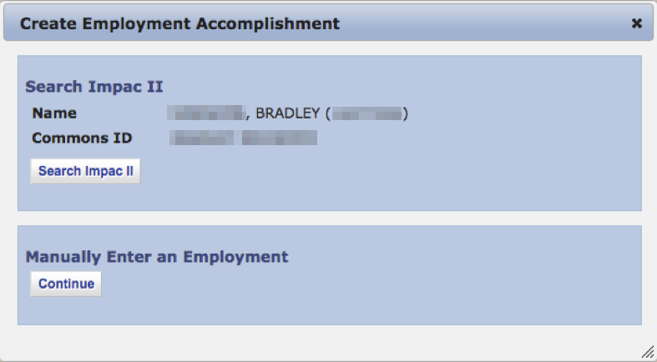

Accomplishments – Employment (Manually Enter) 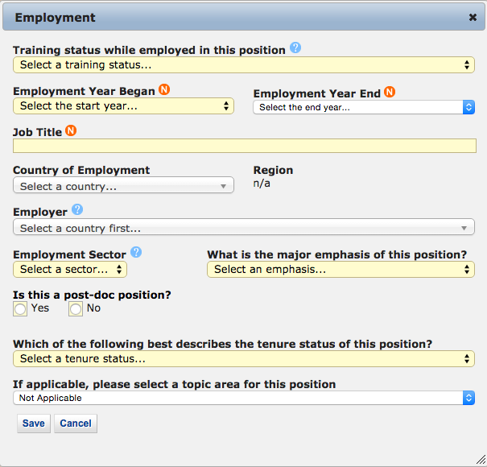

Accomplishments – Fellowship 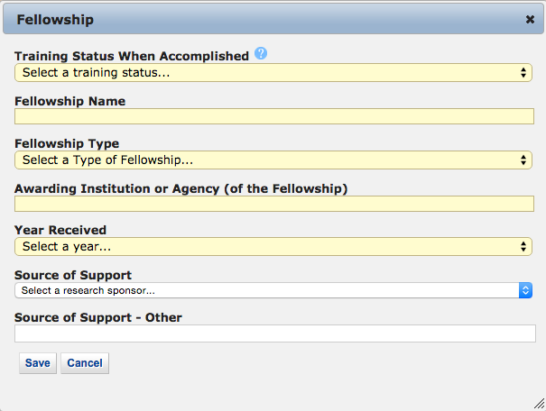

Accomplishments – Honors/Awards 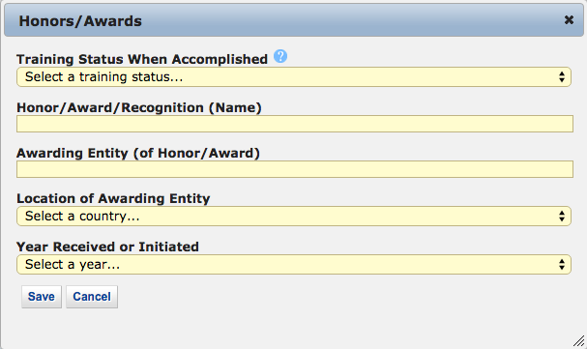

Accomplishments – New Competitive Funding 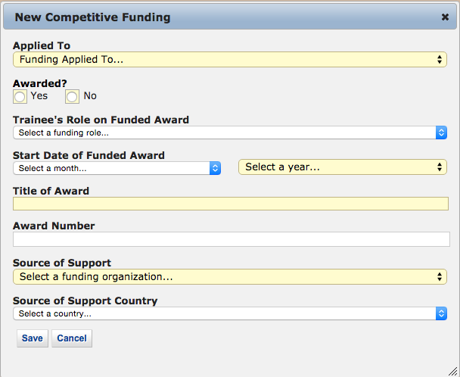

Accomplishments – Post Training Education (Commons Trainees)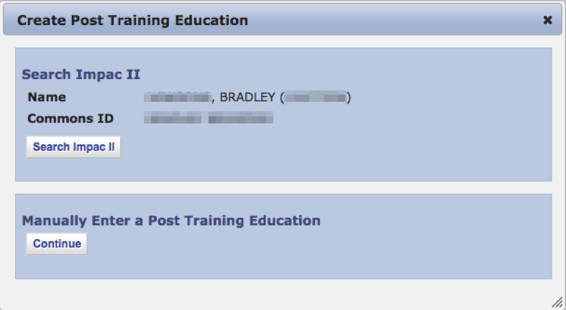

Accomplishments - Post Training Education (Manually Enter)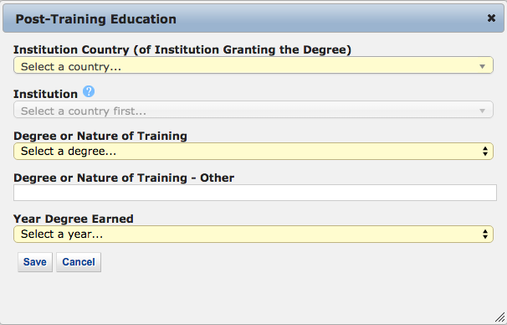

Accomplishments – Posters at Scientific Meetings 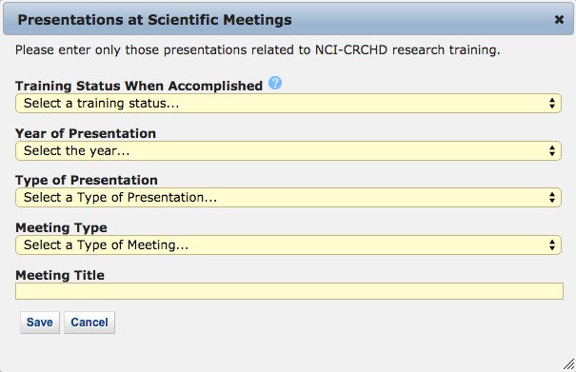

Accomplishments – Product or Policy Development 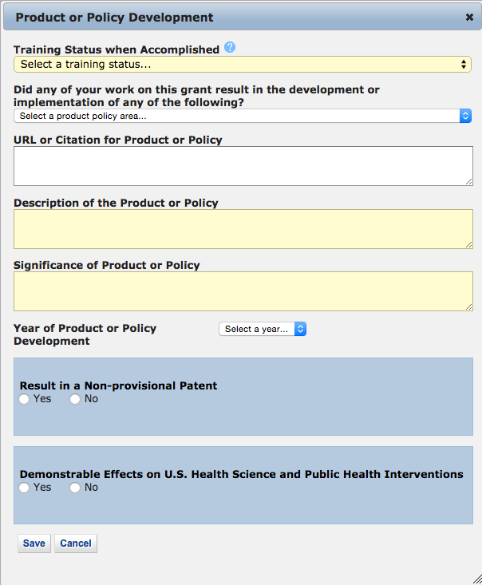

Accomplishments – Publications (Search)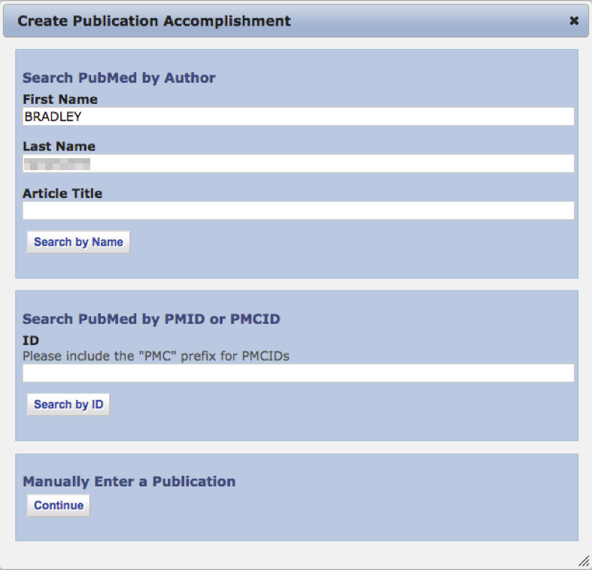

Accomplishments – Publications (Maunally Enter)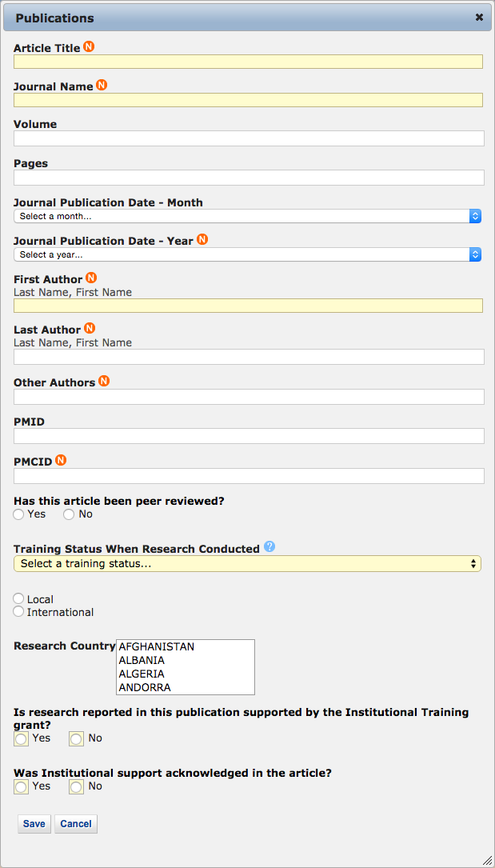

Accomplishments – Students 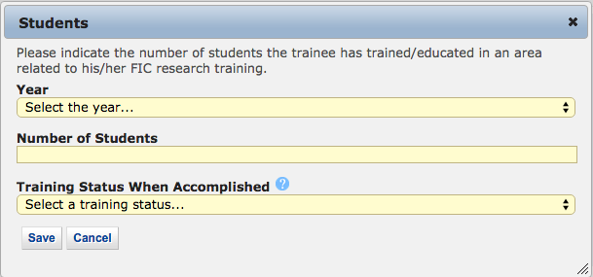
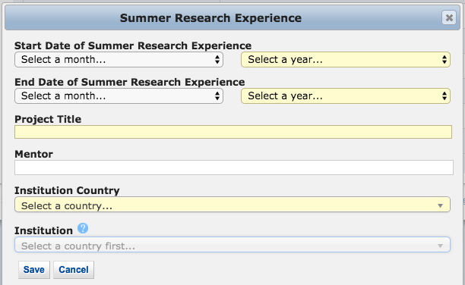
Accomplishments – Summer Research Experience

Comments 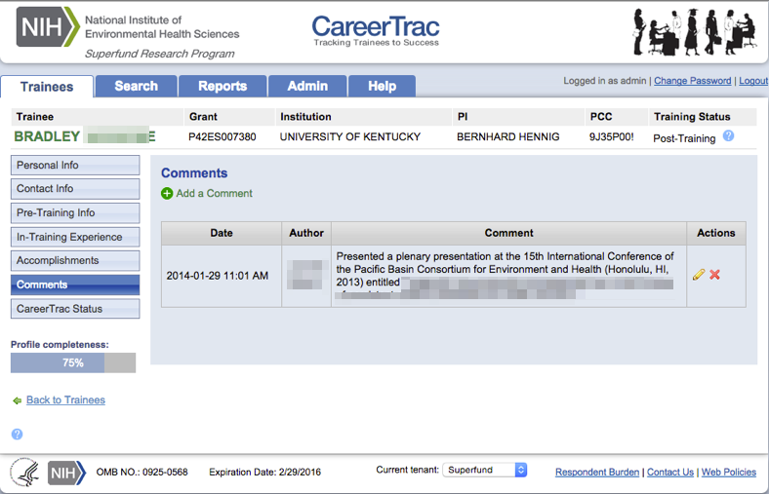

Comments – Add Comments 