CareerTrac Trainee Interface Screenshots
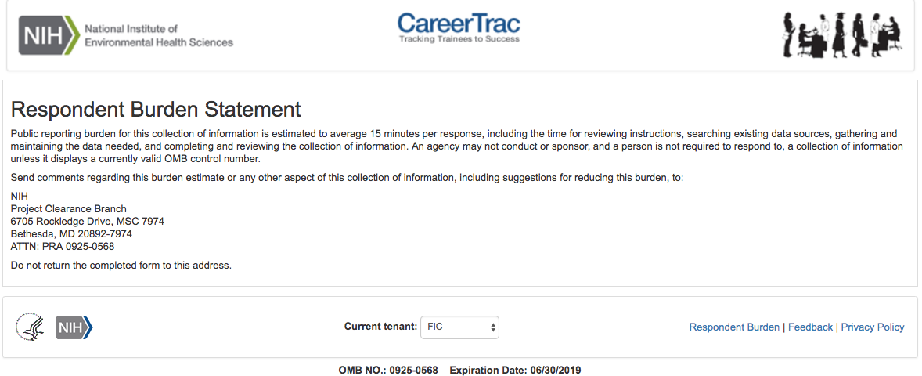
Burden Statement Page

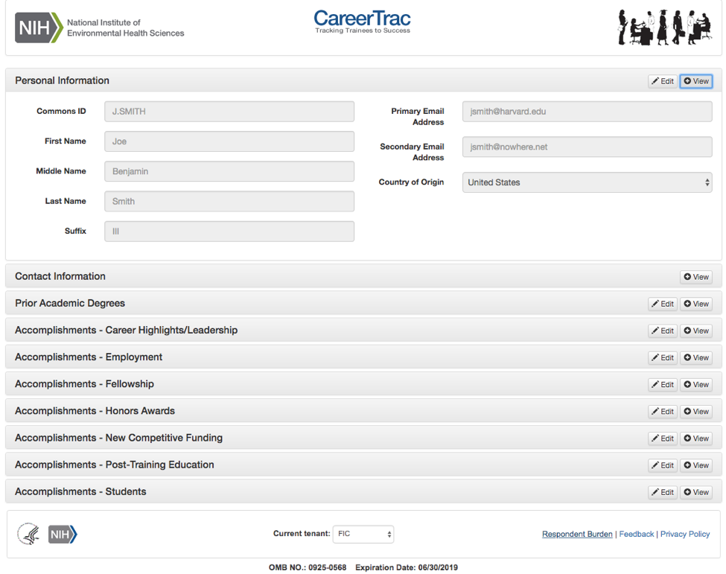
Trainee Interface – Personal Information
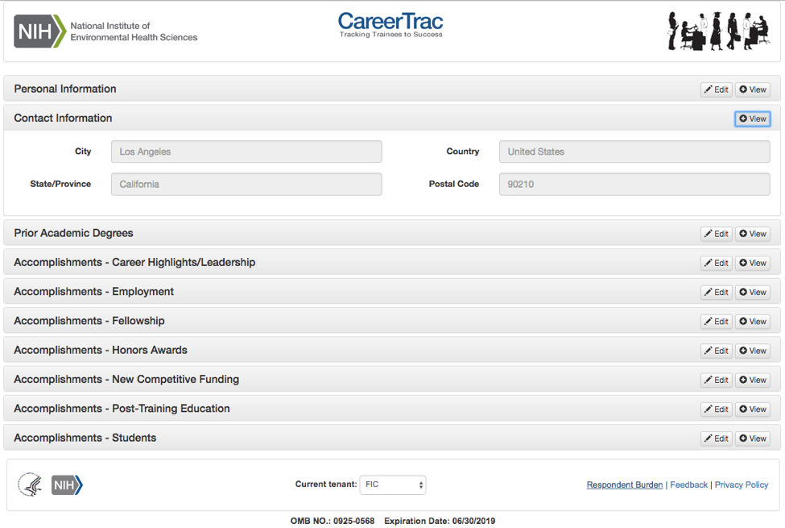
Trainee Interface – Contact Information

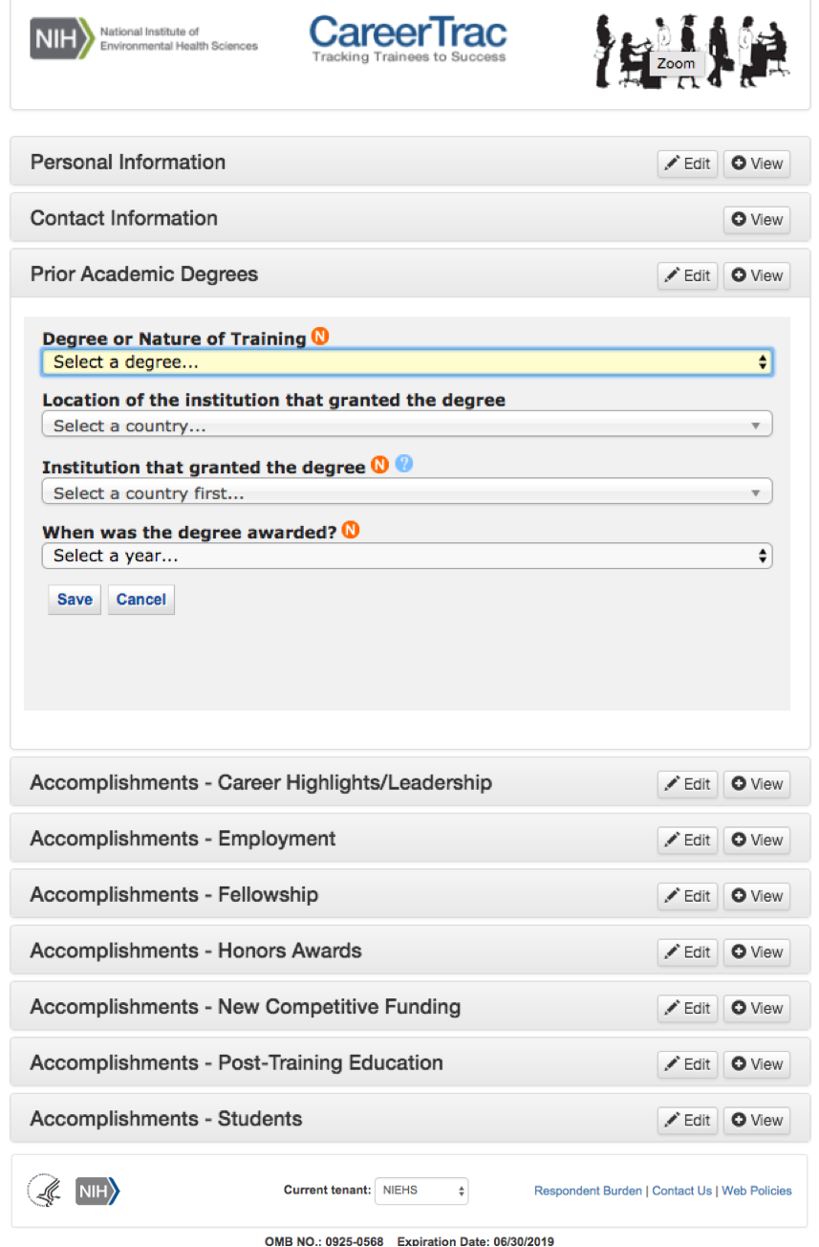
Trainee Interface – Prior Academic Degrees
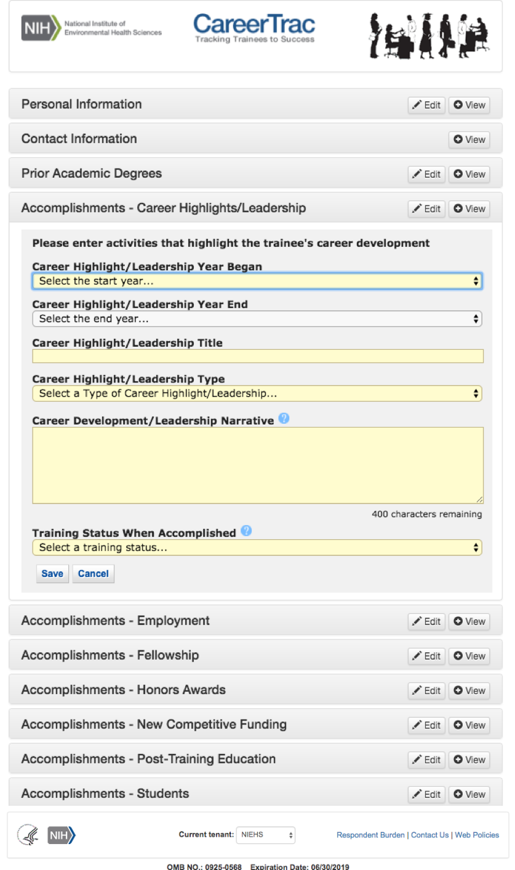
Trainee Interface – Career Highlights/Leadership
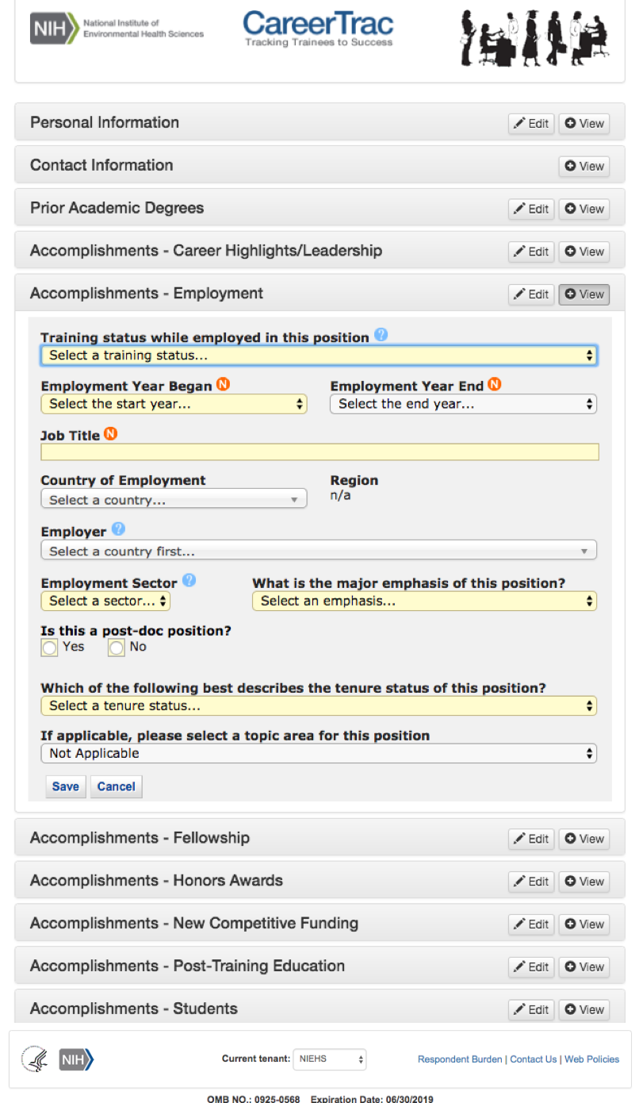
Trainee Interface – Employment
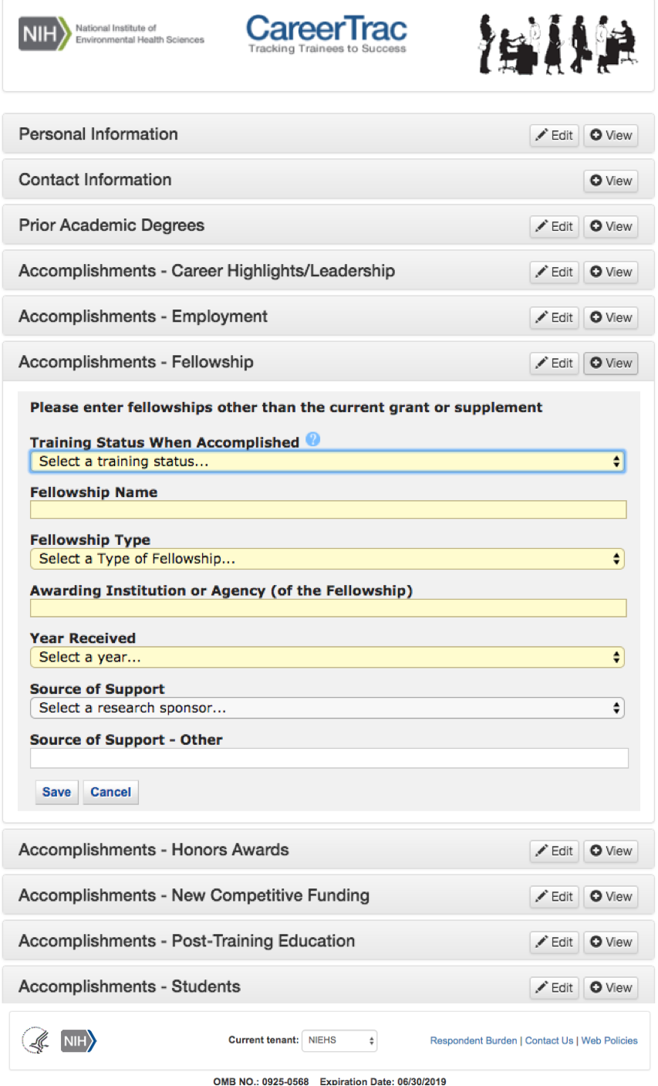
Trainee Interface – Fellowship
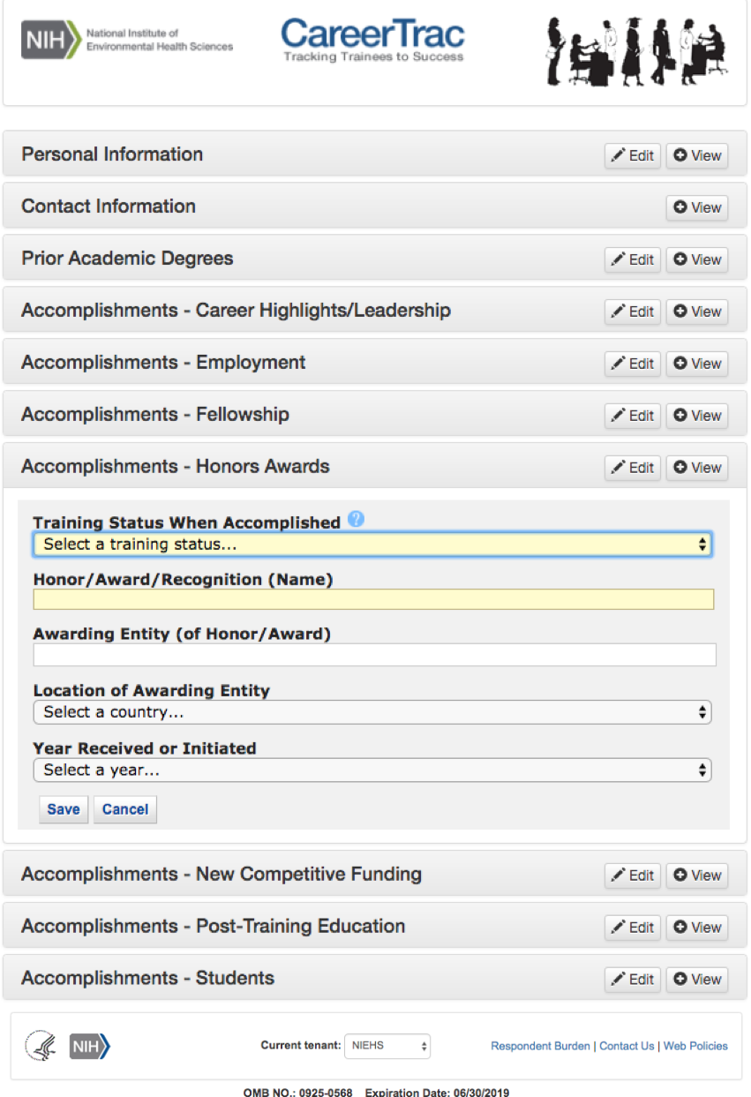
Trainee Interface – Honors/Awards

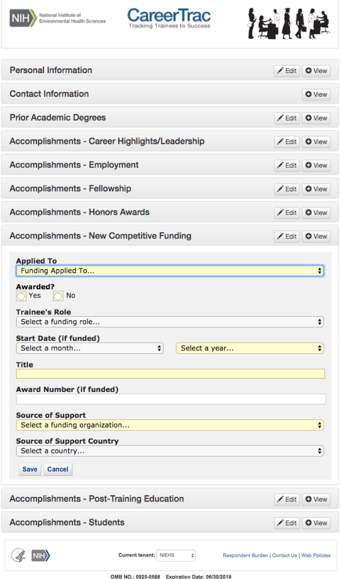
Trainee Interface – New Competitive Funding
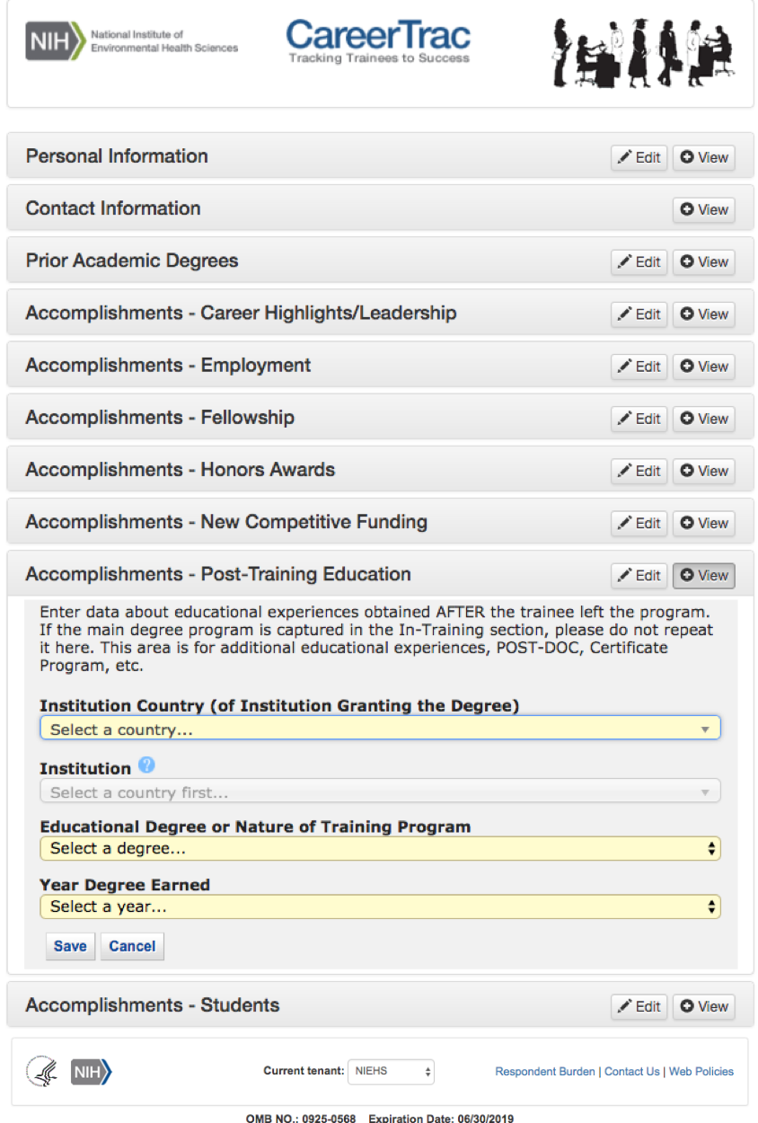
Trainee Interface – Post-Training Education

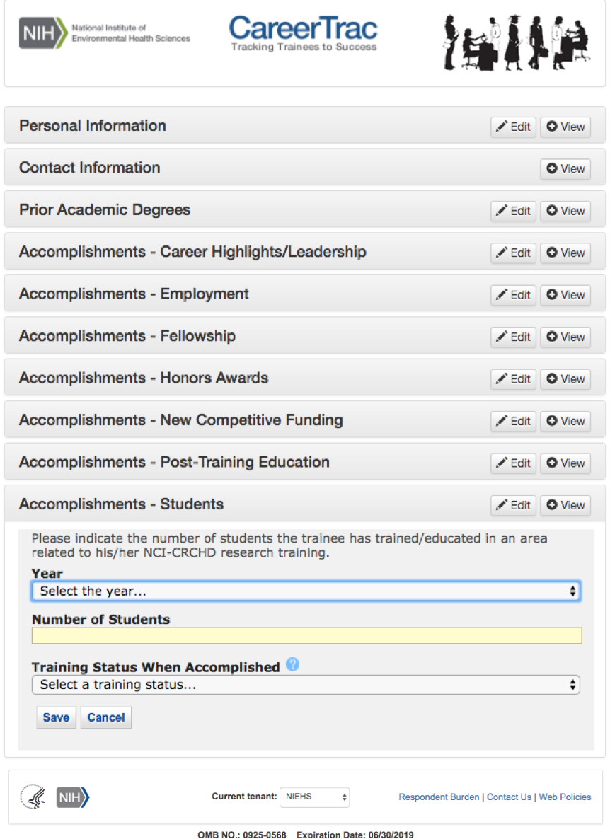
Trainee Interface – Students

