Supporting Statement for OMB Clearance Request

Appendix I: 72-Month Survey Flyer

National Implementation Evaluation of the Health Profession Opportunity Grants (HPOG) to Serve TANF Recipients and Other Low-Income Individuals and HPOG Impact Study

0970-0394

April 2017

Submitted by:
Nicole Constance
Office of Planning, Research
and Evaluation
Administration for Children
and Families
U.S. Department of Health and Human Services

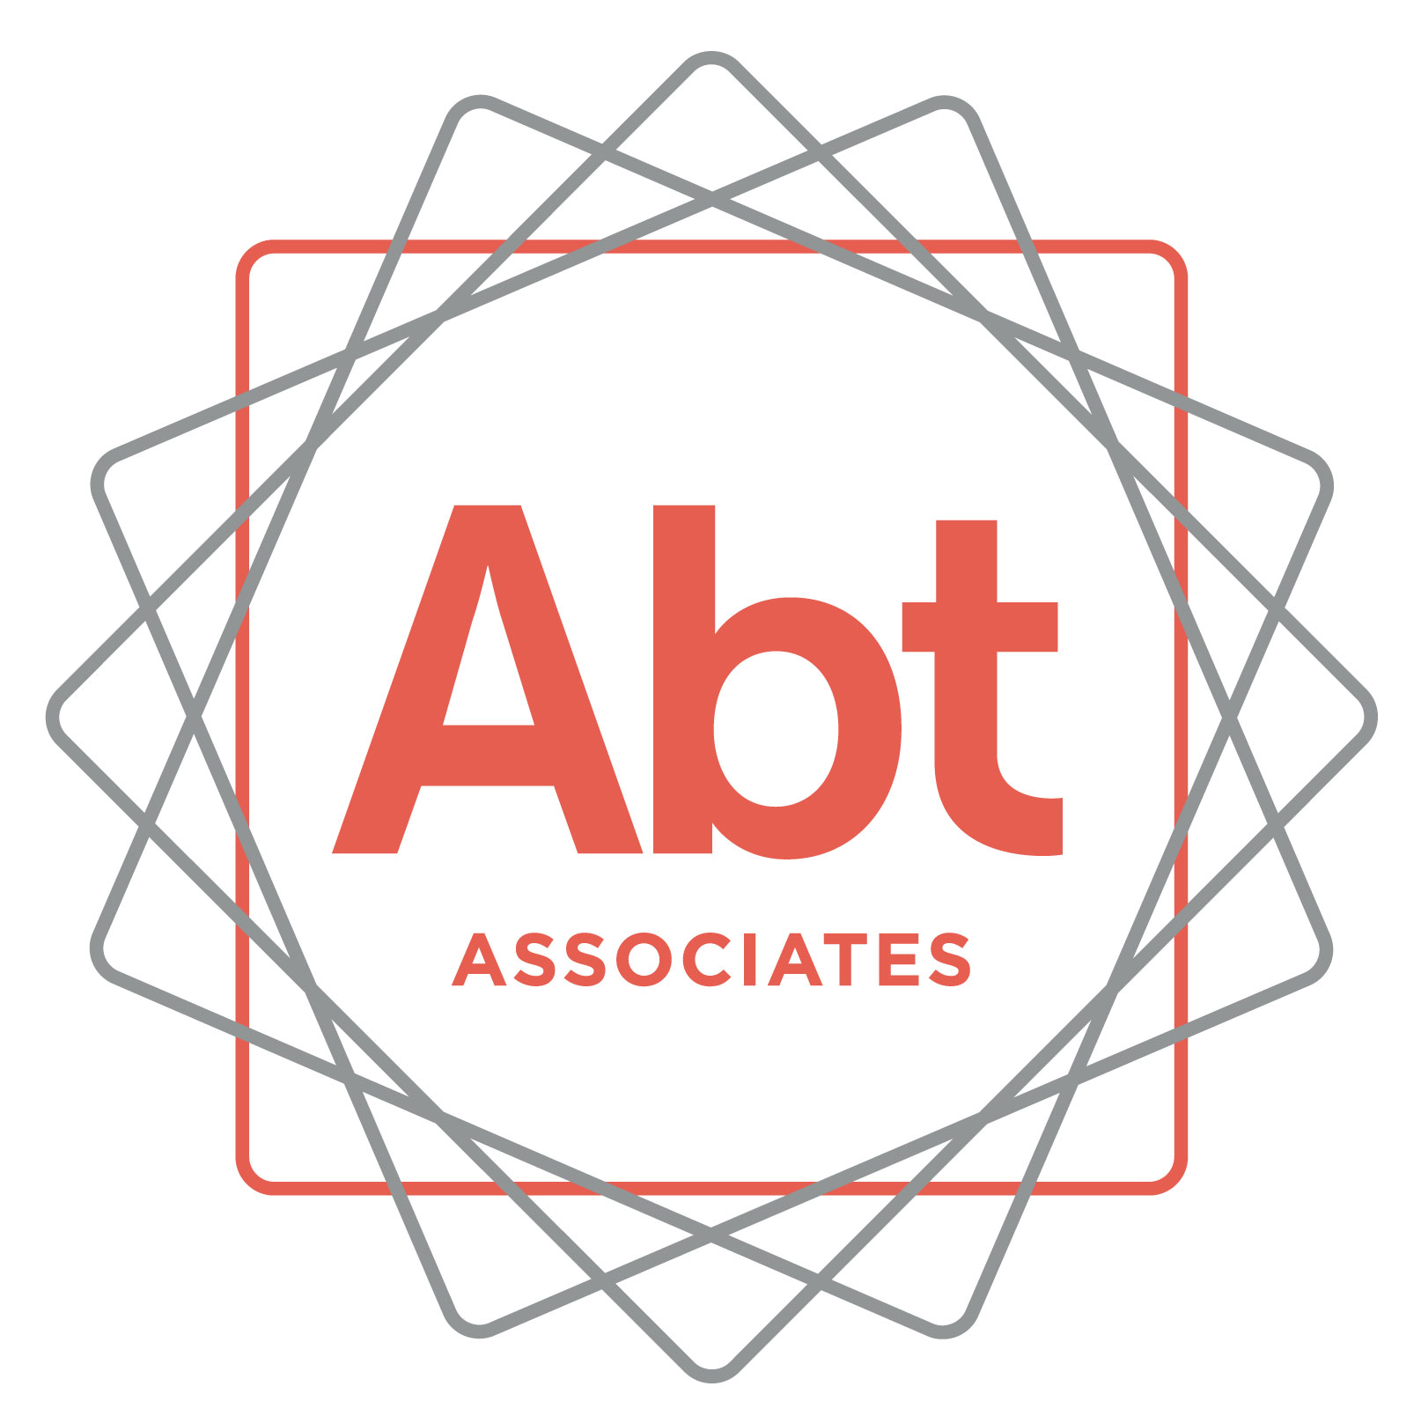
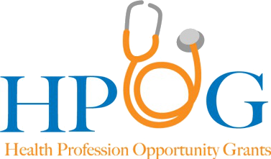
We have been trying to reach you! We’re following up about the Health Professions Opportunity Grant (HPOG) study. You agreed to participate in this study about 72 months ago when you applied to be part of your local HPOG program. This is a very important research study funded by the Administration for Children and Families (ACF). ACF is part of the U.S. Department of Health and Human Services. The study will help ACF improve future education and employment programs.
Upon completion of the survey, you will receive a token of appreciation valued at $45.
To schedule your interview or to get more information about the study,
please call ___________________________
at ___________________________
You may also call my supervisor _____________] at 1-866-491-0770 (toll free).
Thank you and we look forward to speaking with you soon!
ABTID_____________________________________
Please mention this number when you call

