2008/18 BACCALAUREATE AND BEYOND (B&B:08/18) FULL-SCALE
OMB # 1850-0729 v. 13

Appendix E
Sample Member Communication Materials

Submitted by
National Center for Education Statistics
U.S. Department of Education

February 2018

Table of Contents
Introduction 4
Tentative Schedule for Sample Member Contacts (dates are subject to change) 5
Draft Brochure Text 8
Draft Website Text 10
Initial Contact Letter 13
Data Collection Announcement Letter 15
Infographics Mailing 17
Flash Announcement Mailing 19
Abbreviated Interview Invitation Letter 21
Incentive Boost Letter 23
Mini Survey Letter 25
Hard Copy (PAPI) Mini Survey Letter 27
Hard Copy (PAPI) Mini Survey Letter – Replacement Questionnaire 29
Initial Contact E-mail 31
Data Collection Announcement E-mail 32
Flash Announcement E-mail 33
Abbreviated Announcement E-mail 34
Incentive Boost E-mail 35
Mini Survey E-mail 36
Hard Copy (PAPI) Mini Survey Announcement E-mail 37
Reminder E-mail 1 38
Reminder E-mail 2 39
Reminder E-mail 3 40
Reminder E-mail 4 41
Reminder E-mail 5 42
Reminder E-mail 6 43
Reminder E-mail 7 44
Reminder E-mail 8 45
Reminder E-mail 9 46
Reminder E-mail 10 47
Reminder E-mail 11 48
Reminder E-mail 12 49
Reminder E-mail 13 50
Reminder E-mail 14 [Holiday] 51
Reminder E-mail 15 52
Reminder E-mail 16 53
Reminder E-mail 17 54
Reminder E-mail 18 55
Reminder E-mail 19 56
Reminder E-mail 20 57
Reminder E-mail 21 58
Reminder E-mail 22 59
Reminder E-mail 23 60
Reminder E-mail 24 61
Thank You Letter- sent with check 62
Thank You E-mail – PayPal Incentive/No Incentive 64
Thank You E-mail – Check Incentive 65
Résumé Reminder E-mail 1 66
Text Message Reminders 67
Reminder Postcard 1 70
Reminder Postcard 2 72
Reminder Postcard 3 74
Reminder Postcard 4 (Extra Postcard) 76
Reminder Postcard 5 78
Hard Copy (PAPI) Incentive Postcard 80
Mini Survey Postcard 82
Holiday Mailing 84
Holiday Mailing Insert 86
Contingency Contacts 87
Thanksgiving Themed E-mail 88
Partial Complete E-mail 89
Paired Contact E-mail 90
Interruption in Data Collection – Notice/Warning E-mail 91
Interruption in Data Collection – Resume E-mail 92
Pending Ineligible E-mail 93
Hard Refusal E-mail 94
No Good Address for Payment E-mail 95
Canceled PayPal E-mail 96
No Incentive Data E-mail 97
No Contact E-mail 98
Expired Incentive E-mail 99
Preferred to Complete Online 100
Data Collection Extension E-mail 101
Spare Reminder E-mail 1 102
Spare Reminder E-mail 2 103
Spare Reminder E-mail 3 104
Mini Survey Letter – Reminder 105
Data Collection Staff Prompt E-mail 107
B&B:08/18 Consent Text 108

Introduction
Appendix E includes the contacting materials that will be sent to sample members to request their participation in the last follow-up of the Baccalaureate and Beyond Longitudinal Study (B&B:08/18). The B&B:08/18 contact materials include brochure, website text, letters, emails, text messages, postcards, and contingency contacts that may be used during data collection. Within each grouping of contact type, the materials are listed in the order they will be received.
The tentative schedule for sample member contacts varies based on protocol group. As described in the Supporting Statement Part B, the aggressive protocol group (nonrespondents to either B&B:08/09 or B&B:08/12) will receive interventions such as the flash incentive, abbreviated, mini, and PAPI surveys earlier than the default protocol group (respondents to both B&B:08/09 and B&B:08/12). Therefore, each group will receive certain contacting materials at different times.
Merge fields within the contact materials include the various incentive payment options and possible lengths of the survey. The merge fields also account for OFAC cases that must either be paid via check or not be paid at all, depending on the case.
The formatting and graphics of the postcards containing QR codes and the infographics mailings will be adjusted once language is approved by OMB. The QR code provided in the postcards is an example of the QR code sample members will use to access the survey website.

Tentative Schedule for Sample Member Contacts (dates are subject to change)
Mailing label | Mailing type | Estimated Mail Date: Default Protocol Group | Estimated Mail Date: Aggressive Protocol Group
Panel Maintenance E-mail (approved in Field Test package) | Mailing | 3/1/2018 | 3/1/2018
Panel Maintenance Mailing (approved in Field Test package) | E-mail | 3/26/2018 | 3/26/2018
Initial Contact E-mail | E-mail | 6/26/2018 | 6/26/2018
Initial Contact Mailing | Mailing | 6/27/2018 | 6/27/2018
Data Collection Announcement Letter | Mailing | 7/11/2018 | 7/11/2018
Data Collection Announcement E-mail | E-mail | 7/12/2018 | 7/12/2018
Data Collection Text | Text | 7/13/2018 | 7/13/2018
Reminder E-mail 1 | E-mail | 7/23/2018 | 7/23/2018
Reminder Text 1 | Text | 7/25/2018 | 7/25/2018
Reminder E-mail 2 | E-mail | 8/4/2018 | 8/4/2018
Reminder Postcard 1 | Mailing | 8/8/2018 | 8/8/2018
Reminder Text 2 | Text | 8/14/2018 | 8/14/2018
Reminder E-mail 3 | E-mail | 8/16/2018 | 8/16/2018
Reminder E-mail 4 | E-mail | 8/28/2018 | 8/28/2018
Reminder Text 3 | Text | 9/6/2018 | 9/6/2018
Reminder E-mail 5 | E-mail | 9/7/2018 | 9/7/2018
Reminder Postcard 2 | Mailing | 9/13/2018 | 9/13/2018
Reminder E-mail 6 | E-mail | 9/19/2018 | 9/19/2018
Reminder Text 4 | Text | 9/28/2018 | 9/28/2018
Reminder E-mail 7 | E-mail | 9/30/2018 | 9/30/2018
Infographics Mailing | Mailing |  | 10/1/2018
Reminder E-mail 8 | E-mail | 10/11/2018 | 10/11/2018
Infographics Mailing | Mailing | 10/15/2018
Reminder Text 5 | Text | 10/20/2018 | 10/20/2018
Reminder E-mail 9 | E-mail | 10/23/2018
Flash Announcement E-mail | E-mail |  | 10/24/2018
Flash Announcement Mailing | Mailing |  | 10/24/2018
Reminder E-mail 10 | E-mail | 11/4/2018 | 11/4/2018
Flash Text | Text |  | 11/8/2018
Reminder Postcard 3 | Mailing | 11/12/2018
Reminder Text 6 | Text | 11/13/2018 | 11/13/2018
Reminder E-mail 11 | E-mail | 11/14/2018
Abbreviated Announcement E-mail | E-mail |  | 11/14/2018
Abbreviated Interview Invitation Letter | Mailing |  | 11/14/2018
Reminder E-mail 12 | E-mail | 11/22/2018 | 11/22/2018
Reminder Text 7 | Text | 12/3/2018
Abbreviated Text | Text |  | 12/3/2018
Reminder E-mail 13 | E-mail | 12/6/2018 | 12/6/2018
Incentive Boost Letter | Mailing |  | 12/13/2018
Incentive Boost E-mail | E-mail |  | 12/13/2018
Holiday Mailing | Mailing | 12/18/2018 | 12/18/2018
Reminder E-mail 14 [Holiday] | E-mail | 12/20/2018 | 12/20/2018
Reminder E-mail 15 | E-mail | 12/28/2018 | 12/28/2018
Reminder Text 8 | Text |  | 1/4/2019
Flash Announcement Mailing | Mailing | 1/2/2019
Flash Announcement E-mail | E-mail | 1/3/2019
Flash Text | Text | 1/4/2019
Reminder E-mail 16 | E-mail |  | 1/9/2019
Mini Survey Letter or Mini Survey Postcard | Mailing |  | 1/17/2019
Mini Survey E-mail | E-mail |  | 1/18/2019
Abbreviated Announcement E-mail | E-mail | 1/18/2019
Abbreviated Interview Invitation Letter | Mailing | 1/18/2019
Abbreviated Text | Text | 1/25/2019
Mini Survey Text | Text |  | 1/25/2019
Reminder E-mail 17 | E-mail |  | 2/1/2019
Incentive Boost Letter | Mailing | 2/1/2019
Incentive Boost E-mail | E-mail | 2/2/2019
Reminder E-mail 18 | E-mail | 2/11/2019 | 2/11/2019
Reminder Text 9 | Text | 2/19/2019 | 2/19/2019
Reminder E-mail 19 | E-mail |  | 2/21/2019
Mini Survey E-mail | E-mail | 2/21/2019
Mini Survey Letter or Mini Survey Postcard | Mailing | 2/21/2019
Reminder E-mail 20 | E-mail | 2/28/2019
Hard Copy (PAPI) Mini Survey Announcement E-mail | E-mail |  | 2/28/2019
Hard Copy (PAPI) Mini Survey Mailing | Mailing |  | 2/28/2019
Mini Survey Text | Text | 3/5/2019
PAPI Text | Text |  | 3/5/2019
Hard Copy (PAPI) Mini Survey - Replacement Mailing | Mailing |  | 3/10/2019
Reminder E-mail 21 | E-mail | 3/12/2019 | 3/12/2019
Reminder Postcard 5 | Mailing | 3/14/2019 | 3/14/2019
Final Week E-mail 22 | E-mail | 3/18/2019 | 3/18/2019
Reminder Text 10 (Day Before Final Day) | Text |  | 3/24/2019
Reminder E-mail 23 | E-mail | 3/24/2019 | 3/24/2019
Reminder Text 11 (Final Day) | Text | 3/16/2019 | 3/16/2019
Reminder E-mail 24 | E-mail | 3/25/2019 | 3/25/2019
Thank You Letter – sent with check | Mailing | rolling | rolling
Thank you E-mail -Check Incentive | E-mail | rolling | rolling
Thank you E-mail - PayPal Incentive/No Incentive | E-mail | rolling | rolling
Resume Reminder E-mail 1 | E-mail | rolling | rolling
Contingency Contacts
Hard Copy (PAPI) Mini Survey Announcement E-mail | E-mail | TBD
Hard Copy (PAPI) Mini Survey Mailing | Mailing | TBD
PAPI Text | Text
Thanksgiving Themed E-mail | E-mail
Partial Complete Interview | E-mail
Paired Contact E-mail | E-mail
Interruption in Data Collection - Notice/Warning | E-mail
Interruption in Data Collection - Resume | E-mail
Pending Ineligible E-mail | E-mail
Hard Refusal E-mail | E-mail
No Good Address for Payment E-mail | E-mail
Canceled PayPal E-mail | E-mail
No incentive Data E-mail | E-mail
Canceled PayPal E-mail | E-mail
No incentive Data E-mail | E-mail
No Contact E-mail | E-mail
Expired Incentive E-mail | E-mail
Preferred to Complete Online | E-mail
Data Collection Extension E-mail | E-mail
Spare Reminder E-mail 1 | E-mail
Spare Reminder E-mail 2 | E-mail
Spare Reminder E-mail 3 | E-mail
Data Collection Extension | Text
Mini Survey Letter - Reminder | Mailing
Data Collection Staff Prompt E-mail | E-mail

Draft Brochure Text
What is B&B?
The Baccalaureate and Beyond Longitudinal Study (B&B:08/18) is a national study of approximately 17,000 graduates from U.S. colleges and universities who will be asked about their experiences in the 10 years since completing a bachelor’s degree.

The study will collect information on graduate and other education, experiences in the labor market, earnings and expenses, and family status. In addition to survey responses, we collect related information from other sources, such as student loan and enrollment databases. There is a particular focus on careers in K-12 teaching and other employment outcomes.

Why am I being asked to participate?
You have been asked to participate in B&B because you completed the requirements for your bachelor’s degree 10 years ago, during the 2007-08 academic year. Most study participants were first surveyed in 2008 as part of the National Postsecondary Student Aid Study (NPSAS).

Why is my participation important?
The National Center for Education Statistics (NCES) has conducted only one previous 10-year follow-up with baccalaureate graduates – the Class of 1992-93 was surveyed in 2003 as part of B&B:93/03. Your survey responses will help educators, researchers, and policymakers at the local, state, and national levels understand the experiences of recent college graduates. Your experiences are unique, and if you choose not to participate in B&B, no one else can be substituted for you.

What have we learned from previous rounds of B&B?
About three-fifths of 1992-93 bachelor’s degree recipients, surveyed 10 years later, reported that the quality of instruction they received as undergraduates (61 percent) and their undergraduate major field (58 percent) remained very important to their lives.

Within 10 years of completing a bachelor’s degree, 25 percent of 1992–93 bachelor’s degree recipients obtained an occupational license and 30 percent obtained a professional certification.

In 2012, about 77 percent of 2007-08 graduates who had been employed worked in a job related to their major field of study, and about 73 percent reported that they were satisfied with the importance of their work.

What happens to the results?
Results from the current study are scheduled to be released in 2020 and will be posted on the NCES website (https://nces.ed.gov/surveys/b&b/) along with results from previous B&B studies. Your responses will be combined with those of other bachelor’s degree recipients and will be presented in summary form only. No individually identifying information will be published.

Who is conducting B&B?
The 2008/18 Baccalaureate and Beyond Longitudinal Study (B&B:08/18) is conducted by the National Center for Education Statistics (NCES), in the U.S. Department of Education’s Institute for Education Sciences, with data collection being carried out under contract by RTI International, a U.S.-based nonprofit research organization. This is the third follow-up study with a cohort of students who were first selected to participate in the 2008 National Postsecondary Student Aid Study (NPSAS:08).
NCES is authorized to conduct B&B by the Education Sciences Reform Act of 2002 (ESRA 2002, 20 U.S.C. §9543) and to collect students’ education records from educational agencies or institutions for the purposes of evaluating federally supported education programs under the Family Educational Rights and Privacy Act (FERPA, 34 CFR §§ 99.31(a)(3)(iii) and 99.35).

How will my information be protected?
NCES is required to follow strict procedures to protect personal information in the collection, reporting, and publication of data. All of the information you provide may be used only for statistical purposes and may not be disclosed, or used, in identifiable form for any other purpose except as required by law (20 U.S.C. §9573 and 6 U.S.C. §151).

Data security procedures for B&B are reviewed and approved by NCES data security staff. Your answers are secured behind firewalls and are encrypted during internet transmission using Secure Sockets Layer (SSL) protocol. All data entry modules are password protected and require the user to log in before accessing the data. NCES employees and contractors are subject to large fines or imprisonment if individual responses are disclosed.

How do I participate?
You can complete the B&B survey online or over the phone.

ONLINE
Log on to the study website at https://surveys.nces.ed.gov/bb/ using the Study ID and password provided in your welcome letter. The survey is mobile-optimized, so it can be easily completed on a mobile device.

OVER THE PHONE
Call our Help Desk at 877-262-4440 to speak to one of our professional interviewers.

Contact Us

B&B HELP DESK
877-262-4440

bbemail@rti.org
https://surveys.nces.ed.gov/bb/

Ted Socha
B&B Project Officer (NCES)
Ted.Socha@ed.gov
202-245-7071
Melissa Cominole, Ph.D.
B&B Project Director (RTI)
mcominole@rti.org
800-723-8942

Draft Website Text
HOME PAGE:

Welcome to the 2008/18 Baccalaureate and Beyond Longitudinal Study (B&B:08/18)

GET STARTED!
Study ID:
Password:
□ Show me what I’ve typed

LOG IN
Need your Study ID number or password? (hyperlink)

NCES is authorized to conduct B&B:08/18 by the Education Sciences Reform Act of 2002 (ESRA 2002, 20 U.S.C. §9543) and to collect students’ education records from education agencies or institutions for the purposes of evaluating federally supported education programs under the Family Educational Rights and Privacy Act (FERPA, 34 CFR §§ 99.31(a)(3)(iii) and 99.35). The data are being collected for NCES by RTI International, a U.S.-based nonprofit research organization.
All of the information you provide may be used only for statistical purposes and may not be disclosed, or used, in identifiable form for any other purpose except as required by law (20 U.S.C. §9573 and 6 U.S.C. §151).
According to the Paperwork Reduction Act of 1995, no persons are required to respond to a collection of information unless it displays a valid OMB control number. The valid OMB control number for this voluntary information collection is 1850-0729. The time required to complete this information collection is estimated to average approximately <<time>> minutes per response, including the time to review instructions, gather the data needed, and complete and review the information collection. If you have any comments concerning the accuracy of the time estimate, suggestions for improving this survey, or any comments or concerns regarding the status of your individual submission of this survey, please write directly to: The 2008/18 Baccalaureate and Beyond Longitudinal Study (B&B:08/18), National Center for Education Statistics, Potomac Center Plaza, 550 12th St., SW, 4th floor, Washington, DC 20202. OMB Clearance No: 1850-0729. Expiration Date: 5/31/2020.

UPDATE CONTACT INFO (For Initial Contact Updates)
Click on the fields below to enter the information

Study ID
First Name
Middle Name
Last Name
Suffix (drop-down)
Former Name
Cell Phone
Home Phone
Work Phone
E-mail Address
Secondary E-mail Address

Address is an international address (check box)
Address
Address Line 2
City Select State (drop-down) Zip Code

Would you like us to send you a text message reminder about participating in the survey?
(Please note: standard text messaging rates may apply.)

Yes – you can text me at this # (enter 10 digit number with no dashes) [CAPTURE]
No

CONTACT US
If you need assistance accessing the web survey or wish to complete the survey by phone, call the B&B Help Desk:
877-262-4440
bbemail@rti.org

Help Desk staff is available at the following times to assist you:
Monday-Thursday | 9:00 a.m. – Midnight
Friday | 9:00 a.m. – 11:00 p.m.
Saturday | 9:30 a.m. – 9:00 p.m.
Sunday | 1:00 p.m. – 11:00 p.m.

All times are Eastern Time (ET).

Who should I contact if I have additional questions or concerns?
B&B project staff are available to respond to your questions Monday through Friday between 9:00 a.m. and 5:00 p.m. ET.

B&B Project Staff
RTI Project Director | Melissa Cominole, Ph.D.
 | mcominole@rti.org
 | 800-723-8942
NCES Project Officer | Ted Socha
 | Ted.Socha@ed.gov
 | 202-245-7071
WHAT TO EXPECT
How can I complete the B&B survey?
You may complete the B&B survey on the Web – simply log in from the home page by entering your Study ID number and password, which are provided in the B&B letter or e-mail you received. You can even complete it on your mobile device. If you need assistance accessing the survey on the website, or if you want to complete the survey by telephone, contact the B&B Help Desk by calling 877-262-4440 or sending an e-mail to bbemail@rti.org.

How long will the survey take?
For most people, we expect the survey will take about <<time>> minutes, on average, but could take more or less time depending on your answers. You do not need to complete the survey in one session. You can get started and, if you choose, you can easily log out and resume at a later time. If you are asked to provide a résumé, the time to submit the résumé is estimated to average 5 minutes, including time to locate your file, review it, and load it to the website.

Do I have to participate?
Participation in this study is voluntary; however, your involvement is very important to the success of this study. By participating, you have the opportunity to help policymakers, researchers, and others better understand the experiences of bachelor’s degree recipients.

Can I refuse to answer a question?
You may refuse to answer any question at any time. If you choose not to answer or are unable to answer a particular question, you may still continue with the rest of the survey.

How do I know your website is secure?
The B&B website is protected by Secure Sockets Layer (SSL; 128-bit encryption) technology. Your survey responses are collected over a secure server that is also protected by SSL.

Should I use a particular web browser to take the web survey?
To run the survey, your browser needs to support HTML5 and JavaScript, so the latest versions of Firefox, Chrome, or Safari will work, as will Internet Explorer 9 and later. If you are having any trouble completing the survey, please call our Help Desk at 1-877-262-4440 and we will be happy to assist you.

PREVIOUS RESULTS
YOUR PARTICIPATION COUNTS!
Data collected from B&B will help researchers and policymakers better understand how earning a bachelor’s degree impacts choices for additional education and employment paths. As with all prior B&B studies, results will be presented in summary form only; no individual results will be published.

HERE ARE A FEW THINGS WE’VE LEARNED FROM B&B STUDIES…
The National Center for Education Statistics (NCES) has conducted only one previous 10-year follow-up with baccalaureate graduates – the Class of 1993 was surveyed in 2003 as part of B&B:93/03, and the Class of 2008 was followed up with in 2009 and 2012.

When surveyed ten years after receiving their bachelor’s degrees, about 61% of respondents reported that the quality of instruction they received as undergraduates remained very important to their lives. About 58% reported the quality of instruction they received in their undergraduate major field remained very important to their lives.

Within 10 years of completing a bachelor’s degree, 25 percent of 1992–93 bachelor’s degree recipients obtained an occupational license and 30 percent obtained a professional certification.

In 2012, about 72 percent of 2007-08 graduates had a job related to their major field of study.

CONFIDENTIALITY
The National Center for Education Statistics (NCES) is required to follow strict procedures to protect personal information in the collection, reporting, and publication of data. All of the information you provide may be used only for statistical purposes and may not be disclosed, or used, in identifiable form for any other purpose except as required by law (20 U.S.C. §9573 and 6 U.S.C. §151).
Data security procedures for B&B are reviewed and approved by NCES data security staff. Your answers are secured behind firewalls and are encrypted during internet transmission using Secure Sockets Layer (SSL) protocol. All data entry modules are password protected and require the user to log in before accessing any data. NCES employees and contractors are subject to large fines or imprisonment if they knowingly publish or communicate any individually identifiable information.

Congress has authorized the National Center for Education Statistics (NCES) of the U.S. Department of Education’s Institute of Education Sciences to collect data about the costs of postsecondary education to provide reliable and current national data to inform higher education policy.

NCES is authorized to conduct the 2008/18 Baccalaureate and Beyond Longitudinal Study (B&B:08/18) by the Education Sciences Reform Act of 2002 (ESRA 2002, 20 U.S.C. §9543) and to collect students’ education records from educational agencies or institutions for the purposes of evaluating federally supported education programs under the Family Educational Rights and Privacy Act (FERPA, 34 CFR §§ 99.31(a)(3) and 99.35).

The study has been approved by the U.S. Office of Management and Budget (OMB). The valid OMB control number for this voluntary information collection is 1850-0729. The expiration date is 5/31/2020.

ABOUT B&B
The 2008/18 Baccalaureate and Beyond Longitudinal Study (B&B) (B&B:08/18) is a national study of approximately 17,000 graduates from U.S. colleges and universities who will be asked about their experiences since completing a bachelor’s degree.

The study will collect information on graduate and other education, experiences in the labor market, earnings and expenses, family status, and personal and professional goals. In addition to survey responses, we collect related information from sources such as student loan and enrollment databases. There is a particular focus on careers in teaching and other employment outcomes.

B&B:08/18 is the third follow-up survey from a cohort of students who completed their bachelor’s degree requirements during the 2007-08 academic year. Most study participants were first surveyed in 2008 as part of the National Postsecondary Student Aid Study (NPSAS).

B&B:08/18 is conducted by the National Center for Education Statistics (NCES), in the U.S. Department of Education’s Institute of Education Sciences, with data collection being carried out under contract by RTI International, a U.S.-based nonprofit research organization.

Initial Contact Letter

«date»

«fname» «mname» «lname» «suffix» Study ID: «caseid»
«addr1»
«addr2»
«city», «state» «zip» «zip4»

Dear «fname» «lname»:

You have been selected to participate in the third and final round of the Baccalaureate and Beyond Longitudinal Study (B&B), conducted by the National Center for Education Statistics (NCES) in the U.S. Department of Education’s Institute of Education Sciences. B&B is interested in your personal experience since you graduated from college during the 2007–08 school year. Data collected from B&B will help researchers and policymakers better understand how earning a bachelor’s degree «in majors such as [major]» «and [major2] »impacts choices for additional education and employment paths.

Before B&B data collection begins, we need to have the most up-to-date contact information for you. Please take 5 minutes to update your contact information. To update your contact information, please visit our secure website and use the following Study ID:

https://surveys.nces.ed.gov/bb/
Study ID: <<caseID>>

<<Or use the camera on your phone to scan the QR code below to take you to the website
<<QRCODE>>>>

B&B begins in July. At that time, you will receive a letter that will provide specific information about how to participate in the 35-minute survey. [IF INCENTIVE ELIGIBLE: <<As a token of our appreciation, you will receive $«Inc_amount» when you complete it.>>]

NCES has contracted with RTI International, a U.S.-based nonprofit research organization, to collect data for B&B on its behalf. The enclosed brochure provides a brief description of B&B, findings from past studies, and a summary of our confidentiality procedures. If you have additional questions or concerns about the study after reviewing this material, please call the RTI study director, Dr. Melissa Cominole at 800-723-8942.

We thank you in advance for your participation in this important study.

Sincerely,

Christopher Chapman
Associate Commissioner, Sample Surveys Division
National Center for Education Statistics
«panelinfo»/«controlID»

The 2008/18 Baccalaureate and Beyond Longitudinal Study (B&B:08/18) is conducted by the National Center for Education Statistics (NCES). Under contract with NCES, RTI International, a U.S.-based nonprofit research organization, administers B&B:08/18 on behalf of NCES. NCES is authorized to conduct B&B:08/18 by the Education Sciences Reform Act of 2002 (ESRA 2002, 20 U.S.C. §9543) and to collect students’ education records from education agencies or institutions for the purposes of evaluating federally supported education programs under the Family Educational Rights and Privacy Act (FERPA, 34 CFR §§ 99.31(a)(3) and 99.35). All of the information you provide may be used only for statistical purposes and may not be disclosed, or used, in identifiable form for any other purpose except as required by law (20 U.S.C. §9573 and 6 U.S.C. §151).

According to the Paperwork Reduction Act of 1995, no persons are required to respond to a collection of information unless it displays a valid OMB control number. The valid OMB control number for this voluntary information collection is 1850-0729. The time required to complete this information collection is estimated to average approximately <<time>> minutes per response, including the time to review instructions, gather the data needed, and complete and review the information collection. If you have any comments concerning the accuracy of the time estimate, suggestions for improving this survey, or any comments or concerns regarding the status of your individual submission of this survey, please write directly to: The 2008/18 Baccalaureate and Beyond Longitudinal Study (B&B:08/18), National Center for Education Statistics, Potomac Center Plaza, 550 12th St., SW, Room 4004, Washington, DC 20202.

Data Collection Announcement Letter
«date»

«fname» «mname» «lname» «suffix» Study ID: «caseid»
«addr1»
«addr2»
«city», «state» «zip» «zip4»

Dear «fname» «lname»:

Data collection for the Baccalaureate and Beyond Longitudinal Study (B&B), conducted by the National Center for Education Statistics (NCES), within the U.S. Department of Education, is now underway. B&B is interested in understanding how earning a bachelor’s degree «in [major]» «and [major2]» impacted your choices about additional education and employment paths since graduating from college during the 2007–08 school year. [INSERT MERGE FIELD FROM TABLE, BELOW]

[IF INCENTIVE ELIGIBLE AND GOOD ADDRESS: «We have included $2 in gratitude for your «continued» participation in B&B.>>] [IF INCENTIVE ELIGIBLE AND UNSURE OF ADDRESS: <<We sent you $2 via PayPal to «e-mailaddress» in gratitude for your «continued» participation in B&B.»] [IF INCENTIVE ELIGIBLE:<<After you complete the survey, you will receive $«Inc_amount» as a token of our appreciation, payable by <<PayPal or>> check.>>] The survey will take approximately 35 minutes to complete, and can even be completed on your mobile device. Having your résumé or curriculum vitae handy will help you complete the survey.

To complete the survey, log on to our secure website at https://surveys.nces.ed.gov/bb/ using the Study ID and password below:

Study ID = «caseid»
Password = «password» (password is case sensitive)

<<Or use the camera on your phone to scan the QR code below to take you to the <<survey>>/<<website>>:
<<QRCODE>>>>

If you have questions or problems completing your survey online, or prefer to complete the survey over the telephone, call B&B Help Desk at 877-262-4440.

The enclosed brochure answers many common questions about the study and contains additional information on laws and procedures that protect the confidentiality of your responses. You can also learn more about B&B on our study website, https://surveys.nces.ed.gov/bb/.

Thank you in advance for making B&B a success.

Sincerely,

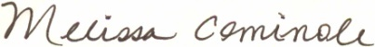
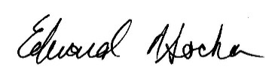

Ted Socha Melissa Cominole, Ph.D.
Project Officer, B&B:08/18 Project Director, B&B:08/18
National Center for Education Statistics RTI International
ted.socha@ed.gov | 202-245-7071 mcominole@rti.org | 800-723-8942

«panelinfo»/«controlID»

MERGE FIELD OPTIONS – PRIOR RESPONSE
NPSAS08 RESPONDENT ONLY | You may recall participating in the National Postsecondary Student Aid Study (NPSAS), a related study, in 2008, and we need your help again.
BB09 RESPONDENT / BB12 NONRESPONDENT | You may recall participating in B&B in 2009, and we need your help again.
BB12 RESPONDENT | You may recall participating in B&B in 2012, and we need your help again.
NPSAS08 / BB09 / BB12 NON-RESPONDENT | You may recall being contacted about B&B in 2012.

The 2008/18 Baccalaureate and Beyond Longitudinal Study (B&B:08/18) is conducted by the National Center for Education Statistics (NCES). Under contract with NCES, RTI International, a U.S.-based nonprofit research organization, administers B&B:08/18 on behalf of NCES. NCES is authorized to conduct B&B:08/18 by the Education Sciences Reform Act of 2002 (ESRA 2002, 20 U.S.C. §9543) and to collect students’ education records from education agencies or institutions for the purposes of evaluating federally supported education programs under the Family Educational Rights and Privacy Act (FERPA, 34 CFR §§ 99.31(a)(3) and 99.35). All of the information you provide may be used only for statistical purposes and may not be disclosed, or used, in identifiable form for any other purpose except as required by law (20 U.S.C. §9573 and 6 U.S.C. §151).
According to the Paperwork Reduction Act of 1995, no persons are required to respond to a collection of information unless it displays a valid OMB control number. The valid OMB control number for this voluntary information collection is 1850-0729. The time required to complete this information collection is estimated to average approximately <<time>> minutes per response, including the time to review instructions, gather the data needed, and complete and review the information collection. If you have any comments concerning the accuracy of the time estimate, suggestions for improving this survey, or any comments or concerns regarding the status of your individual submission of this survey, please write directly to: The 2008/18 Baccalaureate and Beyond Longitudinal Study (B&B:08/18), National Center for Education Statistics, Potomac Center Plaza, 550 12th St., SW, Room 4004, Washington, DC 20202.

Infographics Mailing

B&B Provides Data Researchers & Policymakers Can’t Get Anywhere Else
Your Experiences are Unique, So Share Your Story and Complete the Picture!
Results from Prior Studies with the B&B Cohort that Graduated in 2007-08:
 | 2009 | 2012 | 2018
Have one or more dependent children | 16.87% | 25.05% | ?
Job related to major | 61.0% | 71.5% | ?
Annualized Earnings | $ 37,408 | $ 44,975 | ?
Own Home | 20.45% | 34.06% | ?
Enrolled in graduate or additional undergraduate degree program | 30.20% | 44.12% | ?
Has been a teacher since graduating | 13.71% | 18.38% | ?
Had fully repaid student loans (among those who borrowed) | 9.83% | 13.98% | ?

SOURCE: U.S. Department of Education, National Center for Education Statistics, 2008/12 Baccalaureate and Beyond Longitudinal Studies (B&B:08/12) and 2008/09 Baccalaureate and Beyond Longitudinal Studies (B&B:08/09).

To learn more about the data from previous B&B studies, visit NCES’s B&B website at https://nces.ed.gov/surveys/b&b/
The 2008/18 Baccalaureate and Beyond Longitudinal Study (B&B:08/18) is a survey of individuals who completed their postsecondary education during the 2007-08 academic year. The National Center for Education Statistics (NCES) in the U.S. Department of Education’s Institute of Education Sciences has contracted with RTI International to collect data for B&B on its behalf.
OMB Control Number: 1850-0729
Learn more about our confidentiality procedures for sample members at
https://surveys.nces.ed.gov/bb/confidentiality.aspx

ACCOMPANYING POSTCARD INSERT:
Participate in B&B by visiting https://surveys.nces.ed.gov/bb
Study ID: <<caseID>>
Password: <<password>>
<<Or use the camera on your phone to scan the QR code below to take you to the <<survey>>/<<website>>:
<<QRCODE>>>>

You may also participate by phone at 877-262-4440
The 2008/18 Baccalaureate and Beyond Longitudinal Study (B&B:08/18) is a survey of individuals who completed their postsecondary education during the 2007-08 academic year. The National Center for Education Statistics (NCES) in the U.S. Department of Education’s Institute of Education Sciences has contracted with RTI International to collect data for B&B on its behalf.
OMB Control Number: 1850-0729
Learn more about our confidentiality procedures at
https://surveys.nces.ed.gov/bb/confidentiality.aspx

Flash Announcement Mailing
«date»

«fname» «mname» «lname» «suffix» Study ID: «caseid»
«addr1»
«addr2»
«city», «state» «zip» «zip4»

Dear «fname»:

Your participation «as a [major] «and [major2]» major » is important to make sure that the B&B results represent all types of education and employment. No one can replace you in this study. [INSERT MERGE FIELD FROM TABLE – INCENTIVE ELIGIBILITY BELOW]

You can complete your <<time>>-minute survey by logging on to our secure website at https://surveys.nces.ed.gov/bb/ using the credentials provided below.

Study ID = «caseid»
Password = «password»
Note: The password is case sensitive; you will need to enter it exactly as it appears here.
<<Or use the camera on your phone to scan the QR code below which will take you to the <<survey>>/<<website>>:
<<QRCODE>>>>

You can also call 877-262-4440 to get more information about B&B or to complete the survey by phone.

Sincerely,

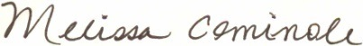

Ted Socha Melissa Cominole, Ph.D.
Project Officer, B&B:08/18 Project Director, B&B:08/18
National Center for Education Statistics RTI International
ted.socha@ed.gov | 202-245-7071 mcominole@rti.org | 800-723-8942

MERGE FIELD OPTIONS –INCENTIVE ELIGIBILITY
INCENTIVE ELIGIBLE, NOT FLASH, NOT BOOST | When you complete the survey, you'll receive $<<Inc_amount>>, payable by <<PayPal or>> check!
INCENTIVE ELIGIBLE, NOT FLASH, BOOST | Since your participation is so important, in addition to your $<<Inc_amount>>, you’re now also getting $<<Boost_Inc>>, for a total of $<<Total_incentive.
INCENTIVE ELIGIBLE, FLASH, NOT BOOST | If you complete the survey by <<early_comp_date>> we will send you $<< Inc_amount>> plus an additional $<<flash_amount>> payable by <<PayPal or>> check. After <<early_comp_date>>, we will send you $<<Inc_amount >> once you complete the survey!
INCENTIVE ELIGIBLE, FLASH, BOOST | Since your participation is so important, in addition to your $<<Inc_amount>>, you’re now also getting $<<Boost_Inc>>. If you complete the survey by <<early_comp_date>> we will send you an additional $<<flash_amount>> for a total of $<<Total_incentive>>. After <<early_comp_date>>, we will send you $<<Inc_amount+Boost_inc>>.

«panelinfo»/«controlID»
The 2008/18 Baccalaureate and Beyond Longitudinal Study (B&B:08/18) is conducted by the National Center for Education Statistics (NCES). Under contract with NCES, RTI International, a U.S.-based nonprofit research organization, administers B&B:08/18 on behalf of NCES. NCES is authorized to conduct B&B:08/18 by the Education Sciences Reform Act of 2002 (ESRA 2002, 20 U.S.C. §9543) and to collect students’ education records from education agencies or institutions for the purposes of evaluating federally supported education programs under the Family Educational Rights and Privacy Act (FERPA, 34 CFR §§ 99.31(a)(3) and 99.35). All of the information you provide may be used only for statistical purposes and may not be disclosed, or used, in identifiable form for any other purpose except as required by law (20 U.S.C. §9573 and 6 U.S.C. §151).
According to the Paperwork Reduction Act of 1995, no persons are required to respond to a collection of information unless it displays a valid OMB control number. The valid OMB control number for this voluntary information collection is 1850-0729. The time required to complete this information collection is estimated to average approximately <<time>> minutes per response, including the time to review instructions, gather the data needed, and complete and review the information collection. If you have any comments concerning the accuracy of the time estimate, suggestions for improving this survey, or any comments or concerns regarding the status of your individual submission of this survey, please write directly to: The 2008/18 Baccalaureate and Beyond Longitudinal Study (B&B:08/18), National Center for Education Statistics, Potomac Center Plaza, 550 12th St., SW, Room 4004, Washington, DC 20202.

Abbreviated Interview Invitation Letter

«date»

«fname» «mname» «lname» «suffix» Study ID: «caseid»
«addr1»
«addr2»
«city», «state» «zip» «zip4»

Dear «fname»:

Your response is important to the B&B study! Please go online today to complete a shortened survey. The B&B survey now takes only <<time>> minutes [IF INCENTIVE ELIGIBLE: <<and upon completion, you will still receive a $<<Total_incentive >> token of our appreciation, payable by <<PayPal or>> check>>]. // [IF INCENTIVE ELIGIBLE AND BOOST: <<and in addition to your $<<Inc_amount>>, you’re now also getting $<<Boost_Inc>>, for a total of $<<Total_incentive>>>>].
Your experiences are unique, and if you choose not to participate in B&B, no one else can be substituted for you. Therefore, it is extremely important that you complete the survey so that researchers and policymakers better understand how earning a bachelor’s degree «in majors such as [major]» «and [major2]» impacts choices for additional education and employment paths. The results from this study will help develop policy regarding participation in higher education.

Please log on to our secure website to participate:

https://surveys.nces.ed.gov/bb/
Study ID = <<caseid>>
Password = <<password>>
Note: The password is case sensitive; you will need to enter it exactly as it appears here.

<<Or use the camera on your phone to scan the QR code below to take you to the <<survey>>/<<website>>:
<<QRCODE>>>>

If you have questions, problems completing your survey online, or prefer to complete the survey over the telephone, simply call the B&B Help Desk at 877-262-4440.

Thank you, in advance, for your participation.

Ted Socha Melissa Cominole, Ph.D.
Project Officer, B&B:08/18 Project Director, B&B:08/18
National Center for Education Statistics RTI International
ted.socha@ed.gov | 202-245-7071 mcominole@rti.org | 800-723-8942

«panelinfo»/«controlID»

The 2008/18 Baccalaureate and Beyond Longitudinal Study (B&B:08/18) is conducted by the National Center for Education Statistics (NCES). Under contract with NCES, RTI International, a U.S.-based nonprofit research organization, administers B&B:08/18 on behalf of NCES. NCES is authorized to conduct B&B:08/18 by the Education Sciences Reform Act of 2002 (ESRA 2002, 20 U.S.C. §9543) and to collect students’ education records from education agencies or institutions for the purposes of evaluating federally supported education programs under the Family Educational Rights and Privacy Act (FERPA, 34 CFR §§ 99.31(a)(3) and 99.35). All of the information you provide may be used only for statistical purposes and may not be disclosed, or used, in identifiable form for any other purpose except as required by law (20 U.S.C. §9573 and 6 U.S.C. §151).
According to the Paperwork Reduction Act of 1995, no persons are required to respond to a collection of information unless it displays a valid OMB control number. The valid OMB control number for this voluntary information collection is 1850-0729. The time required to complete this information collection is estimated to average approximately <<time>> minutes per response, including the time to review instructions, gather the data needed, and complete and review the information collection. If you have any comments concerning the accuracy of the time estimate, suggestions for improving this survey, or any comments or concerns regarding the status of your individual submission of this survey, please write directly to: The 2008/18 Baccalaureate and Beyond Longitudinal Study (B&B:08/18), National Center for Education Statistics, Potomac Center Plaza, 550 12th St., SW, Room 4004, Washington, DC 20202.

Incentive Boost Letter

«date»

«fname» «mname» «lname» «suffix» Study ID: «caseid»
«addr1»
«addr2»
«city», «state» «zip» «zip4»

Dear «fname»:

You have been selected to receive an additional $<<Boost_Inc>> for completing your B&B survey—that’s a total of $<<total_incentive>>! Please log on to our secure website to participate and receive your additional $<<Boost_Inc>> for the <<time>>-minute survey:

https://surveys.nces.ed.gov/bb/
Study ID = <<caseid>>
Password = <<password>>
Note: The password is case sensitive; you will need to enter it exactly as it appears here.

<<Or use the camera on your phone to scan the QR code below to take you to the <<survey>>/<<website>>:
<<QRCODE>>>>

Your experiences are unique, and if you choose not to participate in B&B, no one else can be substituted for you. Therefore, it is extremely important that you complete the survey so that researchers and policymakers better understand how earning a bachelor’s degree «in majors such as [major] <<and [major2]>>>> » impacts choices for additional education and employment paths. The results from this study will help develop policy regarding participation in higher education.

If you have questions, problems completing your survey online, or prefer to complete the survey over the telephone, simply call the B&B Help Desk at 877-262-4440.

Thank you, in advance, for your participation.

Sincerely,

Ted Socha Melissa Cominole, Ph.D.
Project Officer, B&B:08/18 Project Director, B&B:08/18
National Center for Education Statistics RTI International
ted.socha@ed.gov | 202-245-7071 mcominole@rti.org | 800-723-8942
«panelinfo»/«controlID»

The 2008/18 Baccalaureate and Beyond Longitudinal Study (B&B:08/18) is conducted by the National Center for Education Statistics (NCES). Under contract with NCES, RTI International, a U.S.-based nonprofit research organization, administers B&B:08/18 on behalf of NCES. NCES is authorized to conduct B&B:08/18 by the Education Sciences Reform Act of 2002 (ESRA 2002, 20 U.S.C. §9543) and to collect students’ education records from education agencies or institutions for the purposes of evaluating federally supported education programs under the Family Educational Rights and Privacy Act (FERPA, 34 CFR §§ 99.31(a)(3) and 99.35). All of the information you provide may be used only for statistical purposes and may not be disclosed, or used, in identifiable form for any other purpose except as required by law (20 U.S.C. §9573 and 6 U.S.C. §151).
According to the Paperwork Reduction Act of 1995, no persons are required to respond to a collection of information unless it displays a valid OMB control number. The valid OMB control number for this voluntary information collection is 1850-0729. The time required to complete this information collection is estimated to average approximately <<time>> minutes per response, including the time to review instructions, gather the data needed, and complete and review the information collection. If you have any comments concerning the accuracy of the time estimate, suggestions for improving this survey, or any comments or concerns regarding the status of your individual submission of this survey, please write directly to: The 2008/18 Baccalaureate and Beyond Longitudinal Study (B&B:08/18), National Center for Education Statistics, Potomac Center Plaza, 550 12th St., SW, Room 4004, Washington, DC 20202.

Mini Survey Letter

«date»

«fname» «mname» «lname» «suffix» Study ID: «caseid»
«addr1»
«addr2»
«city», «state» «zip» «zip4»

Dear «fname»:

Participating in B&B is easier than ever! The survey now only takes about 5 minutes of your time. [IF INCENTIVE ELIGIBLE: <<As a thank you for participating, you’ll receive $«Total_incentive» payable by <<PayPal or>> check.>>] // [IF INCENTIVE ELIGIBLE AND BOOST: <<In addition to your $<<Inc_amount>>, you’re now also getting $<<Boost_Inc>>, for a total of $<<Total_incentive>>.>>]

You can complete the survey by logging on to our secure website at https://surveys.nces.ed.gov/bb/ using the credentials provided below. (The password is case sensitive; you will need to enter it exactly as it appears here.)
Study ID = «caseid»
Password = «password»

<<Or use the camera on your phone to scan the QR code below to take you to the <<survey>>/<<website>>:
<<QRCODE>>>>

You were selected to represent many other bachelor’s degree recipients with similar backgrounds and degrees «in [major] <<and [major2]>>». No one else can replace you. We hope that you will participate in the study, especially now that the survey takes only 5 minutes!

Thank you in advance for making B&B a success.

Ted Socha Melissa Cominole, Ph.D.
Project Officer, B&B:08/18 Project Director, B&B:08/18
National Center for Education Statistics RTI International
ted.socha@ed.gov | 202-245-7071 mcominole@rti.org | 800-723-8942

«panelinfo»/«controlID»

The 2008/18 Baccalaureate and Beyond Longitudinal Study (B&B:08/18) is conducted by the National Center for Education Statistics (NCES). Under contract with NCES, RTI International, a U.S.-based nonprofit research organization, administers B&B:08/18 on behalf of NCES. NCES is authorized to conduct B&B:08/18 by the Education Sciences Reform Act of 2002 (ESRA 2002, 20 U.S.C. §9543) and to collect students’ education records from education agencies or institutions for the purposes of evaluating federally supported education programs under the Family Educational Rights and Privacy Act (FERPA, 34 CFR §§ 99.31(a)(3) and 99.35). All of the information you provide may be used only for statistical purposes and may not be disclosed, or used, in identifiable form for any other purpose except as required by law (20 U.S.C. §9573 and 6 U.S.C. §151).
According to the Paperwork Reduction Act of 1995, no persons are required to respond to a collection of information unless it displays a valid OMB control number. The valid OMB control number for this voluntary information collection is 1850-0729. The time required to complete this information collection is estimated to average approximately 5 minutes per response, including the time to review instructions, gather the data needed, and complete and review the information collection. If you have any comments concerning the accuracy of the time estimate, suggestions for improving this survey, or any comments or concerns regarding the status of your individual submission of this survey, please write directly to: The 2008/18 Baccalaureate and Beyond Longitudinal Study (B&B:08/18), National Center for Education Statistics, Potomac Center Plaza, 550 12th St., SW, Room 4004, Washington, DC 20202.

Hard Copy (PAPI) Mini Survey Letter

«date»

«fname» «mname» «lname» «suffix» Study ID: «caseid»
«addr1»
«addr2»
«city», «state» «zip» «zip4»

Dear «fname»:

We are now offering you the opportunity to complete your 5-minute B&B survey on paper. Simply complete the enclosed survey and return it to us in the business reply envelope we have provided for you. Participating in B&B is easier than ever, now that it’s only just a few questions! [IF INCENTIVE ELIGIBLE: <<You’ll receive $«total_incentive» payable by <<PayPal or>> check as a thank you for participating.>>] // [IF INCENTIVE ELIGIBLE AND BOOST: <<In addition to your $<<Inc_amount>>, you’re now also getting $<<Boost_Inc>>, for a total of $<<Total_incentive>>.>>]

If you prefer, you can still complete the survey by visiting https://surveys.nces.ed.gov/bb/ and entering the following information:
Study ID = «caseid»
Password = «password» (password is case sensitive)

<<You can also use the camera on your phone to scan the QR code below to take you to the <<survey>>/<<website>>:
<<QRCODE>>>>

Call 877-262-4440 to get more information about B&B or to complete the survey by phone.
You were selected to represent many other bachelor’s degree recipients with similar backgrounds and degrees <<in [major]»« and [major2]». No one else can replace you. We hope that you will participate in the study, especially now that the survey can be completed on paper and only takes 5 minutes!

Thank you in advance for making B&B a success.

Ted Socha Melissa Cominole, Ph.D.
Project Officer, B&B:08/18 Project Director, B&B:08/18
National Center for Education Statistics RTI International
ted.socha@ed.gov | 202-245-7071 mcominole@rti.org | 800-723-8942

«panelinfo»/«controlID»

The 2008/18 Baccalaureate and Beyond Longitudinal Study (B&B:08/18) is conducted by the National Center for Education Statistics (NCES). Under contract with NCES, RTI International, a U.S.-based nonprofit research organization, administers B&B:08/18 on behalf of NCES. NCES is authorized to conduct B&B:08/18 by the Education Sciences Reform Act of 2002 (ESRA 2002, 20 U.S.C. §9543) and to collect students’ education records from education agencies or institutions for the purposes of evaluating federally supported education programs under the Family Educational Rights and Privacy Act (FERPA, 34 CFR §§ 99.31(a)(3) and 99.35). All of the information you provide may be used only for statistical purposes and may not be disclosed, or used, in identifiable form for any other purpose except as required by law (20 U.S.C. §9573 and 6 U.S.C. §151).
According to the Paperwork Reduction Act of 1995, no persons are required to respond to a collection of information unless it displays a valid OMB control number. The valid OMB control number for this voluntary information collection is 1850-0729. The time required to complete this information collection is estimated to average approximately 5 minutes per response, including the time to review instructions, gather the data needed, and complete and review the information collection. If you have any comments concerning the accuracy of the time estimate, suggestions for improving this survey, or any comments or concerns regarding the status of your individual submission of this survey, please write directly to: The 2008/18 Baccalaureate and Beyond Longitudinal Study (B&B:08/18), National Center for Education Statistics, Potomac Center Plaza, 550 12th St., SW, Room 4004, Washington, DC 20202.

Hard Copy (PAPI) Mini Survey Letter – Replacement Questionnaire

«date»

«fname» «mname» «lname» «suffix» Study ID: «caseid»
«addr1»
«addr2»
«city», «state» «zip» «zip4»

Dear «fname»:

We are nearing the end of the B&B data collection period. Please take the time to complete the survey today.

You can complete the 5-minute survey in one of three ways:
- Online: Go to https://surveys.nces.ed.gov/bb/ and enter the following information:
Study ID = «caseid»
Password = «password» (password is case sensitive)
- Mail: Fill out the enclosed survey and mail it back in the postage-paid return envelope.
- Phone: Call 877-262-4440 to complete the survey by phone.

[IF INCENTIVE ELIGIBLE:<< Once you complete the survey you’ll receive $«Total_incentive», payable by <<PayPal or>> check as a thank you.>>]// [IF INCENTIVE ELIGIBLE AND BOOST: <<In addition to your $<<Inc_amount>> for completing the survey, you’re now also getting $<<Boost_Inc>>, for a total of $<<Total_incentive>>.>>]

<<You can also use the camera on your phone to scan the QR code below to take you to the <<survey>>/<<website>>:
<<QRCODE>>>>

If you have any questions or would like more information about B&B, please call 877-262-4440.
We hope that you will participate in the study! Thank you so much for your help in making B&B a success.

Ted Socha Melissa Cominole, Ph.D.
Project Officer, B&B:08/18 Project Director, B&B:08/18
National Center for Education Statistics RTI International
ted.socha@ed.gov | 202-245-7071 mcominole@rti.org | 800-723-8942

«panelinfo»/«controlID»

The 2008/18 Baccalaureate and Beyond Longitudinal Study (B&B:08/18) is conducted by the National Center for Education Statistics (NCES). Under contract with NCES, RTI International, a U.S.-based nonprofit research organization, administers B&B:08/18 on behalf of NCES. NCES is authorized to conduct B&B:08/18 by the Education Sciences Reform Act of 2002 (ESRA 2002, 20 U.S.C. §9543) and to collect students’ education records from education agencies or institutions for the purposes of evaluating federally supported education programs under the Family Educational Rights and Privacy Act (FERPA, 34 CFR §§ 99.31(a)(3) and 99.35). All of the information you provide may be used only for statistical purposes and may not be disclosed, or used, in identifiable form for any other purpose except as required by law (20 U.S.C. §9573 and 6 U.S.C. §151).
According to the Paperwork Reduction Act of 1995, no persons are required to respond to a collection of information unless it displays a valid OMB control number. The valid OMB control number for this voluntary information collection is 1850-0729. The time required to complete this information collection is estimated to average approximately 5 minutes per response, including the time to review instructions, gather the data needed, and complete and review the information collection. If you have any comments concerning the accuracy of the time estimate, suggestions for improving this survey, or any comments or concerns regarding the status of your individual submission of this survey, please write directly to: The 2008/18 Baccalaureate and Beyond Longitudinal Study (B&B:08/18), National Center for Education Statistics, Potomac Center Plaza, 550 12th St., SW, Room 4004, Washington, DC 20202.

Initial Contact E-mail

SUBJECT: The 2008/18 Baccalaureate and Beyond Longitudinal Study (B&B:08/18)
Dear «fname» «lname»:

You have been selected to participate in the third and final round of the Baccalaureate and Beyond Longitudinal Study (B&B), conducted by the National Center for Education Statistics (NCES) in the U.S. Department of Education’s Institute of Education Sciences. B&B is interested in your personal experience since you graduated from college during the 2007–08 school year. Data collected from B&B will help researchers and policymakers better understand how earning a bachelor’s degree «in [major]<<and major2>>» impacts choices for additional education and employment paths.

Before B&B data collection begins, we need to update our contact information for you. Please take 5 minutes to update your contact information online. Click here or login at
https://surveys.nces.ed.gov/bb/
Your Study ID: <<caseID>>

B&B begins in July. At that time, you will receive a letter in a large white envelope that will provide specific information about how to participate in the 35-minute survey. [IF INCENTIVE ELIGIBLE: <<As a token of our appreciation, you will receive $«Inc_amount» when you complete it.>>]

NCES has contracted with RTI International, a U.S.-based nonprofit research organization, to collect data for B&B on its behalf. Please visit https://surveys.nces.ed.gov/bb/ for a brief description of B&B, findings from past studies, and a summary of our confidentiality procedures. If you have additional questions or concerns about the study after reviewing this material, please call the RTI study director, Dr. Melissa Cominole at 800-723-8942.

We thank you in advance for your participation in this important study.

Sincerely,

Ted Socha Melissa Cominole, Ph.D.
Project Officer, B&B:08/18 Project Director, B&B:08/18
National Center for Education Statistics RTI International
ted.socha@ed.gov | 202-245-7071 mcominole@rti.org | 800-723-8942

OMB Control Number: 1850-0729
Learn more about our confidentiality procedures at https://surveys.nces.ed.gov/bb/confidentiality.aspx

Data Collection Announcement E-mail

SUBJECT: The 2008/18 Baccalaureate and Beyond Study (B&B:08/18)
Dear «fname» «lname»:

Data collection for the Baccalaureate and Beyond Longitudinal Study (B&B) is now underway. B&B is interested in understanding how earning a bachelor’s degree <<«in [major]» «and [major2]»>> impacted your choices about further education and work since graduating from college during the 2007–08 academic year. [INSERT MERGE FIELD FROM TABLE, PRIOR RESPONSE, PAGE 16]

[IF INCENTIVE ELIGIBLE AND UNSURE OF ADDRESS: «We sent you $2 via PayPal «to [e-mailaddress]» in gratitude for your «continued» participation in B&B.»] [IF INCENTIVE ELIGIBLE AND GOOD ADDRESS: <<We are sending you $2 in gratitude for you your «continued» participation in B&B.>>]

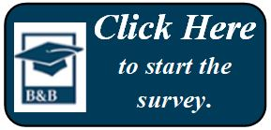

Or go to our secure website at https://surveys.nces.ed.gov/bb/ using the Study ID and password below.
Study ID = «caseid»
Password = «password» (password is case sensitive)

The survey will take about 35 minutes to complete <<IF INCENTIVE ELIGIBLE: and you will receive $«Inc_amount» via <<PayPal or>> check as a thank you for your participation>>. Having your résumé or curriculum vitae handy will help you complete the survey.

If you have questions about the study or prefer to complete the survey over the phone, call the B&B help desk at 877-262-4440. You can also learn more by visiting the study website at https://surveys.nces.ed.gov/bb/.
Your participation, while voluntary, is critical to the study’s success. We hope you enjoy the opportunity to share your experiences.

Many thanks,

Ted Socha Melissa Cominole, Ph.D.
Project Officer, B&B:08/18 Project Director, B&B:08/18
National Center for Education Statistics RTI International
ted.socha@ed.gov | 202-245-7071 mcominole@rti.org | 800-723-8942

OMB Control Number: 1850-0729
Learn more about our confidentiality procedures at https://surveys.nces.ed.gov/bb/confidentiality.aspx

Flash Announcement E-mail
SUBJECT: B&B – Complete Your Survey Soon for an Additional Incentive

«fname»,

I noticed that you haven’t yet participated in the U.S. Department of Education’s 2008/18 Baccalaureate and Beyond Longitudinal Study (B&B:08/18). Your participation is very critical to the success of the study. [INSERT MERGE FIELD FROM TABLE – INCENTIVE ELIGIBILITY PAGE 20]

Remember, this offer is only valid for a limited time, so act now and complete your <<time>>-minute survey!

Or go to our secure website at https://surveys.nces.ed.gov/bb/ using the credentials provided below. (The password is case sensitive; you will need to enter it exactly as it appears here.)
Study ID = «caseid»
Password = «password»

You can call 877-262-4440 to get more information about B&B or to complete the survey by phone.

Your participation «as a [major]« and [major2]» major>> is important to make sure that the B&B results represent all types of life experiences. Thank you in advance for making B&B a success.

Sincerely,

[INSERT MERGE FIELD FROM TABLE – SOURCE AND SIGNATORY BELOW]

OMB Control Number: 1850-0729
Learn more about our confidentiality procedures at https://surveys.nces.ed.gov/bb/confidentiality.aspx

MERGE FIELD OPTIONS – SOURCE AND SIGNATORY
Will be updated as needed to improve response rates as described in Part B.4.b.
From NCES | Ted Socha  Project Officer, B&B:08/18  National Center for Education Statistics  ted.socha@ed.gov | 202-245-7071
From RTI – Project Director | Melissa Cominole, Ph.D.  Project Director, B&B:08/18  RTI International  mcominole@rti.org | 800-723-8942
From RTI – Task Leader | Jeff Franklin  B&B Data Collection Task Leader  RTI International  jwf@rti.org | 800-647-9657
From RTI – B&B Data Collection Team | B&B Data Collection Team  bbemail@rti.org | 877-262-4440

Abbreviated Announcement E-mail

SUBJECT: The B&B Survey Now Takes Only <<time>> Minutes

<<fname>>, the B&B survey now takes only <<time>> minutes to complete [IF INCENTIVE ELIGIBLE:<<, and you'll still receive $<<total_incentive>> for participating, payable by <<PayPal or>> check>>]. // [IF INCENTIVE ELIGIBLE AND BOOST: <<, and in addition to your $<<Inc_amount>>, you’re now also getting $<<Boost_Inc>>, for a total of $<<Total_incentive>>>>].
Or visit https://surveys.nces.ed.gov/bb/.
Log in using your secure credentials:
Study ID = «caseid»
Password = «password»
If you prefer, you may also complete the survey over the telephone by calling the B&B Help Desk at 877-262-4440.
I hope that you will participate in the study, especially now that the survey takes only <<time>> minutes! We need to hear from <<[major]« and [major2] »>> majors like >>you. Thank you in advance for making U.S. Department of Education’s B&B study a success.
[INSERT MERGE FIELD FROM TABLE – SOURCE AND SIGNATORY, PAGE 33]
OMB Control Number: 1850-0729
Learn more about our confidentiality procedures at https://surveys.nces.ed.gov/bb/confidentiality.aspx

Incentive Boost E-mail
INCENTIVE ELIGIBLE SAMPLE ONLY

Subject Line: We Just Increased the Incentive for Your Participation in B&B

Dear «fname»:

You have been selected to receive an additional $<<Boost_Inc>> for completing your B&B survey—that’s a total of <<total_incentive>>! Complete your <<time>>-minute survey today and receive your additional $<<Boost_Inc>>:
Or log on to our secure website to participate:
https://surveys.nces.ed.gov/bb/
Study ID: <<caseid>>
Password: <<password>>

Data collected from B&B will help researchers and policymakers better understand how earning a bachelor’s degree «in majors such as [major] <<and [major2]>>» impacts choices for additional education and employment paths. You represent many other bachelor’s degree recipients like you, and although participation in B&B is voluntary, we hope you will decide to complete the survey about your experiences.

If you need help accessing the online survey, or if you prefer to complete the survey by telephone, please call our Help Desk at 877-262-4440.

Thank you in advance for your participation in this very important U.S. Department of Education study.

Sincerely,

[INSERT MERGE FIELD FROM TABLE – SOURCE AND SIGNATORY, PAGE 33]

OMB Control Number: 1850-0729
Learn more about our confidentiality procedures at https://surveys.nces.ed.gov/bb/confidentiality.aspx

Mini Survey E-mail

SUBJECT: The B&B Survey is Now 5 Minutes

«fname»,

Participating in B&B is easier than ever! The survey is now just a few easy questions which will only take 5 minutes of your time. [IF INCENTIVE ELIGIBLE: <<As a thank you for participating you’ll receive $<<total_incentive>>, payable by <<PayPal or>> check.>>]// [IF INCENTIVE ELIGIBLE AND BOOST: <<In addition to your $<<Inc_amount>>, you’re now also getting $<<Boost_Inc>>, for a total of $<<Total_incentive>>.>>]

Or go to our secure website at https://surveys.nces.ed.gov/bb/ and log in using the credentials provided below. (The password is case sensitive; you will need to enter it exactly as it appears here.)
Study ID = «caseid»
Password = «password»

You can call 877-262-4440 to get more information about B&B or to complete the survey by phone.

You were selected to represent many other bachelor’s degree recipients with similar backgrounds and degrees <<in [major]« and [major2]»>>. No one else can replace you. I hope that you will participate in the study, especially now that the survey takes only 5 minutes!

Thank you in advance for making U.S. Department of Education’s B&B study a success.
[INSERT MERGE FIELD FROM TABLE – SOURCE AND SIGNATORY, PAGE 33]

OMB Control Number: 1850-0729
Learn more about our confidentiality procedures at https://surveys.nces.ed.gov/bb/confidentiality.aspx

Hard Copy (PAPI) Mini Survey Announcement E-mail

SUBJECT: Your B&B Survey Can be Completed on Paper

«fname»,

There are many ways to participate in B&B and we still want to hear from graduates «with [major] «and [major2]» degrees »like you! As we have not yet heard from you, we recently sent you a letter that contains a paper version of this short survey.
The survey will only take 5 minutes to complete. Please complete the survey in one of three ways:
- Online: Click the link below or go to https://surveys.nces.ed.gov/bb/ and log in with your credentials:

Study ID = «caseid»
Password = «password»

- Mail: Fill out the paper survey and mail it back in the postage-paid return envelope.
- Phone: Call 877-262-4440 to complete the survey by phone.

The survey is only a few easy questions which will only take 5 minutes of your time. [IF INCENTIVE ELIGIBLE: <<As a thank you for participating you’ll receive $<<total_incentive>>, payable by <<PayPal or>> check.>>] // [IF INCENTIVE ELIGIBLE AND BOOST: <<In addition to your $<<Inc_amount>>, you’re now also getting $<<Boost_Inc>>, for a total of $<<Total_incentive>>.>>]

I hope that you will participate in this important study for the U.S. Department of Education, especially now that the survey takes only 5 minutes and there are many ways to complete it! Thank you in advance for making B&B a success.
[INSERT MERGE FIELD FROM TABLE – SOURCE AND SIGNATORY, PAGE 33]

OMB Control Number: 1850-0729
Learn more about our confidentiality procedure at https://surveys.nces.ed.gov/bb/confidentiality.aspx

Reminder E-mail 1

SUBJECT: The Baccalaureate and Beyond Study Needs Your Participation

<<fname>>, we need <<[major]« and [major2]» majors like >>you for B&B to be a success!
Recently, we sent you an invitation to take part in the U.S. Department of Education’s 2008/18 Baccalaureate and Beyond Longitudinal Study (B&B:08/18). Your participation is critical to the success of the study, and we hope that you will participate.
It’s easy to complete today! You can:
Or go to https://surveys.nces.ed.gov/bb/ and log in:
Study ID: <<caseID>>
Password: <<password>>

You can also complete the survey over the phone by calling 877-262-4440.

The survey will take about <<time>> minutes to complete [IF INCENTIVE ELIGIBLE: <<and you will receive $«total_incentive» via <<PayPal or>> check as a thank you for your participation>>]. // [IF INCENTIVE ELIGIBLE AND BOOST: <<, and in addition to your $<<Inc_amount>>, you’re now also getting $<<Boost_Inc>>, for a total of $<<Total_incentive>>>>].
If you don't have time to complete the entire survey right now, that is not a problem! You can start the survey now and finish it later — you'll pick up right where you left off.
If you have other questions, please contact the B&B Help Desk at 877-262-4440, or e-mail us at bbemail@rti.org.

[INSERT MERGE FIELD FROM TABLE – SOURCE AND SIGNATORY, PAGE 33]

OMB Control Number: 1850-0729
Learn more about our confidentiality procedures at https://surveys.nces.ed.gov/bb/confidentiality.aspx

Reminder E-mail 2

SUBJECT: B&B Data Collection Continues

B&B won’t be a success without you, «fname»!

Data collection for the U.S. Department of Education’s 2008/18 Baccalaureate and Beyond Longitudinal Study (B&B:08/18) continues and we are interested in hearing from «[major]« and [major2]» majors like »you. The survey – which can easily be completed on your mobile device – takes approximately «time» minutes of your time. [IF INCENTIVE ELIGIBLE: <<When you complete your survey, you will receive $«total_incentive» as a token of our appreciation, payable by <<PayPal or>> check.>>] // [IF INCENTIVE ELIGIBLE AND BOOST: << In addition to your $<<Inc_amount>>, you’re now also getting $<<Boost_Inc>>, for a total of $<<Total_incentive>>.>>]

Or visit https://surveys.nces.ed.gov/bb/
Log in using your secure credentials:
Study ID = «caseid»
Password = «password»

Need help accessing the online survey? Prefer to complete the survey by telephone? Please call our Help Desk at 877-262-4440.

Thank you in advance for your participation in this very important study.

Sincerely,

[INSERT MERGE FIELD FROM TABLE – SOURCE AND SIGNATORY, PAGE 33]

OMB Control Number: 1850-0729
Learn more about our confidentiality procedures at https://surveys.nces.ed.gov/bb/confidentiality.aspx

Reminder E-mail 3

SUBJECT: Don’t Forget About Your B&B Survey, <<fname>>

[IF INCENTIVE ELIGIBLE: <<<<fname>>, your $<<total_incentive>> awaits!>>] // [IF NO INCENTIVE: <<<<fname>>, your participation is critical!>>]

We still need you to participate in the 2008/18 Baccalaureate and Beyond Longitudinal Study (B&B:08/18) for the U.S. Department of Education. Data collection for B&B:08/18 continues and we are interested in hearing from «[major]«and [major2]» majors like »you!

It only takes about «time» minutes [IF INCENTIVE ELIGIBLE: << and, once you’ve completed the survey, you’ll receive $«total_incentive», payable by <<PayPal or>> check>>]! // [IF INCENTIVE ELIGIBLE AND BOOST: <<, and in addition to your $<<Inc_amount>>, you’re now also getting $<<Boost_Inc>>, for a total of $<<Total_incentive>>>>]!

Or go to https://surveys.nces.ed.gov/bb/ and log in using:
Study ID = «caseid»
Password = «password»
You can also complete the survey by phone with one of our trained interviewers by calling 877-262-4440. Find more information on the study website at https://surveys.nces.ed.gov/bb/.
Thanks!

[INSERT MERGE FIELD FROM TABLE – SOURCE AND SIGNATORY, PAGE 33]

OMB Control Number: 1850-0729
Learn more about our confidentiality procedures at https://surveys.nces.ed.gov/bb/confidentiality.aspx

Reminder E-mail 4

SUBJECT: <<Fname>>, Don’t Delay - Participate in B&B Today

«Fname», we’ve been contacting you and other college graduates <<in [major]>> «and [major2] »about participating in B&B!
B&B is an important U.S. Department of Education study that will help policymakers understand how earning a bachelor’s degree impacts choices about further education and work.
We understand there are many demands for your time, but we need your help to make sure that the study includes individuals from a variety of backgrounds - no one can replace you in this study. The survey takes only «time» minutes to complete [IF INCENTIVE ELIGIBLE:<<, and we will send you $«total_incentive» (payable by <<PayPal or>> check) for doing it>>]. // [IF INCENTIVE ELIGIBLE AND BOOST: <<, and in addition to your $<<Inc_amount>>, you’re now also getting $<<Boost_Inc>>, for a total of $<<Total_incentive>>>>].
You can also log on to our secure website https://surveys.nces.ed.gov/bb/ using your study credentials:
Study ID = «caseid»
Password = «password»
Call 877-262-4440 to get more information about B&B or complete the survey by phone.
Thank you for considering participating in this important study. We hope you will – B&B won’t be the same without you.
Thank you!
[INSERT MERGE FIELD FROM TABLE – SOURCE AND SIGNATORY, PAGE 33]

OMB Control Number: 1850-0729
Learn more about our confidentiality procedures at https://surveys.nces.ed.gov/bb/confidentiality.aspx

Reminder E-mail 5

SUBJECT: Take Part in Important Education Research When You Participate in B&B



Hello, <<fname>>! Your participation in B&B is critical to the success of the study, and we hope that you will participate. This U.S. Department of Education study includes all types of bachelor’s degree recipients who graduated from college during the 2007–08 school year. Your participation «as a [major] «and [major2]» major »is important to make sure that the B&B results represent all types of life experiences. No one can replace you in this study.

It only takes about «time» minutes [IF INCENTIVE ELIGIBLE: << and, once you’ve completed the survey, you’ll receive $«total_incentive», payable by <<PayPal or>> check>>]! // [IF INCENTIVE ELIGIBLE AND BOOST: <<, and in addition to your $<<Inc_amount>>, you’re now also getting $<<Boost_Inc>>, for a total of $<<Total_incentive>>>>]!

Or, log onto our site at https://surveys.nces.ed.gov/bb/

Study ID = «caseid»
Password = «password»

You can call the B&B Help Desk at 877-262-4440 if you have any questions or problems completing your survey or would like to participate over the telephone.
Thanks in advance for sharing your experiences with us!
[INSERT MERGE FIELD FROM TABLE – SOURCE AND SIGNATORY, PAGE 33]

OMB Control Number: 1850-0729
Learn more about our confidentiality procedures at https://surveys.nces.ed.gov/bb/confidentiality.aspx

Reminder E-mail 6

SUBJECT: Only You Can Make B&B a Success

B&B is easy to complete, «fname»! You can do it on your mobile device!

This U.S. Department of Education survey only takes about «time» minutes. [IF INCENTIVE ELIGIBLE: <<And, when you complete the survey, you’ll receive $«total_incentive», payable by <<PayPal or>> check.>>] // [IF INCENTIVE ELIGIBLE AND BOOST: <<In addition to your $<<Inc_amount>>, you’re now also getting $<<Boost_Inc>>, for a total of $<<Total_incentive>>.>>]

Use your secure login credentials to access the survey at https://surveys.nces.ed.gov/bb/
Study ID = «caseid»
Password = «password»
You can complete the survey by phone by calling 877-262-4440 and find more information on the study website at https://surveys.nces.ed.gov/bb/
We look forward to hearing about your experiences since graduating from college «with your degree in [major] «and [major2]»>>!
Thanks!

[INSERT MERGE FIELD FROM TABLE – SOURCE AND SIGNATORY, PAGE 33]

OMB Control Number: 1850-0729
Learn more about our confidentiality procedures at https://surveys.nces.ed.gov/bb/confidentiality.aspx

Reminder E-mail 7
SUBJECT: <<fname>>, Participate in an Important U.S. Department of Education Study

«fname»,

The 2008/18 Baccalaureate and Beyond Longitudinal Study (B&B:08/18) is an important education study about the experiences of college graduates conducted on behalf of the U.S. Department of Education. [INSERT MERGE FIELD FROM TABLE – PRIOR RESPONSE, PAGE 16]

B&B helps researchers and policymakers understand how earning a bachelor’s degree «in [major]» «and [major2]» impacts choices for continuing education and employment paths. You can find out more about what we've learned from previous B&B studies here:
https://surveys.nces.ed.gov/bb/prev_results.aspx.

The survey takes about <<time>> and is easy to complete on your mobile device. [IF INCENTIVE ELIGIBLE: <<And, when you complete the survey, you'll receive $<<total_incentive>>, payable by <<PayPal or>> check!>>] // [IF INCENTIVE ELIGIBLE AND BOOST: << In addition to your $<<Inc_amount>>, you’re now also getting $<<Boost_Inc>>, for a total of $<<Total_incentive>>.>>]

Use your secure login credentials to access the survey at https://surveys.nces.ed.gov/bb/
Study ID = «caseid»
Password = «password»

If you prefer, you may also complete the survey over the telephone by calling the B&B Help Desk at 877-262-4440.

Thanks!
[INSERT MERGE FIELD FROM TABLE – SOURCE AND SIGNATORY, PAGE 33]

OMB Control Number: 1850-0729
Learn more about our confidentiality procedures at https://surveys.nces.ed.gov/bb/confidentiality.aspx

Reminder E-mail 8

SUBJECT: B&B Needs You, <<fname>>

<<fname>>, B&B only takes <<time>> minutes and is easy to complete on your mobile device. [IF INCENTIVE ELIGIBLE: <<When you complete the survey, you'll receive $<<total_incentive>> payable by <<PayPal or>> check!>>] // [IF INCENTIVE ELIGIBLE AND BOOST: << In addition to your $<<Inc_amount>>, you’re now also getting $<<Boost_Inc>>, for a total of $<<Total_incentive>>.>>]

Or visit the website and log in: https://surveys.nces.ed.gov/bb/
Study ID: <<caseID>>
Password: <<password>>

You can also complete the survey by telephone by calling 877-262-4440, and find more information on the study website at https://surveys.nces.ed.gov/bb/.
You were selected to represent many other bachelor’s degree recipients with similar backgrounds and degrees <<in [major]<< and [major2]>>>>. No one else can replace you. I hope that you will participate in this important U.S. Department of Education study.
Thanks!

[INSERT MERGE FIELD FROM TABLE – SOURCE AND SIGNATORY, PAGE 33]

OMB Control Number: 1850-0729
Learn more about our confidentiality procedures at https://surveys.nces.ed.gov/bb/confidentiality.aspx

Reminder E-mail 9

SUBJECT: Participate in B&B, an Important Education Study

When you complete your U.S. Department of Education’s B&B survey, which takes about <<time>> minutes, you'll contribute to important education research. [IF INCENTIVE ELGIBLE: <<And, you'll receive $<<total_incentive>>, payable by <<PayPal or>> check!>>] // [IF BOOST: <<Since your participation is so important, in addition to your $<<Inc_amount>>, you’re now also getting $<<Boost_Inc>>, for a total of $<<Total_incentive>>.>>]

Or, you can visit the website and log in: https://surveys.nces.ed.gov/bb/
Study ID: <<caseID>>
Password: <<password>>

If you have questions or prefer to participate by telephone, call 877-262-4440.

We need to hear from <<[major]« and [major2]» majors like>> you! Thanks in advance for your participation.

[INSERT MERGE FIELD FROM TABLE – SOURCE AND SIGNATORY, PAGE 33]

OMB Control Number: 1850-0729
Learn more about our confidentiality procedures at https://surveys.nces.ed.gov/bb/confidentiality.aspx

Reminder E-mail 10

SUBJECT: Share Your Experiences with B&B

<<fname>>, the B&B survey takes about <<time>> minutes! [INSERT MERGE FIELD FROM TABLE – INCENTIVE ELIGIBILITY, PAGE 20]

This is your chance to contribute to important education research about your experiences since obtaining your bachelor’s degree. You were selected to represent many other bachelor’s degree recipients with similar backgrounds and degrees« in [major] «and [major2]»». B&B:08/18 is conducted by the National Center for Education Statistics (NCES), in the U.S. Department of Education's Institute for Education Sciences, with data collection being carried out under contract by RTI International, a U.S.-based nonprofit research organization.
Or, log onto our site at https://surveys.nces.ed.gov/bb/

Study ID = «caseid»
Password = «password»

Call 877-262-4440 to get more information about B&B or complete the survey by phone.
We look forward to hearing about your experiences since graduating from college «with your degree in [major] << and [major2]>>>>!
Thank you!
[INSERT MERGE FIELD FROM TABLE – SOURCE AND SIGNATORY, PAGE 33]

OMB Control Number: 1850-0729
Learn more about our confidentiality procedures at https://surveys.nces.ed.gov/bb/confidentiality.aspx

Reminder E-mail 11
SUBJECT: Please Complete the U.S. Department of Education’s B&B survey

«Fname», we’ve been contacting you and other college graduates to learn about bachelor’s degree recipients in all fields<<, including [major]<< and [major2],>>>> about participating in B&B! [INSERT MERGE FIELD FROM ABBREVIATED AND INCENTIVE ELIGIBILITY TABLE, BELOW]

Or, you can visit the website and log in: https://surveys.nces.ed.gov/bb/
Study ID: <<caseID>>
Password: <<password>>

If you prefer to participate by telephone, have questions, or would like more information, just call 877-262-4440.
Thanks in advance for your participation.
[INSERT MERGE FIELD FROM TABLE – SOURCE AND SIGNATORY, PAGE 33]

OMB Control Number: 1850-0729
Learn more about our confidentiality procedures at https://surveys.nces.ed.gov/bb/confidentiality.aspx
MERGE FIELD OPTIONS – ABBREVIATED AND INCENTIVE ELIGIBILITY
ABBREVIATED, INCENTIVE ELIGIBLE | Now the survey only takes <<time>> minutes and you'll receive $<<total_incentive>>, payable by <<PayPal or>> check when you complete!
ABBREVIATED, INCENTIVE ELIGIBLE+BOOST | Now the survey only takes <<time>> minutes, and in addition to your $<<inc_amount>>, you’re now also getting $<<Boost_Inc>>, for a total of $<<Total_incentive>>!
ABBREVIATED, NOT INCENTIVE ELIGIBLE | Now the survey only takes <<time>> minutes!
NOT ABBREVIATED, INCENTIVE ELIGIBLE | The B&B survey takes about <<time>> minutes and you'll receive $<<total_incentive>>, payable by <<PayPal or>> check when you complete it!
NOT ABBREVIATED, INCENTIVE ELIGIBLE+BOOST | The B&B survey takes about <<time>> minutes and in addition to your $<<inc_amount>>, you’re now also getting $<<Boost_Inc>>, for a total of $<<Total_incentive>>!
NOT ABBREVIATED, NOT INCENTIVE ELIGIBLE | The B&B survey takes about <<time>> minutes to finish.

Reminder E-mail 12

SUBJECT: We Have <<xx>>% of the Participants We Need to Make B&B a Success – We Need Your Help!

<<fname>>, we still need to hear from <<[major] << and [major2]>> majors like >>you! You have the opportunity to contribute to important research sponsored by the U.S. Department of Education. [INSERT MERGE FIELD FROM TABLE – ABBREVIATED AND INCENTIVE ELIGIBILITY, PAGE 48]

Or, log onto our site at https://surveys.nces.ed.gov/bb/

Study ID = «caseid»
Password = «password»

If you prefer, you may also complete the survey over the telephone by calling the B&B Help Desk at 877-262-4440.
Thank you!
[INSERT MERGE FIELD FROM TABLE – SOURCE AND SIGNATORY, PAGE 33]

OMB Control Number: 1850-0729
Learn more about our confidentiality procedures at https://surveys.nces.ed.gov/bb/confidentiality.aspx

Reminder E-mail 13

SUBJECT: We Need Your Help with B&B

<<fname>>,

Data collection for U.S. Department of Education’s B&B:08/18 study continues and we are interested in hearing from «[major]<< and [major2]>> majors like »you!

Or, you can visit the website and log in: https://surveys.nces.ed.gov/bb/
Study ID: <<caseID>>
Password: <<password>>

[INSERT MERGE FIELD FROM TABLE – ABBREVIATED AND INCENTIVE ELIGIBILITY, PAGE 48] You were selected to represent many other bachelor’s degree recipients with similar backgrounds and degrees and the study won't be a success without you, <<fname>>!

If you have questions or would prefer to complete over the telephone, call the B&B Help Desk at 877-262-4440.
Thank you!
[INSERT MERGE FIELD FROM TABLE – SOURCE AND SIGNATORY, PAGE 33]

OMB Control Number: 1850-0729
Learn more about our confidentiality procedures at https://surveys.nces.ed.gov/bb/confidentiality.aspx

Reminder E-mail 14 [Holiday]

SUBJECT LINE: <<fname>>, a personal invitation to participate in B&B
SUBJECT LINE (holiday theme): <<fname>>, wishing you a wonderful holiday season!

Dear «fname» --

[INSERT MERGE FIELD FROM TABLE – HOLIDAY, BELOW]

Here are the important details:

- The survey takes about «time» min. to complete a survey about your experiences since graduating in 2007-08 <<with your bachelor’s degree in [major] << and [major2]>>>>.
- <<IF INCENTIVE ELIGIBLE: You’ll receive $<<total_incentive>> when you complete the survey, payable by check<< or PayPal>>.>>// [IF INCENTIVE ELIGIBLE AND BOOST: <<In addition to your $<<Inc_amount>>, you’re now also getting $<<Boost_Inc>>, for a total of $<<Total_incentive>>.>>]
- Click the link below or login at https://surveys.nces.ed.gov/bb/
  - Your Study ID is «caseID»
  - Your password is «password»
- Alternatively, you can complete the survey over the phone: 877-262-4440.

All of the information you provide may be used only for statistical purposes and may not be disclosed, or used, in identifiable form for any other purpose except as required by law (20 U.S.C. §9573 and 6 U.S.C. §151). If you have questions or problems completing your survey, simply contact the B&B Help Desk at 877-262-4440 or bbemail@rti.org.

Thank you for helping make B&B a success!

[INSERT MERGE FIELD FROM TABLE – SOURCE AND SIGNATORY, PAGE 33]

OMB Control Number: 1850-0729
Learn more about our confidentiality procedures at https://surveys.nces.ed.gov/bb/confidentiality.aspx
MERGE FIELD OPTIONS– HOLIDAY
Holiday Theme  (If e-mail is sent during December) | Happy Holidays from the B&B study team!  We’ve been trying to contact you over the past six months to complete the U.S. Department of Education’s B&B survey. Your response is critically important to the study.  I hope that you will take time out of your busy schedule to complete your survey today [IF INCENTIVE ELIGIBLE: <<and receive a little extra money just in time for the holidays>>]!
Non-Holiday Theme | We’ve been trying to contact you over the past <<number>> months to complete the U.S. Department of Education’s B&B survey. Your response is critically important to the study. I hope that you will take time out of your busy schedule to complete the study today.

Reminder E-mail 15
Subject: New Year’s Resolution: Resolve to Participate in B&B
Hi <<fname>>,

Ring in the New Year by sharing your experiences with B&B. You were selected to represent many other bachelor’s degree recipients with similar backgrounds and degrees «in [major]<< and [major2]>>>>. No one else can replace you. [IF INCENTIVE ELIGIBLE: <<When you complete your survey, you’ll receive $<<total_incentive>>!>>] // [IF INCENTIVE ELIGIBLE AND BOOST: <<Since your participation is so important, in addition to your $<<Inc_amount>>, you’re now also getting $<<Boost_Inc>>, for a total of $<<Total_incentive>>.>>] It <<only>> takes <<time>> minutes. You can complete the survey on your mobile device.

Or, log onto our site at https://surveys.nces.ed.gov/bb/

Study ID = «caseid»
Password = «password»

Our professional interviewers can answer any questions you have, and can complete the survey over the telephone with you, if you prefer. Just call the B&B Help Desk at 877-262-4440.
Wishing you a Happy New Year!
[INSERT MERGE FIELD FROM TABLE – SOURCE AND SIGNATORY, PAGE 33]

OMB Control Number: 1850-0729
Learn more about our confidentiality procedures at https://surveys.nces.ed.gov/bb/confidentiality.aspx

Reminder E-mail 16
SUBJECT: The B&B Survey: Your Questions Answered

<<Fname>>, we still need you to participate in the 2008/18 Baccalaureate and Beyond Longitudinal Study (B&B:08/18) for the U.S. Department of Education. [IF INCENTIVE ELIGIBLE: <<We’re offering $<<total_incentive>> for your participation, which can be completed on a phone or tablet.>>] // [IF INCENTIVE ELIGIBLE AND BOOST: <<Since your participation is so important, in addition to your $<<Inc_amount>>, you’re now also getting $<<Boost_Inc>>, for a total of $<<Total_incentive>>. You can receive your incentive via <<PayPal or>> check.>>]

If you have questions about the study, we’re here to help!

How do I participate?
Or, log onto our site at https://surveys.nces.ed.gov/bb/

Study ID = «caseid»
Password = «password»

I’m not sure why you want to survey me. Should I participate in B&B?
Yes! B&B includes all types of bachelor’s degree recipients who graduated from college during the 2007–08 school year. Your participation« as a [major]<< and [major2]>> major »is important to make sure that the B&B results represent all types of education and employment. No one can replace you in this study.

How long will the survey take?
[INSERT MERGE FIELD FROM TABLE BELOW]

How will my information be protected?
Federal law requires that we respect your privacy. NCES is required to follow strict procedures to protect the confidentiality of persons in the collection, reporting, and publication of data. Read more about our confidentiality procedures at: https://surveys.nces.ed.gov/bb/confidentiality.aspx.

If you need help accessing the survey or you want to complete it over the phone, please call our Help Desk at 877-262-4440. Your participation in B&B is very important and we hope you choose to complete the survey.

Thank you!

[INSERT MERGE FIELD FROM TABLE – SOURCE AND SIGNATORY, PAGE 33]

MERGE FIELD OPTIONS– INTERVIEW LENGTH
Full Interview | For most people, we expect the survey will take about <<time>> minutes, depending on your answers. You do not have to complete the survey in one session. You can get started and, if you choose, you can easily log out and resume at a later time.
Mini/Abbreviated Interview | Your survey was recently shortened and now only takes about <<time>> minutes. You do not have to complete the survey in one session. You can get started and, if you choose, you can easily log out and resume at a later time.

OMB Control Number: 1850-0729
Learn more about our confidentiality procedures at https://surveys.nces.ed.gov/bb/confidentiality.aspx

Reminder E-mail 17

Subject: Share Your Experiences with B&B
<<Fname>>, you can conveniently take the B&B survey on your mobile device!
We still need you to participate in the 2008/18 Baccalaureate and Beyond Longitudinal Study (B&B) for the U.S. Department of Education. It <<now>> only takes <<time>> minutes to complete [IF INCENTIVE ELIGIBLE: <<and, once you’re done, you’ll receive $<<total_incentive>>, payable by <<PayPal or>> check>>]. // [IF INCENTIVE ELIGIBLE AND BOOST: <<and, in addition to your $<<Inc_amount>>, you’re now also getting $<<Boost_Inc>>, for a total of $<<Total_incentive>>. You can receive your incentive via <<PayPal or>> check>>].

Alternatively, you can complete the survey by phone with one of our professional interviewers by calling 877-262-4440. More information on B&B can be found at the study website here: https://surveys.nces.ed.gov/bb/

We look forward to hearing from «[major]<< and [major2]>> majors like »you!

Thanks!
[INSERT MERGE FIELD FROM TABLE – SOURCE AND SIGNATORY, PAGE 33]

YOUR SECURE LOGIN CREDENTIALS:
https://surveys.nces.ed.gov/bb/
Study ID: <<caseID>>
Password: <<password>>

OMB Control Number: 1850-0729
Learn more about our confidentiality procedures at https://surveys.nces.ed.gov/bb/confidentiality.aspx

Reminder E-mail 18

SUBJECT: <<fname>>, Participate in B&B Today
We’ve been contacting you <<and other [major] << and [major2]>> majors >>about participating in B&B, <<fname>>!
We know that you have demands on your time, but we need your help to make sure that the study is representative of all types of bachelor’s degree recipients. To accommodate your busy schedule, the survey <<only>> takes about <<time>> minutes to complete. [IF INCENTIVE ELIGIBLE: We will send you $<<total_incentive>> (payable by <<PayPal or>> check) for completing it!>>] // [IF INCENTIVE ELIGIBLE AND BOOST: <<In addition to your $<<Inc_amount>>, you’re now also getting $<<Boost_Inc>>, for a total of $<<Total_incentive>>. You can receive your incentive via <<PayPal or>> check.>>]
Or, log onto our secure website at https://surveys.nces.ed.gov/bb/

Study ID = «caseid»
Password = «password»

Or, you can call 877-262-4440 to get more information about B&B or to complete the survey by phone with one of our trained interviewers.
We hope you will decide to participate – B&B won’t be the same without you.
Thanks!
[INSERT MERGE FIELD FROM TABLE – SOURCE AND SIGNATORY, PAGE 33]

OMB Control Number: 1850-0729
Learn more about our confidentiality procedures at https://surveys.nces.ed.gov/bb/confidentiality.aspx

Reminder E-mail 19

SUBJECT: Don’t Miss Out: Your B&B Survey Now Takes <<Only>> <<time>> Minutes to Complete

«fname», because hearing from <<[major] << and [major2]>> majors like >>you is so important to us, you were selected to receive a shortened B&B survey, which <<now>> only takes about <<time>> minutes to complete. [IF INCENTIVE ELIGIBLE: <<And, once you complete your survey, you will receive $<<total_incentive>> for participating, payable by <<PayPal or>> check!>>] // [IF INCENTIVE ELIGIBLE AND BOOST: <<In addition to your $<<Inc_amount>>, you’re now also getting $<<Boost_Inc>>, for a total of $<<Total_incentive>>.>>]

Participation is easy!

Or, you can visit the website and log in: https://surveys.nces.ed.gov/bb/
Study ID: <<caseID>>
Password: <<password>>

[IF INCENTIVE ELIGIBLE: <<I hope you will take the time to participate and receive your $<<total_incentive>> token of appreciation.>>] If you have any questions, simply contact us at bbemail@rti.org or our Help Desk at 877-262-4440.

Thanks -
[INSERT MERGE FIELD FROM TABLE – SOURCE AND SIGNATORY, PAGE 33]

OMB Control Number: 1850-0729
Learn more about our confidentiality procedures at https://surveys.nces.ed.gov/bb/confidentiality.aspx

Reminder E-mail 20

SUBJECT LINE: Your B&B Survey Only Takes <<time>> Minutes to Complete

«fname», your B&B survey will take about <<time>> minutes to complete [IF MINI: <<– and it’s only a few easy questions>>]! [IF INCENTIVE ELIGIBLE: <<You will receive $<<total_incentive>> for participating, payable by <<PayPal or>> check.>>] // [IF INCENTIVE ELIGIBLE AND BOOST: <<In addition to your $<<Inc_amount>>, you’re now also getting $<<Boost_Inc>>, for a total of $<<Total_incentive>>.>>]

Or, log onto our secure website at https://surveys.nces.ed.gov/bb/

Study ID = «caseid»
Password = «password»

If you have any questions about the B&B survey, feel free to reply to this e-mail or call our Help Desk at: 877-262-4440.

I hope you decide to participate. We rely on college graduates <<who majored in [major] << and [major2]>>>> like you to make B&B a success!

Sincerely,

[INSERT MERGE FIELD FROM TABLE – SOURCE AND SIGNATORY, PAGE 33]

OMB Control Number: 1850-0729
Learn more about our confidentiality procedures at https://surveys.nces.ed.gov/bb/confidentiality.aspx

Reminder E-mail 21

SUBJECT: B&B is Ending Soon – Don’t Miss Your Chance to Participate
SUBJECT: B&B Needs Your Participation, <<fname>>

<<fname>>, data collection for the U.S. Department of Education's 2008/18 Baccalaureate and Beyond Longitudinal Study (B&B:08/18) <<continues>>//<<will end soon>>, and we need your help to make the study a success! It is crucial to the study that we hear from <<[major]<< and [major2]>> majors like >>you!
Or, log onto our site at https://surveys.nces.ed.gov/bb/

Study ID = «caseid»
Password = «password»

[IF RECEIVED PAPI: <<You can also send back the paper survey you may have received in the mail. Simply complete the survey and send it back to us in the return envelope that was provided.>>]
It only takes about <<time>> minutes to complete the B&B survey. [IF INCENTIVE ELIGIBLE: <<You'll receive $<<total_incentive>> via <<PayPal or>> check!>>] / [IF INCENTIVE ELIGIBLE AND BOOST: <<In addition to your $<<Inc_amount>>, you’re now also getting $<<Boost_Inc>>, for a total of $<<Total_incentive>>.>>]
Our professional interviewers can answer any questions you have, and can complete the survey over the telephone with you, if you prefer. Just call the B&B Help Desk at 877-262-4440.
Thank you!
[INSERT MERGE FIELD FROM TABLE – SOURCE AND SIGNATORY, PAGE 33]

OMB Control Number: 1850-0729
Learn more about our confidentiality procedures at https://surveys.nces.ed.gov/bb/confidentiality.aspx

Reminder E-mail 22

SUBJECT: B&B Is Coming to a Close
Time to participate in B&B is running out, <<fname>>! We still want to hear about your experiences since graduating from college «with a [major]<< and [major2]>>» degree »in 2007-08.
The B&B study ends on <<end_date>>, so we hope that all surveys will be completed by then. Please take time before <<end_date>> to complete your <<time>>-minute survey. [IF INCENTIVE ELIGIBLE: <<If you finish the survey by then, you'll receive $<<total_incentive>> via <<PayPal or>> check!>>] / [IF INCENTIVE ELIGIBLE AND BOOST: <<In addition to your $<<Inc_amount>>, you’re now also getting $<<Boost_Inc>>, for a total of $<<Total_incentive>>.>>]

Or, you can visit the website and log in: https://surveys.nces.ed.gov/bb/
Study ID: <<caseID>>
Password: <<password>>

[IF RECEIVED PAPI: <<You can also send back the paper survey you may have received in the mail. Simply complete the survey and send it back to us in the return envelope that was provided.>>]
If you have any questions, please contact the B&B Help Desk at 877-262-4440.
Best,
[INSERT MERGE FIELD FROM TABLE – SOURCE AND SIGNATORY, PAGE 33]

OMB Control Number: 1850-0729
Learn more about our confidentiality procedures at https://surveys.nces.ed.gov/bb/confidentiality.aspx

Reminder E-mail 23

SUBJECT: B&B Ends Tomorrow – Help Us Learn About Your Experiences Since Graduation
The U.S. Department of Education's 2008/18 Baccalaureate and Beyond Longitudinal Study (B&B:08/18) ends tomorrow, <<fname>>! We still want to hear about your experiences since graduating from college «with a [major] << and [major2]>>» degree »in 2007-08.
Complete your <<time>>-minute survey [IF INCENTIVE ELIGIBLE: <<, and you'll receive $<<total_incentive>> as a token of our appreciation>>]! // [IF INCENTIVE ELIGIBLE AND BOOST: <<, and in addition to your $<<Inc_amount>>, you’re now also getting $<<Boost_Inc>>, for a total of $<<Total_incentive>>>>]!
Or, log onto our site at https://surveys.nces.ed.gov/bb/

Study ID = «caseid»
Password = «password»

If you have questions, or if you would prefer to complete the survey over the telephone, call 877-262-4440.
Thanks in advance for participating! Have a great day.
[INSERT MERGE FIELD FROM TABLE – SOURCE AND SIGNATORY, PAGE 33]

OMB Control Number: 1850-0729
Learn more about our confidentiality procedures at https://surveys.nces.ed.gov/bb/confidentiality.aspx

Reminder E-mail 24

SUBJECT: Your Last Chance to Participate… Don’t Miss Out on B&B
<<fname>>, this is the last e-mail message we will be sending you about this survey. We want you to know how important participation from graduates <<who majored in [major] << and [major2]>>>> like you are to the success of the 2008/18 Baccalaureate and Beyond Longitudinal Study (B&B:08/18)!
Before the study comes to a close, please consider logging in to participate.

It takes about <<time>> minutes and can be completed on a smartphone or tablet. [IF INCENTIVE ELIGIBLE: <<You’ll receive $<<total_incentive>> via <<PayPal or>> check when you finish!>>] // [IF INCENTIVE ELIGIBLE AND BOOST: <<In addition to your $<<Inc_amount>>, you’re now also getting $<<Boost_Inc>>, for a total of $<<Total_incentive>>!>>]
You can learn more about results from previous round of B&B at
https://surveys.nces.ed.gov/bb/prev_results.aspx.
If you have questions, or if you would prefer to complete the survey over the telephone, call 877-262-4440.

Thanks in advance for participating! Have a great day.
[INSERT MERGE FIELD FROM TABLE – SOURCE AND SIGNATORY, PAGE 33]

Your login credentials are:
https://surveys.nces.ed.gov/bb/
Study ID: <<caseID>>
Password: <<password>>

Learn more about our confidentiality procedures at https://surveys.nces.ed.gov/bb/confidentiality.aspx

Thank You Letter- sent with check

«date»

«fname» «mname» «lname» «suffix» Study ID: «caseid»
«addr1»
«addr2»
«city», «state» «zip» «zip4»

Dear «fname»:

On behalf of the National Center for Education Statistics (NCES) in the U.S. Department of Education’s Institute of Education Sciences and the staff of the 2008/18 Baccalaureate and Beyond Longitudinal Study (B&B:08/18), we would like to thank you. Your participation in B&B is very important in helping to ensure the success of the study.
Enclosed you will find a check for $«total_incentive» as a token of our appreciation.

[INSERT MERGE FIELD FROM TABLE – RÉSUMÉ, BELOW]

If you have questions, please do not hesitate to call the B&B Help Desk at 877-262-4440.

Thank you for helping make B&B a success!

[INSERT MERGE FIELD FROM TABLE – SOURCE AND SIGNATORY, PAGE 33]

«panelinfo»/«controlID»

MERGE FIELD OPTIONS – RÉSUMÉ
Résumé – If agreed to submit later | Please take a few minutes to submit your résumé so we can have a better understanding of your experiences since college graduation. [IF INCENTIVE ELIGIBLE: <<Uploading your résumé takes only a few minutes and you will receive $«Resume_amount» for your effort!>>]  Have an electronic copy of your résumé ready. Then log in to our secure website at https://surveys.nces.ed.gov/bb/ using the Study ID and password provided below to upload your résumé.  Study ID = <<caseID>>  Password = <<password>>  <<Or use the camera on your phone to scan the QR code below to take you to the <<resume upload page>>/<<website>>:  <<QRCODE>>>>
Résumé – If did not agree to submit or already submitted | Leave blank
Hard Copy – Selected & Completed in paper | At this point we would like to give you the opportunity to upload your résumé. It takes less than 5 minutes [IF INCENTIVE ELIGBLE: and you will receive an additional $«Resume_amount» as a token of our appreciation>>].  Have an electronic copy of your résumé ready. Then log in to our secure website at https://surveys.nces.ed.gov/bb/ using the Study ID and password provided below to upload your résumé.  Study ID = <<caseID>>  Password = <<password>>  <<Or use the camera on your phone to scan the QR code below to take you to the <<resume upload page>>/<<website>>:  <<QRCODE>>>>

The 2008/18 Baccalaureate and Beyond Longitudinal Study (B&B:08/18) is conducted by the National Center for Education Statistics (NCES). Under contract with NCES, RTI International, a U.S.-based nonprofit research organization, administers B&B:08/18 on behalf of NCES. NCES is authorized to conduct B&B:08/18 by the Education Sciences Reform Act of 2002 (ESRA 2002, 20 U.S.C. §9543) and to collect students’ education records from education agencies or institutions for the purposes of evaluating federally supported education programs under the Family Educational Rights and Privacy Act (FERPA, 34 CFR §§ 99.31(a)(3) and 99.35). All of the information you provide may be used only for statistical purposes and may not be disclosed, or used, in identifiable form for any other purpose except as required by law (20 U.S.C. §9573 and 6 U.S.C. §151).
According to the Paperwork Reduction Act of 1995, no persons are required to respond to a collection of information unless it displays a valid OMB control number. The valid OMB control number for this voluntary information collection is 1850-0729. The time required to complete this information collection is estimated to average approximately <<time>> minutes per response, including the time to review instructions, gather the data needed, and complete and review the information collection. If you have any comments concerning the accuracy of the time estimate, suggestions for improving this survey, or any comments or concerns regarding the status of your individual submission of this survey, please write directly to: The 2008/18 Baccalaureate and Beyond Longitudinal Study (B&B:08/18), National Center for Education Statistics, Potomac Center Plaza, 550 12th St., SW, Room 4004, Washington, DC 20202.

Thank You E-mail – PayPal Incentive/No Incentive

SUBJECT: Thank You from B&B

Dear «fname» «lname»:

On behalf of the National Center for Education Statistics (NCES) in the U.S. Department of Education’s Institute of Education Sciences and the staff of the 2008/18 Baccalaureate and Beyond Longitudinal Study (B&B:08/18), we would like to thank you for participating in B&B. Your participation is very important in helping to ensure the success of the study.

[IF PAYPAL: <<Our records indicate that you chose to receive your token of appreciation via PayPal. Please note it can take up to a full business day to process. Please look for an e-mail from PayPal indicating that you have received funds from RTI International. (You may need to check your SPAM folder as well.) Please contact us with any concerns.>>]
[INSERT MERGE FIELD FROM TABLE – RÉSUMÉ, PAGE 62]

If you have questions, please do not hesitate to call the B&B Help Desk at 877-262-4440.

Thank you for helping make B&B a success!

Sincerely,

[INSERT MERGE FIELD FROM TABLE – SOURCE AND SIGNATORY, PAGE 33]

Study ID: <<caseID>>

OMB Control Number: 1850-0729
Learn more about our confidentiality procedures at https://surveys.nces.ed.gov/bb/confidentiality.aspx

Thank You E-mail – Check Incentive

SUBJECT: Thank You from B&B

Dear «fname» «lname»:

On behalf of the National Center for Education Statistics (NCES) in the U.S. Department of Education’s Institute of Education Sciences and the staff of the 2008/18 Baccalaureate and Beyond Longitudinal Study (B&B:08/18), we would like to thank you for participating in B&B. Your participation is very important in helping to ensure the success of the study. Our records indicate that you selected a check. Your check is being processed and should arrive in a few weeks. Please contact us with any concerns.

[INSERT MERGE FIELD FROM TABLE – RÉSUMÉ, PAGE 62]

If you have questions, please do not hesitate to call the B&B Help Desk at 877-262-4440.

Thank you for helping make B&B a success!

Sincerely,

[INSERT MERGE FIELD FROM TABLE – SOURCE AND SIGNATORY, PAGE 33]

Study ID: <<caseID>>

OMB Control Number: 1850-0729
Learn more about our confidentiality procedures at https://surveys.nces.ed.gov/bb/confidentiality.aspx

Résumé Reminder E-mail 1
SUBJECT: Don’t Forget- Upload Your Résumé for B&B Today

Dear «fname» «lname»:

On behalf of the U.S. Department of Education and the staff of the 2008/18 Baccalaureate and Beyond Longitudinal Study (B&B:08/18), we would like to thank you for completing your B&B survey.

Now that your survey is complete, it’s time to upload your résumé! It takes less than 5 minutes [IF INCENTIVE ELIGIBLE: <<and you will receive $«resume_amount» as a token of our appreciation>>]. The purpose of uploading your résumé is to provide a more complete picture of your education and employment history since you graduated. Seeing what college graduates «with degrees in [major] << and [major2]>>>>» like yourself have been up to is an important part of our study!

To upload your résumé, simply have an electronic copy of your résumé ready, then click here to log in to our secure website at https://surveys.nces.ed.gov/bb/. You can also log in using the Study ID and password provided below to upload your résumé.
Study ID = <<caseID>>
Password = <<password>>
Please do not hesitate to call the B&B Help Desk at 877-262-4440 if we can provide any additional information or assistance.

Again, thank you for your time and willingness to participate. Your ongoing participation in this study is very important to ensuring the study’s success.

[INSERT MERGE FIELD FROM TABLE – SOURCE AND SIGNATORY, PAGE 33]

OMB Control Number: 1850-0729
Learn more about our confidentiality procedures at https://surveys.nces.ed.gov/bb/confidentiality.aspx

Text Message Reminders

INITIAL CONTACT TEXT

<<Fname>>, another round of BB data collection begins soon! Go to [bitly link] to update your information.

IF BITLY LINK UNAVAILABLE: <<Fname>>, the BB survey begins soon! Go to surveys.nces.ed.gov/bb/ to update your information.

DATA COLLECTION TEXT

<<fname>>, your BB survey from the Dept of Ed is now available! [IF INCENTIVE ELIGIBLE: <<You will receive $«Total_incentive» for participating.>>] Click here to take the survey: [bitly LINK]

IF BITLY LINK UNAVAILABLE: <<fname>>, your BB survey from the Dept of Ed is now available! [IF INCENTIVE ELIGIBLE: <<You will receive $«total_incentive» for participating.>>] Go to surveys.nces.ed.gov/bb or call 877-262-4440.

TEXT MESSAGE REMINDER 1

Hi «fname»! Log on to take the US Department of Education’s BB survey [IF INCENTIVE ELIGIBLE: <<and receive $<<Total_incentive>>>>]! Take the survey at: [bitly link]

IF BITLY LINK UNAVAILABLE: Hi «fname»! Log on to take the US Department of Education’s BB survey [IF INCENTIVE ELIGIBLE: <<and receive $<<Total_incentive>>>>]! Call 877-262-4440 today!

TEXT MESSAGE REMINDER 2

«fname», this is a reminder to complete your BB survey. Go to [bitly LINK] to take the survey [IF INCENTIVE ELIGIBLE: <<and get $«Total_incentive» as a token of appreciation>>].

IF BITLY LINK UNAVAILABLE: «fname», this is a reminder to complete your BB survey. Go to surveys.nces.ed.gov/bb/ to take the survey [IF INCENTIVE ELIGIBLE: <<and get $<<Total_incentive>> as a token of appreciation>>].

TEXT MESSAGE REMINDER 3

Your BB survey is still available, «fname»! [IF INCENTIVE ELIGIBLE: <<If you participate you will receive $«Total_incentive».>>] Click this link to take the survey: [bitly LINK]

IF BITLY LINK UNAVAILABLE: Your BB survey is still available, «fname»! [IF INCENTIVE ELIGIBLE: <<If you participate we will say thank you with $<<Total_incentive>>.>>] Take the survey at surveys.nces.ed.gov/bb/

TEXT MESSAGE REMINDER 4

<<Fname>>, don't forget to complete your <<time>>-min BB survey [IF INCENTIVE ELIGIBLE: <<for $<<Total_incentive>>>>]! Complete it now: [bitly LINK]

IF BITLY LINK UNAVAILABLE: <<Fname>>, don't forget to complete your <<time>>-min BB survey [IF INCENTIVE ELIGIBLE: <<for $<<Total_incentive>>>>]! Go to surveys.nces.ed.gov/bb or call 877-262-4440 for your login info.
TEXT MESSAGE REMINDER 5

<<Fname>>, go to [bitly LINK] or call 877-262-4440 to complete your <<time>>-min BB survey and [IF INCENTIVE ELIGIBLE: <<receive $<<total_incentive>>>>]!

IF BITLY LINK UNAVAILABLE: <<Fname>>, go to surveys.nces.ed.gov/bb/ or call 877-262-4440 to complete your only <<time>>-min BB survey [IF INCENTIVE ELIGIBLE: <<and receive $<<Total_incentive>>>>]!

TEXT MESSAGE REMINDER 6

<Fname>, you can complete your <<time>> min BB survey on your mobile phone [IF INCENTIVE ELIGIBLE: <<and still receive $<<Total_incentive>>>>]! Go to [bitly LINK] or call 877-262-4440!

IF BITLY LINK UNAVAILABLE: <<Fname>>, you can complete your <<time>> min BB survey on your mobile phone [IF INCENTIVE ELIGIBLE: <<and still receive $<<Total_incentive>>>>]! Go to surveys.nces.ed.gov/bb/ or call 877-262-4440!

TEXT MESSAGE REMINDER 7

<<Fname>>, your participation in BB is very important! Click here [bitly LINK] to begin your <<time>> min survey [IF INCENTIVE ELIGIBLE: <<and receive $<<Total_incentive>>>>].

IF BITLY LINK UNAVAILABLE: <<Fname>>, your participation in BB is very important! To begin your <<time>> min survey [IF INCENTIVE ELIGIBLE: <<and receive $<<Total_incentive>>>>]: go to surveys.nces.ed.gov/bb/ or call 877-262-4440.

TEXT MESSAGE REMINDER 8

Your <<time>> min BB survey is still available, <<fname>>! [IF INCENTIVE ELIGIBLE: <<Once you complete your survey you will receive $<<Total_incentive>>.>>] Click here to get started: [bitly LINK]

IF BITLY LINK UNAVAILABLE: Your <<time>> min BB survey is still available, <<fname>>! [IF INCENTIVE ELIGIBLE: <<Once you complete your survey you will receive $<<Total_incentive>>.>>] Go to: surveys.nces.ed.gov/bb/

TEXT MESSAGE REMINDER 9

Hurry, «fname»! Your <<time>>-min BB survey [IF INCENTIVE ELIGIBLE: and $<<Total_incentive>>>>] won’t be available for long. Go to [bitly LINK] to begin now.

IF BITLY LINK UNAVAILABLE: Hurry, «fname»! Your <<time>>-min BB survey [IF INCENTIVE ELIGIBLE: <<and $<<Total_incentive>>>>] won’t be available for long. Visit surveys.nces.ed.gov/bb/ to take the survey.

TEXT MESSAGE REMINDER 10 (DAY BEFORE FINAL DAY)

«fname», tomorrow is the last day to participate in BB! [IF INCENTIVE ELIGIBLE: <<You will receive $«Total_incentive»!>>] Take the survey by clicking here: [ bitly LINK]

IF BITLY LINK UNAVAILABLE: «fname», tomorrow is the last day to participate in BB! [IF INCENTIVE ELIGIBLE: <<We will thank you with $«Total_incentive»!>>] Go to surveys.nces.ed.gov/bb/ or call 877-262-4440.

TEXT MESSAGE, REMINDER 11 (LAST DAY)

«fname», today is the LAST DAY to complete your <<time>>-min BB survey [IF INCENTIVE ELIGIBLE: <<and receive $<<Total_incentive>>>>]! Click here to begin: [bitly LINK]

IF BITLY LINK UNAVAILABLE: «fname», today is the LAST DAY to complete your <<time>>-min BB survey [IF INCENTIVE ELIGIBLE: <<and receive $<<Total_incentive>>>>]! Go to surveys.nces.ed.gov/bb/ or call 877-262-4440.

TEXT MESSAGE REMINDER (FLASH)

Act now, «fname»! You’ll receive $<<Total_Incentive> for completing your BB survey until <<Early_comp_date >>! AFTER <<early_comp_date>>, you’ll receive $<<Inc_amount>>//<<Inc_amount+Boost_inc>>. Take advantage now: [bitly LINK]

IF BITLY LINK UNAVAILABLE: Act now, «fname»! You’ll receive $<<Total_incentive>> for completing your BB survey until <<Early_comp_date >>! AFTER <<Early_comp_date >>, you’ll receive $<<Inc_amount>>//<<Inc_amount+Boost_inc>>. Take advantage now: surveys.nces.ed.gov/bb/

TEXT MESSAGE REMINDER (ABBREVIATED)

«fname», your BB survey <<now>> only takes <<time>> minutes [IF INCENTIVE ELIGIBLE: <<and you will get $<<Total_incentive>> as a thank you>>]! Click here to start: [bitly LINK]

IF BITLY LINK UNAVAILABLE: «fname», your BB survey <<now>> only takes <<time>> minutes [IF INCENTIVE ELIGIBLE: <<and you will get $<<Total_incentive>> as a thank you>>]! Go to surveys.nces.ed.gov/bb/

TEXT MESSAGE REMINDER (MINI)

Hi «fname»! Your BB survey is now only a few easy questions [IF INCENTIVE ELIGIBLE: <<and you will get $<<Total_incentive>> as a thank you>>]! Take the survey by clicking here: [bitly LINK]

IF BITLY LINK UNAVAILABLE: «fname», your BB survey is now only a few easy questions [IF INCENTIVE ELIGIBLE: <<and you will get $<<Total_incentive>> to say thanks>>]! Take the survey here: surveys.nces.ed.gov/bb/

TEXT MESSAGE REMINDER (PAPI)

«fname», you can now submit your BB survey on paper. Simply send back your completed survey or start now [IF INCENTIVE ELIGIBLE: <<for your $<<Total_incentive>>>>]! [bitly LINK]

IF BITLY LINK UNAVAILABLE: «fname», you can now submit your BB survey on paper. Simply send back your completed survey or start now [IF INCENTIVE ELIGIBLE: <<for your $<<Total_incentive>>>>]! surveys.nces.ed.gov/bb/

TEXT MESSAGE REMINDER (DC EXTENSION)

«fname», your <<time>>-min BB survey has been extended until <<end_mm_dd>> because your participation is so important! Click here to begin: [bitly LINK] [IF INCENTIVE ELIGIBLE: <<and receive $<<Total_incentive>>>>].

IF BITLY LINK UNAVAILABLE: «fname», your <<time>>-min BB survey has been extended until <<end_mm_dd>> because your participation is so important! Go to surveys.nces.ed.gov/bb/ [IF INCENTIVE ELIGIBLE: <<and receive $<<Total_incentive>>>>].

AUTO-REPLY:
This is an automated reply. Please contact us at bbemail@rti.org or 877-262-4440 for any questions or additional information.

Reminder Postcard 1
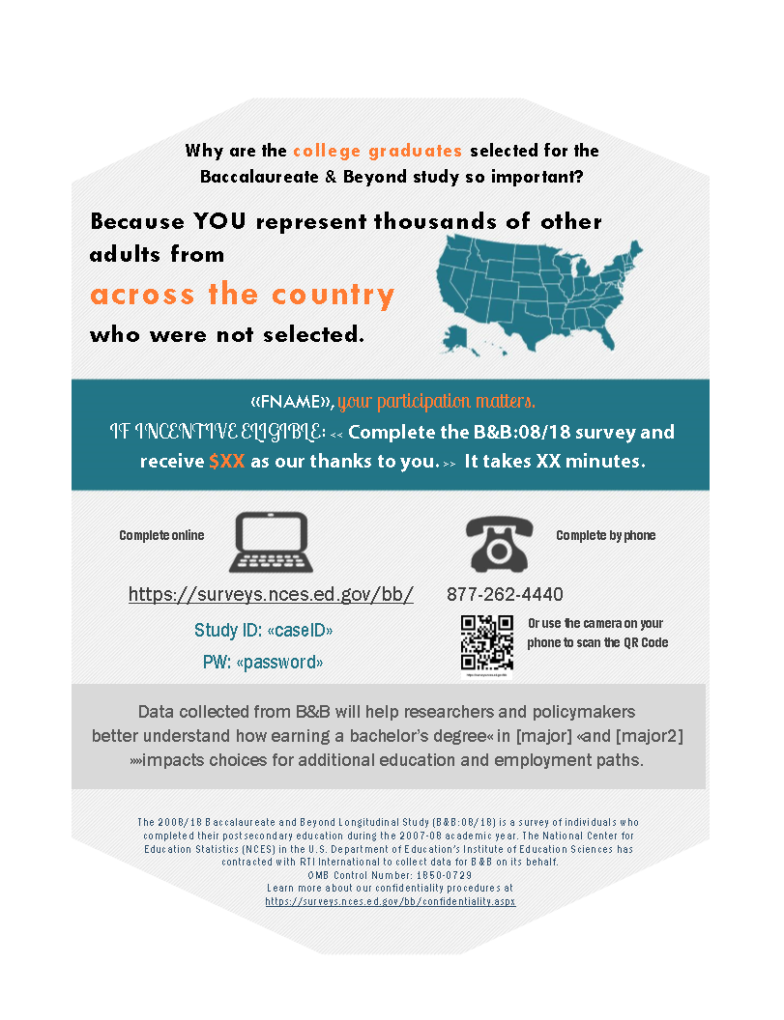
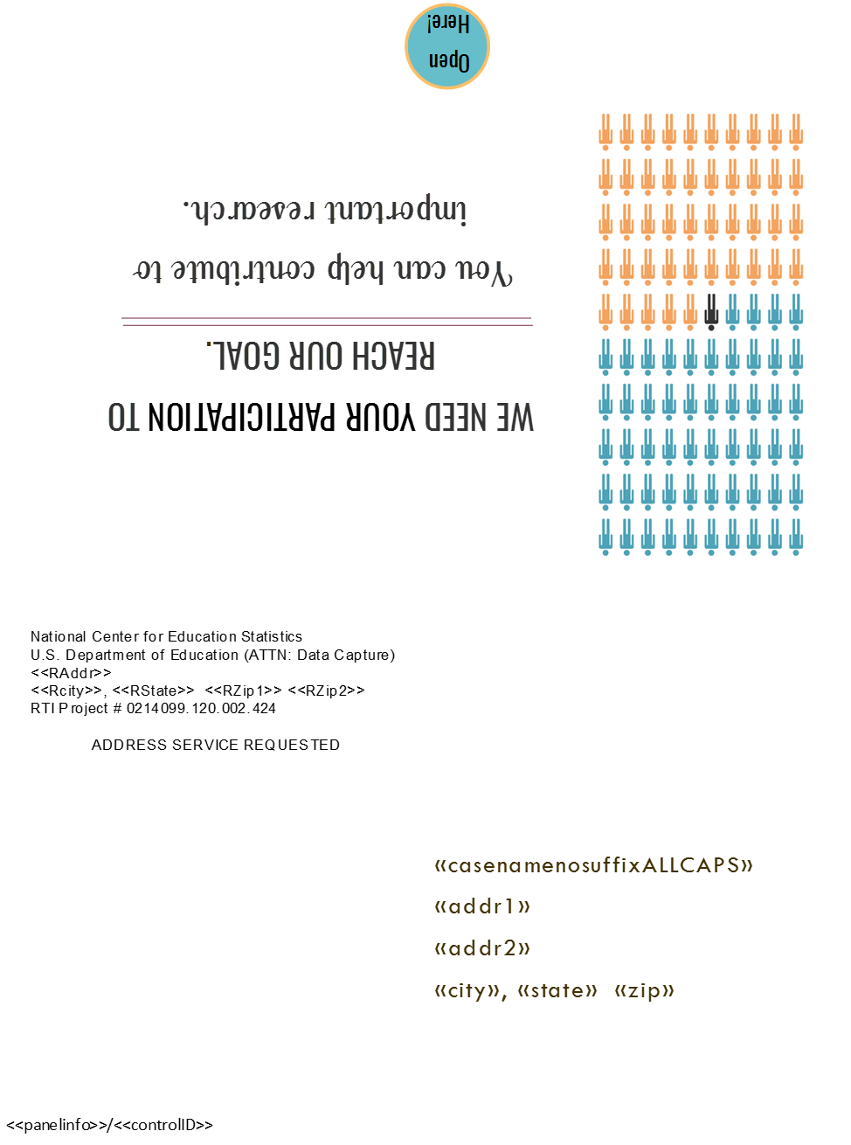

Reminder Postcard 2

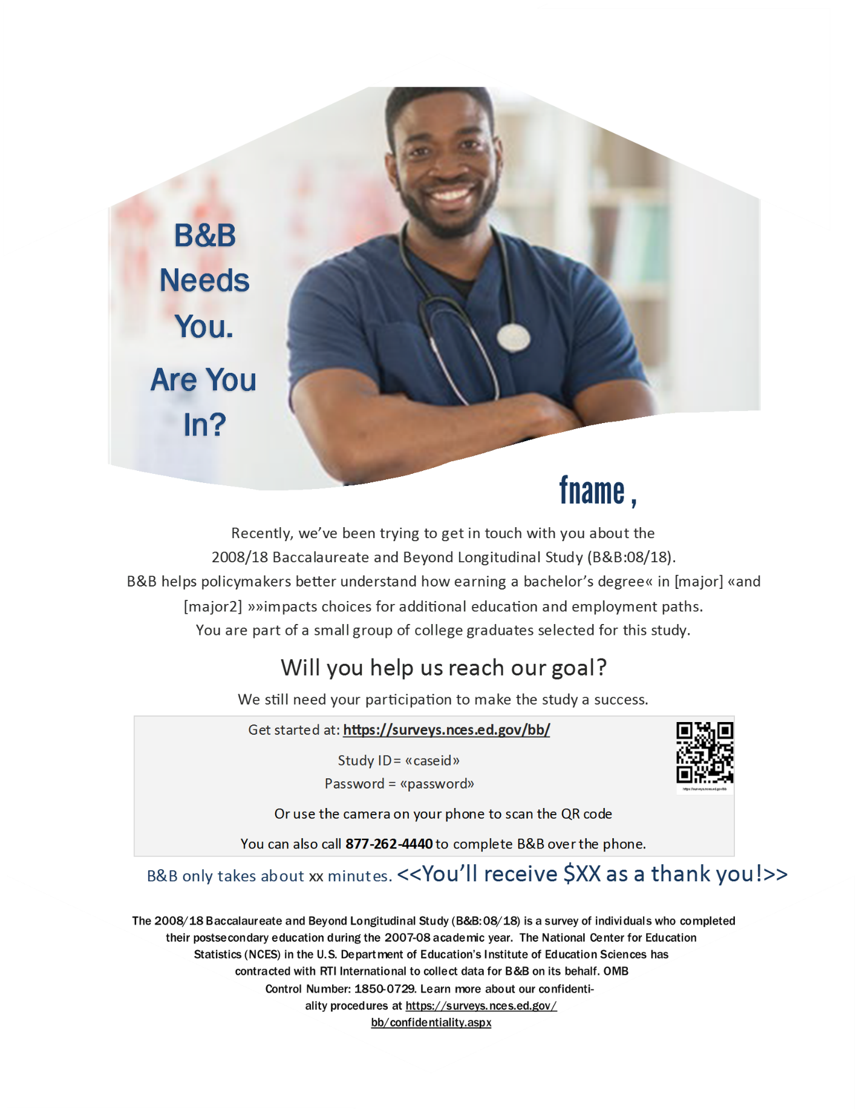
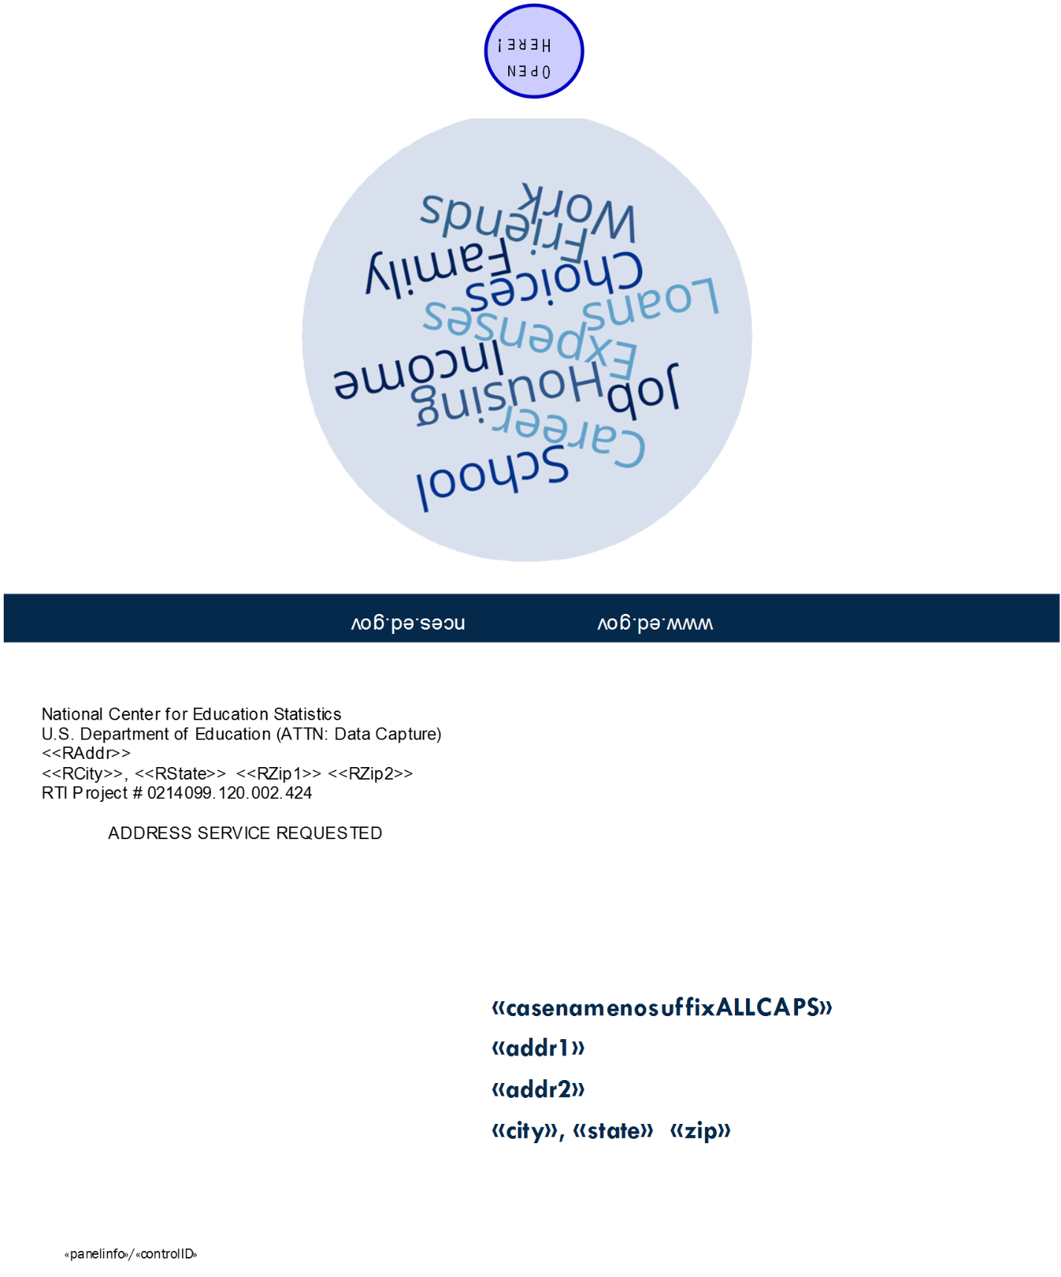

Reminder Postcard 3

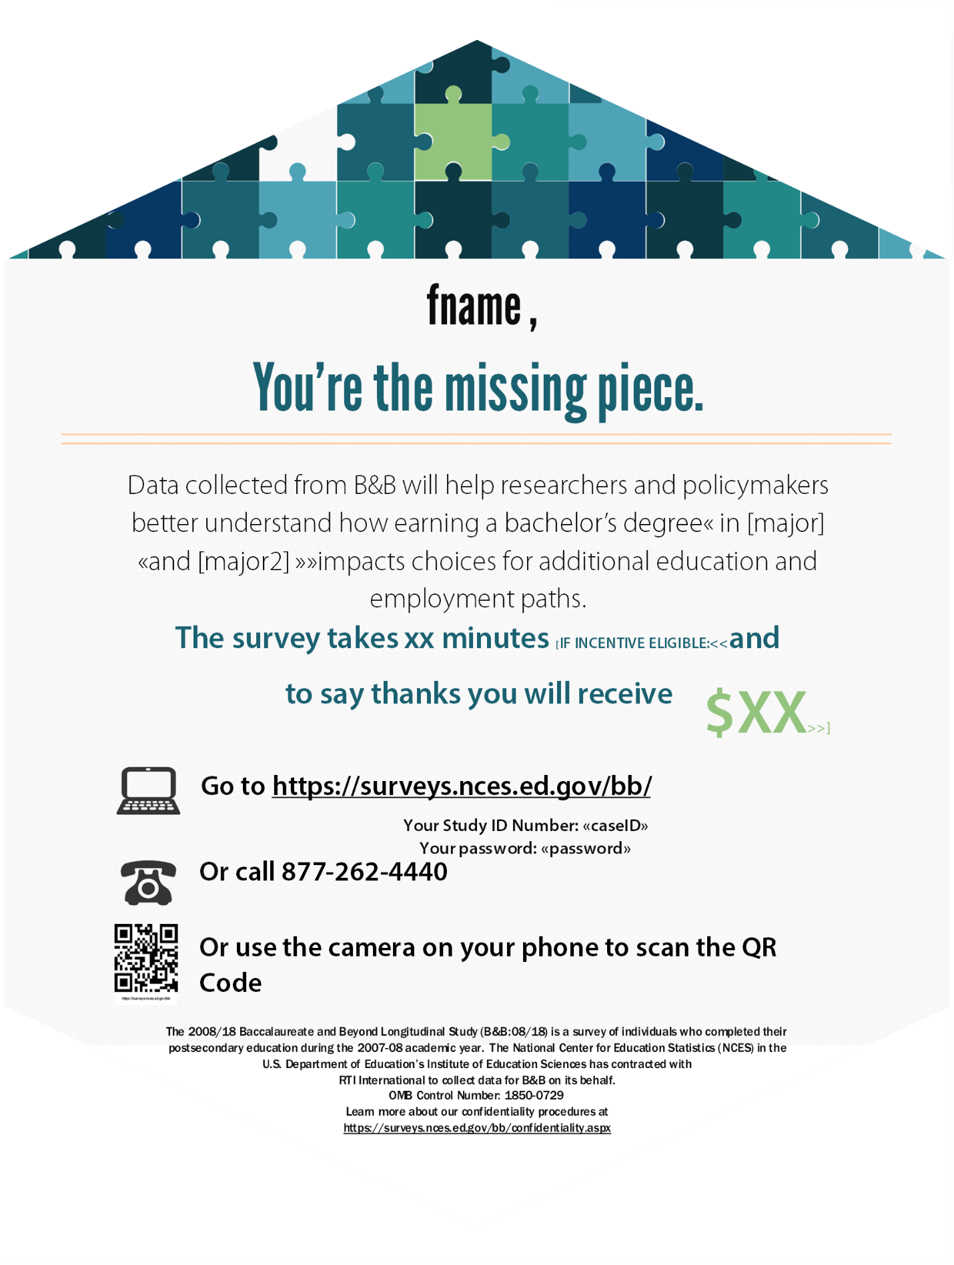
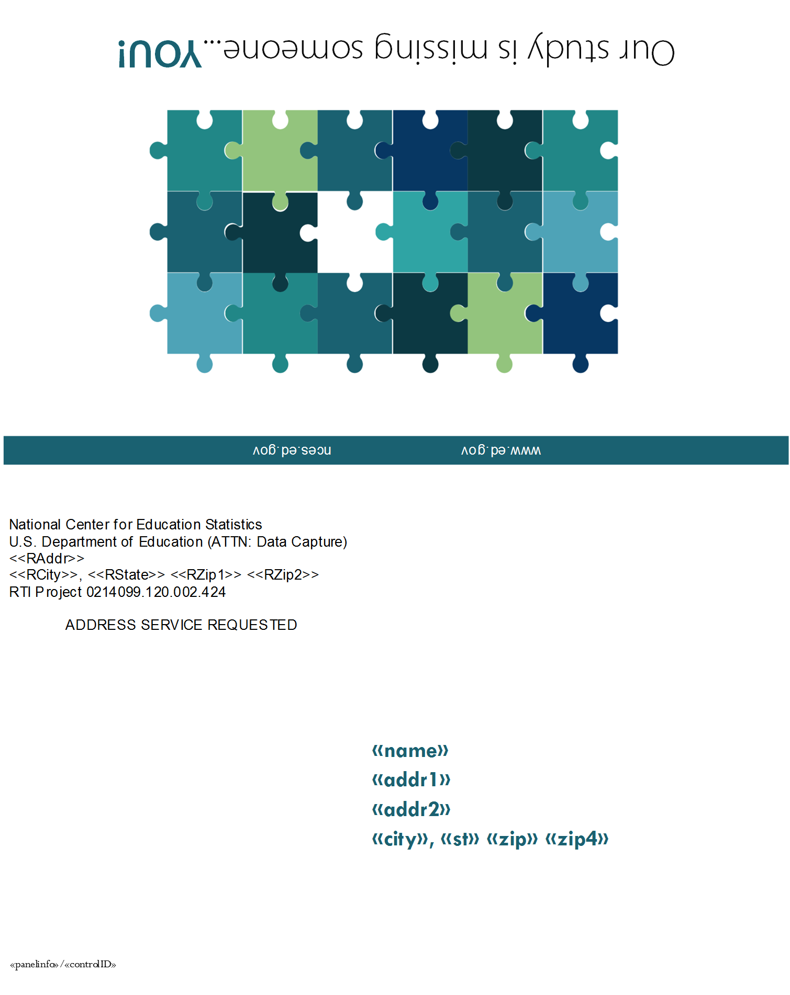

Reminder Postcard 4 (Extra Postcard)
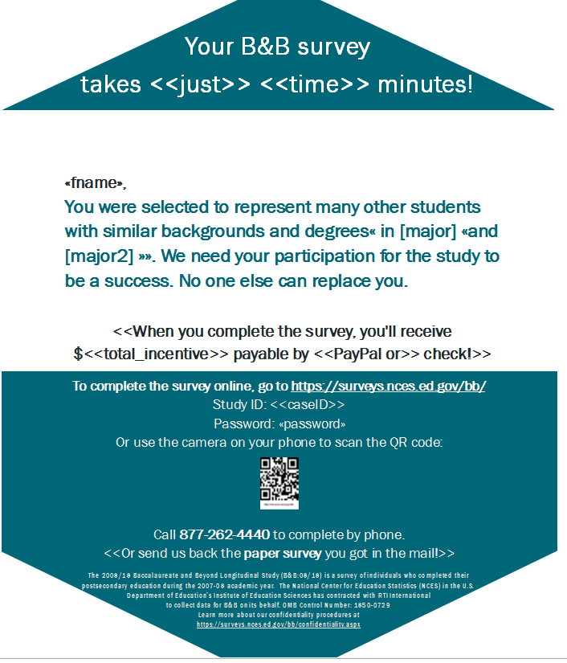
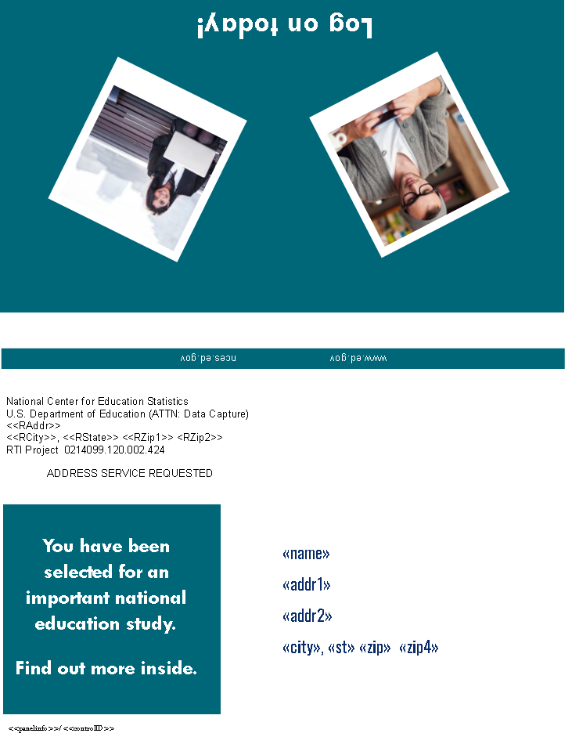

Reminder Postcard 5
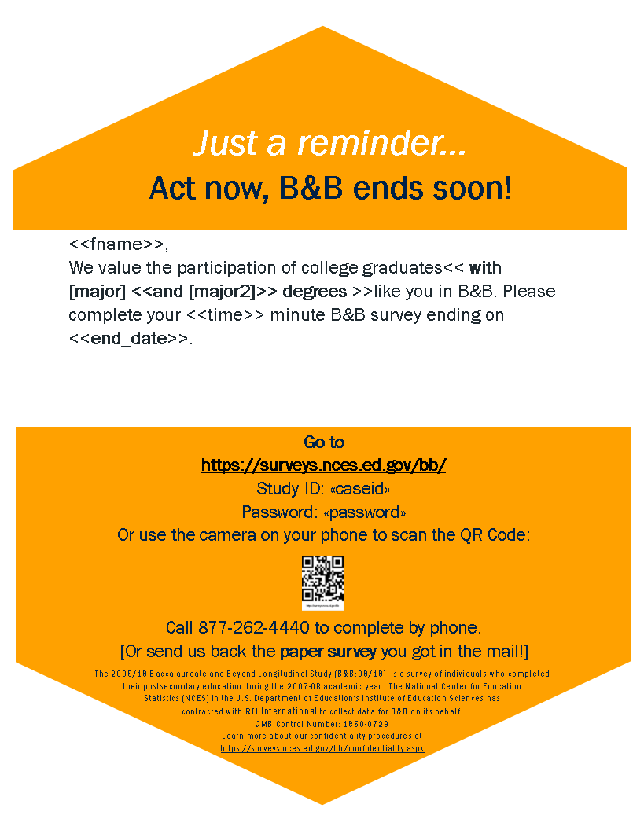
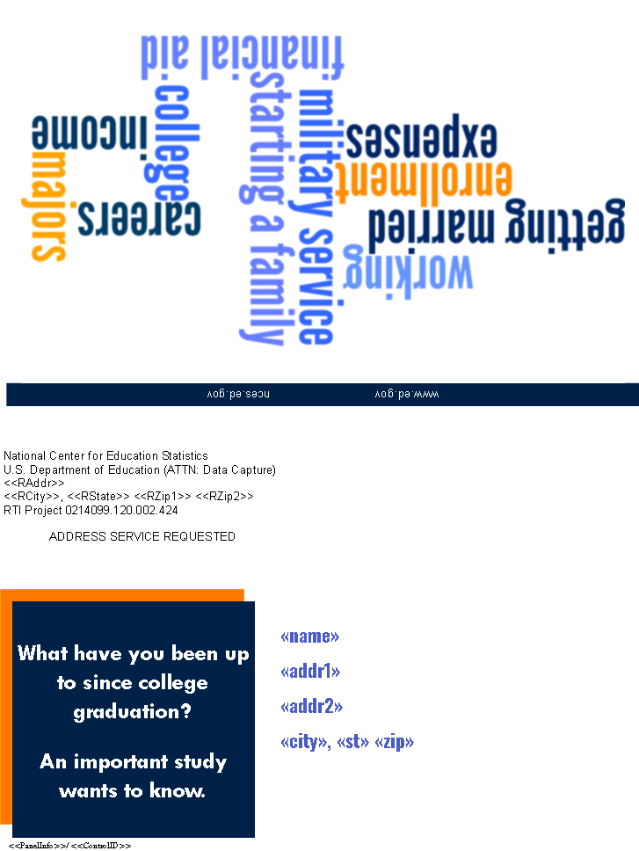

Hard Copy (PAPI) Incentive Postcard
(To be completed by incentive eligible PAPI respondents)
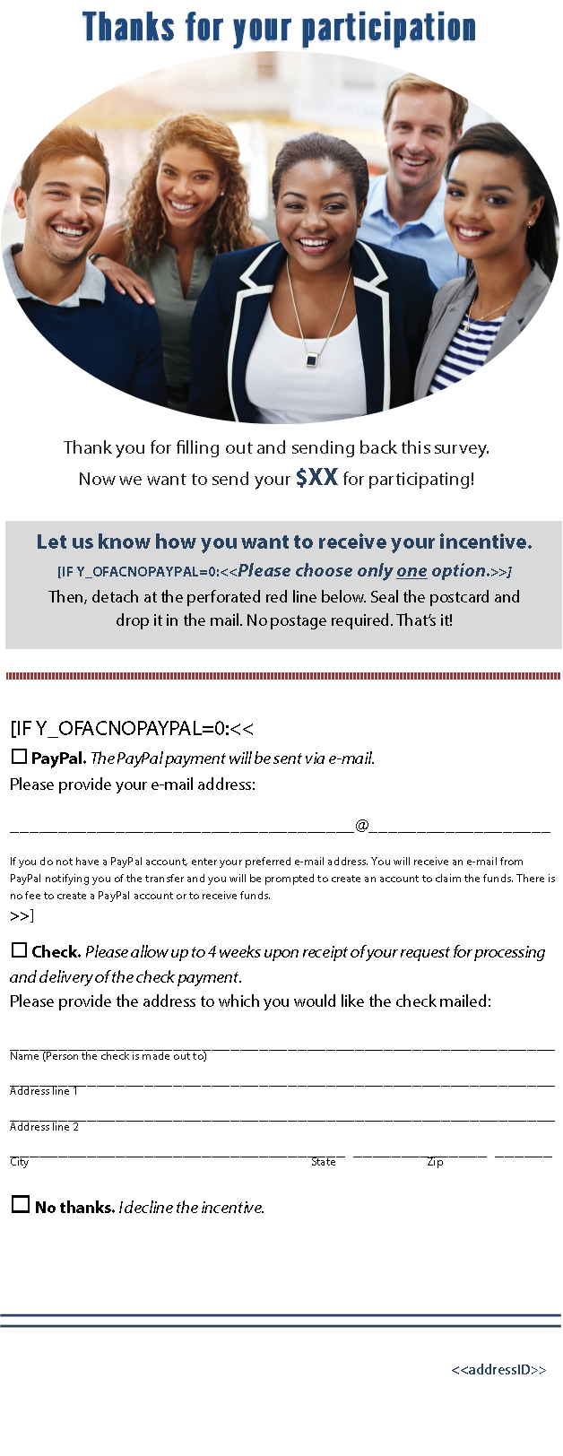
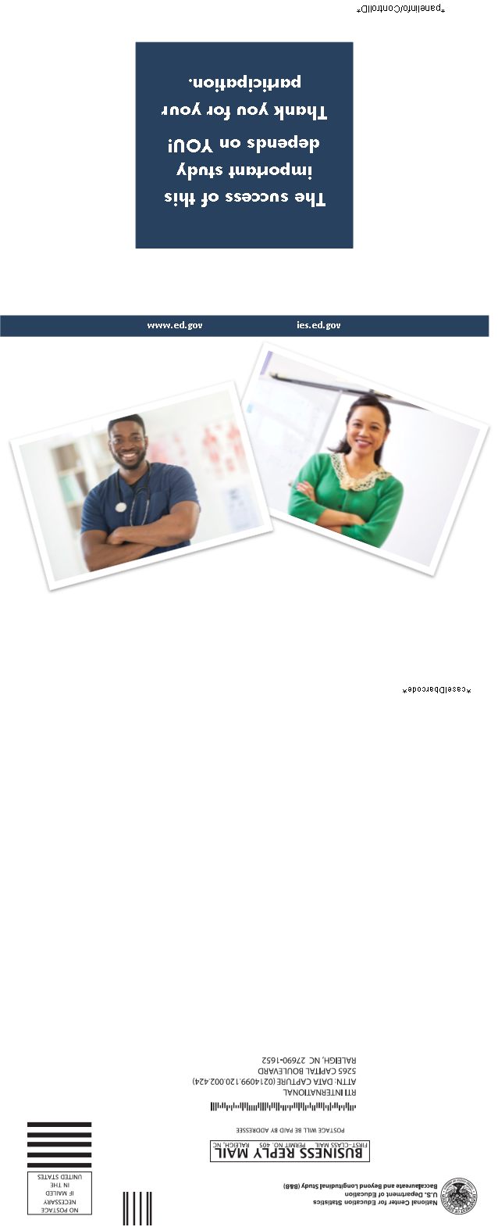

Mini Survey Postcard
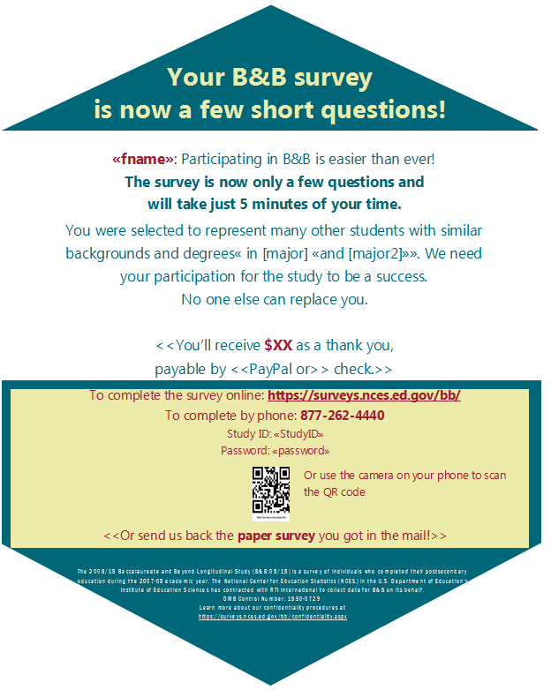
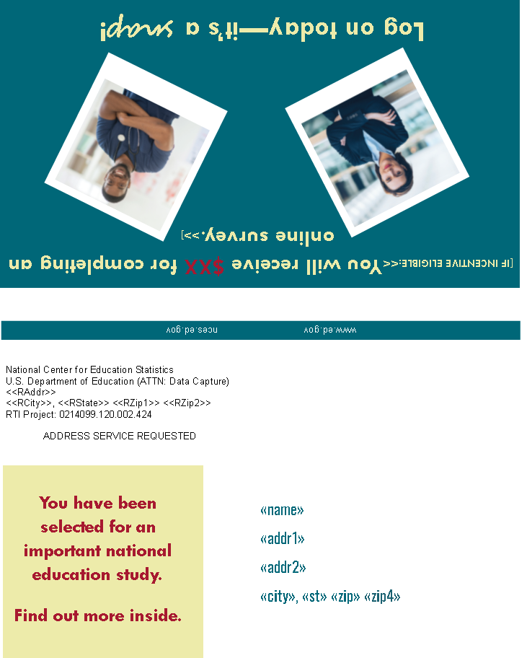

Holiday Mailing
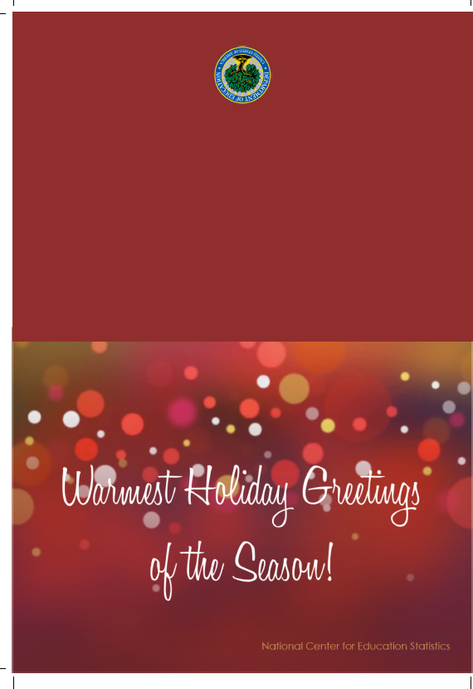
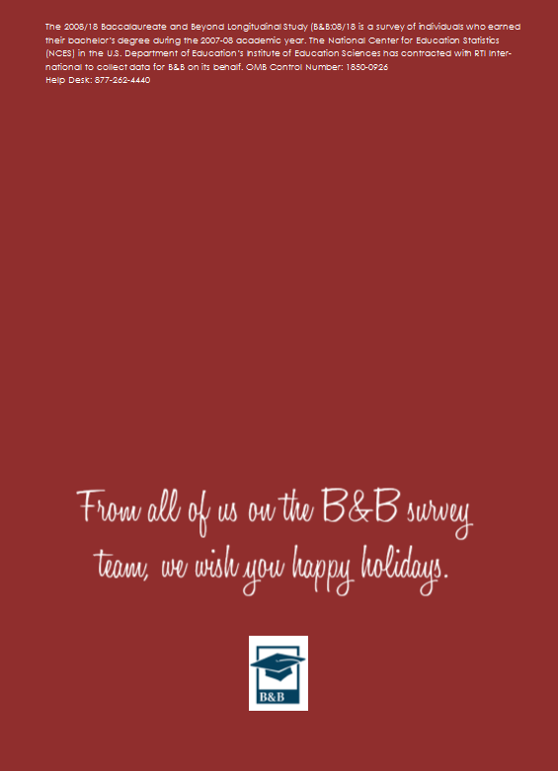

Holiday Mailing Insert

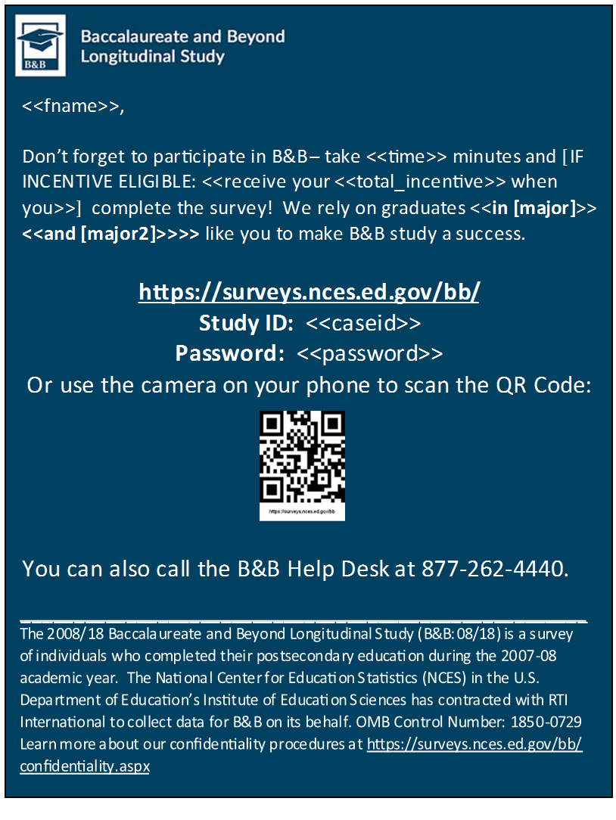

Contingency Contacts

Thanksgiving Themed E-mail

SUBJECT LINE (holiday theme): Happy Thanksgiving from the B&B Team

<<FirstName>>,

The B&B team would like to take the time to wish you a Happy Thanksgiving!
We want to thank you for being a part of the B&B study for the past 10 years, and hope that you will consider participating in this third and final wave of the study. Participating is easy: it takes <<only/about>> <<time>> minutes and can be completed online or over the phone. [IF INCENTIVE ELIGIBLE: <<Plus, we’ll send you $<<total_incentive>> via <<PayPal or>> check to thank you for participating!>>] // [IF BOOST: <<In addition to your $<<Inc_amount>>, you’re now also getting $<<Boost_Inc>>, for a total of $<<Total_incentive>>.>>]
You can easily complete it right now on your mobile device.
Or log on to our secure website to participate:
https://surveys.nces.ed.gov/bb/
Study ID: <<caseid>>
Password: <<password>>

Or, if you prefer, you can complete the survey by phone: 877-262-4440.

Thanks!

[INSERT MERGE FIELD FROM TABLE – SOURCE AND SIGNATORY, PAGE 33]

OMB Control Number: 1850-0729
Learn more about our confidentiality procedures at https://surveys.nces.ed.gov/bb/confidentiality.aspx

Partial Complete E-mail
NOTE: SENT TO CASES WHERE SURVEY HAS BEEN STARTED BUT NOT COMPLETED

SUBJECT: Important Reminder: <<fname>>, come back and complete your B&B Survey!

FROM: [B&B TEAM MEMBER FIRST NAME] (bbemail@rti.org)

We noticed that you started the B&B survey and then stopped. That's okay. You can return to the survey, via phone or web (even on your mobile device), and pick up right where you left off. [IF INCENTIVE ELIGIBLE: <<Don’t miss out on your $<<total_incentive>> incentive for completing the survey!>>]

Got Questions? Prefer to participate over the phone? Call our Help Desk at 877-262-4440 or visit the study website at https://surveys.nces.ed.gov/bb/ to learn more about B&B, findings from past studies, and confidentiality procedures.

Thanks!

[B&B TEAM MEMBER FIRST NAME]
B&B Survey Team Member
bbemail@rti.org
800-723-8942

Your login credentials:
Study ID: <<CaseID>>
Password: <<password>>
OMB Control Number: 1850-0729
Learn more about our confidentiality procedures at https://surveys.nces.ed.gov/bb/confidentiality.aspx

Paired Contact E-mail
NOTE: SENT IN CONJUNCTION WITH CATI CONTACTED EVENT FROM PREVIOUS NIGHT / WEEKEND
SUBJECT: Recent B&B Phone Call

Hi [FIRSTNAME],

[IF SPOKEN WITH YESTERDAY: <<Thank you for taking the time yesterday to speak with <<DCI>> about the 2018 Baccalaureate and Beyond Longitudinal Study (B&B).>>] // [IF SPOKEN WITH RECENTLY: <<A member of our survey team recently spoke with you about the 2018 Baccalaureate and Beyond Longitudinal Study (B&B).>>] Thank you for taking the time to take their call. [INSERT MERGE FIELD FROM TABLE – PRIOR RESPONSE, PAGE 16]

I hope you will take <<time>> minutes to complete the survey [IF INCENTIVE ELIGIBLE: <<and receive your $<<total_incentive>>>>]. I don’t want you to miss out on this important education study.

Use your secure login credentials to access the survey at https://surveys.nces.ed.gov/bb/.

Study ID = «caseid»
Password = «password»

If you would prefer to complete it over the phone, simply call 877-262-4440 and reference your study ID <<caseid>>.

Thank you in advance for your participation!

[B&B TEAM MEMBER FIRST NAME]
B&B Survey Team Member
OMB Control Number: 1850-0729
Learn more about our confidentiality procedures at https://surveys.nces.ed.gov/bb/confidentiality.aspx

Interruption in Data Collection – Notice/Warning E-mail
SUBJECT: The B&B Survey is Temporarily on Hold
Dear <<fname>>,
Due to [REASON FOR DC INTERRUPTION], the B&B:08/18 survey is temporarily suspended and you will not be able to log in to our website, https://surveys.nces.ed.gov/bb/, to complete the survey until further notice. Once the situation has been resolved, we will notify you immediately so you can participate in this important research. We apologize for any inconvenience this may have caused.
In the meantime, we urge you to e-mail us at bbemail@rti.org with your current address and phone number along with the ideal times for us to call you. When we resume data collection we will try to reach you when it’s most convenient.
If you have any questions regarding the survey or this temporary situation, please do not hesitate to call us at 877-262-4440 or send an e-mail to bbemail@rti.org.
Thank you for your understanding.
[INSERT MERGE FIELD FROM TABLE – SOURCE AND SIGNATORY, PAGE 33]

OMB Control Number: 1850-0729
Learn more about our confidentiality procedures at https://surveys.nces.ed.gov/bb/confidentiality.aspx

Interruption in Data Collection – Resume E-mail
SUBJECT: You can now resume your B&B Survey
Dear <<fname>>,
Recently, we sent a notification indicating that the B&B:08/18 survey was suspended due to [REASON FOR DC INTERRUPTION]. We are happy to inform you that the survey has been re-opened and you can once again log in to complete your B&B survey!

Got Questions? Prefer to participate over the phone? Call our Help Desk at 877-262-4440 or visit the study website at https://surveys.nces.ed.gov/bb/

Use your secure login credentials to access the survey at https://surveys.nces.ed.gov/bb/.

Study ID = «caseid»
Password = «password»

Thank you for your understanding during this survey interruption.

[INSERT MERGE FIELD FROM TABLE – SOURCE AND SIGNATORY, PAGE 33]

OMB Control Number: 1850-0729
Learn more about our confidentiality procedures at https://surveys.nces.ed.gov/bb/confidentiality.aspx

Pending Ineligible E-mail
SUBJECT: The Baccalaureate and Beyond Study – Please Try Again
<<Fname>>,
On <<sumdate>>, you were determined to be potentially ineligible to participate in B&B. This determination was made based on your responses to eligibility questions in the beginning of the survey.
After reviewing your case, we believe that you may be eligible to participate in B&B:08/18. We’ve reset your case so you can start again. Please consider logging in again to complete the survey, and make sure to answer the first few questions of the survey carefully.
[IF INCENTIVE ELIGIBLE: <<Remember, if you are eligible and complete the survey, you’ll receive <<total_incentive>>, payable via <<PayPal or>> check, as a token of our appreciation.>>] The survey takes approximately <<time>> minutes to complete.
Please log on to our secure website to participate:
https://surveys.nces.ed.gov/bb/
Study ID = <<caseid>>
Password = <<password>>

If you have questions regarding B&B, or would like to complete the survey over the phone, please do not hesitate to call our Help Desk at 877-262-4440.
We rely on bachelor’s degree recipients like you to make B&B a success. Thanks, in advance, for your participation!

Sincerely,

The B&B Data Collection Team
bbemail@rti.org
800-723-8942
OMB Control Number: 1850-0729
Learn more about our confidentiality procedures at https://surveys.nces.ed.gov/bb/confidentiality.aspx

Hard Refusal E-mail
SUBJECT: Please reconsider participating in our research study

Hi <<fname>>,

Recently, you declined to participate in the Baccalaureate and Beyond Longitudinal Study (B&B), a survey designed to help inform educators, researchers, and policymakers about how earning a bachelor’s degree «in [major] << and [major2]>>» impacts choices for continuing education and employment paths. We understand your hesitation, but are hoping you will reconsider this very important research sponsored by the U.S. Department of Education.

We know your time is valuable—please consider some of the following reasons for participating:

- Your information is vital in helping policymakers and researchers understand the experiences of bachelor’s degree recipients.
- You have the unique opportunity to provide reliable data that otherwise would not be available for policymakers.
- You can complete the only <<time>>-minute survey at your leisure! If you start the survey and need to stop for any reason, you can come back at another time to finish.
- [IF INCENTIVE ELIGIBLE: <<You will receive $<<total_incentive>> by <<PayPal or>> check when finished.>>]

Or log on to our secure website to participate:
https://surveys.nces.ed.gov/bb/
Study ID = <<caseid>>
Password = <<password>>

For more information or to complete the survey by phone call 877-262-4440 or respond to this e-mail. Thanks for your time.

Best,

[B&B TEAM MEMBER FIRST NAME]
B&B Survey Team Member
bbemail@rti.org
OMB Control Number: 1850-0729
Learn more about our confidentiality procedures at https://surveys.nces.ed.gov/bb/confidentiality.aspx

No Good Address for Payment E-mail
SUBJECT: Your B&B Check

Dear <<fname>>,

Thank you for completing your Baccalaureate and Beyond Study (B&B) survey! We have attempted to send you a check as a token of our appreciation, but unfortunately, we do not have a complete address to mail it to you. Please respond to this e-mail with your mailing address or call us at 877-262-4440 and we will send the check.

Thank you,

[B&B TEAM MEMBER FIRST NAME]
B&B Survey Team Member
bbemail@rti.org
800-723-8942

<<caseid>>
OMB Control Number: 1850-0729
Learn more about our confidentiality procedures at https://surveys.nces.ed.gov/bb/confidentiality.aspx

Canceled PayPal E-mail
FROM: bbemail@rti.org
SUBJ: Don’t Forget to Claim Your B&B Incentive

Hi <<fname>>,

Thank you again for completing your Baccalaureate and Beyond Longitudinal Study (B&B) survey! We sent you $<<total_incentive>> via PayPal to <<e-mail>> as a token of our appreciation. However, your original payment was canceled by PayPal because it was not claimed within 30 days. We will reissue the payment today. Please log into your PayPal account associated with <<e-mail>> to claim your payment or look for an e-mail from PayPal, indicating that RTI International has sent you $<<total_incentive>>. Please do not hesitate to contact the B&B Help Desk with any questions at 800-723-8942 or e-mail us at bbemail@rti.org.

Best,
[B&B TEAM MEMBER FIRST NAME]
B&B Survey Team Member
800-723-8942
bbemail@rti.org

OMB Control Number: 1850-0729
Learn more about our confidentiality procedures at https://surveys.nces.ed.gov/bb/confidentiality.aspx

No Incentive Data E-mail
Subject: Your B&B Incentive

Dear [fname],

Thank you for completing your Baccalaureate and Beyond Longitudinal (B&B) survey! We’re contacting you because we attempted to send you $<<total_incentive>> as a token of our appreciation, but we do not have necessary information from you to do so.

If you would like to receive your $<<total_incentive>>, please reply to this e-mail message and indicate whether you prefer PayPal or check. If you prefer PayPal, please provide your PayPal e-mail address. If you prefer to receive a check, please provide a valid mailing address. (Allow 3-4 weeks for processing for check payments.)

Should you choose to decline your incentive, the funds will go back to the study.

Best,

[B&B TEAM MEMBER FIRST NAME]
B&B Survey Team Member
bbemail@rti.org

<<caseid>>

OMB Control Number: 1850-0729
Learn more about our confidentiality procedures at https://surveys.nces.ed.gov/bb/confidentiality.aspx

No Contact E-mail

From: bbemail@rti.org
Subject: The B&B study team is hoping to find you, <<fname>>

Hi <<fname>>,

We’ve recently tried to get in touch with you about the 2018 Baccalaureate and Beyond Longitudinal Study. [If BB:08/12 RESPONDENT: <<You may remember completing the survey for the 2012 Baccalaureate and Beyond Longitudinal Study about 6 years ago, and we need your help again. What has changed in your life since 2012?>>] [IF NPSAS08 OR BB:08/09 RESPONDENT: <<What has changed in your life since you received your bachelor’s degree?>>] I hope you will take <<time>> minutes to complete the survey <<IF INCENTIVE ELIGIBLE: and receive your $<<total_incentive>>.>>

Here’s the information you need to complete the survey on our secure website:

https://surveys.nces.ed.gov/bb/
Study ID: <<caseid>>
Password: <<password>>

If you would prefer to complete it over the phone, simply call 877-262-4440 and reference your study ID <<caseid>>. You can find out more about the study and confidentiality procedures at the above website, and at http://nces.ed.gov/surveys/b&b/.

Thank you in advance for your participation!

[B&B TEAM MEMBER FIRST NAME]
B&B Survey Team Member
bbemail@rti.org

<<studyid>>

OMB Control Number: 1850-0729
Learn more about our confidentiality procedures at https://surveys.nces.ed.gov/bb/confidentiality.aspx

Expired Incentive E-mail

From: bbemail@rti.org
Subject: Your B&B Incentive

Dear <<fname>>,

Thank you again for completing your Baccalaureate and Beyond Longitudinal Study (B&B) survey! We sent you $<<total_incentive>> via check as a token of our appreciation. However, your original payment has been voided since it was not claimed within 90 days.

We would be happy to reissue your payment. Please respond to this e-mail and provide a valid mailing address. (Allow 3-4 weeks for processing for check payments.)

Please do not hesitate to contact the B&B Help Desk with any questions at 877-262-4440 or e-mail us at bbemail@rti.org.

Should you choose to decline your incentive, the funds will go back to the study.

Best,

[B&B TEAM MEMBER FIRST NAME]
B&B Survey Team Member
bbemail@rti.org
OMB Control Number: 1850-0729
Learn more about our confidentiality procedures at https://surveys.nces.ed.gov/bb/confidentiality.aspx

Preferred to Complete Online

Hi <<fname>>,

Recently, a member of our survey interviewing team spoke with you about the 2018 Baccalaureate and Beyond Longitudinal Study. During that brief phone conversation, you indicated that you would prefer to complete the survey online, and an e-mail with your survey login information was sent to you. I just wanted to touch base to make sure you received the email, and to encourage you to complete the survey soon and receive your $<<total_incentive>>.

Here’s the information you need to complete the survey on our secure website:

https://surveys.nces.ed.gov/bb/
Study ID: <<caseID>>
Password: <<password>>

If you decide to complete it over the phone, simply call 877-262-4440 and reference your study ID <<caseID>>.

You can find out more about the study and confidentiality procedures at the above website, and at http://nces.ed.gov/surveys/b&b/.

Thank you in advance for your participation!

[B&B TEAM MEMBER FIRST NAME]
B&B Survey Team Member
OMB Control Number: 1850-0729
Learn more about our confidentiality procedures at https://surveys.nces.ed.gov/bb/confidentiality.aspx

Data Collection Extension E-mail
SUBJECT: B&B Still Needs you, <<fname>>

«fname», we’ve extended B&B data collection to give you <<and other [major] << and [major2]>> majors >>a chance to participate in this important study.

We realize your time is valuable, but remember, the survey only takes about <<time>> minutes and does not have to be completed all at once. [IF INCENTIVE ELIGIBLE: <<We will send you $<<total_incentive>> for completing it.>>] // [IF INCENTIVE ELIGIBLE AND BOOST: <<In addition to your $<<Inc_amount>>, you’re now also getting $<<Boost_Inc>>, for a total of $<<Total_incentive. You can receive your incentive via <<PayPal or>> check.>>]

You have the unique opportunity to provide reliable data that otherwise would not be available for policymakers. Click the icon below to share your experiences and let your voice be heard!
Or, log onto our secure website at https://surveys.nces.ed.gov/bb/

Study ID = «caseid»
Password = «password»

[IF RECEIVED PAPI: <<You can also send back the paper survey you may have received in the mail. Simply complete the survey and send it back to us in the return envelope that was provided.>>]
Call 877-262-4440 to get more information about B&B or to complete the survey by phone with one of our trained interviewers.
We hope you will decide to participate – B&B won’t be the same without you.
Thanks!
[INSERT MERGE FIELD FROM TABLE – SOURCE AND SIGNATORY, PAGE 33]

OMB Control Number: 1850-0729
Learn more about our confidentiality procedures at https://surveys.nces.ed.gov/bb/confidentiality.aspx

Spare Reminder E-mail 1
SUBJECT: Your B&B Survey is Waiting

«fname», start the B&B survey today!

There is still time to participate in the 2008/18 Baccalaureate and Beyond Longitudinal Study (B&B:08/18) for the U.S. Department of Education. Data collection for B&B:08/18 continues and we are interested in hearing from «[major] << and [major2]>> majors like »you!

It <<only>> takes about «time» minutes! [IF INCENTIVE ELIGIBLE: <<Once you’ve completed the survey, you’ll receive $«total_incentive», payable by <<PayPal or>> check!>>] // [IF INCENTIVE ELIGIBLE AND BOOST: <<In addition to your $<<Inc_amount>>, you’re now also getting $<<Boost_Inc>>, for a total of $<<Total_incentive>>.>>]

https://surveys.nces.ed.gov/bb/
Study ID: <<caseID>>
Password: <<password>>

[IF RECEIVED PAPI: <<You can also send back the paper survey you may have received in the mail. Simply complete the survey and send it back to us in the return envelope that was provided.>>]
Or complete the survey by phone by calling 877-262-4440. Find more information on the study website at https://surveys.nces.ed.gov/bb/.
Thanks!
[INSERT MERGE FIELD FROM TABLE – SOURCE AND SIGNATORY, PAGE 33]

OMB Control Number: 1850-0729
Learn more about our confidentiality procedures at https://surveys.nces.ed.gov/bb/confidentiality.aspx

Spare Reminder E-mail 2
SUBJECT: It's Time to Complete B&B, <<fname>>

Dear «fname»,

I haven’t heard from you regarding your participation in the 2008/18 Baccalaureate and Beyond Longitudinal Study (B&B:08/18). I am writing again because of the importance of your responses to help policymakers and researchers understand how earning a bachelor’s degree «in [major] <<and [major2]>>»impacts choices about further education and employment. The study won’t be complete unless we hear from you!
The survey only takes about <<time>> minutes to complete. [IF INCENTIVE ELIGIBLE: You’ll receive $<<total_incentive>> for completing it! You can receive your $<<total_incentive>> by <<PayPal or>> check.>>] // [IF INCENTIVE ELIGIBLE AND BOOST: <<In addition to your $<<Inc_amount>>, you’re now also getting $<<Boost_Inc>>, for a total of $<<Total_incentive>>.>>]
Or log on to our secure website https://surveys.nces.ed.gov/bb/ using your study credentials:
Study ID = «caseid»
Password = «password»

[IF RECEIVED PAPI: <<You can also send back the paper survey you may have received in the mail. Simply complete the survey and send it back to us in the return envelope that was provided.>>]
Call 877-262-4440 to get more information about B&B or complete the survey by phone with one of our trained interviewers.
Thank you for considering participating in this important study. We hope you will – B&B won’t be the same without you.
We hope you will decide to participate.
Thank you!
[INSERT MERGE FIELD FROM TABLE – SOURCE AND SIGNATORY, PAGE 33]

OMB Control Number: 1850-0729
Learn more about our confidentiality procedures at https://surveys.nces.ed.gov/bb/confidentiality.aspx

Spare Reminder E-mail 3

SUBJECT: Limited Time Left to Participate in B&B

There is limited time remaining to participate in B&B [IF INCENTIVE ELIGIBLE: <<and to receive $<<total_incentive>> for your efforts,>> «fname»>>]. // [IF BOOST: <<, and in addition to your $<<Inc_amount>>, you’re now also getting $<<Boost_Inc>>, for a total of $<<Total_incentive>>>>]. We want to hear about your experiences since graduating from college «with your [major] << and [major2]>> degree>>! The study ends on <<end_date>>.

Or, you can visit the website and log in: https://surveys.nces.ed.gov/bb/
Study ID: <<caseID>>
Password: <<password>>

[IF RECEIVED PAPI: <<You can also send back the paper survey you may have received in the mail. Simply complete the survey and send it back to us in the return envelope that was provided.>>]
If you have questions or prefer to participate by telephone, call 877-262-4440.

We hope you will decide to participate – the 2008/18 Baccalaureate and Beyond Longitudinal Study (B&B:08/18) won’t be the same without you.
Thanks!
[INSERT MERGE FIELD FROM TABLE – SOURCE AND SIGNATORY, PAGE 33]

OMB Control Number: 1850-0729
Learn more about our confidentiality procedures at https://surveys.nces.ed.gov/bb/confidentiality.aspx

Mini Survey Letter – Reminder

«date»

«fname» «mname» «lname» «suffix» Study ID: «caseid»
«addr1»
«addr2»
«city», «state» «zip» «zip4»

Dear «fname»:

About <<weeks>> weeks ago, we sent you a request asking you to share your experiences as a college graduate by answering just a few easy questions. We have not yet received your responses. B&B will only take 5 minutes of your time [IF INCENTIVE ELIGIBLE: <<and you’ll receive $«total_incentive», payable by <<PayPal or>> check as a thank you>>]. // [IF INCENTIVE ELIGIBLE AND BOOST: and in addition to your $<<Inc_amount>>, you’re now also getting $<<Boost_Inc>>, for a total of $<<Total_incentive>>>>].

To complete the survey, log on to our secure website at https://surveys.nces.ed.gov/bb/ using the Study ID and password below:

Study ID = «caseid»
Password = «password» (password is case sensitive)

<<Or use the camera on your phone to scan the QR code below to take you to the survey:
<<QRCODE>>>>

We hope that you will participate in the study! Thank you so much for your help in making B&B a success.

Ted Socha Melissa Cominole, Ph.D.
Project Officer, B&B:08/18 Project Director, B&B:08/18
National Center for Education Statistics RTI International
ted.socha@ed.gov | 202-245-7071 mcominole@rti.org | 800-723-8942

«panelinfo»/«controlID»

The 2008/18 Baccalaureate and Beyond Longitudinal Study (B&B:08/18) is conducted by the National Center for Education Statistics (NCES). Under contract with NCES, RTI International, a U.S.-based nonprofit research organization, administers B&B:08/18 on behalf of NCES. NCES is authorized to conduct B&B:08/18 by the Education Sciences Reform Act of 2002 (ESRA 2002, 20 U.S.C. §9543) and to collect students’ education records from education agencies or institutions for the purposes of evaluating federally supported education programs under the Family Educational Rights and Privacy Act (FERPA, 34 CFR §§ 99.31(a)(3) and 99.35). All of the information you provide may be used only for statistical purposes and may not be disclosed, or used, in identifiable form for any other purpose except as required by law (20 U.S.C. §9573 and 6 U.S.C. §151).
According to the Paperwork Reduction Act of 1995, no persons are required to respond to a collection of information unless it displays a valid OMB control number. The valid OMB control number for this voluntary information collection is 1850-0729. The time required to complete this information collection is estimated to average approximately 5 minutes per response, including the time to review instructions, gather the data needed, and complete and review the information collection. If you have any comments concerning the accuracy of the time estimate, suggestions for improving this survey, or any comments or concerns regarding the status of your individual submission of this survey, please write directly to: The 2008/18 Baccalaureate and Beyond Longitudinal Study (B&B:08/18), National Center for Education Statistics, Potomac Center Plaza, 550 12th St., SW, Room 4004, Washington, DC 20202.

Data Collection Staff Prompt E-mail
SUBJECT: Your <<time>>-Minute B&B Survey
Hi <<fname>>,
My name is [Data Collection Staff Member Name] and I work on the U.S. Department of Education’s Baccalaureate and Beyond (B&B) Longitudinal Study. The B&B survey takes <<just>> <<time>> minutes to complete and you will receive $<<total_incentive>> for responding.
Here’s the information you need to complete the survey on your computer or mobile phone:
https://surveys.nces.ed.gov/bb
Study ID: <<caseid>>
Password: <<password>>

Or, you can call 877-262-4440 and complete the survey with one of our telephone interviewers.
Thanks,
[B&B TEAM MEMBER FIRST NAME]
B&B Survey Team Member
bbemail@rti.org

OMB Control Number: 1850-0729
Learn more about our confidentiality procedures at https://surveys.nces.ed.gov/bb/confidentiality.aspx

B&B:08/18 Consent Text
Sample members see the Web Consent Text when they log in to complete the self-administered survey. When sample members agree to complete the survey via CATI, the CATI Consent Text is read to sample members over the telephone by an interviewer.
Web Consent Text:

INFOPAGE:
Recently, we sent you material about the U.S. Department of Education’s Baccalaureate and Beyond Longitudinal Study (B&B). This survey is being conducted to better understand the education, employment, financial, and personal experiences and issues facing college graduates ten years after earning their bachelor's degrees. The survey takes about [{if Y_SURVEY = 0} 35 {else if Y_SURVEY = 1} 15 {else} 5] minutes [{if Y_OFACNOPAY = 0}, and as a token of our appreciation, you will receive $[{if Y_FLASH = 1} [FLASH_AMOUNT] + [INC_AMOUNT] {else} [total_incentive]] for participating]. You may decline to answer any question or stop the survey at any time.

If you have any questions about this study, you may contact the study's director, Dr. Melissa Cominole, at 800-723-8942. (To learn more about your rights as a participant, [helplink]click here.[end helplink])

To review the letter that we mailed, click here (PDF letter).

To review the study brochure, click here (PDF brochure).

May we begin the survey now?

INFOPAGE Help Text:

- You are one of approximately 17,000 college graduates who will be taking part in this study.

- In addition to your survey responses, we collect financial aid, student records and related information from your school and sources such as student loan databases

- All of the information you provide may be used only for statistical purposes and may not be disclosed, or used, in identifiable form for any other purpose except as required by law (20 U.S.C. §9573 and 6 U.S.C. §151).

- Your participation is voluntary and will not affect any aid or other benefits that you may receive. The risk of participating in this study is small and relates to data security. However, there are strict security procedures in place.

CATI Consent Text:

LTR_S - (THIS SCREEN IS READ TO ALL CATI SMs). (read to all sample members who opted for CATI):
Recently, we sent you material about the U.S. Department of Education’s Baccalaureate and Beyond Longitudinal Study. This survey is being conducted to better understand the education, employment, financial, and personal choices and issues facing college graduates ten years after earning their bachelor's degree. The survey takes about <<time>> minutes [if <<total_incentive>> gt 0: and as a token of our appreciation, you will receive $<<total_incentive>> for participating]. You may decline to answer any question or stop the survey at any time. The survey may be monitored or recorded for quality assurance purposes. If you would like to learn more about the study, let me know.

(IF SM HAS ANY QUESTIONS OR WOULD LIKE ADDITIONAL INFORMATION, READ NOLET. OTHERWISE, CONTINUE WITH GOTLTS AND DO NOT READ NOLET)
GOTLTS (read to all sample members who at the end of the LTR_S script do not have any questions):
Do you want to begin the survey now?

(At your request, we can re-mail the material to you. If you have any questions about this study, you may contact the study's director, Melissa Cominole, at 800-723-8942. For questions about your rights as a study participant, please contact RTI's Office of Research Protection at 1-866-214-2043.)

NOLET (read to all sample members who have questions):
READ UNTIL SM INTERRUPTS.
You are one of approximately 17,000 college graduates who will be taking part in this study. In addition to your survey responses, we collect financial aid, student records, and related information from your school and sources such as student loan databases. All of the information you provide may be used only for statistical purposes and may not be disclosed, or used, in identifiable form for any other purpose, except as required by law (20 U.S.C. §9573 and 6 U.S.C. §151).

Your participation is voluntary and will not affect any aid or other benefits that you may receive. The risk of participating in this study is small and relates to data security. However, there are strict security procedures in place.

If you would like us to re-mail the material to you, please let me know. May we begin the survey now?

(For questions about your rights as a study participant, please contact RTI's Office of Research Protection at 1-866-214-2043.)

