NA-IM Student Feedback Survey

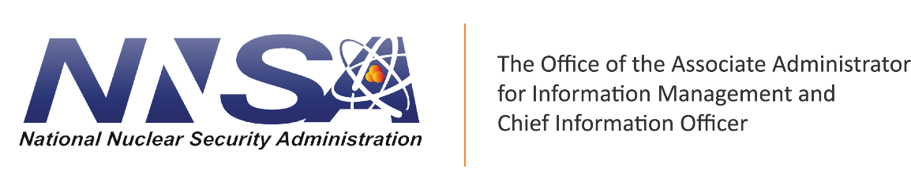

NA-IM Student Survey Questions

# Revision History

|  |  |  |  |
| --- | --- | --- | --- |
| Version Number | Date | Description | Author(s) |
| 1.0 | 05/01/2019 | Draft | Bangura, Morgan |
| 2.0 |  |  |  |

# Purpose

The purpose of these survey questions is to collect student feedback on courses. This feedback with be used to evaluate individual course success as well as the NA-IM training program as a whole. These questions will be used for online, instructor led, and virtual instructor lead courses. Course feedback is vital to the course evaluation process and feedback from these questions will be compiled and evaluated on a regular basis.

## Survey Questions

1. I find content of this course valuable.

* Strongly Agree
* Agree
* Disagree
* Strongly Disagree

1. I found subject matter or course content relevant to my current role.

* Strongly Agree
* Agree
* Disagree
* Strongly Disagree

1. I will be able to immediately apply what I learned.

* Strongly Agree
* Agree
* Disagree
* Strongly Disagree

1. I found the course content was well organized.

* Strongly Agree
* Agree
* Disagree
* Strongly Disagree

1. I found the course materials easy to navigation.

* Strongly Agree
* Agree
* Disagree
* Strongly Disagree

1. I was well engaged during this course by the interactions.

* Strongly Agree
* Agree
* Disagree
* Strongly Disagree

1. I found the amount of time it took to complete this course was appropriate for this content.

* Strongly Agree
* Agree
* Disagree
* Strongly Disagree

1. I found the course modality (online, instructor led, virtual instructor led) was appropriate for the course.

* Strongly Agree
* Agree
* Disagree
* Strongly Disagree

1. Any additional course feedback: