# NCCDB Complaint Entry Home Page

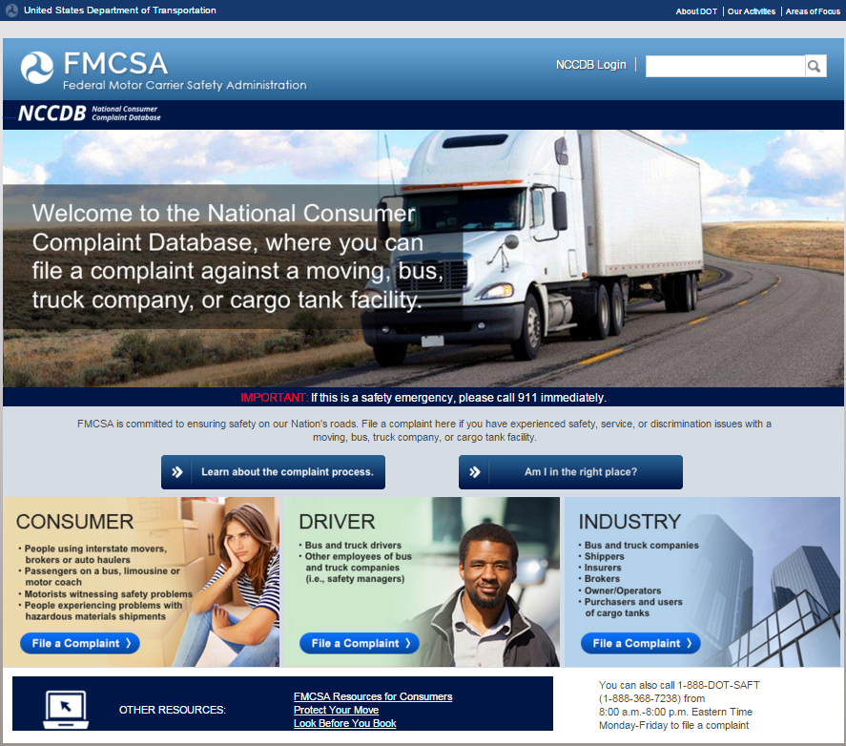

# Driver Moving Complaint Type

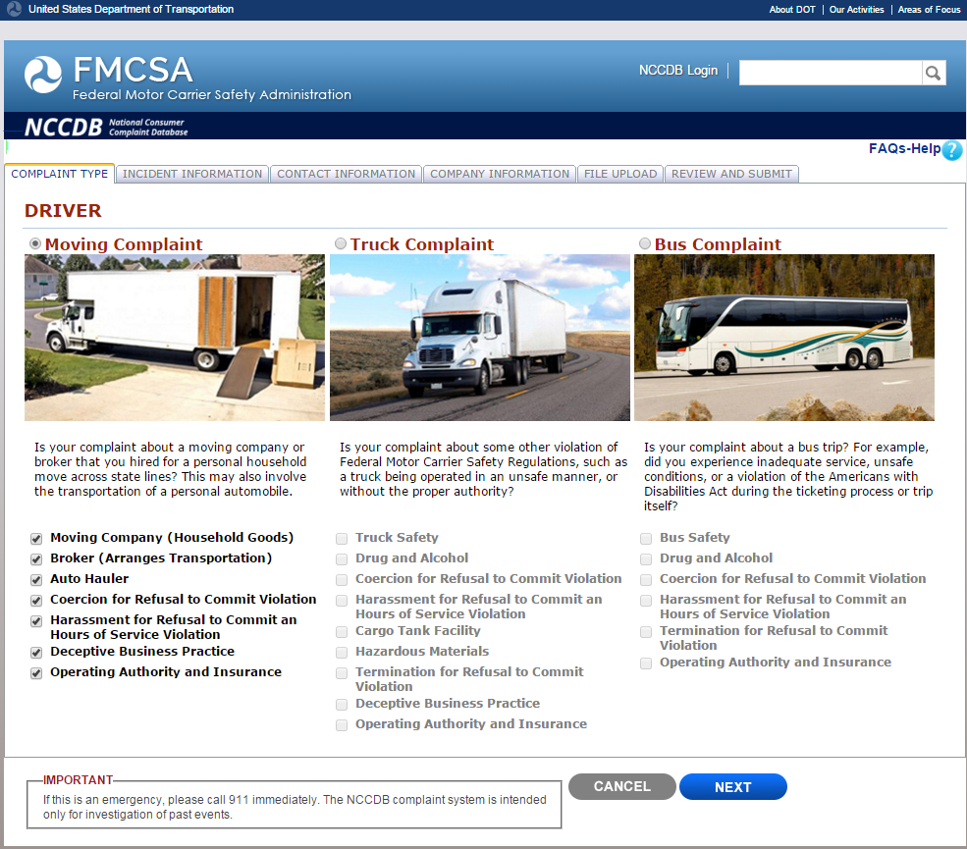

# Driver Moving Complaint Incident Information

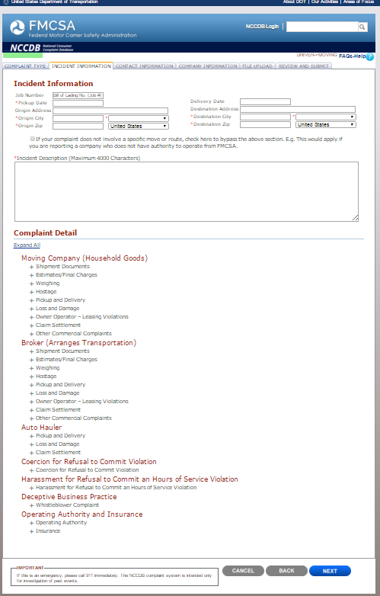

# Driver Moving Complaint Incident Information

## Continued

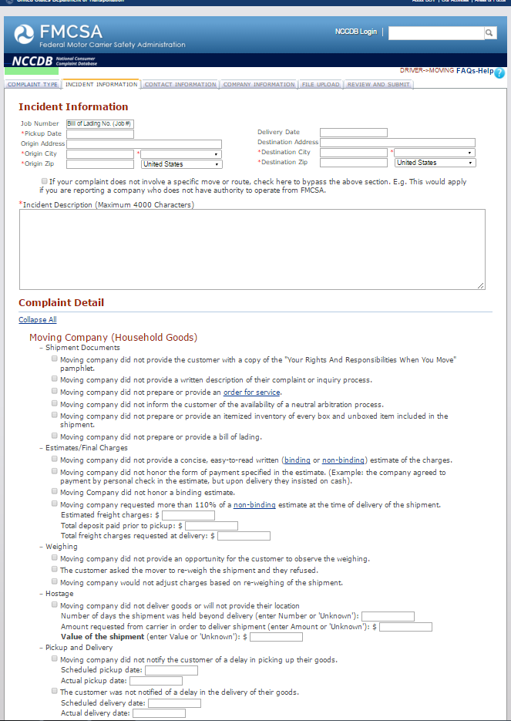

# Driver Moving Complaint Incident Information

## Continued

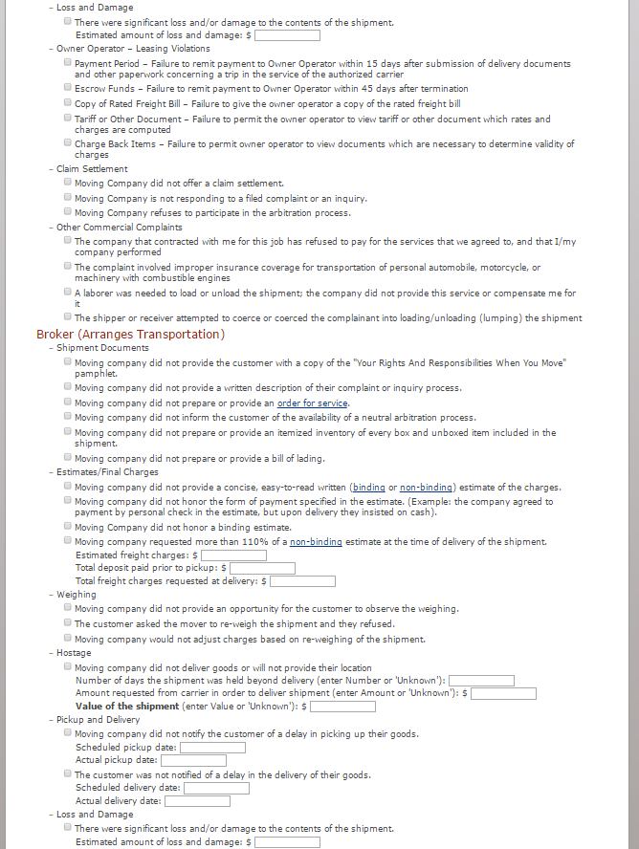

# Driver Moving Complaint Incident Information

## Continued

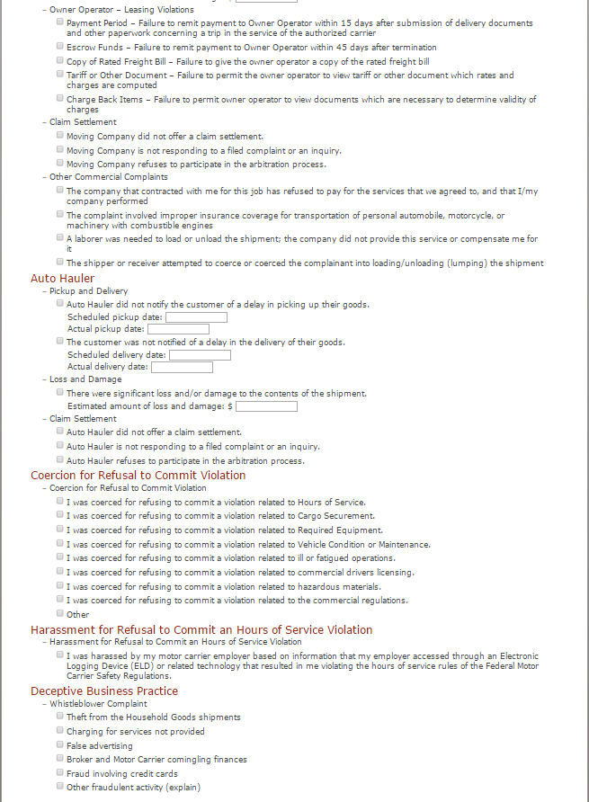

# Driver Moving Complaint Incident Information

## Continued

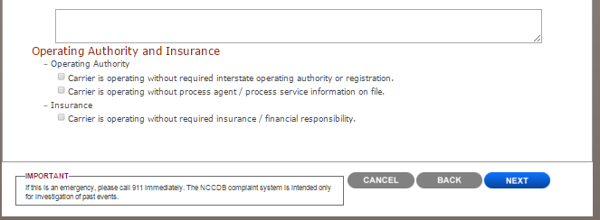

# Driver Moving Complaint Contact Information

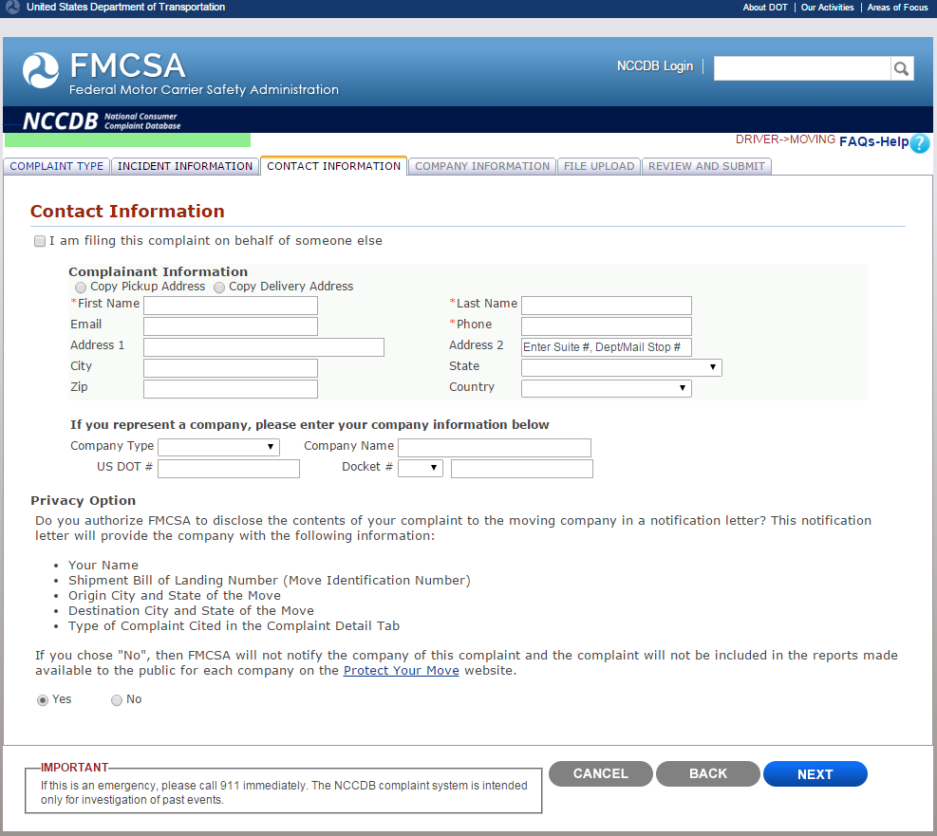

# Driver Moving Complaint Company Information

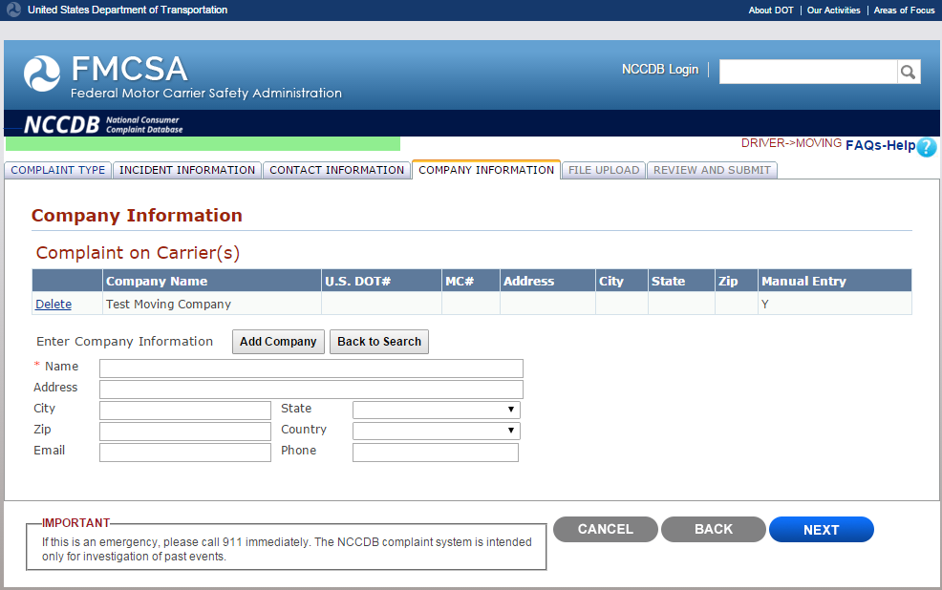

# Driver Moving Complaint File Upload

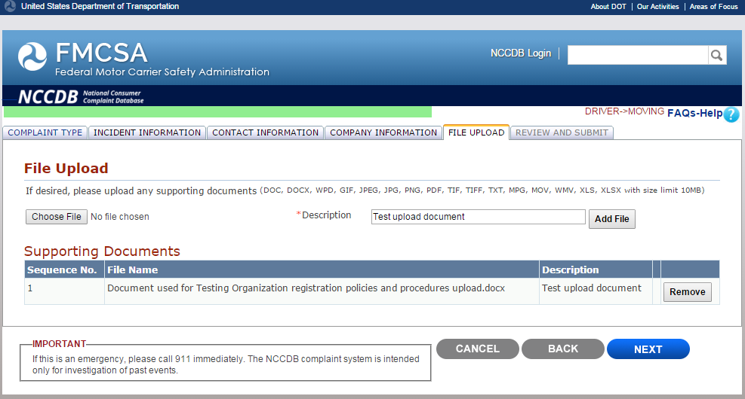

# Driver Moving Complaint Review and Submit

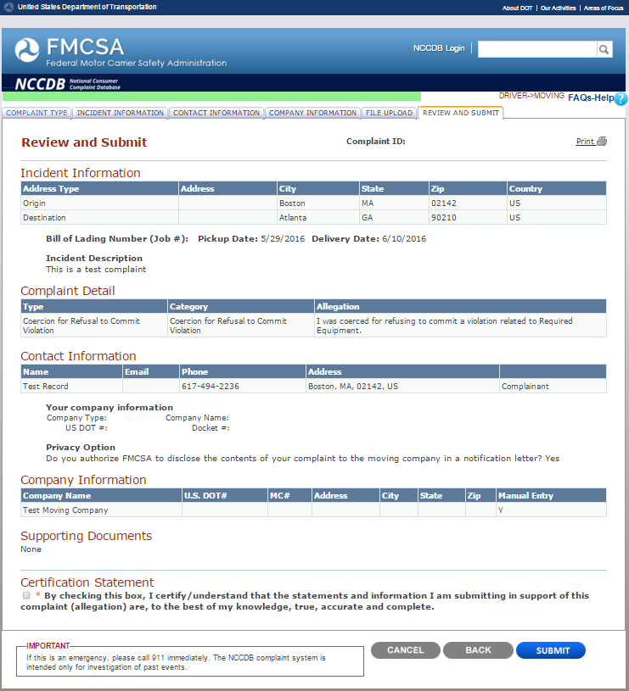

# Driver Truck Complaint Type

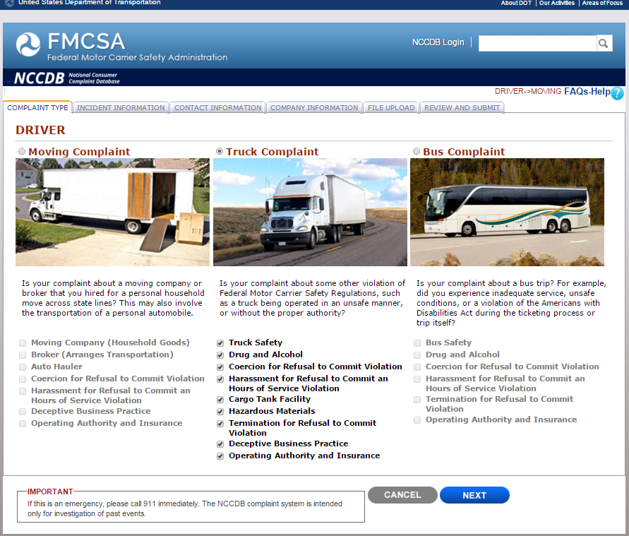

# Driver Truck Complaint Incident Information

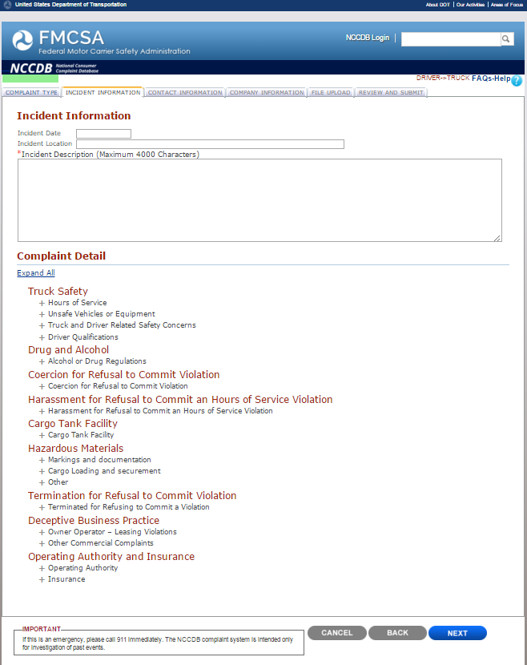

# Driver Truck Complaint Incident Information

## Continued

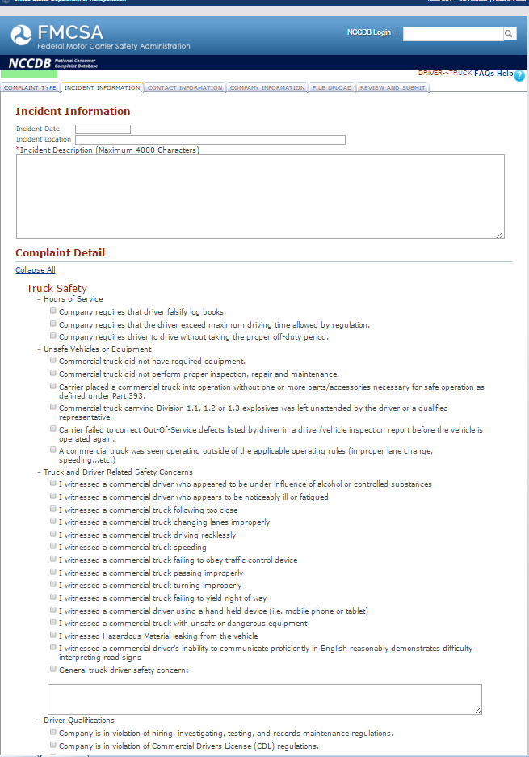

# Driver Truck Complaint Incident Information

## Continued

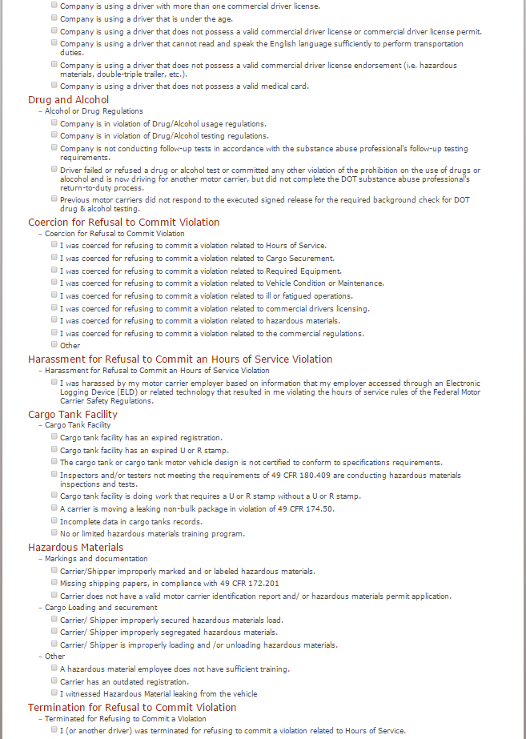

# Driver Truck Complaint Incident Information

## Continued

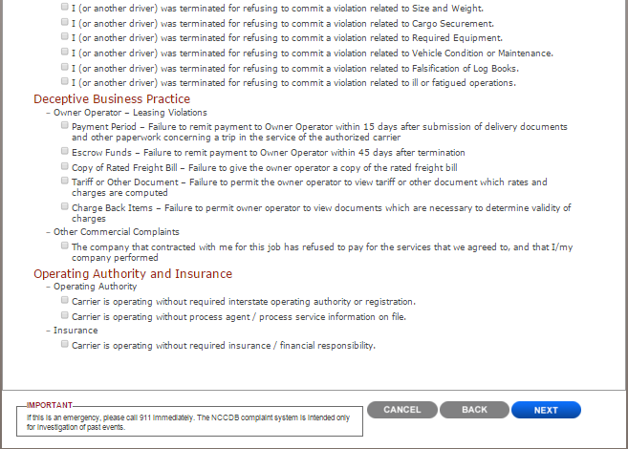

# Driver Truck Complaint Contact Information

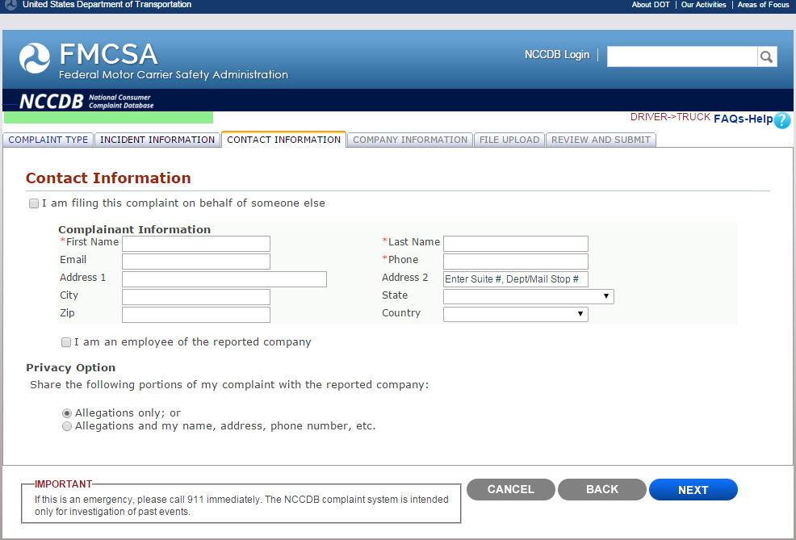

# Driver Truck Complaint Company Information

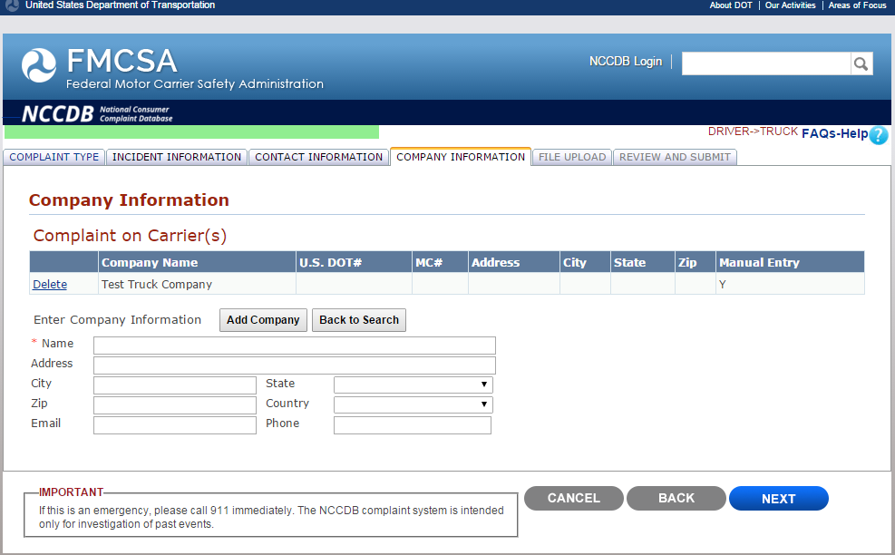

# Driver Truck Complaint File Upload

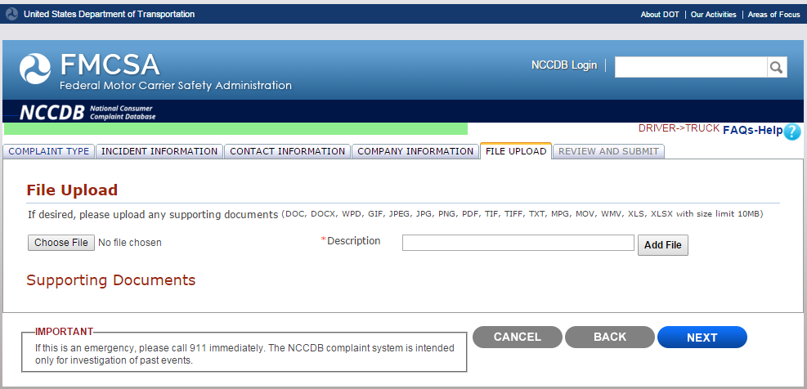

# Driver Truck Complaint Review and Submit

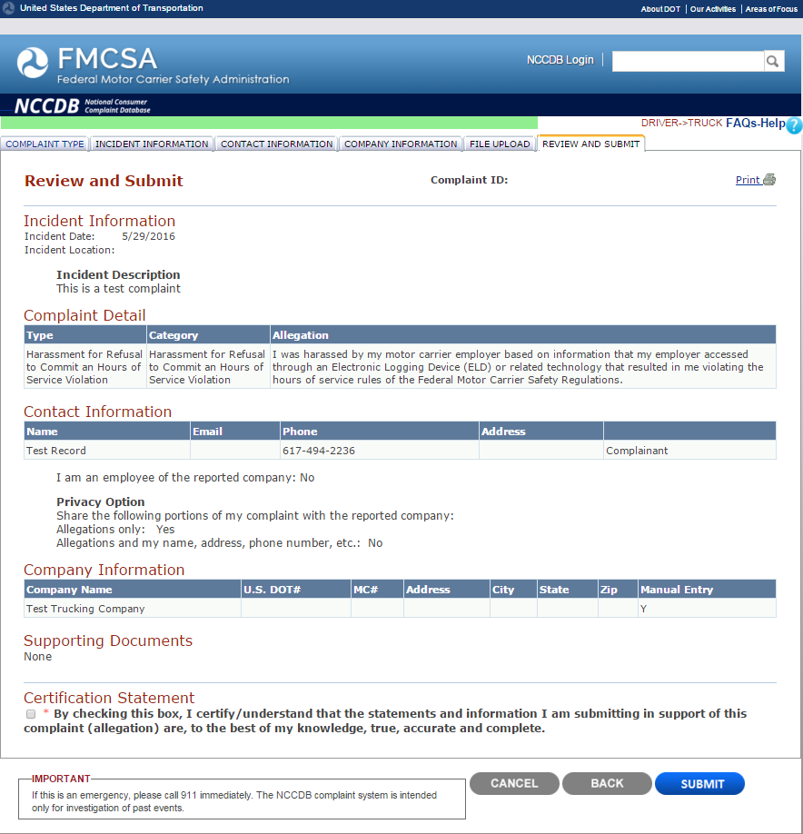

# Driver Bus Complaint Type

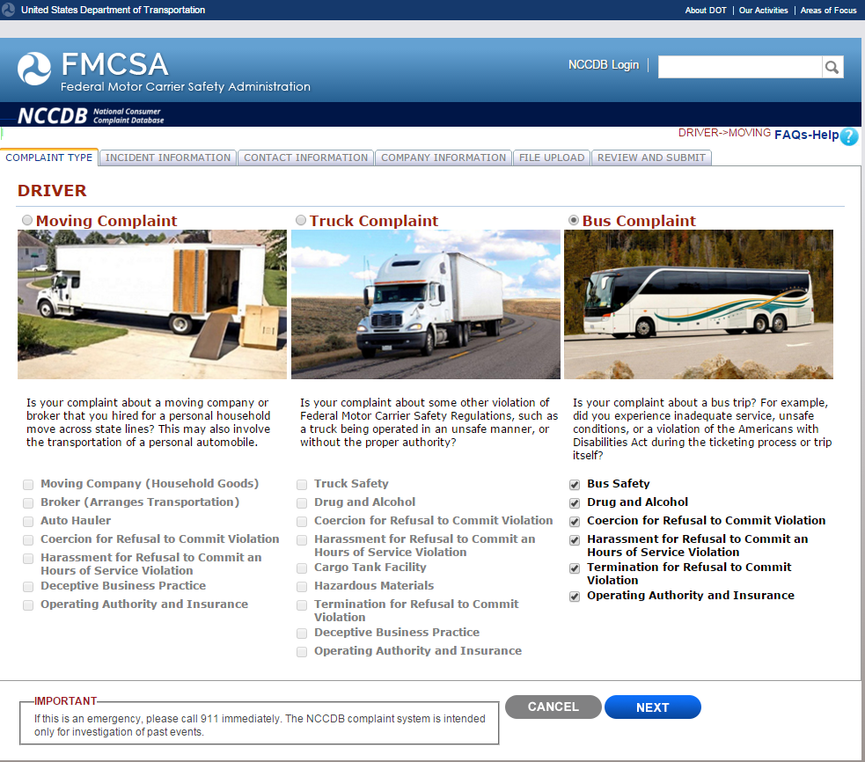

# Driver Bus Complaint Incident Information

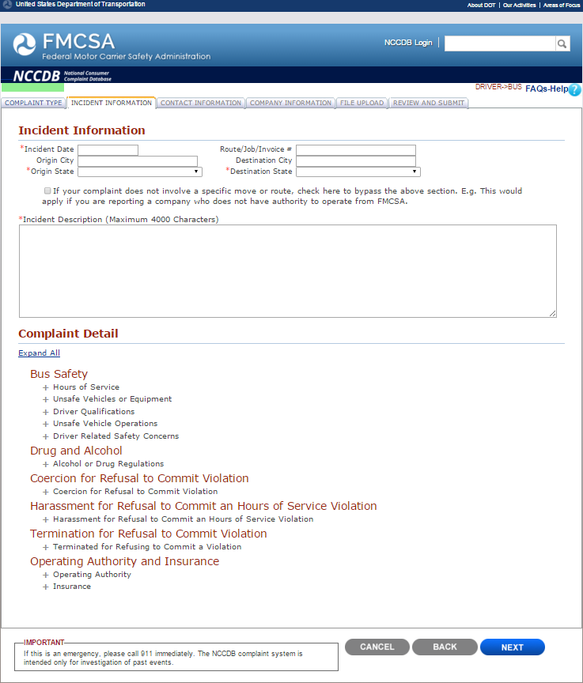

# Driver Bus Complaint Incident Information

## Continued

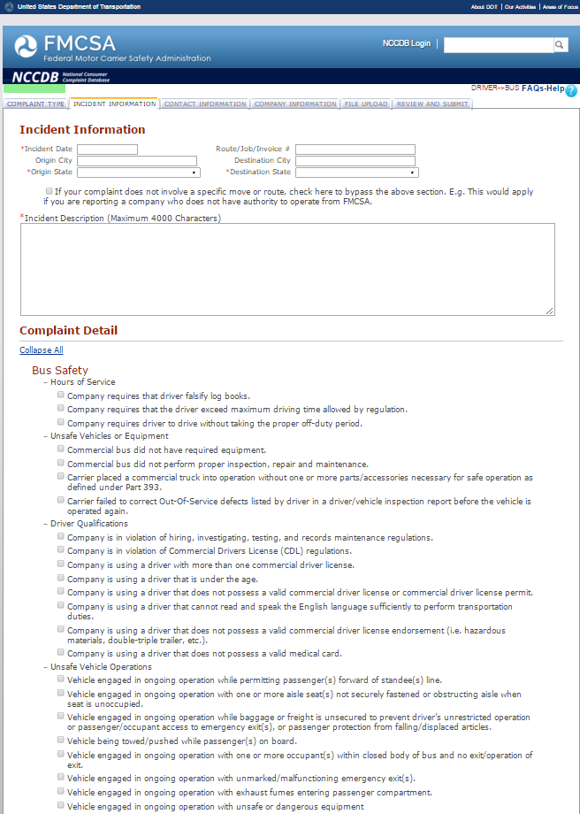

# Driver Bus Complaint Incident Information

## Continued

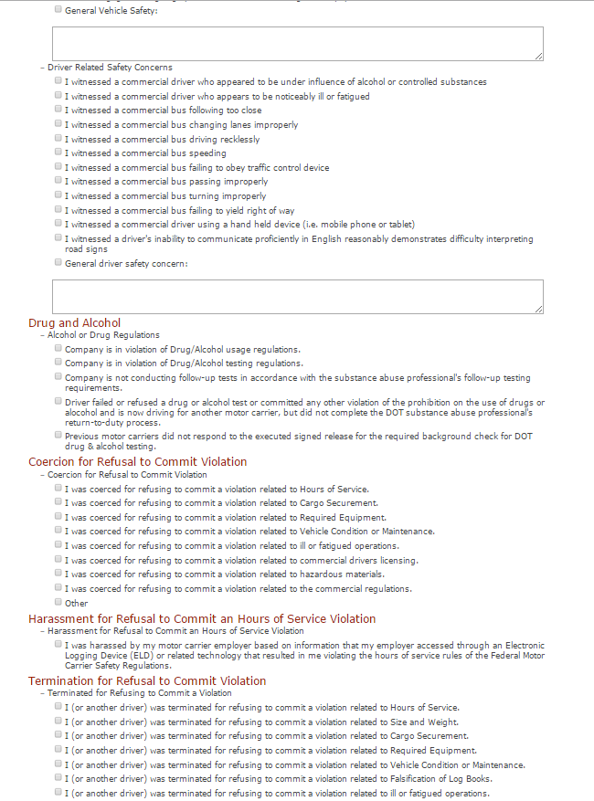

# Driver Bus Complaint Incident Information

## Continued

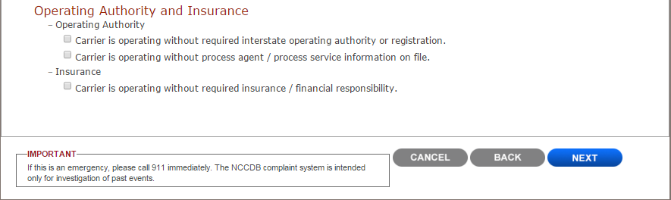

# Driver Bus Complaint Contact Information

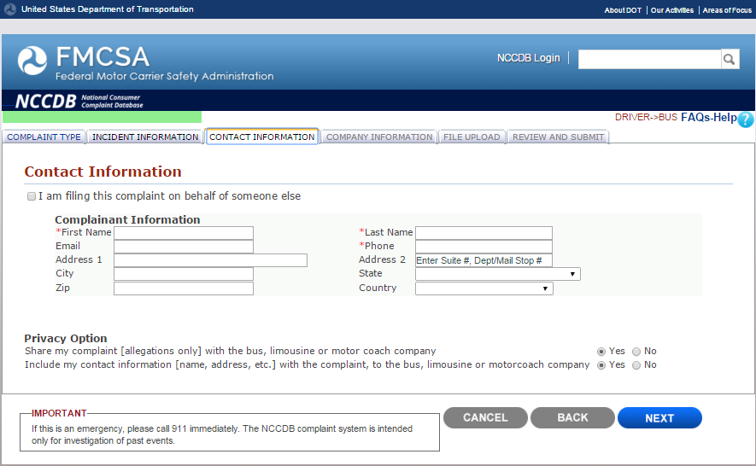

# Driver Bus Complaint Company Information

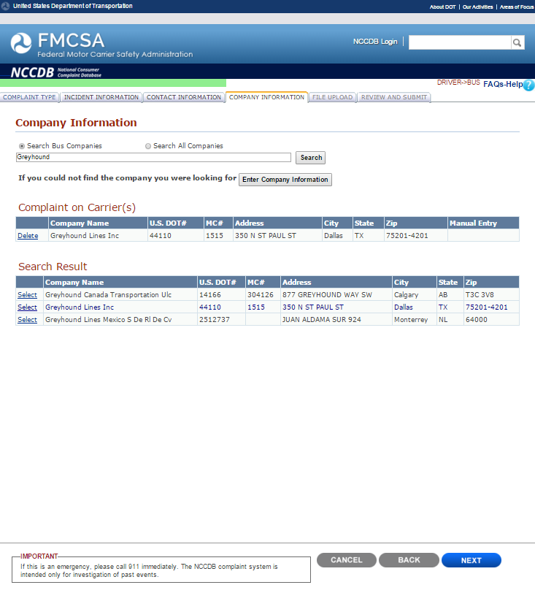

# Driver Bus Complaint File Upload

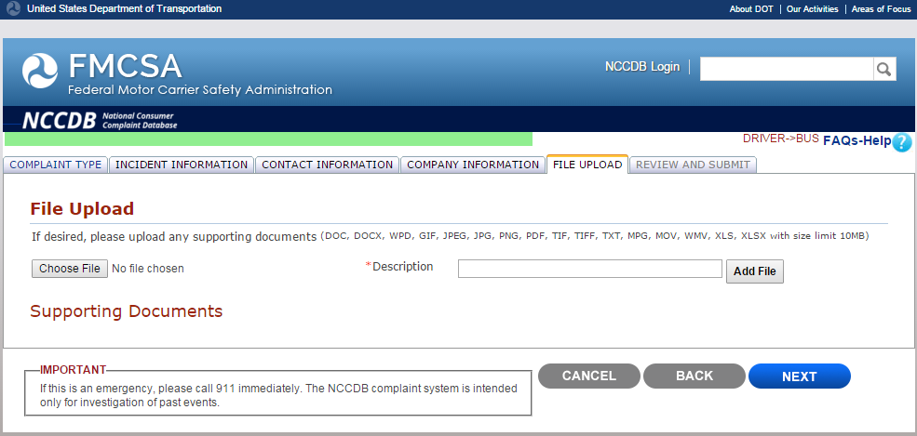

# Driver Bus Complaint Review and Submit

# 