**OMB Non-Substantive Change Request**

**Department:** Commerce

**Agency:** U.S. Census Bureau

**Title:** Boundary and Annexation Survey (BAS) State Certification, State Certifying Official and Discrepancy Correspondence

**OMB Control Number:** 0607-0151

**Expiration Date:** 3/31/2019

**Request:** Change the distribution of the Boundary and Annexation Survey (BAS) State Certification State Certifying Official (SCO) Letter (BASSC-4L) and Discrepancy Letters (BASSC-1L and BASSC-2L), as referenced in the Background section of this document, from a physical mail delivery to electronic mail (email).

**Background:** The BAS State Certification program invites SCOs, whom are appointed by the Governor, from 49 of the 50 states (Hawaii is not included[1]) to review legal boundary changes submitted to the annual Boundary and Annexation Survey (BAS). The Census Bureau’s Master Address File/Topologically Integrated Geographic Encoding and Referencing (MAF/TIGER) system and Geographic Change Catalog System (GCAT) capture these updates each year. The MAF/TIGER system houses all of the Census Bureau’s spatial, geographic, and residential address data needed for census and survey data collection and tabulation. The BAS State Certification Program serves as a component to ensuring that the MAF/TIGER system and GCAT are accurate and complete.

The BAS SCO letter (BASSC-4L) that is delivered annually in November announces the start of the program and initiates the SCO’s review of the BAS State Certification materials. The Census Bureau provides the SCO a file containing the legal boundary changes from the previous BAS cycle added to the MAF/TIGER system and GCAT. The SCO reviews legal boundary changes to ensure the submittal is in accordance with state law. Further, the SCO certifies changes as correct, or requests their removal from the Census Bureau’s MAF/TIGER system and GCAT if not in accordance with state law. In addition, the Census Bureau invites the SCO to add legal boundary changes not reported during the previous BAS cycle.

Once the SCO returns their review with annotations electronically to the Census Bureau, the Census Bureau informs the BAS contacts of local governments that had records marked for additions or removals. Currently, the Census Bureau sends these governments a Discrepancy Letter (BASSC-1L/BASSC-2L) via physical mail delivery. Discrepancy letters will be delivered in August 2017 for the 2016 BAS State Certification cycle. The Census Bureau intends to begin distributing this notification by email in August 2017, as much of the communication to BAS participants is currently conducted via email.

**Timeline:** The BAS State Certification Program is conducted annually.

* August 2017: Discrepancy Letters (BASSC-1L/BASSC-2L) for the current State Certification Program will be distributed via email.
* October 2017: Letter to Governor to appoint SCO (BASSC-3L) will be distributed by physical mail.
* November 2017: Distribution of theSCO letter (BASSC-4L) for the next program cycle via email.
* February 2018: 2017 BAS State Certification Discrepancy Letters (BASSC-1L/BASSC-2L) will be distributed via email.

**Method:** Currently, the BAS State Certification Program outreach consists of four separate mailings.

* October: A letter to the Governor to appoint an SCO ((BASSC-3L) will remain as a physical mail delivery).
* November: A letter to the SCO (BASSC-4L).
* August (2017)/February (2018): A letter to the government where a legal boundary change was marked for removal by the SCO (BASSC-1L).
* August (2017)/February (2018): A letter to the government where a legal boundary change was added by the SCO (BASSC-2L).

With the first mailing, the Census Bureau requests each Governor to appoint an SCO for their state. The Census Bureau will continue to send this letter via physical mail delivery.

The second mailing notifies the SCO of their appointment by the Governor to complete the BAS State Certification. This correspondence will be distributed via email beginning in October 2017.

The third and fourth mailings are sent at the same time to the state, county, or local government BAS contacts. The BASSC-1L letter informs the BAS contact that a legal boundary change was not reported in accordance to their state’s law and to resolve these discrepancies with their SCO. The BASSC-2L letter informs the BAS contact that they did not submit changes to the BAS and requests that they do so in the following BAS cycle. This correspondence will be distributed via email beginning in August 2017. These letters will be distributed via email for following BAS State Certification cycles beginning February 2018.

A majority of our BAS materials are delivered via email, to the BAS contacts throughout the BAS program, therefore the BAS contact is experienced in exchanging communication with the BAS team via email.

All SCOs currently have active email addresses. In the case that an SCO does not have an email address, the Census Bureau will distribute the physical letter to that individual SCO by FedEx or USPS. If delivery to an email address fails, the Census Bureau will work directly with the SCO to revise the contact information and email address on file. In the case that the email failure cannot be resolved, the Census Bureau will distribute the physical letter to that individual SCO by FedEx or USPS.

**Use Incentives:** None.

**Burden:** There is no change in burden to the public associated with the BAS and BAS State Certification programs. No additional contacts are being made. Communication avenues will be reduced by utilizing electronic sources for communication. The Governor’s Letter will still be distributed as a physical mail delivery.

**Attachments:**

Attachment A – Letter to the SCO (BASSC-4L)

Attachment B – Letter to the BAS contact of a government where legal change is to be for removed (BASSC-1L)

Attachment C – Letter to the BAS contact of a government where legal change is to be to added the Census Bureau’s database (BASSC-2L)

**Contact Information:**

Please contact the following individuals for further information about this request:

|  |  |  |
| --- | --- | --- |
| Michael Clements  BAS Project Manager  Geography Division  U.S. Census Bureau  Washington, D.C. 20233  (301) 763-9124  Michael.J.Clements@census.gov | Nathan Jones  Supervisory Geographer,  Partnership Communication and Outreach  Geography Division  U.S. Census Bureau  Washington, D.C 20233  (301) 763-9095  Nathan.Jones@census.gov | Allison Shafer  Partnership Communication and Outreach Branch,  Geography Division  U.S. Census Bureau  Washington, D.C. 20233  (301) 763-1850  Allison.C.Shafer@census.gov |

Attachment A – Letter to the State Certifying Official (BASSC-4L)



Attachment B – Letter to BAS contact regarding removal of records

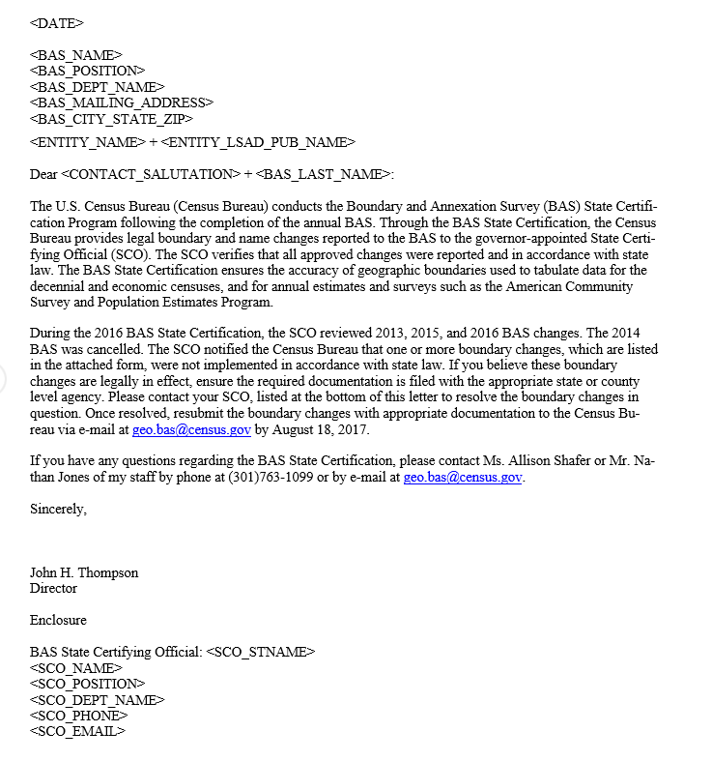

Attachment C - Letter to BAS contact regarding missing records

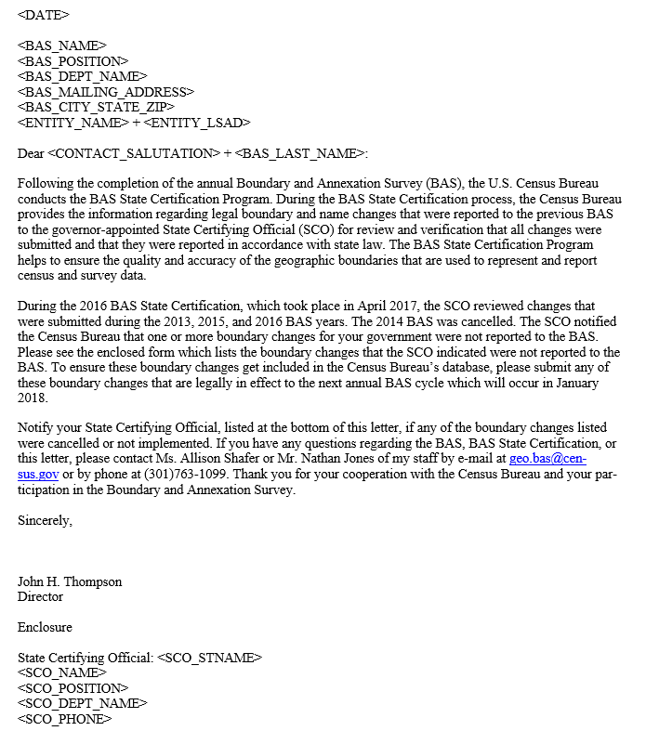

1. Hawaii does not have any functioning incorporated place level governments and does not participate in the Boundary and Annexation Survey (BAS) for the government levels reviewed during BAS State Certification program.