SUPPORTING STATEMENT
ALASKA ROCKFISH PROGRAM: PERMITS AND REPORTS
OMB CONTROL NO. 0648-0545

This action is a request for an extension of an existing information collection.

INTRODUCTION

NMFS manages the groundfish fisheries in the Exclusive Economic Zone (EEZ) off the coast of Alaska under the Fishery Management Plan for Groundfish of the Bering Sea and Aleutian Islands Management Area, the Fishery Management Plan for Groundfish of the Gulf of Alaska (GOA), and the Northern Pacific Halibut Act of 1982. The FMPs were prepared by the North Pacific Fishery Management Council (Council) under the Magnuson-Stevens Fishery Conservation and Management Act.

The Central Gulf of Alaska (CGOA) Rockfish Program (RP) is a catch share program for the rockfish fisheries and other related groundfish species conducted in federal waters near Kodiak,
Alaska, primarily by trawl vessels, and to a lesser extent by longline vessels. Prior to 2007, the
CGOA rockfish fisheries were managed under the License Limitation Program (LLP). The LLP required harvesters to hold an LLP license to participate in GOA fisheries, but did not provide specific exclusive harvest privileges to LLP license holders. From 2007 to 2011, these rockfish fisheries were managed under the Rockfish Pilot Program, which was designed to enhance resource conservation and improve economic efficiency in the rockfish fisheries by establishing cooperatives that receive exclusive harvest privileges. The Council adopted the CGOA RP on June 14, 2010, to replace the existing Rockfish Pilot Program, which was scheduled to expire
December 31, 2011. NMFS published a proposed rule and analysis to implement Amendment 88 to the Gulf of Alaska Fishery Management Plan on August 19, 2011. The final rule was published on December 27, 2011. Fishing under the Rockfish Program began in 2012.

The RP includes similar implementation, management, monitoring, and enforcement measures to those developed for and used in the Pilot Program. The RP is authorized for 10 years, until December 31, 2021.

BACKGROUND

Through the Rockfish Program, NMFS assigned quota share (QS) to LLP licenses for rockfish primary and secondary species based on legal landings associated with that LLP. Primary rockfish species are northern rockfish, Pacific ocean perch, and dusky rockfish. Secondary rockfish species are Pacific cod, rougheye rockfish, shortraker rockfish, sablefish, and thornyhead rockfish.

Each year, an LLP license holder assigns the LLP license with rockfish quota share (QS) to a rockfish cooperative. Each rockfish cooperative receives an annual cooperative fishing quota (CQ) permit, which is an amount of primary and secondary rockfish species the cooperative is authorized to harvest in that fishing year. Halibut prohibited species catch (PSC) is also allocated to participants based on historic halibut mortality rates in the primary rockfish species fisheries. Shore-based processors receiving rockfish CQ must be located within the boundaries of the City of Kodiak. The rockfish cooperative fishing season is authorized May 1 through November 15 of each year. An entry level fishery starts January 1 of each year for harvesters who are directed fishing for rockfish primary species using longline gear only.

Catcher/processor LLP license holders may opt-out of the Rockfish Program but are subject to certain sideboard limitations, which prevent rockfish eligible harvesters from increasing their participation in fisheries other than the Central GOA rockfish fisheries.

This collection contains three elements:
- Application for Rockfish Cooperative Fishing Quota (CQ),
- Application for Inter-Cooperative Transfer of Rockfish Cooperative Quota (CQ), and
- Rockfish Program Vessel Check-In/Check-Out and Termination of Fishing Report.

The collection previously contained the following elements:
- Annual Rockfish Cooperative Report (679.5(r)(6)), which was moved to OMB Control No. 0648-0678 effective January 10, 2017.
- Rockfish Program Fee Submittal Form (§ 679.85(r)(8)) and the Ex-vessel Volume and Value Report (§ 679.5(r)(10)), which were moved to OMB Control No. 0648-0711 effective February 1, 2016.
- Application for Rockfish Quota Share (QS) and administrative appeal of a denial of an application for rockfish QS (§ 679.80(d)) which were removed from this collection effective March 23, 2015, because the application period for applying for QS expired on January 17, 2012.

Another related element, the transfer of LLP licenses with Rockfish QS associated with the LLP ((§ 679.80 and § 679.80(f)) is contained in OMB Control No. 0648-0334 (LLP Program).

A. JUSTIFICATION

1. Explain the circumstances that make the collection of information necessary.

The Rockfish Program allocates exclusive fish harvesting privileges to cooperatives comprised of eligible LLP license holders and processors. These harvest privileges (cooperative quota) are transferable among permitted cooperatives. The collection of information on the application for cooperative quota is necessary to identify and authorize participants in the fishery and to issue specific amounts of cooperative quota to each cooperative each year. The collection of information about quota transfers is necessary to limit transfers to authorized participants and to monitor cooperative quota balances. The check-in/check-out reports are necessary to identify when vessels are participating in the RP fisheries so that catch by these vessels can be properly accounted against a cooperative quota or quotas for other fisheries that the vessels participate in at other times during the year. The termination of fishing report is voluntary if a rockfish cooperative wishes to notify NMFS that it has stopped participating in the RP for the year. This can be beneficial to the cooperatives if some of the halibut PSC allocated to the RP is unused and could be reallocated to their non-RP fisheries later in the year.

2. Explain how, by whom, how frequently, and for what purpose the information will be used. If the information collected will be disseminated to the public or used to support information that will be disseminated to the public, then explain how the collection complies with all applicable Information Quality Guidelines.

Following is general information about each of the three elements of this collection:

Name of form or report | Requirement in 50 CFR part 679 | Submission Format
Application for Rockfish Cooperative Fishing Quota (CQ) | § 679.81(f) | Application form with attachments, required to be submitted on paper or by fax
Application for Inter-Cooperative Transfer of Rockfish Cooperative Quota (CQ) | § 679.81(g) | Application submitted online only through eFISH. No paper or pdf form available.
Rockfish Program Vessel Check-In/Check-Out and Termination of Fishing Report | § 679.5(r)(8) | Application submitted online only through eFISH. No paper or pdf form available.

a. Application for Rockfish Cooperative Fishing Quota (CQ). (REVISED, description updated and minor revisions are made to the form)

Only persons who hold rockfish QS may join a rockfish cooperative. Each year the holder of an LLP license with rockfish QS must assign that LLP license to a rockfish cooperative in order to participate in the Rockfish Program. Rockfish QS can only be fished through cooperative membership.

The cooperative must form an association with the processor to which it historically delivered the most rockfish. The cooperative/processor associations are intended to ensure that a cooperative lands a substantial portion of its catch with its members’ historic processor. The exact terms of the association are subject to negotiation, are confidential to the parties, and require the approval of the associated processor.

Application forms are available through the Internet on the NMFS Alaska Region Web site at

https://alaskafisheries.noaa.gov/fisheries-applications?field_fisheries_program_value=Central+GOA+Rockfish+Program

or by contacting NMFS at 907-586-7228 or 800-304-4846, Option 2.

A completed application must be received by NMFS no later than 1700 hours, A.l.t., March 1 or if sent by U.S. mail, the application must be postmarked by that time. This application may be submitted to NMFS using the methods described below.

by mail to: NMFS Alaska Region
Restricted Access Management (RAM)
P.O. Box 21668
Juneau, AK 99802-1668

by delivery to: Room 713, Federal Building
709 West 9th Street
Juneau, AK

by fax to: (907) 586-7354

A copy of all applications must be retained by the submitter, regardless of submittal method.

Following is a description of the information (data entry fields) collected on the Application for Rockfish Cooperative Fishing Quota (CQ).

Block A – Rockfish Cooperative Identification
Legal name and NMFS person ID
Type of business entity under which cooperative is organized
State in which legally registered as a business entity
Date of incorporation
Name of authorized representative
Permanent business address, including P.O. Box or street address, city, state, and zip code
Business telephone number and fax number, including area code
Business e-mail address
Block B – Members of the Rockfish Cooperative (LLP holder and ownership documentation)
Full name of member and NMFS Person ID
LLP license number(s)
List all persons, to the individual level, holding an ownership interest in the LLP(s) assigned to the cooperative and percent of ownership each person and individual holds in the LLP license(s)
Block C – Identification of Rockfish Cooperative Member Vessels
Vessel name, ADF&G vessel registration number, and USCG documentation number
Block D – Shoreside Processor Associates of the Rockfish Cooperative
Processor name and NMFS person ID
Facility name
ADF&G processor code
Federal processor permit (FPP) number
Block E – Certification of cooperative
Printed name and signature of authorized representative and date signed
Block F – Certification of Processor Associate
Printed name and signature of authorized representative and date signed

In addition to the information required to be submitted on the application form, the applicant also must submit the following information with the application:

- a copy of business license issued by the state in which the cooperative is registered as a business entity;
- a copy of articles of incorporation or partnership agreement of the rockfish cooperative
- a copy of the cooperative agreement signed by the members of the rockfish cooperative (if different from the articles of incorporation or partnership agreement of the rockfish cooperative); and
- A copy of the proposed fishing plan.

The articles of incorporation or the cooperative agreement must specify that the rockfish quota share holders affiliated with rockfish processors cannot participate in price setting negotiations, except as permitted by general antitrust law, the rockfish cooperative has a monitoring program sufficient to ensure compliance with the Rockfish Program, and rockfish quota share holders who are members of the rockfish cooperative must ensure full payment of Rockfish cost recovery fees that may be due.

b. Application for Inter-Cooperative Transfer of CQ. (NO CHANGE, description updated to show eFISH data entry screens rather than creating a separate form-like document to illustrate what is collected online only)

Once NMFS issues annual CQ to a cooperative, the members of the cooperative may fish on that amount or may transfer catch amounts to another cooperative. The transfer of an annual catch amount is valid only during the calendar year of the transfer. A rockfish cooperative may transfer all or part of its CQ to another rockfish cooperative. A cooperative may only transfer or receive by transfer an annual catch amount if the cooperative submits online an application for inter-cooperative transfer to NMFS.

In order for NMFS to approve an inter-cooperative transfer, both parties must be already established and recognized by NMFS as a cooperative prior to the transfer. Under the RP, catcher/processor cooperatives are not permitted to receive quota transfers from catcher vessels cooperatives. This “one-way door” is intended to protect interests of shore plants and communities, in the event that catcher/processor production efficiencies exceed those of the shore-based sector.

The Inter-cooperative Transfer of CQ must be submitted to NMFS online through eFISH on the NMFS Alaska Region website at https://alaskafisheries.noaa.gov/webapps/efish/login. By using the NMFS ID password and submitting the transfer request, the designated representative certifies that all information is true, correct, and complete.

Following are screenshots from eFISH showing the information collected on this application

Once logged in to eFISH, the applicant selects “Transfer Rockfish CQ.”

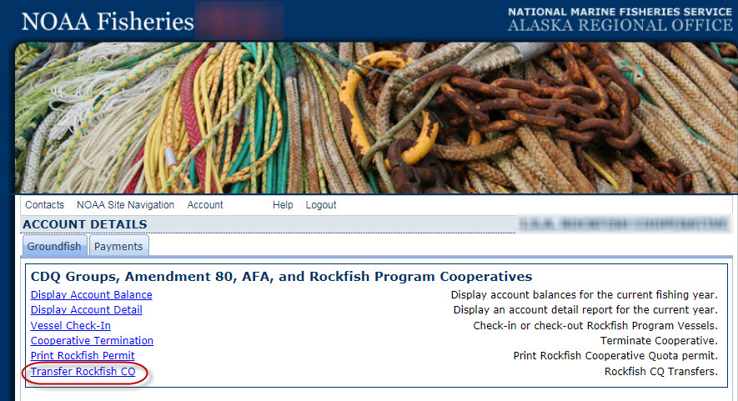

Below is the two data entry screen to request a rockfish CQ transfer.

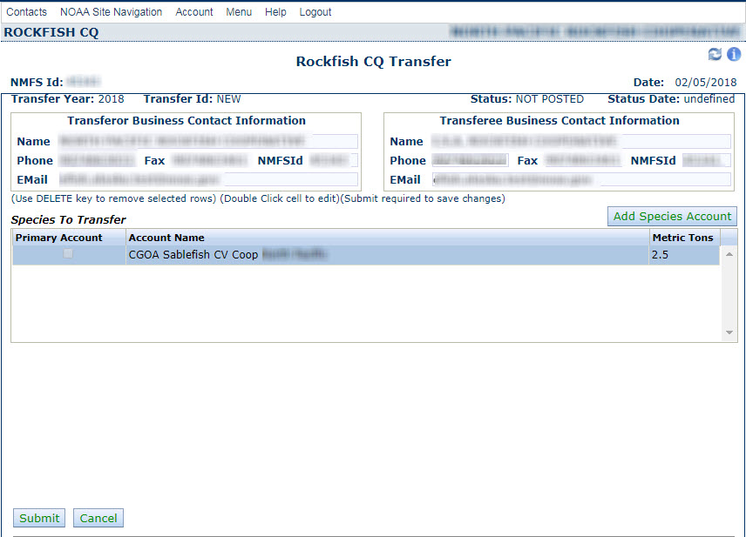

With the information provided when logging into eFISH using a NMFS ID, eFISH autofills the following information about the transferor: name, phone number, fax number, and e-mail address. This information is based on the information the transferring cooperative representative submitted in the Application for Rockfish Fishing CQ.

For each transfer, the following information is autofilled by eFISH:
- Date of the transfer
- Transfer Year
- Transfer ID
- Status
- Status Date

The applicant enters the transferee NMFS ID and eFISH autofills the transferees name, phone number, fax number, and e-mail address based on information the receiving cooperative representative submitted on the Application for Rockfish Fishing CQ.

The applicant selects the species to transfer and enters the weight of the species to transfer, and selects “Submit.” The applicant receives a system generated response notifying them that either the transfer request has been received and processed successfully, or there was an error in their submission. If there is an error in their submission, the applicant may go back to the data entry screen and try again to submit the transfer request.

c. Cooperative check-in/check-out reports and termination of fishing report (NO CHANGE, description updated to show eFISH data entry screens rather than creating a separate form-like document to illustrate what is collected online only)

The designated representative for a rockfish cooperative must submit a check-in report before a vessel authorized to fish under the cooperative’s permit starts fishing for a cooperative and a check-out report when a vessel stops fishing for a cooperative during the fishing season. The check-in/check-out reports are necessary so that NMFS’s catch accounting system can identify catch by a vessel that should accrue to a rockfish cooperative quota allocation from catch that occurs in other, non-Rockfish Program fisheries.

The designated representative for a rockfish cooperative must submit to NMFS a check-in report for a vessel:

♦ At least 48 hours prior to the time the catcher vessel begins a fishing trip to fish under a CQ permit; or

♦ At least 1 hour prior to the time the catcher/processor begins a fishing trip to fish under a CQ permit; and

♦ A check-in designation is effective at the beginning of the first fishing trip after the designation has been submitted.

The designated representative of a rockfish cooperative must designate any vessel that is no longer fishing under a CQ permit for that rockfish cooperative through a check-out report.

A check-out report must be submitted to NMFS within 6 hours after the effective date and time the rockfish cooperative ends the vessel’s authority to fish under the CQ permit.

♦ If the vessel is fishing under a CQ permit for a catcher vessel cooperative, a check-out designation is effective at the end of a complete offload;

♦ If the vessel is fishing under a CQ permit for a catcher/processor cooperative, a check-out designation is effective upon submission to NMFS.

A rockfish cooperative may choose to terminate its CQ permit through a termination of fishing report submitted to NMFS. This declaration notifies NMFS that all vessels fishing for the cooperative have completed fishing in the Rockfish Program for the year.

The Check-in Report, Check-out Report, and Declaration of Termination of Fishing Report must be submitted to NMFS online through eFISH on the NMFS Alaska Region website at https://alaskafisheries.noaa.gov/webapps/efish/login.

Following are screen shots from eFISH showing the data entry screens and information requirements for the check-in report, check-out report, and termination of fishing report.

Once logged in to eFISH, the applicant selects “Vessel Check-In” or “Cooperative Termination.”

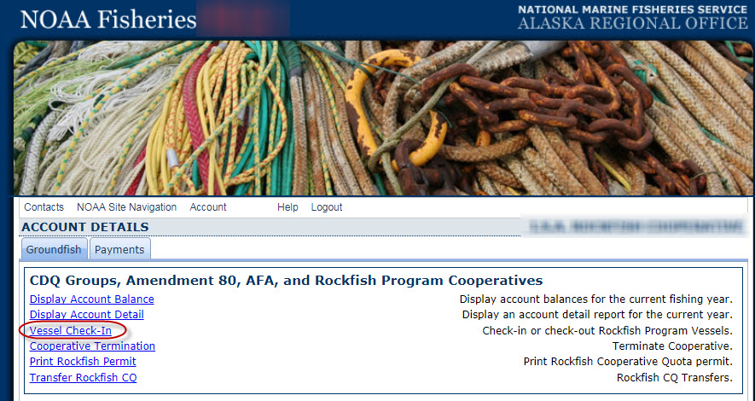

With the information provided when logging in to eFISH using a NMFS ID, eFISH autofills the NMFS ID number, name of the rockfish cooperative, and the date.

For each check-in or check out report, the applicant enters the vessel name, check-in date and time or check-out date and time.

Following are eFISH data entry screens for the check-in report and check-out report.

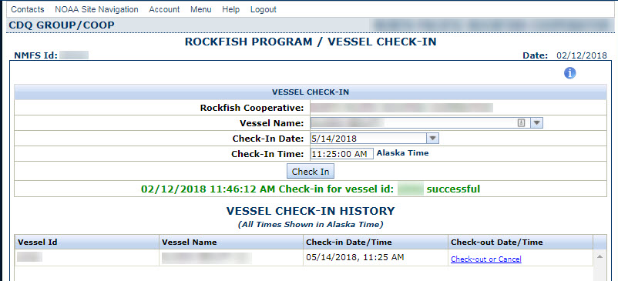

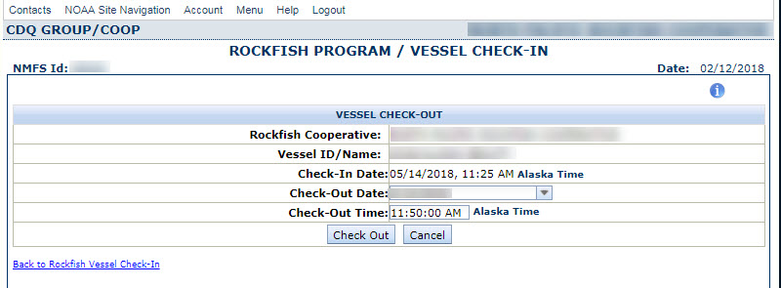

If a cooperative representative elects to submit a termination of fishing report, the representative would submit the cooperative name and select the option “Terminate,” as shown in the eFISH data entry screen below. No termination of fishing reports have been submitted by any of the cooperatives since prior to 2012 under the Rockfish Pilot Program.

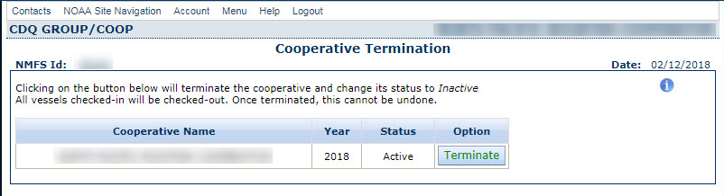

If the information collected will be disseminated to the public or used to support information that will be disseminated to the public, then explain how the collection complies with all applicable Information Quality Guidelines

Section 515 of Public Law 106-554 (the Information Quality Act) requires NMFS to ensure the quality, objectivity, utility, and integrity of information it publicly disseminates. If data submitted about rockfish CQ transfers and check-in/check-out/termination of fishing reports is used in any reports or analyses provided to the public, these data are aggregated, synthesized, summarized, and presented in a non-confidential format. Public dissemination of these data are governed by NOAA's information quality guidelines, which were issued on October 30, 2004 (http://www.cio.noaa.gov/services_programs/IQ_Guidelines_103014.html).

Reports and analyses prepared with these data generally fall under NOAA's information quality category "synthesized products." These products have been developed through analysis of original data by applying methods that require some scientific evaluation and judgment; however, these methods of analysis generally are well documented and relatively routine. Therefore, peer review is generally not required for reports and analyses prepared using VMS data.

Reports and analyses undergo internal agency review by people familiar with the underlying data and fisheries being described. In addition, analyses presented to the North Pacific Fishery Management Council are reviewed by its Scientific and Statistical Committee.

NMFS publishes some information from the Application for Rockfish Cooperative Fishing CQ on the NMFS Alaska Region website (www.alaskafisheries.noaa.gov), including the name of the cooperative, the name of the authorized representative of the cooperative, the business address of the cooperative, the names of the license holders who are members of the cooperative, and the names of the vessels that will be fishing for the cooperative.

Other information provided in this collection is confidential under section 402(b) of the Magnuson-Stevens Act (16 U.S.C. 1801 et seq.); and also under NOAA Administrative Order (AO) 216-100, which sets forth procedures to protect confidentiality of fishery statistics.

3. Describe whether, and to what extent, the collection of information involves the use of automated, electronic, mechanical, or other technological techniques or other forms of information technology.

NMFS requires that the Application for Rockfish Cooperative Fishing Quota (CQ) be submitted on paper or by fax because it requires the submission of copies of attached documents.

The Application for Inter-Cooperative Transfer of Rockfish Cooperative Quota (CQ) and the Rockfish Program Vessel Check-In/Check-Out and Termination of Fishing Reports are required to be submitted via the internet-based online system eFISH.

4. Describe efforts to identify duplication.

NMFS has not identified any duplication with other information collections or information collection requirements. Duplication of application contact information is minimized through the use of eFISH because, by logging in with a NMFS Identification Number, eFISH autofill some data entry fields.

5. If the collection of information involves small businesses or other small entities, describe the methods used to minimize burden.

NMFS attempts to minimize the burden of this information collection on all respondents by collecting only information necessary to manage the Rockfish Program, by providing and supporting the online data collection program eFISH and by providing assistance to users in writing and by phone. eFish has a “help” link within the application that users can click on to view help options and user guides. See https://alaskafisheries.noaa.gov/node/30749 . NMFS also maintains documentation about eFISH in the eLandings Wiki (Confluence), located here: https://elandings.atlassian.net/wiki/spaces/doc/pages/31096857/eFISH+Web+Application

In addition, NMFS maintains a help/support call center with contractors available by phone Monday through Friday from 8:00 am to 4:30 pm Alaska time.

6. Describe the consequences to the Federal program or policy activities if the collection is not conducted or is conducted less frequently.

The Application for Rockfish Fishing CQ and the Application for Inter-Cooperative Transfer of Rockfish Cooperative Quota (CQ) are voluntary. No cooperative representative is compelled to submit this application and no license holder, vessel owner, or processor is required to be a member of a cooperative. However, if the information on this application form were not collected, NMFS could not provide the benefits of the Central Gulf of Alaska Rockfish Program to eligible participants. Requiring an annual Application for Rockfish Cooperative Fishing Quota (CQ) allows the rockfish cooperatives to establish their membership annually and provides some flexibility for license holders and vessel owners to change cooperative or renegotiate cooperative terms. Once a Rockfish CQ permit has been issued to a cooperative, transfers of CQ and halibut PSC may only be done by formal notification to NMFS. In addition, once a RP CQ permit is issued the cooperative representative is required to submit vessel check-in and check-out reports to ensure that NMFS accrues catch under the RP to the correct CQ account. The Termination of fishing report is a voluntary report at the discretion of the cooperative representative.

7. Explain any special circumstances that require the collection to be conducted in a manner inconsistent with OMB guidelines.

No inconsistencies with OMB guidelines were identified for this collection.

8. Provide information on the PRA Federal Register Notice that solicited public comments on the information collection prior to this submission. Summarize the public comments received in response to that notice and describe the actions taken by the agency in response to those comments. Describe the efforts to consult with persons outside the agency to obtain their views on the availability of data, frequency of collection, the clarity of instructions and recordkeeping, disclosure, or reporting format (if any), and on the data elements to be recorded, disclosed, or reported.

Public comment was solicited in a Federal Register Notice published September 25, 2017 (82 FR 44583). The comment period closed on November 24, 2017. No comments were received on this notice.

The Council conducted a review of the Rockfish Program in 2017 and received the final report on the review at its October 2017 meeting, which was during the public comment period on the renewal of the RP information collection. The Central GOA Rockfish Program Review is available on the Council’s website at https://www.npfmc.org/wp-content/PDFdocuments/catch_shares/Rockfish/RockfishProgramReview1017.pdf.

The Council invited public comment on the program review. Two people testified to the Council: Julie Bonney, the authorized representative for seven of the nine RP cooperatives, and Alexus Kwachka, a fisherman, member of the Council’s Advisory Panel, and resident of Kodiak, Alaska. In addition, the Alaska Whitefish Trawlers Association (AWTA), based in Kodiak, submitted written comments to the Council on the program review. The AWTA’s written comments supported the RP and specifically stated that they recommended no substantial changes to the program.

In Section 16.1.5.1 of the program review, NMFS identified several minor regulatory revisions that it would recommend be made when the program is reauthorized. The Council is scheduled to begin to discuss program reauthorization later in 2018. Specific to the information collection requirements for the Rockfish Program, NMFS recommended that we could remove the requirement to submit a copy of a fishing plan in the Application for Rockfish Cooperative Fishing Quota. The deadline for this application (March 1) is so far in advance of when cooperatives make fishing plans for the summer season, that the information needed for the fishing plan is not available when the applications are due. In addition, the type of information needed in the fishing plan is provided in the cooperative annual reports required under § 679.5(r)(6) (OMB Control No. 0648-0678).

9. Explain any decisions to provide payments or gifts to respondents, other than remuneration of contractors or grantees.

No payment or gifts are provided to respondents.

10. Describe any assurance of confidentiality provided to respondents and the basis for assurance in statute, regulation, or agency policy.

All information collected is part of a system of records: NOAA #19, Permits and Registrations for United States Federally Regulated Fisheries. NMFS publishes some information from the Application for Rockfish Cooperative Fishing CQ on the NMFS Alaska Region website (www.alaskafisheries.noaa.gov), including the name of the cooperative, the name of the authorized representative of the cooperative, the business address of the cooperative, the names of the license holders who are members of the cooperative, and the names of the vessels that will be fishing for the cooperative.

Other information provided in this collection is confidential under section 402(b) of the Magnuson-Stevens Act (16 U.S.C. 1801 et seq.); and also under NOAA Administrative Order (AO) 216-100, which sets forth procedures to protect confidentiality of fishery statistics.

11. Provide additional justification for any questions of a sensitive nature, such as sexual behavior and attitudes, religious beliefs, and other matters that are commonly considered private.

Not Applicable.

12. Provide an estimate in hours of the burden of the collection of information.

Table 1 provides responses to Questions 12 and 13.

Table 1 Estimated Number of Respondents, Responses, and Costs for the Information Collection Components for the Central Gulf of Alaska Rockf Program.
 | Application for Rockfish Cooperative Fishing Quota (CQ) | Application for Inter-Cooperative Transfer of Rockfish Cooperative Quota (CQ) | Rockfish Program Vessel Check-In/Check-Out and Termination of Fishing Report | Total for collection
Submission format | Paper or fax | online only through eFISH | online only through eFISH
Number of respondents | 9 | 9 | 9 | 9
Number of responses
- per year per respondent | 1 | 15 | 6
- Total responses, all respondents | 9 | 135 | 54 | 198
Number of burden hours
- per response | 2 hrs | 10 min | 10 min
- Total burden hours, all respondents | 18 hrs | 23 hrs | 9 hrs | 50 hrs
Personnel costs
- $/hr | $37 | $37 | $37
- Total cost | $666 | $851 | $333 | $1,850
Other costs | Photocopy (30 pp x 9 X $0.10/page) =  $27  Postage (9 x $6.70) =  $60  Total = $87 | $0 | $0 | $87

13. Provide an estimate of the total annual cost burden to the respondents or record-keepers resulting from the collection (excluding the value of the burden hours in Question 12 above).

The total annual cost burden to respondents from the collection is $87 for photocopying and postage to submit the Application for Rockfish Cooperative Fishing Quota (CQ). The other information collection components are submitted online through eFISH and the cost of submitting these reports is estimated at zero because these services are included in internet and phone service already purchased by the cooperative for other business purposes.

14. Provide estimates of annualized cost to the Federal government.

A cost recovery program is in effect for the Rockfish Program. Under this cost recovery program, NMFS is authorized to collect direct program costs from the rockfish cooperatives. Therefore, the information collection requirements of the Rockfish Program do not impose a cost on the Federal government. Direct program costs are the costs NMFS incurs to manage, collect data from, and conduct enforcement for the Rockfish Program fisheries.

The direct program costs for the Rockfish Program in 2017 were $208,666.

Examples of the types of tasks that were included under the 2017 Rockfish Program direct program costs are:
- maintenance of electronic reporting systems, including the catch accounting system,
- programming and web design for online applications,
- determination of annual cooperative allocations of cooperative fishing quota and prohibited species catch,
- issuance of CQ, responding to questions about CQ applications,
- transfers of CQ, responding to questions about transfers,
- debriefing of observers on RP vessels,
- catch monitoring control plan specialist,
- monitor cooperative fisheries CQ and PSC, answer questions on cooperative activities, respond to data requests,
- determination of standard ex-vessel prices using value and volume reports submitted by rockfish processors,
- fee determination and collection process,
- cost recovery report,
- analysis and rulemaking activities: regulations to allow NMFS to reapportion unused Chinook salmon prohibited species catch.

15. Explain the reasons for any program changes or adjustments.

No program changes are made in this renewal.

Several adjustments are made in this information collection renewal, as described below:

Application for Rockfish Cooperative Fishing Quota (CQ) –
- no change in the number of respondents (9)
- no change in the number of responses (9)
- no change in the burden hours per response (2 hrs)
- no change in the total burden hours (18 hrs)
- no change in total personnel cost of burden hours ($666)
- an increase in miscellaneous costs from $26 to $87 to reflect adjustments made to the assumptions for the cost of photocopying and mailing application packages.

Application for Rockfish Inter-Cooperative Transfer
- no change in the number of respondents (9)
- an increase in the number of responses per year based on updating actual average number of transfers per cooperative per year (from 27 total to 135 total)
- no change in the burden hours per response (10 min)
- an increase in the total personnel cost of burden hours (from 5 hrs to 23 hrs due to increase in number of responses)
- an increase in the total cost of burden hours (from $185 to $851)
- a decrease in miscellaneous costs from $1 to $0 because the cost of submitting these reports is estimated at zero because these services are included in internet and phone service already purchased by the cooperative for other business purposes.

Vessel Check-In/Check-Out & Declaration of Termination of Fishing

- no change in the number of respondents (9)
- a reduction in the number of responses per year based on updating actual average number of reports per cooperative per year (from 63 total to 54 total)
- no change in the burden hours per response (10 min)
- a reduction in the total burden hours (11 hrs to 9 hrs) due to a decrease in number of responses)
- a decrease in the total personnel cost of burden hours ($407 to $333)
- a decrease in miscellaneous costs from $20 to $0 because the cost of submitting these reports is estimated at zero because these services are included in internet and phone service already purchased by the cooperative for other business purposes.

Overall adjustments for the collection (information for the form 83i)
- no change in the number of respondents (9)
- an increase in the number of responses per year from 99 to 198
- an increase in the total burden hours from 34 to 50
- an increase in the miscellaneous costs from $47 to $87.

16. For collections whose results will be published, outline the plans for tabulation and publication.

NMFS publishes some information from the Application for Rockfish Cooperative Fishing CQ on the NMFS Alaska Region website (www.alaskafisheries.noaa.gov), including the name of the cooperative, the name of the authorized representative of the cooperative, the business address of the cooperative, the names of the license holders who are members of the cooperative, and the names of the vessels that will be fishing for the cooperative.

Other information provided in this collection is confidential under section 402(b) of the Magnuson-Stevens Act (16 U.S.C. 1801 et seq.); and also under NOAA Administrative Order (AO) 216-100, which sets forth procedures to protect confidentiality of fishery statistics.

17. If seeking approval to not display the expiration date for OMB approval of the information collection, explain the reasons why display would be inappropriate.

Not Applicable.

18. Explain each exception to the certification statement.

Not Applicable.

B. COLLECTIONS OF INFORMATION EMPLOYING STATISTICAL METHODS

This collection does not employ statistical methods.

