Attachment G-2
Resident and Participant NCHS Data Briefs

(We are providing screenshots of the first page of the 2014 data briefs. We plan to update with 2016 NSLTCP data)

Accessed at: https://www.cdc.gov/nchs/data/databriefs/db223.pdf
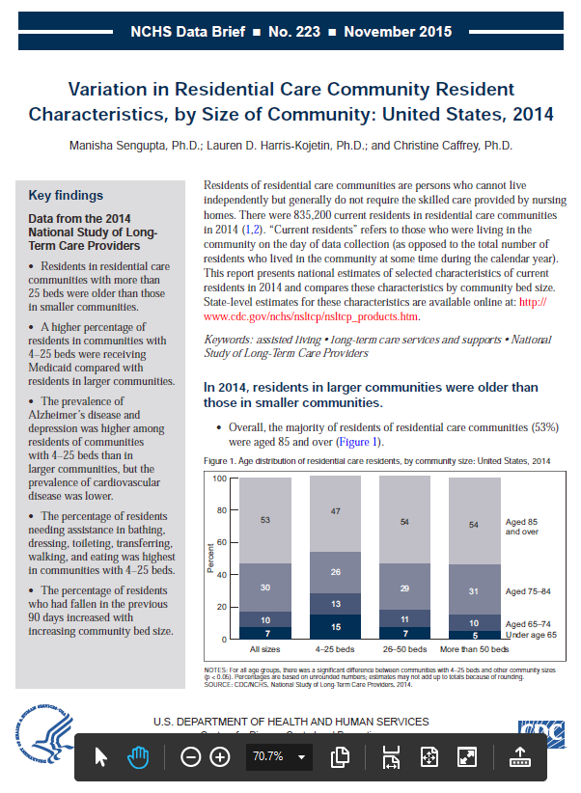

Accessed at https://www.cdc.gov/nchs/data/databriefs/db227.htm

