Attachment I: 2-dimensional hand scan and 3-dimensional body scans

A hand scanner, a head scanner, a foot scanner, and a whole body scanner, housed in a trailer, are used for 2D and 3D body shape registering (Figure 1).
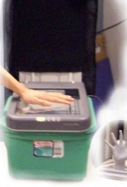(a) 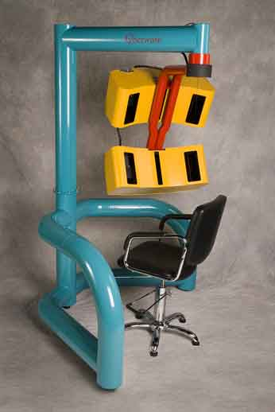(b) (c) (d) 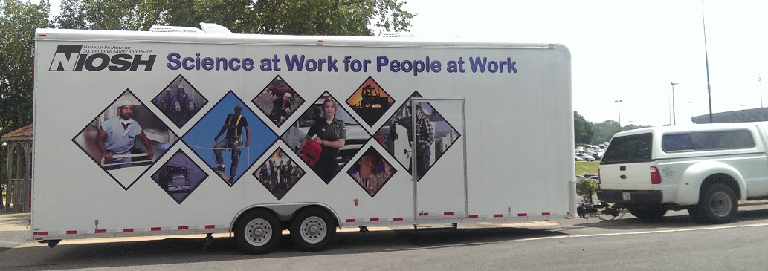 (e)
Figure 1: (a) hand scanner, (b) face & head scanner, (c) foot scanner, and (d) whole-body scanner to be used in the study. They are housed in a mobile anthropometry lab in a truck trailer (e).

The whole-body and head scanning will take 17 seconds each to complete one scan. The hand and foot scanning will take 5 seconds each to complete one scan. Figures 1 (a) and 1 (c) provide an illustration of the hand- and foot-scanning operation. Figure 2 provides an illustration of the whole-body and head-scanning operation.
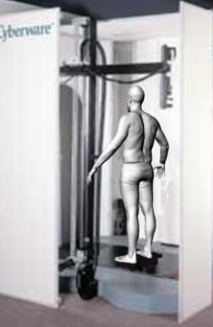 (a) 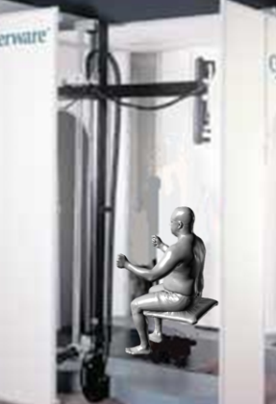 (b) 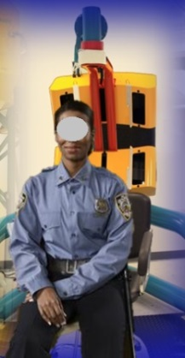 (c)
Figure 2. (a) Standing scan without gear, (b) seated scan without gear, and (c) head scanning

