**Evaluation of an Education Intervention for Immigration Applicants with B1 or B2 Tuberculosis Classifications**

**Gen-IC**

**Information Collection for Evaluation of Education, Communication, and Training (ECT) Activities for Mobile Populations**

**OMB No. 0920-0932**

**Expiration Date: 05/31/2021**

**Submitted on: December 19, 2019**

**Statement B**

**Contact:**

Nancy Khalil, J.D.

MS H16-5

Centers for Disease Control and Prevention

1600 Clifton Road NE

Atlanta, Georgia 30329-4027

Phone: (770) 488-2070

Email: kuj2@cdc.gov

**TABLE OF CONTENTS**

**B.1. Respondent Universe and Sampling Methods** 3

**B.2. Procedures for the Collection of Information** 7

**B.3. Methods to Maximize Response Rates and Deal with Non-response** 9

**B.4. Test of Procedures or Methods to be Undertaken** 9

**B.5. Individuals Consulted on Statistical Aspects and Individuals Collecting and/or Analyzing Data** 9

**REFERENCES (APA)** 9

**PART B. COLLECTION OF INFORMATION EMPLOYING STATISTICAL METHODS**

**B.1. Respondent Universe and Sampling Methods**

This multi-method evaluation will be conducted in 2 phases.

*Methods (Phase 1)*

SMF and CMI clinics conduct medical exams according to the “Tuberculosis Technical Instructions for Panel Physicians” (2018). In 2017, Mexico’s TB incidence rate was estimated by WHO to be 22/100,000, placing it above the Technical Instructions’ 20/100,000 threshold, which then requires countries to perform IGRA testing for children The clinics perform medical histories, physical examinations, and IGRA testing for applicants aged 2-14, as well as chest x-ray for applicants 2-14 who are positive on IGRA testing and all applicants 15 and over or who have signs and symptoms of TB disease.

Currently, clients at the SMF and CMI clinics who are expected to be assigned a B1 or B2 TB classification are generally provided limited and non-standardized information about TB or instructions for follow-up in the United States.

For B1 classifications, the panel physician typically explains the classification and process during a face-to-face visit. At the time of the visit, it is known that the chest x-ray is abnormal, but it is unknown whether the sputum smears and culture testing for *M. tuberculosis* will be positive or negative. If the smears or culture results are determined positive (usually several weeks after specimens are collected), the applicant has tuberculosis disease and will not be approved to immigrate until treatment is completed and the panel physician conducts further testing. Ultimately, these applicants can receive a class B0 or B1 designation and be eligible for Department of State immigration approval. If the initial sputum testing is negative, the applicant is assigned a class B1 designation and the applicant may immigrate without further medical testing or consultation. Since 98.3% of applicants, providing sputum specimens will have negative cultures, at the time of the clinic visit it is usually presumed that the applicant will likely subsequently have a class B condition assigned. Therefore, at this time the panel physician staff provides a provisional explanation about the most likely classification, and how the applicant should continue their immigration process after receiving the sputum results. For B2 classifications, a similar process is followed with the parents of minor children. This verbally delivered consultation typically lasts less than 15 minutes, includes no written information or provision of additional online resources, no clear explanation of how to secure a post-arrival evaluation, and is delivered by clinical staff. For this evaluation, participants who receive this “standard of care” education session are categorized as being in the “comparison condition.”

An enhanced education session has been developed by the project team. This session, provided by panel physician staff at the time of the clinic visit, will consist of additional information, key messages and resources intended to support follow-up in the US. The session was designed by a health communicator using the key concepts from the Health Belief Model (HBM) (Rosenstock, 1974), Theory of Reasoned Action (TRA) and Theory of Planned Behavior (TPB). The basic elements of the HBM theoretical framework, which has been empirically tested multiple times and frequently applied to intervention development (Janz and Becker, 1984; Carpenter, 2010), can be summarized by perceptions of susceptibility, severity, belief in the benefits of action, barriers to action, and cues to action. The model proposes that individuals will be more motivated to enact behavior in health promoting ways if they believe they are susceptible to a negative health outcome. Second, HBM posits that the stronger the individual’s perception about the severity of the health outcome (e.g., death or physical impairment), the more motivated she will be to avoid that outcome. The individual must also believe that the target health promoting behavior will yield strong positive benefits, that is, likely to prevent the health outcome. Third, if an individual perceives there are strong barriers to adopting the preventive behavior (e.g., expense or pain), he will be less likely to do so. The last element includes a cue to action, such that the individual is spurred to adopt the preventive action via an additional prompt, which may be internal (e.g., change in health status) or external (e.g., mass media campaign) to the individual (Carpenter, 2010). The TRA and TPB are similar to the HBM in their value expectancy focus, but they add a proposed casual chain that links behavioral beliefs and normative beliefs to intentions and behavior through attitudes and subjective norms (Montano and Kasprzyk, 2002). The TRA proposes that the most important predictor of behavior is an individual’s behavioral intention (Fishbein, 1967). The determinants of individuals’ intentions are both the attitudes towards performing the behavior and their subjective norms (i.e., the extent to which important referent individuals are perceived to approve or disapprove of the behavior). The TBP asserts that an individual must feel that the behavior is under his volitional control or ability (Ajzen, 1991; Montano and Kasprzyk, 2008). As with HBM, TRA and TPB have both been widely tested and are commonly used to develop health interventions requiring behavior change or action.

The original content for the enhanced education session was assessed via a formative evaluation in Summer-Fall 2018. Key messages were revised based on the findings and organized to fit into the HBM, TRA and TPB theoretical frameworks.

The enhanced education sessions will last approximately 5-8 minutes, include written information, and will be delivered via brief video administered by panel physician staff. For all clients, B1 and B2, the informational content will focus on understanding tuberculosis, understanding the difference between active and latent tuberculosis, what their medical examinations and results mean as it relates to their B classification, the information that they should provide at their consulate interview and at the border, what they should do when they are at home in the US, and emphasize contacting and following up with the local health department. Several known barriers will be discussed, and the panel physician staff will also elicit other perceived barriers from the client so they may be addressed and potential solutions identified. The panel physician staff will also emphasize the importance of follow-up. The panel physician staff will also provide printed materials including a story book intended for low-literacy audiences, including an FAQ sheet in Spanish. Finally, all clients will also be informed about the newly developed web look-up tool specifically deployed for this project in the printed material, the video, as well as by the panel physician. The session has been manualized for consistent delivery across sites, staff, and clients. For this evaluation, participants who receive this “enhanced” education session and resources are categorized as being in the “intervention condition.” See Appendices.

*Sample Size (Phase 1)*

The sample size proposed for this study is based on calculations appropriate for a nonequivalent group design. Several key outcomes were considered in the statistical analysis. Samples sizes were calculated in RStudio using pwr package, validated with G*Power. The results from the specific outcome that generated the highest sample size requirements, are presented here (Scenario 1). The outcome was “Have you been told that you have a class B condition for a health condition? Yes/No.” Based on observations from the formative project and in consultation with CMI and SMF staff, we estimate that at baseline, 10% would report yes and post-intervention 20% will report yes. Table 1 presents the summary of ranges. For this data collection, we have selected Scenario 1 and propose to interview a total of 388 inviduals (194 per condition, alpha=0.05, power=0.80).

**Table 1. Two-sample comparison of proportions**.

|  |  |  |  |  |
| --- | --- | --- | --- | --- |
|  | **Scenario 1** | **Scenario 2** | **Scenario 3** | **Scenario 4** |
| Effect Size (*h)* | 0.28 | 0.28 | 0.28 | 0.28 |
| SS per group | 194 | 153 | 261 | 213 |
| α | 0.05 | 0.1 | 0.05 | 0.1 |
| Power | 0.8 | 0.8 | 0.9 | 0.9 |
| Test | Two-sided | Two-sided | Two-sided | Two-sided |





*Methods (Phase 2)*

As summarized above, Phase 2 involves retrieval of TB follow-up worksheet data via EDN. We will compare follow-up rates for time periods when only the standard health education was administered to time periods when only the enhanced education was administered. Only data for SMF and CMI clients with B1 and B2 classifications will be retrieved. We will not track specific respondents from Phase 1 to Phase 2. There may be some overlap (i.e., same respondents in Phase 1 and 2), but since we are not collecting PII we are unable to track specific individuals.

**B.2. Procedures for the Collection of Information**

*Data collection (Phase 1)*

The interviews will take place face-to-face onsite at SMF and CMI using a standard data collection instrument. (See Appendices G-J) All eligible participants, based on the eligibility criteria outlined in the applicant screener (Appendices C-D), with clinic appointment times within the data collection period will be invited to participate in the interview. The eligibility criteria include: ability to speak Spanish; being over the age of 18; not having had any other member of their household interviewed for this project and the expectation by the panel physician staff that the applicant (or applicant’s child) will likely be assigned a B1 or B2 classification by the Department of State based on sputum testing. For children ages 2-14 who are likely to receive a B2 classification, the parents or legal custodian at the clinic visit will be interviewed (not children).

Individuals living in the same household will not be interviewed; the site staff will invite only one individual from a household to participate. If a household includes B2 and B1 classifications, the B2 interview will be conducted. If the household includes multiple individuals with multiple B1 classifications, the clinic staff will use patient charts to select the individual with the birthday occurring first in the calendar year.

The project team plans for clinic staff to interview participants. Since this is the first data collection conducted with these two panel physician sites, we have built contingency procedures into the data collection plans. SMF and CMI staff will be trained on the project protocol and basic interview techniques. QA procedures, described below, will also monitor data collection.

Both SMF and CMI clients will be interviewed twice on one day at the clinics. Potential participants will be identified through a review of clients and their potential TB classifications. Clinic and project flow charts have been developed based on current the clinic’s current practices. The process for participants with a pending B2 classification is the same at both clinics. However, the process for participants with a pending B1 classification vary slightly amongst the two clinics. The variation is shown in the process diagrams, Figure 1 and Figure 2, below.

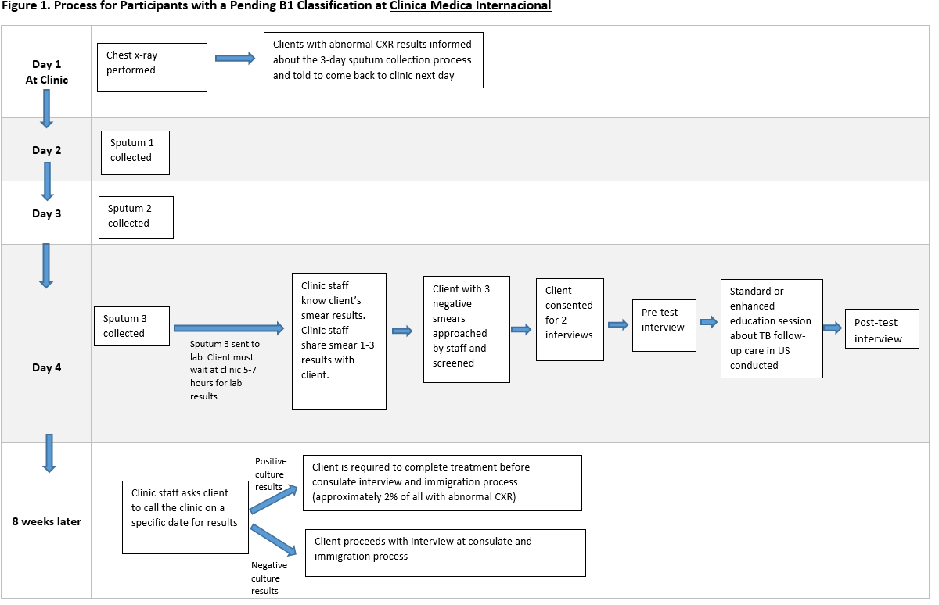

Figure 1 shows the process for participants with a pending B1 classification at CMI. On day one, for clients 15 years of age or older, a chest x-ray is performed. Clients that have an abnormal chest x-ray will receive these results as well as be informed that they will have to undergo a 3-day sputum collection process. The first sputum is collected on Day 2 at the clinic. The second sputum is collected on Day 3 at the clinic and the third sputum is collected on Day 4 at the clinic. On Day 4, after the client provides the third sputum, they must wait 5-7 hours for the laboratory to provide results. Once the clinic staff know the client’s smear results, they will share them with the client. Clients with 3 negative smears will be approached by the project staff (Attachment 8) and if they agree, they will be screened for eligibility (Attachment 9). If the client is eligible, then they will provide consent to participate in the project (Attachment 1).The pre-test interview will then be conducted (Attachment 4), followed by either the standard or enhanced education session about TB follow-up care in the US. Lastly, there will be a post-test interview (Attachment 5). The clinic staff will ask the client to call the clinic 8 weeks after their sputum samples, for the results of their cultures. If the client has positive culture results, they are required to complete treatment before consulate interview and immigration process. Whereas, clients with negative culture results will proceed with interview at the consulate and immigration process.

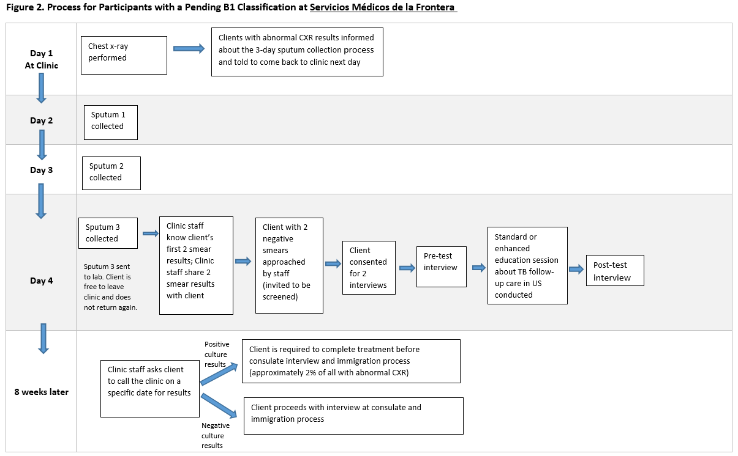

Figure 2 shows the process for participants with a pending B1 classification at SMF. On day one, for clients 15 years of age or older, a chest x-ray is performed. Clients that have an abnormal chest x-ray will receive these results as well as be informed that they will have to undergo a 3-day sputum collection process. The first sputum is collected on Day 2 at the clinic. The second sputum is collected on Day 3 at the clinic and the third sputum is collected on Day 4 at the clinic. On Day 4, after the client provides the third sputum. However, the client is then free to leave the clinic. Once the clinic staff know the client’s first two smear results, they will share them with the client. Clients with 2 negative smears will be approached by the project staff (Attachment 8) and if they agree, they will be screened for eligibility (Attachment 9). If the client is eligible, then they will provide consent to participate in the project (Attachment 1).The pre-test interview will then be conducted (Attachment 4), followed by either the standard or enhanced education session about TB follow-up care in the US. Lastly, there will be a post-test interview (Attachment 5). The clinic staff will ask the client to call the clinic 8 weeks after their sputum samples, for the results of their cultures. If the client has positive culture results, they are required to complete treatment before consulate interview and immigration process. Whereas, clients with negative culture results will proceed with interview at the consulate and immigration process.

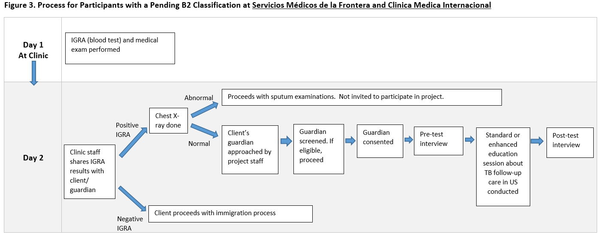

As shown in Figure 3, for clients aged 2 to 14, at both CMI and SMF, the IGRA test is conducted on Day 1 at the clinic. On Day 2, the clinic staff shares IGRA results with the client/guardian. If IGRA is positive, a chest x-ray is performed. If the chest x-ray is abnormal, the client/guardian is excluded from the study because we want to identify and enroll participants on the same day and do not currently have a system of record to accommodate this. If we were to include this group, it could pose a risk to breach confidentiality. If the chest x-ray is normal, once the results are shared with the client/guardian, they will be approached by the project staff (Attachment 10). If the client/guardian agrees they will be screened for eligibility (Attachment 11). If the client/guardian is eligible, then they will provide consent to participate in the project (Attachment 2).The pre-test interview will then be conducted (Attachment 6), followed by either the standard or enhanced education session about TB follow-up care in the US. Lastly, there will be a post-test interview (Attachment 7).

Overall, it is expected that all interviews will be conducted in Spanish and that the consent provided by the client will include the two interviews. Data will be collected using a password-secured tablet (provided to the clinics by DGMQ) using the secure CDC-approved REDCap interface. Interviewers will physically enter responses into the tablet interface while they are conducting the interview, which will last about 15minutes. The tablet will not require wifi access at the time of data collection. If the tablet is unavailable for any reason, the interview can be done on paper. All applicants will receive the same consultation (intervention or standard) based on the time period of their exam, regardless of whether they elect to participate in the interviews.

If clinic staff are unable to conduct the interviews due to clinic management demands, the pilot highlights potential unresolvable challenges to this approach, or if the Principle Investigators determine a better course of action, we will establish an alternative strategy for conducting interviews. Under this revised strategy, two DGMQ staff, who speak fluent Spanish, will conduct the interviews with clients over the phone. Clinic staff will continue to recruit and consent participants. Willing clients will speak to the interviewer via phone. Interviewers will collect and submit the data in the manner outlined above. All interviews will be conducted using the same strategy (i.e., all face-to-face or all over the phone).

No names or other PII will be collected by the interviewers or associated with the responses in any way. The respondent will be assigned a unique identification by REDCap automatically upon starting the pre-test interview to help ensure that the pre- and post-education assessments are associated with the same respondent. In order to ensure that, for the second interview, the unique identification number, is for the same person, the interviews will be done one at a time.

A password-protected online log will be used to document the number, day and time of interviews, interviewer name, and confirmation that consent was gained. Using REDCap to collect and maintain the data will allow the on-site team to upload each interview record upon completion via the facility’s wireless internet connection. Each day, DGMQ project staff will confirm that the REDCap interviews match the on-site log of completed interviews.

*Data collection (Phase 2)*

We will retrieve data from CDC’s EDN system in September 2020. The reporting periods include January 2020- March 2020 for baseline observations (comparison condition) and March 2020- July 2020 for the intervention condition observations. No additional data from individuals will be collected for Phase 2.

**B.3. Methods to Maximize Response Rates and Deal with Non-response**

The following methodology and best practices will be employed to promote efficient enrollment in this voluntary study:

* Informing respondents of what the evaluation project is asking and why it is being asked,
* Using bilingual and bi-cultural facilitators and culturally and linguistically appropriate data collection instruments.
* Addressing data security and anonymity with respondents.
* Minimizing the time needed for participation in the evaluation project.
* Informing respondents how much time the evaluation project will take so that they know what to expect.
* Enrolling the respondents for participation at the same time that they are physically in the clinic waiting to see the clinical staff.
* Completing both interviews on the same day.

**B.4. Test of Procedures or Methods to be Undertaken**

A pilot for phase 1 data collection will be conducted approximately January 2020 at the two panel physician sites in Ciudad Juarez, Mexico (SMF and CMI). To conduct the pilot, the study team will visit the panel physician clinics to conduct orientation and training for the project. At this time, the team will also test and revise the data collection manual, as well pilot the pre-test data collection instruments and make any final adjustments

**B.5. Individuals Consulted on Statistical Aspects and Individuals Collecting and/or Analyzing Data**

This project will use R to conduct all analyses.

The following individuals and institutions, including contractors, provided advice about the protocol design, recruitment methods, and data collection tools:

Kathleen Moser, United States Mexico Unit (USMU) /DGMQ

Heather Joseph, Innovation Development Evaluation Analytics (IDEA)/DGMQ

Leticia Bligh, OTEC/DGMQ

Milan Chuttani, IDEA/DGMQ

Crystal Clements, USMU/DGMQ

Omar DuranPena, USMU/DGMQ

Chris Phares, IRMHB/DGMQ

Deb Lee, IRMHB/DGMQ

Stephanie Morrison, IDEA/DGMQ

Bianka Rubio, USMU/DGMQ

Servicios Medicos de la Frontera (SMF)

Clinica Medica Internacional (CMI)

Brooke Wehrenberg, United States Consulate General Ciudad Juarez

Division of Tuberculosis Elimination, Centers for Disease Control and Prevention

Immigrant, Refugee and Migrant Health, Division of Global Migration and Quarantine

# REFERENCES (APA)

Centers for Disease Control and Prevention. (2018). Tuberculosis (TB) Technical Instructions for Panel Physicians. https://www.cdc.gov/immigrantrefugeehealth/pdf/TB-panel-tech-instructions-h.pdf.

Rosenstock, I.M. (1974). Historical origins of the Health Belief Model. *Health Education Monographs,* 2, 328-335.

Janz, N.K., Becker M.H. (1984). The Health Belief Model: a decade later. *Health Education Quarterly. 11*(1), 1-47.

Carpenter, C. (2010). A meta-analysis of the effectiveness of Health Belief Model variables in predicting behavior. *Health Communication. 25*(8), 661-669.

Montano, D.E., Kasprzyk, D. (2002). The theory of reasoned action and the theory of planned behavior. In Health Behavior and Health Education: Theory, Research, and Practice. Eds. Karen Glanz, Barbara K. Rimer, and Frances Marcus Lewis. 68-98.

Fishbein, M. (1967). Readings in Attitude Theory and Measurement. New York; Wiley.

Ajzen, I. (1991). The theory of planned behavior. *Organizational behavior and human decision processes*, 50, 179-211.

Centers for Disease Control and Prevention. (2018). Burden of TB in the United States. https://www.cdc.gov/features/burden-tb-us/index.html

Ibid.

Centers for Disease Control and Prevention. (2018). Latent TB Infection in the United States – Published Estimates. https://www.cdc.gov/tb/statistics/ltbi.htm

Centers for Disease Control and Prevention. (2018) Reported Tuberculosis in the United States, 2017. https://www.cdc.gov/tb/statistics/reports/2017/table19.htm

Statistic calculation: Total foreign-born cases (6385) / Total cases (9105)

Liu, Yecai & Painter, John & Posey, Drew & P Cain, Kevin & S Weinberg, Michelle & Maloney, Susan & S Ortega, Luis & Cetron, Martin. (2012). Estimating the Impact of Newly Arrived Foreign-Born Persons on Tuberculosis in the United States. PloS one. 7. e32158. 10.1371/journal.pone.0032158.

Ibid.