**Attachment 13: B2 Photo Novella Storyboard**

These are examples of different types of texts in the novella:

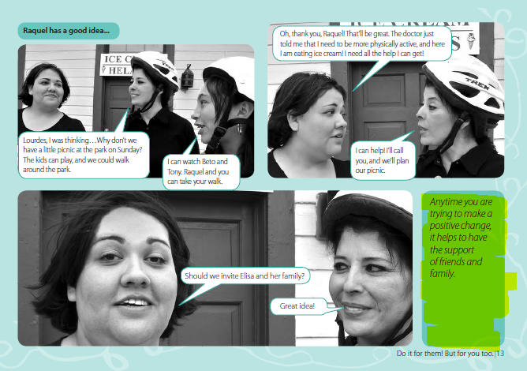

**Block Text:** this is general text that will appear in the photo novella on the side of the visuals.

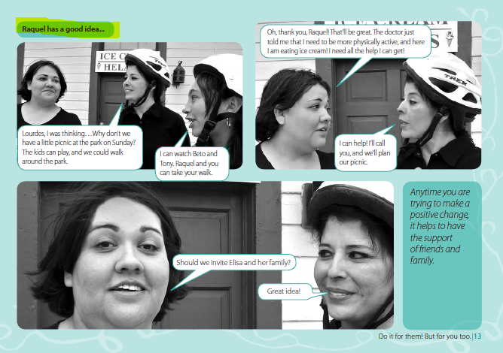

**Photo Caption:** this is the caption that helps the reader transition between different settings/ scenes.

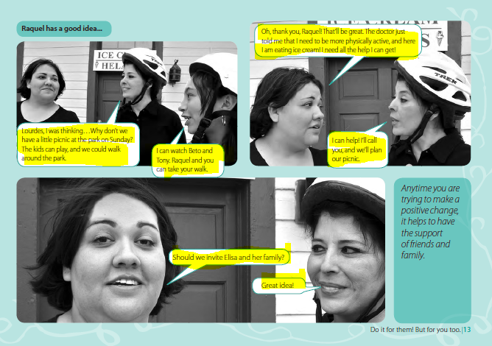

**Bubble Text**: this is the text that shows what the characters are saying.

*Filming and photoshoot will take place in the United States. There are some scenes in the story that take place in Mexico, However, there will be no filming or a photoshoot in Mexico. The scenes in Mexico will be staged and produced in the U.S.

|  |  |
| --- | --- |
| **Visuals and Description** | **Text in Novella** |
| Title Page with image of all characters looking happy with a neutral background (ie. park, in front of a home etc). | Title:  **Moving to the United States: Things to know about Tuberculosis (TB) Testing and Treatment**  CDC logo |
| [1]      [2] | **Photo Caption:** Introduction  This is the story of Manuel Castillo and his mom Carla. They are moving from Mexico to the United States. Before leaving Mexico, they need to visit a doctor to get all the necessary medical evaluations and clearances as part of their pre-immigration check-up.  Manuel’s mom finds out that he has tuberculosis infection and that she will need to contact the health department in the United States for him once they arrive in the U.S.  This is their story. [Show 5 step process]  **Block Text:**  This is Manuel Castillo. He is 10 years old. He is from Mexico. He and his mom just found out that he has tuberculosis infection.  This is Carla Castillo. She is Manuel’s mom. She just found out that her son has tuberculosis infection.  This is Doctor Fernandez. He is the doctor that did Manuel’s pre-immigration checkup for tuberculosis at the immigration clinic in Mexico.  This is Officer Lee. She works at the United States, Mexico border. Her job is to screen travelers coming into the United States. She checks their documents to make sure they are following immigration and customs laws.  This is Doctor Smith. She works at the health department in California. |
| Frame 1: Manuel, and Carla are in the kitchen, Manuel is eating a snack and his mom is sitting down at the table. | **Photo Caption:** At home in Mexico  **Bubble Text:**  Carla: Manuel, since we are moving to California, you need to get your medical checkup. I already had my appointment, and I scheduled your appointment for next week. |
| Frame 2: Image of Manuel, Carla walking into the clinic.    Source: <https://www.google.com/search?q=Clinica+Medica+Internacional&source=lnms&tbm=isch&sa=X&ved=0ahUKEwi8vNDK8-jgAhUOy1kKHVbsBasQ_AUIECgD&biw=1344&bih=746#imgrc=skLVCVPU3lTryM:&spf=1551716817500>  Frame 3: Image of TB germs coming out of someone’s mouth as they cough.    Source: <https://www.cdc.gov/tb/publications/posters/images/StopTBlarge.pdf> | **Photo Caption:** At the Clinic in Mexico  **Block Text:** For your move to the United States, you and your child were required to get a medical exam at an immigration clinic in Mexico. During the medical exam, the doctor tested you and your child for tuberculosis.  **Block Text:**  **Anyone can get TB.** Tuberculosis, or TB, is a serious disease caused by a germ that usually affects the lungs. It is spread from person to person through the air by someone with TB disease. If left untreated, tuberculosis can cause serious illness and even death |
| Frame 4: Manuel and Carla in Dr. Fernandez’s clinic office. Having Dr. Fernandez put the stethoscope to Manuel’s chest    Frame 5: Manuel getting his blood drawn. | **Block Text:**  Like Manuel, your child had a medical checkup and a few tests done at the immigration clinic in Mexico.  During the checkup you were asked questions about your child’s health, and your child was given a physical examination and had a blood test done. If the blood test showed TB infection, your child had a chest x-ray performed.  **Bubble Text:**  **Dr. Fernandez**: Today, we are going to do several tests that are required before your move to the US. |
| Frame 6: Manuel getting an x-ray. | **Photo Caption:** The Results  **Bubble Text:**  **Dr. Fernandez**: Because Manuel has a positive TB blood test, we need to do a chest x-ray. A positive blood test means Miguel has TB germs in his body. |
| Figure 2 Healthy Manuel  Figure 1 Sick Manuel  Source:  [https://sntc.medicine.ufl.edu/Files/Products/UFtuberculosis%20English%20Flyer.pdf](https://sntc.medicine.ufl.edu/Files/Products/UFTB%20English%20Flyer.pdf)  Source: [https://sntc.medicine.ufl.edu/Files/Products/UFtuberculosis%20English%20Flyer.pdf](https://sntc.medicine.ufl.edu/Files/Products/UFTB%20English%20Flyer.pdf)  Two similar images of Manuel appear with a white background, focusing only on Manuel  Frame 7: One image shows Manuel happy and healthy with a friendly posture.  Frame 8: Other image show’s Manuel coughing and looking ill. | **Photo Caption:** Types of tuberculosis  **Block Text:**  In the United States, tuberculosis is also referred to as “TB.” There are two TB-related conditions that exist: tuberculosis infection and tuberculosis disease.  **Tuberculosis Infection:** People with TB infection have tuberculosis germs that are inactive in their body. This is sometimes also known as “sleeping or dormant tuberculosis.” People with TB infection do not have symptoms, do not feel sick, and cannot spread the TB germ to others.    Some people with TB infection may get sick and develop TB disease in the future if they don’t get treated.  **Tuberculosis Disease:**  TB disease develops from TB infection. TB germs multiply and grow in the body. People with TB disease often have a cough, fever, or other symptoms, but some people can have no symptoms at all. People with active TB disease are able to spread TB germs to people they spend a lot of time with, such as family, friends, and co-workers.  . |
| Frame 9: Headshot of Dr. Fernandez  cid:image001.png@01D4BC99.5A008A30  Frame 10: Image of Carla looking relieved  Frame 11: Image of Manuel, Carla and Dr. Fernenadez in the clinic office together. | **Bubble Text:**  Dr. Fernandez: Manuel has sleeping or inactive tuberculosis, also called TB infection. He will be allowed to travel to the U.S., but during the first 30 days after you get to California you should contact the health department. They will do a TB check-up and make sure things have not changed and help you get treatment to prevent his TB infection from becoming TB disease.  **Block Text:**  Treatment for TB infection can be as short as 3 months of medication, which should keep your child from developing TB disease later in life.  **Bubble Text:**  **Carla**: We are so glad to hear that! Will this change our plans to move to California?  **Dr. Fernandez**: Based on his results, he has a TB medical classification of B2. This simply means that he has TB infection, and he is at risk of developing TB disease in the future.  This will not prevent you and Manuel from moving to California, but it is important that you contact the local health department when you arrive so he can have another TB checkup. |
| Frame 12: Manuel and Carla walking into a building that looks like the Mexican consulate building. | **Photo Caption:** The United States Consulate Interview in Mexico |
| Source: <https://nation.com.pk/digital_images/large/2016-11-23/1479923162-6417.jpg>    Source: <https://101clipart.com/wp-content/uploads/02/Office%20Work%20Clipart%2005.jpg>  Frame 13: Manuel and Carla being interviewed at the consulate office. They are standing at the window and the image shows Manuel and Carla one side of the window and the consulate officer on the other. The consulate officer should be working on a computer when asking for updated information. This will be one image combining these two examples. | **Block Text:** After your child’s clinic visit, you will go to the consulate to continue your migratory process. You will need toprovide an address, a phone number, and an e-mail of where you and your child can be reached in the United States.  The consulate will update your contact information and send it to a health department in the United States so that they will have your information.  **Bubble Text:**  **Consulate Officer: To** where will you be moving to in the United States?  **Carla:** We will be staying with my brother Juan in California. His address is 456 Merry Lane, New Town, CA and our phone number is (111) 875-4321. Please use his email, which is JUSA@xmail.com. |
| Frame 14: Manuel and Carla arriving at the United States Port of Entry (ATL Quarantine Station) seen walking toward the CBP officer. | **Photo Caption:** At the United States Port of Entry  **Block Text:** When you arriveat the port of entry, the agent may ask you about your child’s B classification for TB. Don’t worry, you and your child can still enter United States. |
| Frame 15: Officer asking questions and making updates on a computer screen. Carla will be in the frame answering the questions. | **Block Text:** This is a good time to update your address, phone number and e-mail so that the health department in the United States will have your child’s current information.  **Bubble Text:**  **Officer Lee:** What is your new home address, phone number, and e-mail?  **Carla:** Nothing has changed. My address will be 456 Merry Lane, New Town, CA. And the phone and email are also the same. |
| Frame 16: Headshot of Officer | **Bubble Text:**  **Officer Lee:** Based on the address you gave me, the local health department will be notified of your arrival and will electronically receive your child’s medical records. It’s important that you contact the health department within the next 30 days to make an appointment for your son. |
| Frame 17: Show a screen shot of a phone with the directory home page  Source: https://i0.wp.com/cdn.vectorstock.com/i/1000x1000/96/75/cartoon-image-of-cellphone-icon-smartphone-vector-15659675.jpg?resize=700%2C1080&ssl=1    Frame 18: Carla at her home in the United States. They are sitting down at a table. Carla is on the phone with someone from the health department.  Frame 19: The person at the health department is sitting at their desk in the local health department. They are on the phone with Carla. Change screen to say “Health Department” and not “Departamento de Salud” | **Photo Caption:** In the United States  **Block Text:** To contact the health department go to this website (insert directory web address). If your address changes after you move to the United States, this web site can help you contact the right place.  **Block Text:**  Most TB follow up care will be free or at a low cost. Financial assistance may be available but check with the clinic that sees your child.  **Block Text:**  Once in the United States, contact the local health department within the first 30 days of arrival to make an appointment for your child. Health departments may not always have Spanish-speaking staff, so if possible, have someone who you trust with your child’s medical information and who speaks English make the first call.  The health system in the United States is different from the Mexican health system. It is important to contact the local health department. You should not go directly to a private doctor, clinic, or hospital for your TB checkup. The health department in the United States can provide or direct you to the services you need for your child’s TB checkup.  **Bubble Text:**  **Carla:** We just moved to California. I have a child with a tuberculosis class B2 condition, and I want to schedule an appointment for his checkup.  **Person at the local health department:** Ok! How does next week sound? |
| Frame 20: Manuel and Carla arriving at the local health department in the United States. (Make sure it does not look like a hospital) | **Photo Caption:** At the clinic in the United States. |
| Frame 21: Carla talking to the US doctor at the local health department in a patient check-up room.  Frame 22: Manuel getting another medical test (blood draw). | **Bubble Text:**  **Carla:** We just moved to the United States and we wanted to follow-up to make sure that everything is ok with my son.  **Dr. Smith:** Of course! Don’t be concerned. I’m going to ask you a few questions to know if your son needs any more tests and so that I can recommend the best treatment for Manuel. |
| Frame 23: Image of Dr. Smith giving Carla the TB medication. | **Bubble Text:**  **Dr. Smith:** Manuel’s blood test was positive, and his lung x-ray was normal. He is not sick but should take this medicine to prevent him from developing TB disease in the future.Be sure to follow all instructions. This medicine will help keep both Manuel and your family healthy.  **Carla**: Yes, I will make sure that he takes his medicine. I want him to be healthy.  **Block Text:** For more information on tuberculosis you can visit….  To locate a health department clinic, go to… |
| Frame 24: Image of Manuel and Carla together smiling with Dr. Smith |  |
| This will be the last page of the graphic novel. | **Block Text:**  See “For More Information” document. |

See next page

* Immigration Checkup Process for: Things to Know

**Immigration Checkup Process for: Things to Know**

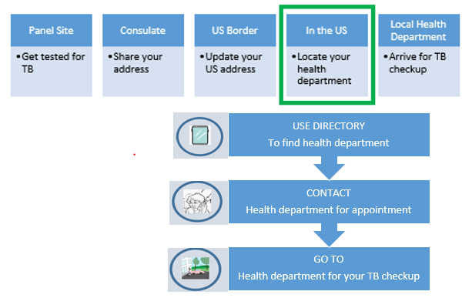[3]

**Remember: You will need to go to the health department for your tuberculosis checkup within 30 days of your arrival.**

**Finding the Health Department:**

To find a health department clinic go to this website (insert directory web address).

**Service Fees at the Local Health Department:**

You can ask the health department about the cost of their services. Many health departments offer free or low-cost services.

**Spanish Language Services:**

Many health departments have staff who speak Spanish, but some do not. If possible, have someone who speaks English help you make the first appointment and come with you to that appointment

**First Medical Exam in Mexico:**

The medical evaluation in Mexico checks to see if your child has any type of tuberculosis (TB). During your child’s checkup they will have blood drawn and potentially have an x-ray done to test for tuberculosis.

**Second Medical Evaluation in the United States:**

The medical evaluation in the United States makes sure your child does not have future problems with TB. Although your child’s current tests for TB are negative, he or she could still have the infection in their body which could become TB disease.

**The Difference Between Tuberculosis Infection and Tuberculosis Disease:**

Not everyone infected with TB becomes sick. There are two TB conditions: TB infection and TB disease. TB infection is sometimes called “sleeping tuberculosis” or “inactive tuberculosis.” Doctors also refer to this as Latent TB Infection or LTBI. People with TB infection do not have symptoms and cannot spread TB bacteria to others. However, people with TB infection should get treatment to prevent it from turning into TB disease. TB disease is sometimes called “active tuberculosis.” TB disease is when tuberculosis bacteria multiply in your body and cause sickness. People with active TB may spread tuberculosis to people they spend time with every day such as friends and family. Symptoms of TB disease include coughing, fever, sweating at night, and weight loss. But some people don’t develop these symptoms until they are in the advanced stage of illness. TB can also occur in other parts of the body like the brain, kidneys and spine.

1.
2. THE FOLLOWING TEXT CHANGES WILL BE MADE TO THE GRAPHIC:

   Immigration Clinic: Add: Confirm your US address, email, and phone number.

   Consulate: Update or confirm your US address, email, and phone number.

   US border: Same as for consulate.

   In the US: Locate and contact….

   Health department: Go to the clinic recommended by the health department for your TB checkup
3. THE FOLLOWING TEXT CHANGES WILL BE MADE TO THE GRAPHIC:

   Immigration Clinic: Add: Confirm your US address, email, and phone number.

   Consulate: Update or confirm your US address, email, and phone number.

   US border: Same as for consulate.

   In the US: Locate and contact….

   Health department: Go to the clinic recommended by the health department for your TB checkup.