Attachment 15: Directory
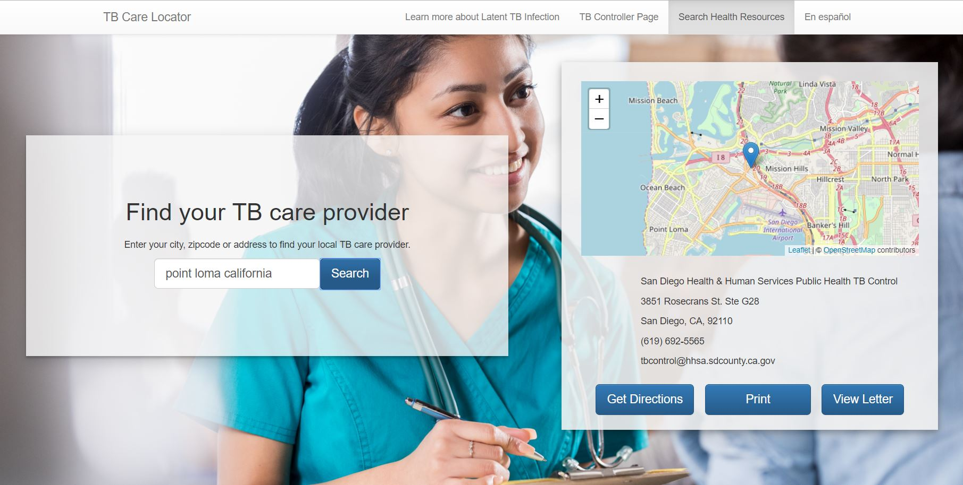

Figure 1: This screenshot is an example of what TB care directory users may see if they search a location in San Diego County. Users of the directory include panel physicians and immigrants.
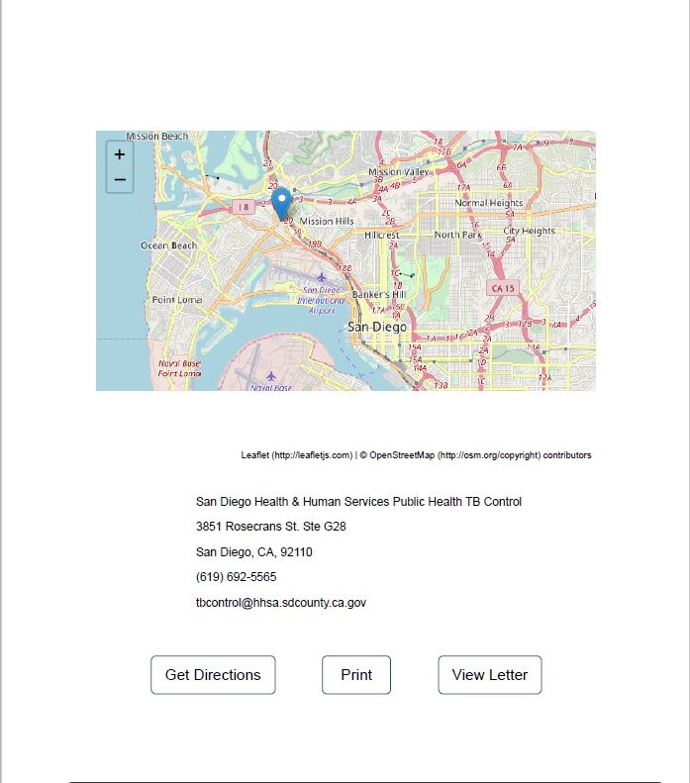
Figure 2: The screenshot shows an example printout from the directory that may be given to immigrants with B1 or B2 TB classifications during the education session. The printout may also include letters from TB control programs in their US destinations if applicable.

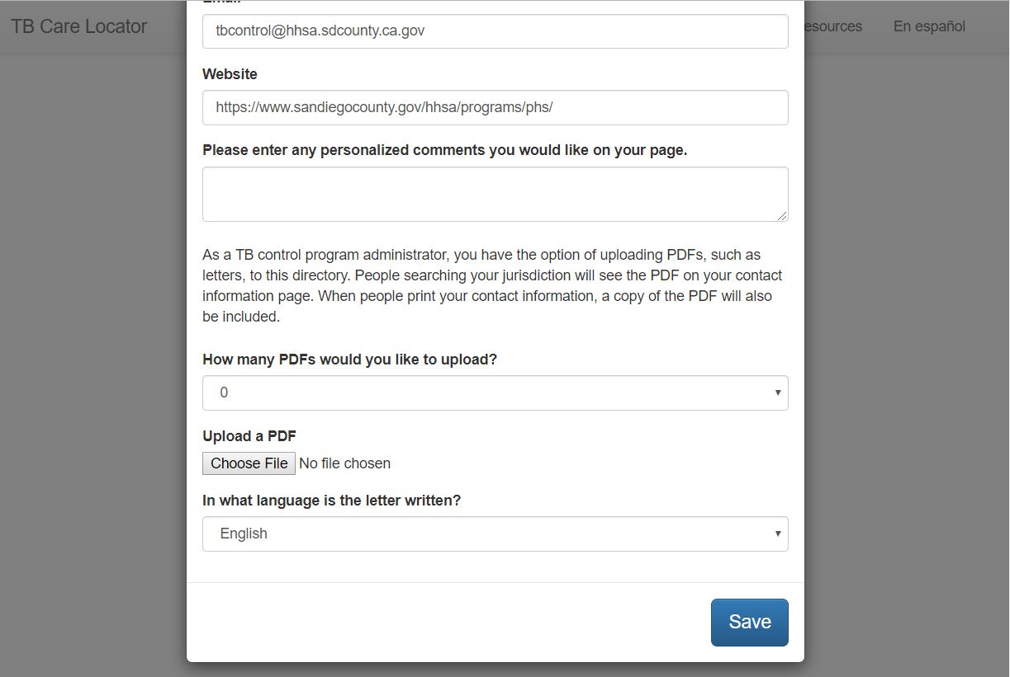
Figure 3: The screenshot above shows the form TB controllers may use to upload their contact information to the directory. Only authorized TB control program staff may edit information on the site.

