Attachment 12: B1 Photo Novella Storyboard
These are examples of different types of texts in the novella:
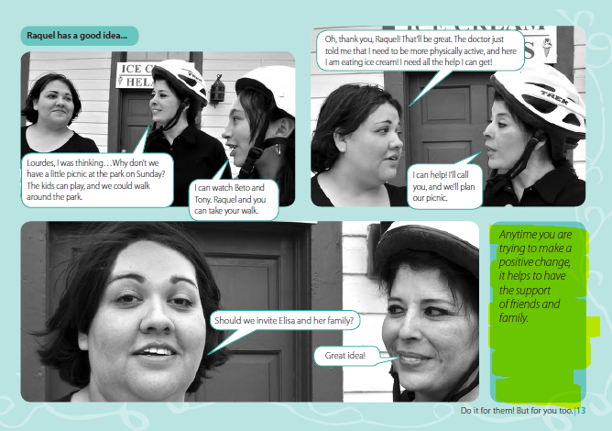
Block Text: this is general text that will appear in the photo novella on the side of the visuals.
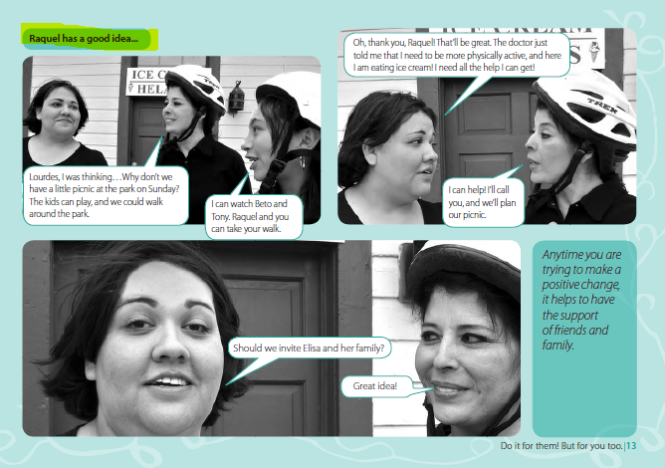
Photo Caption: this is the caption that helps the reader transition between different settings/ scenes.
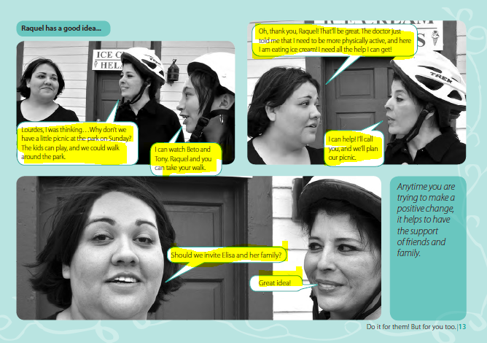
Bubble Text: this is the text that shows what the characters are saying.
*Filming and photoshoot will take place in the United States. There are some scenes in the story that take place in Mexico, However, there will be no filming or a photoshoot in Mexico. The scenes in Mexico will be staged and produced in the U.S.
Visuals and Description | Text in Novella
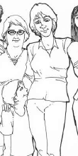  Title Page with image of all characters looking happy with a neutral background (ie. park, in front of a home etc). | Title:  Moving to the United States: Things to know about Tuberculosis (TB) Testing and Treatment  CDC logo
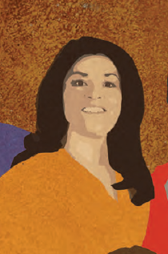  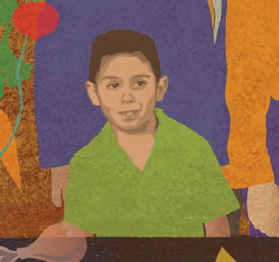  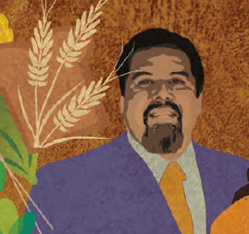  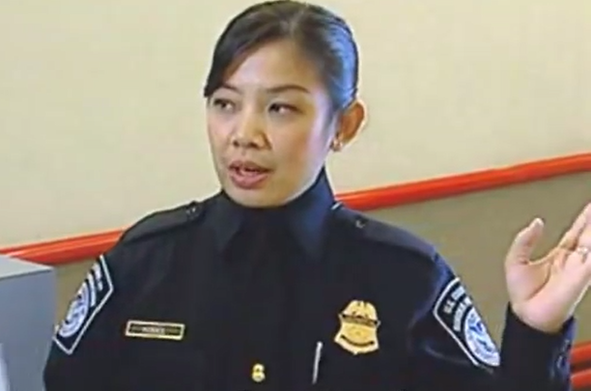  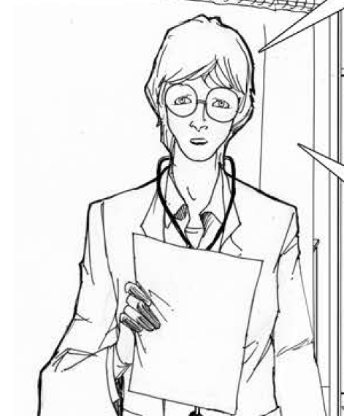 | Photo Caption: Introduction  This is the story of Raquel Martinez and her son Jose. They are moving from Mexico to the United States. Before leaving Mexico, they need to visit a doctor to get all the necessary medical evaluations and clearances as part of their pre-immigration check-up.  As part of the immigration process, Raquel and Jose are tested for tuberculosis.  Raquel finds out that she has an abnormal chest x-ray which indicates that she has tuberculosis germs in her body, and she will need to contact the health department in the United States to follow up and for further medical evaluations.  This is their story on how they immigrated to the United States. [Show 5 step process]  Block Text:  This is Raquel Martinez. She is from Mexico and just found out that she has an abnormal lung x-ray that could indicate that she has tuberculosis (TB). She has one son, Jose.  This is Jose Martinez, Raquel’s son. He is 5 years old.  This is Doctor Fernandez. He is the doctor that did Raquel’s pre-immigration checkup for tuberculosis (TB) at the immigration clinic in Mexico.  This is Officer Lee. She works at the United States-Mexico border. Her job is to process travelers coming into the United States. She checks their documents to make sure they are following immigration and customs laws.  This is Doctor Smith. She works at the health department in California.
Frame 1: Raquel and Jose are in the kitchen, Jose takes a bite of his sandwich and Raquel places her hand on Jose’s back in a comforting way as she speaks to him.   | Photo Caption: At home in Mexico  Bubble Text:  Raquel: Jose, since we are moving to California, we need to get a medical checkup. Our appointments are next week.
Frame 2: Image of Raquel and Jose walking into the clinic.  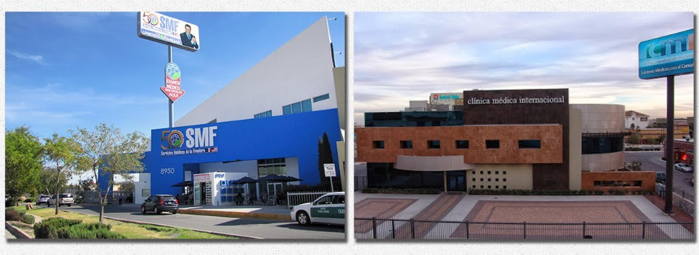  Source: https://www.google.com/search?q=Clinica+Medica+Internacional&source=lnms&tbm=isch&sa=X&ved=0ahUKEwi8vNDK8-jgAhUOy1kKHVbsBasQ_AUIECgD&biw=1344&bih=746#imgrc=skLVCVPU3lTryM:&spf=1551716817500  Frame 3: Image of TB germs coming out of someone’s mouth as they cough.  Source: https://www.cdc.gov/tb/publications/posters/images/StopTBlarge.pdf | Photo Caption: At the clinic in Mexico  Block Text: For your move to the United States, you and your child are required to get a medical exam at an immigration clinic in Mexico. During the medical exam, the doctor tested you for tuberculosis.  Block Text: Anyone can get TB. Tuberculosis, or TB, is a serious disease caused by a germ that is spread through the air and usually affects the lungs. It is spread from person to person through the air by someone with TB disease. If left untreated, tuberculosis can cause serious illness and even death.
Frame 4: Raquel and Jose in Dr. Fernandez’s clinic office. Having Dr. Fernandez put the stethoscope to Raquel’s chest  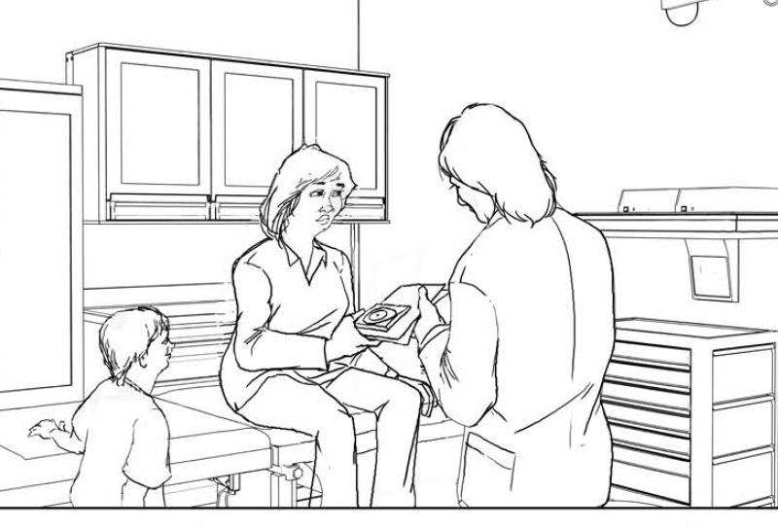  Frame 5: Raquel getting an x-ray.  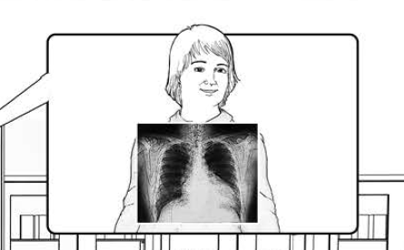 | Bubble Text:  Dr. Fernandez: Today, we are going to do several tests that are required before your move to the US, including a lung x-ray to look for signs of tuberculosis.
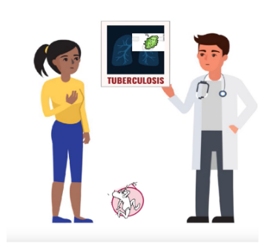  Source: CDC 5 Things Video  Source: http://s3.amazonaws.com/lowres.jantoo.com/medical-colds-influenxa-micro_organism-microorganism-germs-946037113_low.jpg  Frame 6: Interaction between Dr. Fernandez and Raquel  Show Raquel worried and Dr. Fernandez offering caring reassurance. Dr. Fernandez shows Raquel’s x-ray  Frame 7: Raquel giving a phlegm sample.  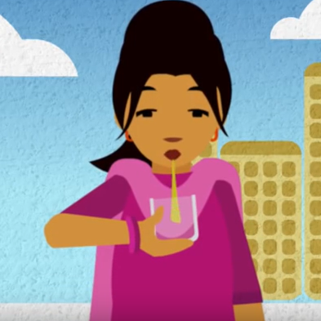  Source: https://www.youtube.com/watch?v=92dT_1kbbek&feature=youtu.be | Photo Caption: The Results  Bubble Text:  Dr. Fernandez: You have an abnormal lung x-ray that shows you might have tuberculosis disease or are at risk of developing tuberculosis disease. Now, you need to provide phlegm samples to see if you have tuberculosis.  Block Text:  Like Raquel, you had a medical checkup and tests done at the immigration clinic in Mexico.  During your checkup you were asked questions about your health, had a physical examination, and had a lung x-ray. Because your lung x-ray was abnormal, you were asked to give phlegm samples to test for tuberculosis.
Figure 2 Healthy Raquel  Figure 1 Sick Raquel  Source:  https://sntc.medicine.ufl.edu/Files/Products/UFtuberculosis%20English%20Flyer.pdf  Source: https://sntc.medicine.ufl.edu/Files/Products/UFtuberculosis%20English%20Flyer.pdf  Two similar images of Raquel appear with a white background, focusing only on Raquel.  Frame 8: One image shows Raquel happy and healthy with a friendly posture.  Frame 9: Other image show’s Raquel coughing and looking ill. | Photo Caption: Types of Tuberculosis  Block Text:  In the United States, tuberculosis is also referred to as “TB.” There are two TB-related conditions that exist: tuberculosis infection and tuberculosis disease.  Tuberculosis Infection People with TB infection have tuberculosis germs that are inactive in their body. This is sometimes also known as “sleeping tuberculosis.” People with TB infection do not have symptoms, do not feel sick, and cannot spread the TB germ to others.  Some people with tuberculosis infection may get sick and develop TB disease in the future if they don’t get treated.  Tuberculosis Disease:  TB disease develops from TB infection. TB germs multiply and grow in the body. People with TB disease often have a cough, fever, or other symptoms, but some people can have no symptoms at all. People with active TB disease are able to spread TB germs to people they spend a lot of time with, such as family, friends, and co-workers.
Frame 10: Headshot of Dr. Fernandez  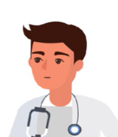  Frame 11: Image of Raquel looking relieved  Frame 12: Image of Raquel, Jose and Dr. Fernenadez in the clinic office together. | Bubble Text:  Dr. Fernandez: Don’t worry, you probably have sleeping or inactive TB, also called TB infection.  Treating TB infection is effective and can prevent you from developing TB disease, which can be very serious and can be spread to others around you.  Bubble Text:  Raquel: I’m so glad to hear that! Will this change my plans to move to the United States?  Dr. Fernandez: Probably not, but you will have to wait for the results of your phlegm tests. It takes about 8 weeks to get a final phlegm test result.  Even though your chest x-ray is abnormal, it is most likely you have TB infection. This means that once we have your phlegm test results you will be given a TB classification of B1, and you will be able to move to the US. When you get to the U.S., you need to contact the health department.  Block Text:  If you have TB infection, you are at risk for developing TB disease. That is why it is very important that you get treatment once you are in the US. Treatment for TB infection can be as short as 3 months, which can keep you TB-free. After you get to your destination in the US, you should contact the health department. They will help you get the treatment that’s right for you.
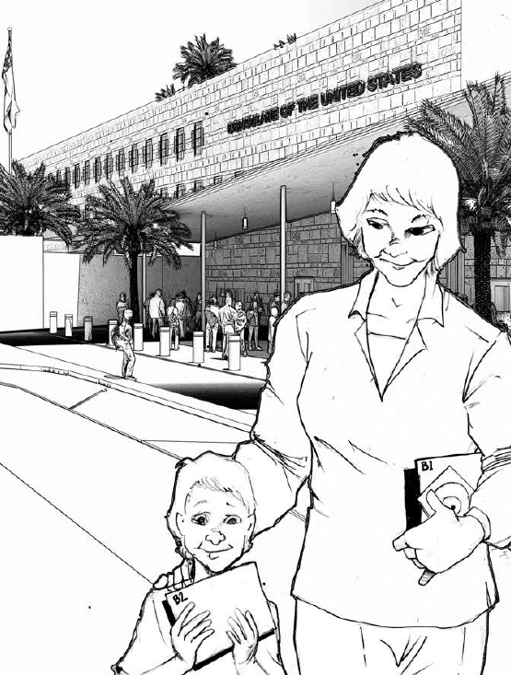  Frame 13: Raquel and Jose walking into a building that looks like the Mexican consulate building. | Photo Caption: The Consulate Interview in Mexico
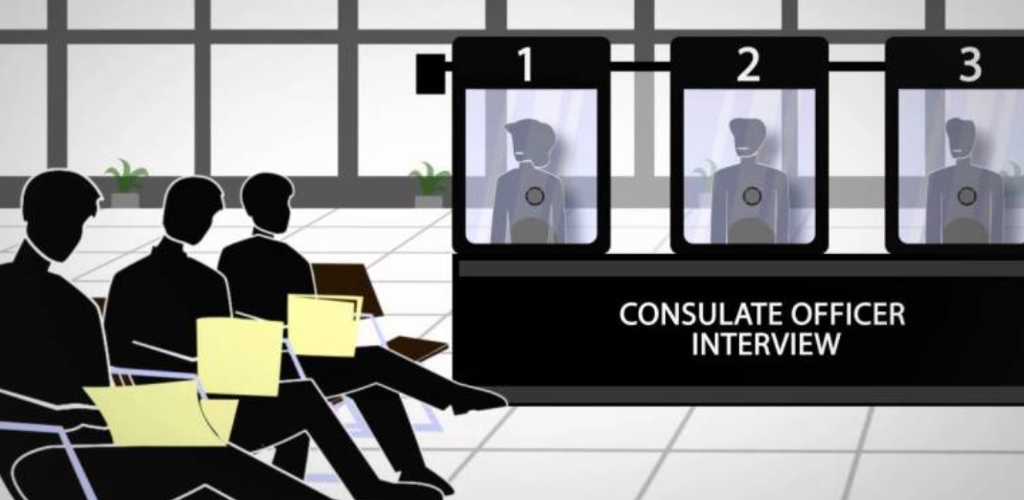  Source: https://nation.com.pk/digital_images/large/2016-11-23/1479923162-6417.jpg    Source: https://101clipart.com/wp-content/uploads/02/Office%20Work%20Clipart%2005.jpg  Frame 14: Raquel and Jose being interviewed at the consulate office. They are standing at the window and the image shows Raquel and Jose on one side of the window and the consulate officer on the other. The consulate officer should be working on a computer when asking for updated information. This will be one image combining these two examples. | Block Text: If you are notified that there is no TB disease in your phlegm, then you will be given a TB classification of B1 and you will go to the consulate for final immigration review. You will need to provide an address, a phone number and an e-mail of where you can be reached in the United States.  The consulate will update your contact information and send it to a health department in the United States, so that they will have your information.  Bubble Text:  Consulate Officer: To where will you be moving to in the United States?  Raquel: We will be staying with my brother Juan in California. His address is 456 Merry Lane, New Town, CA and our phone number is (111) 875-4321. Please use his email, which is JUSA@xmail.com
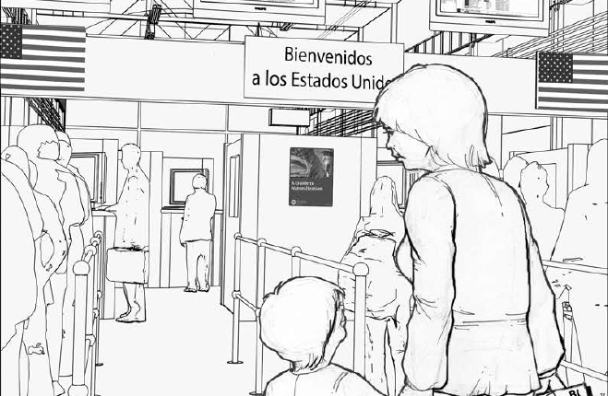  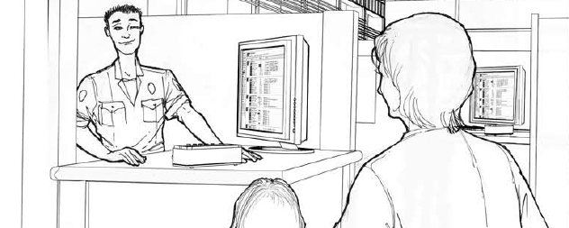 | Photo Caption: At the United States Port of Entry  Block Text: When you arrive at the port of entry, the agent may ask you about your B1 classification for tuberculosis. Don’t worry, you can still enter the United States.
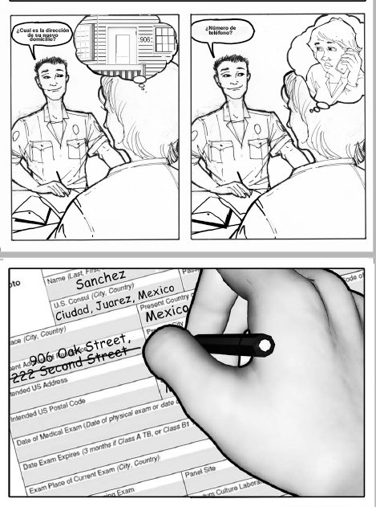  Frame 15: Officer asking questions and making updates on a computer screen. Raquel will be in the frame answering the questions. | Block Text: This is another good time to update your address, phone number, and e-mail so that the health department in the United States will have your most current information.  Bubble Text:  Officer Lee: What is your new home address, phone number, and e-mail?  Raquel: It has not changed. My address will be 456 Merry Lane, New Town, CA. The phone and email are also the same.
Frame 16: Headshot of Officer | Bubble Text:  Officer Lee: Based on the address you gave me, the health department in your area will be notified of your arrival and will electronically receive your TB medical records. It’s recommended that you contact the health department to make an appointment within the next 30 days.
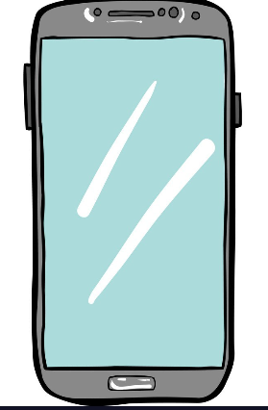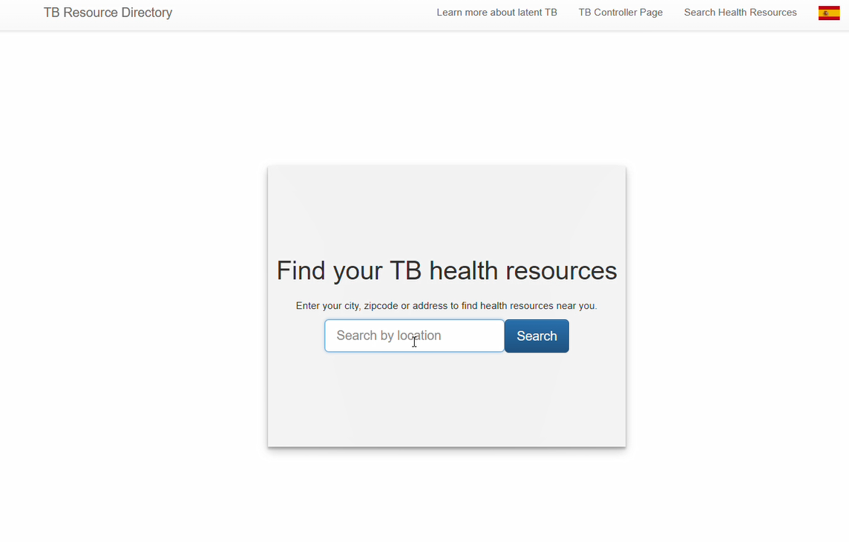  Frame 17: Show a screen shot of a phone with the directory home page  Source: https://i0.wp.com/cdn.vectorstock.com/i/1000x1000/96/75/cartoon-image-of-cellphone-icon-smartphone-vector-15659675.jpg?resize=700%2C1080&ssl=1  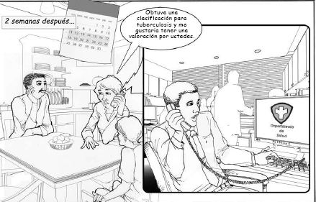  Frame 18: Raquel and Jose at their home in the United States. They are sitting down at a table. Raquel is on the phone with someone from the health department.  Frame 19: The person at the health department is sitting at their desk. They are on the phone with Raquel. Change screen to say “Local Health Department” and not “Departamento de Salud” | Photo Caption: In the United States  Block Text: To contact the health department go to this website (insert directory web address). If your address changes after you move to the United States, this web site can help you contact the right place.  Block Text:  Most TB follow up care will be free or at a low cost. Financial assistance may be available but check with the clinic where you make your appointment.  Block Text:  Once in the United States, contact the health department during the first 30 days of your arrival to make an appointment. Health departments may not always have Spanish-speaking staff. If possible, have someone whom you trust with your medical information and who speaks English make the first call.  The health system in the United States is different from the Mexican health system. It is important to contact the health department. You should not go directly to a private doctor, clinic, or hospital for your TB checkup the health department in the United States can provide or direct you to the services you need for your TB checkup.  Bubble Text:  Raquel: I just moved to California and was instructed to call the health department when I arrived. I have a tuberculosis class B1 condition for TB infection, and I would like to schedule an appointment.  Person at the local health department: Ok! How does next week sound?
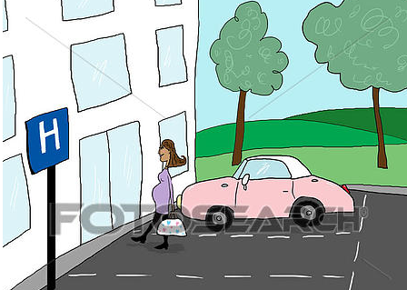  Frame 20: Raquel arriving at the health department in the United States. (Make sure it does not look like a hospital) | Photo Caption: At the health department in the United States.
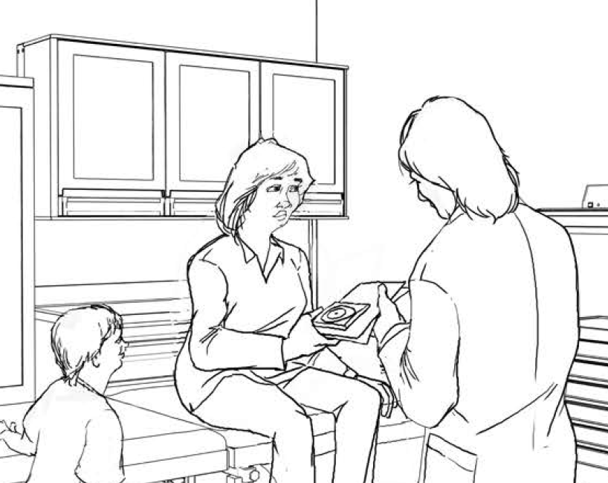  Frame 21: Raquel talking to the US doctor at the local health department in a patient check-up room.  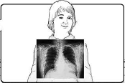  Frame 22: Raquel getting another medical test (x-ray). | Bubble Text:  Raquel: We just moved to the United States, and I hope to start working soon, but I was told to make sure to follow-up for my abnormal x-ray for TB to make sure that everything is ok. I have a tuberculosis class B1 condition for TB infection.  Dr. Smith: Of course! Don’t be scared. I am going to do a few medical tests so that I can recommend the best treatment for you.
Frame 23: Image of Dr. Smith giving Raquel medication. | Bubble Text:  Dr. Smith: Your results show that your x-ray hasn’t changed since the one you got in Mexico and that you have TB infection. We are recommending that you take medicine to prevent developing tuberculosis disease in the future. If you develop TB disease, you could spread it through the air to those who are closest to you. This medicine will help keep you and your family healthy.  Raquel: Yes, I will be sure to take my medicine. I want to be healthy for myself and not give TB to my son.  Block Text: For more information on tuberculosis you can visit….  To locate a health department clinic visit…
Frame 24: Image of Raquel and Jose together smiling with Dr. Smith
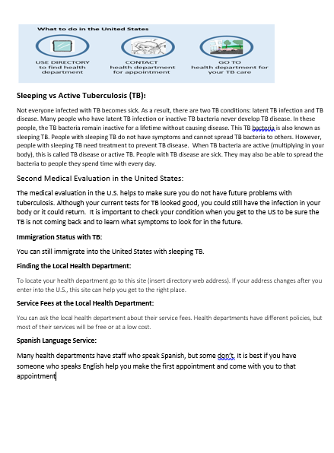  This will be the last page of the graphic novel. | Block Text: See “For More Information” document.

See next page
- Immigration Checkup Process for : Things to Know

Immigration Checkup Process for: Things to Know
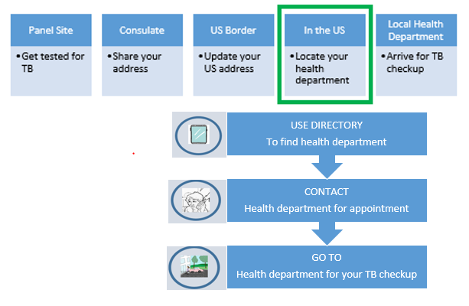
Remember: You should contact the health department for your tuberculosis checkup within 30 days of your arrival.
Finding the Health Department:
To find your health department go to this website (insert directory web address).

Service Fees at the Local Health Department:
You can ask the health department about the cost of their services. Many health departments offer free or low-cost services.

Spanish Language Services:
Many health departments have staff who speak Spanish, but some do not. If possible, have someone who you trust with your medical information and speaks English help you make the first appointment and come with you to that appointment.

First Medical Exam in Mexico:
The medical exam in Mexico checks to see if you have any type of tuberculosis (TB). During your checkup you will have a chest x-ray. If the chest x-ray is abnormal, you will give mucous phlegm samples to test for tuberculosis.

Second Medical Exam in the United States:
The medical exam in the United States makes sure you do not have future problems with tuberculosis. Even if your immigration exam for TB looked good, you still have the tuberculosis infection in your body, or it could develop into TB disease. It is important that they check your condition when you get to the US to be sure the tuberculosis germ is not growing in your body. The doctor will determine the best treatment plan for you.

The Difference Between Tuberculosis Infection and Tuberculosis Disease:
Not everyone infected with TB becomes sick. There are two TB conditions: TB infection and TB disease. TB infection is sometimes called “sleeping tuberculosis” or “inactive tuberculosis.” Doctors also refer to this as Latent TB Infection or LTBI. People with TB infection do not have symptoms and cannot spread tuberculosis bacteria to others. However, people with TB infection should get treatment to prevent it from turning into TB disease. TB disease is sometimes called “active tuberculosis.” TB disease is when tuberculosis bacteria multiply in your body and cause sickness. People with active TB disease may spread tuberculosis to people they spend time with every day such as friends and family. Symptoms of TB disease include coughing, fever, sweating at night, and weight loss. But some people don’t develop these symptoms until they are in the advanced stage of illness. TB can also occur in other parts of the body like the brain, kidneys and spine.

THE FOLLOWING TEXT CHANGES WILL BE MADE TO THE GRAPHIC: - Immigration Clinic: Add: Confirm your US address, email, and phone number. - Consulate: Update or confirm your US address, email, and phone number. - US border: Same as for consulate. - In the US: Locate and contact…. Health department: Go to the clinic recommended by the health department for your TB checkup
THE FOLLOWING TEXT CHANGES WILL BE MADE TO THE GRAPHIC: - Immigration Clinic: Add: Confirm your US address, email, and phone number. - Consulate: Update or confirm your US address, email, and phone number. - US border: Same as for consulate. - In the US: Locate and contact…. Health department: Go to the clinic recommended by the health department for your TB checkup

