ZEN Colombia Study

Zika in Pregnant Women and Children in Colombia

Supporting Statement: Part B

February 13, 2018

Suzanne Gilboa, PhD
Telephone: 404-498-4425
Fax: 404-498-3550
E-mail: suz0@cdc.gov
Pregnancy and Birth Defects Task Force
CDC Zika Virus Response Team
Centers for Disease Control and Prevention
Atlanta, Georgia 30341

Table of Contents

B. Collections of Information Employing Statistical Methods

- Respondent Universe and Sampling Methods
- Procedures for the Collection of Information
- Methods to Maximize Response Rates and Deal with Non-response
- Tests of Procedures or Methods to be Undertaken
- Individuals Consulted on Statistical Aspects and Individuals Collecting and/or Analyzing Data
B. Collections of Information Employing Statistical Methods

B.1. Respondent Universe and Sampling Methods

A causal link has been established between Zika virus (ZIKV) infection in pregnancy and microcephaly and other severe fetal brain defects. CDC surveillance and research efforts are underway in the United States (U.S.) (including territories, particularly Puerto Rico), Brazil, and Colombia to understand the range of other adverse pregnancy and child outcomes associated with Zika infection during pregnancy. However, there are key knowledge gaps that cannot be addressed using surveillance data or retrospective data. Thus, there is an urgent need to prospectively study pregnant women in areas of high Zika virus transmission in order to contribute to understanding of risk factors for ZIKV infection in pregnant women and their children, to estimate the absolute and relative risk for adverse maternal, fetal, and child outcomes associated with ZIKV infection, and to identify modifiers of the risk for adverse outcomes among pregnant women and their children following ZIKV infection. Colombia’s Instituto Nacional de Salud (INS) and the U.S. Centers for Disease Control and Prevention (CDC) will conduct a prospective cohort study designed to answer these questions, many of which cannot be addressed with data from surveillance systems or retrospective studies because of the need to identify the timing of asymptomatic infections and to enumerate the underlying base population.

The target for the ZEN Colombia study enrollment is 5,000 pregnant women, up to 1,250 male partners, 4,500 newborns from birth to 6 months, and a subset of 900 parent-child pairs from 6 months to 4 years of age. This assumes a 25% participation rate among male partners and that 90% of infants are live born. Women will be enrolled from multiple sites across the country including clinics in Barranquilla, Bucaramanga, and Tuluá, and possibly Ibague, and/or Giraldo. The final decision of specific clinics to be included in the study will be made by INS. The use of multiple sites will increase the study’s generalizability.

Participating pregnant women will be screened for eligibility and enrolled until a sample size of 5,000 is achieved. As shown in Figure B1, our planned sample size of 5,000 corresponds to 80% power to detect a risk ratio of 50 for the association between ZIKV infection in pregnancy and microcephaly, assuming an infection rate of 10% in the cohort and a baseline risk of microcephaly of 2 per 10,000 births. In addition to allowing our study to confirm the magnitude of association with microcephaly seen in other studies, this sample size will also allow us to assess a variety of other potential outcomes. Figure B1 displays the power (y-axis) over a range of minimum detectable risk ratios (x-axis) for scenarios defined by the background prevalence of the outcome and the prevalence of Zika virus infection among our study population. Specifically, the outcome of preterm birth (baseline risk is approximately 10% in Colombia), hearing loss (estimated to occur in 3/1,000 newborns in at least one sample in Bogotá, Colombia.), and microcephaly are considered in the figure. Because the prevalence of Zika virus infection during the second wave of the epidemic is unknown, power was estimated for a variety of prevalences – 5%, 10%, and 20%. Our sample size would allow us to detect a risk ratio of at least 1.6 for preterm birth, assuming a ZIKV infection rate of 5% or greater. Assuming a baseline ZIKV infection rate of 20%, our sample size would allow us to detect an association between ZIKV and hearing loss with a risk ratio of 3.9. While our study may be underpowered to detect significant associations after stratifying by trimester of pregnancy or symptom status, a cohort study is the only type of study that will allow us to better understand the spectrum of potential effects of ZIKV infection in pregnancy, including those associated with specific timing of asymptomatic infection during pregnancy, which cannot be ascertained using surveillance data or retrospective study designs. Future studies could subsequently be conducted to confirm and refine the associations observed in this study.

Further, to follow-up on a subset of parent-child pairs until 4 years of age, using preliminary data, we expect about 10% of pregnant women enrolled in ZEN to develop ZIKV infection during pregnancy, which would correspond to about 500 pregnant women by the end of our study if we reach our target enrollment goal. Assuming that 90% of these women have infants eligible for continued follow-up after six months of age (i.e. they did not experience a pregnancy loss, were not lost to follow-up, or did not experience an infant death), we expect to have about 450 infants with evidence of congenital ZIKV exposure eligible for further follow-up. We plan to select at least one, but possibly up to four, unexposed infants to serve as a comparison population for the follow-up study. The number of unexposed infants selected will depend upon actual level of ZIKV infection we observe in the initial study and the actual number of infants eligible for the follow-up study. We plan to frequency match unexposed children to exposed based upon city, gestational age at delivery, and delivery month. Given a baseline prevalence of developmental delays in Colombia ranging from 1-4% and an alpha of 0.05, we would have at least 80% power to detect risk ratios of approximately 3-4 with a total sample for the follow-up study of approximately 1,000 children (Table 1). Our data collection will be for a subset of 900 parent-child pairs who will have met eligibility for the 6 month to 4 year follow-up based on funding availability.

Table B1. ZEN Follow-Up Study Power Calculations*
Total Infants Eligible for Follow-up | Proportion of Infants born to ZIKV-infected Women | Infants Sampled  into Follow-Up Study |  |  | Risk of Developmental Delay Outcome in Unexposed | Power by Risk Ratio
 |  | Exposed (N) | Ratio Unexposed : Exposed** | Total  (N) |  | 1.5 | 2.0 | 3.0 | 4.0 | 5.0 | 7.0 | 10.0
4,500 | 1% | 45 | 1:1 | 90 | 1% | 0.04 | 0.05 | 0.07 | 0.09 | 0.12 | 0.21 | 0.41
 | 5% | 225 | 1:1 | 450 | 1% | 0.06 | 0.12 | 0.30 | 0.53 | 0.76 | 0.97 | 1.00
 | 10% | 450 | 1:1 | 900 | 1% | 0.09 | 0.22 | 0.58 | 0.87 | 0.98 | 1.00 | 1.00
 | 1% | 45 | 4:1 | 225 | 1% | 0.07 | 0.12 | 0.22 | 0.34 | 0.45 | 0.66 | 0.88
 | 5% | 225 | 4:1 | 1125 | 1% | 0.12 | 0.27 | 0.60 | 0.84 | 0.95 | 1.00 | 1.00
 | 1% | 45 | 1:1 | 90 | 4% | 0.06 | 0.11 | 0.25 | 0.45 | 0.67 | 0.95 | 1.00
 | 5% | 225 | 1:1 | 450 | 4% | 0.16 | 0.42 | 0.91 | 1.00 | 1.00 | 1.00 | 1.00
 | 10% | 450 | 1:1 | 900 | 4% | 0.27 | 0.72 | 1.00 | 1.00 | 1.00 | 1.00 | 1.00
 | 1% | 45 | 4:1 | 225 | 4% | 0.11 | 0.24 | 0.54 | 0.79 | 0.93 | 1.00 | 1.00
 | 5% | 225 | 4:1 | 1125 | 4% | 0.28 | 0.68 | 0.99 | 1.00 | 1.00 | 1.00 | 1.00
1,000 | 10% | 100 | 4:1 | 500 | 1% | 0.08 | 0.17 | 0.36 | 0.56 | 0.72 | 0.92 | 1.00
 | 20% | 200 | 4:1 | 1,000 | 1% | 0.11 | 0.25 | 0.56 | 0.80 | 0.93 | 1.00 | 1.00
 | 10% | 100 | 4:1 | 500 | 4% | 0.16 | 0.40 | 0.83 | 0.98 | 1.00 | 1.00 | 1.00
 | 20% | 200 | 4:1 | 1,000 | 4% | 0.26 | 0.64 | 0.98 | 1.00 | 1.00 | 1.00 | 1.00
Gray shading=power>80%
* Using EpiSheet

Figure B1. Study power by minimum detectable risk ratio, for varying Zika virus infection rates and outcome prevalence. Markers depict estimated power for the following outcomes: preterm birth (A), hearing loss (B), and microcephaly (C)
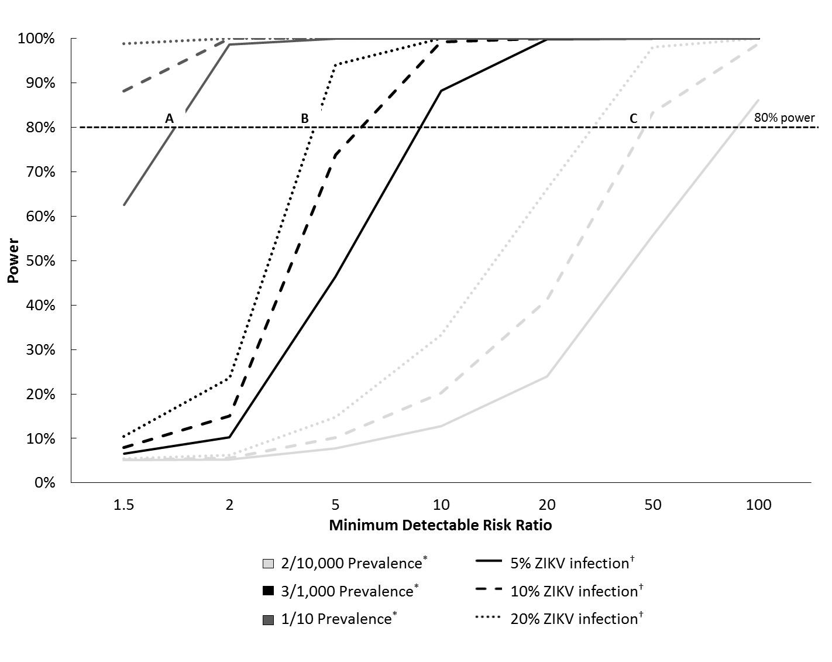
Notes: Assuming a significance level of 0.05 and total sample size of 5,000 women
* Proportion of study cohort with incident ZIKV infection
† Expected number of women exposed to ZIKV in pregnancy

B.2. Procedures for the Collection of Information

Pregnant women will be recruited in the first trimester of pregnancy at participating clinics in Colombia’s private and public health care systems and followed through their pregnancy, delivery, and until the infant is 6 months old. A subset of women (or if not available, the male partner or legal guardian) will be part of the continued follow-up of children to age 4 years.

The Pregnant Woman Eligibility Screener Form (Att B.1; C.1), administered to potential participants by trained ZEN research staff, will be used to confirm participant eligibility prior to consent or assent. At the enrollment visit, study staff will interview pregnant women using the Pregnant Woman Enrollment Questionnaire (Att B.2; C.2) and an Adult Symptoms Questionnaire (Att B.5; C.5). All pregnant women will attend monthly study clinic visits and will be interviewed using the Maternal Follow-Up (Att B.3; C.3) and Adult Symptoms Questionnaires (Att B.5; C.5). Pregnant women will have interval visits (about two weeks after clinic visits) where they will be monitored for incident ZIKV infection by collection of urine and be interviewed using the Adult Symptoms Questionnaire (Att B.5; C.5), until the middle of the third trimester (approximately 32 weeks gestation). If a woman is confirmed to have ZIKV, she will be interviewed using an Adult Symptoms Questionnaire (Att B.5; C.5) every 2 weeks and Maternal Follow-Up Questionnaire every month (Att B.3; C.3) until she is negative for 2 consecutive blood samples. If a woman has a spontaneous fetal demise, she will be interviewed using an Adult Symptoms Questionnaire (Att B.5; C.5), if one has not been completed within 7 days prior to the event. At delivery or within 10 days postpartum, the mother will be interviewed using the Infant Symptoms (Att B.6; C.6), Adult Symptoms (Att B.5; C.5), and Maternal Follow-Up (Att B.3; C.3) Questionnaires.

Infants of mothers participating in the study will be followed from birth to 6 months of age to detect health outcomes that might not have been detectable at birth. Mothers will be interviewed using the Infant Symptoms Questionnaire (Att B.6; C.6) at each visit and Ages and Stages Questionnaires (Att B.11; C.11) at the 2 and 6 month visit. If an infant is symptomatic, the mother be interviewed using the Infant Symptoms Questionnaire (Att B.6; C.6).

We will follow a subset of parent-child pairs from 6 months to 2 years of age. We will examine these parent-child pairs at 6, 9, 12, 18, and 24 months of age. The parent-child pair will be screened for eligibility at around 4 months of age using the Parent-Child Follow-up Eligibility Screening Form (Att B8; C8). If eligible, the parents will be consented and asked to give permission for both the parent and child to participate in the follow-up (Att D5). Upon signed consent and permission, the parent/guardian will be interviewed using the Parent-Child Enrollment Questionnaire (Att B.9; C.9). The Parent-Child Follow-up questionnaire will be asked at every subsequent visit (Att B10; C10). The following questionnaires and assessment tools will be asked at the corresponding visits (Att B.14):
- Ages and Stages Questionnaires (Att B.11; C.11) at 12 and 24 months.
- Bayley Scales of Infant and Toddler Development & Ages and Stages Questionnaires: Social Emotional (Att B.14) at 6, 9, 12, 18, and 24 months
- Strengths and Difficulties Questionnaire (Att B.13; C.13) at 24 months
- Peabody Developmental Motor Scales (Att B.14) at 24 months
- Parenting Stress Index IV (Att B.14) at 6, 9, 12, 18, 24 months
- Center for Epidemiologic Studies Depression scale (Att B.12; Att C.12) at 6, 9, 12, 18, 24 months
- Test of Nonverbal Intelligence (Att B.14) at 9 months

In addition to administered questionnaires, ZEN Colombia study staff will abstract medical records from mothers’ prenatal care, sick visits, and delivery to capture relevant medical information. Mothers’ medical record abstraction will be conducted up to 6 months after delivery to collect information on post-partum medical issues. Staff will also abstract medical records from children enrolled in the study to obtain information on diagnoses, developmental assessment and test results, medical procedures, and hospitalizations up to 4 years of age. Further, infants until 2 years of age will be clinical assessed for developmental delays including in the domains of cognitive, motor, language, and psychosocial development.

Male partners will be recruited via their pregnant partners around the time of their partners’ enrollment into the study. The Male Partner Eligibility Screener Form (Att B.7; C.7), administered to potential participants by trained ZEN research staff, will be used to confirm participant eligibility prior to consent. At enrollment, men will provide a blood sample and will be interviewed using the Male Enrollment Questionnaire (Att B.4; C.4) and Adult Symptoms Questionnaire (Att B.5; C.5). Men will provide urine samples monthly through the second trimester of their partner’s pregnancy (about 27 weeks of gestation) to monitor for incident ZIKV infection and will be interviewed using the Adult Symptoms Questionnaire (Att B.5; C.5) at the time of each specimen collection. If the male partner is confirmed to have ZIKV, semen will be collected every 2 weeks until semen is negative for ZIKV for two consecutive semen samples or until the partner’s pregnancy ends and men will be interviewed using the Adult Symptoms Questionnaire (Att B.5; C.5). If a man does not want to provide semen samples, follow-up will be discontinued. Study staff will also abstract medical records for male partner’s sick visits.

B.3. Methods to Maximize Response Rates and Deal with Non-response

Efforts will be made to maximize the response rate. Participants will be encouraged to complete the study throughout the pregnancy and 6 months following the infant delivery, with the exception of pregnancies that end in fetal loss. For those parent-child pairs participating in the subset from 6 months to 4 years of age, participants will be encouraged to attend all visits and assessments. Participating and completing the study is imperative to better understand the effect of ZIKV infection during pregnancy. To encourage study participation, after being provided with information about the study, potential participants will be given a phone number to call if he or she has questions about the study. In addition, once a participant is enrolled, study staff will follow-up with participants if a study visit is missed.

For parent-child pairs participating in the follow-up, they will be given a study kit at every visit that includes information regarding age appropriate developmental milestones, an age-appropriate developmental toy to help them practice meeting milestone requirements, and an age appropriate developmental book. In addition to the study kit, the study staff will send out birthday cards and other developmental information materials between study visits.

There are also a number of ancillary benefits to study participation that are expected to increase participation rates. As a part of this study, participants will have some tests and procedures performed that are not usually available in the standard prenatal care, including serial Zika testing, blood, and urine diagnostic testing. These tests are likely to result in timely detection of asymptomatic infections and timely confirmation of symptomatic infections. Additionally, both the woman and her male partner will benefit from receiving information and counseling on the health effects they might expect for their infant, and the infant will benefit from being eligible to take part in services and screening recommended for children born to ZIKV-positive mothers. Children will be able to obtain health (e.g., hearing screens, vision screens) and developmental assessments that are not usually available, and the results of these assessments may be used to refer children to needed services. Also, monitoring of parent mental health and stress may allow parents to be referred to needed health services and community agencies that can provide needed resources. ZIKV study-related tests will be paid for by the study as they are not part of the routine clinical care. Participants will also be given any new information gained during the course of the study that might increase their willingness to continue with the study.

Participants may be provided a transportation cost that covers expenses incurred for travel and for meals consistent with the local economy. The cost value will range from 0 to 20,000 Colombian pesos (~0-7 USD) for any single trip and 0 to 12,000 pesos (~0-3 USD) for meals. These may be given to the participants in the form of cash, transportation tickets, or as determined by the cities as appropriate and within guidelines.

We anticipate being able to assess non-response bias by examining participation rates by city and also by clinic. In addition, some information on non-responders may be available from clinics so that we will be able to assess factors associated with non-response.

B.4. Tests of Procedures or Methods to be Undertaken

All data collection instruments were reviewed by medical personnel, laboratorians, epidemiologists and subject matter experts for question wording and appropriate and adequate response options. In collaboration with the Instituto Nacional de Salud (INS), CDC plans to pilot test all data collection instruments, including data entry, data editing, and data management for ZEN Colombia study. Results from the pilot test will provide opportunity to refine and revise questions to minimize burden and improve efficacy. The tools used for the subset of children and parents followed from 6 months to 4 years are copyrighted, standardized, and validated tools.

B.5. Individuals Consulted on Statistical Aspects and Individuals Collecting and/or Analyzing Data

Data collection instruments were reviewed by medical personnel, laboratorians, epidemiologists and subject matter experts. These included individuals from the CDC Zika Virus Response Team, Pregnancy and Birth Defects Task Force (Margaret Honein, PhD; Denise Jamieson, MD; Diana Valencia, MS, MS; Carol Rao, ScD; Elizabeth Ailes, PhD; Sherry Farr, PhD; Suzanne Gilboa, PhD; Candice Johnson, PhD; Jennita Reefhuis, PhD; Christina Renquist, MPH; Andrea Sharma, PhD; Van Tong, MPH; Sarah Tinker, PhD; Julie Villanueva, PhD; Shin Kim, MPH; Kayla Anderson, PhD), Emory University (Lisa Haddad, MD) and Colombia INS (Martha Lucia Ospina Martínez, MD; Jorge Martin Rodriguez, MD, MSc; Yamileth Ortiz Gomez, Bg, MSc; Marcela Mercado, Bact, MSc; Maritza Gonzalez, MD, MSc; May Bibiana Osorio Merchan, MSc); Helena M. Rodríguez P., Bact, Esp, MSc(c)

ZEN Colombia Study designed by:

Zika Transition Unit
Division of Congenital and Developmental Disorders
National Center for Birth Defects and Developmental Disabilities
Centers for Disease Control and Prevention
1600 Clifton Rd., NE
Atlanta, GA 30303
Tel: 770-488-7100
Project Officer: Margaret Honein
E-mail: mrh7@cdc.gov

Instituto Nacional de Salud (INS)
Av. Calle 26 No. 51-20
Bogota, D.C., Colombia
Commutador: (1) 220-7700 Ext. 1703-1704
Fax: (1) 220-7700 Ext. 1283-1269
Directora General: Martha Lucia Ospina Martínez
E-mail: mospina@ins.gov.co

Data collected from 2017--2022 by:

Vysnova Partners, Inc.
1901 Research Blvd. Suite 502
Rockville, MD 20850

CDC Zika Transition Unit
Division of Congenital and Developmental Disorders
Centers for Disease Control and Prevention
1600 Clifton Rd., NE
Atlanta, GA 30303
Tel: 770-488-7100
Project Officer: Margaret Honein
E-mail: mrh7@cdc.gov

Instituto Nacional de Salud (INS)
Av. Calle 26 No. 51-20
Bogota, D.C., Colombia
Commutador: (1) 220-7700 Ext. 1703-1704
Fax: (1) 220-7700 Ext. 1283-1269
Directora General: Martha Lucia Ospina Martínez
E-mail: mospina@ins.gov.co

Data analyzed by:

CDC Zika Transition Unit
Division of Congenital and Developmental Disorders
Centers for Disease Control and Prevention
1600 Clifton Rd., NE
Atlanta, GA 30303
Tel: 770-488-7100
Project Officer: Margaret Honein
E-mail: mrh7@cdc.gov

Instituto Nacional de Salud (INS)
Av. Calle 26 No. 51-20
Bogota, D.C., Colombia
Commutador: (1) 220-7700 Ext. 1703-1704
Fax: (1) 220-7700 Ext. 1283-1269
Directora General: Martha Lucia Ospina Martínez
E-mail: mospina@ins.gov.co

Born too Soon: The Global Action Report on Preterm Birth. ww.who.int/pmnch/media/news/2012/preterm_birth_report/en/index.html
Rojas, J. A., J. E. Bernal, M. A. Garcia, I. Zarante, N. Ramirez, C. Bernal, N. Gelvez and M. L. Tamayo (2014). "Transient evoked oto-acoustic emission screening in newborns in Bogota, Colombia: a retrospective study." Int J Pediatr Otorhinolaryngol 78(10): 1752-1755.

