**Data items collected by the eGov Personal Vehicle Registration request but not collected by the DS-100 Form;**

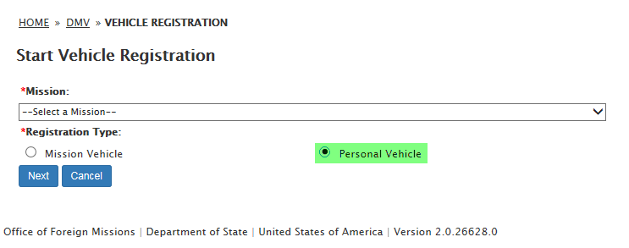

1. **Owner Information:**
   1. **Date of Birth**
   2. **Co-Owner**

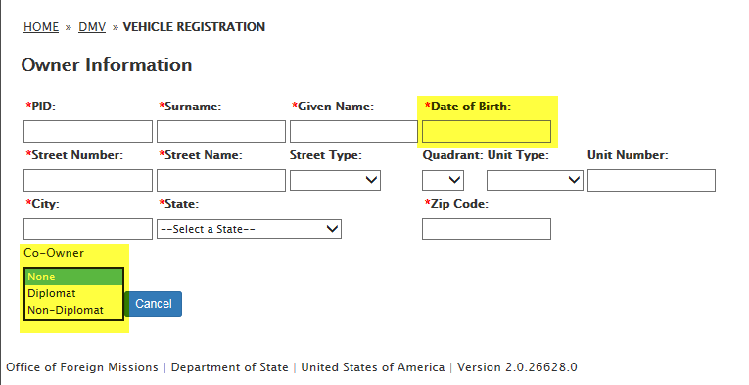

1. **Ownership Type**
   1. **Lease**
   2. **Lien**
   3. **Own**

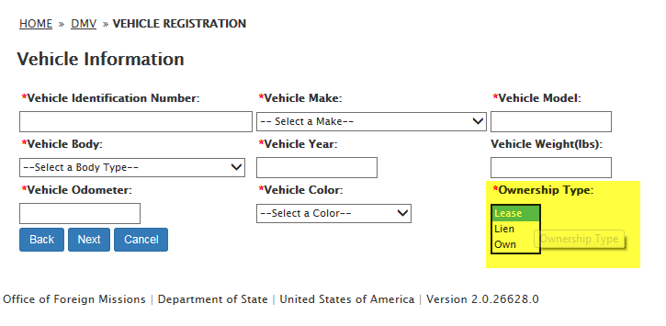

1. **Insurance Company Phone Number**

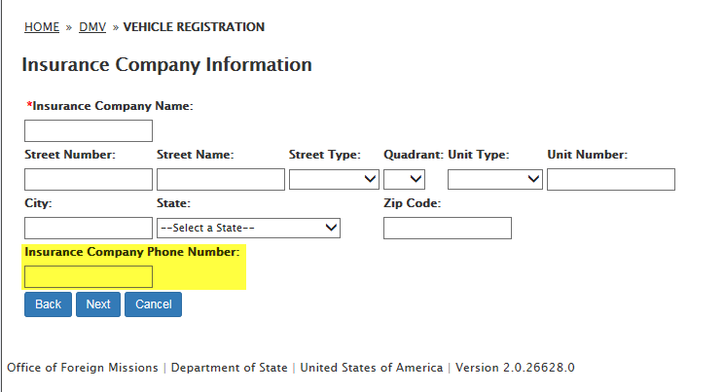

1. **Insurance Broker Phone Number**

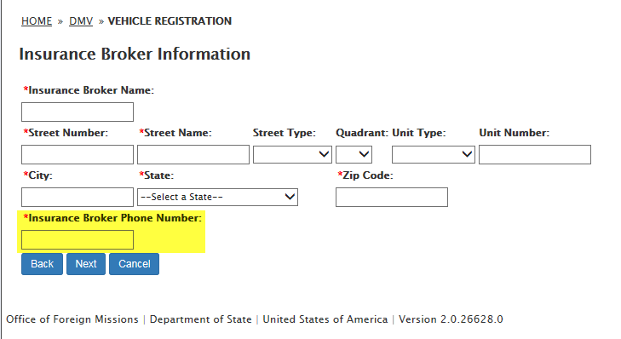

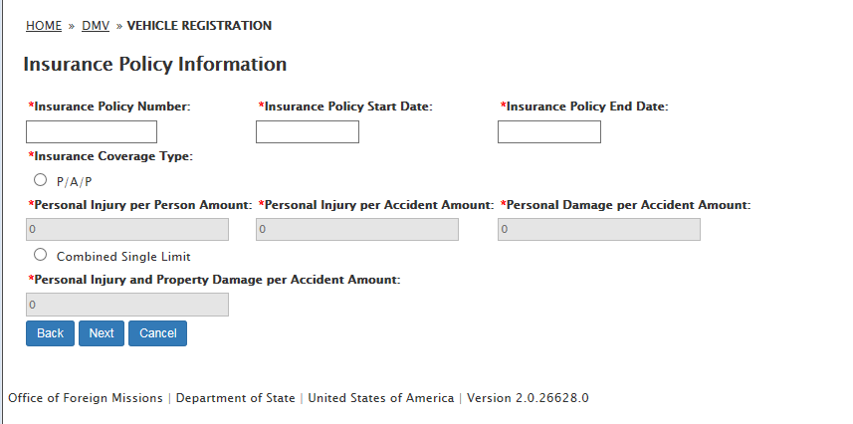

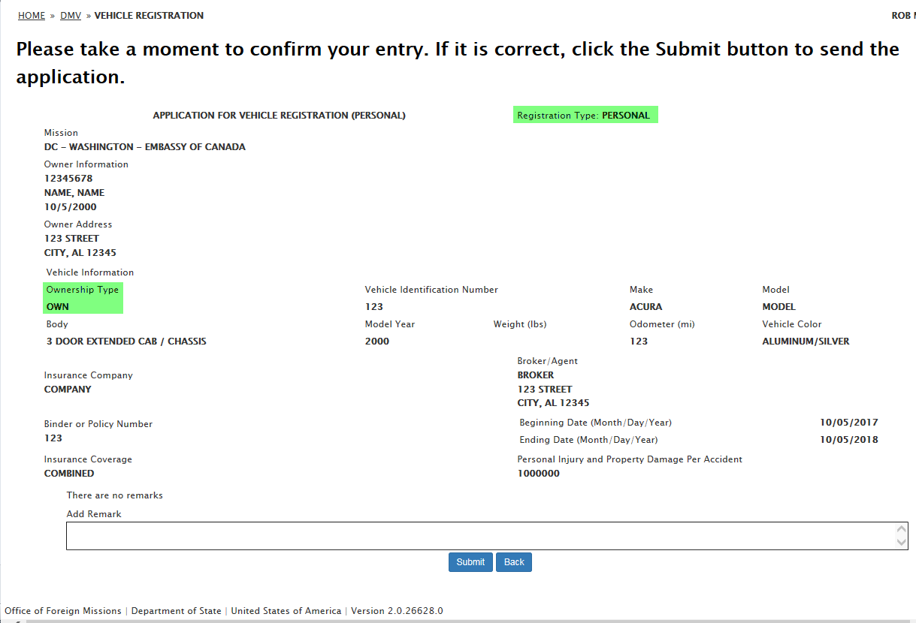

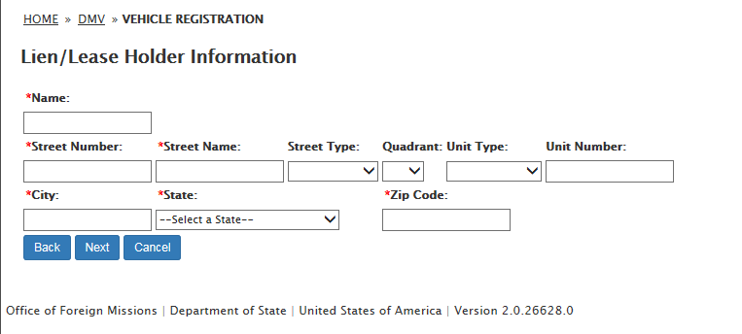

1. **Co-Owner Information:**
   1. **PID**
   2. **Surname**
   3. **Given Name**

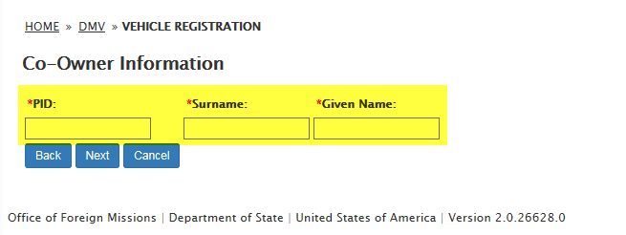

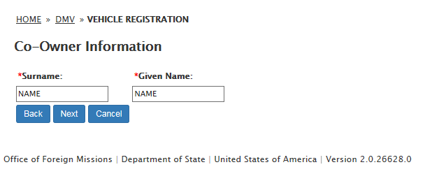

1. **Remarks**

