Data items collected by the eGov Replacement Plates request but not collected by the DS-102 Form;
- Vehicle Registration Type:
  - Mission Vehicle
  - Personal Vehicle

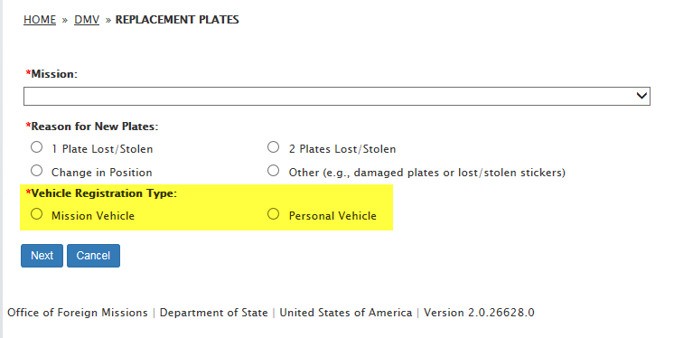
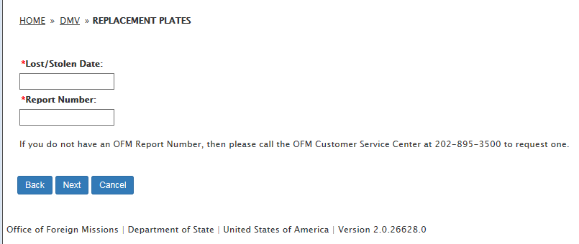
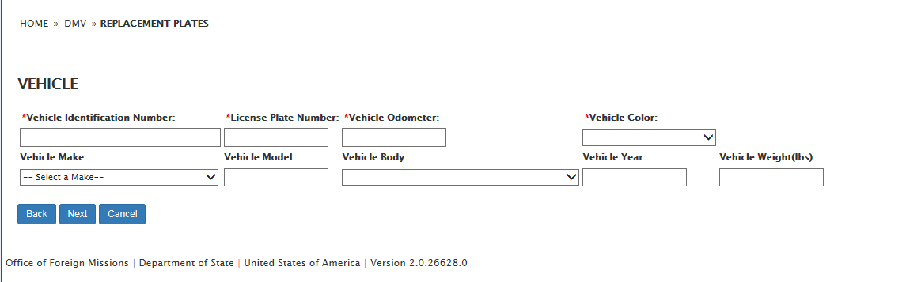
- Insurance Carrier:
  - Insurance Company Name
  - Street Number
  - Street Name
  - Street Type
  - Quadrant
  - Unit Type
  - Unit Number
  - City
  - State
  - Zip Code
  - Insurance Company Phone Number
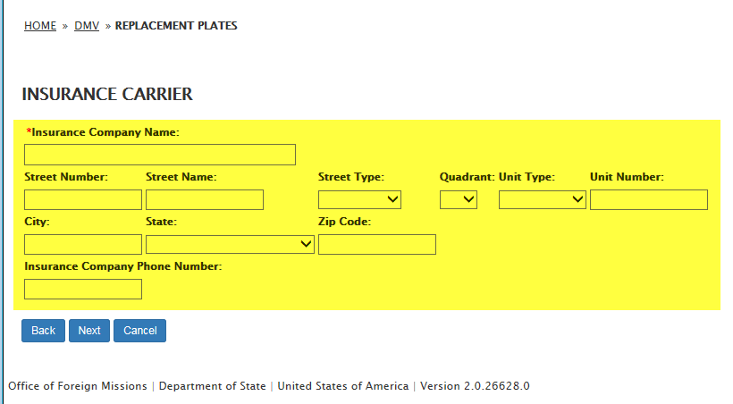

- Insurance Broker:
  - Insurance Broker Name
  - Street Number
  - Street Name
  - Street Type
  - Quadrant
  - Unit Type
  - Unit Number
  - City
  - State
  - Zip Code
  - Insurance Broker Phone Number

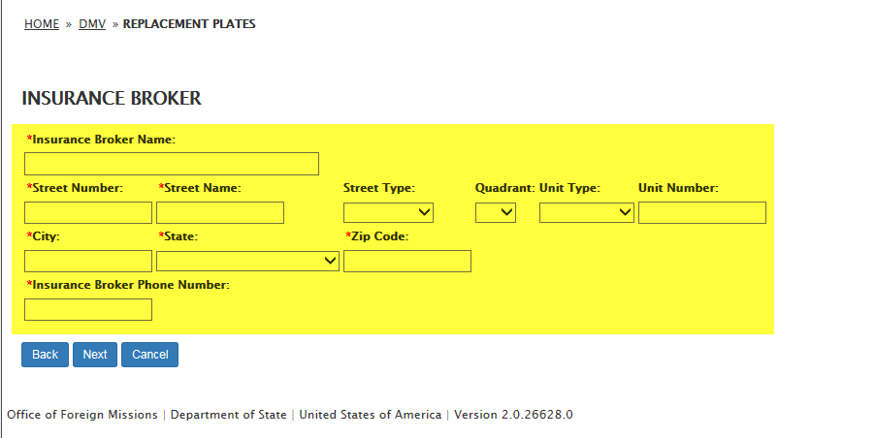

- Insurance Policy:
  - Insurance Policy Number
  - Insurance Policy Start Date
  - Insurance Policy End Date
  - Insurance Coverage Type
    - P/A/P:
      - Personal Injury per Person Amount
      - Personal Injury per Accident Amount
      - Personal Damage per Accident Amount
    - Combined Single Limit:
      - Personal Injury and Property Damage per Accident Amount

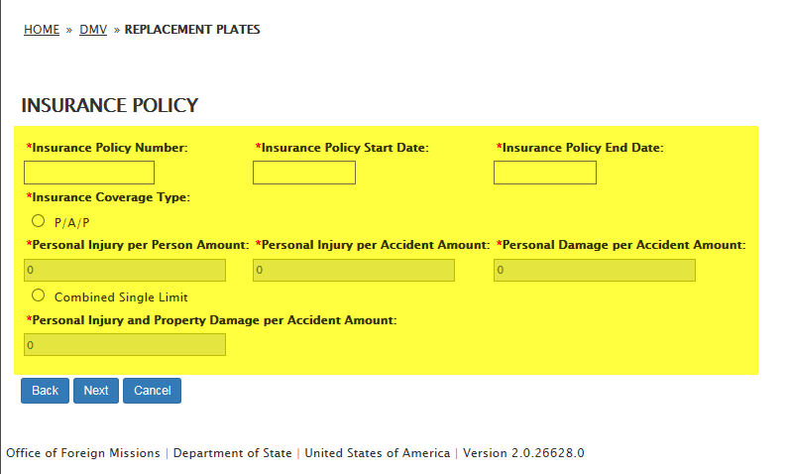

- Remark

