Data items collected by the eGov Diplomatic NOA request but not collected by the DS-2003 & DS-2007* Forms;
- Form DS-2007: NOTIFICATION OF DEPENDENTS OF DIPLOMATIC, CONSULAR AND FOREIGN GOVERNMENT EMPLOYEES (CONTINUATION SHEET)

- Appointee Information:
  - Was the individual an official or the dependent of an official previously assigned to any post in the United States?:
    - None
    - Unknown/Yes
  - PID Number
  - Other Name (if applicable)
  - Does applicant possess citizenship with another country?:
    - Yes
      - Country of another citizenship
    - No
  - Passport Number
  - Visa Foil Number
  - Visa Issue Date
  - Visa Expiration Date
  - I-94 Number
  - I-94 Classification Type
  - I-94 Expiration Date (leave blank for D/S)
  - Manner of Entry Type:
    - Air
    - Host Chartered Plan
    - Truck
    - Commercial Bus
    - Host’s Car
    - Auto Personal
    - Auto Rental
    - Auto Taxi
    - Chauffeured Car
    - Land
    - Leased Plane
    - Mission Bus
    - Not Applicable
    - Ship
    - Train
    - Unknown
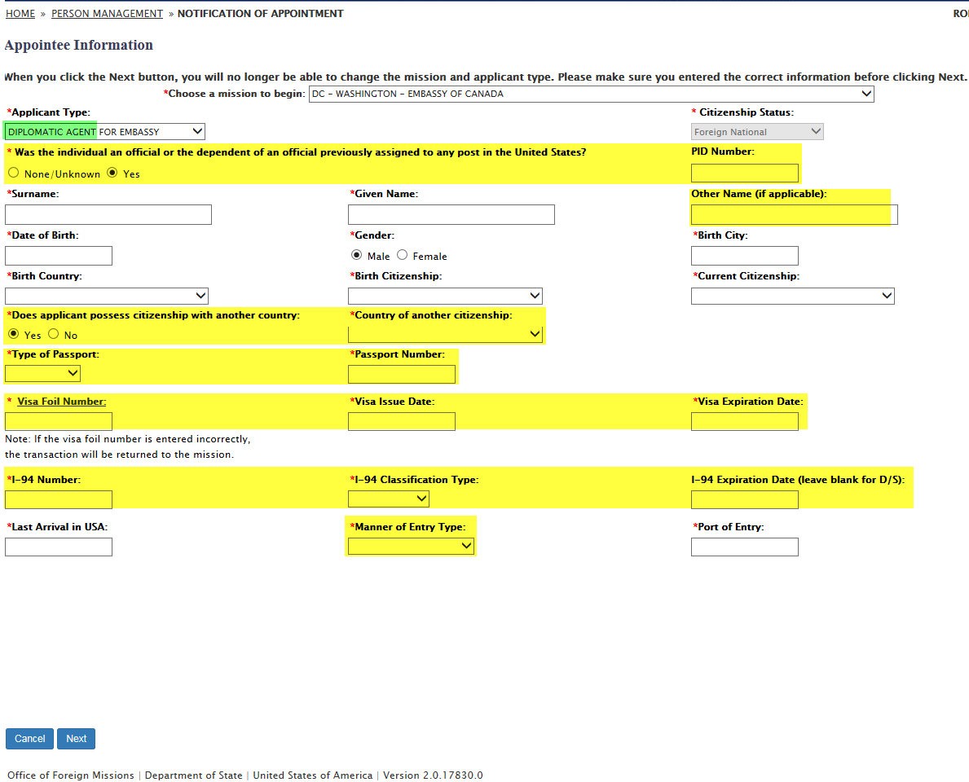

- Residence Address:
  - Residence Country:
    - United States
    - Canada
    - Mexico
  - Email Address
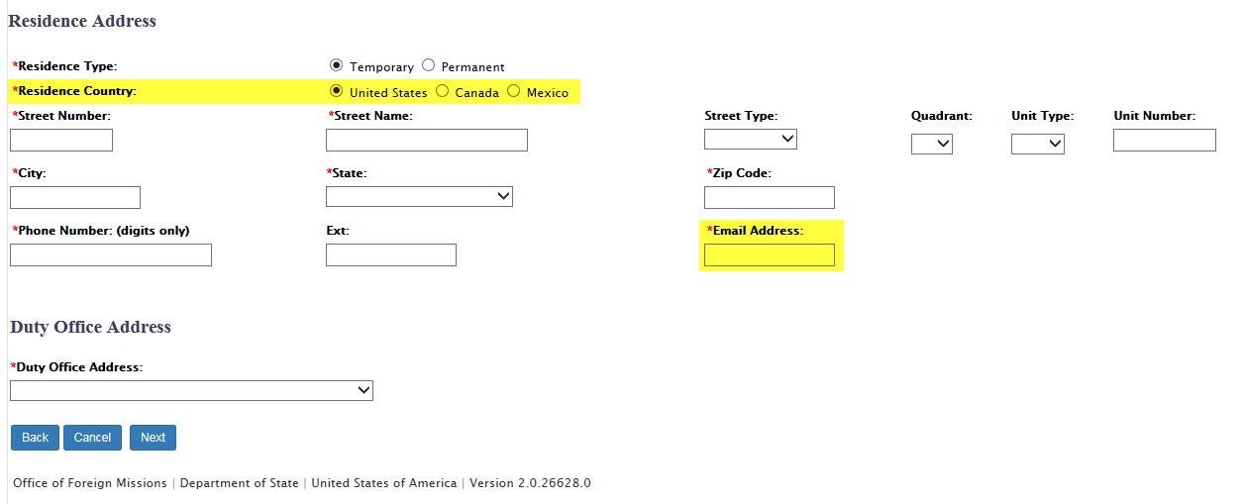
- Predecessor Information: Other Name
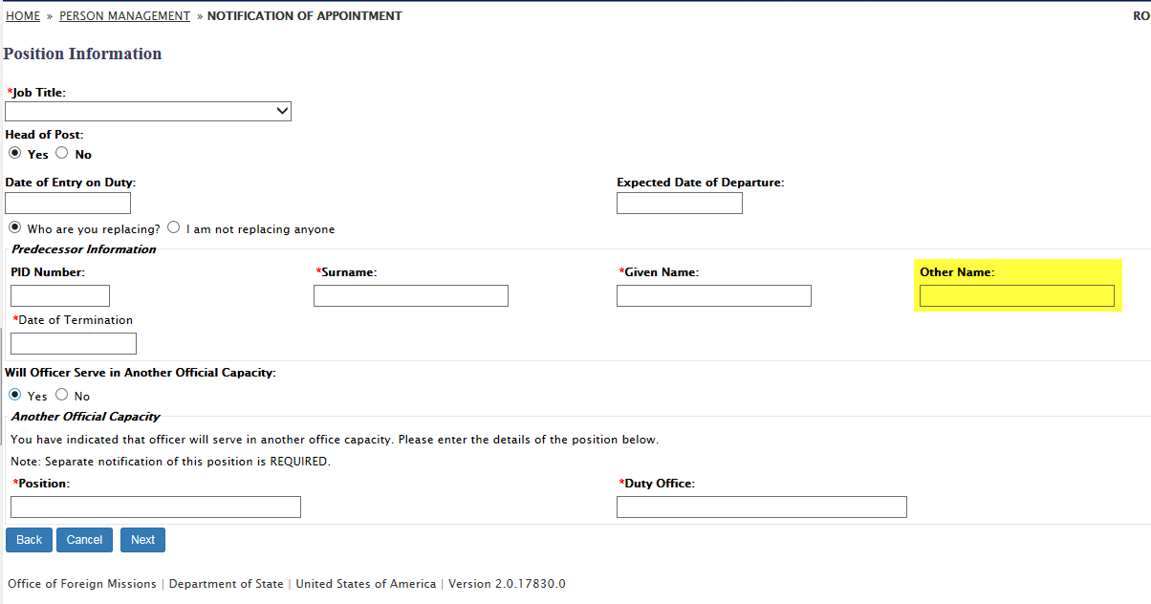
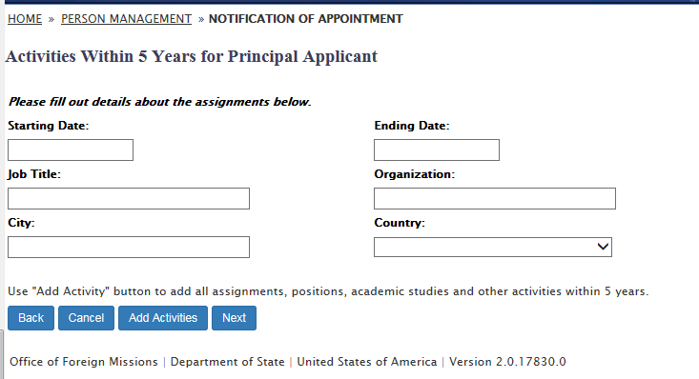
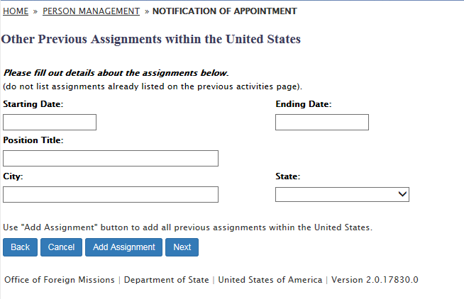

- Immediate Family Member(s) Forming Part of Principal's household:
  - PID (If applicable)
  - Birth Citizenship
  - Citizenship Status
  - Visa Foil Number
  - I-94 Number
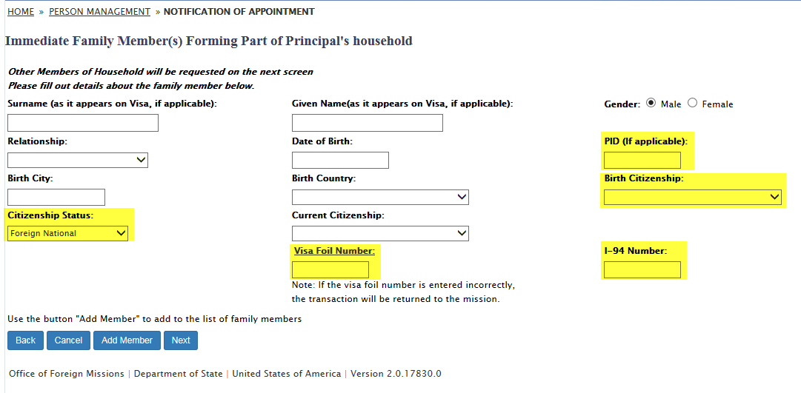
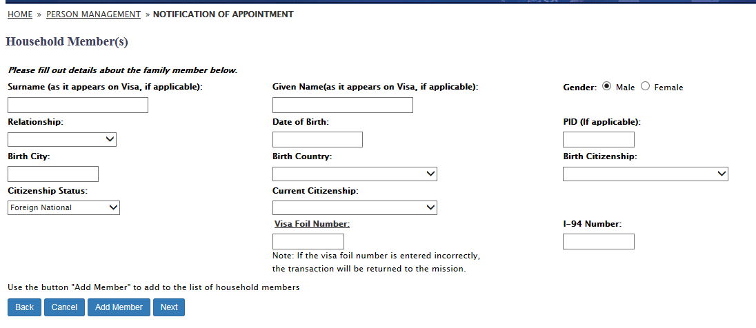

- Family Members Working in the United States for Foreign Government or International Organization: Relationship
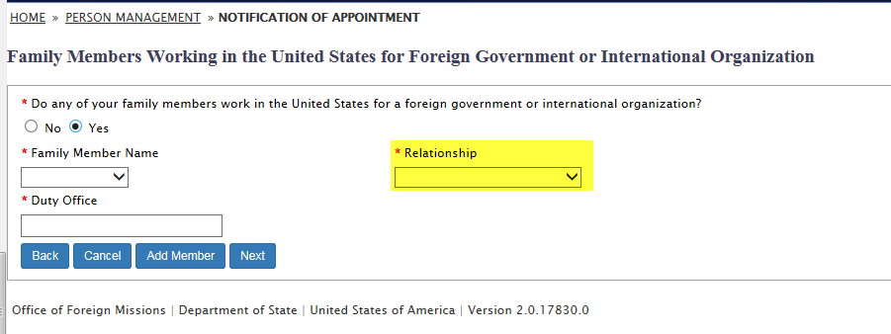
- Documents:
  - DIPLOMATIC NOTE
  - OPTIONAL DOCUMENT FOR NAME2, NAME2
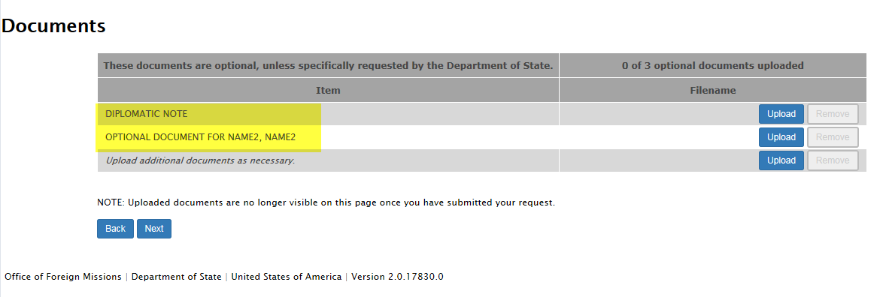

- Remarks
