Data items collected by the eGov Honorary Consular Officer NOA Request but not collected by the DS-2005 Form;
- Appointee Information:
  - Was the individual an official or the dependent of an official previously assigned to any post in the United States?:
    - None
    - Unknown/Yes
  - PID Number
  - Other Name (if applicable)
  - Does applicant possess citizenship with another country?:
    - Yes
      - Country of another citizenship
    - No
  - Document Type:
    - Green Card
  - Green Card Number
  - Expiration Date
  - Applicant Locally Engaged/Hired:
    - Yes
    - No
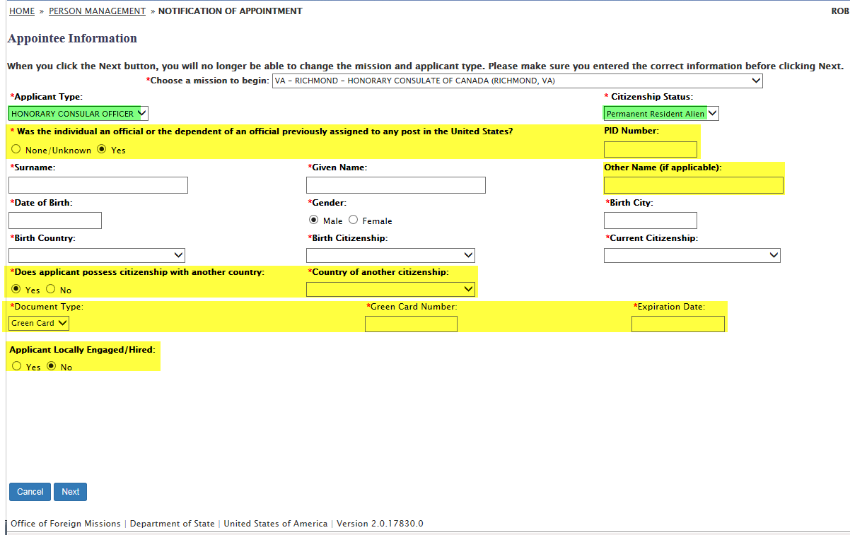
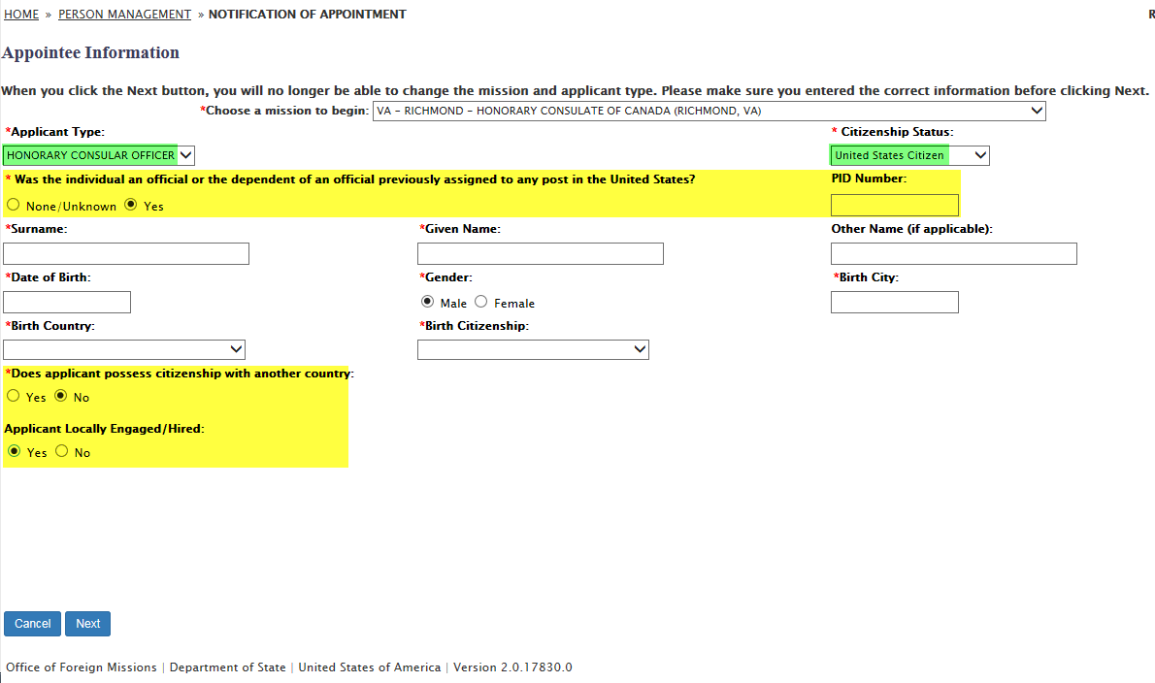
- Residence Address:
  - Residence Country:
    - United States
    - Canada
    - Mexico
  - Email Address
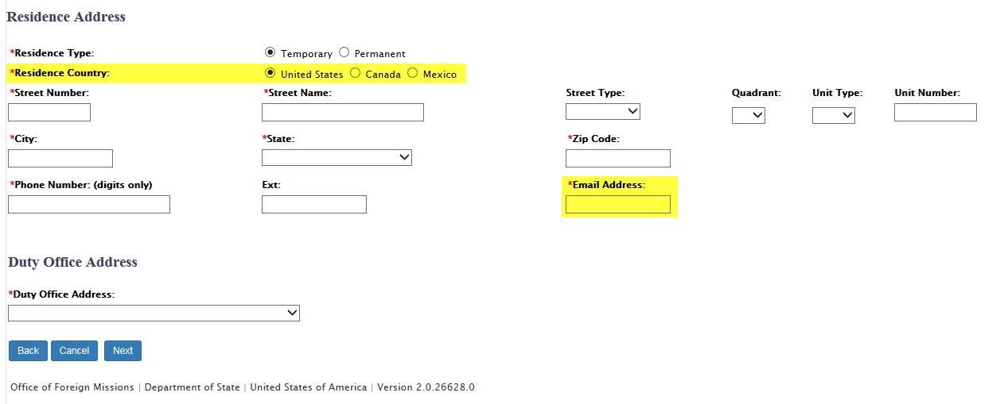

- Predecessor Information: Other Name
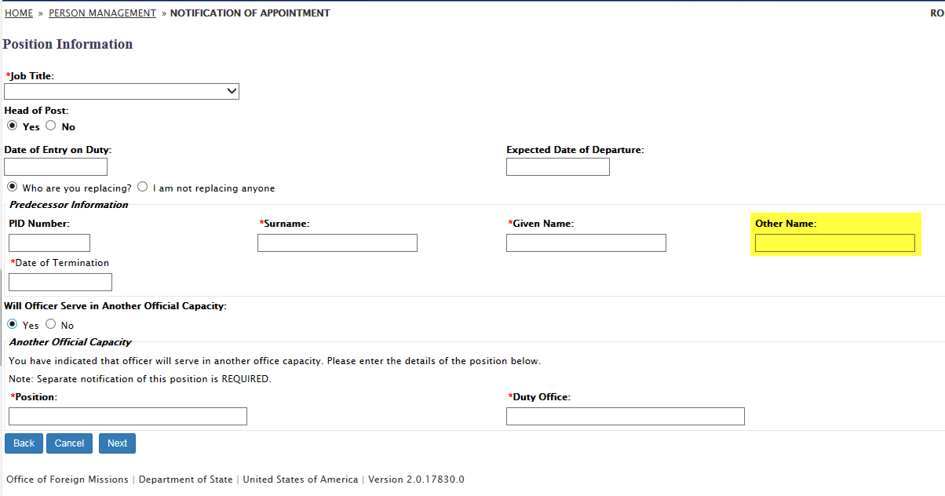
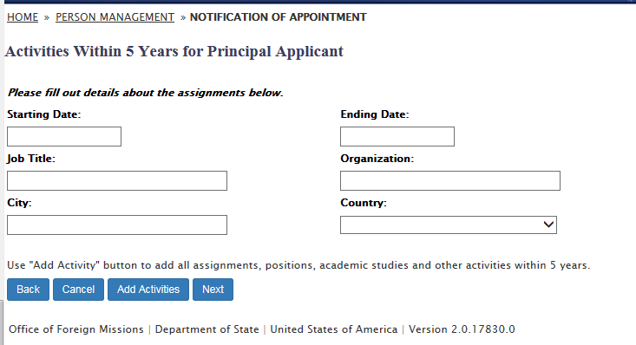
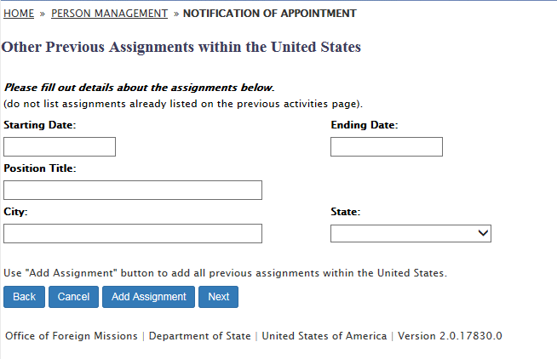
- Immediate Family Member(s) Forming Part of Principal's household:
  - PID (If applicable)
  - Birth Citizenship
  - Citizenship Status
  - Visa Foil Number
  - I-94 Number
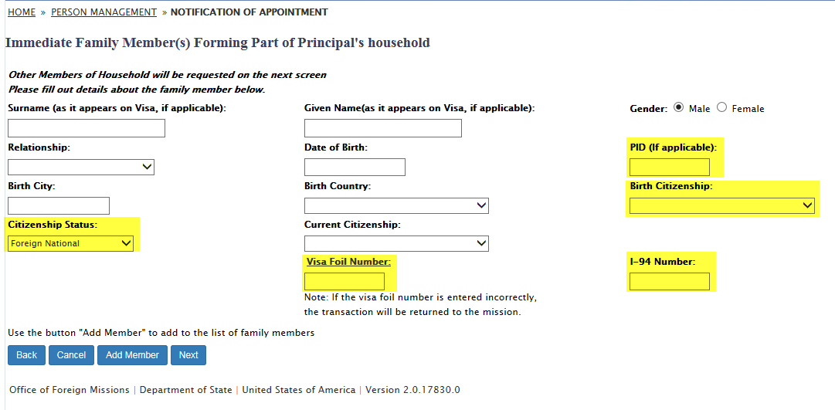
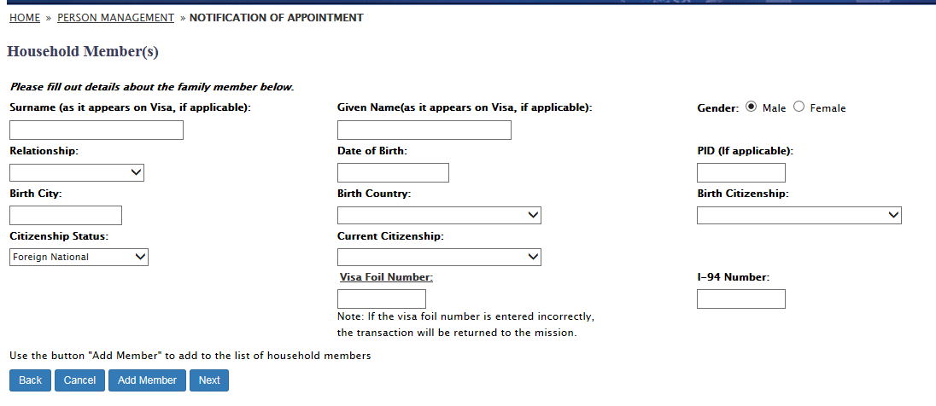
- Family Members Working in the United States for Foreign Government or International Organization: Relationship
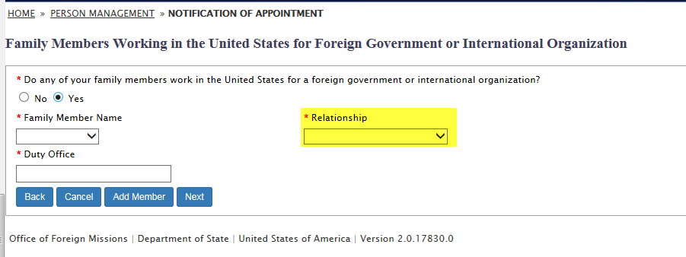
- Documents:
  - DIPLOMATIC NOTE
  - OPTIONAL DOCUMENT FOR NAMELAST, NAMEFIRST
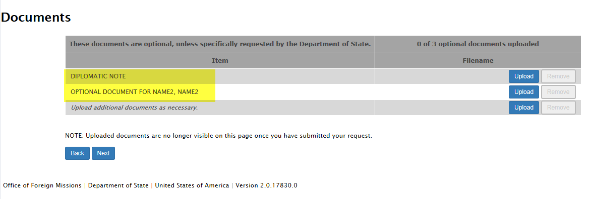
- Remarks
