Data items collected by the eGov ID Card Renewal/Replacement request but not collected by the DS-2006 & DS-2007* Forms;
- Form DS-2007: NOTIFICATION OF DEPENDENTS OF DIPLOMATIC, CONSULAR AND FOREIGN GOVERNMENT EMPLOYEES (CONTINUATION SHEET)

- Address:
  - Street Number:
  - Street Name:
  - Street Type:
    - AVENUE
    - BOULEVARD
    - CANYON
    - CENTER
    - CIRCLE
    - COURT
    - COVE
    - CRESENT
    - DRIVE
    - EXPRESSWAY
    - FREEWAY
    - GATE
    - HIGHWAY
    - LANE
    - LOOP
    - LOT
    - PARK
    - PARKWAY
    - PASSAGE
    - PATH
    - PIKE
    - PLACE
    - PLAZA
    - POINT
    - ROAD
    - SQUARE
    - STREET
    - TERRACE
    - TRAIL
    - TURNPIKE
    - Unknown
    - VIEW
    - WAY
  - Quadrant:
    - NW
    - SW
    - NE
    - SE
    - N
    - S
    - E
    - W
  - Unit Type:
    - APARTMENT
    - BOX
    - BUILDING
    - DEPARTMENT
    - FLOOR
    - LOT
    - OFFICE
    - PENTHOUSE
    - ROOM
    - SUITE
    - UNIT
  - Unit No
  - City
  - State
  - ZIP Code
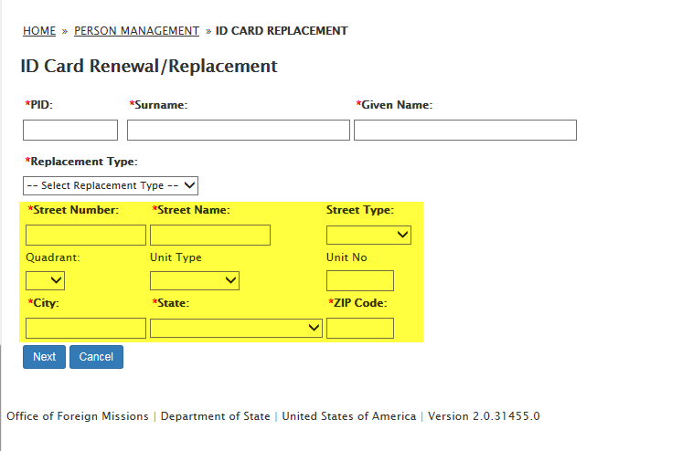
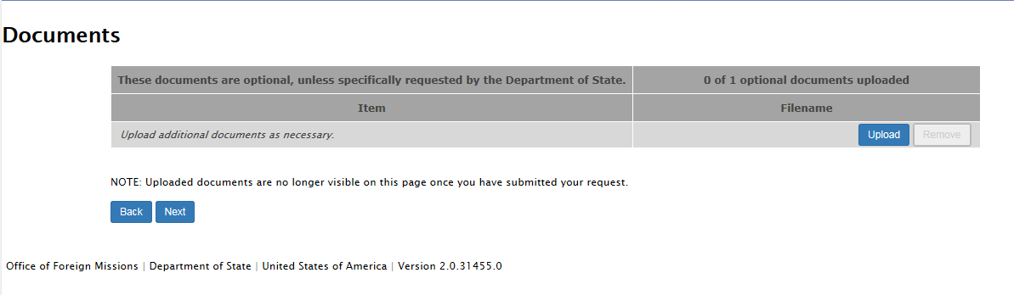
- Replacement Type: Replacement
  - Documents: PAYMENT COVER SHEET OR POLICE REPORT
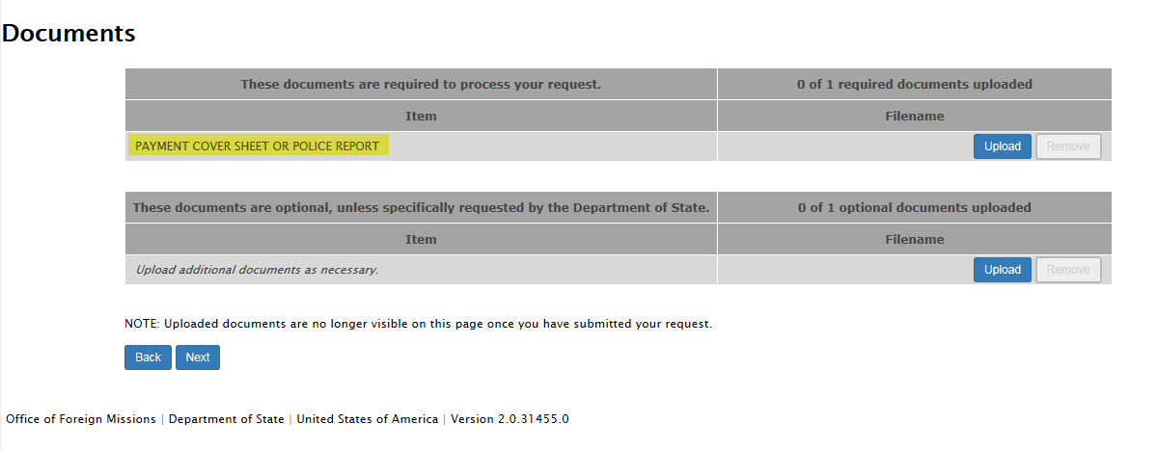

- Remarks
