**Data items collected by the eGov White House Tours (Chief of Mission Tour) request but not collected by the DS-4284 Form;**

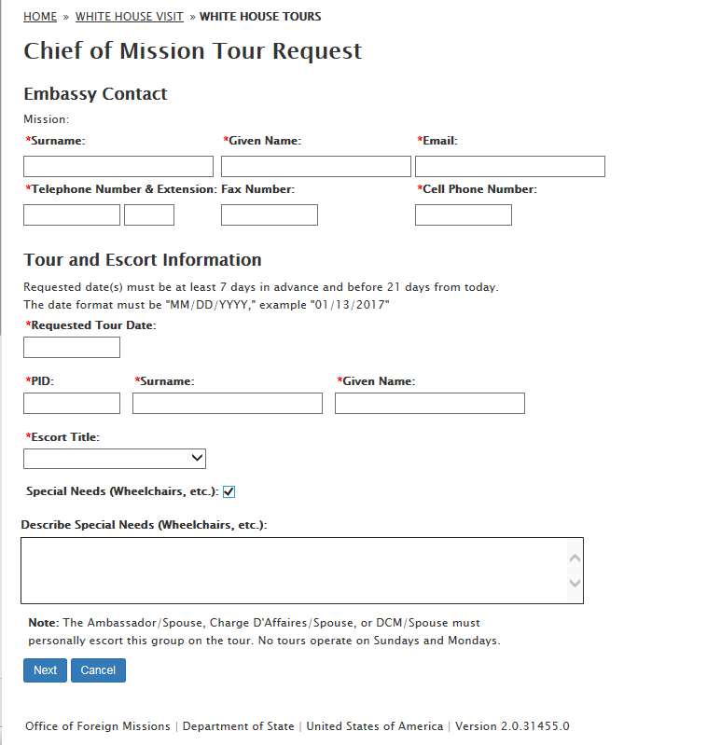

**Tour Information section / Visitor List page**

|  |  |
| --- | --- |
| **DS-4284** | **eGov page** |
| **Number of People (1-6)** | **Please add up to five visitors** |

**Add Visitor dialog box input field label text:**

|  |  |  |
| --- | --- | --- |
| **Input Field** | **DS-4284 Text** | **eGov page Text** |
| Visitor location, City | **City you're staying in the U.S. (example: Atlanta)** | **City living in United States:** |
| Visitor location, State | **State you're staying in the U.S. (example: Georgia)** | **State living in United States:** |

1. **Add Visitor:**
   1. **Citizenship Status: Foreign National**
      1. **Country of Origin**
      2. **Passport Number**
   2. **Citizenship Status: Legal Resident & United States Citizen**
      1. **Social Security Number**

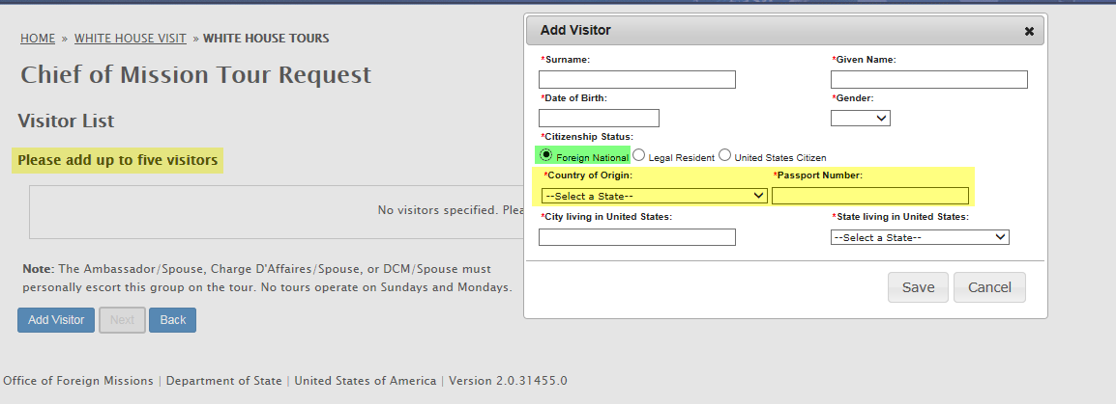

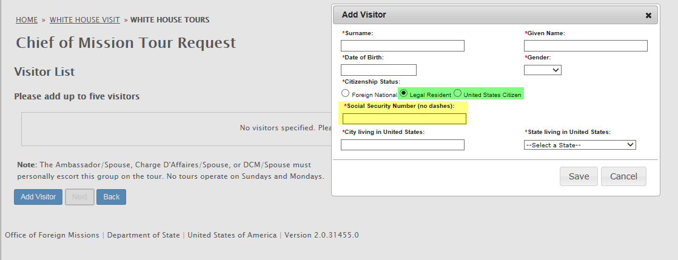

1. **Remark**
2. **Agree with Disclaimer**

