Data items collected by the eGov NOC request but not collected by the DS-2006 & DS-2007* Forms;
- Form DS-2007: NOTIFICATION OF DEPENDENTS OF DIPLOMATIC, CONSULAR AND FOREIGN GOVERNMENT EMPLOYEES (CONTINUATION SHEET)

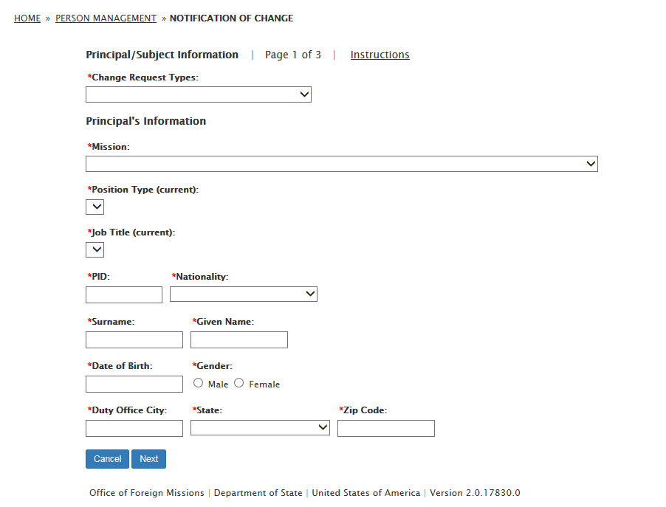
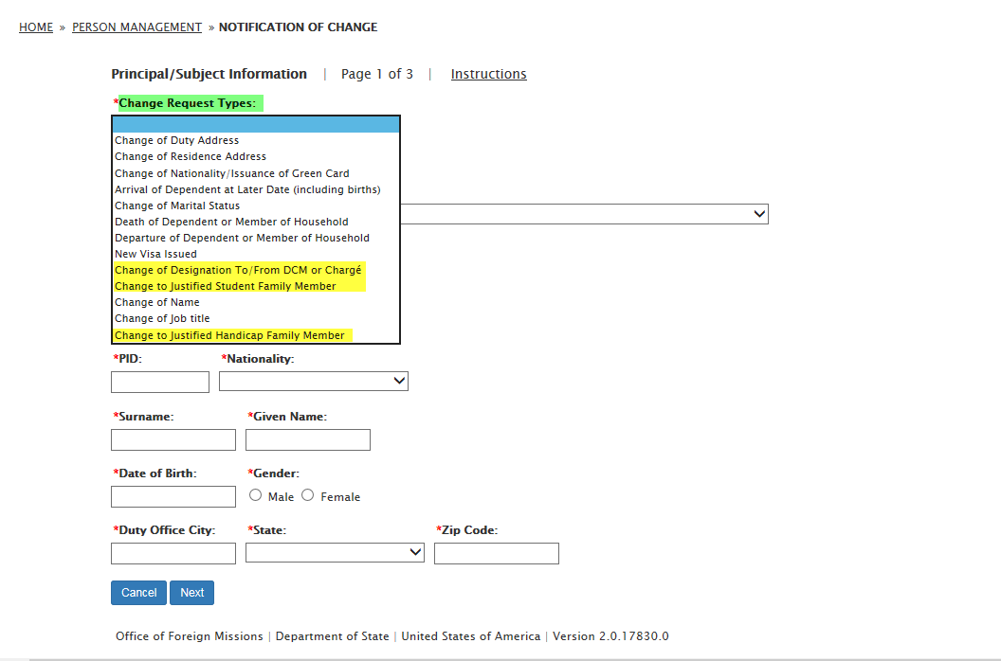
Change Duty Address:
  - Effective Date
  - Remarks
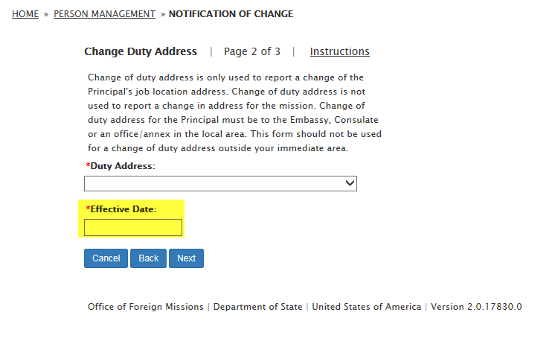

- Change of Residence Address:
  - Residence Country:
    - United States
    - Canada
    - Mexico
  - Effective Date
  - Type of Property:
    - Personal
    - Government
  - Ownership of Property:
    - Owned
    - Leased
  - Remarks
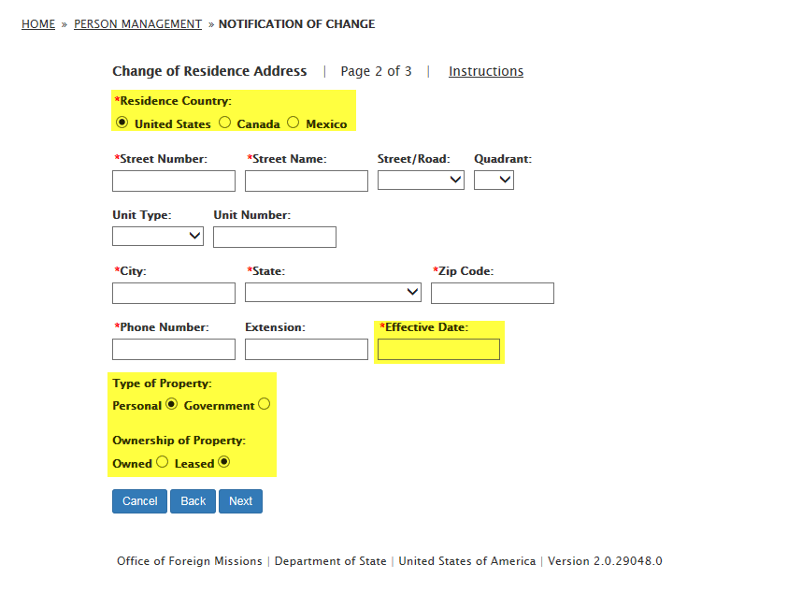

- Change of Citizenship/Issuance of Green Card:
  - To whom do these changes apply:
    - Principal
    - Dependent
  - Dependent Information:
    - PID Number
    - Date of Birth
    - Relationship
  - Effective Date
  - Remarks
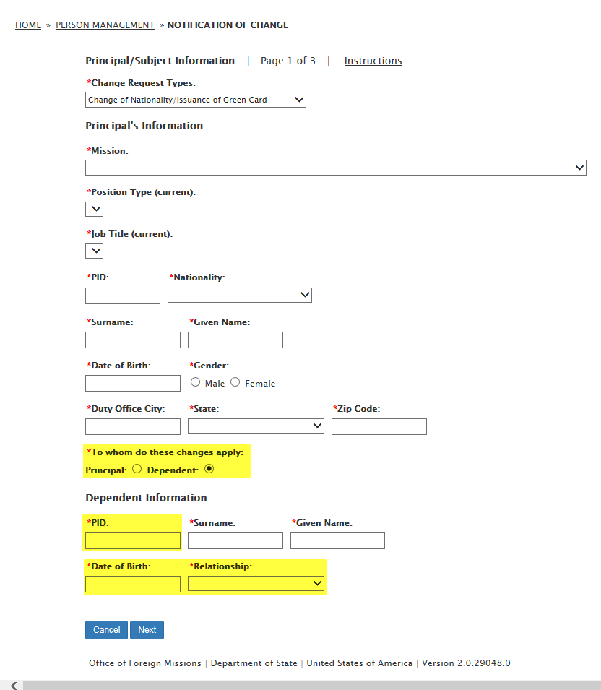
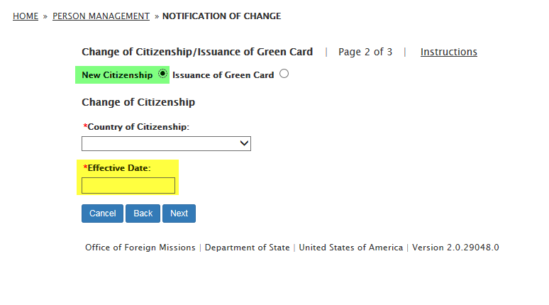
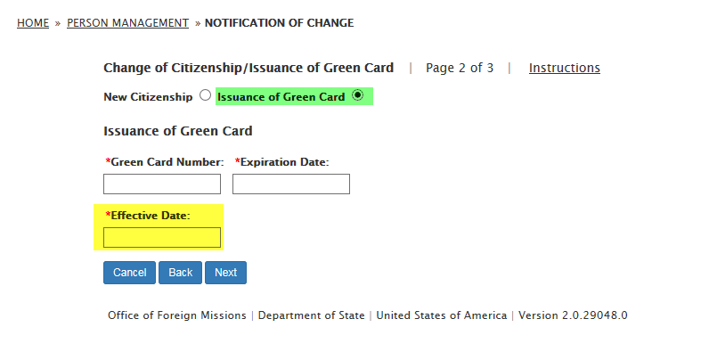

- Birth/Adoption/Arrival of Dependent at Later Date:
  - Was the individual an official or the dependent of an official previously assigned to any post in the United States?:
    - None
    - Unknown/Yes
  - PID Number
  - Birth Citizenship
  - I-94 Number
  - I-94 Expiration Date (leave blank for D/S)
  - I-94 Classification Type
  - Remarks
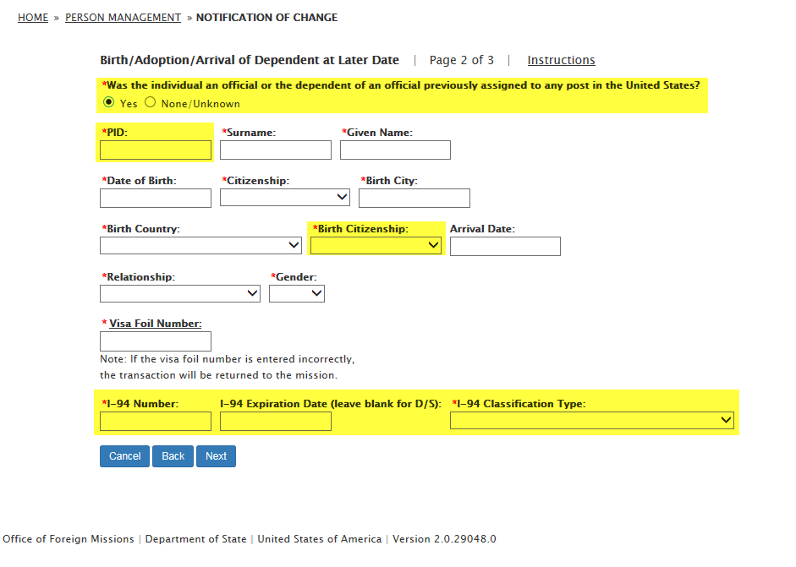

- Change of Marital Status:
  - Change Date
  - Change Reason: Other
  - PID Number
  - Relationship
    - Same Sex Domestic Partner
    - Spouse
  - Dependents to be included in the marital status change:
    - PID Number
    - Surname
    - Given Name
    - Date of Birth
    - Gender
    - Birth City
    - Current Citizenship
    - Birth Country
    - Relationship
  - Remarks
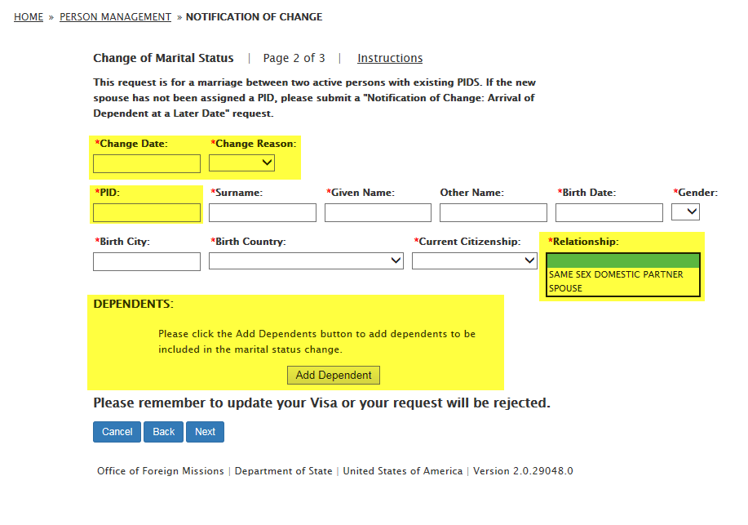
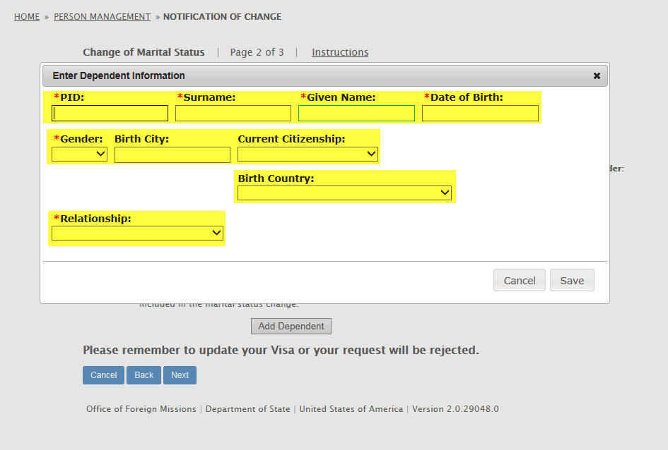
- Death of Dependent or Member of Household:
  - PID Number
  - Remarks
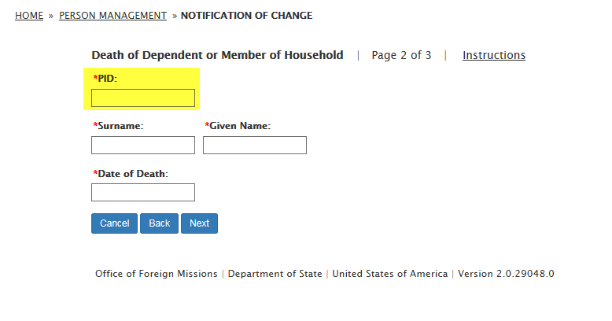

- Departure of Dependent or Member of Household:
  - PID Number
  - Date of Birth
  - Gender
  - Relationship
  - Birth City
  - Birth Country
  - Citizenship
  - Remarks
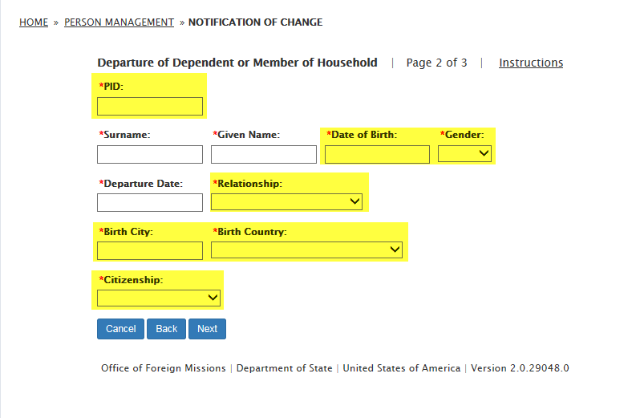

- New Visa Issued:
  - To whom do these changes apply:
    - Principal
    - Dependent
  - Dependent Information:
    - PID Number
    - Date of Birth
    - Relationship
  - Visa Foil Number
  - Visa Issue Date
  - Expiration Date
  - Remarks
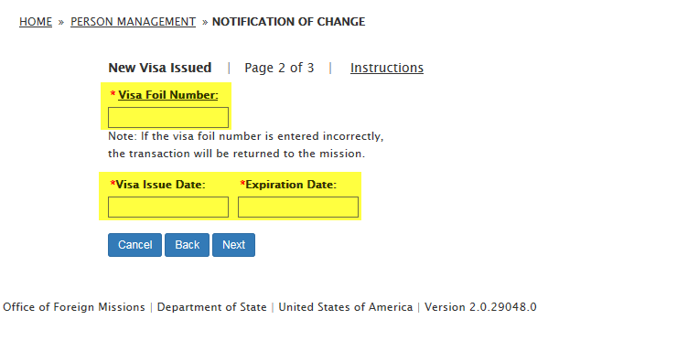

- Change of Designation To/From DCM or Chargé (not included on DS-2006):
  - Principal's Information
    - Mission
    - Position Type (current)
    - Job Title (current)
    - PID Number
    - Nationality
    - Surname
    - Given Name
    - Date of Birth
    - Gender:
      - Male
      - Female
    - Duty Office City
    - State
    - Zip Code
  - Old Title:
    - Chargé d'Affaires
    - Deputy Chief of Mission
    - None
  - New Title:
    - Ambassador Chief of Mission
    - Chargé d'Affaires
    - Deputy Chief of Mission
    - None
  - Effective Date
  - Document: PROOF OF NAME CHANGE
  - Remarks

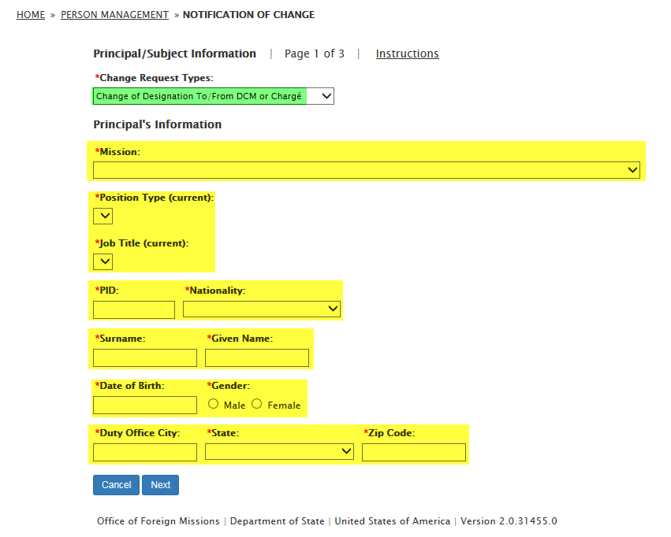
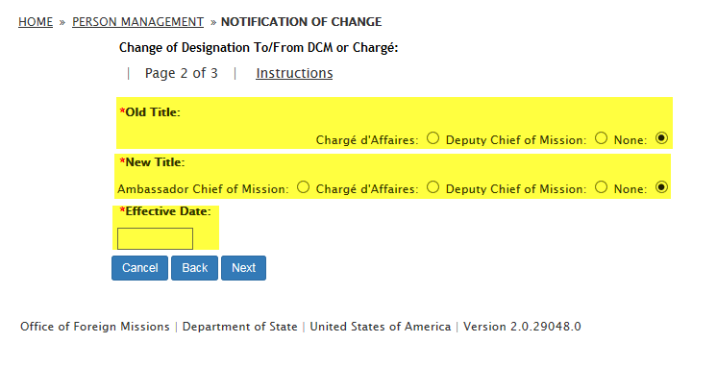
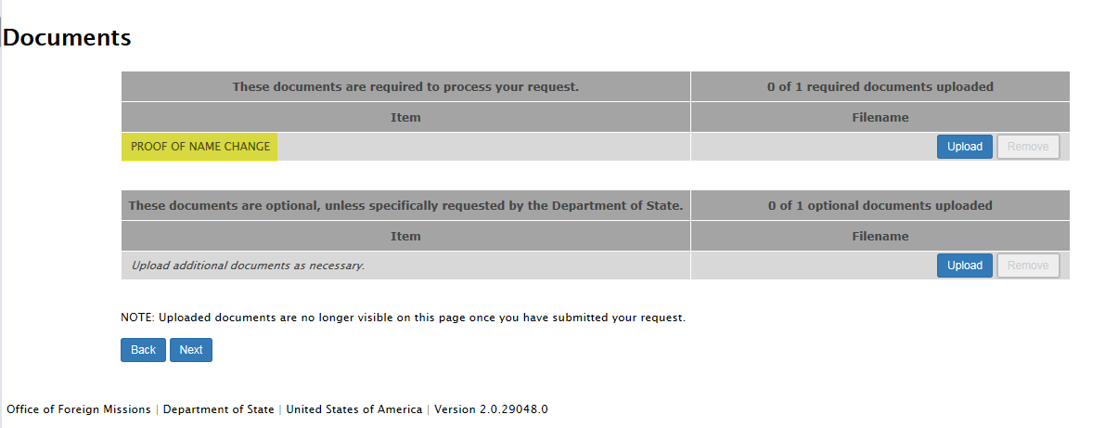

- Change to Justified Student Family Member (not included on DS-2006):
  - Principal's Information:
    - Mission
    - Position Type (current)
    - Job Title (current)
    - PID Number
    - Nationality
    - Surname
    - Given Name
    - Date of Birth
    - Gender:
      - Male
      - Female
    - Duty Office City
    - State
    - Zip Code
  - Justified Student Family Member:
    - Surname
    - Given Name
    - PID Number
    - Date of Birth
  - Document: STUDENT JUSTIFICATION DOCUMENT
  - Remarks
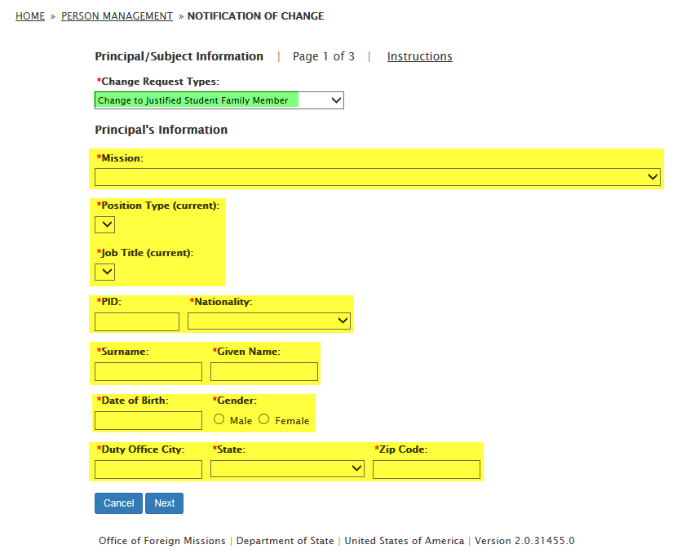
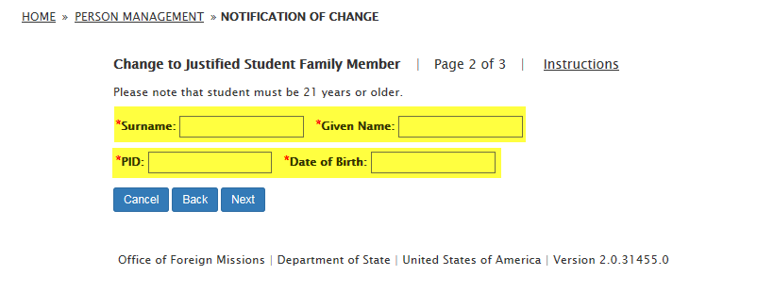
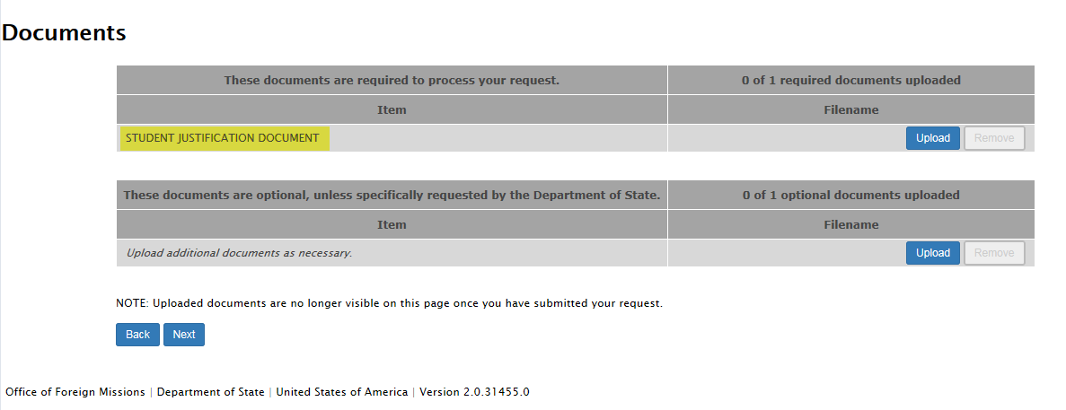

- Change of Name:
  - To whom do these changes apply:
    - Principal
    - Dependent
  - Dependent Information:
    - PID Number
    - Surname
    - Given Name
    - Date of Birth
    - Relationship
  - Remarks
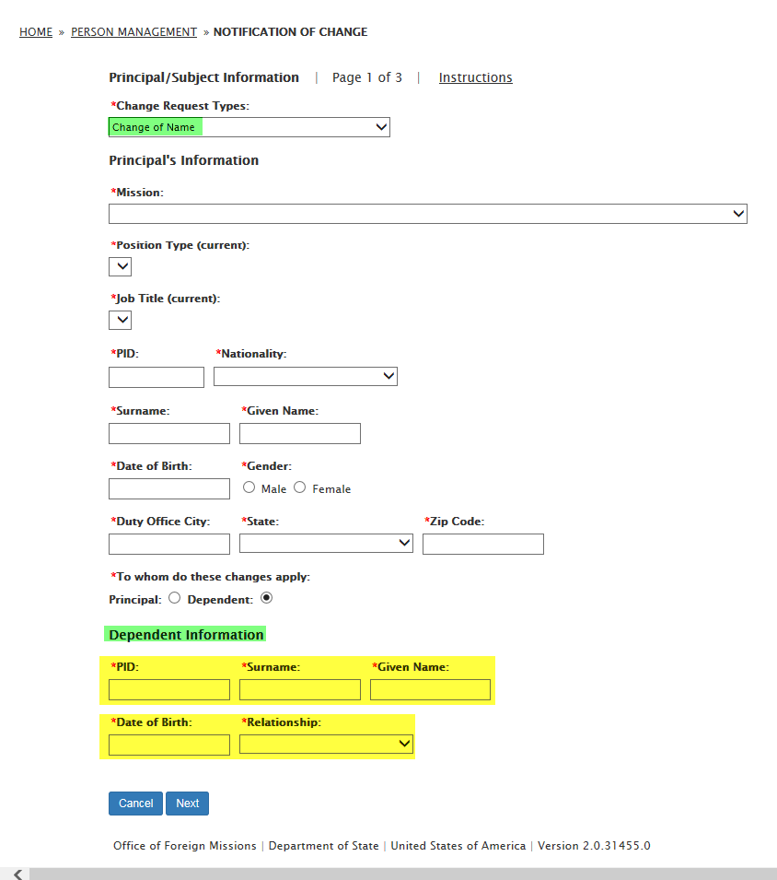
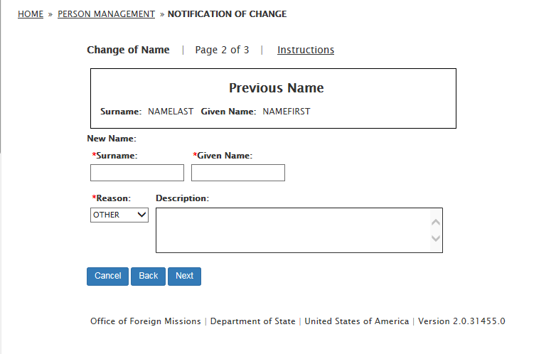
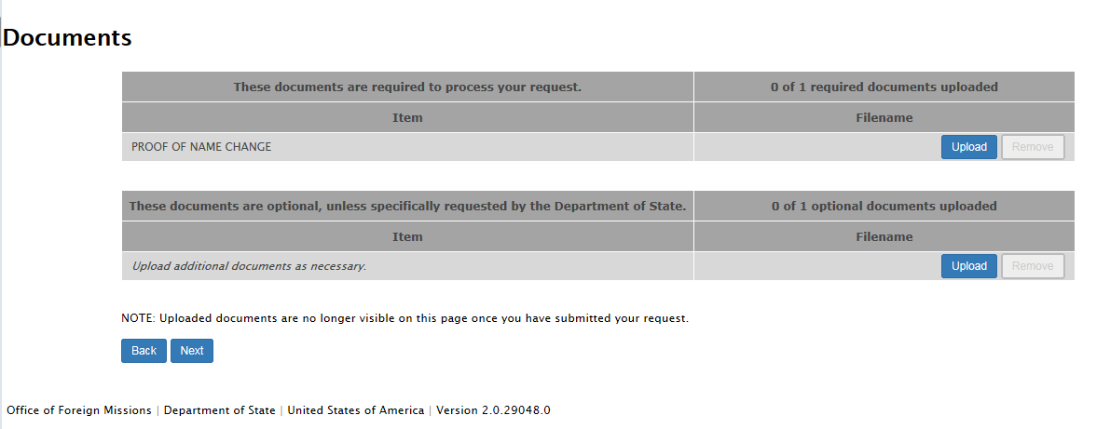

- Change Job Title:
  - Is This a New Position:
    - Yes
    - No
  - New Functional Title
  - Head of Post:
    - Yes
    - No
  - Document: DIPLOMATIC NOTE
  - Remarks
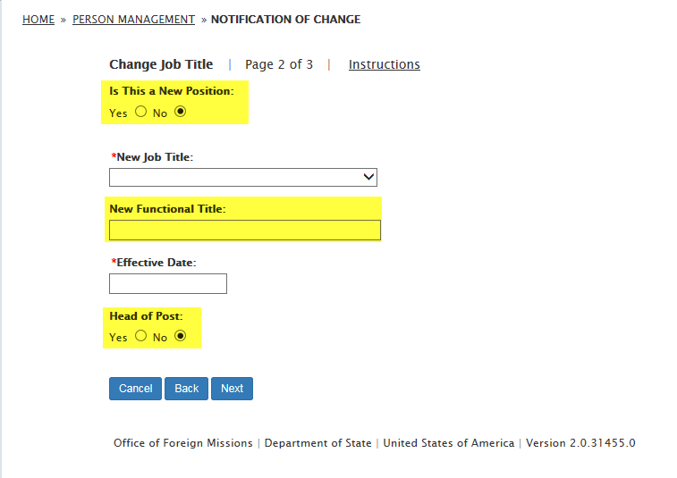
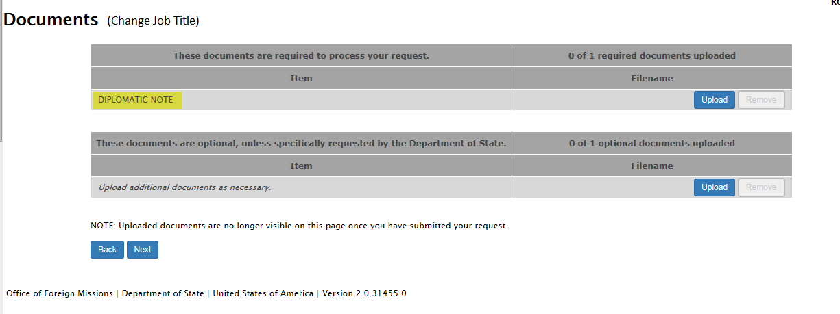
- Change to Justified Handicap Family Member: (not included on DS-2006)
  - Principal's Information:
    - Mission
    - Position Type (current)
    - Job Title (current)
    - PID Number
    - Nationality
    - Surname
    - Given Name
    - Date of Birth
    - Gender:
      - Male
      - Female
    - Duty Office City
    - State
    - Zip Code
  - Justified Handicap Family Member:
    - Surname
    - Given Name
    - PID Number
    - Date of Birth
  - Document: HANDICAP JUSTIFICATION DOCUMENT
  - Remarks

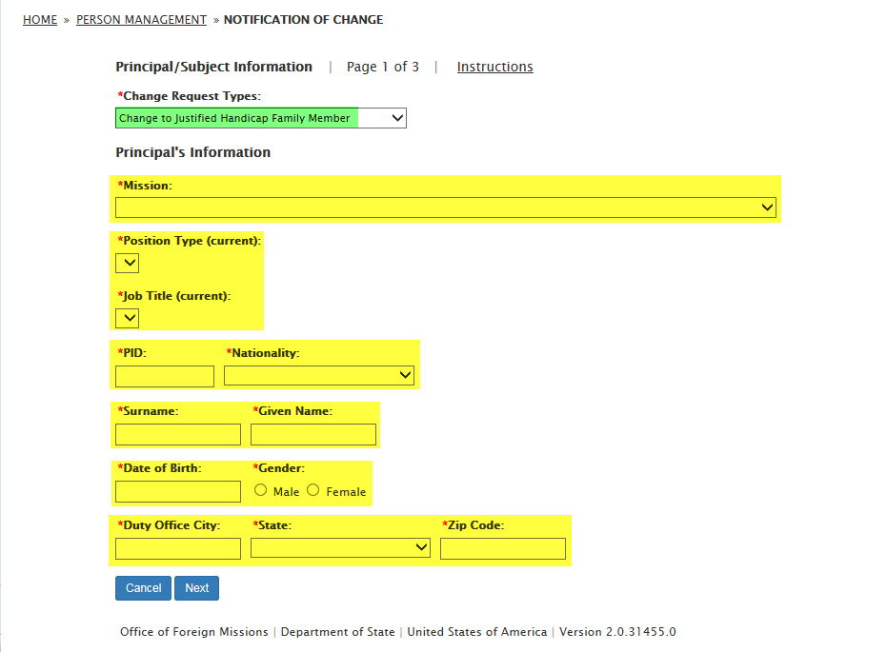
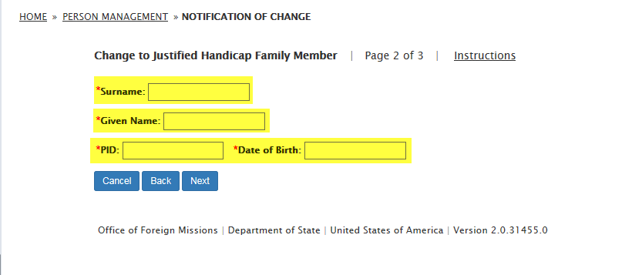
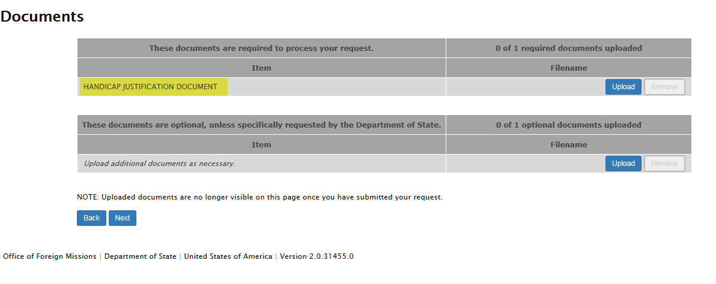
- Remarks
