Data items collected by the eGov Driver License & Non-Driver ID Application request but not collected by the DS-1972 Form;
- Vehicle Class:
  - Regular
  - Motorcycle
  - Regular and Motorcycle
- Have you held a DOS DL?
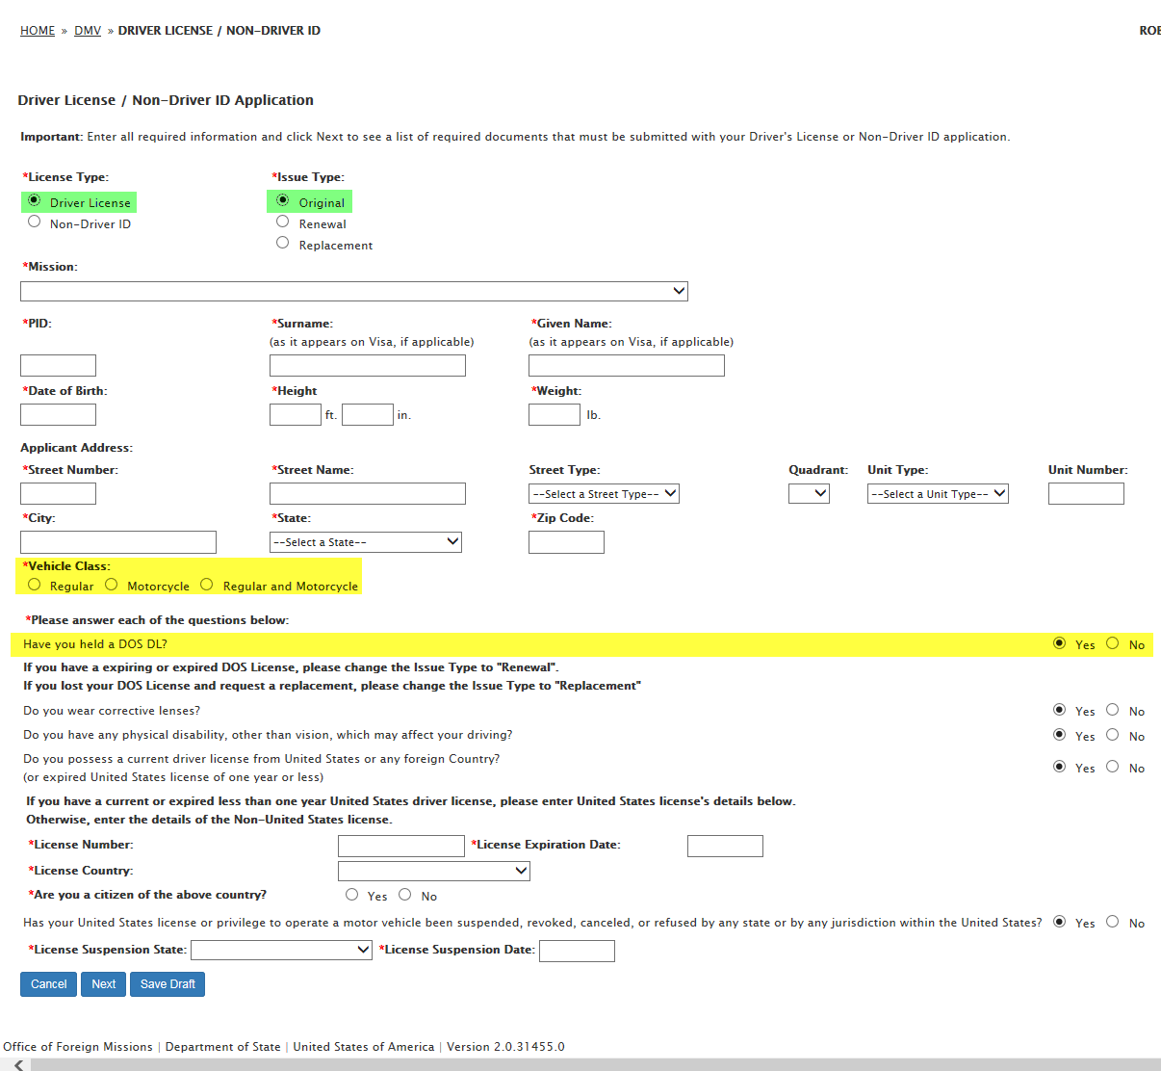

- Do you possess a current driver license from United States or any foreign Country?:
  - Are you a citizen of the above country?
  - If you are not a citizen of the above country, please select your country of citizenship
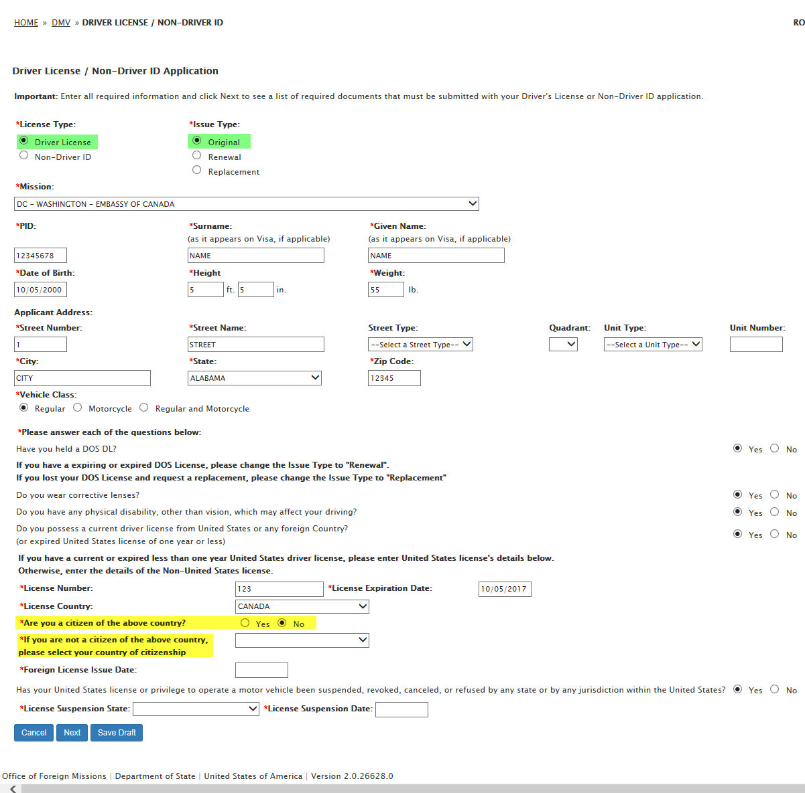
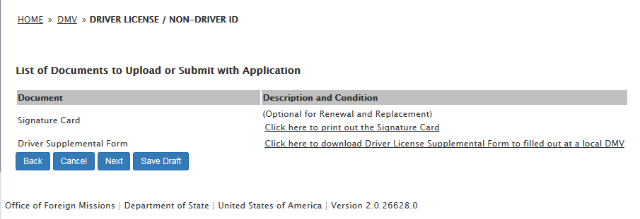

- Remark
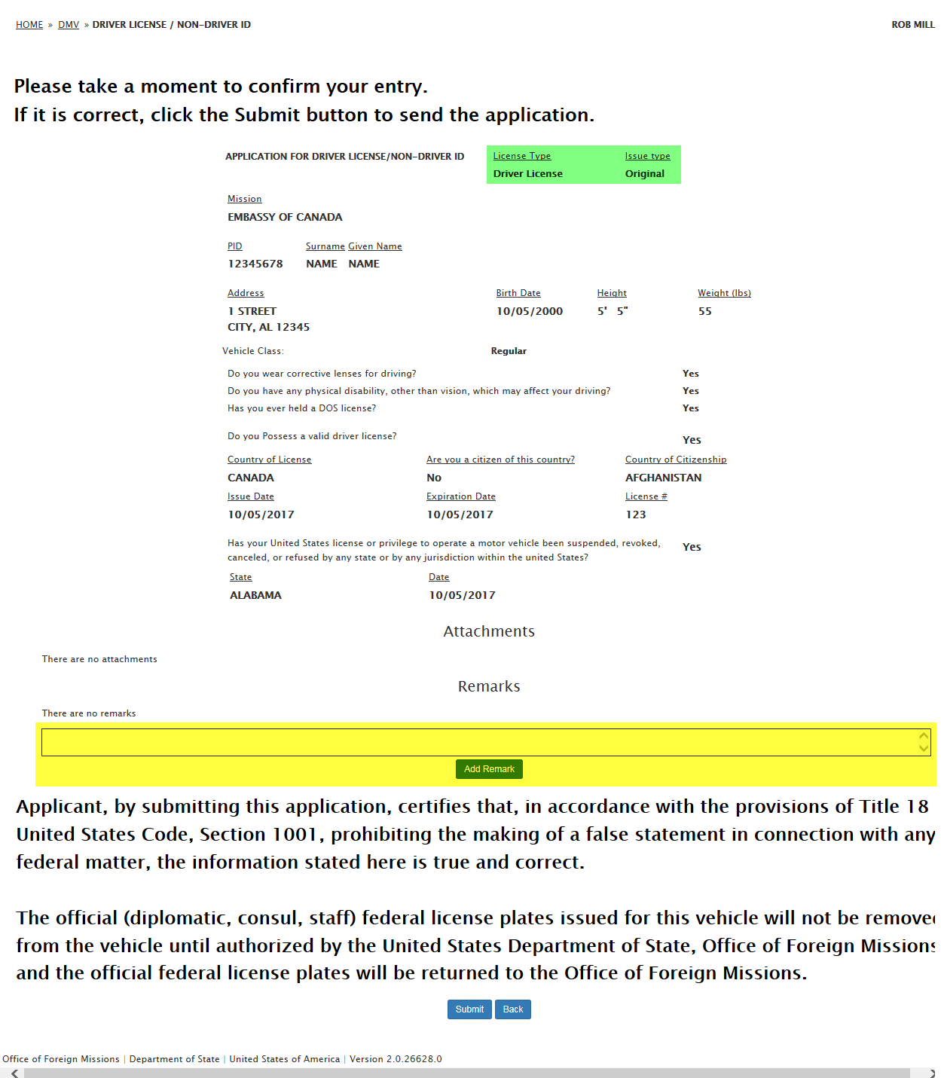

- License Type: Driver License / Issue Type: Replacement:
  - Documents to Upload: Police Report; Copy of police report detailing lost of license
