2016/17 BACCALAUREATE AND BEYOND (B&B:16/17) MAIN STUDY

OMB # 1850-0926 v.7

Appendix E
Sample Member Communication Materials

Submitted by
National Center for Education Statistics (NCES)
U.S. Department of Education

April 2017
revised March 2018

Contents
Contacts Calendar 4
Brochure Text 8
Website Text 10
Initial Contact/Screener Invitation Letter 15
Data Collection Announcement Letter 17
Reminder Postcard 1 19
Reminder Postcard 2 21
Reminder Postcard 3 23
Reminder Postcard 4 25
Reminder Postcard 5 27
Holiday Postcard 6 29
Reminder Postcard 7 30
Reminder Postcard 8 31
Reminder Letter 1 32
Reminder Letter 2 34
Reminder Postcard 9 36
Reminder Postcard 10 37
Reminder Postcard 11 38
Reminder Postcard 12 39
Reminder Postcard 13 40
Reminder Postcard 14 41
Reminder Postcard 15 42
Reminder Flyer 43
Initial Contact/Screener Invitation Email 44
Initial Contact/Screener Reminder Email 45
Data Collection Announcement Email 46
Reminder Email 1 47
Reminder Email 2 48
Reminder Email 3 49
Reminder Email 4 50
Reminder Email 5 51
Reminder Email 6 52
Reminder Email 7 53
Reminder Email 8 54
Holiday Email 55
Reminder Email 9 56
Reminder Email 10 57
First Look Email 58
Reminder Email 11 59
Reminder Email 12 60
Reminder Email 13 61
Reminder Email 14 62
Reminder Email 15 63
Reminder Email 16 64
Reminder Email 17 65
Reminder Email 18 66
Reminder Email 19 67
Reminder Email from NCES 1 68
Reminder Email from NCES 2 69
Reminder Email 20 70
Reminder Email 21 71
Reminder Email 22 72
Reminder Email 23 73
Reminder Email 24 74
Reminder Email 25 75
Reminder Email 26 76
Reminder Email 27 77
Reminder Email 28 78
Reminder Email 29 79
Reminder Email 30 80
Reminder Email 31 81
Reminder Email 32 82
Reminder Email 33 83
Reminder Email 34 84
Reminder Email 35 85
Screener Invitation – Post Data Collection Period 86
Screener Reminder Email – Post Data Collection Period 87
Reminder Email – NCES 3 88
Reminder Email – NCES 4 89
Text Message Reminders 90
Thank You Letter 92
Thank You Email - check 93
Thank You Email - PayPal 94
Consent Text 95
B&B:16/20 FT Panel Maintenance Postcard 96
FS Panel Maintenance Email 99

Note: Emails and letters providing similar content to those shown in this appendix will be sent throughout data collection to encourage participation. In addition, sample members that request follow-up reminders via text message will receive text message prompts to complete the survey. The materials included in this appendix reference the full-scale study to be conducted in 2017-18.

Contacts Calendar

Contact materials revised in March 2018 are highlighted in Turquoise and additional contacts are highlighted in Green.

Contact Name | Page in Appendix E | Data Collection Phase | Type | Approximate Date  - Groups 1 & 2 | Approximate Date  - Groups 3 & 4 | Reason for Change
Initial Contact/Screener Invitation Letter | E-15, E-16 | Pre-data collection | Letter | 7/31/17 | N/A | No change
Initial Contact/Screener Invitation Email | E-44 | Pre-data collection | Email | 7/31/17 | N/A | No change
Initial Contact/Screener Reminder Email | E-45 | Pre-data collection | Email | 8/14/17 | N/A | No change
Data collection Announcement Letter | E-17 | Early Completion | Letter | 9/25/2017 | 7/31/2017 | No change
Data collection announcement email | E-46 | Early Completion | Email | 9/18/2017 | 7/31/2017 | No change
Reminder text 1 | E-90 | Early Completion | Text | 12/15/2017 | 9/25/17 | No change
Reminder email 1 (only those with no text) | E-47 | Early Completion | Email | 09/25/2017 | 8/7/2017 | No change
Reminder postcard 1 | E-19 – E-20 | Early Completion | Postcard | 10/9/2017 | 8/14/2017 | No change
Reminder email 2 | E-48 | Production I | Email | 10/11/2017 | 8/23/2017 | No change
Reminder email 3 | E-49 | Production I | Email | 10/24/2017 | 9/5/2017 | No change
Reminder text 2 | E-90 | Production I | Text | 1/15/2018 | 10/31/2017 | No change
Reminder email 4 | E-50 | Production I | Email | 11/1/2017 | 9/13/2017 | No change
Reminder postcard 2 | E-21 – E-22 | Production I | Postcard | 11/20/2017 | 9/25/2017 | No change
Reminder text 3 | E-90 | Production I | Text | 2/14/2017 | 12/01/2017 | No change
Reminder email 5 | E-51 | Production I | Email | 12/2/2017 | 10/14/2017 | No change
Reminder email 6 | E-52 | Production I | Email | 12/16/2017 | 10/25/2017 | No change
NCES Email #1 | E-68 | Production I | Email | 1/10/2017 | 11/9/2017 | No change
Reminder postcard 3 | E-23 – E-24 | Production I | Postcard | 1/17/2018 | 11/15/2017 | No change
Reminder 7/Abbreviated Announcement Email | E-53 | Production II | Email | 1/8/2018 (or upon refusal of full interview) | 2/19/2018 (or upon refusal of full interview) | No change
Reminder text 4 | E-90 | Production II | Text | 3/15/2018 | 1/15/2018 | No change
Reminder email 8 (only those with no text) | E-54 | Production II | Email | 1/24/2018 | 12/3/2017 | No change
Holiday Postcard (Postcard 6) | E-29 | Production I | Postcard | 12/15/2017 | 12/15/2017 | No change
Reminder postcard 4 | E-25 – E-26 | Production II | Postcard | 2/8/2018 | 1/25/2017 | No change
Holiday Email | E-55 | Production I | Email | 12/20/2017 | 12/20/2017 | No change
Reminder email 9 | E-56 | Production II | Email | 2/17/2018 | 12/27/2017 | No change
Reminder email 10 | E-57 | Production II | Email | 2/24/2018 | 1/3/2018 | No change
First Look Email | E-58 | Production II | Email | 1/13/2018 | 1/13/2018 | No change
Reminder Email 11 | E-59 | Production II | Email |  | 1/24/2018 | No change
Reminder Postcard 7 | E-30 | Production II | Postcard | 3/6/2018 | 3/6/2018 | No change
Reminder text 5 | E-90 | Nonresponse Conversion | Text | 6/26/2018 | 6/26/2018 | Changed timing because of extension
NCES Email #2 | E-69 | Production II | Email | 3/9/2018 | 3/9/2018 | No change
Reminder Postcard 8 | E-29 | Production II | Postcard |  | 3/13/2018 | No change
Reminder text 6 | E-90 | Nonresponse Conversion | Text | 6/29/2018 | 6/29/2018 | Changed timing because of extension
Reminder email 12 | E-60 | Production II | Email |  | 2/16/2018 | No change
Reminder email 13 | E-61 | Production II | Email | 3/2/2018 | 3/2/2018 | No change
Reminder postcard 5 | E-26 – E-27 | Nonresponse Conversion | Postcard |  | 2/27/2018 | No change
Reminder email 14 | E-62 | Nonresponse Conversion | Email | 3/13/2018 | 3/13/2018 | No change
Reminder text 7 | E-90 | Data Collection Extension | Text | 3/27/2018 | 3/27/2018 | Added because of extension
Reminder email 15 | E-63 | Nonresponse Conversion | Email | 6/15/2018 | 6/15/2018 | Changed timing because of extension
Reminder email 16 | E-64 | Nonresponse Conversion | Email | 6/25/2018 | 6/25/2018 | Changed timing because of extension
Reminder email 17 | E-65 | Nonresponse Conversion | Email | 6/27/2018 | 6/27/2018 | Changed timing because of extension
Reminder email 18 | E-66 | Nonresponse Conversion | Email | 6/28/2018 | 6/28/2018 | Changed timing because of extension
Reminder email 19 | E-67 | Nonresponse Conversion | Email | 6/29/2018 | 6/29/2018 | Changed timing because of extension
Reminder email 20 | E-70 | Data Collection Extension | Email | 3/21/2018 | 3/21/2018 | Added because of extension
Reminder email 21 | E-71 | Data Collection Extension | Email | 3/23/2018 | 3/23/2018 | Added because of extension
Reminder email 22 | E-72 | Data Collection Extension | Email | 3/29/2018 | 3/29/2018 | Added because of extension
Reminder Postcard 9 | E-36 | Data Collection Extension | Postcard | 3/30/2018 | 3/30/2018 | Added because of extension
Reminder email 23 | E-73 | Data Collection Extension | Email | 4/4/2018 | 4/4/2018 | Added because of extension
Reminder Postcard 10 | E-37 | Data Collection Extension | Postcard | 4/6/2018 | 4/6/2018 | Added because of extension
Reminder email 24 | E-74 | Data Collection Extension | Email | 4/9/2018 | 4/9/2018 | Added because of extension
Reminder Letter 1 | E-32 – E-33 | Data Collection Extension | Letter | 4/13/2018 | 4/16/2018 | Added because of extension
Reminder email 25 | E-75 | Data Collection Extension | Email |  | 4/18/2018 | Added because of extension
Reminder Postcard 11 | E-38 | Data Collection Extension | Postcard | 4/20/2018 | 4/23/2018 | Added because of extension
Reminder email 26 | E-76 | Data Collection Extension | Email | 4/23/2018 | 4/23/2018 | Added because of extension
Reminder Postcard 12 | E-39 | Data Collection Extension | Postcard | 4/27/2018 | 4/30/2018 | Added because of extension
Reminder email 27 | E-77 | Data Collection Extension | Email | 4/28/2018 | 4/28/2018 | Added because of extension
Reminder text 8 | E-90 | Data Collection Extension | Text | 4/29/2018 | 4/29/2018 | Added because of extension
Reminder email 28 | E-78 | Data Collection Extension | Email | 5/3/2018 | 5/3/2018 | Added because of extension
Reminder email 29 | E-79 | Data Collection Extension | Email | 5/8/2018 | 5/8/2018 | Added because of extension
Reminder Letter 2 | E-34 E-35 | Data Collection Extension | Letter | 5/11/2018 | 5/11/2018 | Added because of extension
Reminder email 30 | E-80 | Data Collection Extension | Email | 5/14/2018 | 5/14/2018 | Added because of extension
Reminder text 9 | E-91 | Data Collection Extension |  | 5/20/2018 | 5/20/2018 | Added because of extension
Reminder email 31 | E-81 | Data Collection Extension | Email | 5/23/2018 | 5/23/2018 | Added because of extension
Reminder email 32 | E-82 | Data Collection Extension | Email | 5/25/2018 | 5/25/2018 | Added because of extension
Reminder Postcard 13 | E-40 | Data Collection Extension | Postcard | 5/28/2018 | 5/28/2018 | Added because of extension
Reminder email 33 | E-83 | Data Collection Extension | Email | 5/29/2018 | 5/29/2018 | Added because of extension
Reminder text 10 | E-91 | Data Collection Extension |  | 6/4/2018 | 6/4/2018 | Added because of extension
Reminder Postcard 14 | E-41 | Data Collection Extension | Postcard | 6/11/2018 | 6/8/2018 | Added because of extension
Reminder email 34 | E-84 | Data Collection Extension | Email | 6/8/2018 | 6/8/2018 | Added because of extension
Reminder email 35 | E-85 | Data Collection Extension | Email | 6/12/2018 | 6/12/2018 | Added because of extension
Reminder Flyer | E-43 | Data Collection Extension | Flyer | 6/18/2018 | 6/18/2018 | Added because of extension
Screener Invitation Email (post-data collection) | E-86 | Post-data collection | Email | 7/1/2018 | 7/1/2018 | Added because of extension
Screener Postcard 15 | E-42 | Post-data collection | Postcard | 7/2/2018 | 7/2/2018 | Added because of extension
Screener Reminder Email (post-data collection) | E-87 | Post-data collection | Email | 7/16/2018 | 7/16/2018 | Added because of extension
NCES Email #3 | E-88 | Data Collection Extension | Email | As needed | As needed | Added because of extension
NCES Email #4 | E-89 | Data Collection Extension | Email | As needed | As needed | Added because of extension

Confidentiality Pledge Fills:
Control: All of the information you provide may be used only for statistical purposes and may not be disclosed, or used, in identifiable form for any other purpose except as required by law (20 U.S.C. §9573 and 6 U.S.C. §151).
Homeland Security Version: All of the information you provide may be used only for statistical purposes and may not be disclosed, or used, in identifiable form for any other purpose except as required by law (20 U.S.C. §9573). By law, any NCES employee or NCES contractor who willfully discloses any identifiable information about you or your school is subject to a jail term of up to 5 years, a fine of up to $250,000, or both. Electronic transmission of your information will be monitored for viruses, malware, and other threats by Homeland Security in accordance with the Cybersecurity Enhancement Act of 2015.
Federal Employee Version: All of the information you provide may be used only for statistical purposes and may not be disclosed, or used, in identifiable form for any other purpose except as required by law (20 U.S.C. §9573). By law, any NCES employee or NCES contractor who willfully discloses any identifiable information about you or your school is subject to a jail term of up to 5 years, a fine of up to $250,000, or both. Electronic transmission of your information will be monitored for viruses, malware, and other threat by Federal employees and contractors in accordance with the Cybersecurity Enhancement Act of 2015.

Brochure Text
What is B&B?
The 2016/17 Baccalaureate and Beyond Longitudinal Study (B&B:16/17) is a national study of approximately 29,000 graduates from U.S. colleges and universities who will be asked about their experiences since completing a bachelor’s degree.
The study will collect information on graduate and other education, experiences on the job market and in the labor force, earnings and expenses, family status, and personal and professional goals. In addition to survey responses, we collect related information from sources such as student loan and enrollment databases. There is a particular focus on careers in teaching and other employment outcomes.
Why am I being asked to participate?
You have been asked to participate in B&B:16/17 because you completed the requirements for your bachelor’s degree during the 2015-16 academic year.
Why is my participation important?
Your survey responses help educators, researchers, and policymakers at the local, state, and national levels understand the experiences of recent college graduates. Your experiences are unique, and if you choose not to participate in B&B:16/17, no one else can be substituted for you.
What have we learned from previous rounds of B&B?
In 1994, 79 percent of bachelor’s degree recipients had a full-time job in the year following their graduation, compared to 78 percent in 2001, and 64 percent in 2009. SOURCE: U.S. Department of Education, National Center for Education Statistics (NCES), 1993/94, 2000/01, and 2008/09 Baccalaureate and Beyond Longitudinal Studies (B&B: 93/94, B&B:2000/01, and B&B:08/09).
What happens to the results?
Results from the current study are scheduled to be released in 2019 and will be posted on the NCES website (https://nces.ed.gov/) along with results from previous B&B studies. Your responses will be combined with those of other students and will be presented in summary form only. No individually-identifying information will be published.
Who is conducting B&B?
The 2016/17 Baccalaureate and Beyond Longitudinal Study (B&B:16/17) is conducted by the National Center for Education Statistics (NCES), in the U.S. Department of Education’s Institute for Education Sciences, with data collection being carried out under contract by RTI International, U.S.-based nonprofit research organization.
NCES is authorized to conduct B&B by the Education Sciences Reform Act of 2002 (ESRA 2002, 20 U.S.C. §9543) and to collect students’ education records from educational agencies or institutions for the purposes of evaluating federally supported education programs under the Family Educational Rights and Privacy Act (FERPA, 34 CFR §§ 99.31(a)(3)(iii) and 99.35).

How will my information be protected?
NCES is required to follow strict procedures to protect personal information in the collection, reporting, and publication of data. [PLEDGE FILL]
Data security procedures for B&B are reviewed and approved by NCES data security staff. Your answers are secured behind firewalls and are encrypted during internet transmission using Secure Sockets Layer (SSL) protocol. All data entry modules are password protected and require the user to log in before accessing the data. NCES employees and contractors are subject to large fines or imprisonment if individual responses are disclosed.
How do I participate?
You can complete the B&B survey online or over the phone.
ONLINE
Log onto the study website at <<Website URL>>/ using the Study ID and password provided in your welcome letter.
The survey is mobile-optimized, so it can be easily completed on a mobile device.
PHONE
Call our Help Desk at 877-287-3782 to speak to one of our professional interviewers.
Contact Us
B&B HELP DESK
877-287-3782

bandb@rti.org
<<Website URL>>

Ted Socha
B&B Project Officer (NCES)
Ted.Socha@ed.gov
202-245-7071
Jennifer Wine, Ph.D.
B&B Project Director (RTI)
jennifer@rti.org
877-225-8470

Website Text

HOME PAGE:
Welcome to the 2016/17 Baccalaureate and Beyond Longitudinal Study (B&B:16/17)
GET STARTED!
Study ID
Password:
□ Show me what I’ve typed
LOG IN
Need your Study ID number or password? (hyperlink)
FOOTER:
NCES is authorized to conduct B&B:16/17 by the Education Sciences Reform Act of 2002 (ESRA 2002, 20 U.S.C. §9543) and to collect students’ education records from education agencies or institutions for the purposes of evaluating federally supported education programs under the Family Educational Rights and Privacy Act (FERPA, 34 CFR §§ 99.31(a)(3)(iii) and 99.35). The data are being collected for NCES by RTI International, a U.S.-based nonprofit research organization. [PLEDGE FILL]
According to the Paperwork Reduction Act of 1995, no persons are required to respond to a collection of information unless it displays a valid OMB control number. The valid OMB control number for this voluntary information collection is 1850-0926. The time required to complete this information collection is estimated to average approximately <<time>> minutes per response, including the time to review instructions, gather the data needed, and complete and review the information collection. If you have any comments concerning the accuracy of the time estimate, suggestions for improving this survey, or any comments or concerns regarding the status of your individual submission of this survey, please write directly to: The 2016/17 Baccalaureate and Beyond Longitudinal Study (B&B:16/17), National Center for Education Statistics, Potomac Center Plaza, 550 12th St, SW, Room 4004, Washington, DC 20202.

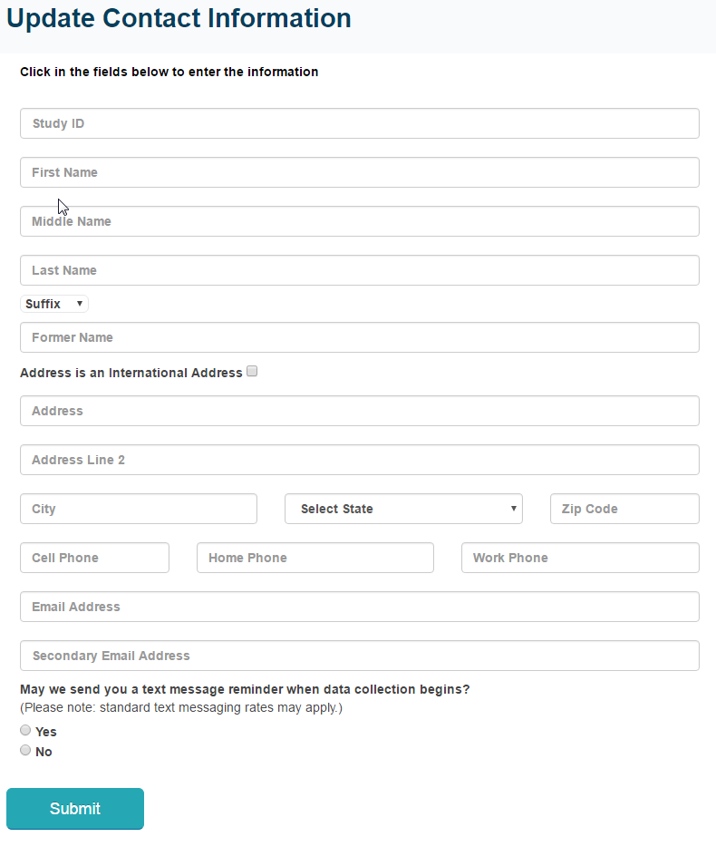

CONTACT US
If you need assistance accessing the web survey or wish to complete the survey by phone, call the B&B Help Desk:
Help Desk Hours
Monday-Thursday | 9:00 a.m. – midnight.
Friday | 9:00 a.m. – 11:00 p.m.
Saturday | 9:30 a.m. – 9:00 p.m.
Sunday | 1:00 p.m. – 11:00 p.m.
All times are Eastern time (ET).
Telephone
Phone: 877-287-3782
Email
bandb@rti.org
B&B Staff
B&B project staff are available to respond to your questions Monday through Friday between 9:00 a.m. and 5:00 p.m. ET.
B&B Staff
RTI Project Director | Jennifer Wine, Ph.D.
 | jennifer@rti.org
 | 877-225-8470
NCES Project Officer | Ted Socha
 | Ted.Socha@ed.gov
 | 202-245-7071
WHAT TO EXPECT
How can I complete the B&B survey?
You may complete the B&B survey on the Web – simply Log in from the home page by entering your study ID number and password, which are provided in the B&B letter or e-mail you received. You can even complete it on your mobile device. If you need assistance accessing the survey on the website, or if you want to complete the survey by telephone, contact the B&B Help Desk by calling 877-287-3782 or sending an e-mail to bandb@rti.org.
How long will the survey take?
For most people, we expect the survey will take about 30 minutes, depending on your answers. You do not have to complete the survey in one session. You can get started and, if you choose, you can easily log out and resume at a later time. If you are asked to provide a resume, the time to submit the resume is estimated to average 5 minutes.

Do I have to participate?
Participation in this study is voluntary; however, your involvement is very important to the success of this study. By participating, you have the opportunity to help policymakers, researchers, and others better understand the experiences of recent bachelor’s degree recipients. You may recall being contacted about or participating in the National Postsecondary Student Aid Study (NPSAS) last year. You can participate in B&B whether or not you completed a survey for NSPAS – we need your participation for the study to be a success!
Can I refuse to answer a question?
You may refuse to answer any question at any time. If you choose not to answer or are unable to answer a particular question, you may still continue with the rest of the survey.

How do I know your website is secure?
The B&B website is protected by Secure Sockets Layer (SSL; 128-bit encryption) technology. Your survey responses are collected over a secure server and connection is also protected by SSL.
Should I use a particular web browser to take the web survey?
The survey needs to use a browser that supports HTML5 and JavaScript. The latest versions of Firefox, Chrome, and Safari will work, as will Internet Explorer 9 and later. If you are having any trouble completing the survey, please call our Help Desk at 877-287-3782 and we will be happy to assist you.
PREVIOUS RESULTS
Your Participation Counts!
As with all prior B&B studies, results will be presented in summary form only; no individual results will be published. Data collected from B&B will help researchers and policymakers better understand how earning a bachelor’s degree impacts choices for additional education and employment paths.
Here’s what we learned from the B&B cohort of students who graduated with their bachelor’s degree in the 2007-2008 school year:
- Pie chart: Bachelor’s degree major: (16% STEM, 16% social sciences, 12% humanities, 23% business, 33% other) [SOURCE: U.S. Department of Education, National Center for Education Statistics, 2008/09 Baccalaureate and Beyond Longitudinal Study (B&B:08/09) http://nces.ed.gov/pubs2013/2013150.pdf]
- Bar chart: Among bachelor’s degree recipients, average amount borrowed, by sector (Public 4-year: $20,800; Private nonprofit 4-year: $28,900; for-profit 4-year: $36,800) [SOURCE: U.S. Department of Education, National Center for Education Statistics, 2008/09 Baccalaureate and Beyond Longitudinal Study (B&B:08/09) http://nces.ed.gov/pubs2013/2013150.pdf]
- Pie chart: Employment and enrollment four years after bachelor degree receipt (69% employed only, 11% both employed and enrolled, 6% enrolled only, 15% neither employed nor enrolled) [SOURCE: U.S. Department of Education, National Center for Education Statistics, 2008/12 Baccalaureate and Beyond Longitudinal Study (B&B:08/12). http://nces.ed.gov/pubs2014/2014141.pdf ]

INFORMATION SECURITY
The National Center for Education Statistics (NCES) is required to follow strict procedures to protect personal information in the collection, reporting, and publication of data. Your responses will be combined with those of other students and will be presented in summary form only. No individually-identifying information will be published.
Data security procedures for B&B are reviewed and approved by NCES data security staff. Your answers are secured behind firewalls and are encrypted during internet transmission using Secure Sockets Layer (SSL) protocol. All data entry modules are password protected and require the user to log in before accessing confidential data.
Congress has authorized the National Center for Education Statistics (NCES) of the U.S. Department of Education’s Institute of Education Sciences to collect data about the costs of postsecondary education because policymakers at all levels need reliable and current national data in order to make decisions about postsecondary education.
NCES is authorized to conduct the 2016/17 Baccalaureate and Beyond Longitudinal Study (B&B:16/17) by the Education Sciences Reform Act of 2002 (ESRA 2002, 20 U.S.C. §9543) and to collect students’ education records from educational agencies or institutions for the purposes of evaluating federally supported education programs under the Family Educational Rights and Privacy Act (FERPA, 34 CFR §§ 99.31(a)(3)(iii) and 99.35).
The study has been approved by the U.S. Office of Management and Budget (OMB). The valid OMB control number for this information collection is 1850-0926. The expiration date is 5/31/2019.
ABOUT B&B
The 2016/17 Baccalaureate and Beyond Longitudinal Study (B&B:16/17) is a national study of approximately 29,000 graduates from U.S. colleges and universities to find out about their experiences since completing a bachelor’s degree.
The study will collect information on graduate and other education, experiences on the job market and in the labor force, earnings and expenses, family status, and personal and professional goals. In addition to survey responses, we collect related information from sources such as student loan and enrollment databases. There is a particular focus on careers in teaching and other employment outcomes.
B&B:16/17 is the first follow-up survey from a cohort of students who completed their bachelor’s degree requirements during the 2015-2016 academic year. Most study participants were first surveyed in 2016 as part of the National Postsecondary Student Aid Study (NPSAS).
B&B:16/17 is conducted by the National Center for Education Statistics (NCES), in the U.S. Department of Education’s Institute for Education Sciences, with data collection being carried out under contract by RTI International, a U.S.-based nonprofit research organization..

To learn more about the data from previous B&B studies, visit NCES’s B&B website.

Initial Contact/Screener Invitation Letter

<<date>>

<<name>>
<<addr1>>
<<addr2>>
<<city>>, <<st>> <<zip>>

Dear <<fname>>,

You have been randomly selected to participate in the 2016/17 Baccalaureate and Beyond Longitudinal Study (B&B:16/17), conducted by the U.S. Department of Education’s National Center for Education Statistics (NCES). [IF base-year interview respondent:]<<You may recall participating in the National Postsecondary Student Aid Study (NPSAS) last year.>> B&B will collect education, employment, and other information from you and others like you who earned their bachelor’s degree during the 2015-16 school year. Data collected from B&B will help researchers and policymakers better understand how earning a bachelor’s degree impacts choices for additional education and employment paths. These data are being collected for NCES by RTI International, a U.S.-based nonprofit research organization. Your participation in B&B is critical to the success of the study.
Before B&B data collection begins in a few weeks, we need to update our contact information for you.
Please answer a few questions about your eligibility for the study, and update your contact information online at <<Website URL>>. <<NPSAS study member, INCENTIVE ELIGIBLE : To thank you for completing this update, which should take about 10 minutes, we will send you $10 via <<PayPal or>> check!>>
Go to <<Website URL>>
Enter your Study ID number <<caseid>> and
Password: <<pswd>>

<<IF NPSAS study member: In the next few weeks we will contact you again with specific information about how to participate in the B&B study.>> You can also find out more about B&B at the website listed above. If you have additional questions or concerns about the study, please call the RTI study director, Jennifer Wine, at 877-225-8470.
We thank you in advance for your participation in this important study. Your cooperation is greatly appreciated.

Sincerely,

National Center for Education Statistics (NCES)

NCES is authorized to conduct B&B:16/17 by the Education Sciences Reform Act of 2002 (ESRA 2002, 20 U.S.C. §9543) and to collect students’ education records from education agencies or institutions for the purposes of evaluating federally supported education programs under the Family Educational Rights and Privacy Act (FERPA, 34 CFR §§ 99.31(a)(3)(iii) and 99.35). The data are being collected for NCES by RTI International, a U.S.-based nonprofit research organization. [PLEDGE FILL]
According to the Paperwork Reduction Act of 1995, no persons are required to respond to a collection of information unless it displays a valid OMB control number. The valid OMB control number for this voluntary information collection is 1850-0926. The time required to complete this information collection is estimated to average approximately <<time>> minutes per response, including the time to review instructions, gather the data needed, and complete and review the information collection. If you have any comments concerning the accuracy of the time estimate, suggestions for improving this survey, or any comments or concerns regarding the status of your individual submission of this survey, please write directly to: The 2016/17 Baccalaureate and Beyond Longitudinal Study (B&B:16/17), National Center for Education Statistics, Potomac Center Plaza, 550 12th St, SW, Room 4004, Washington, DC 20202.

Data Collection Announcement Letter

<<date>>

<<name>>
<<addr>>
<<city>>, <<st>> <<zip>>

Dear «fname» «lname»:

Recently, we contacted you about the 2016/17 Baccalaureate and Beyond Longitudinal Study (B&B:16/17), an important study that will collect education, employment, and other information from you and others like you who received their bachelor’s degree during the 2015-16 school year. Data collected from B&B will help researchers and policymakers better understand how earning a bachelor’s degree impacts choices for additional education and employment paths.

Approximately 29,000 recent bachelor’s degree recipients from schools across the nation have been randomly selected to participate in B&B. Sample members like you are being asked to complete a <<time>> survey. Having your resume handy will help you complete the survey more easily. <<IF GROUP 2-3 and incentive-eligible: If you complete the survey by <<early_comp_date>> we will send you $<<incamt+early_bird>> payable by <<PayPal or>> check. After <<early_comp_date>>, we will send you $<<IncAmt>> once you complete the survey.>> <<GROUPS 1 & 4 and incentive-eligible: Once you complete the survey, we will send you $«IncAmt», payable by <<PayPal or>> check. .>>

Log on to our secure website at <<Website URL>> to complete your survey on your computer, smartphone, or tablet:

Study ID = «caseid»
Password = «password»m (password is case sensitive).

Your participation is critical to the study’s success. You represent other recent college graduates like you who were not selected for this study. Your participation in B&B is voluntary and will not affect any aid or other benefits you may receive.
The enclosed brochure answers many common questions about the study and contains additional information on laws and procedures that protect the confidentiality of your responses. If you have questions about the study send an email to bandb@rti.org, or, if you prefer to complete the survey over the phone, call the B&B help desk at 877-287-3782. You can also learn more by visiting the study website at <<Website URL>>.

Thank you in advance for making B&B a success.

Sincerely,
Ted Socha
B&B Project Officer
National Center for Education Statistics (NCES)Ted.Socha@ed.gov
202-245-7071
Jennifer Wine, Ph.D.
B&B Project Director
RTI International
jennifer@rti.org
877-225-8470

Enclosure
«panelinfo»/«ctrl»

NCES is authorized to conduct B&B:16/17 by the Education Sciences Reform Act of 2002 (ESRA 2002, 20 U.S.C. §9543) and to collect students’ education records from education agencies or institutions for the purposes of evaluating federally supported education programs under the Family Educational Rights and Privacy Act (FERPA, 34 CFR §§ 99.31(a)(3)(iii) and 99.35). The data are being collected for NCES by RTI International, a U.S.-based nonprofit research organization. [PLEDGE FILL]
According to the Paperwork Reduction Act of 1995, no persons are required to respond to a collection of information unless it displays a valid OMB control number. The valid OMB control number for this voluntary information collection is 1850-0926. The time required to complete this information collection is estimated to average approximately <<time>> minutes per response, including the time to review instructions, gather the data needed, and complete and review the information collection. If you have any comments concerning the accuracy of the time estimate, suggestions for improving this survey, or any comments or concerns regarding the status of your individual submission of this survey, please write directly to: The 2016/17 Baccalaureate and Beyond Longitudinal Study (B&B:16/17), National Center for Education Statistics, Potomac Center Plaza, 550 12th St, SW, Room 4004, Washington, DC 20202.

Reminder Postcard 1 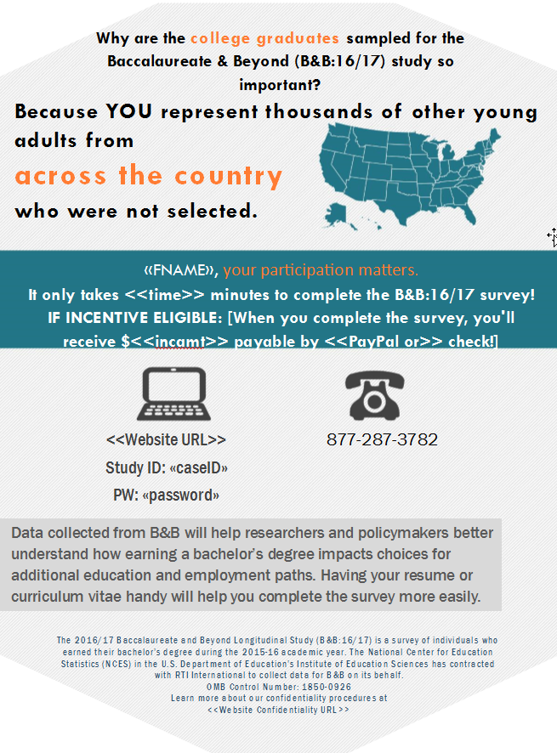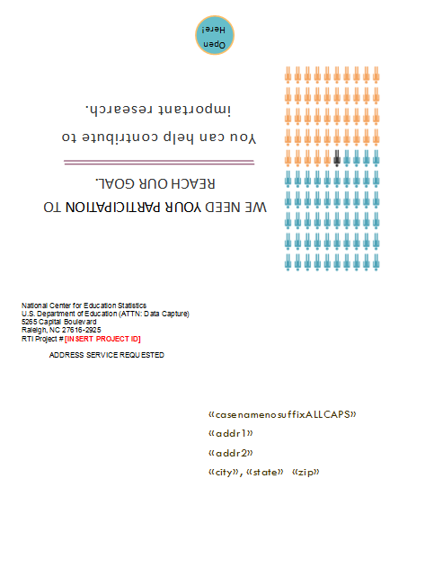

Reminder Postcard 2
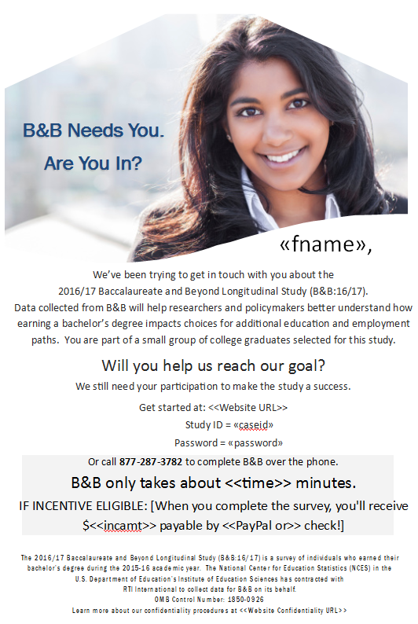

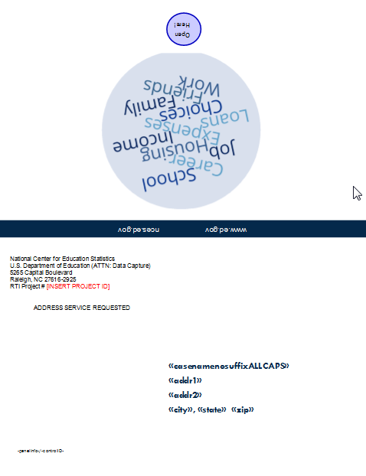

Reminder Postcard 3
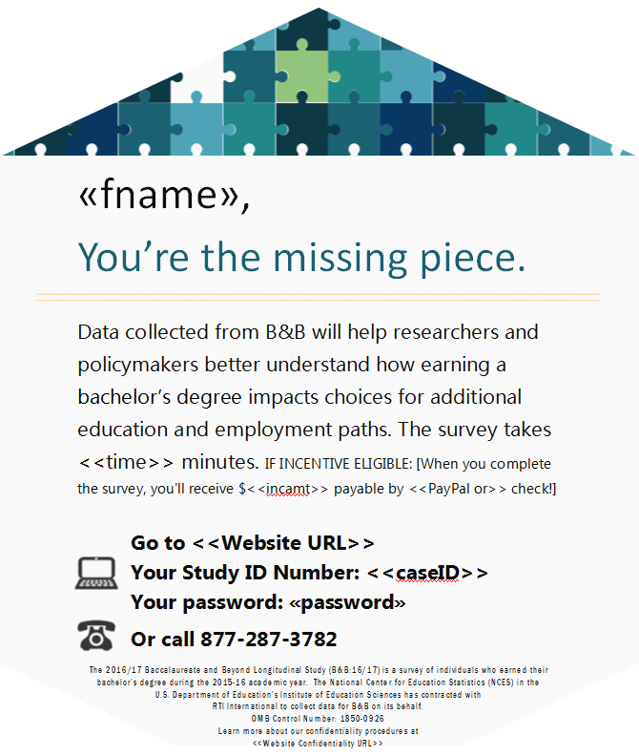
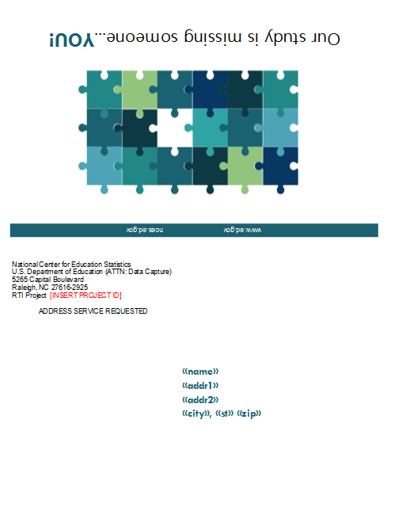

Reminder Postcard 4
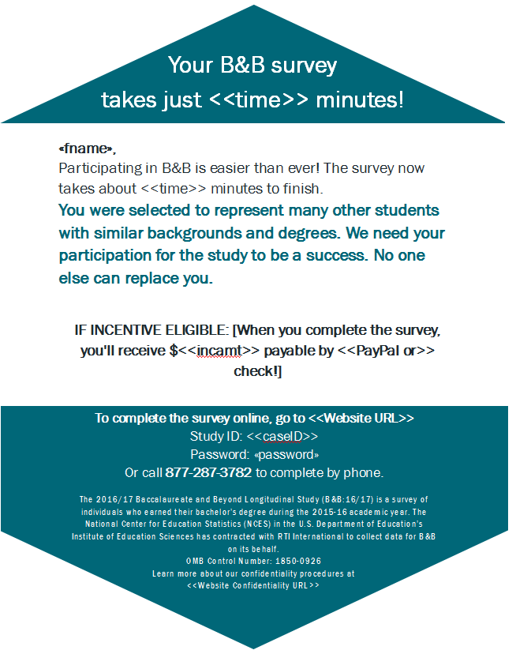
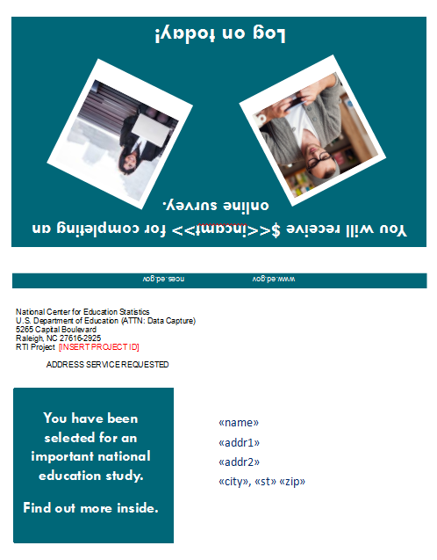

Reminder Postcard 5 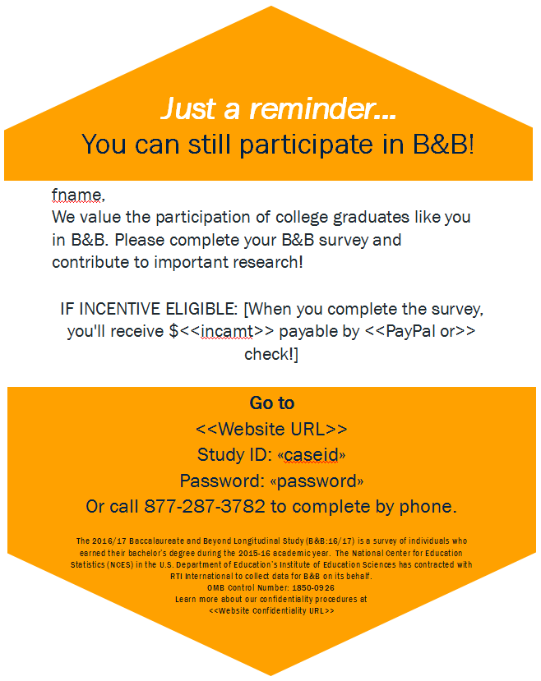
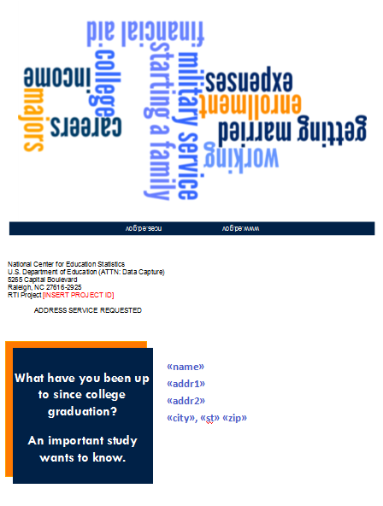

Holiday Postcard (Postcard 6)
Front: Warmest Holiday Greetings of the Season!
Inside:
From all of us on the B&B survey team, we wish you happy holidays.
Don’t forget to participate in B&B – and receive your <<incamt>> when you take the survey!
We rely on students like you to make the B&B study a success. Take a few minutes to participate now.

Log in here: <<Website URL>>
Study ID:
Password:

We appreciate your help. Happy New Year!

The 2016/17 Baccalaureate and Beyond Longitudinal Study (B&B:16/17 is a survey of individuals who earned their bachelor’s degree during the 2015-16 academic year. The National Center for Education Statistics (NCES) in the U.S. Department of Education’s Institute of Education Sciences has contracted with RTI International to collect data for B&B on its behalf.
OMB Control Number: 1850-0926
Learn more about confidentiality procedures at <<Website Confidentiality URL>>

Reminder Postcard 7
Front: Don’t Forget to Participate in B&B, <<fname>>! We need students with a major in <<major>> like you!
Inside:
With your Bachelor’s Degree in <<major>>, you’re an important contributor to the B&B study! Please participate today and receive <<incamt>> when you complete the survey.
Data collected from B&B will help researchers and policymakers understand how students fare after earning a bachelor’s degree, and no one can substitute for your response.

Log on here: <<Website URL>>
Study ID:
Password:

Thank you for making B&B a success!

The 2016/17 Baccalaureate and Beyond Longitudinal Study (B&B:16/17 is a survey of individuals who earned their bachelor’s degree during the 2015-16 academic year. The National Center for Education Statistics (NCES) in the U.S. Department of Education’s Institute of Education Sciences has contracted with RTI International to collect data for B&B on its behalf.
OMB Control Number: 1850-0926
Learn more about confidentiality procedures at <<Website Confidentiality URL>>

Reminder Postcard 8

Front: The B&B study is missing students with a major in <<major>> like you! Participate today!
Inside:
<<fname>>, we need your participation to make B&B a success!

We know you have demands on your time. The survey will only take about <<time>> minutes to complete, and once you do, you’ll receive <<incamt>>!
Will you log on today to help?

<<Website URL>>
Study ID:
Password:

Your participation is much appreciated. Thank you!

The 2016/17 Baccalaureate and Beyond Longitudinal Study (B&B:16/17 is a survey of individuals who earned their bachelor’s degree during the 2015-16 academic year. The National Center for Education Statistics (NCES) in the U.S. Department of Education’s Institute of Education Sciences has contracted with RTI International to collect data for B&B on its behalf.
OMB Control Number: 1850-0926
Learn more about confidentiality procedures at <<Website Confidentiality URL>>

Reminder Letter 1

«date»

«fname» «mname» «lname» «suffix» Study ID: «caseid»
«addr1»
«addr2»
«city», «state» «zip» «zip4»

Dear «fname»:

Data collection for the Baccalaureate and Beyond Longitudinal Study (B&B) has now been happening for the past <#> months. B&B is interested in understanding how earning a bachelor’s degree «in [major]» impacted your choices about additional education and employment paths since graduating from college during the 2015-2016 school year.

Approximately 29,000 recent bachelor’s degree recipients from schools across the nation have been randomly selected to participate in B&B. Sample members like you are being asked to complete a <<time>>-minute survey. Having your resume handy will help you complete the survey more easily. <<IF incentive-eligible: Once you complete the survey, we will send you $«Inc_amt», payable by <<PayPal or>> check. .>>

Log on to our secure website at <<Website URL>> to complete your survey on your computer, smartphone, or tablet:

Study ID = «caseid»
Password = «password»
Note: The password is case sensitive; you will need to enter it exactly as it appears here.

If you have questions about the study send an email to bandb@rti.org, or, if you prefer to complete the survey over the phone, call the B&B help desk at 877-287-3782. You can also learn more by visiting the study website at <<Website URL>>.

Thank you in advance for making B&B a success.

Sincerely,
Ted Socha
B&B Project Officer
National Center for Education Statistics (NCES)Ted.Socha@ed.gov
202-245-7071
Jennifer Wine, Ph.D.
B&B Project Director
RTI International
jennifer@rti.org
877-225-8470

Enclosure
«pledgegroup»/«controlid»

NCES is authorized to conduct B&B:16/17 by the Education Sciences Reform Act of 2002 (ESRA 2002, 20 U.S.C. §9543) and to collect students’ education records from education agencies or institutions for the purposes of evaluating federally supported education programs under the Family Educational Rights and Privacy Act (FERPA, 34 CFR §§ 99.31(a)(3)(iii) and 99.35). The data are being collected for NCES by RTI International, a U.S.-based nonprofit research organization. [PLEDGE FILL]
According to the Paperwork Reduction Act of 1995, no persons are required to respond to a collection of information unless it displays a valid OMB control number. The valid OMB control number for this voluntary information collection is 1850-0926. The time required to complete this information collection is estimated to average approximately <<time>> minutes per response, including the time to review instructions, gather the data needed, and complete and review the information collection. If you have any comments concerning the accuracy of the time estimate, suggestions for improving this survey, or any comments or concerns regarding the status of your individual submission of this survey, please write directly to: The 2016/17 Baccalaureate and Beyond Longitudinal Study (B&B:16/17), National Center for Education Statistics, Potomac Center Plaza, 550 12th St, SW, Room 4004, Washington, DC 20202.

Reminder Letter 2

«date»

«fname» «mname» «lname» «suffix» Study ID: «caseid»
«addr1»
«addr2»
«city», «state» «zip» «zip4»

Dear «fname»:

Your response is important to the B&B study! Please go online today to complete our <shortened> survey. The B&B survey takes only <<time>> minutes [IF INCENTIVE ELIGIBLE: <<and upon completion, you will receive a $<<Inc_amt >> token of our appreciation, payable by <<PayPal or>> check>>].
Only a limited number of people were selected for the study, so each person represents many others who were not selected. Therefore, it is extremely important that you complete the interview so that researchers and policymakers better understand how earning a bachelor’s degree «in majors such as [major]» impacts choices for additional education and employment paths. The results from this study will help develop policy regarding participation in higher education.

Please log on to our secure website to participate:

<<Website_URL>>
Study ID = <<caseid>>
Password = <<password>>
Note: The password is case sensitive; you will need to enter it exactly as it appears here.

If you have questions, problems completing your survey online, or prefer to complete the survey over the telephone, simply call the B&B Help Desk at 877-287-3782.

Thank you, in advance, for your participation.

Sincerely,
Ted Socha
B&B Project Officer
National Center for Education Statistics (NCES)Ted.Socha@ed.gov
202-245-7071
Jennifer Wine, Ph.D.
B&B Project Director
RTI International
jennifer@rti.org
877-225-8470

Enclosure
«pledgegroup»/«controlid»

NCES is authorized to conduct B&B:16/17 by the Education Sciences Reform Act of 2002 (ESRA 2002, 20 U.S.C. §9543) and to collect students’ education records from education agencies or institutions for the purposes of evaluating federally supported education programs under the Family Educational Rights and Privacy Act (FERPA, 34 CFR §§ 99.31(a)(3)(iii) and 99.35). The data are being collected for NCES by RTI International, a U.S.-based nonprofit research organization. [PLEDGE FILL]
According to the Paperwork Reduction Act of 1995, no persons are required to respond to a collection of information unless it displays a valid OMB control number. The valid OMB control number for this voluntary information collection is 1850-0926. The time required to complete this information collection is estimated to average approximately <<time>> minutes per response, including the time to review instructions, gather the data needed, and complete and review the information collection. If you have any comments concerning the accuracy of the time estimate, suggestions for improving this survey, or any comments or concerns regarding the status of your individual submission of this survey, please write directly to: The 2016/17 Baccalaureate and Beyond Longitudinal Study (B&B:16/17), National Center for Education Statistics, Potomac Center Plaza, 550 12th St, SW, Room 4004, Washington, DC 20202.

Reminder Postcard 9

Front: The B&B study needs graduates who majored in <<major>> like you!
Inside:
<<fname>>, we need YOU for our B&B study!
We know you’re busy, but this survey will only take about <<time>> minutes to complete.
<<IF GROUP 3, 4 & INCENTIVE-ELIGIBLE: If you complete the survey by <<early_comp_date>> we will send you $<<inc_amt+inc_boost+flash_inc>> payable by <<PayPal or>> check. After <<early_comp_date>>, we will send you $<<Inc_amt+inc_boost>> once you complete the survey.>> <<GROUPS 1, 2 & INCENTIVE ELIGIBLE: Once you complete the survey, we will send you $«Inc_amt», payable by <<PayPal or>> check. >>
Will you take our quick survey today?

<<Website URL>>
Study ID:
Password:

Thank you so much for your participation!

The 2016/17 Baccalaureate and Beyond Longitudinal Study (B&B:16/17 is a survey of individuals who earned their bachelor’s degree during the 2015-16 academic year. The National Center for Education Statistics (NCES) in the U.S. Department of Education’s Institute of Education Sciences has contracted with RTI International to collect data for B&B on its behalf.
OMB Control Number: 1850-0926
Learn more about confidentiality procedures at <<Website Confidentiality URL>>

Reminder Postcard 10

Front: Remember to Participate in B&B, <<fname>>! As a graduate with a major in <<major>>, we need to learn from your unique experiences!
Inside:
With your <<major>> degree, you’re a vital contributor to the B&B study! Would you like to get paid? Once you complete the survey we’ll send you <<inc_amt>>?
The data collected from B&B will assist researchers and policymakers in understanding how students fare after earning a bachelor’s degree, and no one can substitute for your response.

Log on here: <<Website URL>>
Study ID:
Password:

B&B will be a success only with your help!

The 2016/17 Baccalaureate and Beyond Longitudinal Study (B&B:16/17 is a survey of individuals who earned their bachelor’s degree during the 2015-16 academic year. The National Center for Education Statistics (NCES) in the U.S. Department of Education’s Institute of Education Sciences has contracted with RTI International to collect data for B&B on its behalf.
OMB Control Number: 1850-0926
Learn more about confidentiality procedures at <<Website Confidentiality URL>>

Reminder Postcard 11

Front: You have been selected for an important national education study. Find out more inside.
Inside:
Your B&B survey is now a few short questions!
«fname»: Participating in B&B is easier than ever!
The survey is now only a few questions and will take just <time> minutes of your time.
You were selected to represent many other students with similar backgrounds and «[major] »degrees. We need your participation for the study to be a success.
No one else can replace you.
IF INCENTIVE ELIGIBLE:
<<You’ll receive $ <inc_amt> as a thank you, payable by <<PayPal or>> check.>>
To complete the survey online: <<Website URL>>
To complete by phone: 877-287-3782
Study ID: «StudyID»
Password: «password»

The 2016/17 Baccalaureate and Beyond Longitudinal Study (B&B:16/17 is a survey of individuals who earned their bachelor’s degree during the 2015-16 academic year. The National Center for Education Statistics (NCES) in the U.S. Department of Education’s Institute of Education Sciences has contracted with RTI International to collect data for B&B on its behalf.
OMB Control Number: 1850-0926
Learn more about confidentiality procedures at <<Website Confidentiality URL>>

Reminder Postcard 12

Front: Only a limited number of people <<with a major in [major]>> were selected for this study! You represent many others who were not selected.
Inside:
You can influence educators and policymakers!
«fname»:
It is extremely important that you complete the interview so that educators and policymakers better understand the experiences of students as they transition into employment. Because the results from this study will help develop policy regarding participation in higher education, your experiences and opinions will help determine how future tax dollars are spent.
The survey takes just <<time> minutes of your time and IF INCENTIVE ELIGIBLE:
<<You’ll receive $ <inc_amt> as a thank you, payable by <<PayPal or>> check.>>
To complete the survey online: <<Website URL>>
To complete by phone: 877-287-3782
Study ID: «StudyID»
Password: «password»

The 2016/17 Baccalaureate and Beyond Longitudinal Study (B&B:16/17 is a survey of individuals who earned their bachelor’s degree during the 2015-16 academic year. The National Center for Education Statistics (NCES) in the U.S. Department of Education’s Institute of Education Sciences has contracted with RTI International to collect data for B&B on its behalf.
OMB Control Number: 1850-0926
Learn more about confidentiality procedures at <<Website Confidentiality URL>>

Reminder Postcard 13

Front: Researchers, educators, and policymakers want to know the issues that affect college graduates!
Inside:
«fname»,
We’re offering $<inc_amount> to thank you for completing the <time>-minute B&B survey.
B&B helps researchers, educators, and policymakers understand the issues that impact you!
What are the costs of pursuing higher education?
What impact does student loan debt have on students’ lives?
Are postsecondary schools preparing students to get the jobs they want?
You represent many other students like you. If you choose not to participate, no one else can be substituted for you.
Please help make this study a success by participating today!
To complete the survey online: <<Website URL>>
To complete by phone: 877-287-3782
Study ID: «StudyID»
Password: «password»

The 2016/17 Baccalaureate and Beyond Longitudinal Study (B&B:16/17 is a survey of individuals who earned their bachelor’s degree during the 2015-16 academic year. The National Center for Education Statistics (NCES) in the U.S. Department of Education’s Institute of Education Sciences has contracted with RTI International to collect data for B&B on its behalf.
OMB Control Number: 1850-0926
Learn more about confidentiality procedures at <<Website Confidentiality URL>>

Reminder Postcard 14

Front: What have you been up to since college graduation? An important study wants to know.
Inside:
Just a reminder... Act now, B&B ends soon!
<<fname>>,
We value the participation of college graduates <<with [major] degrees >>like you in B&B. Please complete your <<time>> minute B&B survey ending on <<end_date>>.
IF INCENTIVE ELIGIBLE: [When you complete the survey, you'll receive $<<inc_amount>> payable by <<PayPal or >>check!]
Go to
<<Website URL>>
Study ID:
Password:
Call 877-287-3782 to complete by phone.

The 2016/17 Baccalaureate and Beyond Longitudinal Study (B&B:16/17 is a survey of individuals who earned their bachelor’s degree during the 2015-16 academic year. The National Center for Education Statistics (NCES) in the U.S. Department of Education’s Institute of Education Sciences has contracted with RTI International to collect data for B&B on its behalf.
OMB Control Number: 1850-0926
Learn more about confidentiality procedures at <<Website Confidentiality URL>>

Screener Postcard 15

Front: Reminder: An important request from the B&B survey. Please answer a few questions about your eligibility for the study, and update your contact information online.
Inside:
You have been randomly selected to participate in the 2016/17 Baccalaureate and Beyond Longitudinal Study (B&B:16/17), conducted by the U.S. Department of Education's National Center for Education Statistics (NCES). <<IF NPSAS:16 FS respondent: You may recall participating in the National Postsecondary Student Aid Study (NPSAS) in 2016.>> B&B is an important study that follows up with recent bachelor's degree recipients to learn more about their education, employment, and other experiences after graduation. These data are being collected for NCES by RTI International, a U.S.-based nonprofit research organization.
<<Website URL>>
Study ID: «StudyID»
Password: «password»
<<IF NPSAS study member & INCENTIVE ELIGIBLE: To thank you for completing this update, which should take about 10 minutes, we will send you $10 via <<PayPal or>> check!>>

Your participation is critical to the success of B&B. If you have additional questions or concerns about the study, please call the study director, Jennifer Wine, at 877-225-8470.
We thank you in advance for your participation in this important study. Your cooperation is greatly appreciated.
The 2016/17 Baccalaureate and Beyond Longitudinal Study (B&B:16/17 is a survey of individuals who earned their bachelor’s degree during the 2015-16 academic year. The National Center for Education Statistics (NCES) in the U.S. Department of Education’s Institute of Education Sciences has contracted with RTI International to collect data for B&B on its behalf.
OMB Control Number: 1850-0926
Learn more about confidentiality procedures at <<Website Confidentiality URL>>

Reminder Flyer

<<Fname>>
Start the summer off right with $<<inc_amt>>!
The B&B survey closes on <<Date>>! This is the last chance to make a difference.
Data collected from B&B will help researchers and policymakers better understand how earning a bachelor’s degree impacts choices for additional education and employment paths. These data are being collected for NCES by RTI International, a U.S.-based nonprofit research organization. Your participation in B&B is critical to the success of the study.
Participating takes <<time>> minutes and
you will receive $<<inc_amount>> as a token of our appreciation.
Go to <<Website URL>>
Your Study ID Number: <<StudyID>>
Your password: <<Password>>
Or call 877-287-3782
The 2016/17 Baccalaureate and Beyond Longitudinal Study (B&B:16/17 is a survey of individuals who earned their bachelor’s degree during the 2015-16 academic year. The National Center for Education Statistics (NCES) in the U.S. Department of Education’s Institute of Education Sciences has contracted with RTI International to collect data for B&B on its behalf.
OMB Control Number: 1850-0926
Learn more about confidentiality procedures at <<Website Confidentiality URL>>

Initial Contact/Screener Invitation Email

SUBJECT: The Baccalaureate and Beyond Study is coming soon
Dear <<fname>>,
You have been randomly selected to participate in the 2016/17 Baccalaureate and Beyond Longitudinal Study (B&B:16/17), conducted by the U.S. Department of Education's National Center for Education Statistics (NCES). <<IF NPSAS:16 FS respondent: You may recall participating in the National Postsecondary Student Aid Study (NPSAS) last year.>> B&B is an important study that follows up with recent bachelor's degree recipients to learn more about their education, employment, and other experiences after graduation. These data are being collected for NCES by RTI International, a U.S.-based nonprofit research organization.
Before B&B data collection begins in a few weeks, we need to update our contact information for you. Please answer a few questions about your eligibility for the study, and update your contact information online:
<<Website URL>>
Your Study ID number: <<caseID>>
<<IF NPSAS study member & INCENTIVE ELIGIBLE: To thank you for completing this update, which should take about 10 minutes, we will send you $10 via <<PayPal or>> check!>>

<<IF NPSAS study member: In the next few weeks, we will contact you again with specific information about how to participate in the full B&B study.>> Your participation is critical to the success of B&B. If you have additional questions or concerns about the study, please call the study director, Jennifer Wine, at 877-225-8470.
We thank you in advance for your participation in this important study. Your cooperation is greatly appreciated.
Thank you,
Jennifer Wine, Ph.D.
B&B:16/17 Study Director
RTI International

OMB Control Number: 1850-0926
Learn more about our confidentiality procedures at <<Website URL>>

Initial Contact/Screener Reminder Email
SUBJECT: Update Your Information for an Important U.S. Department of Education Study
B&B data collection will begin soon, and we want to make sure we have the most current contact information for you, <<fname>>!
Please answer a few questions about your eligibility for the study, and update your contact information online:
<Website URL>>
Your Study ID number: <<caseID>>
Password: <<pswd>>
<<IF NPSAS study member: To thank you for completing this update, which should take approximately 10 minutes or less, we will send you $10 via PayPal or check!>>

<<IF NPSAS study member: We will contact you again with specific information about how to participate in the full B&B study. Look for an email from us in the coming weeks.>>
If you have additional questions or concerns about the study, please call the study director, Jennifer Wine, at 877-225-8470.
We thank you in advance for your participation. Your cooperation is greatly appreciated.
Thank you,
Jennifer Wine, Ph.D.
B&B:16/17 Study Director
RTI International

OMB Control Number: 1850-0926
Learn more about our confidentiality procedures at <<Website URL>>

Data Collection Announcement Email

SUBJECT: It’s time to complete your B&B survey!
Dear <<fname>>,
Recently, we contacted you about the 2016/17 Baccalaureate and Beyond Longitudinal Study (B&B:16/17), an important study that will collect education, employment, and other information from you and others like you who completed their bachelor's degree during the 2015-16 school year. Data collected from B&B will help researchers and policymakers better understand how earning a bachelor's degree impacts choices for additional education and employment paths.
Approximately 29,000 recent bachelor’s degree recipients from schools across the nation have been randomly selected to participate in B&B. Sample members like you are being asked to complete a <<time>> survey. Having your resume handy will help you complete the survey more easily. <<IF GROUP 2-3 & INCENTIVE-ELIGIBLE: If you complete the survey by <<early_comp_date>> we will send you $<<incamt+early_bird>> payable by <<PayPal or>> check. After <<early_comp_date>>, we will send you $<<IncAmt>> once you complete the survey.>> <<GROUPS 1, 4 & INCENTIVE ELIGIBLE: Once you complete the survey, we will send you $«IncAmt», payable by <<PayPal or>> check. >>
Click here to complete your survey on your computer, smartphone or tablet.
<<Website URL>>
Study ID = <<caseid>>
Password = <<pswd>> (password is case sensitive).
If you have questions about the study send an email to bandb@rti.org, or, if you prefer to complete the survey over the phone, call the B&B help desk at 877-287-3782. You can also learn more by visiting the study website at <<Website URL>>.
Thank you in advance for making B&B a success.
Jennifer Wine, Ph.D.  B&B Project Director  RTI International  jennifer@rti.org  877-225-8470 |  | Ted Socha  B&B Project Officer  National Center for Education Statistics (NCES)  Ted.Socha@ed.gov  202-245-7071
OMB Control Number: 1850-0926
Learn more about our confidentiality procedures at <<Website URL>>.

Reminder Email 1

SUBJECT: The Baccalaureate and Beyond Study Needs Your Participation

<<fname>>, we still need you for B&B to be a success!
Recently, I sent you an invitation to take part in the 2016/17 Baccalaureate and Beyond Longitudinal Study (B&B:16/17). As a recent college graduate, your participation is critical to the success of the study, so I hope you will participate soon.
IF INCENTIVE ELIGIBLE: <<GROUPS 2-3: As a reminder, if you complete the survey by <<Early_comp_date>> you will receive $<<incamt+early_amt>> payable by <<PayPal or>> check. If you complete the survey after <<Early_date>> you will receive $<<incamt>>.>> <<GROUPS 1 & 4: When you complete the survey, we’ll send you $<incamt> via <<PayPal or>> check! >>
It’s easy to complete today! You can:
- Click here or go to <<Website URL>> and log in:
Study ID: <<caseID>>
Password: <<pswd>>
- Or, complete the survey over the telephone at 877-287-3782.
If you don't have time to complete the entire survey right now, that is not a problem! You can start the survey now and finish it later — you'll pick up right where you left off.
If you have other questions, please contact the B&B Help Desk at 877-287-3782 or email us at bandb@rti.org. Thank you in advance for making B&B a success.
Jennifer Wine, Ph.D.
B&B Project Director
RTI International
OMB Control Number: 1850-0926
Learn more about our confidentiality procedures at <<Website URL>>

Reminder Email 2

SUBJECT: B&B Data Collection Continues…

... have you claimed your $<<incamt>>, <<fname>>?
Data collection for the 2016/17 Baccalaureate and Beyond Longitudinal Study (B&B:16/17) continues! IF INCENTIVE ELIGIBLE: [The survey — which can easily be completed on your computer or mobile device — takes approximately <<time>>, and when you complete your survey, you will receive $<<incamt>> as a token of our appreciation, payable by <<PayPal or>> check.] IF NO INCENTIVE: [The survey — which can easily be completed on your computer or mobile device — takes approximately <<time>>.]
To access the online survey on our secure website, click here and log in using your secure login credentials:
Study ID: <<caseID>>
Password: <<pswd>>
Need help accessing the online survey? Prefer to complete the survey by telephone? Please call our Help Desk at 877-287-3782.
Thank you in advance for your participation in this very important study.
Sincerely,
Jennifer Wine, Ph.D.
B&B Project Director
RTI International
OMB Control Number: 1850-0926
Learn more about our confidentiality procedures at <<Website URL>>.

Reminder Email 3

SUBJECT: Don’t Forget About Your B&B Survey

<<fname>>, your $<<incamt>> awaits!
We still need you to participate in the 2016/17 Baccalaureate and Beyond Longitudinal Study (B&B:16/17) for the U.S. Department of Education.
Click here to get started right away! You only need to enter your ID and password:
Study ID: <<caseID>>
Password: <<pswd>>
IF INCENTIVE ELIGIBLE: [As a token of our appreciation, you will receive $<<incamt>> for completing the survey.]
You can complete the survey by phone by calling 877-287-3782, and find more information on the study website at <<Website URL>>.
Thanks!
Jennifer Wine, Ph.D.
B&B Project Director
RTI International
jennifer@rti.org
877-225-8470

OMB Control Number: 1850-0926
Learn more about our confidentiality procedures at <<Website URL>>.

Reminder Email 4

SUBJECT: Don’t Delay – Participate in B&B Today

We've been contacting you and other recent college graduates about participating in B&B, <<fname>>!
IF INCENTIVE ELIGIBLE: [Because your participation is so important to us, we will send you $<<incamt>> when you complete your survey — just click here to get started.]
IF NO INCENTIVE OFFER: [Just click here to get started.]
You can also log in at our secure website:
<<Website URL>>
Study ID: <<caseID>>
Password: <<pswd>>
B&B is an important study that will help policymakers understand the experiences of students who recently earned their bachelor's degree. We know that you have a lot of demands on your time, but we need your help to make sure we hear from all different types of recent college graduates.
Call 877-287-3782 to get more information about B&B or complete the survey by telephone.
Thank you for considering participating in this important study. B&B won't be the same without you!
Jennifer Wine, Ph.D.
Project Director, B&B
RTI International
jennifer@rti.org
OMB Control Number: 1850-0926
Learn more about our confidentiality procedures at <<Website URL>>.

Reminder Email 5

SUBJECT: Take Part In Important Education Research When You Participate in B&B


Hello, <<fname>>! When you complete your survey for the 2016/17 Baccalaureate and Beyond Longitudinal Study (B&B:16/17), conducted by the National Center for Education Statistics (NCES) in the U.S. Department of Education IF INCENTIVE ELIGIBLE[, you will receive $<<incamt>> via <<PayPal or>> check.]
To get started right away, you'll need:
- about <<time>> minutes (but you don't have to finish it all at once),
- to click here or go to <<Website URL>> and enter your personal login information:
Study ID: <<caseID>>
Password: <<pswd>>
You can call the B&B Help Desk at 877-287-3782 if you have any questions or problems completing your survey or would like to participate over the telephone.
Thanks in advance for sharing your experiences with us!
The B&B Team
RTI International
bandb@rti.org
877-225-8470
OMB Control Number: 1850-0926
Learn more about our confidentiality procedures at <<Website URL>>.

Reminder Email 6

SUBJECT: Participate in Important U.S. Department of Education Study and Receive $<<incamt>> for a <<time>> Survey

<<fname>>, the 2016/17 Baccalaureate and Beyond Longitudinal Study (B&B:16/17) is an important education study about the experiences of recent college graduates conducted on behalf of the U.S. Department of Education. We sincerely thank you for your participation in the National Postsecondary Student Aid Study (NPSAS) last year, and hope you will help us by completing the B&B survey.
You can find out more about what we've learned from previous B&B studies here:
<<Website URL>>prev_results.aspx
The survey takes about <<time>> and is easy to complete on your mobile device. IF INCENTIVE ELIGIBLE: [And, when you complete the survey, you'll receive $<<incamt>>, payable by <<PayPal or>> check!] To get started right away, just click here!
YOUR SECURE LOGIN CREDENTIALS:
<<Website URL>>
Study ID: <<caseID>>
Password: <<pswd>>
You can also complete the survey by telephone by calling 877-287-3782, and find more information on the study website at <<Website URL>>.
Thanks!
Jennifer Wine, Ph.D.
Project Director, B&B
RTI International
jennifer@rti.org
877-225-8470
OMB Control Number: 1850-0926
Learn more about our confidentiality procedures at <<Website URL>>.

Reminder Email 7 – Abbreviated Interview Announcement
SUBJECT: The B&B Survey Now Takes Only 10 Minutes

<<fname>>, the B&B survey now takes only about 10 minutes to complete IF INCENTIVE ELIGIBLE: [, and you'll receive $<<incamt>> for participating, payable by <<PayPal or>> check.]
Just click here to start the survey right away!
Or, go to <<Website URL>> and log in:
Study ID: <<caseID>>
Password: <<pswd>>
If you prefer, you may also complete the survey over the telephone by calling the B&B Help Desk at 877-287-3782.
I hope that you will participate in the study, especially now that the survey takes only 10 minutes! Thank you in advance for making B&B a success.
Jennifer Wine, Ph.D.
Project Director, B&B
RTI International
877-225-8470
OMB Control Number: 1850-0926
Learn more about our confidentiality procedures at <<Website URL>>.

Reminder Email 8

SUBJECT: B&B Needs <<major>> Majors Like You, <<fname>>!

<<fname>>, B&B only takes <<time>> minutes and is easy to complete on your mobile device.
We need to hear from college graduates «with degrees in [major]» like you.
IF INCENTIVE ELIGIBLE: [When you complete the survey, you'll receive $<<incamt>> payable by <<PayPal or>> check!]
To get started, just click here or visit the website and log in.
<<Website URL>>
Study ID: <<caseID>>
Password: <<pswd>>
You can also complete the survey by telephone by calling 877-287-3782, and find more information on the study website at <<Website URL>>.
Thanks!
Jennifer Wine, Ph.D.
Project Director, B&B
RTI International
jennifer@rti.org
877-225-8470
OMB Control Number: 1850-0926
Learn more about our confidentiality procedures at <<Website URL>>.

Holiday Email

SUBJECT: Happy Holidays from all of us on the B&B survey team!

Don’t forget to take a few minutes to participate in the B&B survey this winter.
As you know, the survey takes about <<time>> minutes IF INCENTIVE ELIGIBLE [and you'll receive $<<incamt>>, payable by <<PayPal or>> check for completing it]!
To take the survey now please click here, or log in at <<Website URL>>
Study ID: <<caseID>>
Password: <<pswd>>
Please call 877-287-3782 if you would prefer to take the survey by telephone, or if we can answer any questions for you.
We appreciate your participation in this important study, as we need students like you to make it a success.
Wishing you and yours a happy holiday season, and a joyous New Year!
The B&B Survey Team
RTI International
bandb@rti.org
877-225-8470
OMB Control Number: 1850-0926
Learn more about our confidentiality procedures at <<Website URL>>.

Reminder Email 9

SUBJECT: Participate in B&B, an Important Education Study, for Students with a Major in <<major>>!

When you complete your B&B survey, which takes about <<time>> minutes, you'll contribute to important education research. IF INCENTIVE ELGIBLE: [And, you'll receive $<<incamt>>, payable by <<PayPal or>> check!] Just click here to get started right away.
YOUR SECURE LOGIN CREDENTIALS:
<<Website URL>>
Study ID: <<caseID>>
Password: <<pswd>>
We rely on students with a major in <<major>> to participate and make the study a success.
If you have questions or prefer to participate by telephone, call 877-287-3782.
Thanks in advance for your participation.
Jennifer Wine, Ph.D.
Project Director, B&B
RTI International
jennifer@rti.org
877-225-8470
OMB Control Number: 1850-0926
Learn more about our confidentiality procedures at <<Website URL>>.

Reminder Email 10

SUBJECT: Share Your Experiences as a Bachelor’s Degree Recipient Majoring in <<major>> with B&B for $<<incamt>>

<<fname>>, The B&B survey takes about <<time>> minutes IF INCENTIVE ELIGIBLE[, and when you complete it, you'll receive $<<incamt>>, payable by <<PayPal or>> check]!
This is your chance to contribute to important education research about recent college graduates. We need to hear from those students who majored in <<major>> like you!
B&B:16/17 is conducted by the National Center for Education Statistics (NCES), in the U.S. Department of Education's Institute for Education Sciences, with data collection being carried out under contract by RTI International, a U.S.-based nonprofit research organization.
Just click here to get started right away, or log in at <<Website URL>>:
Study ID: <<caseID>>
Password: <<pswd>>
If you have questions or prefer to participate by telephone, call 877-287-3782.
Thanks in advance for your participation.
Jennifer Wine, Ph.D.
Project Director, B&B
RTI International
jennifer@rti.org
877-225-8470
OMB Control Number: 1850-0926
Learn more about our confidentiality procedures at <<Website URL>>.

First Look Email

SUBJECT: Your participation matters! Review the NPSAS:15/16 First Look results now.

[If Group 3 or 4] Thank you for participating in the NPSAS:15/16 study. [If Group 1 or 2] You may remember hearing about the NPSAS:15/16 study, for which we surveyed students like you.
Here are some key findings from NPSAS:15/16 you might be interested in:
• Selected Finding 1
•Selected Finding 2
•Selected Finding 3
You can read about these and other findings in the NPSAS:15/16 First Look, now available here: <<Website URL>>.
We rely on your participation to produce these results. That’s why we’re contacting you to take part in the B&B survey. The survey takes about <<time>> minutes IF INCENTIVE ELIGIBLE [and you'll receive $<<incamt>>, payable by <<PayPal or>> check when you complete it]!
To take the B&B survey now just click here, or log in at <<Website URL>>
Study ID: <<caseID>>
Password: <<pswd>>
If you would prefer to participate by telephone, or have any questions, please call 877-287-3782.
Thanks in advance for your participation. It is much appreciated.
Sincerely,
Jennifer Wine, Ph.D.
Project Director, B&B
RTI International
jennifer@rti.org
877-225-8470
OMB Control Number: 1850-0926
Learn more about our confidentiality procedures at <<Website URL>>.

Reminder Email 11

SUBJECT: Please complete our B&B survey

The survey takes about <<time>> minutes IF INCENTIVE ELIGIBLE [and you'll receive $<<incamt>>, payable by <<PayPal or>> check when you complete]!
To get started right away just click here, or log in at <<Website URL>>
Study ID: <<caseID>>
Password: <<pswd>>
If you prefer to participate by telephone, have questions, or would like more information, just call 877-287-3782.
Thanks in advance for your participation.
Jennifer Wine, Ph.D.
Project Director, B&B
RTI International
jennifer@rti.org
877-225-8470
OMB Control Number: 1850-0926
Learn more about our confidentiality procedures at <<Website URL>>.

Reminder Email 12

SUBJECT: B&B Surveys are Still Underway for Students with a Major in <<major>>!

<<fname>>, when you participate in B&B, which takes about <<time>> minutes, IF INCENTIVE ELIGIBLE [you'll receive $<<incamt>> as a thank you, payable by <<PayPal or>> check, and] you’ll contribute to important research conducted by the U.S. Department of Education.
We need students with a major in <<major>> to participate, and hope you will choose to do so.
To get started right away, click here, or go to <<Website URL>> and log in:
Study ID: <<caseID>>
Password: <<pswd>>
If you prefer, you may also complete the survey over the telephone by calling the B&B Help Desk at 877-287-3782.
Thank you!
Jennifer Wine, Ph.D.
Project Director, B&B
RTI International
OMB Control Number: 1850-0926
Learn more about our confidentiality procedures at <<Website URL>>.

Reminder Email 13

SUBJECT: We Need Your Help with B&B <<, Especially Students With a <<major>> Major!>>

GROUPS 1-2: <<fname>>, just click here, or go to <<Website URL>> and log in:
GROUPS 3-4: <<fname>>, the B&B interview now takes just 10 minutes! To start your survey, click here, or go to <<Website URL>> and log in:
Study ID: <<caseID>>
Password: <<pswd>>
GROUPS 1-2, INCENTIVE ELIGIBLE: The B&B survey takes about <<time>> minutes to finish, and you'll receive $<<incamt>> via PayPal or check! You are one of a few selected people and the study won't be a success without you, <<fname>>! We especially need students with a <<major>> major like you!
GROUPS 3-4, INCENTIVE ELIGIBLE: When you finish, you'll receive $<<incamt>> via PayPal or check! You are one of a few selected people and the study won't be a success without you, <<fname>>! We especially need students with a <<major>> major like you!
GROUPS 1-2, NO INCENTIVE: The B&B survey takes about <<time>> minutes to finish. You are one of a few selected people and the study won't be a success without you, <<fname>>! We especially need students with a <<major>> major like you!
GROUPS 3-4, NO INCENTIVE: You are one of a few selected people and the study won't be a success without you, <<fname>>! We especially need students with a <<major>> major like you!
If you have questions or would prefer to complete over the telephone, call the B&B Help Desk at 877-287-3782.
Thank you!
Jennifer Wine, Ph.D.
Project Director, B&B
RTI International
OMB Control Number: 1850-0926
Learn more about our confidentiality procedures at <<Website URL>>.

Reminder Email 14

SUBJECT: B&B is Ending Soon – Don’t Miss Your Chance to Participate

<<fname>>, data collection for the U.S. Department of Education's 2016/17 Baccalaureate and Beyond Longitudinal Study (B&B:16/17) will end soon, and we need your help to make the study a success!
Go to <<Website URL>> and log in or click here to get started right away:
Study ID: <<caseID>>
Password: <<pswd>>
It only takes about <<time>> minutes to complete the B&B survey. IF INCENTIVE ELIGIBLE: [You'll receive $<<incamt>> via <<PayPal or>> check!]
Our professional interviewers can answer any questions you have, and can complete the interview over the telephone with you, if you prefer. Just call the B&B Help Desk at 877-287-3782.
Thank you!
Jennifer Wine, Ph.D.
Project Director, B&B
RTI International
OMB Control Number: 1850-0926
Learn more about our confidentiality procedures at <<Website URL>>.

Reminder Email 15

SUBJECT: B&B Is Coming to a Close!
Only one more week to participate, <<fname>>!
The B&B study ends on <<end_date>>, so we hope that all questionnaires will be completed by then. IF INCENTIVE ELIGIBLE: [If you finish the survey by then, you'll receive $<<incamt>> via <<PayPal or>> check!]
Click here to go right to the survey!
If you have any questions, please contact the B&B help desk at 877-287-3782.
Thank you for your participation!
Best,
Jennifer Wine, Ph.D.
Project Director, B&B
RTI International
<<Website URL>>
Study ID: <<caseID>>
Password: <<pswd>>
OMB Control Number: 1850-0926
Learn more about our confidentiality procedures at <<Website URL>>.

Reminder Email 16
SUBJECT: B&B ends June 30 - Just 5 days left!

<<fname>>, we don't want you to miss out on your opportunity to contribute to this important study and make your voice heard. B&B ends on <<end_date>>, so there are only 5 days left for you to participate in this <<time>>-minute survey.
IF INCENTIVE ELIGIBLE: [When you complete the survey, you will receive $<<incamt>> via <<PayPal or>> check.]
Ready to get started? Click here or use the following information:
<<Website URL>>
Study ID: <<caseID>>
Password: <<pswd>>
Please call the B&B Help Desk at 877-287-3782 or visit the study website at <<Website URL>> if you have any questions or problems completing your survey or would like to participate by telephone.
Thank you!
Jennifer Wine, Ph.D.
Project Director, B&B
RTI International
OMB Control Number: 1850-0926
Learn more about our confidentiality procedures at <<Website URL>>.

Reminder Email 17
SUBJECT: Just Two More Days to Participate in B&B!

<<fname>>, B&B ends Friday! Complete your <<time>>-minute survey today IF INCENTIVE ELIGIBLE [, and receive $<<incamt>> as a token of our appreciation!]
Click here to start the survey right away!
Your manual login credentials are:
<<Website URL>>
Study ID: <<caseID>>
Password: <<pswd>>
Thanks in advance for participating! Have a great day.
Jennifer Wine, Ph.D.
Project Director, B&B
RTI International
OMB Control Number: 1850-0926
Learn more about our confidentiality procedures at <<Website URL>>.

Reminder Email 18

SUBJECT: B&B Ends Tomorrow – Help Us Learn About Your Experiences Since Graduation!

The U.S. Department of Education's 2016/17 Baccalaureate and Beyond Longitudinal Study (B&B:16/17) ends tomorrow, <<fname>>!
IF INCENTIVE ELIGIBLE: [When you complete your <<time>>-minute survey you'll receive $<<incamt>> as a token of our appreciation.]
Your secure login credentials are:
<<Website URL>>
Study ID: <<caseID>>
Password: <<pswd>>
Or, just click here to start the survey right away!
If you have questions, or if you would prefer to complete the survey over the telephone, call 877-287-3782.
Thanks in advance for participating! Have a great day.
Jennifer Wine, Ph.D.
Project Director, B&B
RTI International
OMB Control Number: 1850-0926
Learn more about our confidentiality procedures at <<Website URL>>.

Reminder Email 19

SUBJECT: Your Last Chance to Participate… Don’t Miss Out on B&B!

<<fname>>, this is the last email message we will be sending you about this survey. We want you to know how very important your participation is to the success of the 2016/17 Baccalaureate and Beyond Longitudinal Study (B&B:16/17), which is why we've been so persistent in reminding you to complete your survey!
Before the study comes to a close, please consider logging in to participate - just click here to take the survey now!
IF INCENTIVE ELIGIBLE: [It takes about <<time>> minutes, can be completed on a smartphone or tablet, and you'll receive $<<incamt>> via <<PayPal or>> check when you finish!]
IF NO INCENTIVE: [It takes about <<time>> minutes, and can be completed on a smartphone or tablet.]
You can learn more about results from previous round of B&B at
<<Website URL>>prev_results.aspx
If you have questions, or if you would prefer to complete the survey over the telephone, call 877-287-3782.
Thanks in advance for participating! Have a great day.
Jennifer Wine, Ph.D.
Project Director, B&B
RTI International
Your manual login credentials are:
<<Website URL>>
Study ID: <<caseID>>
Password: <<pswd>>
OMB Control Number: 1850-0926
Learn more about our confidentiality procedures at <<Website URL>>.

Reminder Email from NCES 1

SUBJECT: Message from the U.S. Department of Education
Dear <<fname>>,

My name is Ted Socha. As the Project Officer for the 2016/17 Baccalaureate and Beyond Longitudinal Study (B&B:16/17), from the National Center for Education Statistics (NCES), I hope that you will take time out of your busy schedule to complete the B&B survey today. It is an important study of college graduates and their lives after college. The U.S. Department of Education, Congress, and the White House use data from this study to inform policy decisions regarding student loans and other critical issues.

On average, the survey takes only about <<time>> minutes IF INCENTIVE ELIGIBLE: [and you will receive $<<incamt>> as a token of appreciation for completing it.]

To complete the B&B survey online, go to our secure website:

<<Website URL>>
Study ID number = <<caseID>>
Password = <<pswd>>

If you have questions or prefer to complete the survey over the telephone with one of our professional telephone interviewers, you can call us at 877-287-3782.

Thank you for helping to make B&B a success. For further information and findings from previous B&B studies, go to <<Website URL>>.

Ted Socha
B&B Project Officer
National Center for Education Statistics (NCES)
U.S. Department of Education
Ted.Socha@ed.gov

OMB Control Number: 1850-0926
Learn more about our confidentiality procedures at <<Website URL>>
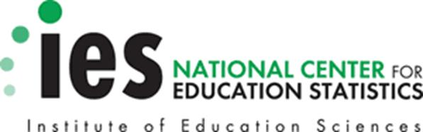

Reminder Email from NCES 2

SUBJECT: U.S. Department of Education Message About Baccalaureate and Beyond
Dear <<fname>>--
My name is Ted Socha. You may recall receiving an email from me a couple weeks ago. As the Project Officer for the 2016/17 Baccalaureate and Beyond Longitudinal Study (B&B:16/17), from the National Center for Education Statistics (NCES), I hope that you will take time out of your busy schedule to complete the B&B survey today. It is an important study of college graduates and their lives after college. The U.S. Department of Education, Congress, and the White House use data from this study to inform policy decisions regarding student loans and other critical issues.
On average, the survey takes only about <<time>> minutes IF INCENTIVE ELIGIBLE:[ and you will receive $<<incamt>> as a token of appreciation for completing it.]
To complete the B&B survey online, go to our secure website:
<<Website URL>>
Study ID number = <<caseID>>
Password = <<pswd>>

If you have questions or prefer to complete the survey over the telephone with one of our professional telephone interviewers, you can call us at 877-287-3782.
Thank you for helping to make B&B a success. For further information and findings from previous B&B studies, go to <<Website URL>>.
Ted Socha
B&B Project Officer
National Center for Education Statistics (NCES)
U.S. Department of Education
Ted.Socha@ed.gov
OMB Control Number: 1850-0926
Learn more about our confidentiality procedures at <<Website URL>>
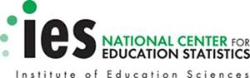

Reminder Email 20

SUBJECT: Reminder: An Important Request from the B&B Survey Team

<<fname>>, we still need you for B&B to be a success!
As a recent college graduate, your participation is critical to the success of this important U.S. Department of Education study, so I hope you will participate soon. The data collected in this study helps researchers understand the paths of recent college graduates <<in [major]>><<and [major2]>>, and we need your input.
IF INCENTIVE ELIGIBLE: [And, when you complete the survey, you'll receive $<<incamt>>, payable by <<PayPal or>> check!]
It’s easy to complete today, even on your mobile device, and only takes about <<time>> minutes to complete.
- Click here or go to <<Website URL>> and log in:
Study ID: <<caseID>>
Password: <<pswd>>
- Or, complete the survey over the telephone at 877-287-3782.
If you have other questions, please contact the B&B Help Desk at 877-287-3782 or email us at bandb@rti.org. Thank you for your participation!
Jennifer Wine, Ph.D.
B&B Project Director
RTI International
OMB Control Number: 1850-0926
Learn more about our confidentiality procedures at <<Website URL>>

Reminder Email 21

SUBJECT: Carry On a Civic Tradition: Please Help By Taking the B&B Survey

«Fname», we’ve been contacting you and other college graduates <<in [major]>> <<and [major2>> about participating in B&B!
The study is an important follow up to the National Postsecondary Student Aid Study, conducted in 2016, and relies on students like you to carry on the tradition of acquiring data about financial aid, employment and educational paths, and other topics that impact recent bachelor’s degree recipients.
Join the thousands of students who have already participated! IF INCENTIVE ELIGIBLE: [And, when you complete the survey, you'll receive $<<incamt>>, payable by <<PayPal or>> check!]
The survey — which can easily be completed on your computer or mobile device — takes approximately <<time>> minutes to complete.
To access the online survey on our secure website, just click here or log in yourself at the site below:
<<Website URL>>
Your secure login credentials:
Study ID: <<caseID>>
Password: <<pswd>>
Need help accessing the online survey? Prefer to complete the survey by telephone? Please call our Help Desk at 877-287-3782.
Thank you in advance for your participation in this very important study.
Sincerely,
Jennifer Wine, Ph.D.
B&B Project Director
RTI International
OMB Control Number: 1850-0926
Learn more about our confidentiality procedures at <<Website URL>>.

Reminder Email 22

SUBJECT: Don’t Forget About Your B&B Survey

<<fname>>,
We still need you to participate in the 2016/17 Baccalaureate and Beyond Longitudinal Study (B&B:16/17) for the U.S. Department of Education. Your participation «as a [major] «and [major2]»major» is important to make sure that the B&B results represent all types of life experiences. No one can replace you in this study.

Click here to get started right away! Or log on at <<Website URL>> using your ID and password:
Study ID: <<caseID>>
Password: <<pswd>>
IF INCENTIVE ELIGIBLE: [And, when you complete the survey, you'll receive $<<incamt>>, payable by <<PayPal or>> check!]
You can complete the survey by phone by calling 877-287-3782, and find more information on the study website at <<Website URL>>.
Thanks!
Jennifer Wine, Ph.D.
B&B Project Director
RTI International
jennifer@rti.org
877-225-8470

OMB Control Number: 1850-0926
Learn more about our confidentiality procedures at <<Website URL>>.

Reminder Email 23

SUBJECT: Your Response is Important to Us – Please Take the B&B Survey

We've been contacting you and other recent college graduates about participating in B&B, <<fname>>! We need your response to help make the study a success.
IF INCENTIVE ELIGIBLE: [Because your participation is so important to us, we will send you $<<incamt>> when you complete your survey — just click here to get started.]
IF NO INCENTIVE OFFER: [Just click here to get started.]
You can also log in at our secure website:
<<Website URL>>
Study ID: <<caseID>>
Password: <<pswd>>
We know that you have many demands on your time, but we would really appreciate it if you could take a few minutes to complete this important survey.
Call 877-287-3782 to get more information about B&B or complete the survey by telephone.
Thank you, in advance, for your participation. B&B won't be the same without you!
Jennifer Wine, Ph.D.
Project Director, B&B
RTI International
jennifer@rti.org
OMB Control Number: 1850-0926
Learn more about our confidentiality procedures at <<Website URL>>.

Reminder Email 24

SUBJECT: Friendly Reminder To Take Part In The B&B Survey

Hello, <<fname>>! Please remember to complete your survey for the 2016/17 Baccalaureate and Beyond Longitudinal Study (B&B:16/17), conducted by the National Center for Education Statistics (NCES) in the U.S. Department of Education. B&B helps researchers and policymakers understand how earning a bachelor’s degree «in [major]» «and [major2]» impacts choices for continuing education and employment paths.
[IF INCENTIVE ELIGIBLE: You will receive $<<incamt>> via <<PayPal or>> check.]
To get started right away, you'll need:
- about <<time>> minutes (but you don't have to finish it all at once),
- to click here or go to <<Website URL>> and enter your personal login information:
Study ID: <<caseID>>
Password: <<pswd>>
You can call the B&B Help Desk at 877-287-3782 if you have any questions or problems completing your survey or would like to participate over the telephone.
Thanks in advance for sharing your experiences with us. We appreciate your time!
The B&B Team
RTI International
bandb@rti.org
877-225-8470
OMB Control Number: 1850-0926
Learn more about our confidentiality procedures at <<Website URL>>.

Reminder Email 25 – Boost Announcement (Groups 3 and 4)

SUBJECT: Take the B&B Survey for an Additional $<<Boost_Inc>>!

<<fname>>, the 2016/17 Baccalaureate and Beyond Longitudinal Study (B&B:16/17) is an important education study about the experiences of recent college graduates conducted on behalf of the U.S. Department of Education.
We rely on students like you to make it a success, and hope you will help us by completing the B&B survey.
The survey takes about <<time>> minutes, and is easy to complete on your mobile device. Groups 3 and 4: [IF INCENTIVE ELIGIBLE AND BOOST: << In addition to your $<<Inc_amount>>, you’ll also now receive $<<Boost_Inc>>, for a total of $<<Total_incentive>>!]
To get started right away, just click here!
YOUR SECURE LOGIN CREDENTIALS:
<<Website URL>>
Study ID: <<caseID>>
Password: <<pswd>>
You can also complete the survey by telephone by calling 877-287-3782, and find more information on the study website at <<Website URL>>.
Thanks!
Jennifer Wine, Ph.D.
Project Director, B&B
RTI International
jennifer@rti.org
877-225-8470

Reminder Email 26

SUBJECT: Help Inform Education Policy: Take the B&B Survey Today!

<<fname>>, B&B only takes <<time>> minutes and is easy to complete on your mobile device. Your participation «as a [major] «and [major2]» major» is important to the study’s success!

IF INCENTIVE ELIGIBLE: Groups 1 and 2: When you complete the survey, you'll receive $<<incamt>> payable by <<PayPal or>> check!]

Groups 3 and 4: [IF INCENTIVE ELIGIBLE AND BOOST: << In addition to your $<<Inc_amount>>, you’ll also now receive $<<Boost_Inc>>, for a total of $<<inc_amount+boost_inc>> for participating.] [IF ALSO FLASH: Additionally, if you complete the survey by <<flash_comp_date>> we will send you $<<incamt+boost_inc+flash_inc>> payable by <<PayPal or>> check. After <<flash_comp_date>>, we will send you $<<IncAmt+boost_inc>> once you complete the survey.>>
Researchers and policymakers rely on the B&B study to provide important data regarding recent college graduates and their employment and education paths. Please help make the study a success!
To get started, just click here or visit the website and log in:
<<Website URL>>
Study ID: <<caseID>>
Password: <<pswd>>
You can also complete the survey by telephone by calling 877-287-3782, and find more information on the study website at <<Website URL>>.
Thanks!
Jennifer Wine, Ph.D.
Project Director, B&B
RTI International
jennifer@rti.org
877-225-8470
OMB Control Number: 1850-0926
Learn more about our confidentiality procedures at <<Website URL>>.

Reminder Email 27

SUBJECT: Make Your Voice Heard: Your education and work experiences are unique!

<<fname>>, no one can substitute for your responses, and we need bachelor’s degree recipients with similar backgrounds and degrees <<in [major]<< and [major2]>>>> to participate in B&B and share your unique education and work experiences. Please consider participating today.
When you complete your B&B survey, which takes about <<time>> minutes, you'll contribute to important education research. IF INCENTIVE ELIGIBLE: Groups 1 and 2: When you complete the survey, you'll receive $<<incamt>> payable by <<PayPal or>> check!]

Groups 3 and 4: [IF INCENTIVE ELIGIBLE AND BOOST: << In addition to your $<<Inc_amount>>, you’ll now also receive $<<Boost_Inc>>, for a total of $<<Total_incentive>>.] [IF ALSO FLASH: Additionally, if you complete the survey by <<flash_comp_date>> we will send you $<<incamt+boost_inc+flash_inc>> payable by <<PayPal or>> check. After <<flash_comp_date>>, we will send you $<<IncAmt+boost_inc>> once you complete the survey.>>

Just click here to get started.
YOUR SECURE LOGIN CREDENTIALS:
<<Website URL>>
Study ID: <<caseID>>
Password: <<pswd>>
If you have questions or prefer to participate by telephone, call 877-287-3782.
Thanks in advance for your participation. We know your time is valuable, and appreciate your willingness to help us make this study a success.
Jennifer Wine, Ph.D.
Project Director, B&B
RTI International
jennifer@rti.org
877-225-8470
OMB Control Number: 1850-0926
Learn more about our confidentiality procedures at <<Website URL>>.

Reminder Email 28

SUBJECT: Share Your Experiences with B&B for $<<incamt>>, <<fname>>

The B&B survey takes about <<time>> minutes IF INCENTIVE ELIGIBLE Groups 1 and 2[, and when you complete it, you'll receive $<<incamt>>, payable by <<PayPal or>> check]! Groups 3 and 4: [IF INCENTIVE ELIGIBLE AND BOOST: << In addition to your $<<Inc_amount>>, you’ll also now receive $<<Boost_Inc>>, for a total of $<<inc_amount+boost_inc>> for participating.] [IF ALSO FLASH: Additionally, if you complete the survey by <<flash_comp_date>> we will send you $<<incamt+boost_inc+flash_inc>> payable by <<PayPal or>> check. After <<flash_comp_date>>, we will send you $<<IncAmt+boost_inc>> once you complete the survey.>>
This is your chance to contribute to important education research about recent college graduates. Please participate today so that your voice is heard!

B&B:16/17 is conducted by the National Center for Education Statistics (NCES), in the U.S. Department of Education's Institute for Education Sciences, with data collection being carried out under contract by RTI International, a U.S.-based nonprofit research organization.
Just click here to get started right away, or log in at <<Website URL>>:
Study ID: <<caseID>>
Password: <<pswd>>
If you have questions or prefer to participate by telephone, call 877-287-3782.
Thanks in advance for your participation. Your time is appreciated!
Jennifer Wine, Ph.D.
Project Director, B&B
RTI International
jennifer@rti.org
877-225-8470
OMB Control Number: 1850-0926
Learn more about our confidentiality procedures at <<Website URL>>.

Reminder Email 29

SUBJECT: <<fname>>, can you spare about <<time>> minutes to take the B&B survey?

The B&B survey takes only about <<time>> minutes IF INCENTIVE ELIGIBLE, Groups 1 and 2 [and you'll receive $<<incamt>>, payable by <<PayPal or>> check when you complete]! Groups 3 and 4: [IF INCENTIVE ELIGIBLE AND BOOST: << In addition to your $<<Inc_amount>>, you’ll also now receive $<<Boost_Inc>>, for a total of $<<inc_amount+boost_inc>> for participating.] [IF ALSO FLASH: Additionally, if you complete the survey by <<flash_comp_date>> we will send you $<<incamt+boost_inc+flash_inc>> payable by <<PayPal or>> check. After <<flash_comp_date>>, we will send you $<<IncAmt+boost_inc>> once you complete the survey.>>
Please help us make the study a success by participating today. We’re relying on you!
To get started just click here, or log in at <<Website URL>>
Study ID: <<caseID>>
Password: <<pswd>>
If you prefer to participate by telephone, have questions, or would like more information, just call 877-287-3782.
We know your time is limited, and we appreciate you completing the survey.
Thanks!
Jennifer Wine, Ph.D.
Project Director, B&B
RTI International
jennifer@rti.org
877-225-8470
OMB Control Number: 1850-0926
Learn more about our confidentiality procedures at <<Website URL>>.

Reminder Email 30

SUBJECT: B&B Surveys are Still Underway

<<fname>>, when you participate in B&B, which takes about <<time>> minutes, IF INCENTIVE ELIGIBLE [you'll receive $<<incamt>> as a thank you, payable by <<PayPal or>> check, and] you’ll contribute to important research conducted by the U.S. Department of Education. The data collected in this study helps researchers understand the paths of recent college graduates <<in [major]>><<and [major2]>>, and we could really use your input!
To get started right away, click here, or go to <<Website URL>> and log in:
Study ID: <<caseID>>
Password: <<pswd>>
If you prefer, you may also complete the survey over the telephone by calling the B&B Help Desk at 877-287-3782.
Thank you!
Jennifer Wine, Ph.D.
Project Director, B&B
RTI International
OMB Control Number: 1850-0926
Learn more about our confidentiality procedures at <<Website URL>>.

Reminder Email 31

SUBJECT: <<fname>>, <<XX,XXX>> people have already participated in B&B – Will you?

Just click here, or go to <<Website URL>> and log in:
Study ID: <<caseID>>
Password: <<pswd>>
The B&B survey takes about <<time>> minutes to finish [IF INCENTIVE ELIGIBLE] and you'll receive $<<incamt>> via <<PayPal or>> check when you complete it.
You are one of a few selected people to participate in this important study, <<fname>>, and it won’t be the same without your input.
If you have questions or would prefer to complete over the telephone, call the B&B Help Desk at 877-287-3782.
Thank you, in advance, for making the B&B survey a success!
Jennifer Wine, Ph.D.
Project Director, B&B
RTI International
OMB Control Number: 1850-0926
Learn more about our confidentiality procedures at <<Website URL>>.

Reminder Email 32

SUBJECT: Don’t Miss Out – This is Your Chance to Participate in Important Education Research!

<<fname>>, data collection for the U.S. Department of Education's 2016/17 Baccalaureate and Beyond Longitudinal Study (B&B:16/17) continues, and we need your help to make the study a success! We’re including recent college graduates <<in [major]>><<and [major2]>> like yourself, who will make a unique contribution to the study.
Go to <<Website URL>> and log in or click here to get started right away:
Study ID: <<caseID>>
Password: <<pswd>>
It only takes about <<time>> minutes to complete the B&B survey. IF INCENTIVE ELIGIBLE: [You'll receive $<<incamt>> via <<PayPal or>> check!]
Our professional interviewers can answer any questions you have, and can complete the interview over the telephone with you, if you prefer. Just call the B&B Help Desk at 877-287-3782.
Thank you in advance for your participation!
Jennifer Wine, Ph.D.
Project Director, B&B
RTI International
OMB Control Number: 1850-0926
Learn more about our confidentiality procedures at <<Website URL>>.

Reminder Email 33

SUBJECT: The Department of Education wants you to complete your B&B survey, <<fname>>. Will you?
We rely on students like you to make B&B a success. Please take a few minutes to complete your survey today! The data collected helps policymakers and researchers understand the employment and educational paths of recent college graduates like you.
IF INCENTIVE ELIGIBLE: [You'll receive $<<incamt>> via <<PayPal or>> check when you complete the survey!]
Click here to go right to the survey.
If you have any questions, please contact the B&B help desk at 877-287-3782.
Thank you for your participation!
Best,
Jennifer Wine, Ph.D.
Project Director, B&B
RTI International
<<Website URL>>
Study ID: <<caseID>>
Password: <<pswd>>
OMB Control Number: 1850-0926
Learn more about our confidentiality procedures at <<Website URL>>.

Reminder Email 34
SUBJECT: B&B needs you, <<fname>>!
<<fname>>, we don't want you to miss out on your opportunity to contribute to this important study and make your voice heard. B&B is conducted for the U.S. Department of Education, and allows researchers and policymakers to better understand the educational and employment paths of recent college graduates. The data collected in this study helps researchers understand the paths of recent college graduates <<in [major]>><<and [major2]>>, just like you!
IF INCENTIVE ELIGIBLE: [When you complete the survey, you will receive $<<incamt>> via <<PayPal or>> check.]
Ready to get started? Great!
Click here or use the following information:
<<Website URL>>
Study ID: <<caseID>>
Password: <<pswd>>
Please call the B&B Help Desk at 877-287-3782 or visit the study website at <<Website URL>> if you have any questions or problems completing your survey or would like to participate by telephone.
Thank you!
Jennifer Wine, Ph.D.
Project Director, B&B
RTI International
OMB Control Number: 1850-0926
Learn more about our confidentiality procedures at <<Website URL>>.

Reminder Email 35 – INCENTIVE ONLY
SUBJECT: <<incamt>> to complete a <<time>>-minute survey? Yes, please!
<<fname>>, When you complete the B&B survey, you will receive $<<incamt>> via <<PayPal or>> check.]
Ready to get started? Click here or use the following information:
<<Website URL>>
Study ID: <<caseID>>
Password: <<pswd>>
Please call the B&B Help Desk at 877-287-3782 or visit the study website at <<Website URL>> if you have any questions or problems completing your survey or would like to participate by telephone.
Thank you!
Jennifer Wine, Ph.D.
Project Director, B&B
RTI International
OMB Control Number: 1850-0926
Learn more about our confidentiality procedures at <<Website URL>>.

Screener Invitation Email – Post-DC Period

SUBJECT: The Baccalaureate and Beyond study needs your help!
Dear <<fname>>,
As you may know, you were randomly selected to participate in the 2016/17 Baccalaureate and Beyond Longitudinal Study (B&B:16/17), conducted by the U.S. Department of Education's National Center for Education Statistics (NCES).
B&B is an important study that surveys recent bachelor's degree recipients to learn more about their education, employment, and other experiences after graduation. These data are being collected for NCES by RTI International, a U.S.-based nonprofit research organization.
Please take about 10 minutes to answer a few questions about your eligibility for the study, and update your contact information online:
<<Website URL>>
Your Study ID number: <<caseID>>
[IF INCENTIVE ELIGIBLE] To thank you for completing this update, we will send you $10 via <<PayPal or>> check!

We thank you in advance for taking a few minutes to update your information. Your cooperation is greatly appreciated.
Thank you,
Jennifer Wine, Ph.D.
B&B:16/17 Study Director
RTI International

OMB Control Number: 1850-0926
Learn more about our confidentiality procedures at <<Website URL>>

Screener Reminder Email – Post DC-Period

SUBJECT: Update Your Information for an Important U.S. Department of Education Study
B&B data collection continues, and we want to make sure we have the most current contact information for you, <<fname>>!
Please answer a few questions about your eligibility for the study, and update your contact information online:
<<Website URL>>
Your Study ID number: <<caseID>>
Password: <<pswd>>
<<IF INCENTIVE ELIGIBLE: To thank you for completing this update, which should take approximately 10 minutes or less, we will send you $10 via PayPal or check!>>

If you have additional questions or concerns about the study, please call the study director, Jennifer Wine, at 877-225-8470.
We thank you in advance for your participation. Your cooperation is greatly appreciated.
Thank you,
Jennifer Wine, Ph.D.
B&B:16/17 Study Director
RTI International

OMB Control Number: 1850-0926
Learn more about our confidentiality procedures at <<Website URL>>

Reminder Email from NCES 3

SUBJECT: The B&B Survey Requires Your Attention
Dear <<fname>>,

My name is Ted Socha. As the Project Officer for the 2016/17 Baccalaureate and Beyond Longitudinal Study (B&B:16/17), from the National Center for Education Statistics (NCES), I hope that you will take time out of your busy schedule to complete the B&B survey today. As you know, the U.S. Department of Education, Congress, and the White House use data from this study to inform policy decisions regarding student loans and other critical issues. You were selected to represent many other bachelor’s degree recipients with similar backgrounds and degrees« in [major] «and [major2]»».

The survey takes only about <<time>> minutes IF INCENTIVE ELIGIBLE: [and you will receive $<<incamt>> as a token of appreciation for completing it.]

To complete the B&B survey online, go to our secure website:

<<Website URL>>
Study ID number = <<caseID>>
Password = <<pswd>>

If you have questions or prefer to complete the survey over the telephone with one of our professional telephone interviewers, you can call us at 877-287-3782.

Thank you for helping to make B&B a success.

Ted Socha
B&B Project Officer
National Center for Education Statistics (NCES)
U.S. Department of Education
Ted.Socha@ed.gov

OMB Control Number: 1850-0926
Learn more about our confidentiality procedures at <<Website URL>>

Reminder Email from NCES 4

SUBJECT: Message from the U.S. Department of Education
Dear <<fname>>,

My name is Ted Socha. You might remember hearing from me over the last few months regarding the B&B survey. It is an important study of college graduates and their lives after college, and we rely on the participation of student like you to make the study a success. For further information and findings from previous B&B studies, go to <<Website URL>>.

On average, the survey takes only about <<time>> minutes IF INCENTIVE ELIGIBLE: [and you will receive $<<incamt>> as a token of appreciation for completing it.]

To complete the B&B survey online, go to our secure website:

<<Website URL>>
Study ID number = <<caseID>>
Password = <<pswd>>

If you have questions or prefer to complete the survey over the telephone with one of our professional telephone interviewers, you can call us at 877-287-3782.

Thank you for your participation!

Ted Socha
B&B Project Officer
National Center for Education Statistics (NCES)
U.S. Department of Education
Ted.Socha@ed.gov

OMB Control Number: 1850-0926
Learn more about our confidentiality procedures at <<Website URL>>

Text Message Reminders

TEXT MESSAGE REMINDER 1
Hi «fname»! Your B&B survey from the U.S. Department of Education is now online. [You will receive $«IncAmt+Early_AMT» to complete the survey today!] Click here to take the survey: [LINK]

TEXT MESSAGE REMINDER 2
«fname», this is a reminder to complete your B&B survey. Follow this link to take the survey [and get $«IncAmt» as a token of appreciation]: [LINK]

TEXT MESSAGE REMINDER 3
Your B&B survey is still available, «fname»! [If you participate we will say thank you with $«IncAmt».] Click this link to take the survey: [LINK]

TEXT MESSAGE REMINDER 4
Hi «fname»! Your B&B survey now takes only 10 minutes[ and you will get $«IncAmt» as a thank you]! Take the survey by clicking here: [LINK]

TEXT MESSAGE REMINDER 5
Last chance, «fname»! Your B&B survey [and the $«IncAmt» thank you] is only available through June 30. Follow this link to take the survey: [LINK]

TEXT MESSAGE, REMINDER 6
«fname», tomorrow is the last day to participate in B&B! [We will thank you with $«IncAmt»!] Take the survey by clicking here: [LINK]

TEXT MESSAGE, REMINDER 7
Hi <<fname>! Log on to take the U.S. Department of Education’s BB survey and receive $<<incamt>>! Call 877-287-3782 today!
Nopay cases: Log on to take the U.S. Department of Education’s BB survey! Call 877-287-3782 today!

TEXT MESSAGE, REMINDER 8
Take the U.S. Department of Education’s BB survey online today and receive $<<incamt>>! Call 877-287-3782 to learn more!
Nopay cases: Take the U.S. Department of Education’s BB survey online today! Call 877-287-3782 to learn more!

TEXT MESSAGE, REMINDER 9
<<fname>, please remember to take the BB survey and receive $<<incamt>>! Call 877-287-3782 today!
Nopay cases: <<fname>, please remember to take the BB survey! Call 877-287-3782 today!

TEXT MESSAGE, REMINDER 10
Hi <<fname>! Receive $<<incamt>> when you log on and take the BB survey! Call 877-287-3782 today!
Nopay cases: Hi <<fname>! Please log on and take the BB survey! Call 877-287-3782 today!

Thank You Letter – sent with check

<<date>>

<<name>>
<<addr1>>
<<addr2>>
<<city>>, <<st>> <<zip>>
Dear «fname» «lname»:
On behalf of the National Center for Education Statistics (NCES) in the U.S. Department of Education’s Institute of Education Sciences and the staff of the 2016/17 Baccalaureate and Beyond Longitudinal Study (B&B:16/17), we would like to thank you. Your participation in B&B is very important in helping to ensure the success of the study.
Enclosed you will find a check for $«IncAmt» as a token of our appreciation.
If you have any questions, please do not hesitate to contact us at 877-225-8470.

Sincerely,

Jennifer Wine, Ph.D. Ted Socha
B&B Project Director NCES Project Officer
RTI International National Center for Education Statistics (NCES)

Thank You Email – Check Incentive

SUBJECT: Thank you for your participation in B&B

Dear <<fname>>,
On behalf of the National Center for Education Statistics (NCES) in the U.S. Department of Education's Institute of Education Sciences and the staff of the 2016/17 Baccalaureate and Beyond Longitudinal Study (B&B:16/17), we would like to thank you for your participation in the B&B survey. Your participation in this study is very important to its success! Our records indicate that you selected a check. Your check is being processed and should arrive in a few weeks. Please contact us with any concerns.
If you have additional questions, please do not hesitate to contact B&B project staff at 877-225-8470.
Again, thank you for your time and willingness to participate.
B&B Data Collection Team

Study ID: <<caseID>>

OMB Control Number: 1850-0926
Learn more about our confidentiality procedures at <<Website URL>>

Thank You Email – PayPal Incentive

Dear <<fname>>,
On behalf of the National Center for Education Statistics (NCES) in the U.S. Department of Education's Institute of Education Sciences and the staff of the 2016/17 Baccalaureate and Beyond Longitudinal Study (B&B:16/17), we would like to thank you for your participation in the B&B survey. Your participation in this study is very important to its success!
Our records indicate that you chose to receive your token of appreciation via PayPal. Please note it can take up to a full business day to process. Please look for an email from PayPal indicating that you have received funds from RTI International. (You may need to check your SPAM folder as well!) Please contact us with any concerns.
If you have additional questions, please do not hesitate to contact B&B project staff at 877-225-8470.
Again, thank you for your time and willingness to participate.
B&B Data Collection Team

Study ID: <<caseID>>

OMB Control Number: 1850-0926
Learn more about our confidentiality procedures at <<Website URL>>

B&B:16/17 Information Page Text

READ VERBATIM:
Recently, we sent you material about the U.S. Department of Education’s 2016/17 Baccalaureate and Beyond Longitudinal Study (B&B:16/17). (This survey is being conducted to better understand the education and employment experiences of recent college graduates.) IF INCENTIVE ELIGIBLE: [As a token of our appreciation, you will receive $ <<INC_AMOUNT>> once you complete the survey.]

The survey takes about <<time>> minutes and may be monitored or recorded for quality assurance purposes. Your participation is voluntary and you may skip any question or stop the survey at any time. If you would like to learn more about your rights as a participant, let me know. [PAUSE] May we begin the survey now?

(At your request, we can re-mail the material to you. For questions about your rights as a study participant, please contact RTI's Office of Research Protection at 1-866-214-2043.)

If sample member indicates they would like to learn more about their rights as a participant:
READ UNTIL SAMPLE MEMBER INTERRUPTS:

In addition to your survey responses, we are authorized by law to collect other information, such as financial aid data, student records, and related information from colleges you have attended and sources such as student loan databases and admissions testing agencies. Your responses, combined with other data sources, may be used only for statistical purposes and may not be disclosed, or used, in identifiable form for any other purpose except as required by law. (20 U.S.C. §9573 and 6 U.S.C. §151)

(You are one of approximately 29,000 recent college graduates selected for this study.)

Your participation is voluntary and will not affect any financial aid or other benefits that you may receive. You may decline to answer any question or stop the survey at any time. The risk of participating in this study is small and relates to data security. However, there are strict security procedures in place. If you would like us to re-mail the material to you, please let me know. May we begin the survey now?
(For questions about your rights as a study participant, please contact RTI's Office of Research Protection at 1-866-214-2043.)

B&B:16/20 FT Panel Maintenance Postcard
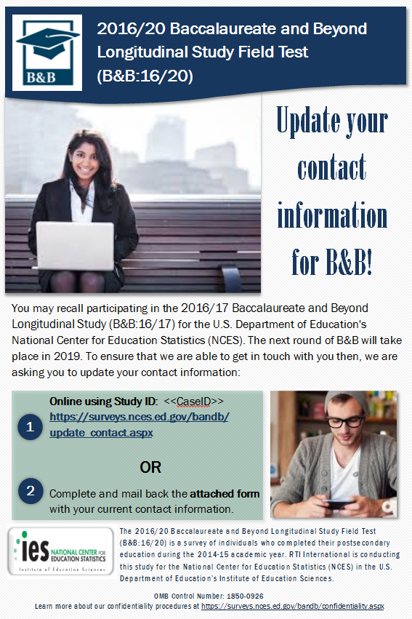

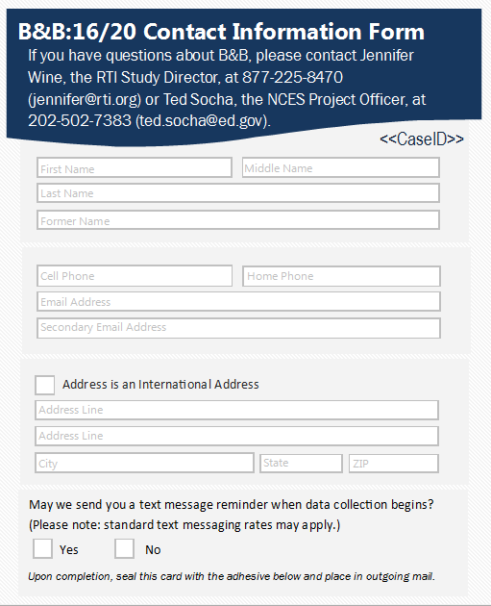

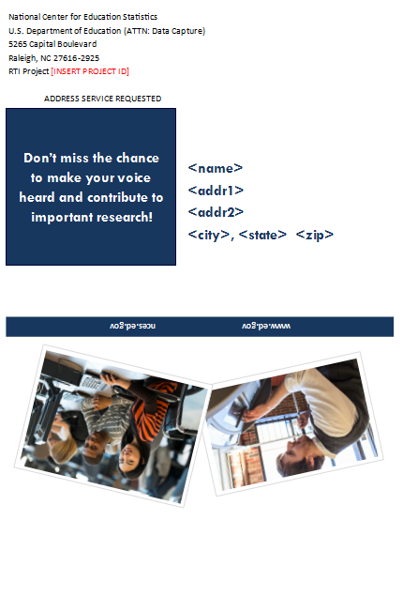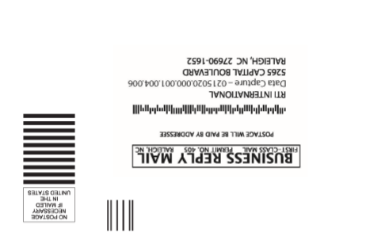

B&B:16/20 Panel Maintenance Email

SUBJECT: Update Your Contact Information for B&B

Dear «fname» «lname»:

The second round of data collection for the 2016/20 Baccalaureate and Beyond Longitudinal Study (B&B:16/20) will be starting in Summer of 2019! The National Center for Education Statistics (NCES) in the U.S. Department of Education’s Institute of Education Science has contracted with RTI International to collect data for B&B on its behalf. Help us inform educators, researchers, and policymakers about how a bachelor’s degree «in [major]» impacts choices for continuing education and employment paths.

Please take about 5 minutes to update your contact information so we can contact you when data collection begins.

You can update your information on our secure website: <<Website URL>> - just use your unique study ID and password to log on.
Study ID = «caseid»
Password = «password»
If you have any questions, encounter any difficulty on the website, or would prefer to update this information over the telephone, please call us at 877-225-8470.
Thank you in advance for helping making B&B a success!

OMB Control Number: 1850-0926
Learn more about our confidentiality procedures at <<Website URL>>confidentiality.aspx

