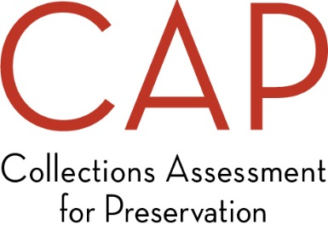

**Application Feedback Form**

Thank you for applying for the Collections Assessment for Preservation Program! In order to help us improve the application process, we ask that you take 5-10 minutes to let us know how you heard about CAP and provide feedback about the application process. Your responses will be anonymous and will not affect your application.

We thank you in advance for your feedback!

Where did you get the information that prompted your interest in applying for the CAP Program? *Check all that apply*.

🞐 AIC/FAIC (Foundation of the American Institute for Conservation) website

🞐 Discussion with CAP staff person (in person or by phone)

🞐 IMLS (Institute of Museum and Library Services) website

🞐 IMLS publications

🞐 Discussion with an IMLS () staff person

🞐 CAP printed material

🞐 LISTSERV posting (please specify which Listserv): __________________________

🞐 Social media (Facebook, Twitter, LinkedIn, etc.) (please specify): ________________________________________

🞐 From a colleague

🞐 From an assessor or other conservation professional

🞐 From a museum association (American Alliance of Museums, state or regional museum

association, etc.) (please specify):______________________________________🞐 Professional association meeting or event

(please specify): __________________________________________

🞐 My organization previously participated in CAP

🞐 Other: ________________________________________

If more than one, which was most influential in encouraging you to apply?

🞐 AIC/FAIC (Foundation of the American Institute for Conservation) website

🞐 Discussion with CAP staff person (in person or by phone)

🞐 IMLS (Institute of Museum and Library Services) website

🞐 IMLS publications

🞐 Discussion with an IMLS () staff person

🞐 CAP printed material

🞐 LISTSERV posting (please specify which Listserv): __________________________

🞐 Social media(Facebook, Twitter, LinkedIn, etc.) (please specify): ________________________________________

🞐 From a colleague

🞐 From an assessor or other conservation professional

🞐 From a museum association (American Alliance of Museums, state or regional museum

association, etc.) (please specify):______________________________________🞐 Professional association meeting or event

(please specify): __________________________________________

🞐 My organization previously participated in CAP

**Rate the CAP application package by placing an “X” in the appropriate column below.**

|  |  |  |  |  |  |
| --- | --- | --- | --- | --- | --- |
|  | **Excellent** |  |  |  | **Poor** |
|  | **5** | **4** | **3** | **2** | **1** |
|  |  |  |  |  |  |
| Instructions were clear. |  |  |  |  |  |

**Did you contact FAIC staff while completing the application?** 🞐 Yes 🞐 No

If yes,please answer the question in the chart below.

|  |  |  |  |  |  |
| --- | --- | --- | --- | --- | --- |
|  | **Completely satisfied** |  |  |  | **Complete unsatisfied** |
|  | **5** | **4** | **3** | **2** | **1** |
| How satisfied were you with the assistance you received? |  |  |  |  |  |

What could we have done to better assist you (*optional*)?

Approximately how many hours did it take you to complete this application? ___ hours

How many staff members participated in gathering all of the information? ___________________

Please share any additional comments on the application process below (*optional*).

  