Lake Erie Harmful Algal Bloom (HAB) Bulletin Survey
NOTE: The final version for the web-based survey software will feature better images than the ones used here.

This is a voluntary survey.

A Federal agency may not conduct or sponsor, and a person is not required to respond to, nor shall a person be subject to a penalty for failure to comply with an information collection subject to the requirements of the Paperwork Reduction Act of 1995 unless the information collection has a currently valid OMB Control Number. The approved OMB Control Number for this information collection is 0648-0342. Without this approval, we could not conduct this information collection. Public reporting for this information collection is estimated to be approximately 10 minutes per response, including the time for reviewing instructions, searching existing data sources, gathering and maintaining the data needed, and completing and reviewing the information collection. All responses to this information collection are voluntary. Send comments regarding this burden estimate or any other aspect of this information collection, including suggestions for reducing this burden to the NOAA National Ocean Service, National Centers for Coastal Ocean Science, Attn: Lonnie Gonsalves, 1305 East West Hwy., Rm 8325, Silver Spring, MD 20910.

Thank you for taking the time to respond to this survey!
This survey is designed to collect information on the use and usefulness of the Lake Erie Harmful Algal Bloom (HAB) Bulletin from 2009-2019. The Bulletin is sent out twice per week during the summer to early fall to provide information on HABs in the western Lake Erie basin.
This survey should take no more than 10 minutes to complete and will provide NOAA with valuable feedback on how the Bulletin is used and how it can be improved.
- How would you best describe the sector you work in (i.e., how you might receive or use the Bulletin)?
__ Federal government
__ State government
__ Local government
__ Commercial sector
__ Non-profit
__ Academic/Research
__ Private citizen

- For which state(s) or province do you use the Lake Erie HAB Bulletin? (Check all that apply)
__ Ohio
__ Michigan
__ Indiana
__ Pennsylvania
__ New York
__ Ontario Province

- Which of the following frequencies best describes how often do you consult the HAB Bulletins?
__ Weekly or more frequently
__ Every other week
__ Monthly
__ Every other month
__ 1-2 times per year
__ Never [Skip to Q12]

- Do you use the Bulletin for any of the following types of advisories or decision-making?
 | Yes | No
Beach closures
Drinking water advisories/decisions
Fish or shellfish consumption
Recreational fishing decisions/advisories
Other health advisories (not listed above)
Other: _______________

- How useful is the Bulletin in each of these uses for your purpose?
(Only asked for the ones selected in Q4.)
 | Not at all useful | Minimally useful | Moderately useful | Very useful
Beach closures
Drinking water advisories/decisions
Fish or shellfish consumption
Recreational fishing decisions/advisories
Other health advisories (not listed above)
Other: _______________

- How would you describe the extent to which the Bulletin is your primary/only source of information?
__ I have other sources of information that I prefer
__ I use multiple sources of information on HABs, including the NOAA HAB Bulletin
__ I rely primarily on the Bulletin for information on HABs

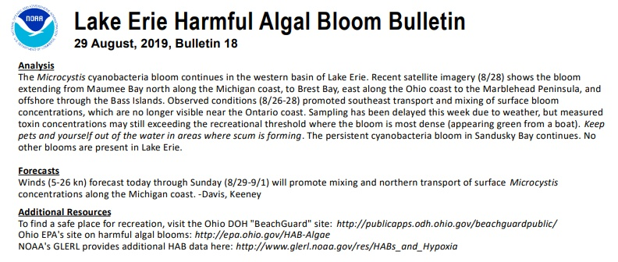
- The image {above} shows the Bloom Analysis in the Bulletin. How useful do you find this part of the Bulletin?
__ Very useful
__ Useful
__ Minimally useful
__ Not useful
__ Not applicable/something I don’t use

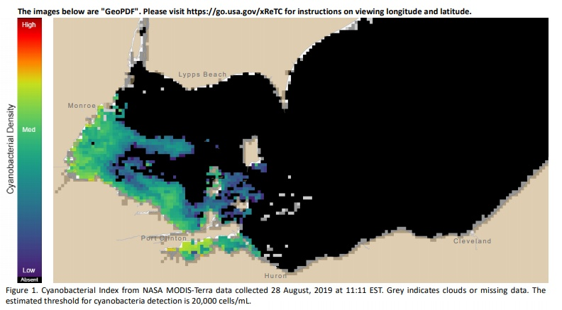
- The image {above} shows Satellite Imagery for the western/central basin of Lake Erie in the Bulletin. How useful do you find this part of the Bulletin?
__ Very useful
__ Useful
__ Minimally useful
__ Not useful
__ Not applicable/something I don’t use

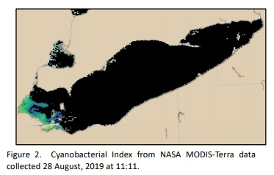

- The image {above} shows Satellite Imagery for the entirety of Lake Erie in the Bulletin. How useful do you find this part of the Bulletin?
__ Very useful
__ Useful
__ Minimally useful
__ Not useful
__ Not applicable/something I don’t use

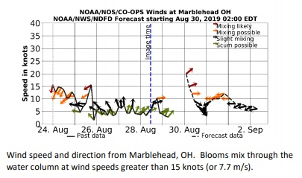

- The image {above} shows the Mixing Forecast in the Bulletin. How useful do you find this part of the Bulletin?
__ Very useful
__ Useful
__ Minimally useful
__ Not useful
__ Not applicable/something I don’t use

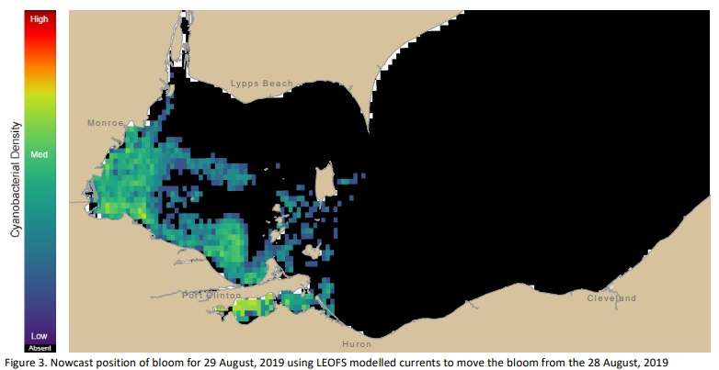

- The image {above} shows the Transport Nowcast in the Bulletin. How useful do you find this part of the Bulletin?
__ Very useful
__ Useful
__ Minimally useful
__ Not useful
__ Not applicable/something I don’t use

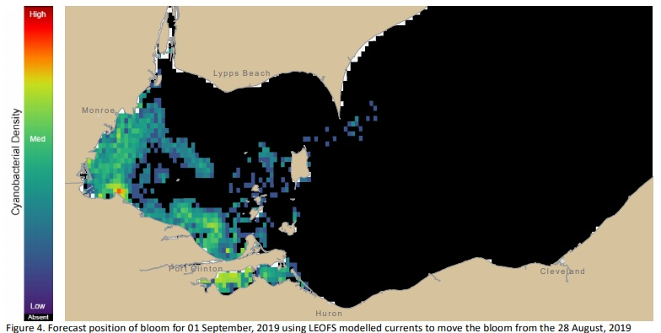

- The image {above} shows the Transport Forecast in the Bulletin. How useful do you find this part of the Bulletin?
__ Very useful
__ Useful
__ Minimally useful
__ Not useful
__ Not applicable/something I don’t use

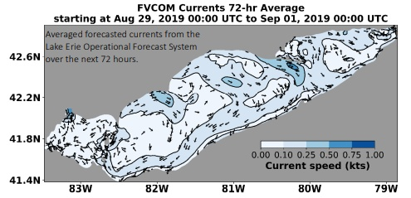

- The image {above} shows the Current Forecast in the Bulletin. How useful do you find this part of the Bulletin?
__ Very useful
__ Useful
__ Minimally useful
__ Not useful
__ Not applicable/something I don’t use

- If NOAA were to add the following elements to the Bulletin, how useful would these new elements be to you?
Potential New Element | Not useful | Minimally useful | Useful | Very useful
Real-time data
Animated transport forecast
Plot of forecast for vertical distribution of bloom in water column
Forecast surface water temperature
Export data (i.e. satellite imagery)

- To what extent do you agree with each of the following statements?
The Bulletin… | Strongly disagree | Disagree | Agree | Strongly Agree | Don’t Know
Is easy to read
Is understandable
Provides actionable information
Is usually correct in its forecast
Is sent too frequently
Is not sent frequently enough

- You indicated that the Bulletin was not {category from above with a “strongly disagree” or “disagree”}, are there ways in which it can be improved?
Note: There would be 6 of these questions that would only appear when the respondent selects a “strongly disagree” or “disagree” to one of the above.
{Open-Ended}

- Overall, how satisfied are you with the Lake Erie HAB Bulletin?
__ Not at all satisfied
__ Somewhat satisfied
__ Moderately satisfied
__ Very satisfied

[Q12 is only asked of those who said “Rarely/Never” on Q3]
- You said you “rarely/never” read the Bulletin. Why is that? (Select all that apply)
__ Not relevant for me
__ The information is too complex
__ The information is too simple
__ I/my workplace generates HABs-related data
__Don’t like the format

[Q13 is asked of everyone.]

- Is there a feature or additional type of information that you need for your decision-making that is not provided?

{Open-ended}

- Overall, are there ways in which NOAA can improve the HAB Bulletin?

{Open-ended}

