OMB Control No. 0648-0342
Expiration Date: 6/30/2021

Paperwork Reduction Act

A Federal agency may not conduct or sponsor, and a person is not required to respond to, nor shall a person be subject to a penalty for failure to comply with an information collection subject to the requirements of the Paperwork Reduction Act of 1995 unless the information collection has a currently valid OMB Control Number. The approved OMB Control Number for this information collection is 0648-0342. Without this approval, we could not conduct this survey. Public reporting for this information collection is estimated to be approximately 1-5 minutes per response, including the time for reviewing instructions, searching existing data sources, gathering and maintaining the data needed, and completing and reviewing the information collection. All responses to this information collection are voluntary. Send comments regarding this burden estimate or any other aspect of this information collection, including suggestions for reducing this burden to the National Weather Service/Analyze, Forecast and Support Office, Elliott.Jacks@noaa.gov.

Survey Instrument

Introduction

For decades, the National Weather Service (NWS) has used the "Watch, Warning, and Advisory" (WWA) system to make users aware of expected weather and water hazards. Social science research with NWS meteorologists, core partners, and the public has found that these three WWA terms can be misunderstood and/or confused. Based on this research, we are now proposing changes to the WWA system. In this survey, we’re asking for your feedback on the proposed changes.

Thank you for taking the time to complete our survey.

Questions 1 and 2 will be asked for each of the surveys. Questions 3-5 will vary slightly based on the specific hazard and contain a graphical example prior to the question.

Demographics

Before we begin the survey, we'd like to ask you a few questions about yourself. These answers will help us ensure that we capture the perspectives of a broad range of people from different backgrounds. If you feel uncomfortable answering any particular question, you may skip it.

1. What is your affiliation?

- Individual
- Student/teacher K-12
- University student
- University faculty/staff
- Other research institution
- Business/industry
- NOAA
- Other Federal government
- News media
- State/local government
- Other _______________________

2. Where are you located?

*Drop-down of all US States and territories provided*

Core Survey Covering Most Hazards:

The following two questions would be used for the core survey that would cover the majority of hazards (excepting the ones listed below this section that require specific questions). In addition to the core survey, question #3 below would be used during partner webinars as a poll question.

Sample Winter product example to be used in the survey:
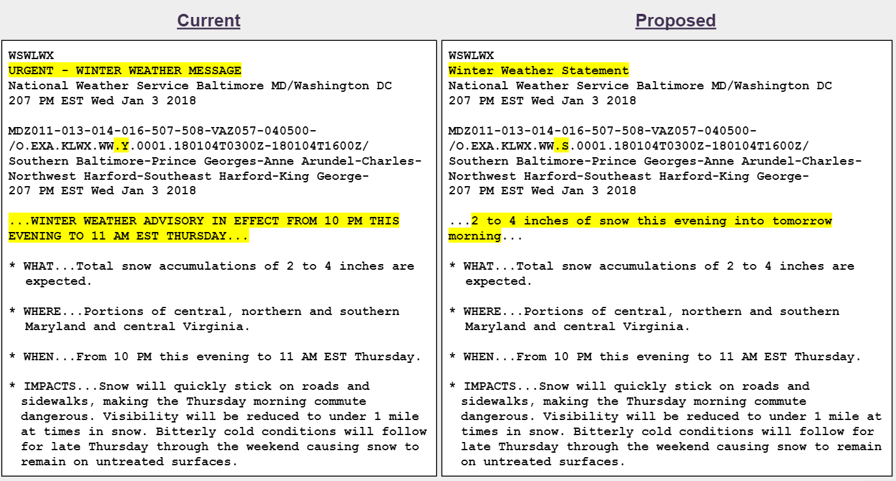

3. Please share your level of agreement/disagreement with the following statement:

NWS should discontinue the use of Advisory, Special Weather Statement (SPS), and Short Term Forecast (NOW) terms in favor of a plain language headline.

- Strongly agree
- Agree
- Neither disagree or agree
- Disagree
- Strongly disagree
- I don’t know

4. Do you have any suggestions as to how NWS can improve this proposal?
[text field]

El Nino/La Nina Survey:

Sample ENSO Alert headline examples to be used in the survey:
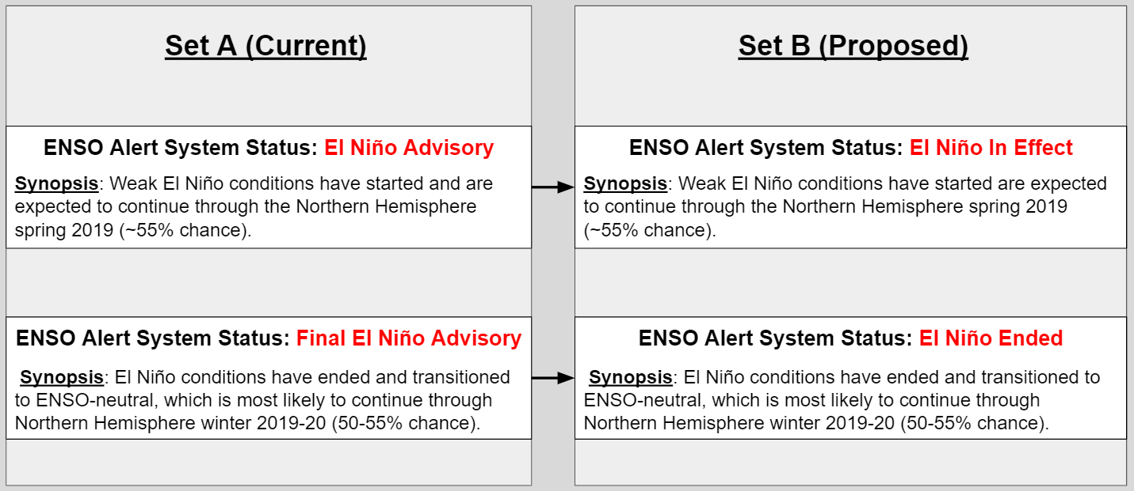

3. Which set of headlines do you prefer?

- Set A (Current)
- Set B (Proposed)
- I don’t know

4. Do you have any suggestions as to how NWS can improve this proposal?
[text field]

High Surf Advisory survey:

Sample High Surf Advisory example to be used in the survey:
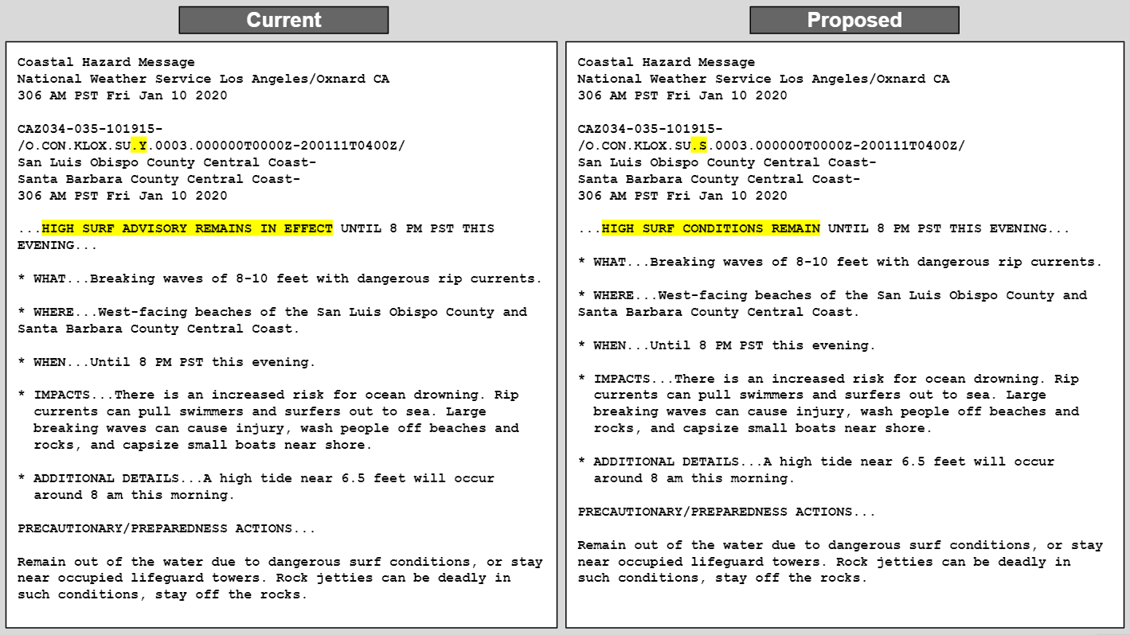

3. Please share your level of agreement/disagreement with the following statement:

NWS should transition High Surf Advisory to a plain language headline.

- Strongly agree
- Agree
- Neither disagree or agree
- Disagree
- Strongly disagree
- I don’t know

4. Do you have any suggestions as to how NWS can improve this proposal?
[text field]

Small Craft Advisory survey:

3. Please share your level of agreement/disagreement with the following statement:

NWS should rename its Small Craft Advisory to Small Craft Warning as part of this proposed change.

- Strongly agree
- Agree
- Neither disagree or agree
- Disagree
- Strongly disagree
- I don’t know

4. Do you have any suggestions as to how NWS can improve this proposal?
[text field]

Tsunami survey:

Sample Tsunami product examples to be used in the survey:
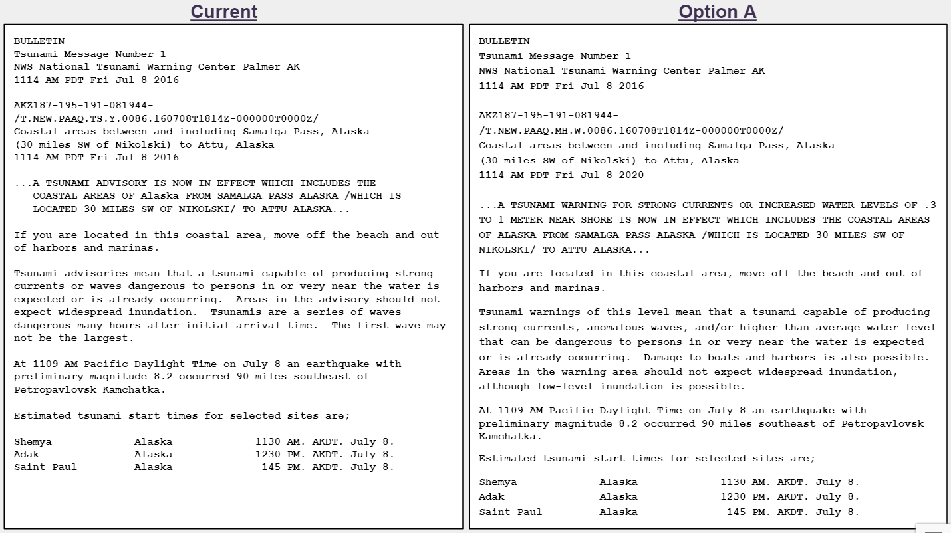
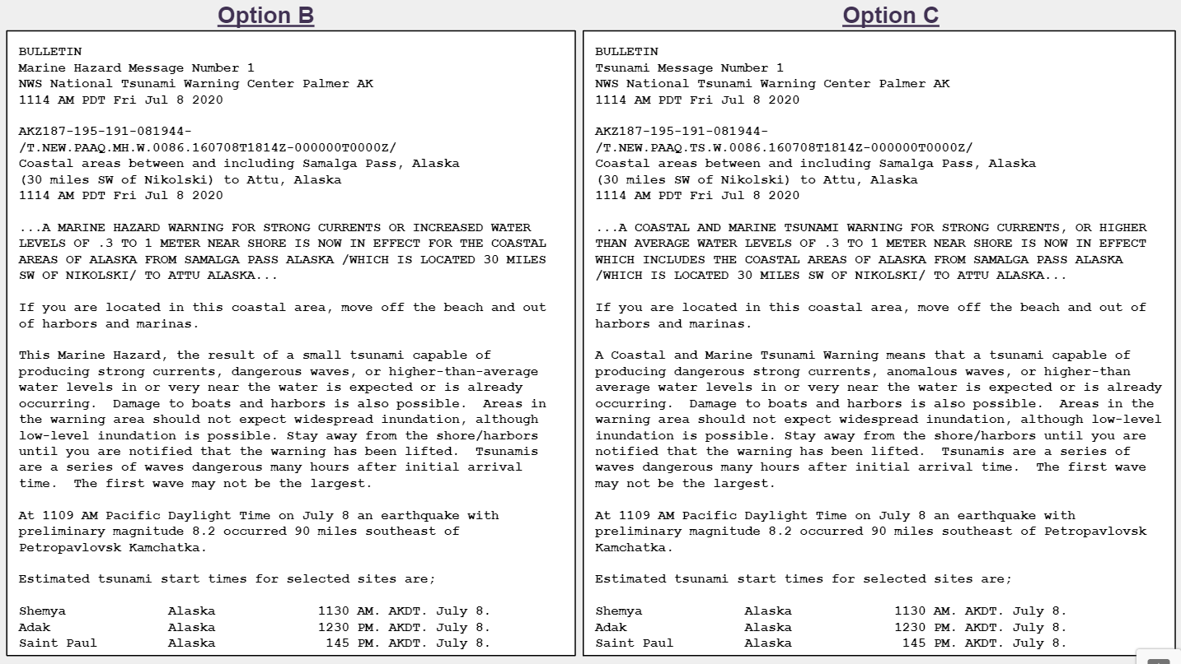

3. Which of the examples most clearly illustrates the nature of this lower-level tsunami hazard?

- Current Product
- Option A
- Option B
- Option C
- I don't know

4. Which of the examples provides the best guidance on the actions needed to be taken by people at the coast during such an event?

- Current Product
- Option A
- Option B
- Option C
- I don't know

5. Do you have any suggestions as to how NWS can improve this proposal?
[text field]

Updating Warnings survey:

Sample Severe Weather Statement examples to be used in the survey:
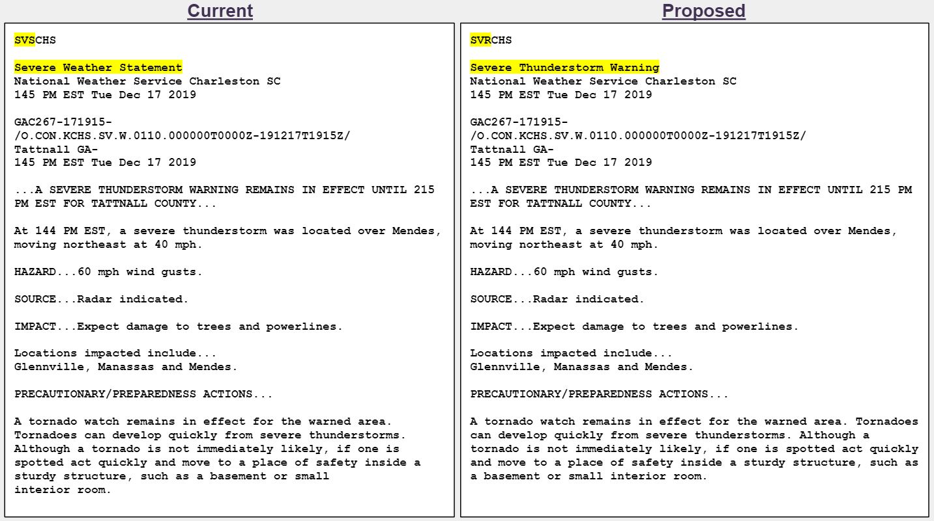

3. Please share your level of agreement/disagreement with the following statement:

NWS should update Severe Thunderstorm Warning, Tornado Warning, Extreme Wind Warning, Flash Flood Warning, Flood Warning, and Special Marine Warning within the same Warning product (and PIL) rather than through a separate statement product.

- Strongly agree
- Agree
- Neither disagree or agree
- Disagree
- Strongly disagree
- I don’t know

4. Do you have any suggestions as to how NWS can improve this proposal?
[text field]

Emergency level - survey version 1

Sample Ice Storm Warning product examples to be used in the survey:
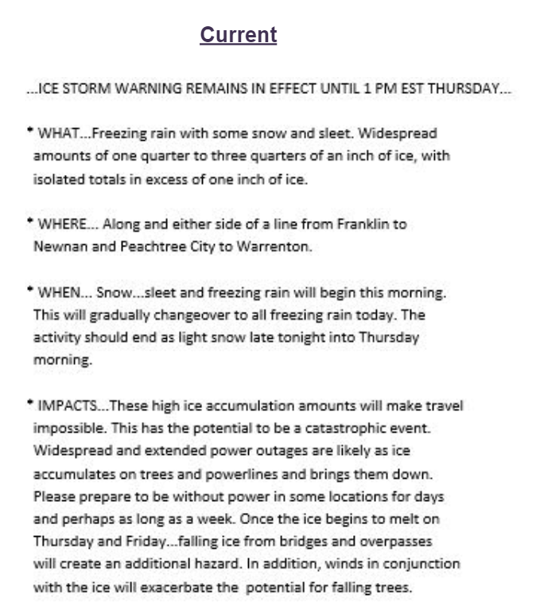
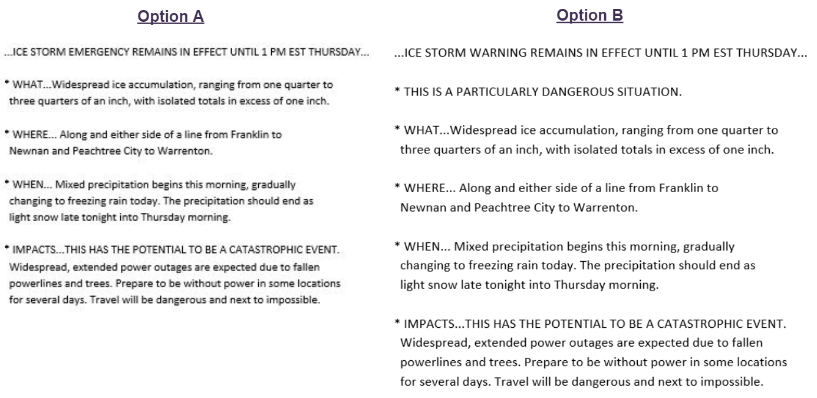

4. Which of the options should NWS consider to better communicate highly impactful situations?

- Current Product (no additional Emergency level)
- Option A
- Option B
- I don't know

5. Do you have any suggestions as to how NWS can improve this proposal?
[text field]
Emergency level - survey version 2

Sample Excessive Heat Warning product examples to be used in the survey:

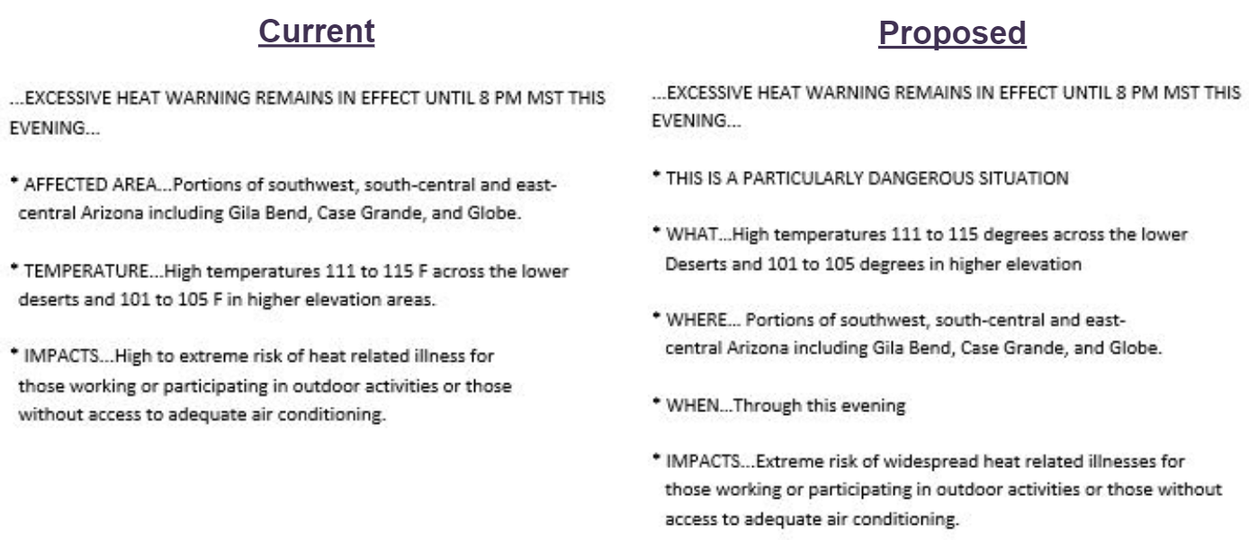

3. Please share your level of agreement/disagreement with the following statement:

NWS should include Particularly Dangerous Situation (PDS) language in certain Excessive Heat Warning products when the impacts are expected to be extreme.

- Strongly agree
- Agree
- Neither disagree or agree
- Disagree
- Strongly disagree
- I don’t know

4. Do you have any suggestions as to how NWS can improve this proposal?
[text field]

Special Marine Warning survey

Sample Special Marine Warning example to be used in the survey
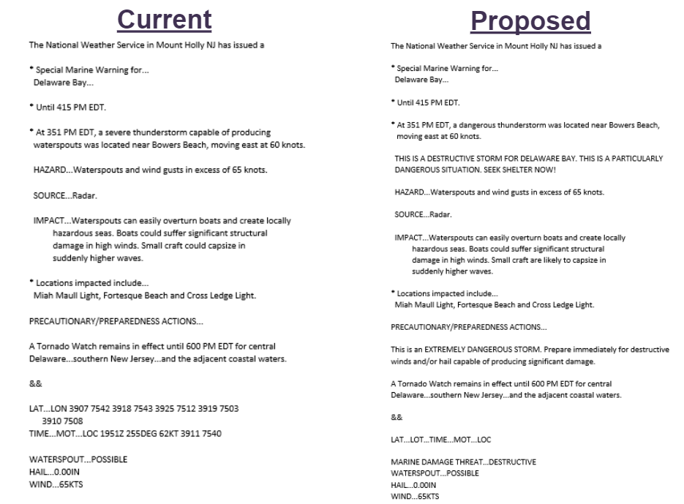

3. Please share your level of agreement/disagreement with the following statement:

NWS should utilize damage threat tags in the Special Marine Warning to better convey expected impacts.

- Strongly agree
- Agree
- Neither disagree or agree
- Disagree
- Strongly disagree
- I don’t know

4. Do you have any suggestions as to how NWS can improve this proposal?
[text field]
Extreme Wind Warning IBW survey

Sample Extreme Wind Warning product example to be used in the survey:
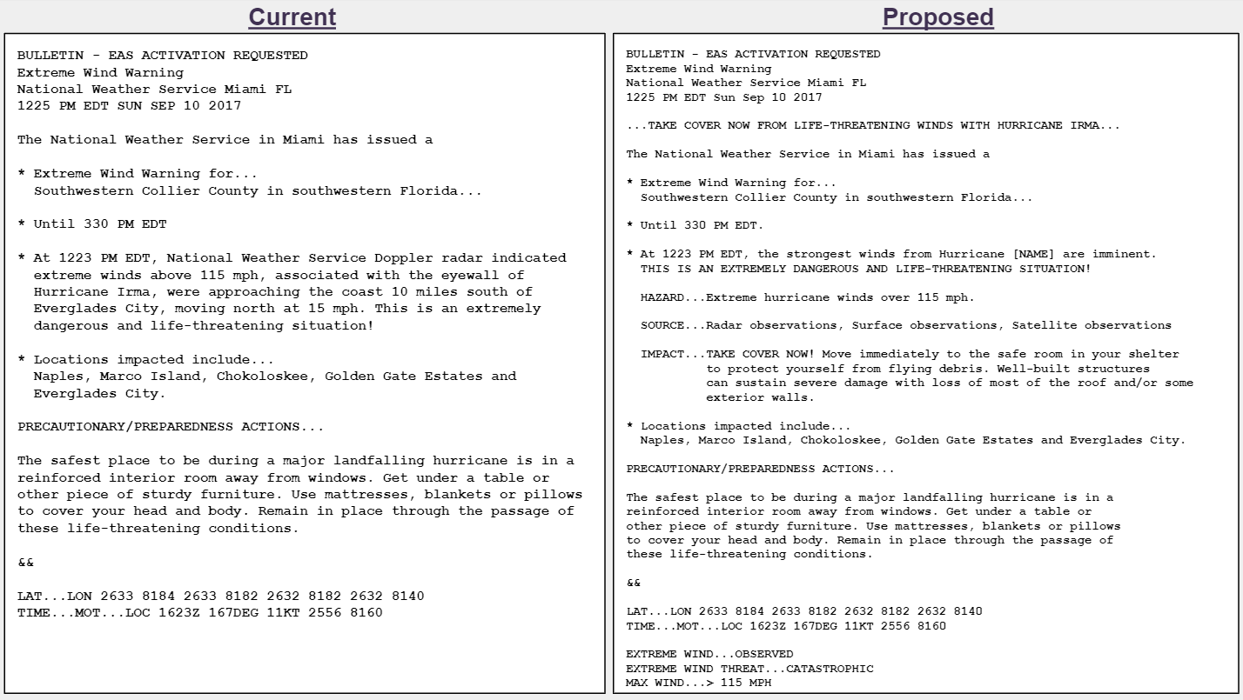

3. Please share your level of agreement/disagreement with the following statement:

NWS should transition the current Extreme Wind Warning product format to Impact-Based Warning (IBW) format.

- Strongly agree
- Agree
- Neither disagree or agree
- Disagree
- Strongly disagree
- I don’t know

4. Do you have any suggestions as to how NWS can improve this proposal?
[text field]

Plain language headline survey:

Option A
...2 TO 4 INCHES OF SNOW FROM 7PM EDT TONIGHT TO 5AM EDT TOMORROW MORNING...

Option B
...BE AWARE: 2 TO 4 INCHES OF SNOW FROM 7PM EDT TONIGHT TO 5AM EDT TOMORROW MORNING...

Option C
...CAUTION: 2 TO 4 INCHES OF SNOW FROM 7PM EDT TONIGHT TO 5AM EDT TOMORROW MORNING...

3. Which of the examples would most likely capture your attention?

- Option A
- Option B
- Option C
- I don't know

4. Which of the examples would most likely prompt you to take an action to protect/prepare yourself or your family for the weather event?

- Option A
- Option B
- Option C
- I don't know

5. Do you have any suggestions as to how NWS can improve this proposal?
[text field]

