**Customer Baseline Survey**

**Introduction**

The [United States Coast Pilot®](https://nauticalcharts.noaa.gov/publications/coast-pilot/index.html) comprises nine nautical books published by the National Oceanic and Atmospheric Administration’s (NOAA) Office of Coast Survey. The Coast Pilot covers a variety of information important to navigators of coastal and intracoastal waters and the Great Lakes that is difficult to portray on NOAA’s nautical charts.

The purpose of this survey is to gain a better understanding on how different groups use the Coast Pilot. In accordance with Executive Order 12862, the National Performance Review, and good management practices, NOAA offices want to determine whether their customers are satisfied with the services and products they are receiving, and whether they have suggestions as to how the services and products may be improved or made more useful. This resulting information will help the Office of Coast Survey make improvements to the Coast Pilot product.

Public reporting burden for this collection of information averages 15 minutes. Send comments regarding this burden estimate or any other aspect of this collection of information, including suggestions for reducing this burden, to:  
  
 **Thomas Loeper**

**Chief, Nautical Publications Branch**

**NOAA, Office of Coast Survey  
 1315 East-West Highway, Silver Spring, MD 20910  
 (240) 533-0068**

Responses to this survey will not be treated as official correspondence to the agency, so you may not receive a reply from NOAA. Do not use this survey to provide public comments on rulemakings, respond to solicitations, or communicate about any official agency action. Instead, provide your comments or feedback as described in the action you want to respond to, or use a designated channel for official comments (for example, [www.regulations.gov](http://www.regulations.gov) to comment on notices of rulemaking). If you want a response to a specific question, comment, or want to report a product discrepancy, please use our [contact page](https://nauticalcharts.noaa.gov/about/contact.html).  
  
Responding to this survey is completely voluntary. No confidentiality can be provided for responses, it is optional to supply your name or address. Any information you provide will be used to for the sole purpose of improving NOAA's products and services, in particular, the Coast Pilot. Notwithstanding any other provision of the law, no person is required to respond to, nor shall any person be subject to a penalty to comply with, a collection of information subject to the requirements of the Paperwork Reduction Act, unless that collection of information displays a currently valid OMB Control Number:  
  
 **Paperwork Reduction Act Information  
 (OMB Control Number 0648-0342)  
 Expires 06/30/2021**

**Section 1 - Demographics**

1. **Which category best describes the type of user you are? (radio buttons)**
   1. Professional Mariner
   2. Government/Military
   3. Academic/Maritime Institute
   4. Recreational Boater
   5. Electronic Chart System Provider
   6. Other (Please Specify) (free text)
2. **What type of vessel(s) do you operate? (check boxes)**
   1. Public/Military Vessel
   2. Towing Vessel
   3. Commercial Shipping Vessel
   4. Passenger Vessel
   5. Commercial Fishing Vessel
   6. Power Recreational Vessel
   7. Sailing Recreational Vessel
   8. Other (Please Specify) (free text)
3. **How many total years of experience do you have operating on coastal waters of the United States? (radio buttons)**
   1. <1 year
   2. 1-5 years
   3. 5-10 years
   4. 10-20 years
   5. >20 years
4. **On average, how many days do you spend operating a vessel per year? (radio buttons)**
   1. <30 days
   2. 30-90 days
   3. 90-180 days
   4. >180 days
5. **What product(s) do you rely on for navigation? (check boxes for all that apply)**
   1. NOAA Paper Chart
   2. Electronic Chart Display and Information System (ECDIS) with NOAA Electronic Navigational Charts (NOAA ENC®)
   3. Electronic Chart System (ECS) with NOAA Electronic Navigational Charts (NOAA ENC)
   4. Electronic Chart System (ECS) with NOAA Raster Navigational Charts (NOAA RNC®)
   5. Chart Plotter with NOAA Charts (ENC or RNC)
   6. Chart Plotter with Vendor Charts.
   7. Mobile Application
   8. Coast Pilot
   9. Other (Please Specify) (free text)
6. **In which areas do you generally operate/navigate? (checkboxes)**

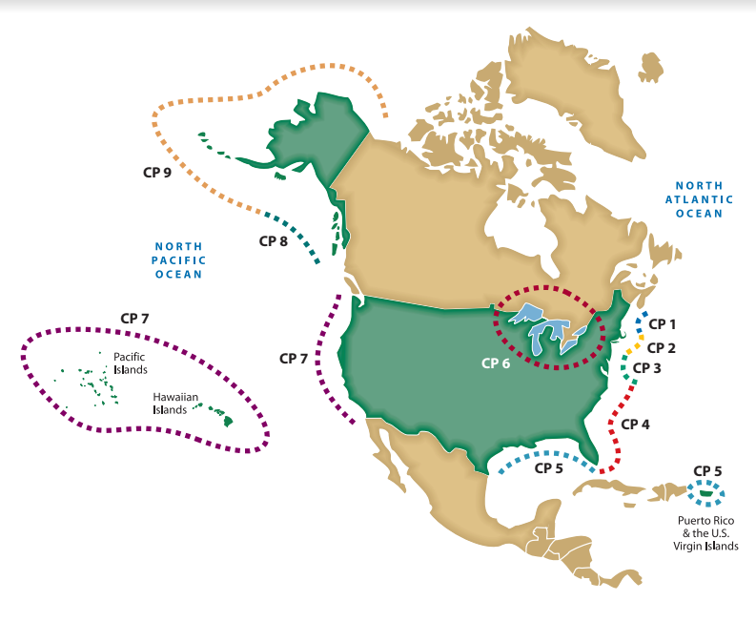

* 1. CP1 - Atlantic Coast: Eastport, ME to Cape Cod, MA
  2. CP2 - Atlantic Coast: Cape Cod, MA to Sandy Hook, NJ
  3. CP3 - Atlantic Coast: Sandy Hook, NJ to Cape Henry, VA
  4. CP4 - Atlantic Coast: Cape Henry, VA to Key West, FL
  5. CP5 - Gulf of Mexico, Puerto Rico and Virgin Islands
  6. CP6 - Great Lakes: Lakes Ontario, Erie, Huron, Michigan, Superior, and St. Lawrence River
  7. CP7 - Pacific Coast: California, Oregon, Washington, Hawaii and Pacific Islands
  8. CP8 - Alaska: Dixon Entrance to Cape Spencer
  9. CP9 - Alaska: Cape Spencer to Beaufort Sea

**Section 2 - Coast Pilot Usage**

1. **When do you use the Coast Pilot? (check all boxes that apply)**
   1. During route planning
   2. To supplement information found on the nautical chart
   3. While referencing applicable federal regulations
   4. To become familiar with the predominant environmental conditions for a particular area (e.g. weather, tides, currents)
   5. To provide situational awareness using photos within the book
   6. To provide situational awareness/aid in visual identification by reading the descriptions of the physical environment for a given area
   7. To learn about services available at ports
   8. Other (free text)
2. **Considering your responses above, what three uses of the Coast Pilot do you find most valuable and explain why (Please list in order of importance to you)? (free text responses)**
   1. (free text)
   2. (free text)
   3. (free text)

1. **Please select the five Coast Pilot topics listed below that you find the most useful. (Check boxes)**

For Waterways and Coastal Navigation

* Chapter 1 – General Information (This chapter is the same for all 9 volumes)
* Chapter 2 – Navigation Regulations (This chapter contains selected extracts from the Code of Federal Regulations, Title 33 that directly affect mariners)
* Appendix A – Includes general information for the area covered by a particular volume such as sales and service information for NOAA and NGA products and services and offices and services of other government agencies
* Appendix B – Includes climatological and meteorological tables, distances between U.S. ports, standard abbreviations and conversion tables
* General Marine Ecological and Environmental Information
* Local Magnetic Disturbances
* Navigation Guidelines, Rules, and Regulations
* Weather/ice
* Tides/Water levels
* Currents
* Fishing

1. **Please select the five Coast Pilot topics listed below that you find the most useful. (Check boxes)**

Port Information

* Prominent Features
* Major Aids
* Shipping Safety Fairways
* Traffic Separation Scheme
* Vessel Traffic Service
* Routes (approach)
* Channels
* Pilotage
* Anchorages
* Dangers/Cautions
* Regulated Navigation Areas (security zones, safety zones, No-Discharge Zone)
* Bridges
* Towage
* Quarantine, Customs, Immigration and Agricultural Quarantine
* Coast Guard
* Harbormaster/Harbor Regulations
* Wharves
* Supplies (deep-draft)
* Repairs (deep-draft)
* Small-craft Facilities
* Ferries
* Air and Ground Transportation

1. **Do you have other sources that supply the same information contained in the Coast Pilot? (radio buttons)**
   1. No, the Coast Pilot is my sole source
   2. Yes, I use other sources (please specify sources, which source is preferred and why)(free text)
2. **Is there anything else that you would like us to know about your use of the Coast Pilot? (free text entry)**
3. **Do you have any thoughts on how the Coast Pilot could be improved? (free text entry)**
4. **If you are willing to be contacted regarding any of your responses above or would like to be notified about any future improvements to the Coast Pilot, please send an e-mail to** [**Coast.Pilot@noaa.gov**](mailto:Coast.Pilot@noaa.gov)**.**