OMB Control No. 0648-0342
Expiration Date: 6/30/2021

Public reporting burden for this collection of information is estimated to average 15 minutes per response, including the time for reviewing instructions, searching existing data sources, gathering and maintaining the data needed, and completing and reviewing the collection of information. Send comments regarding this burden estimate or any other suggestions for reducing this burden to Jessica Schauer at the NOAA/National Weather Service/Analyze, Forecast and Support Office:

Jessica.Schauer@noaa.gov

Notwithstanding any other provisions of the law, no person is required to respond to, nor shall any person be subjected to a penalty for failure to comply with, a collection of information subject to the requirements of the Paperwork Reduction Act, unless that collection of information displays a currently valid OMB Control Number.

Tropical Cyclone Advisory (TCM) Survey

{The same content can be viewed through survey monkey here. You may choose between English and Spanish in the right corner dropdown menu. }

The National Weather Service (NWS) provides forecasts and analyses of hazardous tropical weather to save lives, mitigate property loss, and improve economic efficiency by issuing forecasts, watches, and warnings to the public through various tropical cyclone graphical and text products.

To increase understanding of these hazards, the NWS strives to improve products. This survey is designed to invite feedback on potential changes to the Tropical Cyclone Forecast/Advisory (TCM) product issued by the National Hurricane Center (NHC) and the Central Pacific Hurricane Center (CPHC). The TCM contains a list of all current coastal watches and warnings for a tropical or subtropical cyclone, as well as the current latitude and longitude coordinates, intensity, and system motion. The advisory contains forecasts of the cyclone positions, intensities, track, and wind fields for 12, 24, 36, 48, 72, 96, and 120 hours from the forecast’s nominal initial time. The information collected through this survey may be used for research reports, presentations, publications, educational materials, or future studies.

Please note that the examples shown in this survey are designed to invite feedback and are not an exact representation of the content of NWS tropical cyclone products in the future.

By initiating this survey, you are voluntarily agreeing to participate in the survey and allow your anonymous responses to be used for research purposes. You are also confirming that you, the survey participant, are at least 18 years of age.

Thank you.

{The same questions and answers are also offered in English and Spanish.}

1. Which best describes your professional affiliation? (Multiple Choice)

Weather Software/App Developer
Weather producer
Meteorologist for Digital Media
Broadcast Meteorologist
Cruiser (non-commercial mariner)
Commercial Mariner
Department of Defense (Coast Guard/Navy)
Government (federal, local, state)
Emergency Management
Public Safety
None of the above

{If the respondent selects “None of the above”, they will not proceed with the rest of the survey}

2. Which of the following text products do you use? (Check all that apply)
Tropical Cyclone Public Advisory (TCP)
Tropical Cyclone Forecast/Advisory (TCM)
Tropical Cyclone Discussion (TCD)
Tropical Cyclone Update (TCU)
Tropical Cyclone Valid Time Event Code (TCV)

{If the respondent does not select the “Tropical Cyclone Forecast/Advisory”, they will not proceed with the rest of the survey}

{If the respondent selects a profession and selects the “Tropical Cyclone Forecast/Advisory” they will proceed with the rest of the survey.}

Here is an example of a Tropical Cyclone Forecast/Advisory (TCM):
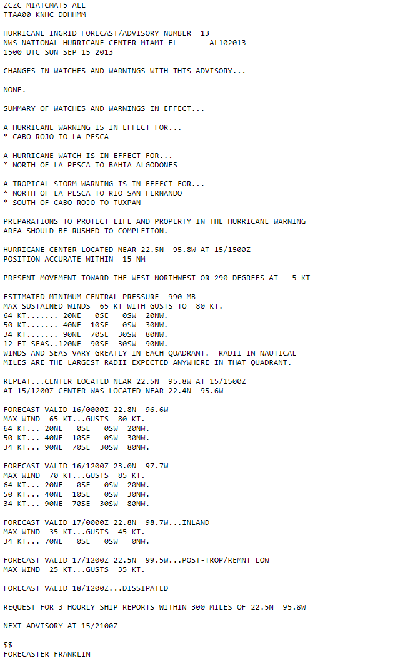

3. What is the primary way you access the forecast information in the Tropical Cyclone Forecast/Advisory (TCM)? (Multiple Choice)
NHC & CPHC website/ RSS Feed
Hurricane tracking software (ex: HURREVAC or apps)
Commercial website
NWS Gateway
Satellite data provider
FTP site

4. How do you consume the information provided in the Tropical Cyclone Forecast/Advisory (TCM)? (Check all that apply)
Parsing data automatically
Quickly scanning for a few parts of information (ex: only wind, gust)
Manually reading the entire text product
Through graphics or other secondary products and services created from the information found in the TCM text product
None of the above

5. In using the Tropical Cyclone Forecast/Advisory (TCM), please indicate how useful the following pieces of information are individually. (Ranking)
Choose from the following:
Very useful, somewhat useful, neutral, somewhat less useful, not useful

Estimated Position Accuracy
Coastal Watches & Warnings
Synoptic Position (3 hours old position)
Current 12 Foot Seas Radii
Eye Diameter
6. Which is the primary text product you access to find the latest watches and warnings from NHC/CPHC? (Multiple Choice)
Tropical Cyclone Public Advisory (TCP)
Tropical Cyclone Forecast/Advisory (TCM)
National Tropical Cyclone Watch/Warning Valid Time Event Code (TCV)
I don't use text products to find watch/warning information.
I don't know.

The National Weather Service may consider changing the format of the TCM in the future to make the number of lines in the product more predictable and more easily allow for the addition of new forecast parameters. An example provided on the following page displays the information as a matrix. The "9999" values throughout the example are placeholders for code that is unavailable."
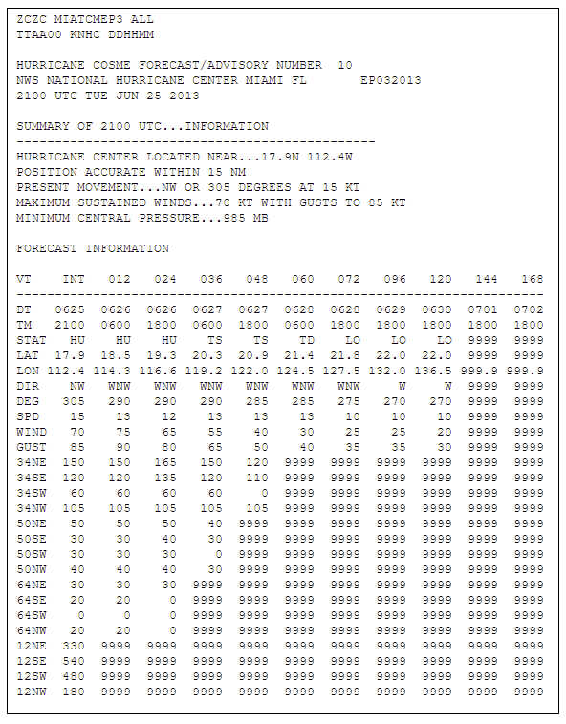

7. Using the matrix above, can you identify the forecast direction of motion for Hurricane Cosme on June 29 at 18Z? (Multiple Choice)

WNW
SW
W
NW

Please review the two formats of the TCM below.

A.) Current format of the TCM
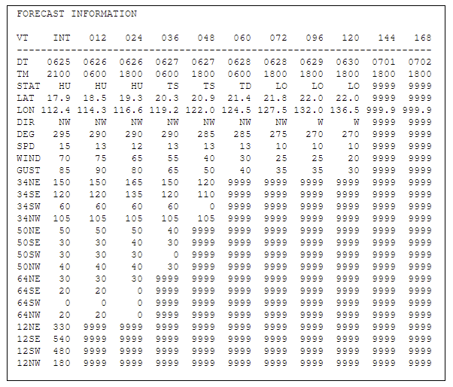

B.) Proposed Matrix Format
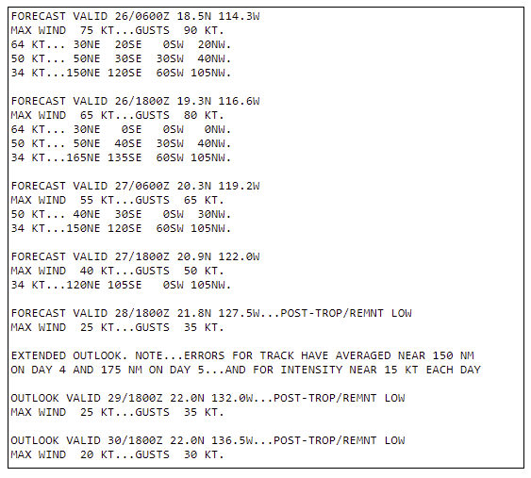

8. Which of the following formats do you prefer to examine the wind field over time? Please select one of the following: (Multiple Choice)
A.) Current format of the TCM B.) Proposed Matrix Format

9. From your perspective, what application of effort would be required to use the proposed matrix format?
(Multiple Choice)
Minimal effort
Moderate effort
Significant effort
This change would prevent me from reading/parsing the TCM.
Please click "Done" to submit your answers below. Thank you for your participation!

10. If you have additional comments regarding the TCM, please share them in the box below. (Note: This is optional. You may submit your survey without providing comments.) (Optional)

