NWS Partner Survey on Tropical Products/Services

Public reporting burden for this collection of information is estimated to average 15 minutes per response, including the time for reviewing instructions, searching existing data sources, gathering and maintaining the data needed, and completing and reviewing the collection of information. Send comments regarding this burden estimate or any other suggestions for reducing this burden to: tropical.program@noaa.gov
Notwithstanding any other provisions of the law, no person is required to respond to, nor shall any person be subjected to a penalty for failure to comply with, a collection of information subject to the requirements of the Paperwork Reduction Act, unless that collection of information displays a currently valid OMB Control Number. Finally, please note that under no circumstances will individual responses be shared.

Target Audience: The media, weather vendors, software/app developers, and emergency management

T: Technical
B/EM: Broadcast/Emergency Management

1. Which best describes your professional affiliation? (Multiple Choice; use this question to determine if they are a technical user or not) [All]
- Weather Software/App/Web Developer [T]
- Weather producer [T]
- Private weather vendor [T]
- Meteorologist for Digital Media [B/EM]
- Broadcast Meteorologist [B/EM]
- Department of Defense meteorologist [B/EM]
- Government (federal, local, state) [B/EM]
- Government/Non-profit IT provider/manager/developer (federal, local, state, DoD, non-profit) [T]
- Emergency Management [B/EM]
- Public Safety [B/EM]
- Non-Profit Organizations [B/EM]
- None of the above [Exit Survey]

2. What area do you primarily serve? [T & B/EM]
- Global
- National
- Regional
- State
- Local

3. How do you access NWS tropical hazard messages to meet your professional needs (select all that apply)? [T & B/EM]
- Through a web browser pointed to NWS websites (weather.gov, hurricanes.gov, etc.)
- Through social media
- NWS alerts feed which includes common alerting protocol (CAP) messages for hurricane warnings, storm surge watches, etc.
- RSS feed or json file on hurricanes.gov
- NOAA Weather Radio All Hazards
- Fill-in-the-blank Other dissemination services (EMWIN, Weather Wire, NOAA Port, non-NWS sources, etc.)

4. Which of the following tropical products do you use? (Check all that apply) [T & B/EM]
- NWS Social Media posts
- WFO Briefings/Webinars
- Tropical Cyclone Public Advisory (TCP)
- Tropical Cyclone Valid Time Event Code (National TCV)
- Local Watch/Warning Statement (Local TCV)
- Hurricane Local Statement (HLS)
- Hurricane Threats & Impacts information (HTI)
- Tropical Watch/Warning Common Alerting Protocol (CAP) Messages
- I use another source for tropical information (app, subscription service, Hurrevac)
*If they do not select the national TCV, local TCV, HLS or HTI in question 4, the survey will end for the respondent.

5. In which of the following ways do you use the national TCV? (Check all that apply) (only for those who state they use national TCV in question 4) [T & B/EM]
- Use Valid Time Event Code (VTEC) to generate broadcast media graphics
- Use Valid Time Event Code (VTEC) to generate weather alerts on weather apps or websites
- Determine which NWS WFOs are issuing tropical wind and/or storm surge hazards
- Fill-in-the-blank Other [100 character limit]

6. In which of the following ways do you use the local TCV? (Check all that apply) (only for those who state they use local TCV in question 4) [T & B/EM]
- Manually read the product
- Use Valid Time Event Code (VTEC) to generate information on broadcast media graphics
- Use Valid Time Event Code (VTEC) to generate weather alerts on weather apps or websites
- Parse a particular hazard section (storm surge, wind, flooding rain, tornadoes)
- Parse “LATEST LOCAL FORECAST”
- Parse “POTENTIAL THREAT TO LIFE AND PROPERTY”
- Parse “POTENTIAL IMPACTS”
- Use information to scroll on TV
- Use information to populate weather apps
- Use information to populate website
- Fill-in-the-blank Other [100 character limit]

7. In using the local TCV, please indicate how useful the following pieces of information are individually? [T & B/EM]

Choose from the following:
Very useful, somewhat useful, neutral, somewhat less useful, not useful

- The Headline (e.g., “Storm Surge Warning Remains in Effect”)
- Latest Local Forecast section
- Potential Threat section
- Potential Impacts section
- Watch/Warning Valid Time Event Code (VTEC) text string

8a. The Local Tropical Cyclone Watch/Warning (TCV) product currently contains both tropical wind watch/warning and storm surge watch/warning Valid Time Event Code (VTEC) used to trigger dissemination systems. Which statement do you agree with most? Please select from the following: [T & B/EM]
- I prefer to have both the tropical wind and storm surge VTEC in one product during a tropical cyclone event [Advance to 8b]
- I prefer to have tropical wind VTEC in the TCV, but I would like storm surge to appear in the product where I find them when there is not a tropical cyclone - the Coastal Hazards Messages (CFW). [Advance to 8c if T, otherwise 8d]
- It does not matter to me what product the tropical wind and storm surge VTEC is in as long as the Local TCV from the WFOs continues to contain plain language threats and impacts information on the wind, surge, flooding rain, and tornado hazards [Advance to 8c if T, otherwise 8d]
- It does not matter to me what product the tropical wind and storm surge VTEC is in, and I do not use the plain language threats and impacts information in the Local TCV. [Advance to 8c if T, otherwise 8d]

8b. In order to use the Storm Surge Watch/Warning hazard for non-tropical events, the NWS may need to move the Storm Surge Watch/Warning out of the Tropical Cyclone Watch/Warning (TCV) product. What potential outcome is the most desirable for your operations? [T & B/EM, all T advance to 8c, others to 8d]
- NHC stops issuing the National Tropical Cyclone Watch/Warning (TCV) product. This product currently contains all tropical wind and storm surge hazards attributed to an identified tropical cyclone in one place (as opposed to the local TCV products which only list the hazards within their area of operations).
- The National Tropical Cyclone Watch/Warning (TCV) product from NHC continues to be issued, but only contains tropical wind hazards
- The National Tropical Cyclone Watch/Warning (TCV) product from NHC continues to be issued containing all tropical wind hazards, and a new National Storm Surge Watch/Warning product from NHC is issued containing all Storm Surge Watches/Warnings for a tropical cyclone.

8c. The NWS is considering moving the Storm Surge Watch/Warning Valid Time Event Code (VTEC) from the TCV and include it in the CFW/Coastal Hazards message in order to issue the Storm Surge Watch/Warning for non-tropical events. What kind of impact would this have on your operations? [T, advance to 8d]

- 5 Very large impact
- 4 Large impact
- 3 Neutral impact
- 2 Little Impact
- 1 Very little impact
- 0 No impact

8d. Rate the importance of each component within a Storm Surge/CFW message.

Choose from the following:
Very important, somewhat important, neutral, somewhat less important, not important

- Timing
- Maximum forecast values
- Valid Time Event Code (VTEC)
- Zone Segments
- Impact Statements
- Threat Statements

9. In using the Hurricane Local Statement, please indicate how useful the following pieces of information are: [T & B/EM]

Choose from the following:
Very useful, somewhat useful, neutral, somewhat less useful, not useful

- New Information
- Situation Overview
- Potential Impacts
- Precautionary/Preparedness Actions

10. In which of the following ways do you use the Hurricane Local Statement? (Check all that apply) [T & B/EM]
- Use forecast zone codes to generate information on broadcast media graphics
- Use forecast zone codes to generate weather alerts on weather apps or websites
- Parse a particular hazard section (storm surge, wind, flooding rain, tornadoes)
- Parse “NEW INFORMATION”
- Parse “SITUATION OVERVIEW”
- Parse “POTENTIAL IMPACTS”
- Parse “PRECAUTIONARY/PREPAREDNESS ACTIONS”
- Use information to scroll on TV
- Use information to populate weather apps
- Use information to populate website
- Manually read the product
- None of the above
- Fill-in-the-blank other

11. How do you access HTI information? (Check all that apply) [T & B/EM]
- KML download
- WFO website
- NDFD website
- NDFD GRIB2 files
- Fill in the blank other (e.g. 3rd party vendor)

12. In which of the following ways do you use the Hurricane Threat & Impact information? (Check all that apply) [T & B/EM]
- Use information to create images for broadcast media
- Use information to populate weather apps
- Use information to populate website
- View the product on web page
- Other (fill in the blank)

13. In using the Hurricane Threat & Impact information, please indicate how useful the following pieces of information are individually? [T & B/EM]

Choose from the following:
Very useful, somewhat useful, neutral, somewhat less useful, not useful

- Flooding Rain
- Storm Surge
- Tornado
- Wind

14. When do you utilize these Hurricane Threat & Impact information?
- Pre Watch/Warning
- Watch phase
- Warning phase

15. When you access NWS products directly, what is your preference for obtaining hazard information (i.e., storm surge, flooding rain, tornadoes, etc.) during a tropical event?
- I want to get the information delivered using the same products that I access during a non-tropical event.
- I want to get all of the information delivered in a single product that is only produced for tropical cyclones.

16. Do you use the Hazardous Weather Outlook? (Check all that apply) [T & B/EM]
- I use the text HWO product
- I use the graphical HWO product
- I use the enhanced HWO product
- I do not utilize the Hazardous Weather Outlook in any form

17. The Hurricane Threats and Impacts (HTI) Wind Threat map on the right highlighted in red shows the potential for exceeding certain wind speed thresholds over a 3-day period, accounting for a reasonable worst-case scenario. The Enhanced Hazardous Weather Outlook (HWO) map on the left highlighted in blue shows the potential for exceeding different wind thresholds over a 1-day period based on a deterministic forecast that does not take uncertainty into account, while the “Non-Thunderstorm Wind” option in the table at the bottom left shows a generalized daily threat level over the following 6 days also based on a deterministic forecast.

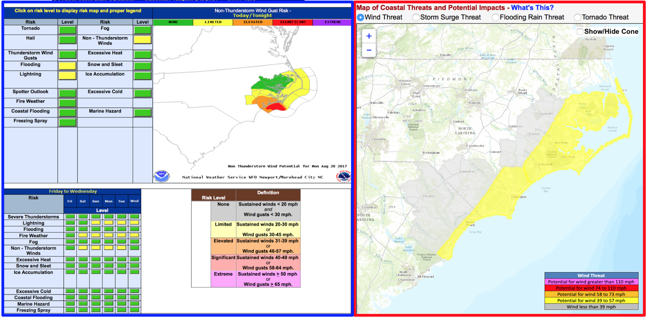

Assume your operations over the next 3 days have a sensitivity to winds over 40 mph. Given the information provided in the figures above, which of these tools would you use to assess wind risk?
- I would use both maps, but favor the one on the left
- I would use both maps, but favor the one on the right
- I’d only use the one on the left
- I’d only use the one on the right
- I would not use either of these options
- I need further explanation on how to use these graphics

18. Please explain your answer to the previous question. [300 character limit]

