TAB 1 – APACS milCloud home page
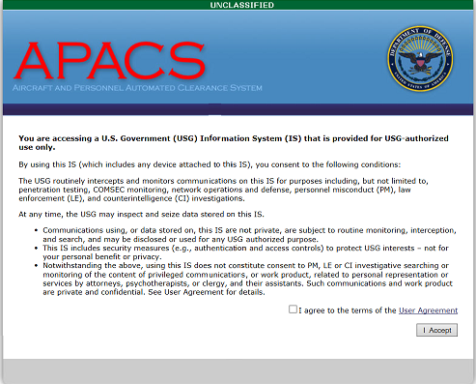
Tab 2 – APACS milCloud User Agreement
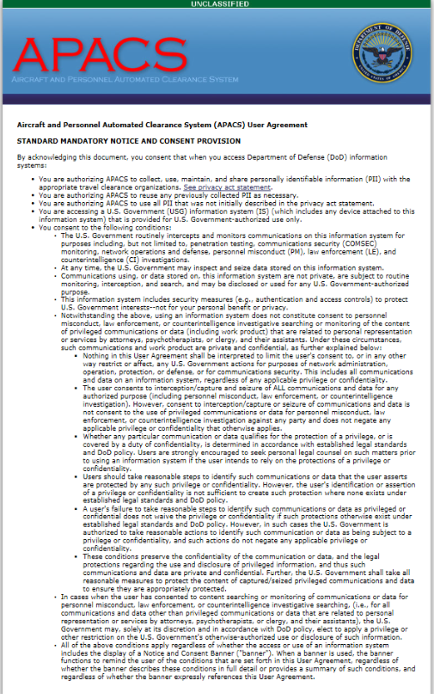
Tab 3 – APACS milCloud Privacy Act Statement
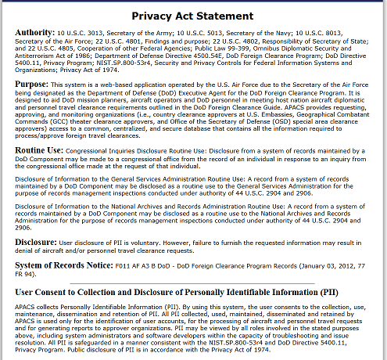

Tab 4 – APACS milCloud Login Page
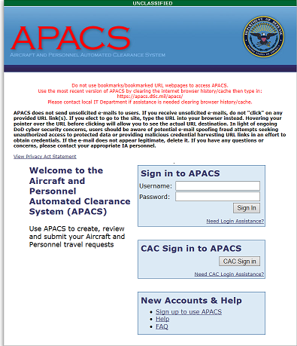
Tab 5 – APACS milCloud Internal Home (after login)
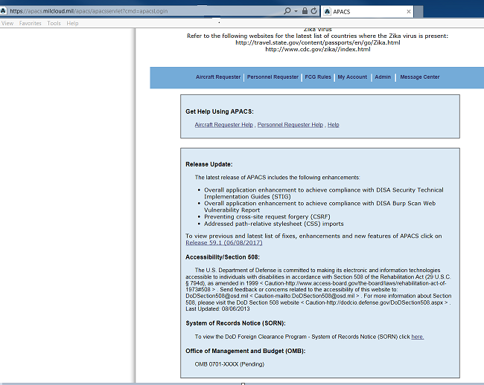
Tab 6 – APACS milCloud Traveler Notes (PII Requirements – Netherlands)
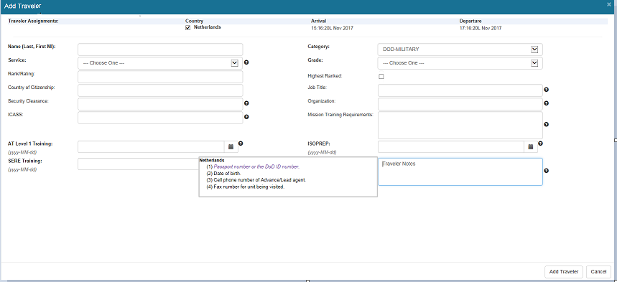
Tab 7 – APACS milCloud Security Clearance Requirement (Netherlands)
