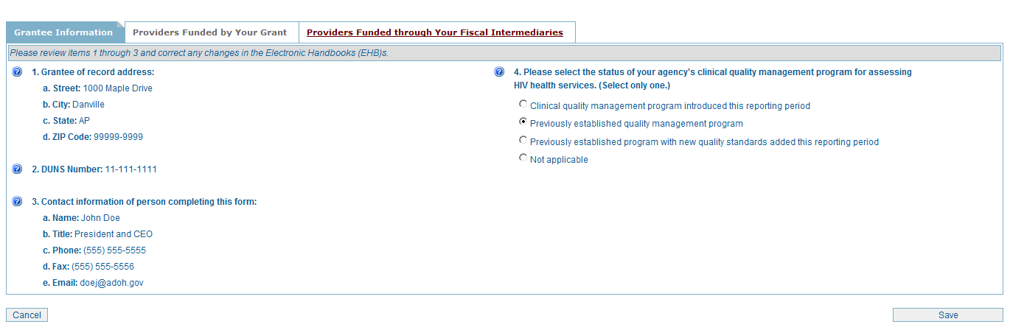

Grantees complete a separate grantee form for each Ryan White HIV/AIDS Program grant they receive from HRSA — e.g., an agency with only a Part C grant completes one grantee form; an agency with a Part C and Part D grant completes two grantee forms, one for its Part C grant and another for its Part D grant.
Items 1 – 3 (display only): These items show the grantee and user information stored in the HRSA Electronic Handbooks (EHBs). To edit this information, grantees must update their agency information and/or user profile in the EHBs.
Item 4: Select the status of your agency’s clinical quality management program during this reporting period.

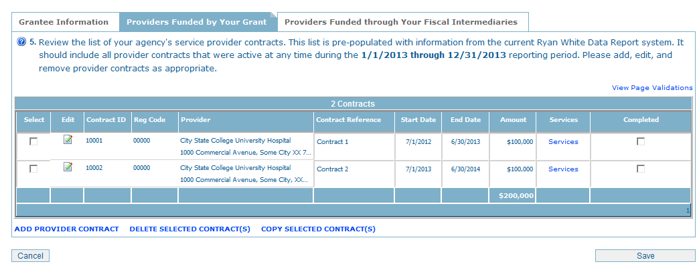

Review the list of service provider contracts that were active during the given reporting period. (Note: For the initial report, this list will be pre-populated with the provider lists in the current Ryan White Services Report System.) Add new provider contracts with the ADD PROVIDER CONTRACT link. Remove any provider contracts by checking the box next to the provider’s name and selecting the DELETE SELECTED CONTRACT(S) link. Copy a contract by selecting the check the box next to the provider’s name and selecting the COPY SELECTED CONTRACT(S) link. Edit the provider address (and other provider information) by clicking the Edit icon. Part C and D grantees must include its own organization on its provider contracts list.

Update contract information (Note: For the purpose of the Ryan White Data Report, “contracts” include formal contracts, memorandum of understanding, or other agreements) by reviewing and editing:
- Contract Reference (optional): Specify a reference for use by your providers in reporting Ryan White HIV/AIDS Program data associated with this contract.
- Contract Start and End Date: Enter the actual start date and end date of the contract for each provider.
- Services: This link opens another screen (see pages 4 – 7). Select the services the agency has been contracted to provide under this agreement (check all that apply).
- Amount: Enter the total amount of funding for the selected contract.

After completing all information for each funded contract, check “Completed.”

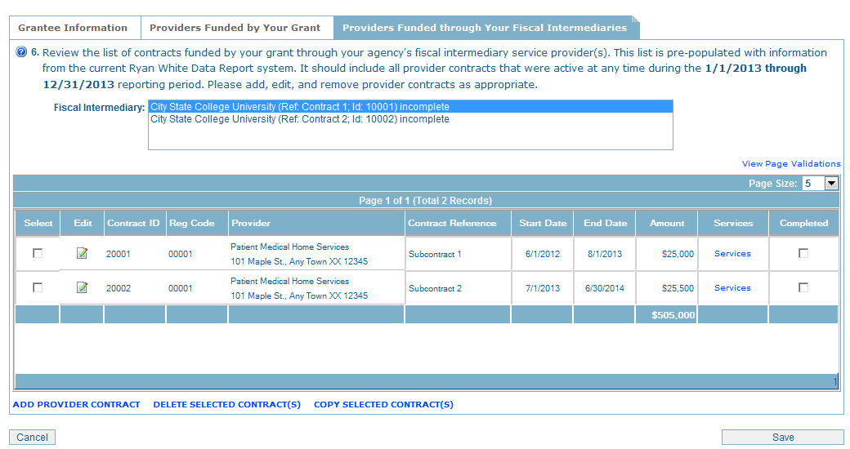

Grantees that contract with an agency to provide fiscal intermediary services (i.e., grantees that utilize a pass-through agency) must also enter the list of contracts funded by their grant through the selected fiscal intermediary (FI) service provider(s).

Select a contract for FI services from the list box. A list of contracts funded by your grant through the selected FI service provider will be displayed.

Review the service provider contracts under the selected FI provider to ensure that:
- All contracts that were active during the given reporting period are listed; and,
- The services each agency was contracted to provide under each agreement have been selected.

After completing all information for each contract, check “Completed.”

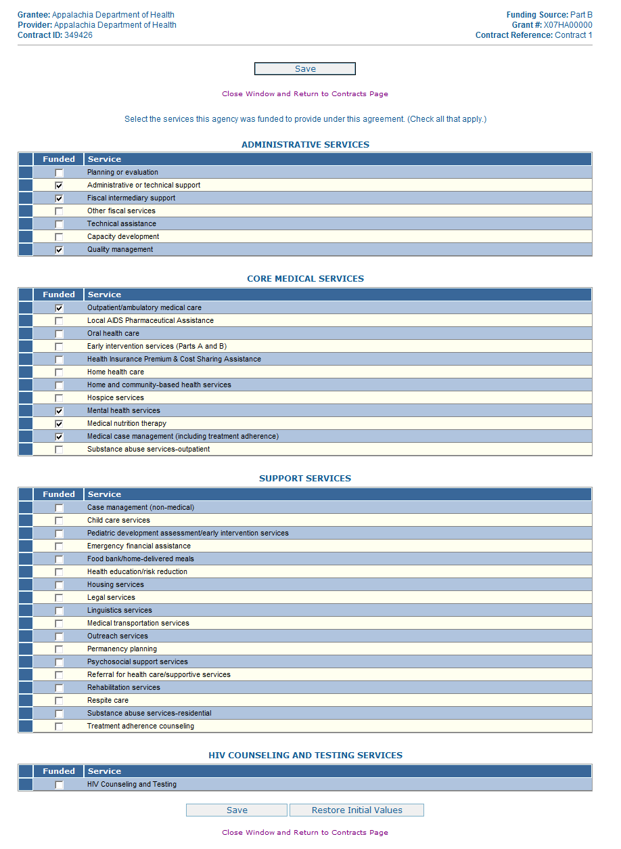
Check all of the services that this agency is contracted to provide.

Please see the following pages for magnified views of each service section.

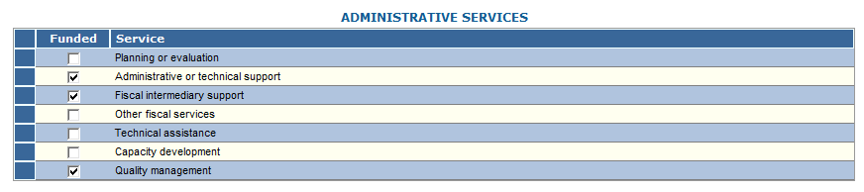
If this agency is contracted to provide administrative services, please select the service(s) funded under this agreement.

When entering & verifying Provider contracts and services in Item 5, Grantees may select a Provider organization to perform as a fiscal intermediary.
To do this, when you are selecting the Services for the Provider that is a fiscal intermediary, select the “Fiscal Intermediary Support” checkbox on the Administrative & Technical Services portion of the tab.

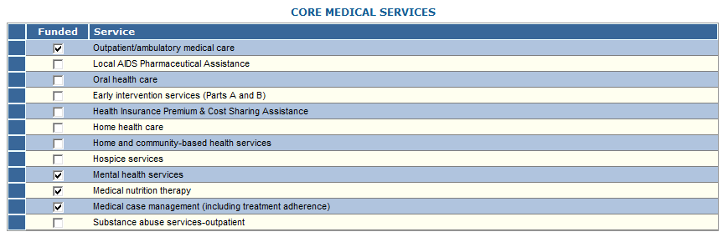

If this agency is funded to provide core medical services, please select the service(s) funded under this agreement. Check all that apply.

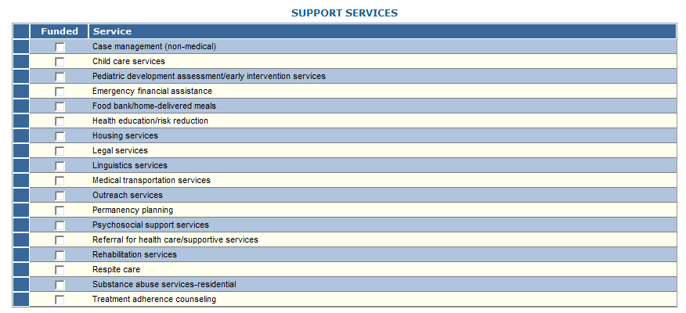

If this agency is funded to provide support services, please select the service(s) funded under this agreement. Check all that apply.

Check the box if the agency is funded to provide HIV counseling and testing services.

