Proposed changes:

We are proposing adding three new responses/questions below:

- Within your organization/agency, identify the number of physicians, nurse practitioners, or physician assistants who obtained a Drug Addiction Treatment Act of 2000 (DATA) waiver to treat opioid use disorder with medications (medication assisted treatment [MAT], e.g. buprenorphine) specifically approved by the U.S. Food and Drug Administration (FDA).;
- How many of the above physicians, nurse practitioners, or physician assistants prescribed MAT (e.g. buprenorphine, vivitrol) for opioid use disorders in the reporting year?; and
- How many clients were treated with MAT during the reporting period?

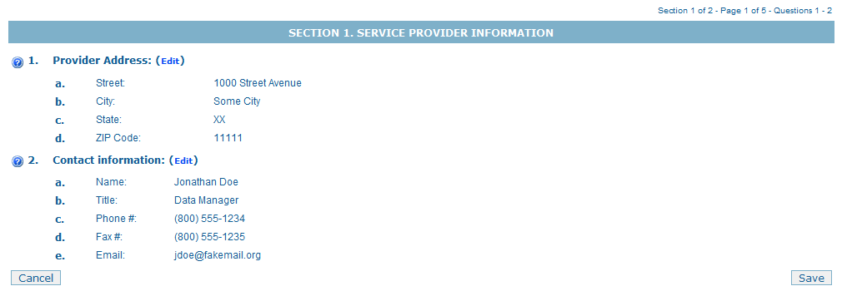

Items 1 – 2: If the information in Item 1 or Item 2 is incorrect, it must be corrected. Providers may edit the information by selecting the “edit” link next to the Item.

2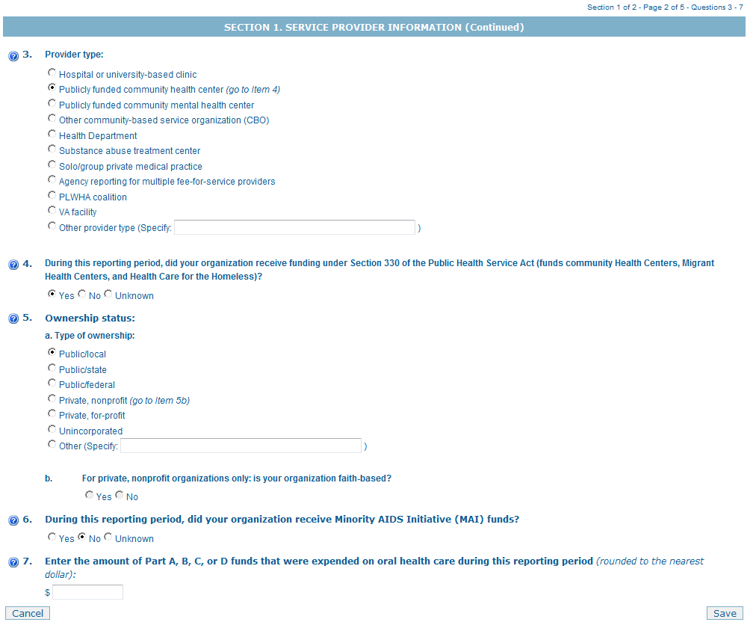

Item 3: Select the provider type that best describes the organization. After the initial submission, this item will be pre-populated in subsequent data reports.
Item 4: Indicate if your organization received funding under Section 330 of the Public Health Service Act during the given reporting period.

Item 5: Select the category that best describes your organization’s ownership status. If “Private, nonprofit” is selected, you must answer Item b. After the initial submission, this item will be pre-populated in subsequent data reports.
Item 6: Indicate if your organization received Minority AIDS Initiative (MAI) funds during the given reporting period.
Item 7: Enter the amount of Ryan White Program funds expended on oral health care during the given reporting period

7*: Within your organization/agency, identify the number of physicians, nurse practitioners, or physician assistants who obtained a Drug Addiction Treatment Act of 2000 (DATA) waiver to treat opioid use disorder with medications (medication assisted treatment [MAT], e.g. buprenorphine) specifically approved by the U.S. Food and Drug Administration (FDA).
7**: How many of the above physicians, nurse practitioners, or physician assistants prescribed MAT (e.g. buprenorphine, vivitrol) for opioid use disorders in the reporting period?
7***: How many clients were treated with MAT during the reporting period?

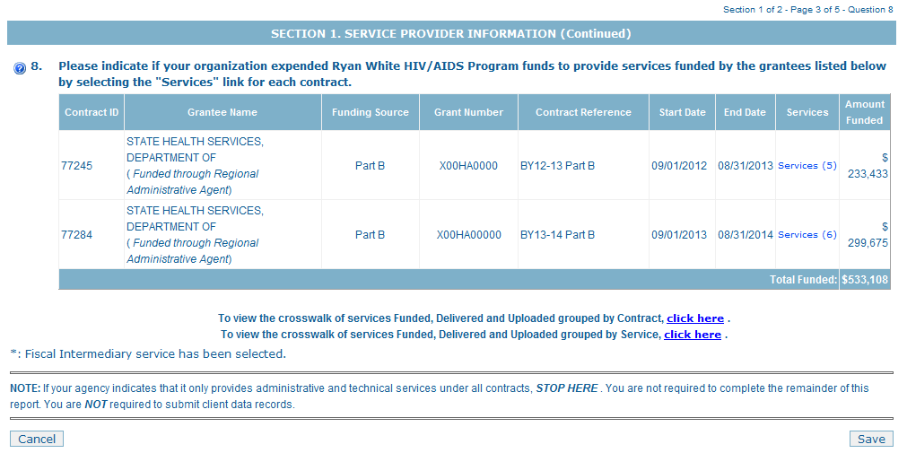

Item 8: Grantee/contract information: This list of contracts is populated with information provided by Ryan White HIV/AIDS Program grantees. The contract reference, if specified, will help you report the data associated with a particular contract. (Note: For the purposes of the Ryan White Data Report, “contracts” include formal contracts, memorandum of understanding, and other agreements.)
Services: This link opens another screen (see page 3).

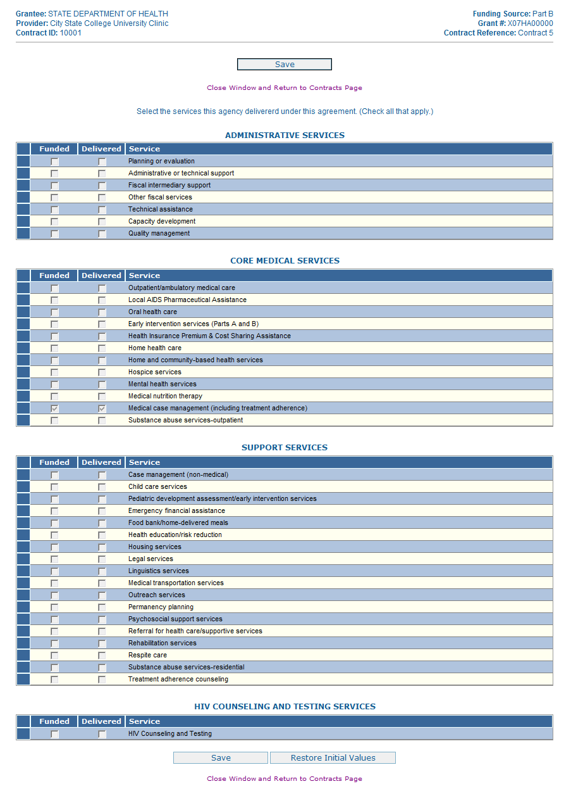
- Select the services delivered under each agreement during the given reporting period.

Please see the following pages (pgs. 5-6) for magnified views of each service section.

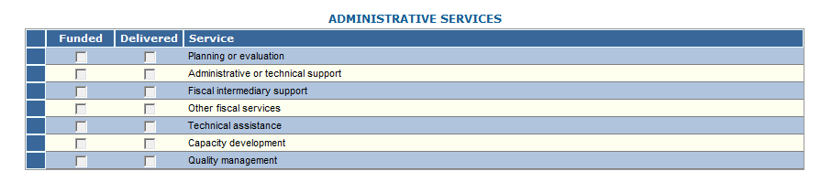

- Please select the administrative services delivered under this agreement during the given reporting period (check all that apply).

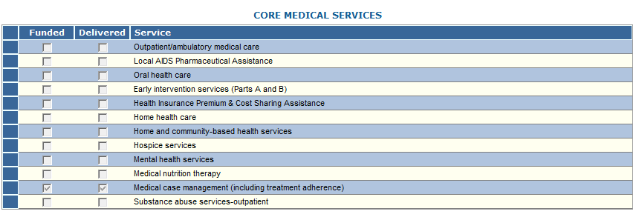

- Please select the core medical services delivered under this agreement during the given reporting period (check all that apply).

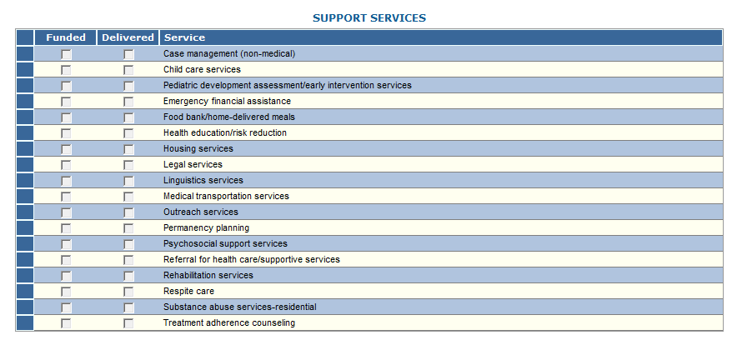

- Please select the support services delivered under this agreement during the given reporting period (check all that apply).

- Please check the box if this agency delivered HIV Counseling and Testing Services during the given reporting period.

Items 9 through 11 – Core Medical Services
If you indicated in Item 8 (services delivered), that you delivered ONLY “Administrative Services” and/or “Support Services,” then Items 9 through 17 are not required.
You will STOP here.
Conversely, if you indicated that you did deliver “Core Medical Services,” then Items 9 through 11 will be required.
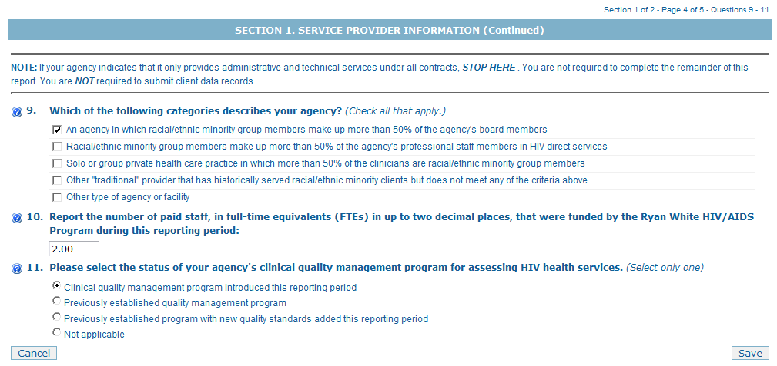

Item 9: Select the categories that best describe your organization.
Item 10: Report the number of paid staff, in full-time equivalents (FTEs), funded by the Ryan White HIV/AIDS Program during the given reporting period.
Item 11: Select the status of your agency’s clinical quality management program

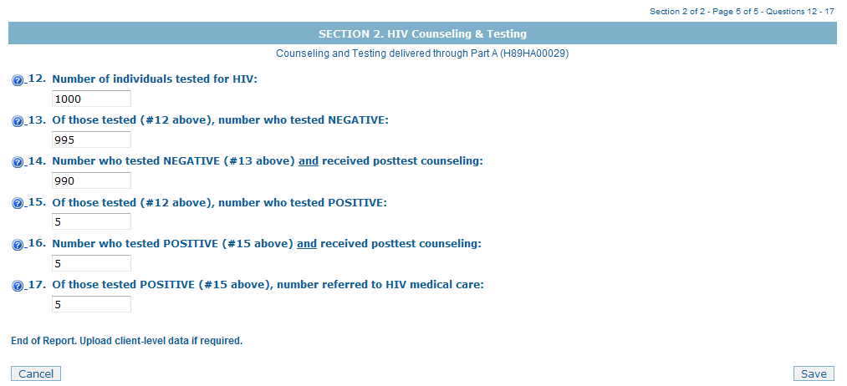
Items 12–17: If a grantee indicates in Item 8 that your organization was contracted to provide HIV counseling and testing services during the given reporting period, your organization then Items 12 through 17 ARE required.

Conversely, if you indicated that you did NOT deliver “HIV Counseling and Testing”, then Items 12 through 17 will be disabled.

Item 12 – Number Tested for HIV
Item 13 – Number of Test Results Negative
Item 14 – Number of Results Negative & Received Counseling
Item 15 – Number of Test Results Positive
Item 16 – Number of Test Results Positive & Received Counseling
Item 17 – Number of Test Results Positive and Referred

