Attachment A2. Screenshots of Partner Cost and Resource Utilization Tool
Login Screen
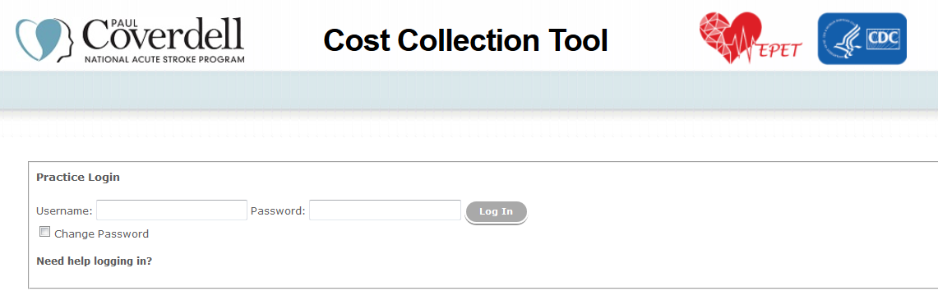
Home Screen
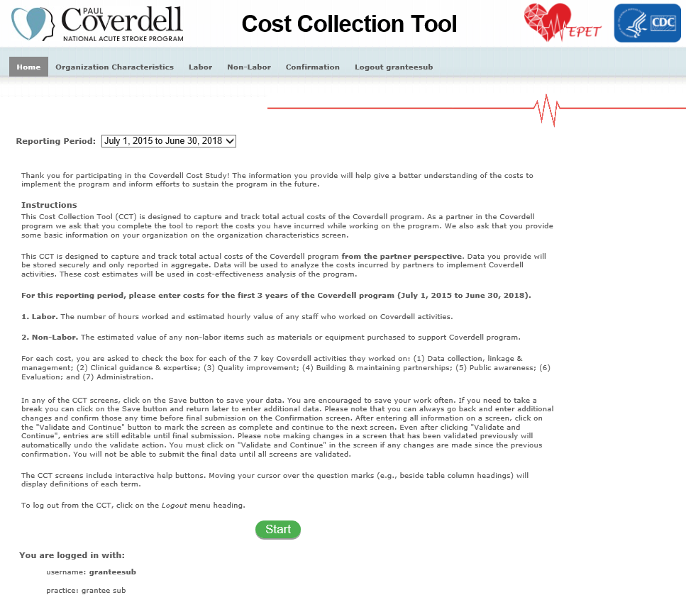
Organization Characteristics Screen
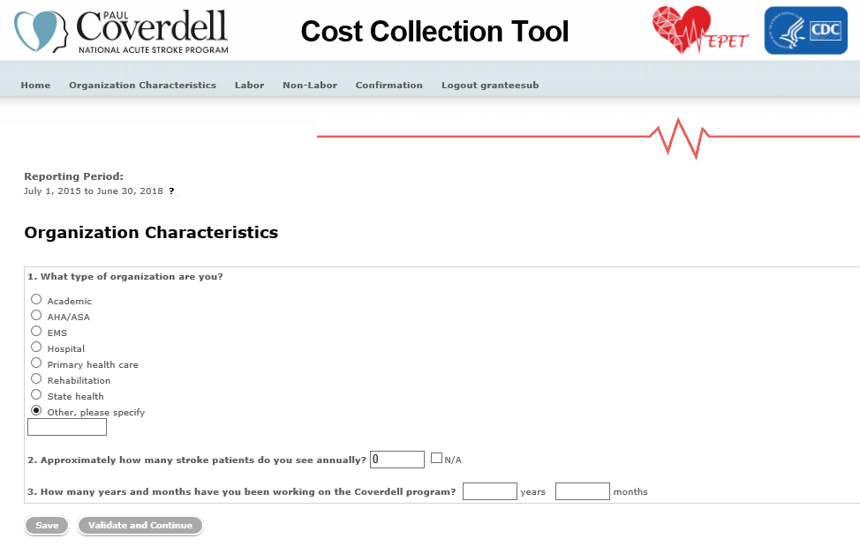

Labor Screen
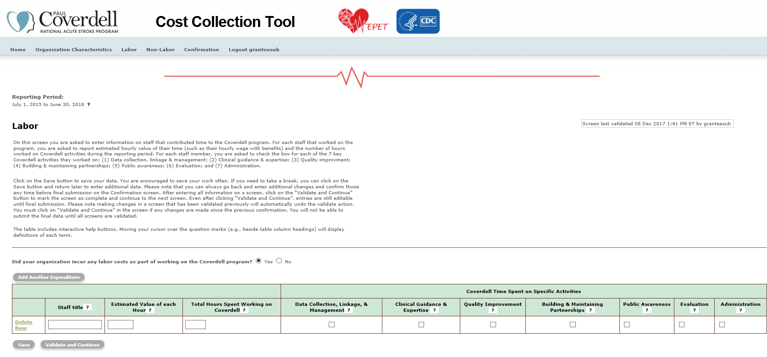

Non-Labor Screen
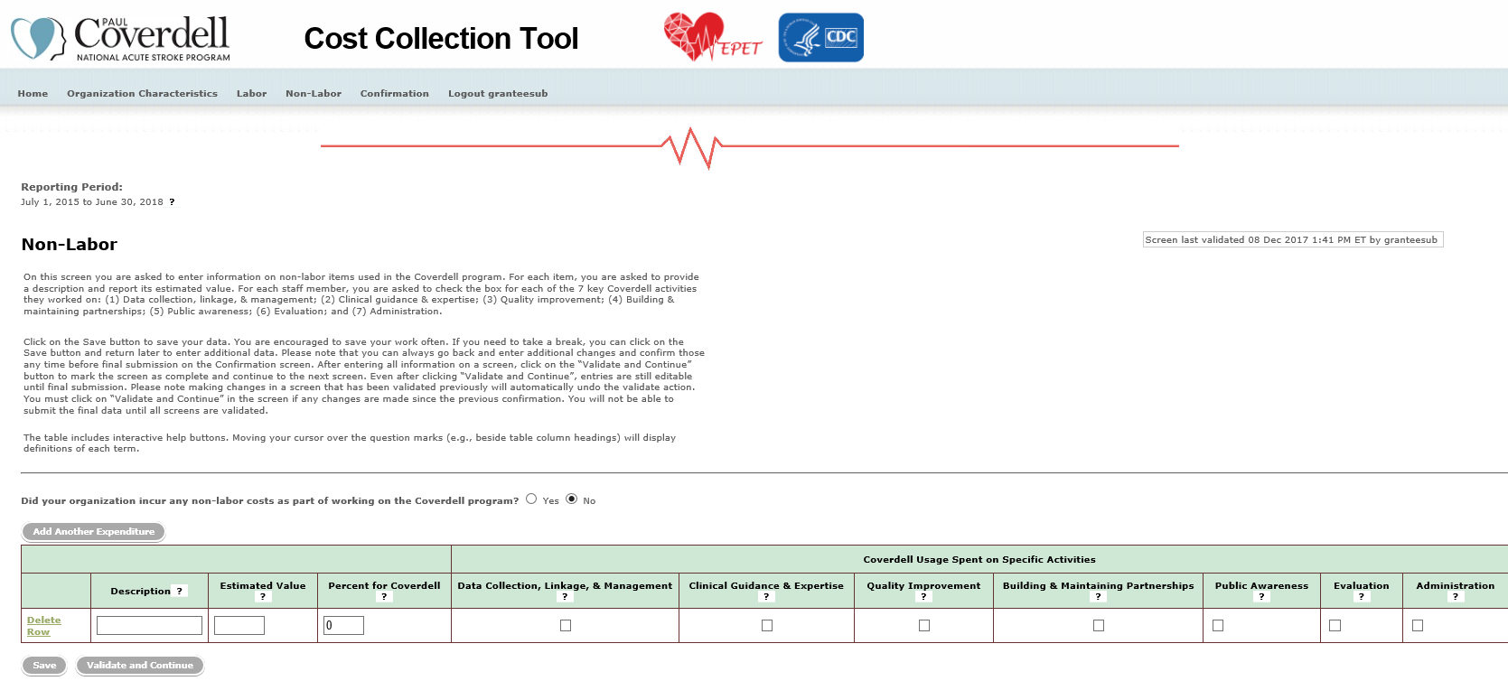

Confirmation screen
