A3. Partner Cost and Resource Utilization Tool User Manual

Centers for Disease Control and Prevention
Paul Coverdell National Acute Stroke Program
COST, RESOURCE AND UTILIZATION (CCT) PARTNER DATA COLLECTION
USERS’ INSTRUCTION GUIDE/MANUAL

RTI INTERNATIONAL

Form Approved
OMB No. 0920-XXXX
Expiration Date: XX/XX/XXXX
INTRODUCTION
This user’s manual has been prepared by RTI International to assist partner organizations participating in the Paul Coverdell National Acute Stroke Program (PCNASP) in completing the PCNASP Cost Collection Tool (CCT). The CCT is used to collect information on PCNASP implementation cost data elements from the perspective of partner organizations and allocations of these costs across key Coverdell implementation activities. Examples of costs to include in the CCT are staff time devoted to Coverdell quality improvement activities and software purchased to support Coverdell efforts related to data collection, linkage, and management. Examples of costs not to include in the CCT are staff time related to normal clinical stroke practice and normal purchases of surgical equipment. Participation in the PCNASP cost study is voluntary. All data is submitted over a secure password protected system and will only be reported in aggregate. This data collection effort will provide important information about how partner organizations contribute to the implementation of Coverdell activities and the costs incurred from that support. Thank you for your assistance.
The PCNASP-CCT collects a set of standardized cost data elements developed to ensure that consistent and complete information on annual costs and allocation of funds is collected for a sample of PCNASP partner organizations. All costs supporting Coverdell activities incurred in the reporting period (the first reporting period is July 1, 2015 to June 30, 2017 and the second reporting period is July 1, 2017 to June 30, 2018) should be reported for each of these categories, if possible. The PCNASP-CCT requests basic information on each partner organization and expenditure details in the following areas:
- Labor
- Non-labor
To reduce respondent burden, data collection errors, and delays in data processing, cost data will be collected via the Web (coverdellcoststudy.rti.org). The Web-based PCNASP-CCT includes several features to reduce burden and collect high-quality data. The instrument contains automated data checks so that grantees can perform self-directed quality checks on the data as they enter them. Data submission occurs over a secure password protected web instrument. Your data will be held securely and will only be reported in aggregate.
Thank you for agreeing to participate in the PCNASP cost study. The data you submit will provide important insights into the costs incurred by partners in supporting the implementation of Coverdell activities. Participation is voluntary and we very much appreciate your involvement.
Public reporting burden of this collection of information is estimated to average 2 hours per response, including the time for reviewing instructions, searching existing data sources, gathering and maintaining the data needed, and completing and reviewing the collection of information. An agency may not conduct or sponsor, and a person is not required to respond to a collection of information unless it displays a currently valid OMB control number. Send comments regarding this burden estimate or any other aspect of this collection of information, including suggestions for reducing this burden to CDC/ATSDR Information Collection Review Office, 1600 Clifton Road NE, MS D-74, Atlanta, Georgia 30333; ATTN: PRA (0920-XXXX).

2. Who Should Submit Cost Data
We are requesting participation from a sample of PCNASP partner organizations. Participating is voluntary. Participating partner organizations are asked to complete the PCNASP-CCT and submit data to RTI twice. The first reporting period will cover the first two years of this round of the Coverdell program (July 1, 2015 to June 30, 2017) and the second reporting period will cover the third year of the Coverdell program (July 1, 2017 to June 30, 2018). A participating partner may choose to appoint an PCNASP-CCT Coordinator who will be responsible for the cost data collection and reporting. This person should be a staff person who is familiar with everyday operations, management, and administration of all activities conducted to support implementation of PCNASP. When completing the PCNASP-CCT, this person is encouraged to seek assistance from other program staff members (e.g., those whose daily responsibilities include financial management for the organization).

3. When to Submit Cost Data
Participating organizations are asked to complete the PCNASP-CCT and submit data to RTI twice during the PCNASP project period: April/May 2018 and 2019. The first reporting period will cover the first two years of this round of the Coverdell program (July 1, 2015 to June 30, 2017) and the second reporting period will cover the third year of the Coverdell program (July 1, 2017 to June 30, 2018). The PCNASP-CCT Coordinator at each organization will receive notice in advance of the data collection each year and will receive reminders weekly over the study period until the final data is submitted.

4. Who to Contact for Questions
Technical assistance (TA) on the PCNASP-CCT is provided by RTI. Please contact Ben Yarnoff (byarnoff@rti.org or 919-541-6640) if you have any questions regarding the PCNASP-CCT. For general questions about the evaluation please contact the CDC Evaluation lead Kincaid Lowe Beasley (Klowe@cdc.gov or 404-718-6633) or the RTI evaluation lead Stephanie Teixeira-Poit (steixeira@rti.org or 919-541-5915).

5. How to Access the PCNASP-CCT
The PCNASP-CCT can be accessed via the secure, password protected PCNASP-CCT Web site (coverdellcoststudy.rt.org). Once on the Log-in Screen (Exhibit 1), you will be asked to enter your log-in information, which will be provided to you via email by RTI. Please enter your log-in information on this screen.
To change your password, check the Change Password checkbox. Remember to write down your password and keep it in a safe place. If you forget your password or need help logging in, click on the Need help logging in? link. An e-mail window will open addressed to the Web site administrator. Please include your username in the e-mail text, describe the problem you are having with the Log-in screen, and send the e-mail to the address indicated.
After logging in, please navigate through the PCNASP-CCT screens using the menu buttons located on top of the screen and review and enter the required information.
Exhibit 1. PCNASP-CCT Log-in Screen
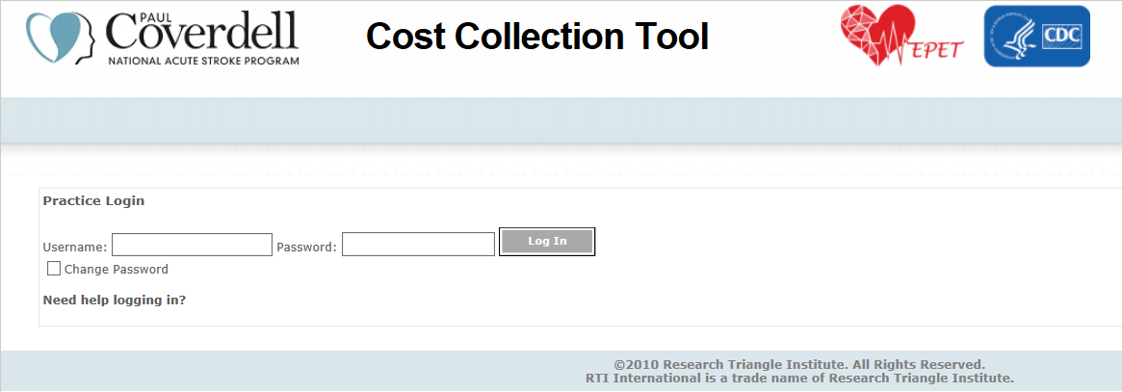

6. PCNASP-CCT Data Screens
The PCNASP-CCT menu consists of the following screens:
- Home
- Organization Characteristics
- Labor
- Non-Labor
- Confirmation
- Logout
Use the menu at the top of the screen (Exhibit 2) to navigate through the screens.
Exhibit 2. PCNASP-CCT Menu
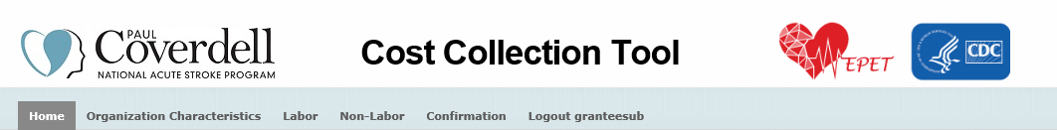

This Cost Collection Tool (CCT) is designed to capture and track total actual costs of the Coverdell program from the partner perspective.
The CCT asks you for cost information for 2 cost categories:
1. Labor. The number of hours worked and estimated hourly value of any staff who worked to support Coverdell activities.
2. Non-Labor. The estimated value of any non-labor items used to support Coverdell activities and the percent of each item that was used to support Coverdell activities.
For each cost category, you are asked to check a box indicating which of the 7 key Coverdell activities the staff member worked on or supply was used to support. The 7 Coverdell activities are:
- Data collection, linkage, & management;
- Partner recruitment;
- Quality improvement;
- Building & maintaining partnerships;
- Public awareness;
- Evaluation; and
- Administration.
In any of the CCT screens, click on the Save button to save your data. You are encouraged to save your work often. If you need to take a break, you can click on the Save button and return later to enter additional data. Please note that you can always go back and enter additional changes and confirm those any time before final submission on the Confirmation screen.
After entering all information on a screen, click on the “Validate and Continue” button to mark the screen as complete and continue to the next screen. Even after clicking “Validate and Continue”, entries are still editable until final submission. Please note making changes in a screen that has been validated previously will automatically undo the validate action. You must click on “Validate and Continue” in the screen if any changes are made since the previous confirmation. You will not be able to submit the final data until all screens are validated.
The CCT screens include interactive help buttons. Moving your cursor over the question marks (e.g., beside table column headings) will display definitions of each term.
To log out from the CCT, click on the Logout menu heading.
Instructions on how to complete each of the PCNASP-CCT screens are presented below.

6.1. Organization Characteristics Screen
On the organization characteristics screen (Exhibit 3) you are asked to provide information on:
- The type of your organization (hospital, EMS, rehabilitation, AHA/ ASA, academic, primary health care, state health department, or other)
- The number of stroke patients your organization sees annually
- The number of year and months your organization has been working on the Coverdell program
Click on the Save button to save your data. You are encouraged to save your work often. If you need to take a break, you can click on the Save button and return later to enter additional data. Please note that you can always go back and enter additional changes and confirm those any time before final submission on the Confirmation screen.
After entering all information on a screen, click on the “Validate and Continue” button to mark the screen as complete and continue to the next screen. Even after clicking “Validate and Continue”, entries are still editable until final submission. Please note making changes in a screen that has been validated previously will automatically undo the validate action. You must click on “Validate and Continue” in the screen if any changes are made since the previous confirmation. You will not be able to submit the final data until all screens are validated.

Exhibit 3. Organization Characteristics Screen
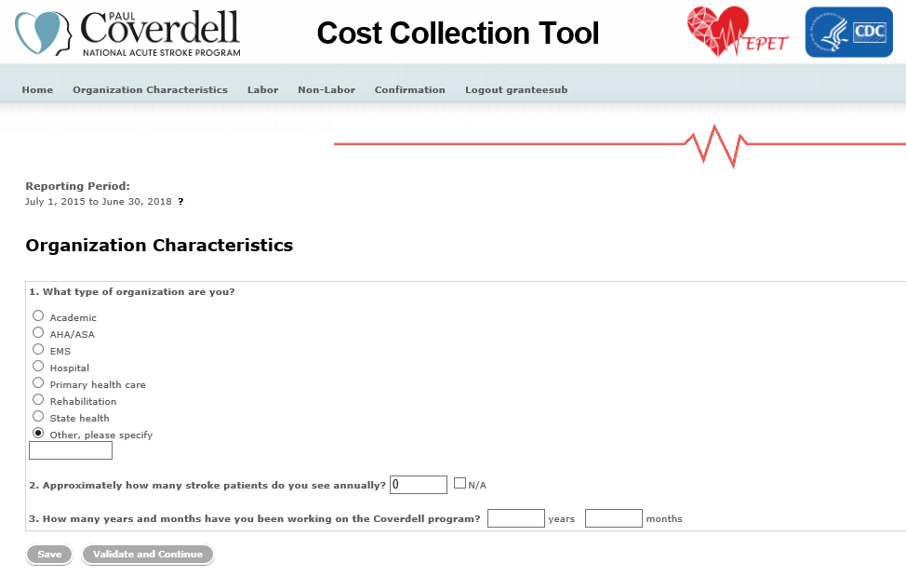

6.2. Labor Screen
On the labor screen (Exhibit 4) you are asked to enter information on staff that contributed time to the Coverdell program.
For each staff that worked on the Coverdell program, you are asked to report
- Title of the staff member
- Estimated hourly value of their time
- The number of hours worked on Coverdell activities during the reporting period.
- Which of the 7 Coverdell activities the staff member worked on:
  - Data collection, linkage, & management;
  - Partner Recruitment;
  - Quality improvement;
  - Building & maintaining partnerships;
  - Public awareness;
  - Evaluation; and
  - Administration
To add more staff members to the table, click on the Add Another Staff Member link at the top of the screen. To delete staff members from the list, click on Delete Row in the first column of the row corresponding to that staff member.
Click on the Save button to save your data. You are encouraged to save your work often. If you need to take a break, you can click on the Save button and return later to enter additional data. Please note that you can always go back and enter additional changes and confirm those any time before final submission on the Confirmation screen.
After entering all information on a screen, click on the “Validate and Continue” button to mark the screen as complete and continue to the next screen. Even after clicking “Validate and Continue”, entries are still editable until final submission. Please note making changes in a screen that has been validated previously will automatically undo the validate action. You must click on “Validate and Continue” in the screen if any changes are made since the previous confirmation. You will not be able to submit the final data until all screens are validated.
The table includes interactive help buttons. Moving your cursor over the question marks (e.g., beside table column headings) will display definitions of each term.
Exhibit 4. Labor Screen
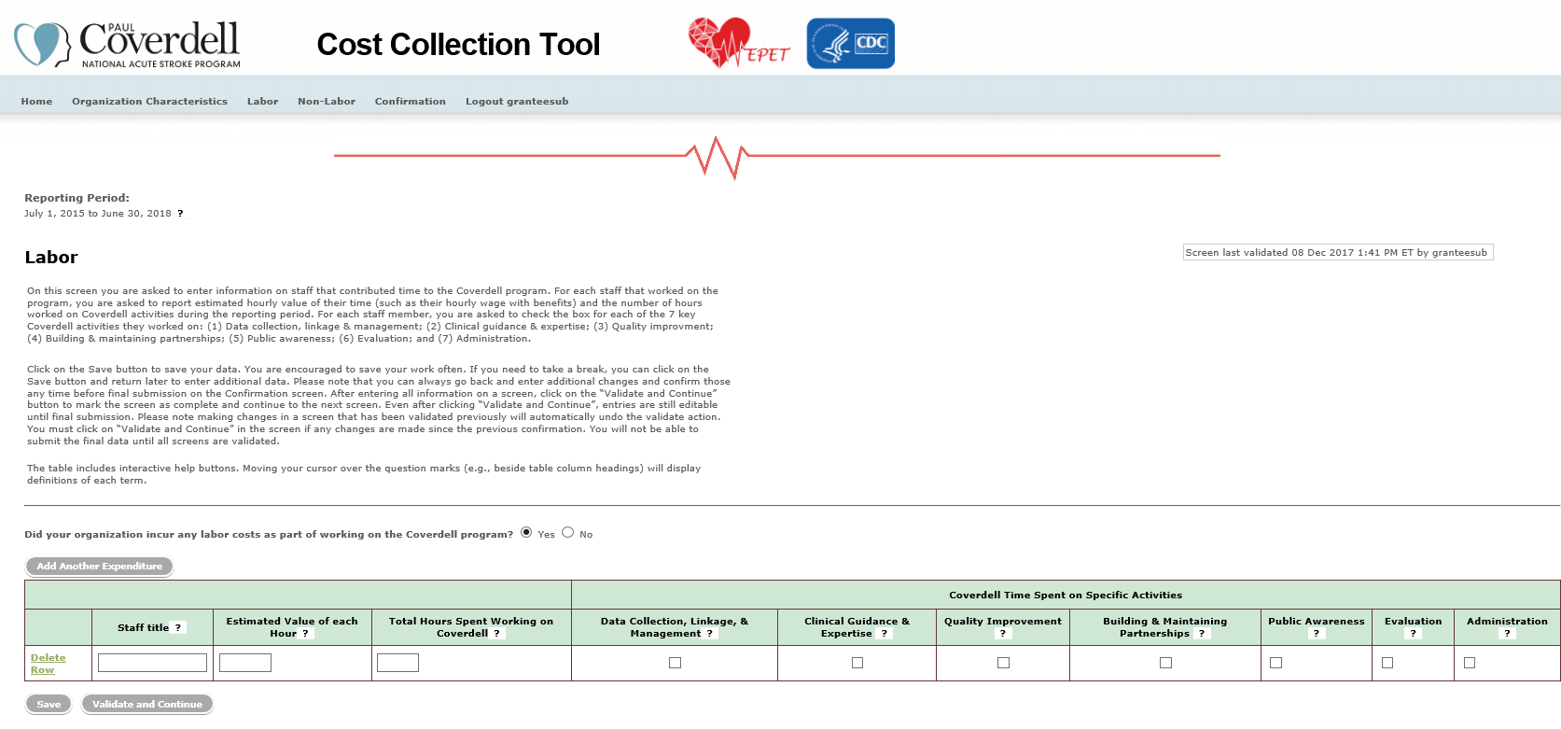

6.3. Non-Labor Screen
On the non-labor screen (Exhibit 5) you are asked to enter information on non-labor items used in the Coverdell program.
For each item, you are asked to provide
- A description of the item
- Estimated value
- Estimated percent of the item used for Coverdell activities
- Which of the 7 Coverdell activities the item was used to support:
  - Data collection, linkage, & management;
  - Partner Recruitment;
  - Quality improvement;
  - Building & maintaining partnerships;
  - Public awareness;
  - Evaluation; and
  - Administration
To add more expenditures to the table, click on the Add Another Expenditure link at the top of the screen. To delete materials from the list, click on Delete Row in the first column of the row corresponding to that material.
Click on the Save button to save your data. You are encouraged to save your work often. If you need to take a break, you can click on the Save button and return later to enter additional data. Please note that you can always go back and enter additional changes and confirm those any time before final submission on the Confirmation screen.
After entering all information on a screen, click on the “Validate and Continue” button to mark the screen as complete and continue to the next screen. Even after clicking “Validate and Continue”, entries are still editable until final submission. Please note making changes in a screen that has been validated previously will automatically undo the validate action. You must click on “Validate and Continue” in the screen if any changes are made since the previous confirmation. You will not be able to submit the final data until all screens are validated.
The table includes interactive help buttons. Moving your cursor over the question marks (e.g., beside table column headings) will display definitions of each term.
Exhibit 5. Non-Labor Screen
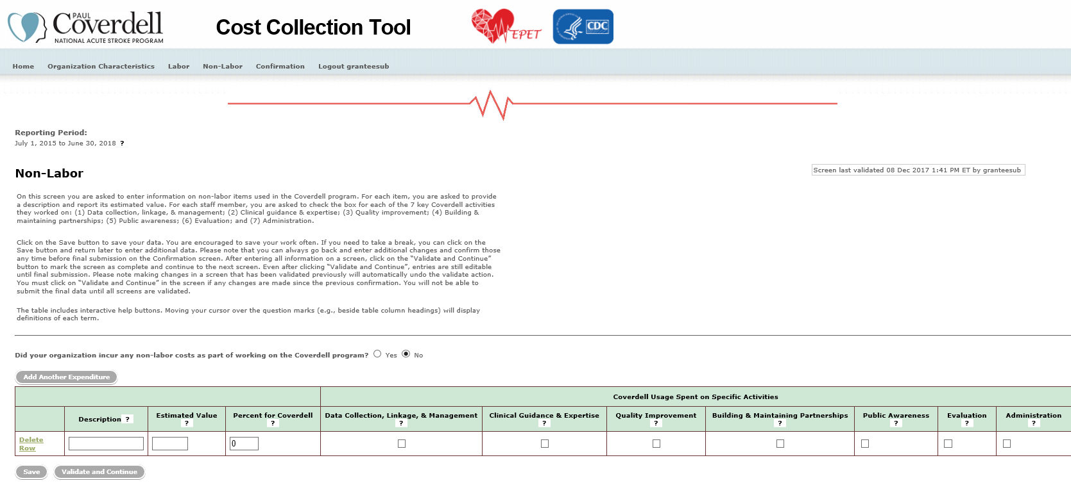

6.4 Confirmation
The Confirmation screen (Exhibit 6) summarizes annual expenditure data that you entered in the other screens of the PCNASP-CCT. The tables display whether the data entered in each screen have been validated by you. You must validate the data entered in all the screens for your submission to be considered complete. The Confirmation screen will display error messages until all entries in all other screens have been confirmed. To confirm the data, go to the appropriate screen and click on the Validate and Continue button. Making any changes in a screen that has been previously validated will automatically undo the validation action; the validation stamp will disappear, and the Please Validate message will be displayed again. The user must re-validate the screen if any changes are made since the previous validation.
Exhibit 6. Confirmation Screen
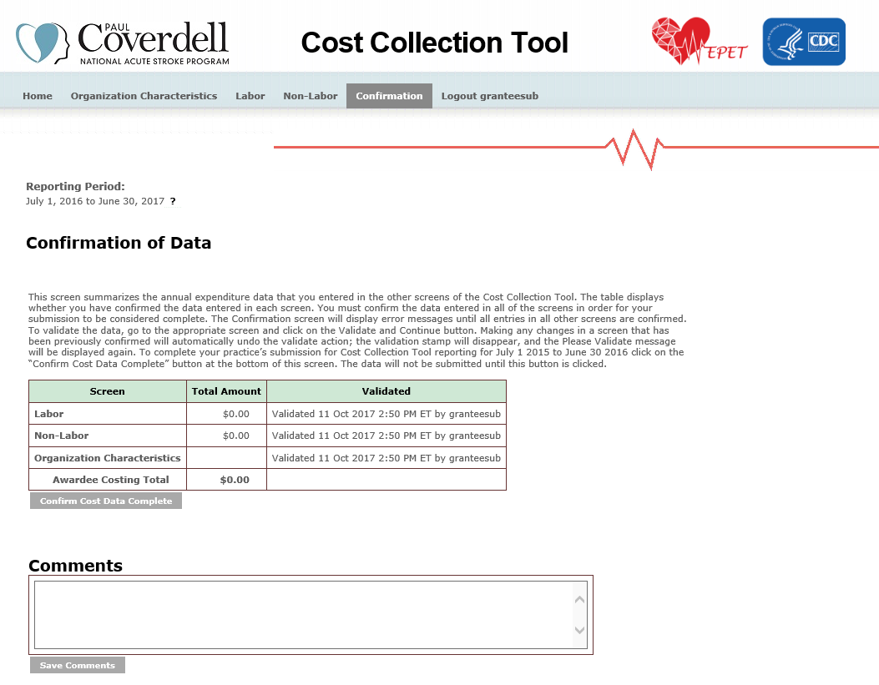
Users will not be able to finalize their submission until all errors have been resolved. To complete the data submission, click on the Confirm Cost Data Complete button on the Confirmation screen.
After you click on the Confirm Cost Data Complete button, an automated notification e-mail will be sent to the users whose e-mail addresses are associated with the organizations’ s account to confirm a successful transmission of the data to RTI. This will include a summary report of the data entered for your information (Exhibit 7).
Exhibit 7 Summary Report
Paul Coverdell National Acute Stroke Program Cost Study Partner Report

This report summarizes the data reported on implementation costs of the Paul Coverdell National Acute Stroke Program (PCNASP) for the reporting period <Insert Reporting Period> by <Insert Partner Organization Name>. The following tables summarize different aspects of the data reported.

Table 1: Total Expenditures by Resource Categories
Resource Category | Total Expenditures in the Period
All Categories
Labor
Non-Labor

Table 2: Total Expenditures by Activity
Activity | Total Expenditures in the Period
Data collection, linkage, & management
Partner Recruitment
Quality improvement
Building & maintaining partnerships
Public awareness
Evaluation
Administration

6.5 Data REview
The RTI evaluation team will review all submitted data and identify questions about any data elements. If they have any questions about your data, they will reach out to you via email with specific questions. The goal of this review is to make sure that the evaluation team fully understands the data each organizations submits and includes it properly in the analysis. Your support in answering these questions is greatly appreciated.

