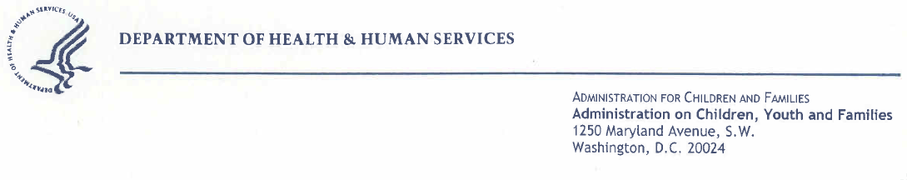
September 22, 2017

Anjani Chandra, Ph.D.
National Survey of Family Growth
National Center for Health Statistics
3311 Toledo Road
Hyattsville, MD 20782

Dear Dr. Chandra:

The Inter-Agency Agreement between the National Center for Health Statistics (NCHS) and the Children’s Bureau has been a fruitful one for several years. The NCHS work on the National Survey of Family Growth (NSFG) adds important information to that gathered by the Children’s Bureau on the children and youth we serve, including foster children and youth.

The Children’s Bureau’s concern is primarily with children who are maltreated, or not kept safe, by their parents. When it becomes necessary to remove a child from the home, the primary goal is to try to find a safe and permanent place for the child, which can be back in the home when that is feasible, or with an adoptive family or guardian when reunification with the parents is not feasible.

The NSFG has provided useful comparison data on adoption for several years. The updated NSFG is proving especially important and valuable to the Children’s Bureau because it now gathers information on the former foster care status of the people that they survey.

Small studies have found that former foster youth tend to have unwanted pregnancies at a young age, and that they may have more of a tendency to get sexually transmitted diseases. The Children’s Bureau wants and needs more national data on such issues but we cannot collect those data ourselves. We have only scant national data on what happens to former foster youth. The NSFG data are providing a solid complement to the data we are able to collect. The NSFG data can be used for comparison purposes and this will help us to be more successful in our mission of helping to ensure the safety, permanency and well-being of vulnerable foster children and youth.

In summary, the Children’s Bureau strongly recommends that the Office of Management and Budget allow this important survey to continue. It should not be diminished in any way because that would jeopardize the high quality and scope of the data upon which my agency and many others depend.

Relevant Authorizations for the Children’s Bureau’s Work

I am attaching the most recent, relevant information that authorizes the work of the Children’s Bureau in the areas of foster care, adoption, and prevention of child maltreatment. In a sense, these laws go back to 1935 because they are linked to the original Social Security Act. In more modern times, there is a long history of laws related to this work going back to 1974, including:

- The Child Welfare Services Program and the Promoting Safe and Stable Families Program authorized in Title IV-B of the Social Security Act, 42 USC 621.

- The Foster Care Maintenance Payments Program, Adoption Assistance Program and Guardianship Assistance Program authorized in Title IV-E of the Social Security Act, 42 USC 670.

These programs in the Social Security Act are essential because they are the primary source of dedicated Federal child welfare funding to help State and local child welfare agencies support the critical services needed by children who are at-risk of or have been abused and neglected by their families.

A compilation of titles IV-B and IV-E of the Social Security Act are available on the Children’s Bureau website at http://www.acf.hhs.gov/programs/cb/laws_policies/cblaws/safe2010draft.htm.

Below are the laws that provide the most updated authorizations for the Children’s Bureau’s work:
- The Fostering Connections to Success and Increasing Adoptions Act of 2008, Pub. L. 110-351 (pdf attached)

- The Child Abuse Prevention and Treatment ACT (CAPTA) Reauthorization Act of 2010, Pub. L. 111-320 (pdf attached); and the related Comprehensive Addiction and Recovery Act (CARA, 2016) that modified CAPTA. See attached: Public Law 114-198

- The Patient Protection and Affordable Care Act, Pub. L. 111-148. Attached is the section of the law that refers to foster care and the health care needs of youth aging out of foster care. [Note: This full law is not attached because it is over 1,000 pages long, but is available at this link: http://www.gpo.gov/fdsys/pkg/PLAW-111publ148/pdf/PLAW-111publ148.pdf

- The Child and Family Services Improvement and Innovation Act, Public Law (Pub. L.) 112-34; [Note: this extended the authorization for Title IV-B, Part I, Child Welfare Services, and Part II, Promoting Safe and Stable Families (PSSF) through 2016. It was passed September 30, 2011. http://www.gpo.gov/fdsys/pkg/PLAW-112publ34/pdf/PLAW-112publ34.pdf

If you require any additional information, please let me know. Thank you.

Sincerely yours,

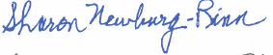

Sharon Newburg-Rinn, Ph.D.

Social Science Research Analyst

Office of Data Analysis, Research & Evaluation/Children’s Bureau

Administration on Children, Youth and Families, Administration for Children and Families

U.S. Department of Health and Human Services

1250 Maryland Avenue, SW, Room 8116

Washington, DC 20024

Sharon.Newburg-Rinn@acf.hhs.gov

