Mobile Messaging Intervention to Present New HIV Prevention Options for Men who have Sex with Men: Randomized Controlled Trial

3. Recruitment Materials

Our recruitment plan is primarily built around online advertising venues, with promotional materials to be distributed by a 3rd-party entity with expertise in online recruitment. The following images are presented as examples of promotional images to be used as web banner ads as part of study recruitment: 

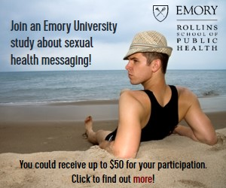

While individual elements of each ad may be tailored to better recruit sub-groups of MSM (e.g. young MSM, Black MSM, Latino MSM), such as choosing particular images or language to attract targeted subgroups of MSM, the core elements of each ad will follow these guidelines:

1. Photographs : Any photographs of human beings used in promotional materials require a signed talent-release and appropriate licensure agreements for use. The apparent emotional state of any human models should be unambiguously positive or neutral;
2. Text : Any promotional materials should contain text briefly describing the study, such as “Participate in our MSM messaging study. Check your eligibility”;
3. Referral : Every piece of promotional material should provide at least one means of connecting the audience of the promotional image to the study enrollment process, including:
   1. Hyperlinking -- the promotional material, where presented, can be clicked or otherwise interacted with in order to direct the user’s browser towards the study’s consent and online enrollment portal.
   2. Barcodes – the promotional material, where presented, bears a recognizable barcode which can be scanned using a smartphone or other barcode-scanning device. The contents of that barcode should be the web address of the study’s consent and online enrollment portal.
   3. Text – the promotional material, where presented, displays the written web address of the study’s consent and online enrollment portal, which participants can enter into their web browser for access.
4. Style (Color) - Color schemes used in promotional materials should be selected from the range of Emory University approved identity branding colors, which can be referenced here: <http://communications.emory.edu/brand_licensing/IdentityGuidelines/IdentityColor.html>;
5. Style (Logo) - All promotional materials should bear the Emory University logo, or appropriate Emory University logo sub-variant, such as “Emory University Health Study.” Some logo resources are available here: <http://communications.emory.edu/brand_licensing/IdentityGuidelines/LogosFullSets.html>;
6. Style (Font) - Typeface for all text elements should conform to Emory University typeface identity guidelines, available here: <http://communications.emory.edu/brand_licensing/IdentityGuidelines/IdentityFonts.html>;