APHIS/CDC Form 4: Report of the Identification of a Select Agent or Toxin

Outside the entity information and select agent identified, data for the APHIS/CDC Form 4 were not collected in NSAR. The pdf of the form was scanned into the system. The below screen prints show what will be collected in eFSAP.
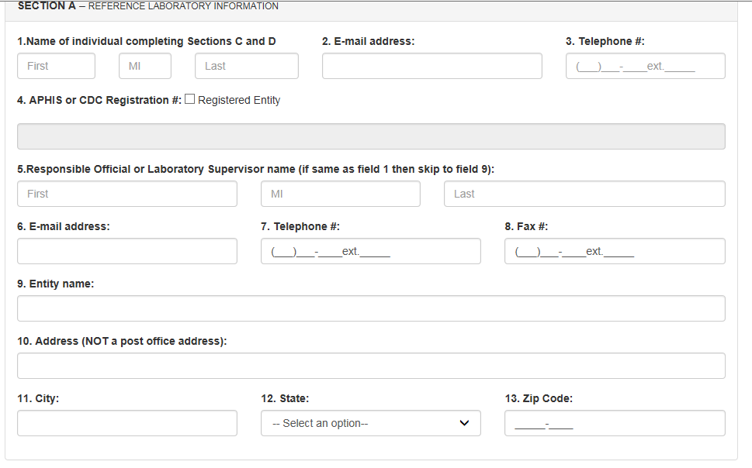

For the below screen print, this is found in Section B of the form.
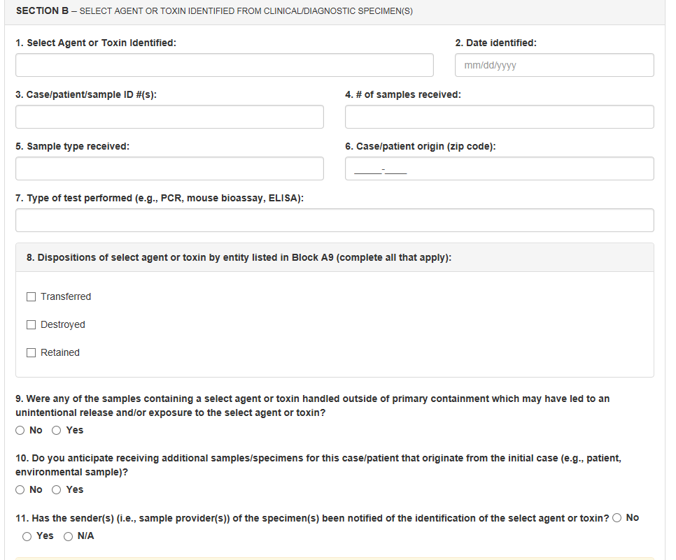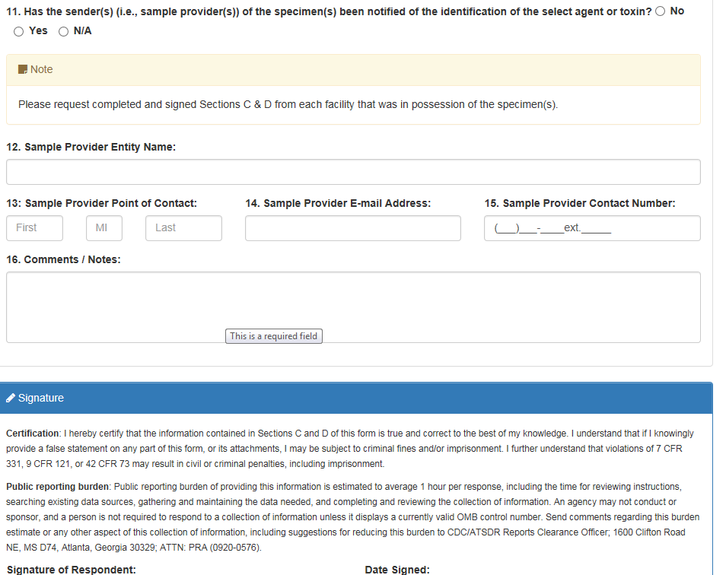

For the below screen print, this is found in Section C of the form.
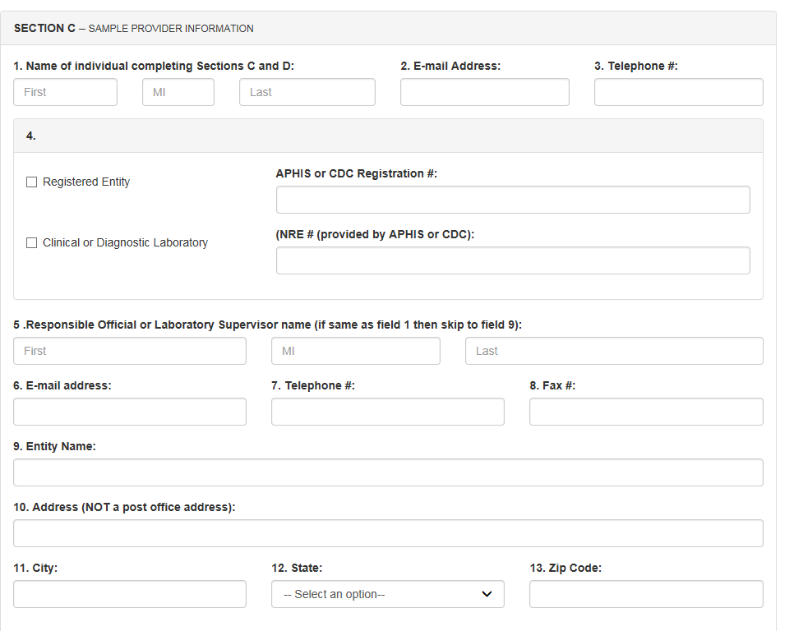

For the below screen prints, this is found in Section D of the form.
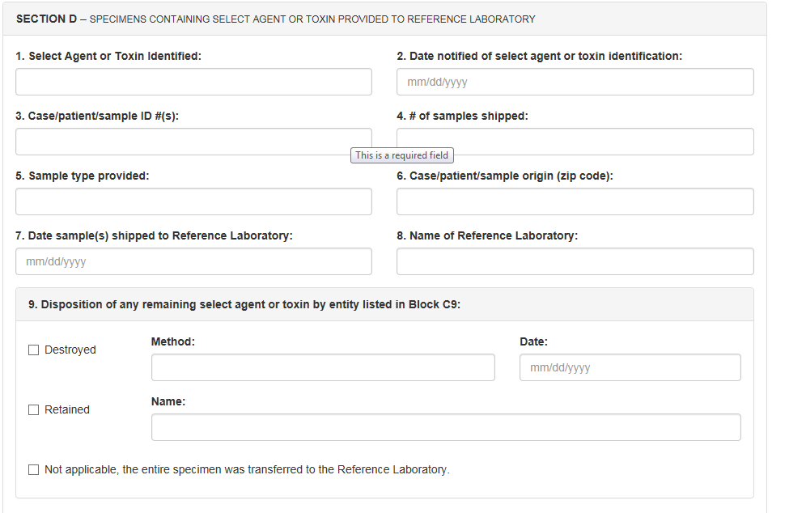

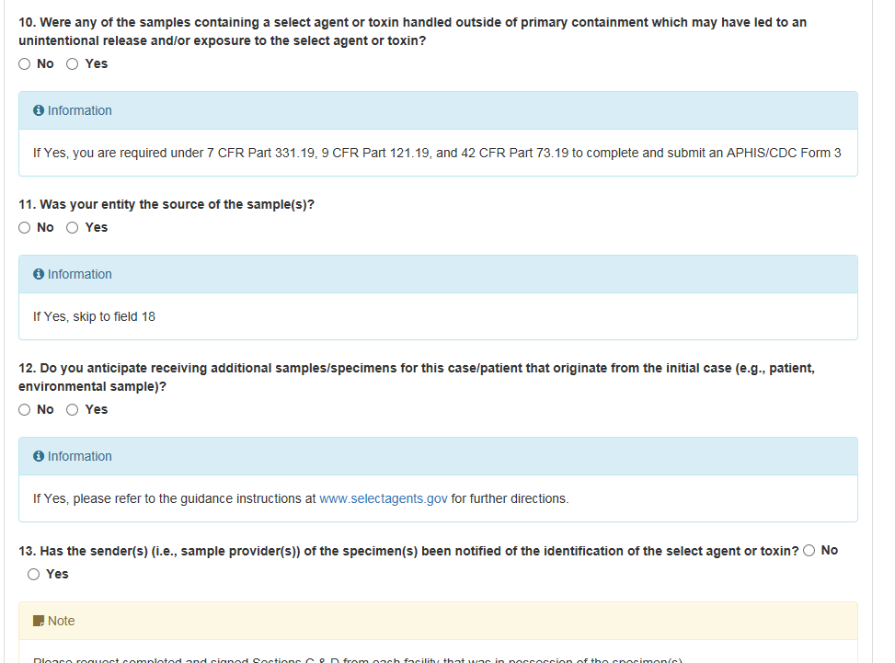
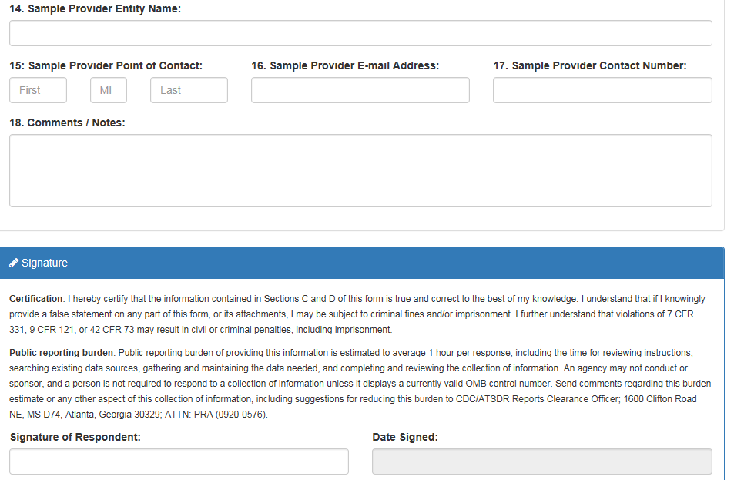

APHIS/CDC Form 5: Request for Exemption of Select Agents and Toxins for an Investigational Product

Similar to NSAR, the form will not be available in the new system. Applicants will still complete the pdf available on the Federal Select Agent Program website.

