**Attachments include the following:**

**Page 2: Outreach Contact Letter**

**Page 3: Web-based Survey, Landing Page**

**Page 4: Web-based Survey, Language Selection Page**

**Page 5: Web-based Survey, Research Information Page**

**Page 6: Web-based Survey, Screening Questions Page**

**Page 7: Web-based Survey, Ineligibility Notification**

**Page 8-33: Web-based Survey, Instrument**

**Page 34: Two new questions in the web-based survey**

**Outreach Contact Letter**

Dear Cervical Cancer Survivor,

It’s always a pleasure for me to share new ways in which you can be active in the Cervivor community.

Today I’d like to tell you about a study that The Centers for Disease Control and Prevention (CDC) is conducting about cervical cancer and a special invitation they have extended to the Cervivor network.

The CDC wants to help prevent women from developing cervical cancer. To do so, they are seeking to better understand women's screening and follow-up experiences prior to their being diagnosed with invasive cervical cancer. Cervical cancer survivors like you and me are invited to share our stories with them by taking an online survey. Results from the study would be used to recommend changes that could improve access to care for other women.

The survey will take about 15 minutes to complete.

The study will not collect any information that could personally identify you, including your name or e-mail address. All information that you share is confidential and will only be used for research purposes. [www.Cervivor.org](http://cervivor.org/) will not have access to your information.

I hope you will join me in completing the survey so that your personal impact story can make a difference.

If you would like to participate, please go to this link to complete the survey, *LINK TO WEB-SURVEY*.

Thank you,

***Tamika Felder***  
Chief Visionary   
Cervivor  
PO Box 2942  
Upper Marlboro, MD 20773  
  
866-595-2448 ext. 701  
240-823-6002 fax

[www.cervivor.org](http://www.cervivor.org)  
[cid:image001.gif@01D36D0D.A2C331A0Facebook](http://www.facebook.com/cervivor)

[cid:image002.gif@01D36D0D.A2C331A0Twitter](http://twitter.com/@iamcervivor)

You Are Not Alone: <http://bit.ly/1IQYEkR>

**Web****-based Survey, Landing Page**

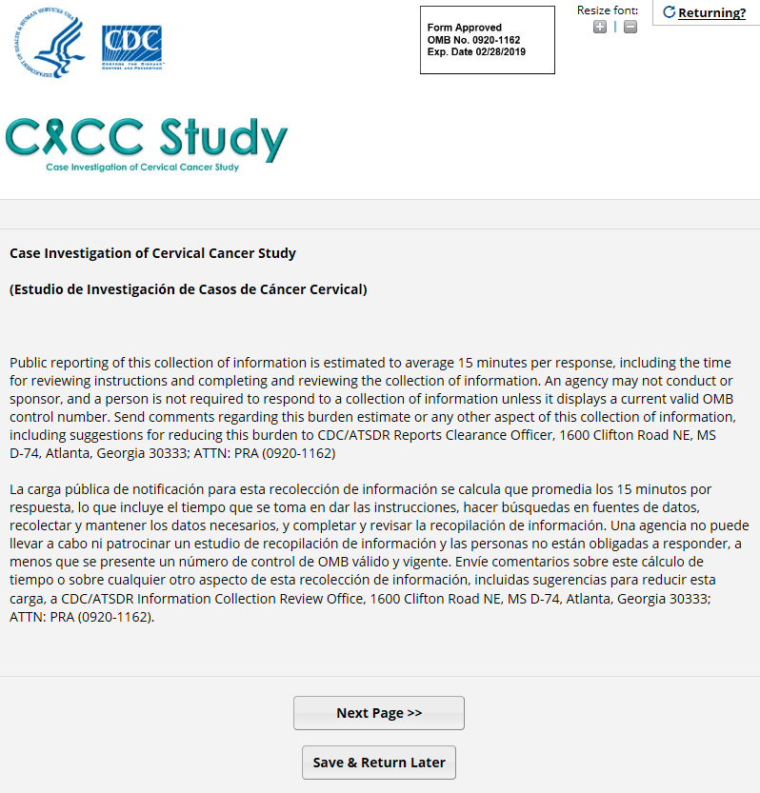

**Web-based Survey, Language Selection Page**

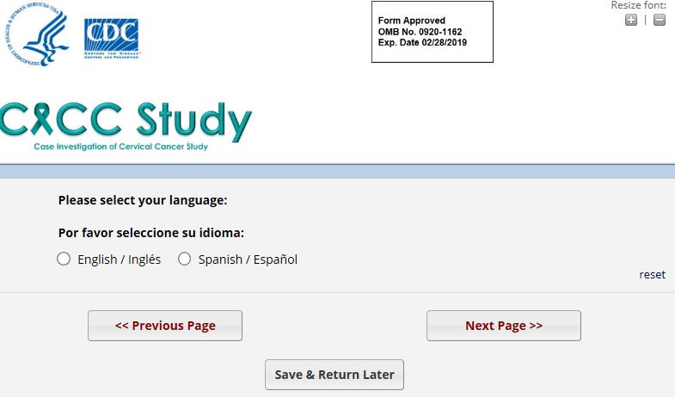

**Web-based Survey, Research Information Page**

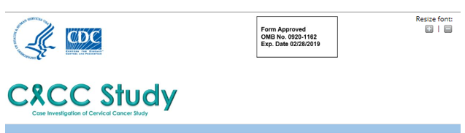

**Case Investigation of Cervical Cancer (CICC) Study  
  
Your participation in this survey is very important to us. Thank you for sharing your story.**  
  
The Centers for Disease Control and Prevention (CDC) wants to better understand women's screening and follow-up experiences prior to their being diagnosed with invasive cervical cancer. Results from the study would be used to recommend changes that could improve access to care for other women. CDC has contracted with the non-profit research institute Battelle to conduct the study.  
  
The survey has questions about your cervical cancer screening history and follow-up of abnormal test results prior to your cancer diagnosis. **It is your choice whether to do the survey. There are no direct benefits to you from taking part in this research,** but your participation could help researchers improve access to cancer care for others by better understanding the experiences of cervical cancer survivors prior to diagnosis.

The study does not provide any medical treatment or care. Your decision to participate will not affect any of your health care benefits or services. Some survey questions related to your cervical cancer experience may cause you distress and you do not have to answer questions that make you feel uncomfortable.  
  
We will not collect any information that could personally identify you, including your name or e-mail address. All information that you share with us is confidential and will only be used for research purposes. [www.Cervivor.org](http://cervivor.org/) will not have access to your information.   
  
We estimate that this survey will take about **15 minutes** to complete.  
  
If you have any questions or difficulty completing the survey, please call April Greek at (206) 528-3167. This survey has been reviewed and approved by the Battelle Institutional Review Board (IRB), a committee tasked to protect the rights, health, safety, and privacy of people who participate in research. If you have any questions about your rights as a survey respondent, you may call Battelle's IRB toll-free at 1-877-810-9530, Ext. 500.  
  
**Thank you for your participation.**

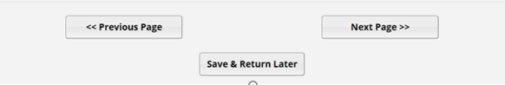

**Web-based Survey, Screening Questions Page**

**If “Yes” to both questions, the potential participant is eligible and taken to the first question the survey.**

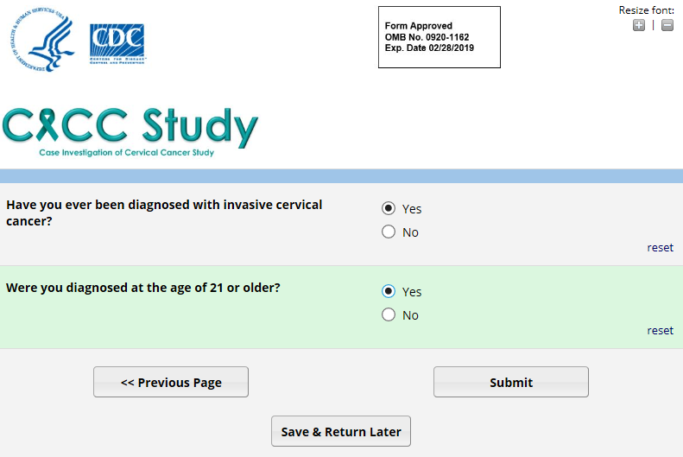

**Web-based Survey, Ineligibility Notification**

**If “No” to either of the screener questions, the potential participant is not eligible for the study.**

**INELIGIBLE IF:**

**(1) not diagnosed with invasive cervical cancer**

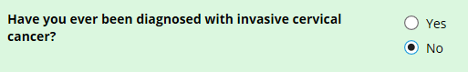

**OR**

**(2) under the age of 21 years when diagnosed with invasive cervical cancer**

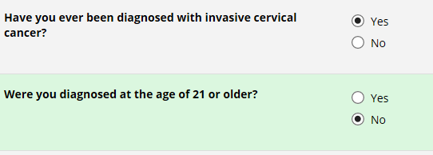

**If INELIGIBLE, the potential participant will see the following message:**

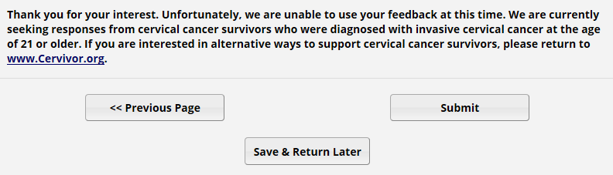

**Web-based Survey, Instrument**

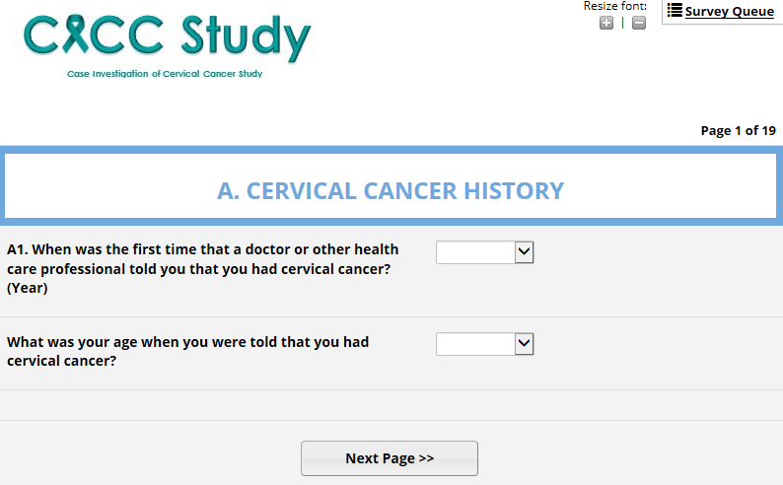

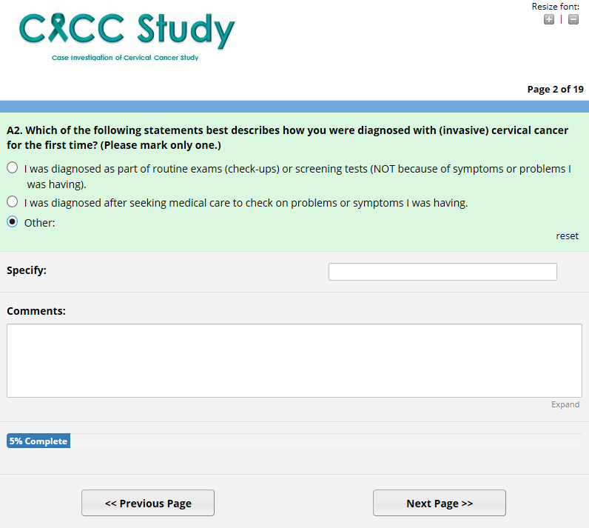

*Note: Question A2, “Other” option is selected to show the “Specify” response box.*

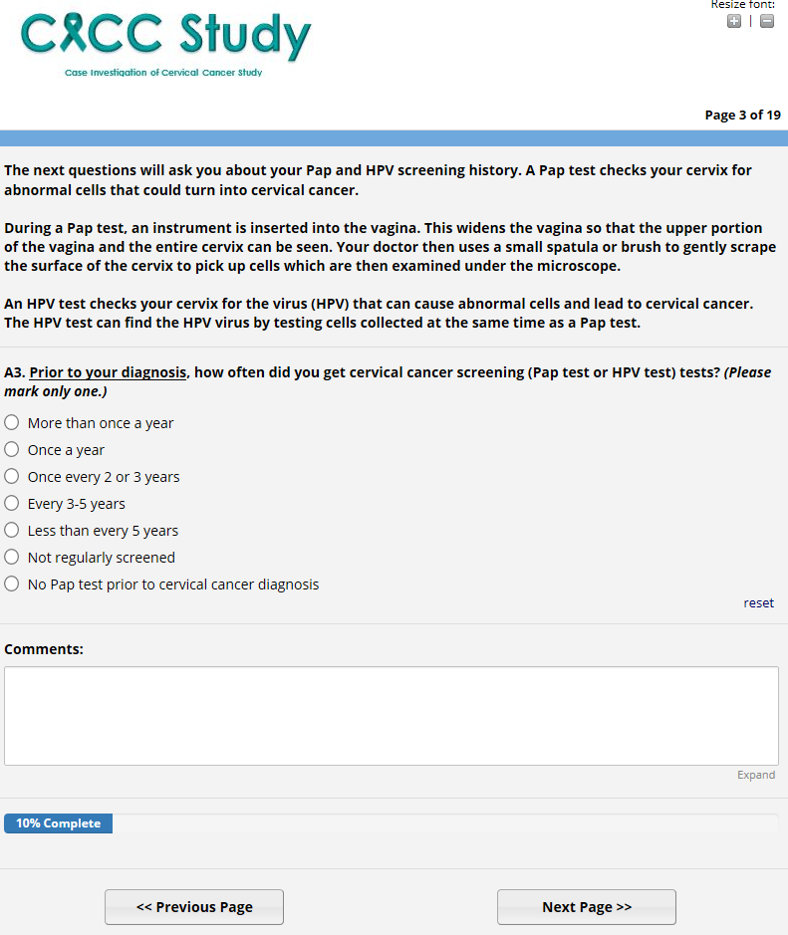

**SKIP PATTERN:**

**If Question A4 is answered “No” survey proceeds to question A5.**

**If Question A4 is answered “Yes” survey skips to question A6.**

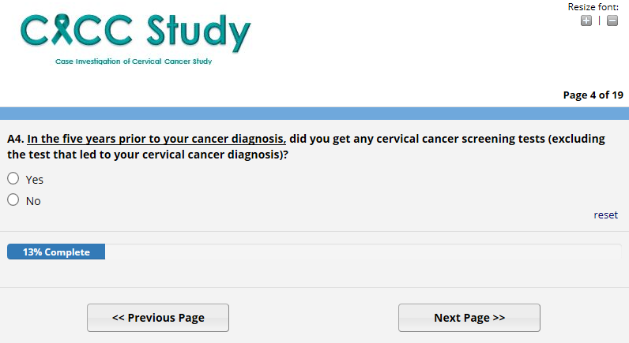

**Question A5 (continued), Response options “a” – “j”**

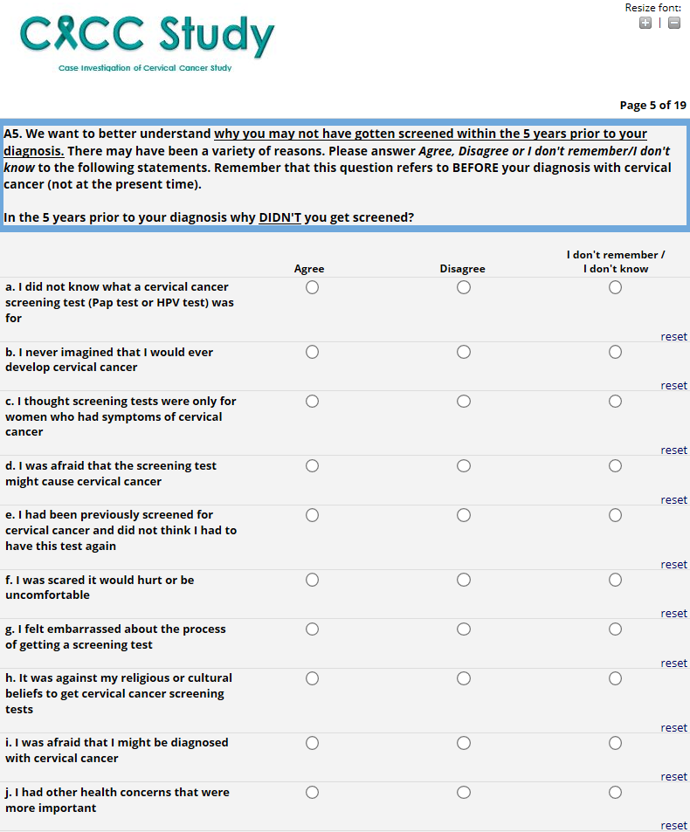

*(survey “Page 5 of 19” is continued on the next page)*

**Question A5 (continued), Response options “k” – “z”**

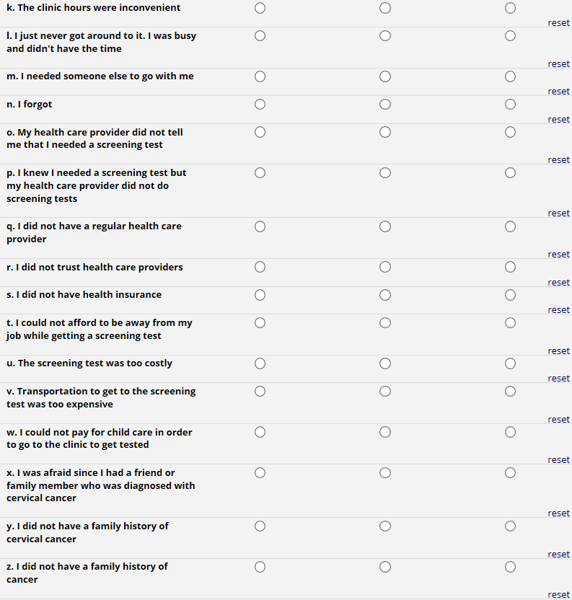

*(survey “Page 5 of 19” is continued on the next page)*

**Question A5 (continued), Response options “aa” – “dd” and “Other”**

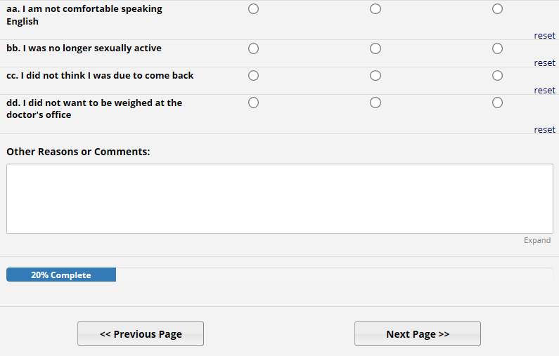

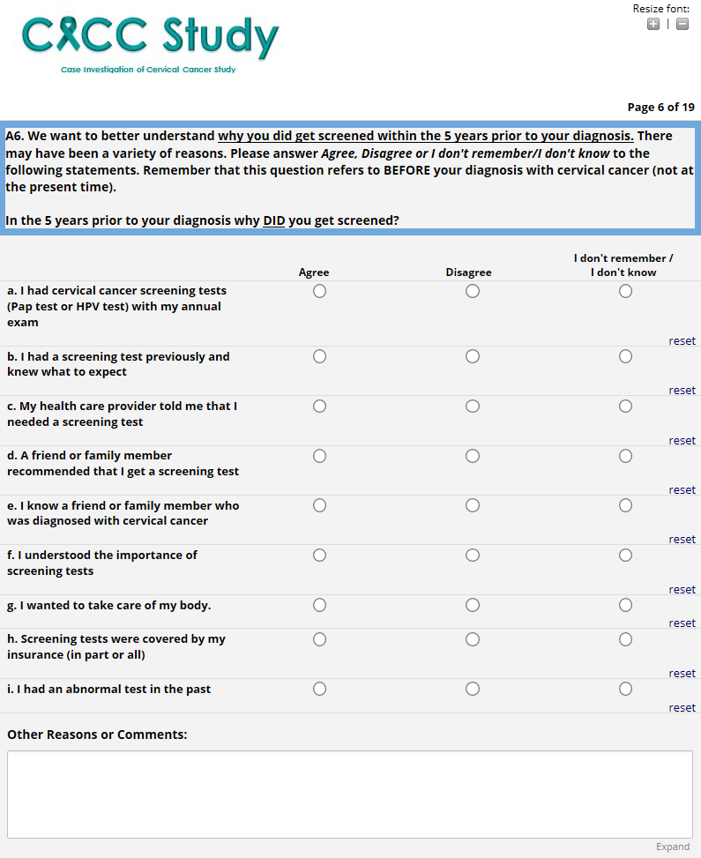

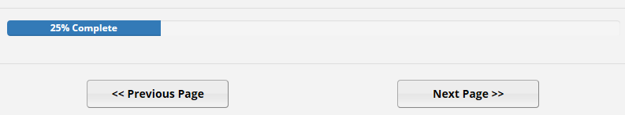

**Question A7, Pap Test Results with example response for year of first Pap test entered to show response options for test results**

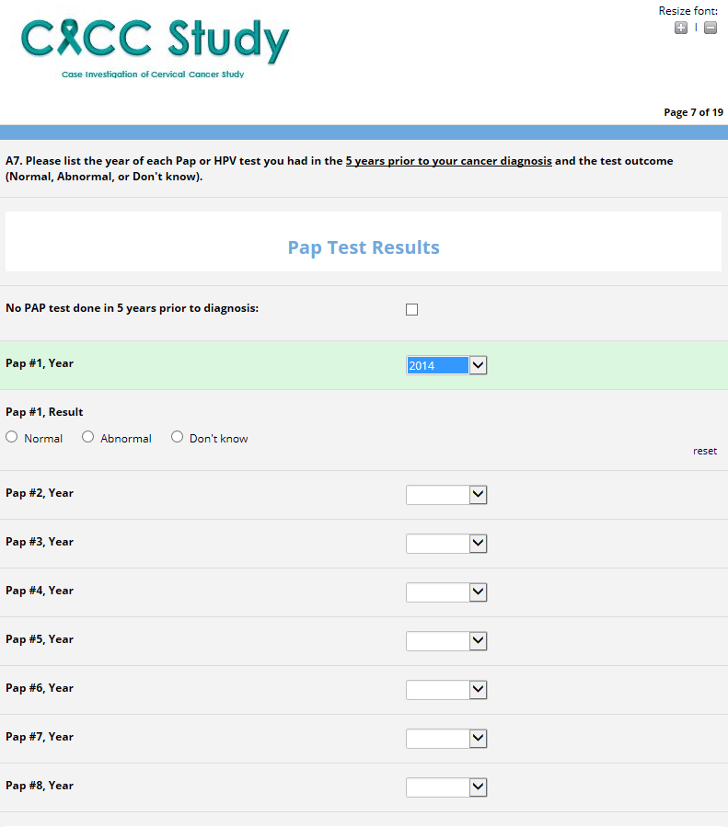

*(survey “Page 7 of 19” is continued on the next page)*

**Question A7 (continued), HPV Test Results with example response for year of first HPV test entered to show response options for test results**

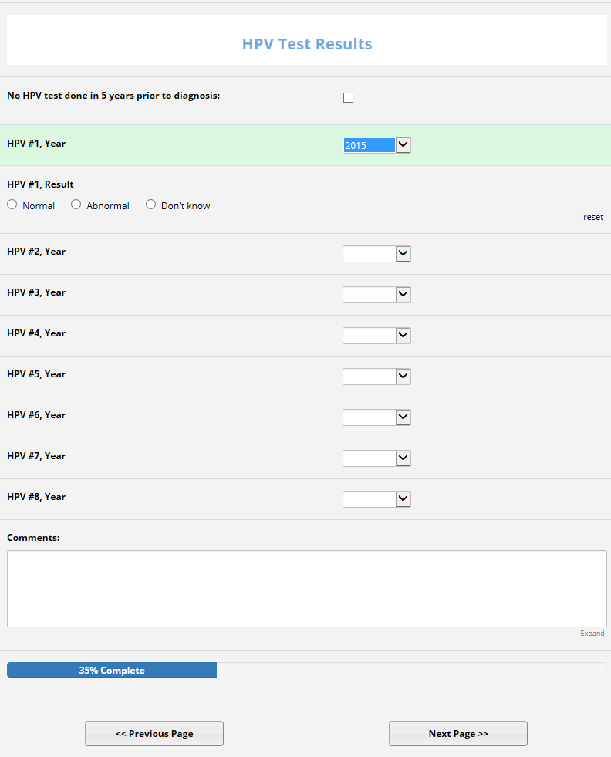

**SKIP PATTERN:**

**If “Yes, as recommended by my doctor” or “Yes, but I waited longer than recommended”, proceed to question A9.**

**Otherwise, skip to question A10.**

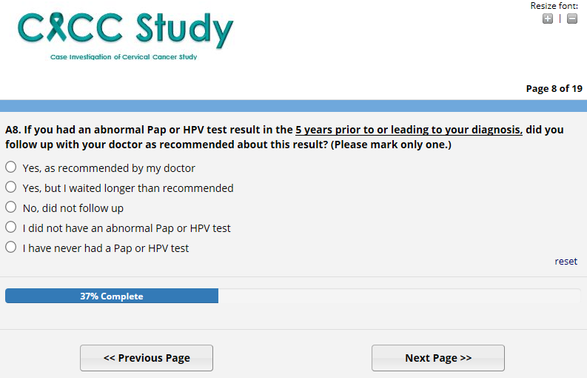

**Question A9, response options “a” – “n”**

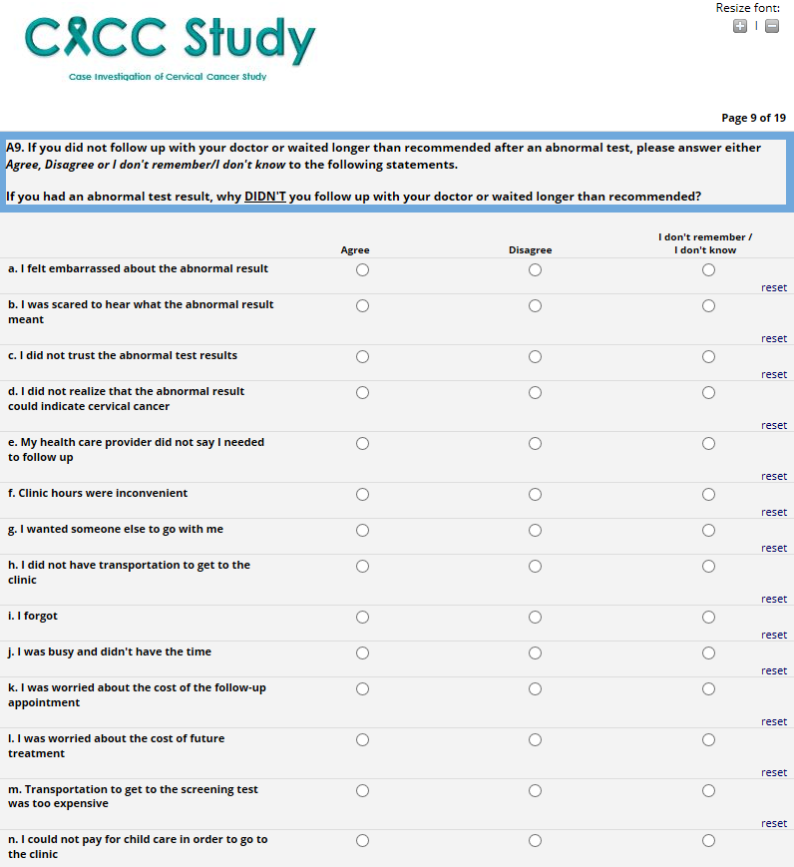

*(survey “Page 9 of 19” is continued on the next page)*

**Question A9 (continued), response options “o” – “s” and “Other”**

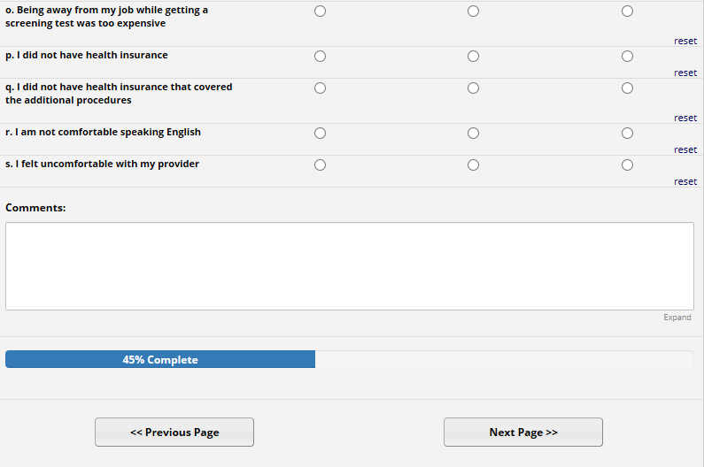

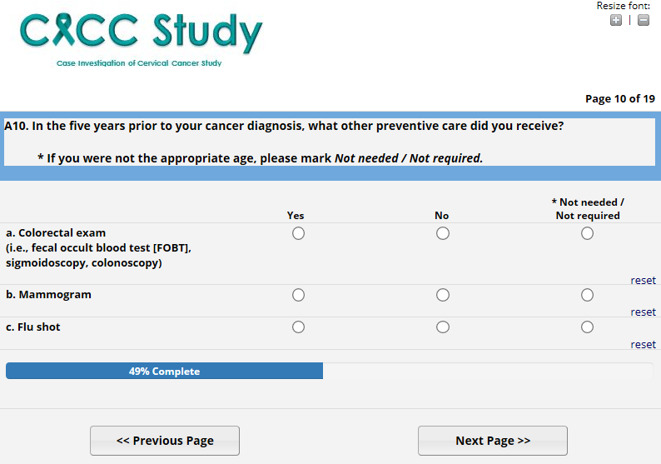

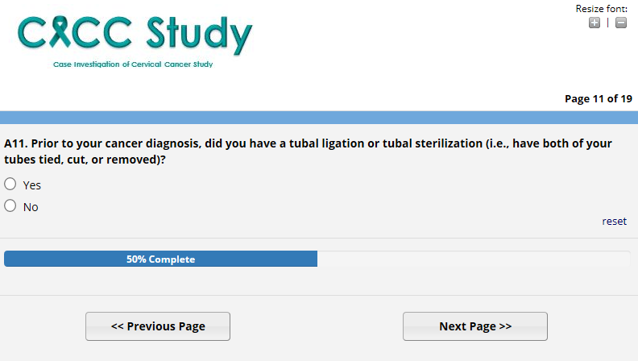

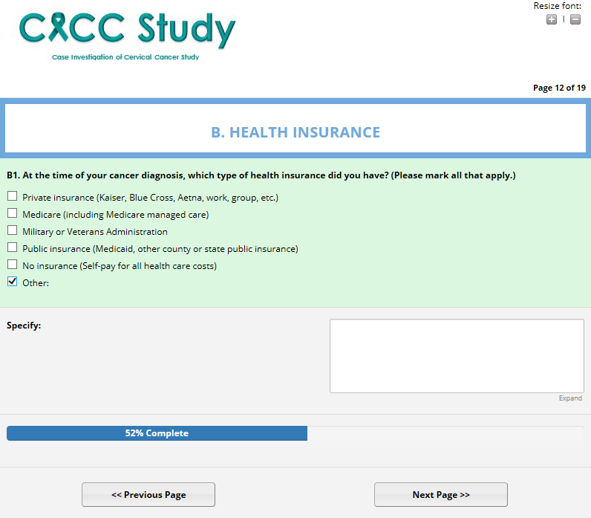

*Note: Question B1 response option “Other” is selected to show “Specify” text box.*

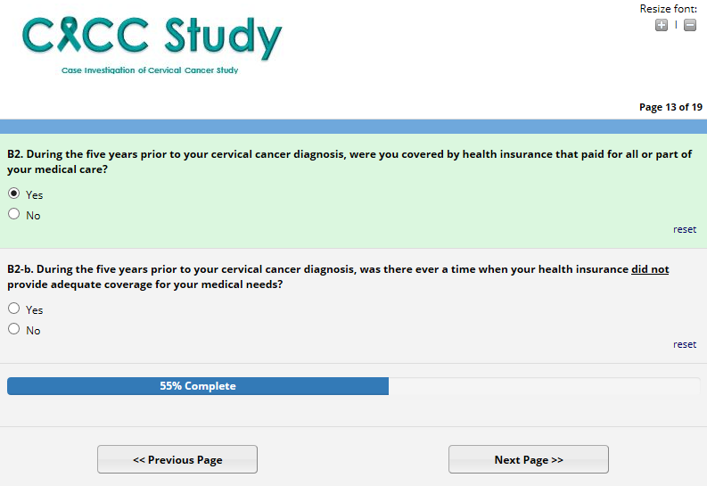

*Note: Question B2 response option “Yes” is selected to show question B2-b.*

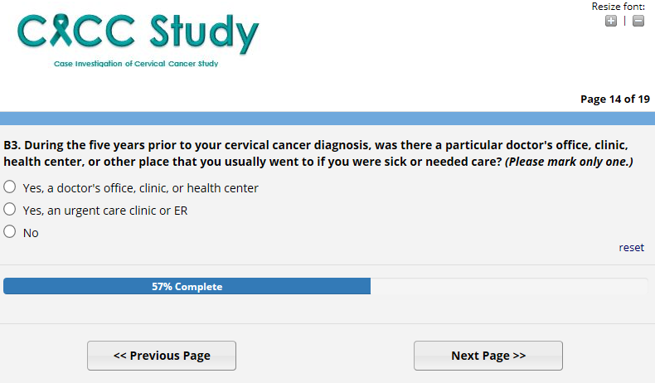

**Question C1, options “a” – “m”.**

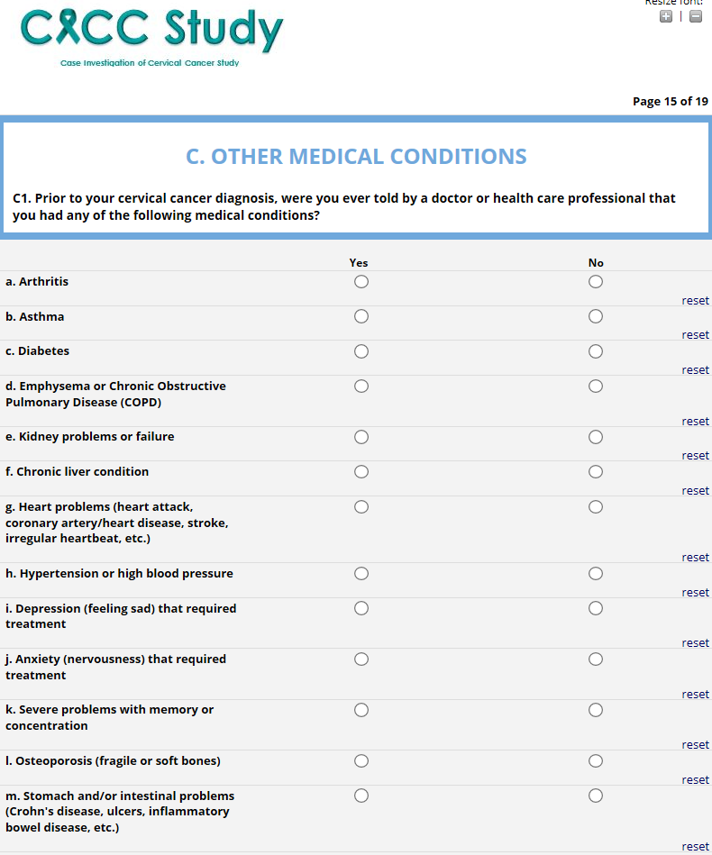

*(survey “Page 15 of 19” is continued on the next page)*

**Question C1 (continued)**

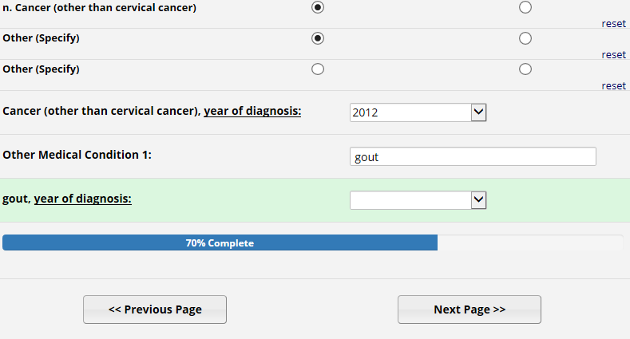

*Note: Options “n” and “Other” have example answers to display follow up response options.*

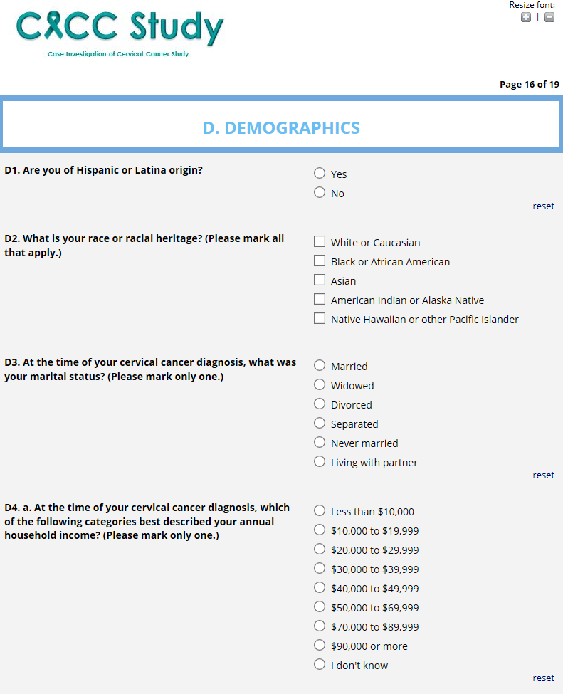

*(survey “Page 16 of 19” is continued on the next page)*

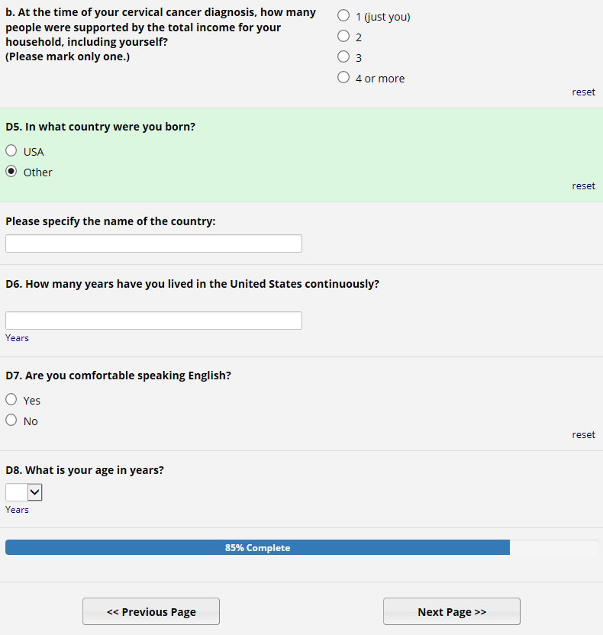

*Note: Question D5 response option “Other” is selected to display follow up questions.*

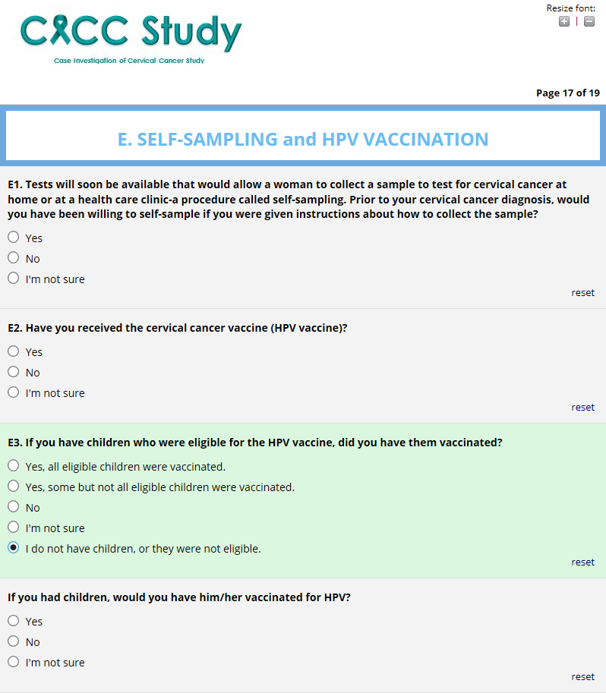

*Note: Question E3 response option “I do not have children…” is selected to display follow up question.*

*(survey “Page 17 of 19” is continued on the next page)*

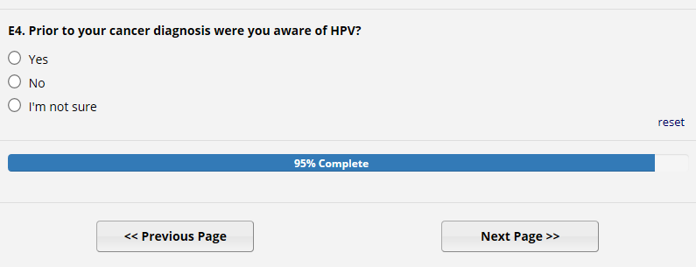

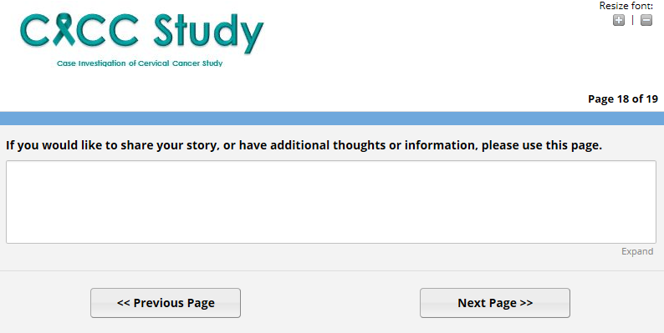

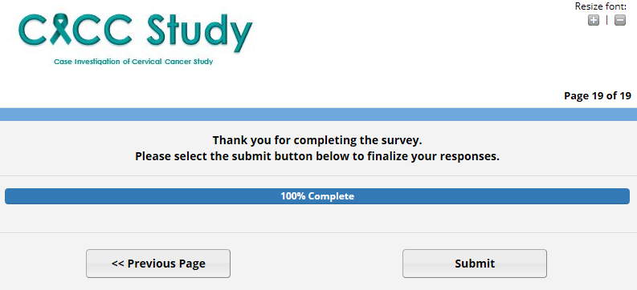

**Two new questions in the web-based survey**

This information is provided by the cancer registries for the other sample.

#1. On page 1 of 19 in the web-based survey:

*What was your age when you were told that you had cervical cancer? (years)*

#2. On page 16 of 19 in the web-based survey:

*What is your age in years?*