Attachment B: Questionnaires/Data Collection Instruments

Form Approved  
OMB No. 0935-XXXX  
Exp. Date XX/XX/20XX

The OMR data collection system is a web-based collection mechanism. The screenshots included in this document represent all sections that will be visible to registered users completing a Measure Profile and Sub-Element Profile. The Measure Profile has 12 sections and the Sub-Element Profile has 1 section.

**MEASURE PROFILE**

1)

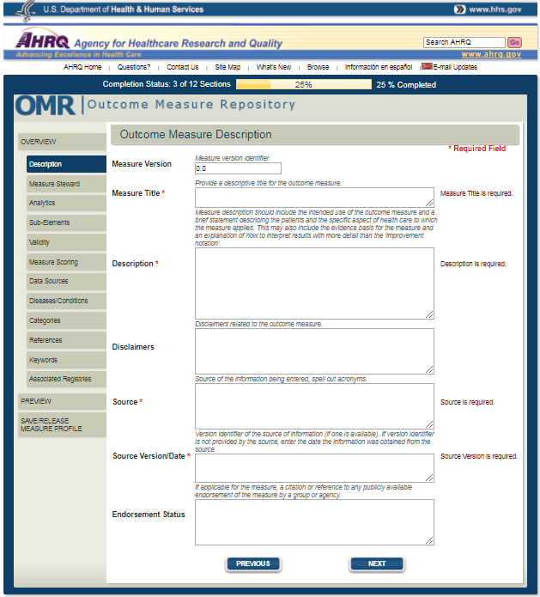

Public reporting burden for this collection of information is estimated to average 16 minutes per response, the estimated time required to complete the survey. An agency may not conduct or sponsor, and a person is not required to respond to, a collection of information unless it displays a currently valid OMB control number. Send comments regarding this burden estimate or any other aspect of this collection of information, including suggestions for reducing this burden, to: AHRQ Reports Clearance Officer Attention: PRA, Paperwork Reduction Project (0935-XXXX) AHRQ, 5600 Fishers Lane, # 07W41A, Rockville, MD 20857.

2)

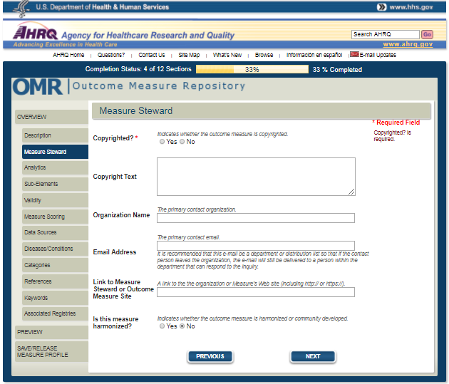

3)

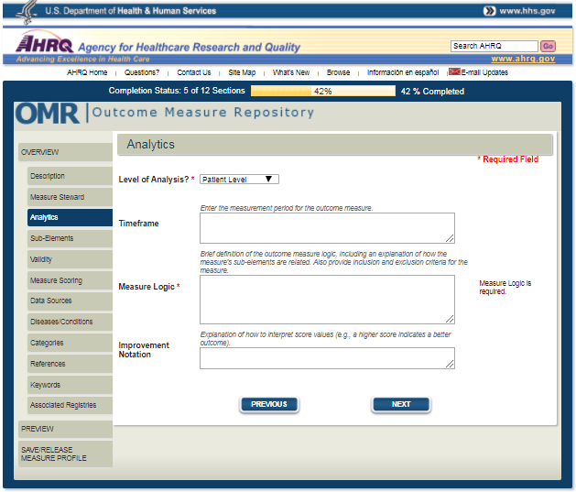

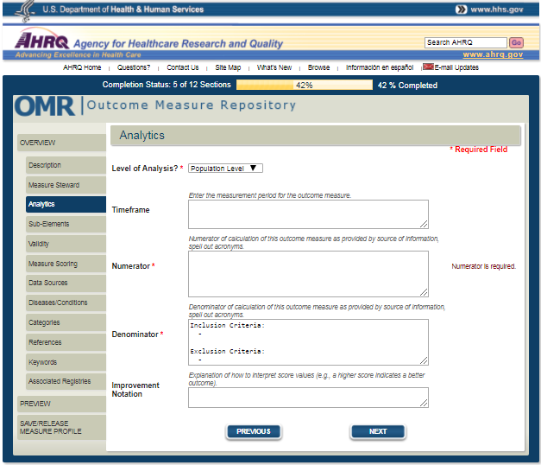

4)

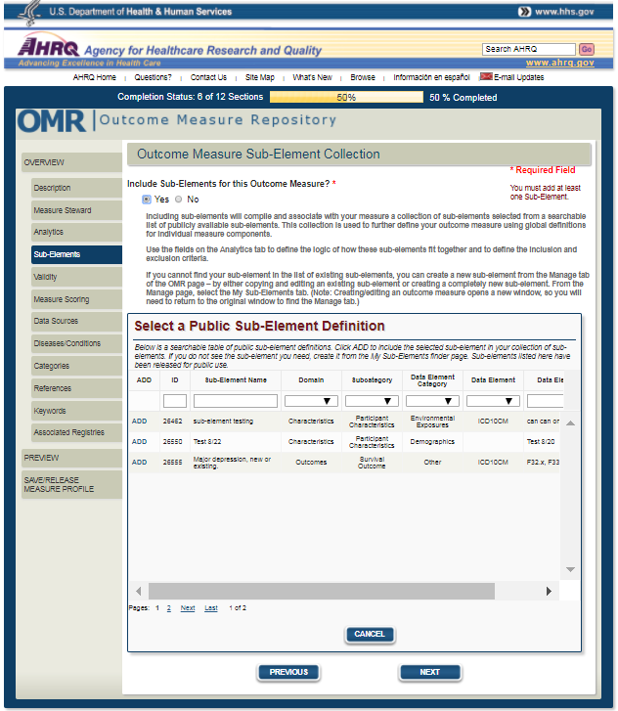

5)

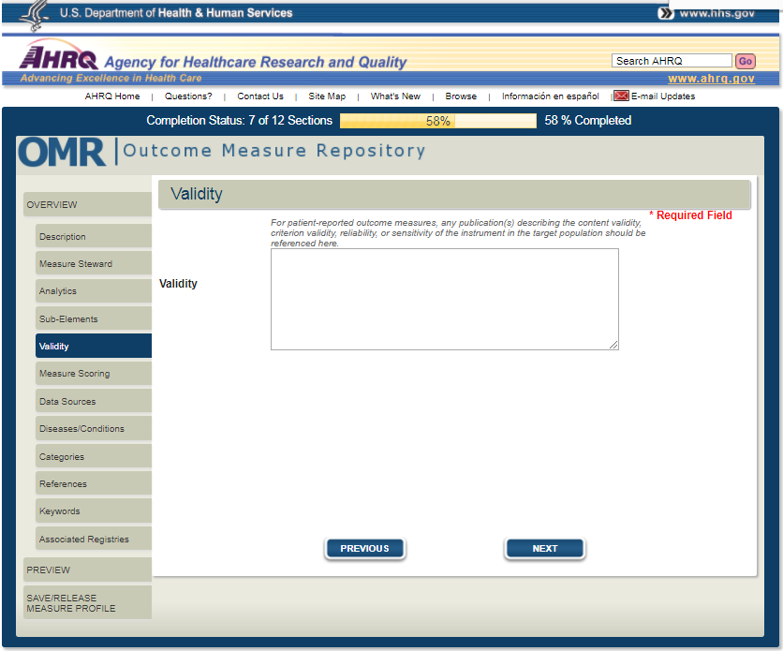

6)

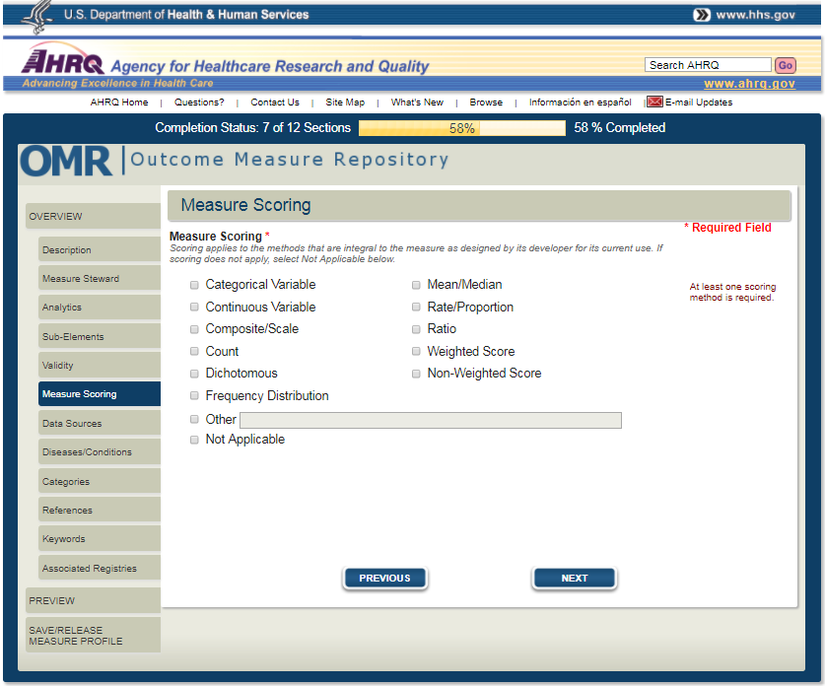

7)

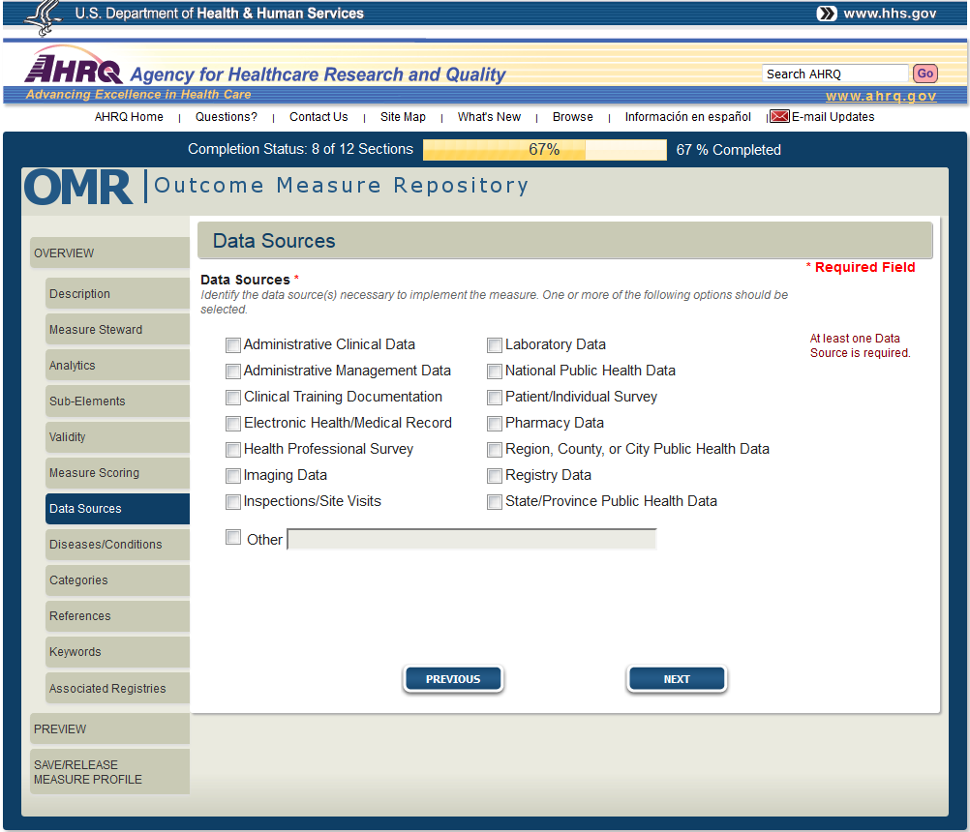

8)

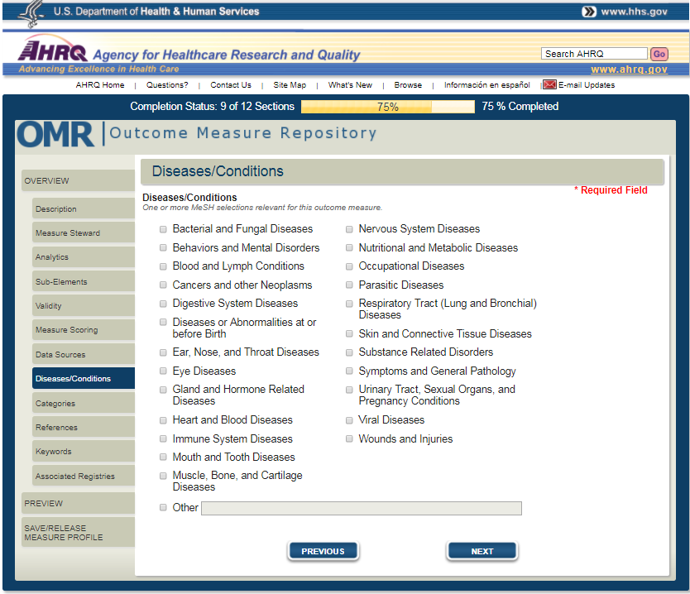

9)

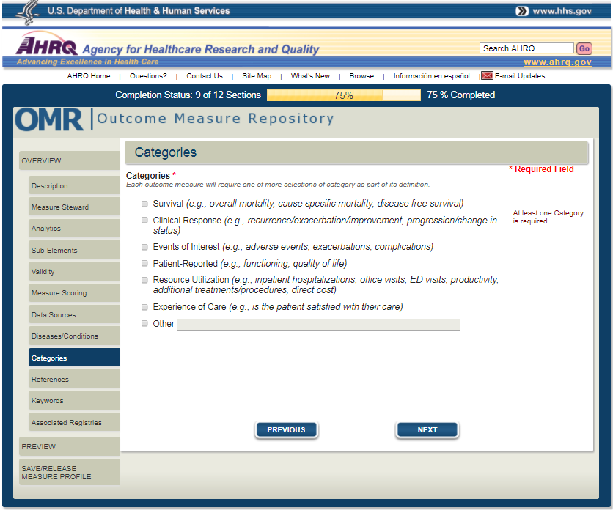

10)

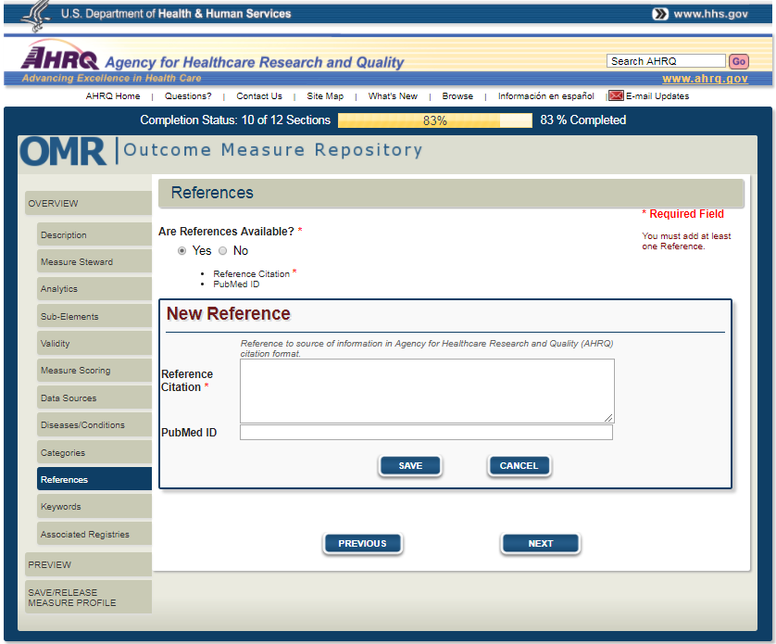

11)

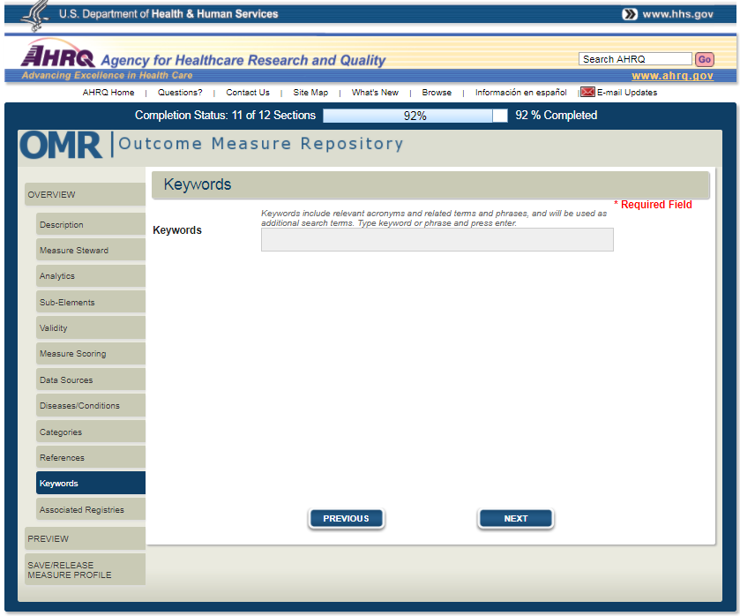

12)

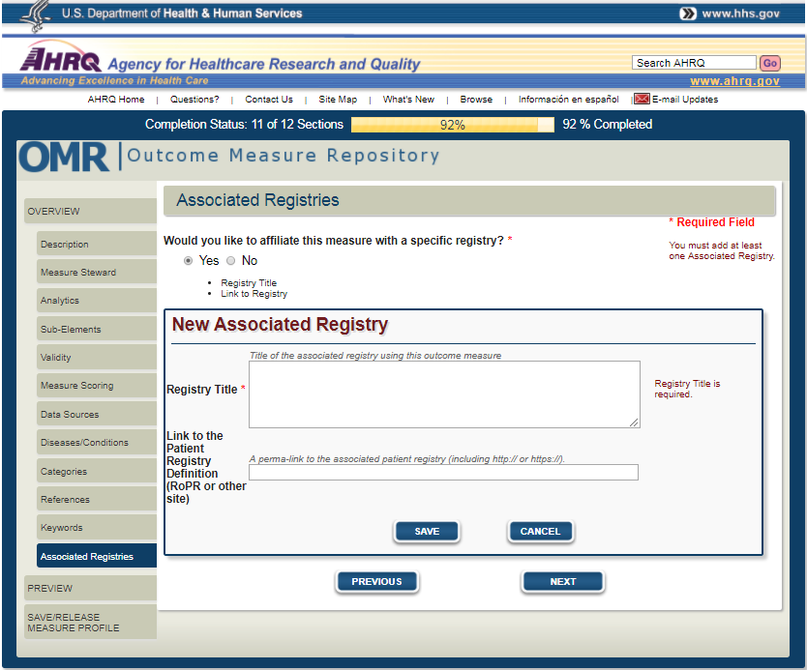

**SUB-ELEMENT PROFILE**

1)

