**Survey on Travel.state.gov**

*OMB Control No.: 1405-0193*

*EXPIRATION DATE: 4-30-2021*

*ESTIMATED BURDEN: 2 minutes*

*SV-2018-0002*

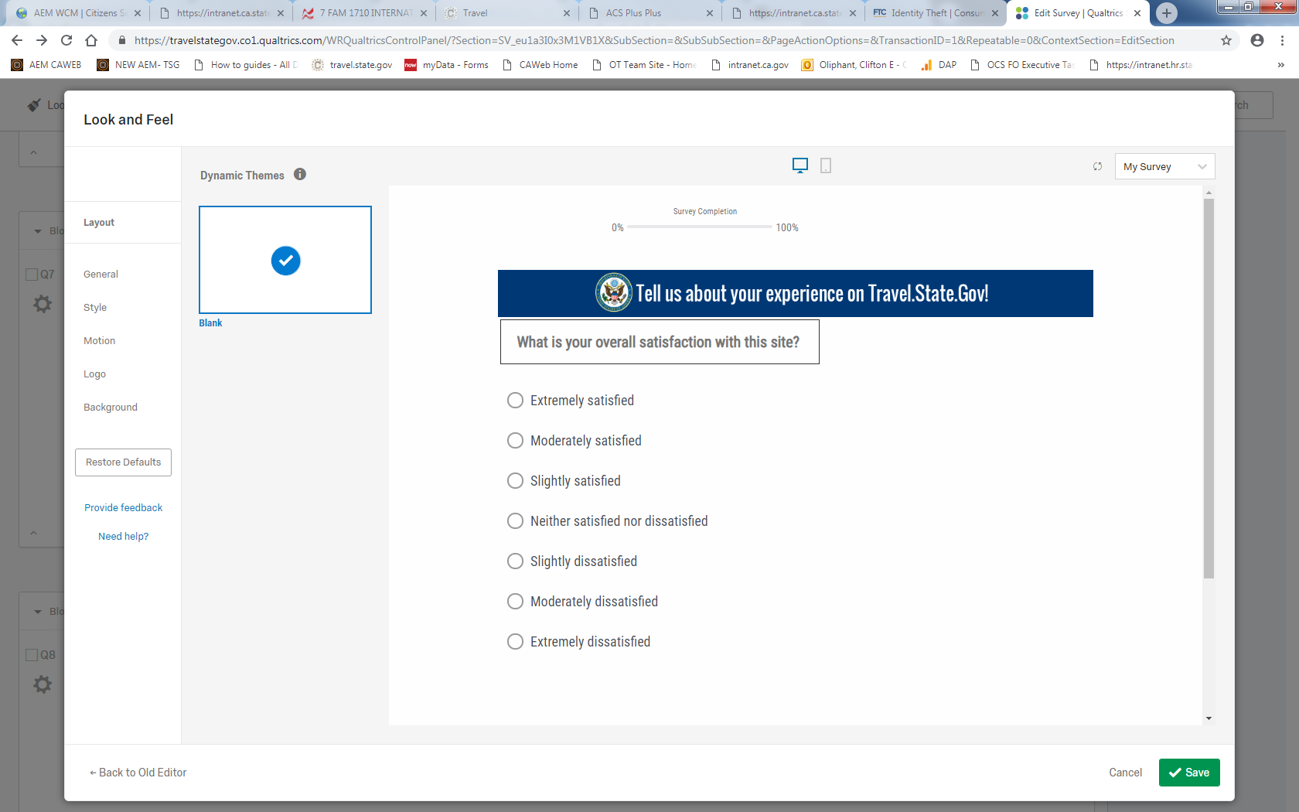

1. What is your overall satisfaction with the site?

□ Extremely satisfied

□ Somewhat satisfied

□ Neither satisfied nor dissatisfied

□ Somewhat dissatisfied

□ Extremely dissatisfied

1. How well does this site meet your expectations?

□ Far exceeds expectations

□ Exceeds expectations

□ Meets expectations

□ Short of expectations

□ Far short of expectations

1. Please rate the visual appeal of the site.

□ Excellent

□ Good

□ Average

□ Poor

□ Terrible

1. Please rate how well the site is organized.

□ Extremely well

□ Very well

□ Moderately well

□ Slightly well

1. How likely are you to use this site as your primary resource for information?

□ Extremely likely

□ Somewhat likely

□ Neither likely nor unlikely

□ Somewhat unlikely

□ Extremely unlikely

1. Please rate the usefulness of the search tool provided by this site.

□ Extremely useful

□ Somewhat useful

□ Neither useful nor useless

□ Somewhat useless

□ Extremely useless

1. Please rate the options available for navigating this site.

□ Excellent

□ Good

□ Average

1. How likely are you to return to this site?

□ Extremely likely

□ Somewhat likely

□ Neither likely nor unlikely

□ Somewhat unlikely

□ Extremely unlikely

1. What category best describes the area of the site you are visiting today?

□ Passports

□ General International Travel Information

□ Visas

□ Intercountry Adoptions

□ Child Abductions

□ Other legal issues

□ Other, please specify ________________

1. Were you able to find the information that you were seeking?

□ Yes

□ No

□ Other, please specify ________________

1. Please rate how clear you found the writing on this site.

□ 1 = Difficult to understand

□ 2

□ 3

□ 4

□ 5 Very clear and concise

□ Other, please specify ___

1. How can we improve travel.state.gov?
2. How can we make the navigation tabs or menus more useful to you?
3. How can we make the search feature more useful to you?
4. Please tell us more about what you had trouble doing or finding today?
5. If you could make one recommendation to the site, what would it be?
6. What international travel information were you looking for?

□ Learn about a country I will be traveling to or residing in as a U.S. Citizen

□ Learn about Travel Advisories

□ Get services for Americans abroad

□ Enroll travel plans with a U.S. Embassy or STEP (Smart Traveler Enrollment Program)

□ Locate/contact U.S. Embassy or Consulate abroad

□ Contact the Department of State

□ Find general information about international travel

□ Obtain statistics or reports

□ Other, please specify __________________

1. Are you aware of the Smart Traveler Enrollment Program (STEP)

□ Yes, I plan to enroll in STEP

□ Yes, I am currently enrolled in STEP

□ Yes, but I do not plan to enroll in STEP

□ No, I am not aware of STEP

1. What is your reason for visiting the International Parental Child Abduction section of the website?

□ Learn how to respond to a child abduction from the U.S. to another country

□ Get information about prevent international parental child abductions

□ Get information about other countries’ (non-U.S.) laws

□ Locate/contact U.S. Embassy or Consulate abroad

□ Obtain statistics or reports

□ Find general information about international parental child abduction

□ Other, please specify __________________

1. What is your reason for visiting the Intercountry Adoptions section of the website?

□ Obtain information about a country’s adoption laws and policies

□ Access Adoption Tracking Service

□ Submit complaint

□ Browse general intercountry adoption information

□ Learn about the eligibility requirements to become an adoptive parent

□ Learn about a specific country’s adoption process

□ Find adoption notices

□ Find adoption statistics or reports

□ Learn about how to get a U.S. Visa for your adopted child

□ Contact the Department of State, Office of Children’s Issues; Adoption Division,

□ Other, please specify __________________

1. Did you accomplish the goal of your visit?

□ Yes

□ No

□ Other, please specify ________________

1. Were you able to understand the visa process with the information provided on this site?

□ Yes

□ No

□ Other, please specify ___________

1. Is the Visa content organized in a logical manner?

□ Yes

□ No

□ Other, please specify ___________

1. Did you find the Visa information easy to understand?

□ Yes

□ No

□ Other, please specify ___________

1. Was there any missing Visa information?

□ Yes

□ No

□ Other, please specify ___________

1. Did you use our interactive features such as the “Visa Wizard” or the interview “Appointment Wait Time”?

□ Yes

□ No

□ Other, please specify ___________

1. If you could make one improvement to the visa pages on the site, what would it be and why?
2. Was this page helpful?

□Yes

□No (skip logic)

If No is selected – Skip to: The page was not helpful because it

29. The page was not helpful because it.

□ Has too little information

□ Has too much information

□ is confusing

□ Is out of date

30. Would you like to tell us more about how we can improve the page?

□Yes (skip logic)

□No

If Yes is selected – Skip to: Thank you! How can we make this page more helpful?

31. Thank you! How can we make this page more helpful?

Thank you for taking the time to complete this survey!

*Public reporting burden for this collection of information is estimated to average 2 minutes per response, including time required for searching existing data sources, gathering the necessary documentation, providing the information and/or documents required, and reviewing the final collection. You do not have to supply this information unless this collection displays a currently valid OMB control number. If you have comments on the accuracy of this burden estimate and/or recommendations for reducing it, please send them to* *TSG_Feedback@state.gov*