International Computer and Information Literacy Study (ICILS 2018) MAIN STUDY

OMB# 1850-0929 v.8

Appendix A

ICILS Main Study Recruitment and Consent Materials

Submitted by:

National Center for Education Statistics (NCES)
Institute of Education Sciences (IES)
U.S. Department of Education
Washington, DC

November 2017
revised April 2018

Contents
State ICILS Main Study Letter 3
School District ICILS Main Study Letter [First Tier/Second Tier] 4
School ICILS Main Study Letter [First Tier/Second Tier] 5
Teacher Questionnaire ICILS Main Study Letter [First Tier/Second Tier] 7
ICILS Main Study Brochure Content: 8 ½ X 11in Tri-fold 8
ICILS Main Study FAQ 10
Summary of School Activities: ICILS 2018 Main Study 12
ICILS Main Study Sample Notification Letter 13
ICILS Main Study Sample Implicit Consent Letter 14
ICILS Main Study Implicit Consent Form: 15
ICILS Main Study Sample Explicit Consent Letter 16
ICILS Main Study Explicit Consent Form 17
ICILS Facts for Parents about the Main Study 18
MyICILS Login Page 19
Email to Principal or SC for MyICILS Registration and PSI Completion 21
MyICILS Provide School Information Page 23
Email to School Coordinator to Submit Student and Teacher Lists for Main Study 24
Instructions for Submitting Student List for the Main Study 25
Instructions for Submitting Teacher List for the Main Study 29
School Principal Questionnaire Login Card 31
ICT (Information and Communications Technology) Coordinator Questionnaire Login Card 32
Teacher Questionnaire Login Card 33
Online Questionnaire Login Screen Text 34
Student Appointment Card for ICILS 2018 MS 35
Second Tier School ICILS Main Study Recruitment Letter (to participating schools with no follow-through/to non-participating schools with no final refusal) 37

State ICILS Main Study Letter
[Date]

[Title] [Name First] [Name Last]
[Department]
[State Agency Name]
[Address 1]
[City], [State] [Zip code]

Dear [Title] [Name Last]:

The United States is participating in an important international study in 2018: the International Computer and Information Literacy Study (ICILS). ICILS provides a unique opportunity to compare U.S. eighth-grade students’ computer and information literacy skills and access to and use of technology with that of their peers in countries around the world. ICILS was developed internationally as a response to the increasing use of information and communication technology (ICT) in modern society and the need for citizens to develop relevant skills in order to participate effectively in the digital age. ICILS was first administered internationally in 2013 in 21 education systems and will be administered again in 2018. Results from ICILS are used by researchers and policymakers to chart national progress against international standards and other countries around the world, informing national discussions about international competitiveness.

Some schools in your state have been randomly selected to participate in ICILS in spring 2018. I am writing to ask your agency to support the participation of those selected schools.

ICILS is described in more detail in the enclosed materials. In the United States, ICILS is conducted by the National Center for Education Statistics (NCES), part of the U.S. Department of Education, and the data are being collected by Westat. The U.S. Office of Management and Budget has approved the data collection under OMB# 1850-0929. For information on the confidentiality of the data collected, please see the enclosed FAQ. While participation in this study is voluntary, your support of school participation in your state is invaluable so that the United States has a representative sample of schools across the country.

We are in contact with your state assessment director and NAEP State Coordinator to keep them informed about ICILS, and how ICILS fits in with other national data collections conducted by NCES. We also coordinate the administration of ICILS with NAEP and other NCES activities. If you have questions about the study, please do not hesitate to call [Contact Name] at [Contact Phone Number] or send an email to [Contact Email]. You may also get more information about this study by contacting Lydia Malley at NCES at 202-245-7266 or Lydia.malley@ed.gov, or by visiting the ICILS website at https://nces.ed.gov/surveys/icils.

Thank you for your time and support of this important international study.

Sincerely,

Peggy G. Carr, Ph.D.
Acting Commissioner, NCES

cc: [State assessment director]
[NAEP State Coordinator]

Enclosures
NCES is authorized to conduct this study under the Education Sciences Reform Act of 2002 (ESRA 2002, 20 U.S.C. §9543). By law, the data provided by your schools, staff, and students may only be used for statistical purposes and may not be disclosed, or used, in identifiable form for any other purpose except as required by law (20 U.S.C. §9573 and 6 U.S.C. §151).

School District ICILS Main Study Letter [First Tier/Second Tier]
[Date]

[Title] [Name First] [Name Last]
[Department]
[School District]
[Address 1]
[City], [State] [Zip code]

Dear [Title] [Name Last]:

I am writing to notify you that [number] schools in your district have been randomly selected to participate in an important international study in 2018: the International Computer and Information Literacy Study (ICILS). ICILS provides a unique opportunity to compare U.S. eighth-grade students’ computer and information literacy skills and access to and use of technology with that of their peers in countries around the world. ICILS was developed internationally as a response to the increasing use of information and communication technology (ICT) in modern society and the need for citizens to develop relevant skills in order to participate effectively in the digital age. ICILS was first administered internationally in 2013 in 21 education systems and will be administered again in 2018. Results from ICILS are used by researchers and policymakers to chart national progress against international standards and other countries around the world, informing national discussions about international competitiveness.

[Selected schools are notified in advance so that principals can place the assessment date on their calendars and incorporate ICILS into the planned school program. I am writing to ask your district to support the participation of those selected schools. Participating schools will receive $200, and each school’s ICILS school coordinator (the school staff person designated to work with ICILS staff) will receive $100 as a thank you for his or her time and effort./Selected schools are notified so that principals can place the assessment date on their calendars. I am writing to ask your district to support the participation of those selected schools. We understand that we are asking schools to participate in ICILS late in the school year when schedules are tight, and therefore are offering each school $800 as a thank you for participation. In addition, each school’s ICILS school coordinator (the school staff person designated to work with ICILS staff) will receive $100 as a thank you for his or her time and effort.] A school administrator and selected teachers will each be asked to complete a questionnaire. Teachers will receive [$20/$40] as a thank you for completing the questionnaire. Each student who participates will receive a small gift as a token of appreciation.

ICILS is described in more detail in the enclosed materials. In the United States, ICILS is conducted by the National Center for Education Statistics (NCES), part of the U.S. Department of Education, and the data are being collected by Westat. The U.S. Office of Management and Budget has approved the data collection under OMB# 1850-0929. For information on the confidentiality of the data collected, please see the enclosed FAQ. While participation in this study is voluntary, your support of school participation in your district is invaluable so that the United States has a representative sample of schools across the country. The schools will be contacted soon with more information about the assessment.

The list of selected schools in your district is attached. Please include the ICILS assessment window (XX to XX 2018) on your district test calendar. [Name], our NAEP State Coordinator, will contact your staff with additional information.

If you have questions about the study, please do not hesitate to call [Contact Name] at [Contact Phone Number] or send an email to [Contact Email]. You may also get more information about this study by contacting Lydia Malley at NCES at 202-245-7266 or Lydia.malley@ed.gov, or by visiting the ICILS website at https://nces.ed.gov/surveys/icils.

I know that I can count on you to help accomplish our goal of 100 percent participation. Thank you for your time and support of this important international study.

[Name of Chief State School Officer]
Enclosures
CC: [State Testing Director], [District Test Coordinator], [NAEP State Coordinator]

NCES is authorized to conduct this study under the Education Sciences Reform Act of 2002 (ESRA 2002, 20 U.S.C. §9543). By law, the data provided by your schools, staff, and students may only be used for statistical purposes and may not be disclosed, or used, in identifiable form for any other purpose except as required by law (20 U.S.C. §9573 and 6 U.S.C. §151).

School ICILS Main Study Letter [First Tier/Second Tier]

[Date]

[Title] [Name First] [Name Last]
[Department]
[School Name]
[Address 1]
[City], [State] [Zip code]

Dear [Title] [Name Last]:

[Your school has been randomly selected to represent schools across the United States by participating in an important international study in 2018: the International Computer and Information Literacy Study (ICILS). ICILS provides a unique opportunity to compare U.S. eighth-grade students’ computer and information literacy skills and access to and use of technology with that of their peers in countries around the world. ICILS was developed internationally as a response to the increasing use of information and communication technology (ICT) in modern society and the need for citizens to develop relevant skills in order to participate effectively in the digital age. ICILS was first administered internationally in 2013 in 21 education systems and will be administered again in 2018. Results from ICILS are used by researchers and policymakers to chart national progress against international standards and other countries around the world, informing national discussions about international competitiveness.]

[The United States is seeking to learn more about how digital technology is impacting teaching and learning around the world, especially for U.S. students and teachers, by participating in the International Computer and Information Literacy Study (ICILS) 2018. However, we will not be able to understand and compare the experience and skills of U.S. students without a sample of schools that represents the full spectrum of American students and teachers.
Currently, we do not have a sufficient number of schools like yours participating in this study to give us an accurate picture of American students and teachers experience and skills. It is very late in the school year and the ICILS data collection ends on May 25, 2018, but as the ICILS Project Director, conducting this study on behalf of the National Center for Education Statistics (NCES), I wish to personally ask you to consider joining this study because your school would represent hundreds of schools across the country similar to yours.
If you can help us secure a fully representative sample, we are offering a special indication of appreciation for your school’s time. If you participate, we will give your school $800. Students who take ICILS will receive a small gift to thank them for their participation. Your school’s ICILS school coordinator (the school staff person designated to work with ICILS staff) will receive $100 as a thank you for his or her time and effort. Selected teachers will receive $40 for completing a brief questionnaire about themselves.]
NCES recognizes the burden of assessments on schools and works to reduce that burden as much as possible both in terms of time and resources. Under contract to NCES, Westat is responsible for all aspects of the assessment administration and will work with you to make ICILS a success in your school. ICILS will sample 30 eighth-graders from your school to participate in ICILS, and 20 eighth-grade teachers. A school administrator will also be asked to complete a questionnaire.
[As a token of appreciation for participating in ICILS, your school will receive $200. Students who take ICILS will receive a small gift to thank them for their participation. Your school’s ICILS school coordinator (the school staff person designated to work with ICILS staff) will receive $100 as a thank you for his or her time and effort. Selected teachers will receive $20 for completing a brief questionnaire about themselves.]

ICILS is described in more detail in the enclosed materials. In the United States, ICILS is conducted by the National Center for Education Statistics (NCES), part of the U.S. Department of Education, and the data are being collected by Westat. The U.S. Office of Management and Budget has approved the data collection under OMB# 1850-0929. For information on the confidentiality of the data collected, please see the enclosed FAQ. While participation in this study is voluntary, your school’s participation is invaluable so that the United States has a representative sample of schools across the country.

[The assessment window is March 5 to May 25, 2018. Within the next few weeks I will send you an assessment date. Should there be a conflict on this date, an ICILS representative will work with you to identify an alternative time. Please put this date on your 2017-2018 school calendar. In [MONTH], I will send you detailed information about the assessment and will ask you to identify a school coordinator. ICILS representatives will provide significant support to schools, bring all necessary materials, including [computers/tablets] and all equipment, and administer the assessment.

If you have questions, please do not hesitate to call [Contact Name] at [Contact Phone Number] or send an email to [Contact Email]. Further information about ICILS may be found by visiting the ICILS website at https://nces.ed.gov/surveys/icils.]

[The ICILS data collection has already begun, and will end on May 25, 2018, so a representative of ICILS at Westat will be calling you soon to discuss your decision. I am also available directly by phone at 240-314-2492, and by email at ChrisAverett@westat.com. Furthermore, you may get more information about this study by contacting Lydia Malley at NCES at 202-245-7266 or lydia.malley@ed.gov, or by visiting the ICILS website at https://nces.ed.gov/surveys/icils.]

Your participation in ICILS 2018 is very important to its success. Thank you for your time and for supporting this important international study.

[Name of State Coordinator
NAEP State Coordinator]
[Chris Averett
Project Director, ICILS in the United States]

Enclosures

NCES is authorized to conduct this study under the Education Sciences Reform Act of 2002 (ESRA 2002, 20 U.S.C. §9543). By law, the data provided by your school, staff, and students may only be used for statistical purposes and may not be disclosed, or used, in identifiable form for any other purpose except as required by law (20 U.S.C. §9573 and 6 U.S.C. §151).

Teacher Questionnaire ICILS Main Study Letter [First Tier/Second Tier]

[Date] Web Address:
[Title] [Name First] [Name Last] Your Study ID:
[Teacher] Your Password:
[School]
[Address 1]
[City], [State] [Zip code]

Dear [Title] [Name Last]:

[School Name] is participating in an important international study in 2018: the International Computer and Information Literacy Study (ICILS). ICILS provides a unique opportunity to compare U.S. eighth-grade students’ computer and information literacy skills and access to and use of technology with that of their peers in countries around the world. ICILS was developed internationally as a response to the increasing use of information and communication technology (ICT) in modern society and the need for citizens to develop relevant skills in order to participate effectively in the digital age. ICILS was first administered internationally in 2013 in 21 education systems and will be administered again in 2018. The United States will participate for the first time in the spring of 2018. Results from ICILS are used by researchers and policymakers to chart national progress against international standards and other countries around the world, informing national discussions about international competitiveness.

We are asking you to complete a 30-minute questionnaire to provide insight into school and classroom contexts for information and communication technology learning, use of information and communication technology for teaching and learning, and teacher views on and confidence in using computers. You may complete the questionnaire by hardcopy or online using a secure website. To access the questionnaire online, please use the web address and unique study ID and password provided on this letter. [You will receive a $20/Since we understand that we are asking you to participate in ICILS late in the school year when schedules are tight, we are offering you a $40] Amazon gift card upon completing the questionnaire as a token of our appreciation.

In the United States, ICILS is conducted by the National Center for Education Statistics (NCES), part of the U.S. Department of Education, and the data are being collected by Westat. The U.S. Office of Management and Budget has approved the data collection under OMB# 1850-0929. For information on the confidentiality of the data collected, please see the enclosed FAQ. While participation in this questionnaire is voluntary, your participation is invaluable.

If you have any questions, please do not hesitate to call [Contact Name] at [Contact Phone Number] or send an email to [Contact Email]. You may also get more information about this study by visiting the ICILS website at https://nces.ed.gov/surveys/icils. If you have questions about your rights as a study participant, you may call NCES at 202-245-7266.

Your participation in the teacher questionnaire for ICILS 2018 is very important to its success. Thank you for your time and for supporting this important international study.

Peggy G. Carr, Ph.D.
Acting Commissioner, NCES

Enclosures
NCES is authorized to conduct this study under the Education Sciences Reform Act of 2002 (ESRA 2002, 20 U.S.C. §9543). By law, the data provided by your school, staff, and students may only be used for statistical purposes and may not be disclosed, or used, in identifiable form for any other purpose except as required by law (20 U.S.C. §9573 and 6 U.S.C. §151).

ICILS Main Study Brochure Content: 8 ½ X 11in Tri-fold

Title page:

ICILS USA Logo
Map of world
International Computer and Information Literacy Study (ICILS) 2018

Inside panels:

What is ICILS?
The International Computer and Information Literacy Study (ICILS) is an international assessment and research project designed to measure computer and information literacy achievement at the eighth grade, as well as school and teacher practices related to instruction. ICILS provides a unique opportunity to compare U.S. eighth-grade students’ computer and information literacy skills and access to and use of technology with that of their peers in countries around the world. ICILS was developed internationally as a response to the increasing use of information and communication technology (ICT) in modern society and the need for citizens to develop relevant skills in order to participate effectively in the digital age. ICILS was first administered internationally in 2013 in 21 education systems and will be administered again in 2018. The United States will participate for the first time in the spring of 2018. In 2018, ICILS will involve students from more than xx countries.

ICILS is sponsored by the International Association for the Evaluation of Educational Achievement (IEA) and conducted in the United States by the National Center for Education Statistics (NCES), part of the U.S. Department of Education.

Why is ICILS important?
ICILS provides a unique opportunity to compare the computer and information literacy of U.S. eighth-grade students with that of their peers in countries around the world. ICILS complements what we learn from national assessments by identifying the strengths and weaknesses of student performance relative to students around the world. The results inform national discussions about education as well as international competitiveness.

ICILS provides valuable benchmark information on how U.S. students compare to students around the world, allows educators and policymakers to examine other education systems for practices that could have application to the United States, and contributes to ongoing discussions of ways to improve the quality of education of all students.

What type of assessment is ICILS?
ICILS is developed through an international collaborative process involving input from U.S. and international experts in computer and information literacy and measurement. In a final step, the assessment is endorsed as suitable by all participating countries. The assessment contains a mix of interactive computer tasks. Examples of released ICILS items are available at http://www.iea.nl/icils_2013.html.

Key findings from ICILS 2013
At grade 8, the use of information and communication technology (ICT) in schools was limited in participating countries. Teachers tend to use ICT in teaching when they are confident in these skills. Less than 50 percent of teachers consider themselves self-sufficient when it comes to using computers for more complex tasks, such as installing software and collaborating with others using shared resources. 46 percent of teachers acquire ICT skills by observing other teachers using ICT in teaching. Although students have grown up in the digital age, it does not necessarily imply that they are digital natives. In all the participating countries, on average 17 percent of the students did not achieve at Level 1. On average, only 2 percent of the students achieved at Level 4 with a maximum of 5 percent in Korea. On average, 94 percent of students used computers for more than 7 years. However, 87 percent of students stated that they used a computer once a week at home, with only 54 percent reporting the same frequency of computer usage at school.
SOURCE: Fraillon, J., Ainley, J., Schulz, W., Friedman, T., & Gebhardt, E. (2014). Preparing for life in a digital age: The IEA International Computer and Information Literacy Study international report. Cham: Springer.

Back panels:

Countries participating in ICILS 2018

[TBD]

NCES is authorized to conduct ICILS under the Education Sciences Reform Act of 2002 (ESRA 2002, 20 U.S.C. §9543). Information collected will help the U.S. Department of Education’s ongoing efforts to benchmark student achievement in the United States. Participation is voluntary. By law, data collected may be used only for statistical purposes and may not be disclosed, or used, in identifiable form for any other purpose except as required by law (20 U.S.C. §9573 and 6 U.S.C. §151). The U.S. Office of Management and Budget has approved the data collection under OMB# 1850-0929. Individual responses will be combined with those from other participants to produce summary statistics and reports.

ICILS USA logo
IES / NCES logo

For questions about ICILS 2018, contact the ICILS Information Hotline at [Contact Phone Number] or by email at [Contact Email].

ICILS Main Study FAQ
International Computer and Information Literacy
Frequently Asked Questions

What is ICILS?
The International Computer and Information Literacy Study (ICILS) is an international assessment and research project designed to measure trends in computer and information literacy at the eighth-grade level as well as school and teacher practices related to instruction. ICILS provides a unique opportunity to compare U.S. eighth-grade students’ computer and information literacy skills and access to and use of technology with that of their peers in countries around the world. ICILS was developed internationally as a response to the increasing use of information and communication technology (ICT) in modern society and the need for citizens to develop relevant skills in order to participate effectively in the digital age. ICILS was first administered internationally in 2013 in 21 education systems. ICILS 2018, the second study in the series, will involve students from more than xx countries. The United States will participate for the first time in the spring of 2018.

Why was my school selected for participation?
Schools of varying demographics and locations were randomly selected so that the overall U.S. sample is representative of the overall U.S. school population. The random selection process is important for ensuring that a country’s sample accurately reflects its schools and, therefore, can be compared fairly with samples of schools from other countries.
Will all our eighth-grade students be asked to participate?
No. Only up to 30 randomly selected students will be asked to participate.
Who conducts the ICILS assessment?
The entire assessment process will be carried out by trained staff from Westat, a research organization under contract with the National Center for Education Statistics (NCES) in the U.S. Department of Education. NCES is authorized to conduct this study under the Education Sciences Reform Act of 2002 (ESRA 2002, 20 U.S.C. §9543) and approval of the U.S. Office of Management and Budget under OMB# 1850-0929.
How are the teacher and school questionnaires administered?
The teacher and school questionnaires are administered either online from a secure website or via a hardcopy form. Teacher questionnaires take about 30 minutes to complete and ask teachers questions about school and classroom contexts for information and communication technology learning, use of information and communication technology for teaching and learning, and teacher views on and confidence in using computers. The school questionnaire takes about 20 minutes to complete and asks about perceptions of information and communication technologies use for teaching and learning at the school.
Do teachers need to help administer the assessment?
No, Westat field staff will visit the school on the day of the assessment, bringing with them all the materials required. These field staff will administer the assessments to students.
When will the assessment be conducted?
The assessment will be conducted between March and May, 2018. Westat will work with schools to identify an assessment date convenient for the school in that time period.
Where will the assessment be conducted?
The assessment will be conducted in the schools that are selected to participate.
How long does the assessment take?
The main assessment session is approximately 3 hours, including time for directions.
What will happen with the collected data?
The data from the assessment will be used to evaluate how the knowledge and skills of U.S. students compare to those of their peers in other participating countries. By law, the data provided by schools, staff, and students may be used only for statistical purposes and may not be disclosed or used, in identifiable form for any other purpose except as required by law (20 U.S.C. §9573 and 6 U.S.C. §151). Reports of the findings from the assessment will not identify participating districts, schools, students, or individual staff. Individual responses will be combined with those of other participants to produce summary statistics and reports.
Are schools required by federal law to participate?
No. School participation is voluntary. However, we hope you will participate in this study so that students like those in your school are accurately and fairly represented.
What are the benefits?
The nation as a whole benefits from ICILS by having a greater understanding of how the computer and information literacy knowledge and skills of U.S. 8th graders compare with 8th graders from other countries. To thank participating schools and individuals for their time and effort we offer tokens of appreciation: schools that participate in ICILS will receive $200 and the school coordinator (staff person designated to assist with the study) will receive $100. Teachers who complete a survey will receive $20, and each student who participates will receive a small gift.
Where can I find more information about ICILS?
Visit the ICILS website at https://nces.ed.gov/surveys/icils.

For additional information about ICILS 2018, contact the ICILS U.S. home office at [Contact Phone Number] or by email at [Contact Email].

Summary of School Activities: ICILS 2018 Main Study
Summary of School Activities: ICILS 2018 Main Study
 | October-December 2017 | January-February 2018  Prior to assessment day | March-May 2018  Assessment day | Benefits
Principal | - Designate a school coordinator | - Complete a brief School Questionnaire on the characteristics of the school, its enrollment, resources, policies, and learning environment (available online or hardcopy)  - Share the importance of participation in the study with school staff | - Support assessment day activities  - Encourage students to participate and do their best on the assessment | - Represent other similar U.S. schools  - Receive a $200 check for the school
School coordinator | - Select an assessment date convenient for your school | - Arrange the day and location for the ICILS.  - Confirm dates and location with ICILS assessment staff  - Provide teacher lists, student lists, and contact information for grade 8 students  - Notify selected teachers, selected students, and students’ parents of the study and benefit of participating  - Work with assessment staff to identify students with special needs  - Coordinate the principal’s completion of the School Questionnaire (online or hardcopy)  - Coordinate the teacher’s completion of the Teacher Questionnaire (online or hardcopy)  - Collect parental consent forms where required and submit to ICILS staff | - Confirm space for assessment is problem-free  - Collect complete School and Teacher Questionnaires (if not completed online) and give to assessment staff  - Ensure all sampled students attend the assessment session  - Meet with assessment staff and provide feedback about the assessment process | - Receive a $100 check
Selected Teachers |  | - Complete Teacher Questionnaire online (paper versions will be available on assessment day) |  | - Receive a $20 Amazon gift card  - Represent the United States in preparations for the international study
Selected Students |  |  | - Attend the assessment session, complete the assessment and Student Questionnaire | - Receive a small thank-you gift  - Represent the United States in preparations for the international study
Westat assessment staff | - Work with the school to set an assessment date  - Help school coordinator with assessment details and logistics  - Protect school and student confidentiality | - Call the school coordinator to discuss assessment day location(s) and student participation  - Select student sample and notify school of selected students  - Provide School and Teacher Questionnaires to the school coordinator for distribution | - Administer assessment from start to finish  - Furnish all the assessment materials, pencils, and test booklets  - Administer a brief debriefing interview with the school coordinator at the end of the assessment  - Maintain security of all materials | - Ensure quality and uniformity of data collected across the United States
For additional information, go to https://nces.ed.gov/surveys/icils.

ICILS Main Study Sample Notification Letter
SCHOOL LETTERHEAD
Dear Parent or Guardian,
This letter is to inform you about an important international study of student learning being conducted in our school this spring. The International Computer and Information Literacy Study (ICILS) provides a unique opportunity to compare U.S. eighth-grade students’ computer and information literacy skills and access to and use of technology with that of their peers in countries around the world. ICILS was developed internationally as a response to the increasing use of information and communication technology (ICT) in modern society and the need for citizens to develop relevant skills in order to participate effectively in the digital age. ICILS was first administered internationally in 2013 in 21 education systems and will be administered again in 2018. The United States will participate for the first time in the spring of 2018.
Our school has accepted an invitation from the National Center for Education Statistics (NCES), part of the U.S. Department of Education, to participate in the ICILS main study. Thirty of our 8th grade students will take part. The enclosed summary sheet provides some background information about ICILS, explains what is involved for each student selected to participate in the study, and gives a contact phone number and email address where you can find answers to any questions you might have.
To have an accurate picture of U.S. 8th graders’ computer and information literacy, it is important that each student selected takes part in the study. In addition to answering computer and information literacy questions, students will be asked to complete a brief questionnaire about themselves. Although participation in this study is entirely voluntary, I urge you to support this effort by encouraging your child to take part. Previous experience suggests that students actually enjoy taking part, and participating students will receive a small gift, which we think they will like.
All of the information collected is safeguarded, as required by law. NCES is authorized to conduct this study under the Education Sciences Reform Act of 2002 (ESRA 2002, 20 U.S.C. §9543). Under that law, the data provided by schools, staff, and students may be used only for statistical purposes and may not be disclosed, or used, in identifiable form for any other purpose except as required by law (20 U.S.C. §9573 and 6 U.S.C. §151). Students and schools are never identified in any reports. All reported statistics refer to the United States as a whole.

Thank you for taking the time to learn about this important study.

Sincerely,

[School official]

Enclosures:
Facts for Parents about the ICILS Main Study

ICILS Main Study Sample Implicit Consent Letter
SCHOOL LETTERHEAD
Dear Parent or Guardian,
This letter is to inform you about an important international study of student learning being conducted in our school this spring. The International Computer and Information Literacy Study (ICILS) provides a unique opportunity to compare U.S. eighth-grade students’ computer and information literacy skills and access to and use of technology with that of their peers in countries around the world. ICILS was developed internationally as a response to the increasing use of information and communication technology (ICT) in modern society and the need for citizens to develop relevant skills in order to participate effectively in the digital age. ICILS was first administered internationally in 2013 in 21 education systems and will be administered again in 2018. The United States will participate for the first time in the spring of 2018.
Our school has accepted an invitation from the National Center for Education Statistics (NCES), part of the U.S. Department of Education, to participate in the ICILS main study. Thirty of our 8th grade students will take part. The enclosed summary sheet provides some background information about ICILS, explains what is involved for each student selected to participate in the study, and gives a contact phone number and email address where you can find answers to any questions you might have.
To have an accurate picture of U.S. 8th graders’ computer and information literacy, it is important that each student selected takes part in the study. In addition to answering computer and information literacy questions, students will be asked to complete a brief questionnaire about themselves. Although participation in this study is entirely voluntary, I urge you to support this effort by encouraging your child to take part. Previous experience suggests that students actually enjoy taking part, and participating students will receive a small gift, which we think they will like.
All of the information collected is safeguarded, as required by law. NCES is authorized to conduct this study under the Education Sciences Reform Act of 2002 (ESRA 2002, 20 U.S.C. §9543). Under that law, the data provided by schools, staff, and students may be used only for statistical purposes and may not be disclosed, or used, in identifiable form for any other purpose except as required by law (20 U.S.C. §9573 and 6 U.S.C. §151). Students and schools are never identified in any reports. All reported statistics refer to the United States as a whole.
If you have any objection to your child joining in the ICILS activities, please let us know by completing the attached consent form and returning it to the school.
Thank you for taking the time to learn about this important study.
Sincerely,
[School Official]

Enclosures:
Facts for Parents about the ICILS Main Study
Parent/Guardian Consent Form

ICILS Main Study Implicit Consent Form:

International Computer and Information Literacy Study (ICILS)
Main Study
Parent/Guardian Consent Form
Your child has been asked to participate in an international study of student learning called the International Computer and Information Literacy Study (ICILS). Each student who participates will receive a small gift.
The student assessment will be administered by a team of researchers from Westat, on behalf of the National Center for Education Statistics (NCES).
If you grant permission for your child to participate in the 2018 ICILS, you do not need to return this form.

If you do not consent to your child’s participation in the 2018 ICILS, please return this form to your child’s school as soon as possible.

I do not grant permission for my child, _______________________________, to participate in the International Computer and Information Literacy Main Study.
__________________________________________________________________
(Signature of parent or guardian)
Date of signature: _______/_______/____________
PLEASE PRINT:
Student name: _____________________________________________
School name: ______________________________________________
FOR OFFICE USE ONLY:
Student ID: ________________________________________________

ICILS Main Study Sample Explicit Consent Letter
SCHOOL LETTERHEAD
Dear Parent or Guardian,
This letter is to inform you about an important international study of student learning being conducted in our school this spring. The International Computer and Information Literacy Study (ICILS) provides a unique opportunity to compare U.S. eighth-grade students’ computer and information literacy skills and access to and use of technology with that of their peers in countries around the world. ICILS was developed internationally as a response to the increasing use of information and communication technology (ICT) in modern society and the need for citizens to develop relevant skills in order to participate effectively in the digital age. ICILS was first administered internationally in 2013 in 21 education systems and will be administered again in 2018. The United States will participate for the first time in the spring of 2018.
Our school has accepted an invitation from the National Center for Education Statistics (NCES), part of the U.S. Department of Education, to participate in the ICILS main study. Thirty of our 8th grade students will take part. The enclosed summary sheet provides some background information about ICILS, explains what is involved for each student selected to participate in the study, and gives a contact phone number and email address where you can find answers to any questions you might have.
To have an accurate picture of U.S. 8th graders’ computer and information literacy, it is important that each student selected takes part in the study. In addition to answering computer and information literacy questions, students will be asked to complete a brief questionnaire about themselves. Although participation in this study is entirely voluntary, I urge you to support this effort by encouraging your child to take part. Previous experience suggests that students actually enjoy taking part, and participating students will receive a small gift, which we think they will like.
All of the information collected is safeguarded, as required by law. NCES is authorized to conduct this study under the Education Sciences Reform Act of 2002 (ESRA 2002, 20 U.S.C. §9543). Under that law, the data provided by schools, staff, and students may be used only for statistical purposes and may not be disclosed, or used, in identifiable form for any other purpose except as required by law (20 U.S.C. §9573 and 6 U.S.C. §151). Students and schools are never identified in any reports. All reported statistics refer to the United States as a whole.
Before we can allow your child to join in the ICILS activities, we must have your written consent. Please let us know by completing the attached form and returning it to the school.
Thank you for taking the time to learn about this important study and to consider your child’s participation in it.
Sincerely,

[School Official]

Enclosures:
Facts for Parents about the ICILS Main Study
Parent/Guardian Consent Form

ICILS Main Study Explicit Consent Form

International Computer and Information Literacy Study (ICILS)
Main Study
Parent/Guardian Consent Form
Your child has been asked to participate in an international study of student learning called the International Computer and Information Literacy Study (ICILS). Each student who participates will receive a small gift.
The student assessment will be administered by a team of researchers from Westat, on behalf of the National Center for Education Statistics (NCES).

Yes I grant permission for my child to participate in the 2018 ICILS.

No, I do not grant permission for my child to participate in the 2018 ICILS.

__________________________________________________________________
(Signature of parent or guardian)
Date of signature: _______/_______/____________
PLEASE PRINT:
Student name: _____________________________________________
School name: ______________________________________________
FOR OFFICE USE ONLY:
Student ID: ________________________________________________

ICILS Facts for Parents about the Main Study

Between March and May of this year, your child’s school will be one of about 300 nationwide taking part in the ICILS 2018 Main Study. The schools were selected randomly to represent the nation’s schools with 8th grade students. Within each school, 8th grade students were selected randomly to represent the nation’s 8th graders, and your child was among those students selected to take part in the ICILS main study.
What is ICILS?
ICILS (International Computer and Information Literacy Study) is an international assessment that measures student computer and information literacy. ICILS provides a unique opportunity to compare U.S. eighth-grade students’ computer and information literacy skills and access to and use of technology with that of their peers in countries around the world. ICILS was developed internationally as a response to the increasing use of information and communication technology (ICT) in modern society and the need for citizens to develop relevant skills in order to participate effectively in the digital age. ICILS was first administered internationally in 2013 in 21 education systems and will be administered again in 2018. Along with more than XX other nations, the U.S. will take part in the 2018 ICILS cycle. The National Center for Education Statistics (NCES) within the U.S. Department of Education conducts ICILS with the United States
What is involved?
ICILS staff will visit the school and administer the study. The main assessment will take approximately 3 hours and include a questionnaire that asks students about themselves and their educational experience.
What are the benefits?
The nation as a whole benefits from ICILS by having a greater understanding of how the computer and information literacy knowledge and skills of U.S. 8th graders compare with 8th graders from other countries. Schools that participate in ICILS will receive $200, and each student who participates will receive a small gift.
Who administers ICILS?
The entire assessment is administered by trained staff from Westat, a research organization under contract to the U.S. Department of Education’s National Center for Education Statistics (NCES).
All of the information collected is safeguarded, as required by law. NCES is authorized to conduct this study under the Education Sciences Reform Act of 2002 (ESRA 2002, 20 U.S.C. §9543). Under that law, the data provided by schools, staff, and students may be used only for statistical purposes and may not be disclosed, or used, in identifiable form for any other purpose except as required by law (20 U.S.C. §9573 and 6 U.S.C. §151). Students and schools are never identified in any reports. All reported statistics refer to the United States as a whole.
Where can I find out more about ICILS?
More information about ICILS is available at the ICILS website at https://nces.ed.gov/surveys/icils. Or if you like to contact an ICILS staff member directly, please feel free to call the ICILS U.S. home office at [Contact Phone Number] or email us at [Contact Email].

MyICILS Login Page
ICILS USA LOGO
MyICILS
Login

MyICILS is a restricted-use website that contains information on the International Computer and Information Literacy Study (ICILS).

Existing User Login First time visiting the MyICILS 2017 site?
Schools can register starting December, 2017!
User Name: Please register
Password:
Forgot Password | Having trouble logging in?
Log In

The National Center for Education Statistics (NCES), within the U.S. Department of Education, conducts ICILS in the United States as authorized by the Education Sciences Reform Act of 2002 (ESRA 2002, 20 U.S.C. §9543). All of the information you provide may be used only for statistical purposes and may not be disclosed, or used, in identifiable form for any other purpose except as required by law (20 U.S.C. §9573 and 6 U.S.C. §151).
According to the Paperwork Reduction Act of 1995, no persons are required to respond to a collection of information unless such collection displays a valid OMB control number. The valid OMB control number for this voluntary information collection is 1850-0929. The time required to complete this information collection and participate in study activities is estimated to average 240 minutes per school coordinator, including the time to review instructions, search existing data resources, gather the data needed, and complete and review the information collection. If you have any comments or concerns regarding the accuracy of the time estimate(s), suggestions for improving the form, or questions about the status of your individual submission of this form, write directly to: International Computer and Information Literacy Study (ICILS), National Center for Education Statistics, Potomac Center Plaza (PCP), 550 12th St., SW, 4th floor, Washington, DC 20202.
OMB No. 1850-0929, Approval Expires 01/31/2021.

Notice: You are accessing a U.S. Government information system.
This warning banner provides privacy and security notices consistent with applicable federal laws, directives, and other federal guidance for accessing this Government system, which includes all devices/storage media attached to this system. This system is provided for Government-authorized use only. Unauthorized or improper use of this system is prohibited and may result in disciplinary action and/or civil and criminal penalties.
(MyICILS Login Page screenshot)

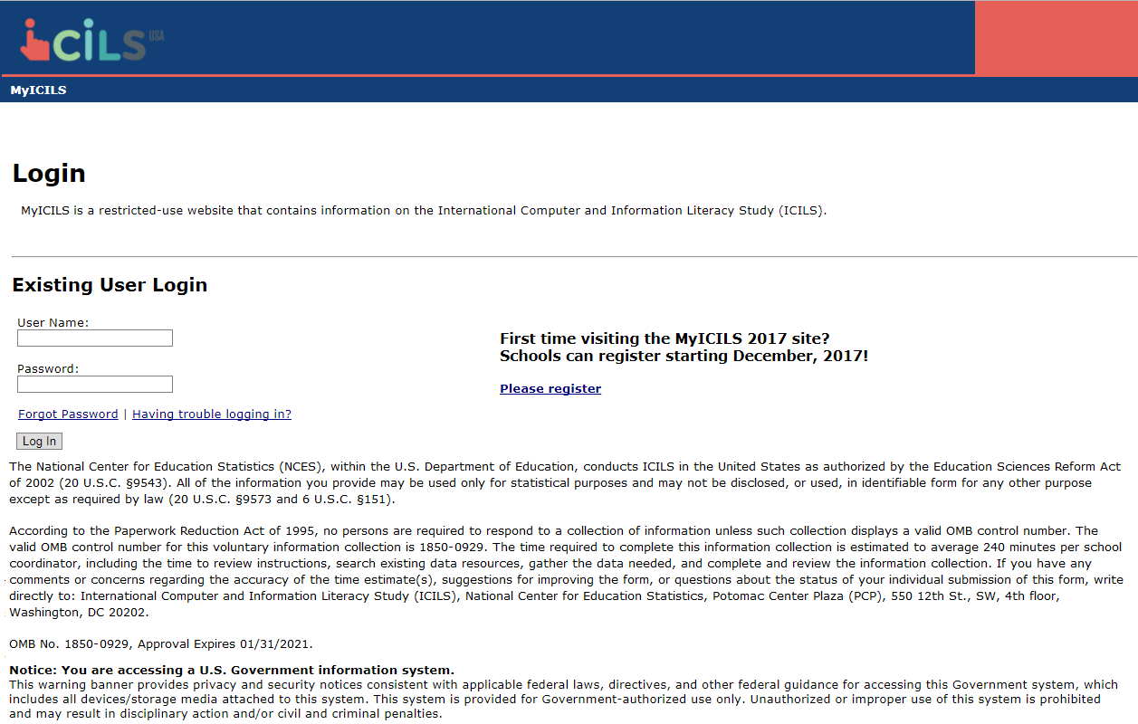

Email to Principal or SC for MyICILS Registration and PSI Completion

Dear [Principal] [Last name]:
We hope that this finds you well and enjoying another terrific school year! We are following up with you to remind you to put the International Computer and Information Literacy Study (ICILS) 2018 assessment date, [date], on your school calendar at [school name]. We appreciate your commitment to ICILS, and we know your students will be excited and proud to represent U.S. students in this important international assessment. The ICILS 2018 team looks forward to working with you to coordinate ICILS in your school.
A sample of your grade 8 students will be taking ICILS. In most schools, ICILS will randomly select about 30 students to participate in the assessment.
As school coordinator, you will have a number of responsibilities critical to making ICILS a success. Please review the attached Summary of School Activities: ICILS 2018 for an overview of these responsibilities. The MyICILS website (www.MyICILS.com) will assist you with these responsibilities and provide information about the assessment. Please register on MyICILS using this registration ID: [MyICILS school registration ID].
If you have already registered, then please make sure to complete the questions on the Provide School Information page on the MyICILS website. If you would like to designate someone else from your school to be the school coordinator, please forward this email to them and ask them to register on the MyICILS website.
The timeline below provides an overview of these activities:
• Today – Register on MyICILS and answer the questions on the MyICILS Provide School Information page.
• January 2018 – Prepare and submit a list of students and teachers electronically on the Submit Student List and Submit Teacher List pages of MyICILS. The ICILS 2018 team will contact you in late December 2017 with directions for submitting the student and teacher lists.
• January through March 2018 –
- Receive a packet of ICILS materials, including an ICILS 2018 Parent FAQ, sample parent/guardian notification letters, and student appointment cards. These materials will also be available on the MyICILS website.
- An assigned ICILS representative will contact you to discuss assessment logistics and accommodations for students with disabilities or English language learners.
- Notify parents/guardians that their children have been selected for the assessment. A sample parent/guardian notification letter will be available on the MyICILS website for you to customize and print on your school letterhead.

- One week before the assessment – Distribute student appointment cards (mailed to you prior to assessment) and notify teachers in advance so they know when to release students, and remind them that they need to complete an online ICILS Teacher Questionnaire, which should have been emailed to them by then. Request that the school principal or designee complete the ICILS School Questionnaire and that the designated ICT coordinator complete the ICT Coordinator Questionnaire as well.
Thank you in advance for your cooperation and effort in helping to coordinate this important assessment. If you have any questions, please feel free to contact the ICILS information hotline at 1-(855)-445-5604 or ICILS@westat.com. You may also get more information about this study by visiting the ICILS website at https://nces.ed.gov/surveys/icils/.
Sincerely,
The ICILS 2018 Team
Attachment: Summary of School Activities: ICILS 2018

MyICILS Provide School Information Page

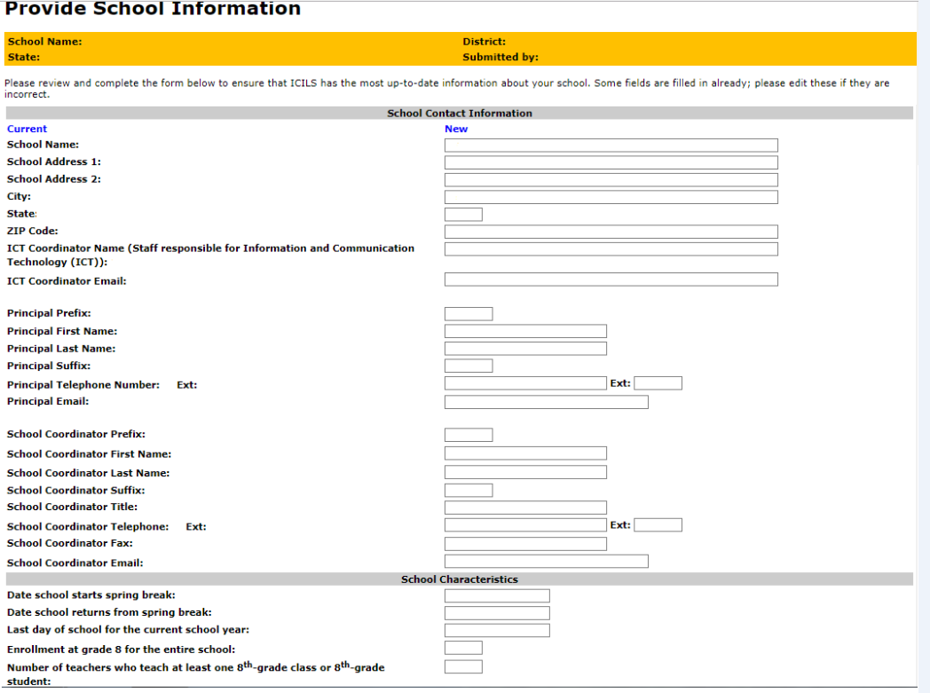

Email to School Coordinator to Submit Student and Teacher Lists for Main Study
Dear [School Coordinator],
ICILS needs a complete and current list of all of your school’s eighth-grade students in order to randomly select students to participate in the ICILS assessment. ICILS also needs a list of all of your school’s eighth-grade teachers in order to randomly select teachers to complete the ICILS teacher questionnaire.
Please go to [MyICILS website] to submit student lists. If you have forgotten your login ID please contact the ICILS helpdesk at xxx@xxxx.com or 1-xxx-xxx-xxxx. If you have forgotten your password, you can request a new password on the MyICILS login page.
After logging in, select Submit Student List to provide an electronic list of currently enrolled eighth-grade students in your school. Once you have provided information about all eighth-grade students, select Submit Teacher List to provide a list of all eighth-grade teachers in your school.
Instructions for Submit Student List and Submit Teacher List are attached. These tip sheets and Excel templates can also be found in the Documents section of MyICILS. An optional webinar will be held on XXXXXXXX to review the Submit Student and Submit Teacher procedures. Registration information for the webinar will be sent to you in a separate mail. The webinar will be recorded for viewing at a later time as well.
If you have any questions about submitting your list, please email or call the ICILS E-File Help Desk at xxx@xxxx.com or 1-xxx-xxx-xxxx. ​
Please submit your student E-File by XXXXXX. ICILS will process your submission and select the sample of eighth-grade students to be assessed. You will be informed of the students and teachers selected within a few weeks of submitting your lists.
Thank you very much for participating in ICILS and for submitting your school's student and teacher lists!
Sincerely,
ICILS Team

Attachments: Submit Student List Tip Sheet; Submit Teacher List Tip Sheet

NCES is authorized to conduct this study under the Education Sciences Reform Act of 2002 (ESRA 2002, 20 U.S.C. §9543). By law, the data provided by your school, staff, and students may only be used for statistical purposes and may not be disclosed, or used, in identifiable form for any other purpose except as required by law (20 U.S.C. §9573 and 6 U.S.C. §151).

Instructions for Submitting Student List for the Main Study

ICILS needs a complete and current list of all students in grade 8 in order to draw a random sample of students to participate in the assessment. Your student data electronic file (E-File) must be submitted as a Microsoft Excel file.

You may use one of the ICILS Excel Templates (located in Documents on [MyICILS Website] and described below) or you may provide an Excel file with the same information. If you cannot submit your student data with this information in an Excel file, please call or email the ICILS E-File Help Desk at xxx@xxxx.com or 1-xxx-xxx-xxxx.

Step 1 – Compile Data in an Excel File

Prepare an Excel file with the following data elements for all students in grade 8.

Data Element | Description
Student Name | The preferred format is First Name, Middle Name (or Initial), and  Last Name in separate columns. However, TIMSS will accept student names in one column.
Sex | Codes (numeric or text) for Male/Female
Date of Birth | The preferred format is Month of Birth and Year of Birth in separate columns. However, TIMSS will accept Date of Birth in one column.
Student with a Disability  (SD) Status | School-defined codes for:  • Yes, IEP: Student has an Individualized Education Plan (IEP). Students with 504 plans that need accommodations can be coded this value as well.  • No, not SD:  • Information unavailable at this time.
English Language  Learner (ELL) Status | School-defined codes for:  • Yes, ELL  • No, not ELL  • Information unavailable at this time.

You may use one of the templates provided or create your own Excel file with these data for each student. It is preferred that you include column headers as the first row in your E-File, as in these templates. However, E-Files without column headers will be accepted.

Template 1 has student name in three separate columns, and month of birth and year of birth in two separate columns.

Template 2 has student name in one column, and date of birth in one column.

Tips for ensuring the E-File process goes smoothly:

• Use the template or provide column headers. Student information should begin on the second row. There should be no empty rows within the student data.
• Be sure to give your file a unique, descriptive name. Within Excel, click on File, then Save As, and give your file a name such as “Your School Name Grade 8 Students.xls.”
• The first row of data in your file will be read as the column header unless you indicate otherwise on the Submit Student List webpage. Each succeeding row will be considered a student record.
• There should be only one worksheet with data in the Excel file. If there are other worksheets, they must not contain any data.

Step 2 – Upload Your Excel File

Once your file is prepared and checked for accuracy and completeness, login to [MyICILS Website] and select “Submit Student List” from the left-hand menu.

[The following screenshots are from TIMSS to provide an example and will be updated with ICILS images and instructions]
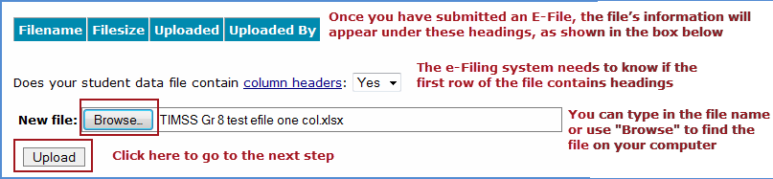

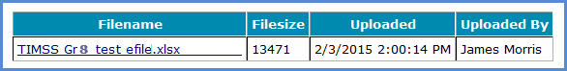

Step 3 – Identify Your Columns

We need to know what information is in each column of your student data file (E-File). If you provided column headers in your E-File (preferred), they are displayed in Column Heading Is in the table. If you did not provide column headers, Column Heading Is will contain numbers for each column in your submitted E-File. Click on the down arrows in Your Column Contains to select descriptions for each column header. If there is no appropriate description in the drop-down list, please select N/A.

Select Next after all columns have been identified.

[The below screenshot is from TIMSS to provide an example and will be updated to reflect ICILS]
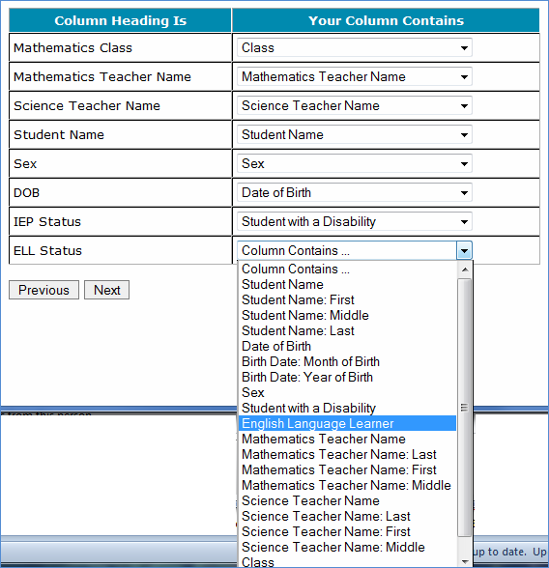

Step 4 – Match Your Values to ICILS Codes

ICILS also needs to know the values for some of the columns in your E-File. The tables contain the following information for each column:

• Your Values: The values in your E-File
• ICILS Codes: Click on the down arrow and select the ICILS Code that best matches Your Values
• Number: The number of students in your E-File with that value
• Percentage: The percentage in your E-File with that value

[The below screenshot is from TIMSS to provide an example and will be updated to reflect ICILS]
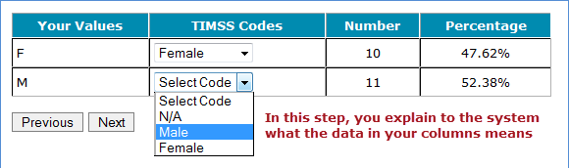

Use the Previous and Next buttons to navigate from column header to column header.

If there is an error in your data file, exit E-File, correct the problem in your Excel file, and upload the file again.

Step 5 – Verify Your E-File

The table in this section summarizes the information you have provided on your student list (E-File). Please review this summary and verify that the information is correct. Total Enrollment at the bottom of the table should match the number of students in your E-File, and the total number of students currently enrolled in grade 8.

Record whether the information is correct or incorrect by selecting the appropriate button at the bottom of the page. Then click the Submit button. If you select INCORRECT, you will need to correct your E-File and resubmit it.

[The below screenshot is from TIMSS to provide an example and will be updated to reflect ICILS]

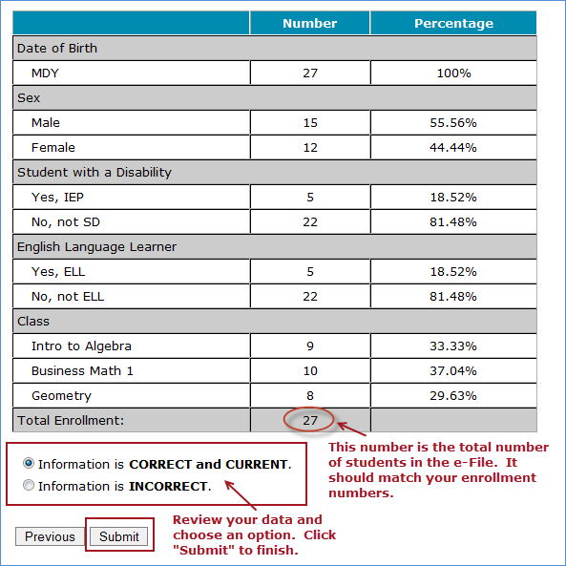

If you need assistance, please contact the ICILS E-File Help Desk at xxx@xxxx.com or 1-xxx-xxx-xxxx.

Instructions for Submitting Teacher List for the Main Study

In addition to a student list, ICILS needs a complete and current list of all of your school’s eighth-grade teachers in order to select a random sample to complete the teacher questionnaire. This list should include all teachers that are teaching regular school subjects to eighth-grade students (regardless of the subject or the number of hours taught) during the ICILS testing period and since the beginning of the school year.

Enter information about all teachers of eighth-grade students:

On [MyICILS Website] select Submit Teacher List from the navigation menu on the left. Enter into the form each teacher’s name and the courses the teacher teaches to eighth-grade students. Click on the Save button, and continue until you have entered information about all teachers who teach eighth-grade students.

Example: [This is an example from TIMSS, and will be updated for ICILS instructions to not be specific to science teachers and to allow multiple course listings if needed]

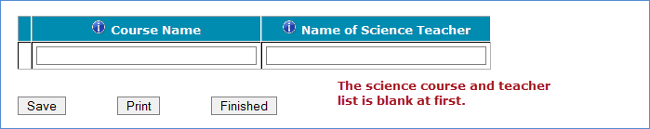

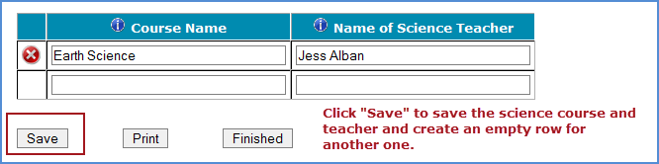

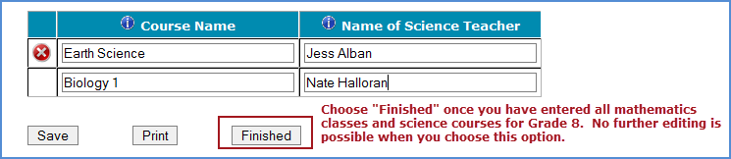

When you have entered information for all eighth-grade teachers in your school click on the Finished button.

Additional tips:

- Use the most current enrollment information.
- Include all teachers who teach to eighth-grade students in the list, regardless of the subject or number of hours taught, and even if they also teach students in other grades.
- Print a list of the teachers you included for your future reference using the Print button.

If you need assistance, email xxx@xxxx.com or call 1-xxx-xxx-xxxx.

School Principal Questionnaire Login Card

Front of Card:
Welcome to ICILS!
Your school is participating in the main study for International Computer and Information Literacy Study (ICILS) 2018. This online questionnaire seeks information about schools and their use of ICT (Information and Communications Technology), which provides important context to understanding the achievement of students taking the assessment.

Please go to the web address (URL) given below and log in to the online questionnaire with your “School ID” and “Password”, which are printed on the label attached below. Please contact the ICILS Help Desk (ICILS@westat.com)
if you have problems logging on.
The website link is: https://portal.myicils.us/
[Insert Label]

The online questionnaire does NOT require JavaScript or cookies to work. Responses are saved automatically as you go from question to question. The “Table of Contents” link on the bottom of each page provides an overview of all questions and whether you have completed them. You may leave the questionnaire at any time and log in again later. See notes on the back of this card.
OMB# 1850-0929 (expires 1/31/21).

Back of Card:
NOTES
- Please use the Previous and Next buttons to navigate backward and forward
- You may exit the questionnaire at any time and log in again later— all of your responses will be saved automatically.
- The Table of Contents provides an overview of all questions and shows whether you have completed all questions.
- To exit the Table of Contents, click on any question link or section header.
- If you would like a printed copy of the online questionnaire, click on the “Prepare Printer Version” link on the Table of Contents page.
- It is estimated that it will take approximately 15 minutes to complete the questionnaire.
- If you have problems accessing the online questionnaire or need assistance, please contact the ICILS help desk at 1-855-445-5604 or email ICILS@westat.com.
- If you would prefer to complete a paper questionnaire, please contact your ICILS School Coordinator.

Thank you for the thought, time, and effort you have put into completing the questionnaire!

ICT (Information and Communications Technology) Coordinator Questionnaire Login Card

Front of Card:
Welcome to ICILS!
Your school is participating in the main study for International Computer and Information Literacy Study (ICILS) 2018. This online questionnaire seeks information about your role as ICT (Information and Communications Technology) coordinator and its use in school, which provides important context to understanding the achievement of students taking the assessment.

Please go to the web address (URL) given below and log in to the online questionnaire with your “ICT Coordinator ID” and “Password”, which are printed on the label attached below. Please contact the ICILS Help Desk (ICILS@westat.com) if you have problems logging on.
The website link is: https://portal.myicils.us/
[Insert Label]

The online questionnaire does NOT require JavaScript or cookies to work. Responses are saved automatically as you go from question to question. The “Table of Contents” link on the bottom of each page provides an overview of all questions and whether you have completed them. You may leave the questionnaire at any time and log in again later. See notes on the back of this card.
OMB# 1850-0929 (expires 1/31/21).

Back of Card:
NOTES
- Please use the Previous and Next buttons to navigate backward and forward
- You may exit the questionnaire at any time and log in again later— all of your responses will be saved automatically.
- The Table of Contents provides an overview of all questions and shows whether you have completed all questions.
- To exit the Table of Contents, click on any question link or section header.
- If you would like a printed copy of the online questionnaire, click on the “Prepare Printer Version” link on the Table of Contents page.
- It is estimated that it will take approximately 15 minutes to complete the questionnaire.
- If you have problems accessing the online questionnaire or need assistance, please contact the ICILS help desk at 1-855-445-5604 or email ICILS@westat.com.
- If you would prefer to complete a paper questionnaire, please contact your ICILS School Coordinator.

Thank you for the thought, time, and effort you have put into completing the questionnaire!

Teacher Questionnaire Login Card

Front of Card:
Welcome to ICILS!
Your school is participating in the main study for International Computer and Information Literacy Study (ICILS) 2018. This online questionnaire seeks information about teachers and their use of ICT (Information and Communications Technology), which provides important context to understanding the achievement of students taking the assessment.

Please go to the web address (URL) given below and log in to the online questionnaire with your “Teacher ID” and “Password”, which are printed on the label attached below. Please contact the ICILS Help Desk (ICILS@westat.com)
if you have problems logging on.
The website link is: https://portal.myicils.us/
[Insert Label]

The online questionnaire does NOT require JavaScript or cookies to work. Responses are saved automatically as you go from question to question. The “Table of Contents” link on the bottom of each page provides an overview of all questions and whether you have completed them. You may leave the questionnaire at any time and log in again later. See notes on the back of this card.
OMB# 1850-0929 (expires 1/31/21).

Back of Card:
NOTES
- Please use the Previous and Next buttons to navigate backward and forward
- You may exit the questionnaire at any time and log in again later— all of your responses will be saved automatically.
- The Table of Contents provides an overview of all questions and shows whether you have completed all questions.
- To exit the Table of Contents, click on any question link or section header.
- If you would like a printed copy of the online questionnaire, click on the “Prepare Printer Version” link on the Table of Contents page.
- It is estimated that it will take approximately 30 minutes to complete the questionnaire.
- If you have problems accessing the online questionnaire or need assistance, please contact the ICILS help desk at 1-855-445-5604 or email ICILS@westat.com.
- If you would prefer to complete a paper questionnaire, please contact your ICILS School Coordinator.
- After you complete the questionnaire, please email the ICILShelpdesk@westat.com and provide an email address where we can send your $20 Amazon gift card code as a token of appreciation for your participation.

Thank you for the thought, time, and effort you have put into completing the questionnaire!

Online Questionnaire Login Screen Text
(for the Principal, ICT Coordinator, Teachers, and Students)

ICILS2018MS - English (United States)
You are not logged in.

Welcome to the IEA - DPC SurveySystem
Online Questionnaires

Please enter your user ID and password (Checksum).
User ID:
Password:

The National Center for Education Statistics (NCES), within the U.S. Department of Education, conducts ICILS in the United States as authorized by the Education Sciences Reform Act of 2002 (ESRA 2002, 20 U.S.C. §9543). All of the information you provide may be used only for statistical purposes and may not be disclosed, or used, in identifiable form for any other purpose except as required by law (20 U.S.C. §9573 and 6 U.S.C. §151).
According to the Paperwork Reduction Act of 1995, no persons are required to respond to a collection of information unless such collection displays a valid OMB control number. The valid OMB control number for this voluntary information collection is 1850-0929. The time required to complete this information collection is estimated to average 15 minutes per principal, 15 minutes per ICT coordinator, or 30 minutes per teacher, including the time to review instructions, search existing data resources, gather the data needed, and complete and review the information collection. If you have any comments or concerns regarding the accuracy of the time estimate(s), suggestions for improving the form, or questions about the status of your individual submission of this form, write directly to: International Computer and Information Literacy Study (ICILS), National Center for Education Statistics, Potomac Center Plaza (PCP), 550 12th St., SW, 4th floor, Washington, DC 20202.
OMB No. 1850-0929, Approval Expires 1/31/2021.

© IEA Online SurveySystem 2018 - Help

Student Appointment Card for ICILS 2018 MS

Front
(ICILS Graphic and Logo)
Welcome to the ICILS USA Team!
Congratulations, you have been selected to be part of a special group of students representing the United States in the 2018 International Computer and Information Literacy Study (ICILS).

Back
This spring, selected students from the United States will be assessed in the main study.
Join us on....
ICILS Date:
ICILS Time:
ICILS Location:

During the assessment, you are not permitted to use devices that can connect to the Internet. Aside from the testing equipment, you cannot use a laptop or other portable computer, pocket organizer, device with a typewriter-style keyboard, electronic writing pad, pen input device, or a cell phone.
See front for details.
(ICILS USA and IES logos)

(Student Appointment card example from the 2017 Field Test; will be updated for the 2018 Main Study with the language listed on page 34 of this document)
Front
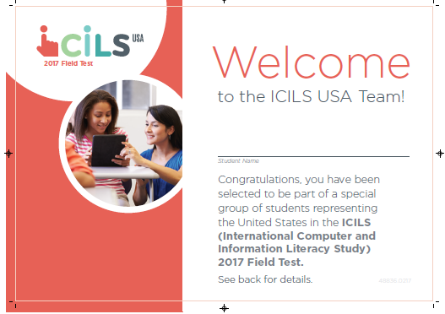
Back
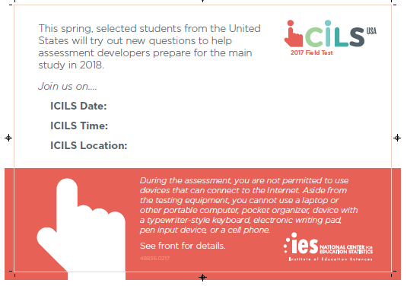

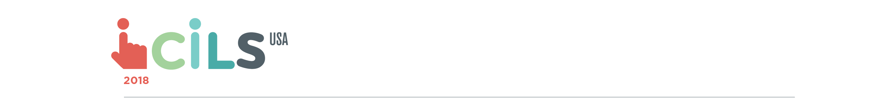
Second Tier School ICILS Main Study Recruitment Letter [to participating schools with no follow-through/to non-participating schools with no final refusal]

[Principal Prefix, First Name, Last Name]
[School Name]
[School Address]
[School City, State, Zip]

Dear [Principal Prefix, Last Name],

The United States is seeking to learn more about how digital technology is impacting teaching and learning around the world, especially for U.S. students and teachers, by particitping in the International Computer and Information Literacy Study (ICILS) 2018. However, we will not be able to understand and compare the experience and skills of U.S. students without a sample of schools that represents the full spectrum of American students and teachers—and your school is an important part of such a sample.
As the ICILS Project Director, conducting this study on behalf of the National Center for Education Statistics (NCES), [I want to thank you for agreeing to participate in the ICILS 2018 study. Unfortunately, we have not been able to confirm the ICILS assessment date at your school and receive student and teacher lists for sampling. Your school represents hundreds of schools with a student body like yours. I hope that you can move forward with participation so that ICILS can fully represent schools like yours.] [I understand that you have not agreed to particate but I wish personally to ask you to reconsider because your school represents hundreds of schools across the country similar to yours (but those schools cannot participate because they were not sampled and do not meet the international sampling requirements for the study).]
[To secure a/If you can help us secure a] fully representative sample, we are offering an additional token of appreciation for your school’s time. If you participate, we will give your school $800. Students who take ICILS will receive a small gift to thank them for their participation. Your school’s ICILS school coordinator (the school staff person designated to work with ICILS staff) will receive $100 as a thank you for his or her time and effort. Selected teachers will receive $40 for completing a brief questionnaire about themselves.
The ICILS data collection has already begun, and will end on May 25, 2018, so a representative of ICILS at Westat will be calling you soon to discuss your decision. I am also available directly by phone at 240-314-2492, and by email at ChrisAverett@westat.com. Furthermore, you may get more information about this study by contacting Lydia Malley at NCES at 202-245-7266 or lydia.malley@ed.gov, or by visiting the ICILS website at https://nces.ed.gov/surveys/icils.

Thank you for your time and consideration.
Sincerely,

Chris Averett
Project Director, ICILS in the United States

NCES is authorized to conduct this study under the Education Sciences Reform Act of 2002 (ESRA 2002, 20 U.S.C. §9543). By law, the data provided by your schools, staff, and students may only be used for statistical purposes and may not be disclosed, or used, in identifiable form for any other purpose except as required by law (20 U.S.C. §9573 and 6 U.S.C. §151).

