**Public Comments Received During the 30-day Comment Period –**

**May 2018**

**State Longitudinal Data System (SLDS) Survey 2018 – 2019**

ED-2018-ICCD-0043 Comments on FR Doc # 2018-08068

**Document:** ED-2018-ICCD-0043-0005

**Name:** Keric Ashley

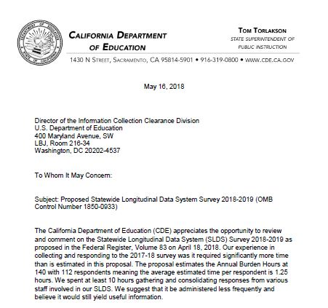

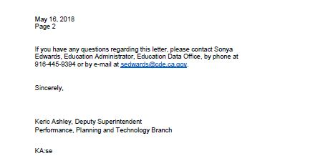

Dear Mr. Ashley,

Thank you for your feedback posted on May 17, 2018 responding to a 30-day request for comments on the Statewide Longitudinal Data System (SLDS) Survey 2018-2019. We take the level of burden on the respondent very seriously, and would like to point out numerous factors that were considered when assessing the current estimated average level of effort for respondents:

1. We anticipated that the initial 2017 collection, which has been completed at this point, would take the longest amount of time to complete. The first collection required that State Education Agency (SEA) respondents identify cross-agency contacts, data sources, etc. Now that those informants, data sources, and connections have been identified, the time required to complete subsequent survey collections on an annual basis should decrease.
2. Upon approval of this submission, the Survey will be prepopulated with the previous year’s collection data to ease the level of burden for respondents. If there have been no changes or enhancements to capacity, the respondent can simply review unchanged sections without having to input responses.
3. The Survey is being administered annually to most accurately track movement in the field. While administering the Survey less frequently would provide us with a snapshot or glimpse of state’s data capacity, we would lose information about annual advances in a field that is continually evolving due to a variety of desires for increased functionality and external pressures and developments. Understanding changes in state capacity are critical as we currently annually use data collected from states to craft SLDS technical assistance plans and to guide changes to the SLDS program as a whole. Annual data will also inform development in other USED programs, including, for example, the Common Education Data Standards (CEDS).

The burden times presented in this submission are estimates based on our best understanding of how long review and completion of the survey in Year 2 should take on average across all SEAs. However, if you find that the Year 2 survey completion takes significantly longer than our estimate, please contact us again and let us know.

Sincerely Yours,

Nancy S. Sharkey

Statistician, National Center for Education Statistics

United States Department of Education

Institute of Education Sciences

550 12th Street, SW, Room 4162

Washington, DC 20202

Tel. (202) 245-7689

[Nancy.Sharkey@ed.gov](mailto:Nancy.Sharkey@ed.gov)