Research goal
Given the limited exposure to SAE ratings of automation technology and the inconsistencies in nomenclature among OEMs, research is needed to help 1) identify the most effective way to communicate with and educate consumers about the different levels of automation and 2) understand the best approach to how consumers can map specific vehicles back to the different levels of automation (and overcome issues with inconsistent nomenclature among manufacturers). The research will generate a greater understanding of the driving public and how they think about the six different levels of vehicle automation technology (Level 0 – Level 5), what types of technologies comprise those levels, and how best to effectively communicate the availability and functionalities and limitations of these technologies to consumers when they are engaging dealers to purchase a new or used vehicle manufactured in model year 2016 or newer. In turn, this will help inform strategies to communicate and educate consumers so they can make more informed decisions when purchasing new vehicles.

In meeting this objective to better understand how to communicate with the driving public on the levels of automation we recommend a series of eight qualitative focus groups across four markets (two groups per market) to explore in-depth the public’s understanding of levels of autonomy, where key barriers to understanding exist, both within and across levels, and how communications may be structured to more effectively educate purchase-minded drivers about the important safety features offered at each progressive level of automation.

NOTE TO MODERATOR: When group is fully assembled, read:

This focus group is being conducted to collect information that will help us better understand your opinions about an important highway safety issue.

This collection of information is voluntary and will be used for formative purposes only so that we may develop communications programs designed to reduce the number of traffic-related injuries and deaths. A federal agency may not conduct or sponsor, and a person is not required to respond to, nor shall a person be subject to a penalty for failure to comply with a collection of information subject to the requirements of the Paperwork Reduction Act unless that collection of information displays a current valid OMB Control Number. The OMB Control Number for this information collection is 2127-0682. Your participation today in this collection of information is estimated to average 90 minutes, including the time for reviewing instructions. All responses to this collection of information are voluntary.

- Warm-up [5 minutes/5 minutes total]
  - Welcome & Introduction
  - Over the past several years there has been a range of new technologies that automobile manufacturers have introduced to improve vehicle safety. To begin, when you think about these technologies…what sorts of things come to mind?
    - For you personally, do these types of technologies impact how safe you feel? PROBE - make you feel more safe or less safe? Why?

- Levels of Automation Top-of-Mind [30 minutes/35 minutes total]
Our discussion this evening is going to focus on levels of automation for passenger vehicles. When we talk about levels of automation, we are referring to a wide range of technologies incorporated into vehicles. This runs the full spectrum of technology from simple alerts that help inform the driver, to more advanced technologies that can intervene and take action under certain conditions, to emerging technologies being developed and tested that can handle virtually all aspects of the driving experience.

  - When you think about vehicles and you hear the phrase levels of automation, what comes to mind? What do you think about?
[BUILD LISTS FOR #1 TECHNOLOGIES AND #2 ATTITUDES/PERCEPTIONS]
    - Is that positive or negative
      - Positive – why?
      - Negative – why?
    - What do you see as the biggest benefits?

  - Now let’s talk about the different places where you read, hear or see information about the types of technologies or features that exist along the different levels of automation.
      - Let’s build a list of sources for this kind of information. [CAPTURE ON EASEL]
      - From this list, what sources do you find to be most credible?

  - When it comes to overall vehicle safety and technology, people can have different perspectives. I’m going to read you two perspectives and after I do, I’d like you to tell me, which one comes closer to your own. As a point of reference, think about what is available now and what you know about technology as it stands, rather than the potential for perfect technology.

PAGE 2 IN WORKBOOK – ACTIVITY #1
    - [HUMANS ARE SAFER] Some people say that it’s safer when the human driver is in complete control of all the vehicle functions. They trust themselves more than technology, and say that technology software could be hacked, or that they can’t fully relax in a vehicle where the computer assists with certain driving tasks.

    - [TECHNOLOGY IS SAFER] Others say that vehicles in which drivers are assisted by a computer are safer. Technology can react more quickly and reliably than people can, technology can be rigorously tested in a wide range of situations before they are allowed on vehicles, and new and better technology is on the horizon.

[DEBRIEF]
- Place a check mark next to the one you most agree with
- Show of hands around the table
- Why do you feel that way?

  - Next, I’d like to show you a description of the type advanced driver assistance systems that are found in some vehicles today and are part of the continuum of automation:
PAGE 3 IN WORKBOOK – DESCRIPTION 1

Advanced driver assistance systems in today’s motor vehicles are already helping to save lives and prevent injuries.

A number of today’s new motor vehicles have technology that helps drivers avoid drifting into adjacent lanes or making unsafe lane changes, or that warns drivers of other vehicles behind them when they are backing up, or that brakes automatically if a vehicle ahead of them stops or slows suddenly, among other things. These and other technologies use a combination of hardware (sensors, cameras, and radar) and software to help vehicles identify certain safety risks so they can warn the driver to act to avoid a crash. They are the precursor and building blocks to more futuristic technological vehicle safety advancements.

The continuing evolution of automotive technology aims to deliver even greater safety benefits and – one day – deliver automated driving systems that can handle the whole task of driving when we don’t want to or can’t do it ourselves.

[CAPTURE ON EASEL]

    - Based on this description of current technology and the direction technology is going, what do you see as the benefits to increasing the number of vehicles on the road with advanced driver assistance systems? And what about automated driving systems? PROBE: Do you feel the same way about advanced driver assistance systems as automated driving systems?
    - If you have concerns about automation technologies or advanced driver assistance systems in general, what are those concerns? Why is that a concern for you?
    - How could that concern be overcome?
    - What would you need to read, see or hear to lessen your concerns? PROBE ON advanced driver assistance systems vs. automated driving systems.
    - On the whole, do you believe the benefits of these technologies outweigh any risks you might perceive? Why? Do think of the benefits vs. risks are any different for advanced driver assistance systems vs. automated driving systems?

- Technology Progression [35 minutes/70 minutes total]

  - As I mentioned earlier, there are a variety of different levels of automation that can be incorporated into vehicles to assist drivers and help vehicles operate more safely. Let’s think of these across different levels.

PAGE 4 IN WORKBOOK – DESCRIPTION 2
[MODERATOR READS WITH PARTICIPANTS]
Level 0 | You are driving and have access to driver support features that are limited to warnings and momentary assistance (vehicle offers blind spot warning, lane departure warning and/or emergency braking).
Level 1 | You are driving and have access to driver support features that provide steering OR brake acceleration to support the driver (vehicle offers lane centering, adaptive cruise control but they work independently).
Level 2 | You are driving and have access to driver support features that provide steering AND brake acceleration to support the driver (vehicle offers lane centering and adaptive cruise control at the same time).
Level 3 | You are NOT driving when the automated driving features are engaged – even if you are seated in the driver’s seat. These features can drive the vehicle under limited conditions and will not operate unless all required conditions are met. Additionally, when the feature requests, you must drive.
Level 4 | You are NOT driving when the automated driving features are engaged – even if you are seated in the driver’s seat. These features can drive the vehicle under limited conditions and will not operate unless all required conditions are met. You are not required to take over driving.
Level 5 | You are NOT driving when the automated driving features are engaged – even if you are seated in the driver’s seat. These features can drive the vehicle under all conditions.

  - What is your overall reaction to these different levels?
  - Does this overall idea of a progression of automation make sense to you?
  - Do these different levels each make sense? Just to be sure, let’s review each one, one-by-one. [BEGINNING WITH LEVEL 0, READ EACH AND CHECK TO SEE IF THERE IS ANYTHING UNCLEAR OR THAT SHOULD BE REWORDED SO IT CAN BE BETTER UNDERSTOOD]
  - Does providing this explanation of automation allow for an effective way to help educate consumers about technology progression from assistance to fully automated?
    - What works well? What do you like best?
  - Are there any changes to the wording or the concepts in this description that you would make to help it be clearer and easier to understand?
  - If you were thinking about purchasing a car, would you want to know what type of features it has and where it would fit on the level of automation at the time of purchase?
    - If you wanted to know what the level of technology/automation is, how would you go about finding that information? Where would you go? What would you do?

Progression from Level 0 – 1
i. Now let’s talk about the specific levels of automation. You can refer to the table in your workbook to see the descriptions of each level. Thinking of these first two levels, Level 0 and Level 1, what are some of the benefits that you might see in a Level 1 vehicle that could make it appealing to drivers?
[CAPTURE ON EASEL]

ii. Let’s think about the other side as well. What are some of the concerns that you might see in a Level 1 vehicle that could make it unappealing to drivers?
[CAPTURE ON EASEL]

iii. Now that you have weighed some of the benefits and concerns of a Level 1 vehicle, how comfortable would you be moving from driving a Level 0 vehicle to Level 1 vehicle? Please record your response in your workbook.

PAGE 5 IN WORKBOOK – ACTIVITY #2.1
SCALE: 0 – Not at all comfortable to 10 – Extremely comfortable

Progression from Level 1 – 2
iv. Thinking of these next two levels, Level 1 and Level 2, what are some of the benefits that you might see in a Level 2 vehicle that could make it appealing to drivers?
[CAPTURE ON EASEL]

v. Let’s think about the other side as well. What are some of the concerns that you might see in a Level 2 vehicle that could make it unappealing to drivers?
[CAPTURE ON EASEL]

vi. Now that you have weighed some of the benefits and concerns of a Level 2 vehicle, how comfortable would you be moving from driving a Level 1 vehicle to Level 2 vehicle? Please record your response in your workbook.

PAGE 5 IN WORKBOOK – ACTIVITY #2.2
SCALE: 0 – Not at all comfortable to 10 – Extremely comfortable

Progression from Level 2 – 3
vii. Thinking of these next two levels, Level 2 and Level 3, what are some of the benefits that you might see in a Level 3 vehicle that could make it appealing to drivers?
[CAPTURE ON EASEL]

viii. Let’s think about the other side as well. What are some of the concerns that you might see in a Level 3 vehicle that could make it unappealing to drivers?
[CAPTURE ON EASEL]

ix. Now that you have weighed some of the benefits and concerns of a Level 3 vehicle, how comfortable would you be moving from driving a Level 2 vehicle to Level 3 vehicle? Please record your response in your workbook.

PAGE 6 IN WORKBOOK – ACTIVITY #2.3
SCALE: 0 – Not at all comfortable to 10 – Extremely comfortable

Progression from Level 3 – 4
x. Thinking of these next two levels, Level 3 and Level 4, what are some of the benefits that you might see in a Level 4 vehicle that could make it appealing to drivers?
[CAPTURE ON EASEL]

xi. Let’s think about the other side as well. What are some of the concerns that you might see in a Level 4 vehicle that could make it unappealing to drivers?
[CAPTURE ON EASEL]

xii. Now that you have weighed some of the benefits and concerns of a Level 4 vehicle, how comfortable would you be moving from driving a Level 3 vehicle to Level 4 vehicle? Please record your response in your workbook.

PAGE 6 IN WORKBOOK – ACTIVITY #2.4
SCALE: 0 – Not at all comfortable to 10 – Extremely comfortable

Progression from Level 4 – 5
xiii. Thinking of these last two levels, Level 4 and Level 5, what are some of the benefits that you might see in a Level 5 vehicle that could make it appealing to drivers?
[CAPTURE ON EASEL]

xiv. Let’s think about the other side as well. What are some of the concerns that you might see in a Level 5 vehicle that could make it unappealing to drivers?
[CAPTURE ON EASEL]

xv. Now that you have weighed some of the benefits and concerns of a Level 5 vehicle, how comfortable would you be moving from driving a Level 4 vehicle to Level 5 vehicle? Please record your response in your workbook.

PAGE 7 IN WORKBOOK – ACTIVITY #2.5
SCALE: 0 – Not at all comfortable to 10 – Extremely comfortable

PAGE 8 IN WORKBOOK – ACTIVITY #3
  - Now that you have had some time to think about all these different levels and what they each do, let’s look back across the levels.
    - For each level, I would like you to tell me what you think the defining feature is along with any keywords or phrases that should be used in defining that level and making it clear how it is different from other levels.
    - What would you call each level? Please write it down so that everyone is forming their own name.

  - As we went through the different levels, we identified some of the concerns at each level. Let’s revisit those for the next part of our discussion.
    - Overall, where are the biggest concerns? [PROBE TO IDENTIFY BIGGEST CONCERN AT EACH LEVEL]
    - What can be done specifically from a communications perspective to help overcome these concerns?

PAGE 9 IN WORKBOOK – DESCRIPTION 3
    - Let’s look at some names for each level. Please take a moment and read through the table of names and descriptions. As you read through the names and descriptions, I want you to think about how well the name fits with the description and if there is anything need to make it a better fit.

No Automation | You are driving and have access to driver support features that are limited to warnings and momentary assistance (vehicle offers blind spot warning, lane departure warning and/or emergency braking).
Driver Assistance | You are driving and have access to driver support features that provide steering OR brake acceleration to support the driver (vehicle offers lane centering, adaptive cruise control but they work independently).
Partial Automation | You are driving and have access to driver support features that provide steering AND brake acceleration to support the driver (vehicle offers lane centering and adaptive cruise control at the same time).
Conditional Automation | You are NOT driving when the automated driving features are engaged – even if you are seated in the driver’s seat. These features can drive the vehicle under limited conditions and will not operate unless all required conditions are met. Additionally, when the feature requests, you must drive.
High Automation | You are NOT driving when the automated driving features are engaged – even if you are seated in the driver’s seat. These features can drive the vehicle under limited conditions and will not operate unless all required conditions are met. You are not required to take over driving.
Full Automation | You are NOT driving when the automated driving features are engaged – even if you are seated in the driver’s seat. These features can drive the vehicle under all conditions.

After reading through the list, were there any names that are not a good fit with the description? If so, what changes need to be made to the name to make it a better fit?

- Visual Comparison [10 minutes/80 minutes total]

PAGE 10 IN WORKBOOK – DESCRIPTION 4
  - Now, let’s look at these in a slightly different way. [SHOW SAE ILLUSTRATION BELOW]. Does this way of illustrating these different levels of automation help you to better understand what they are? [PROBE INTO HOW AND WHY?] What do you like about this visualization of the different levels? What do you dislike?

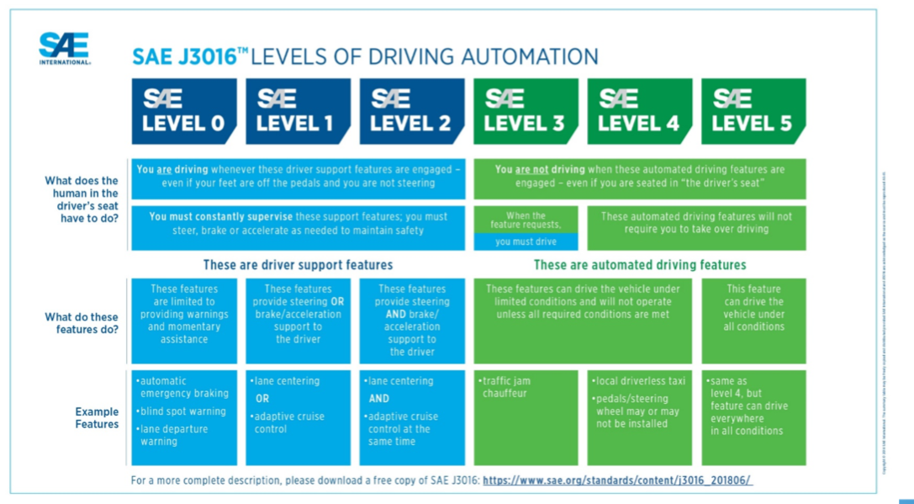

PAGE 11 IN WORKBOOK – DESCRIPTION 5
  - Again, let’s look at these in a slightly different way. [SHOW NHTSA ILLUSTRATION BELOW]. Does this way of illustrating these different levels of automation help you to better understand what they are? [PROBE INTO HOW AND WHY?] What do you like about this visualization of the different levels? What do you dislike?
  - Can you take a look at each of the pictures and identify the differences in the images? Do those images adequately differentiate between what is expected of the driver for each level?

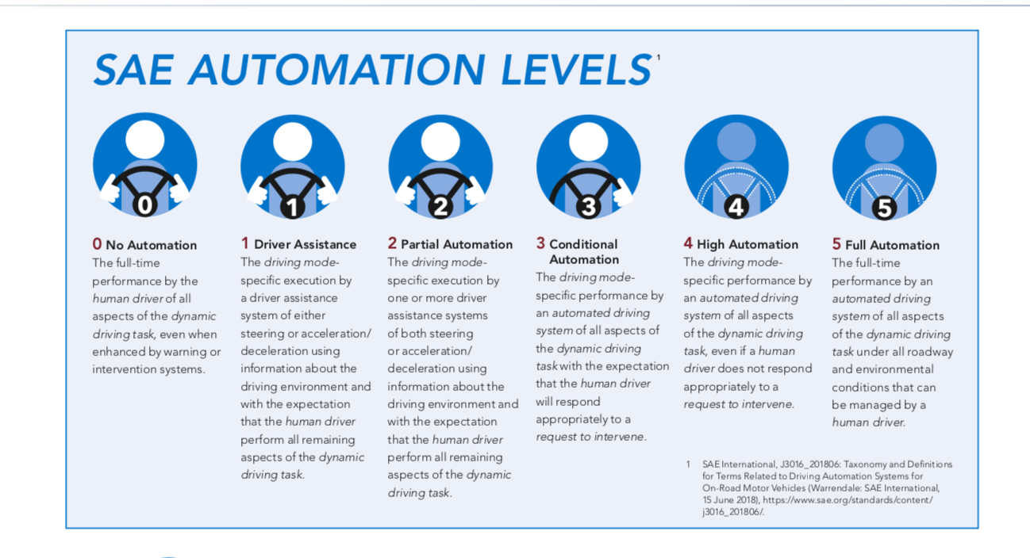

PAGE 12 IN WORKBOOK – DESCRIPTION 6
  - Again, let’s look at these in a slightly different way. [SHOW ILLUSTRATION BELOW]. Does this way of illustrating these different levels of automation help you to better understand what they are? [PROBE INTO HOW AND WHY?] What do you like about this visualization of the different levels? What do you dislike?
  - The language in this is more technical. Does that appeal to you?
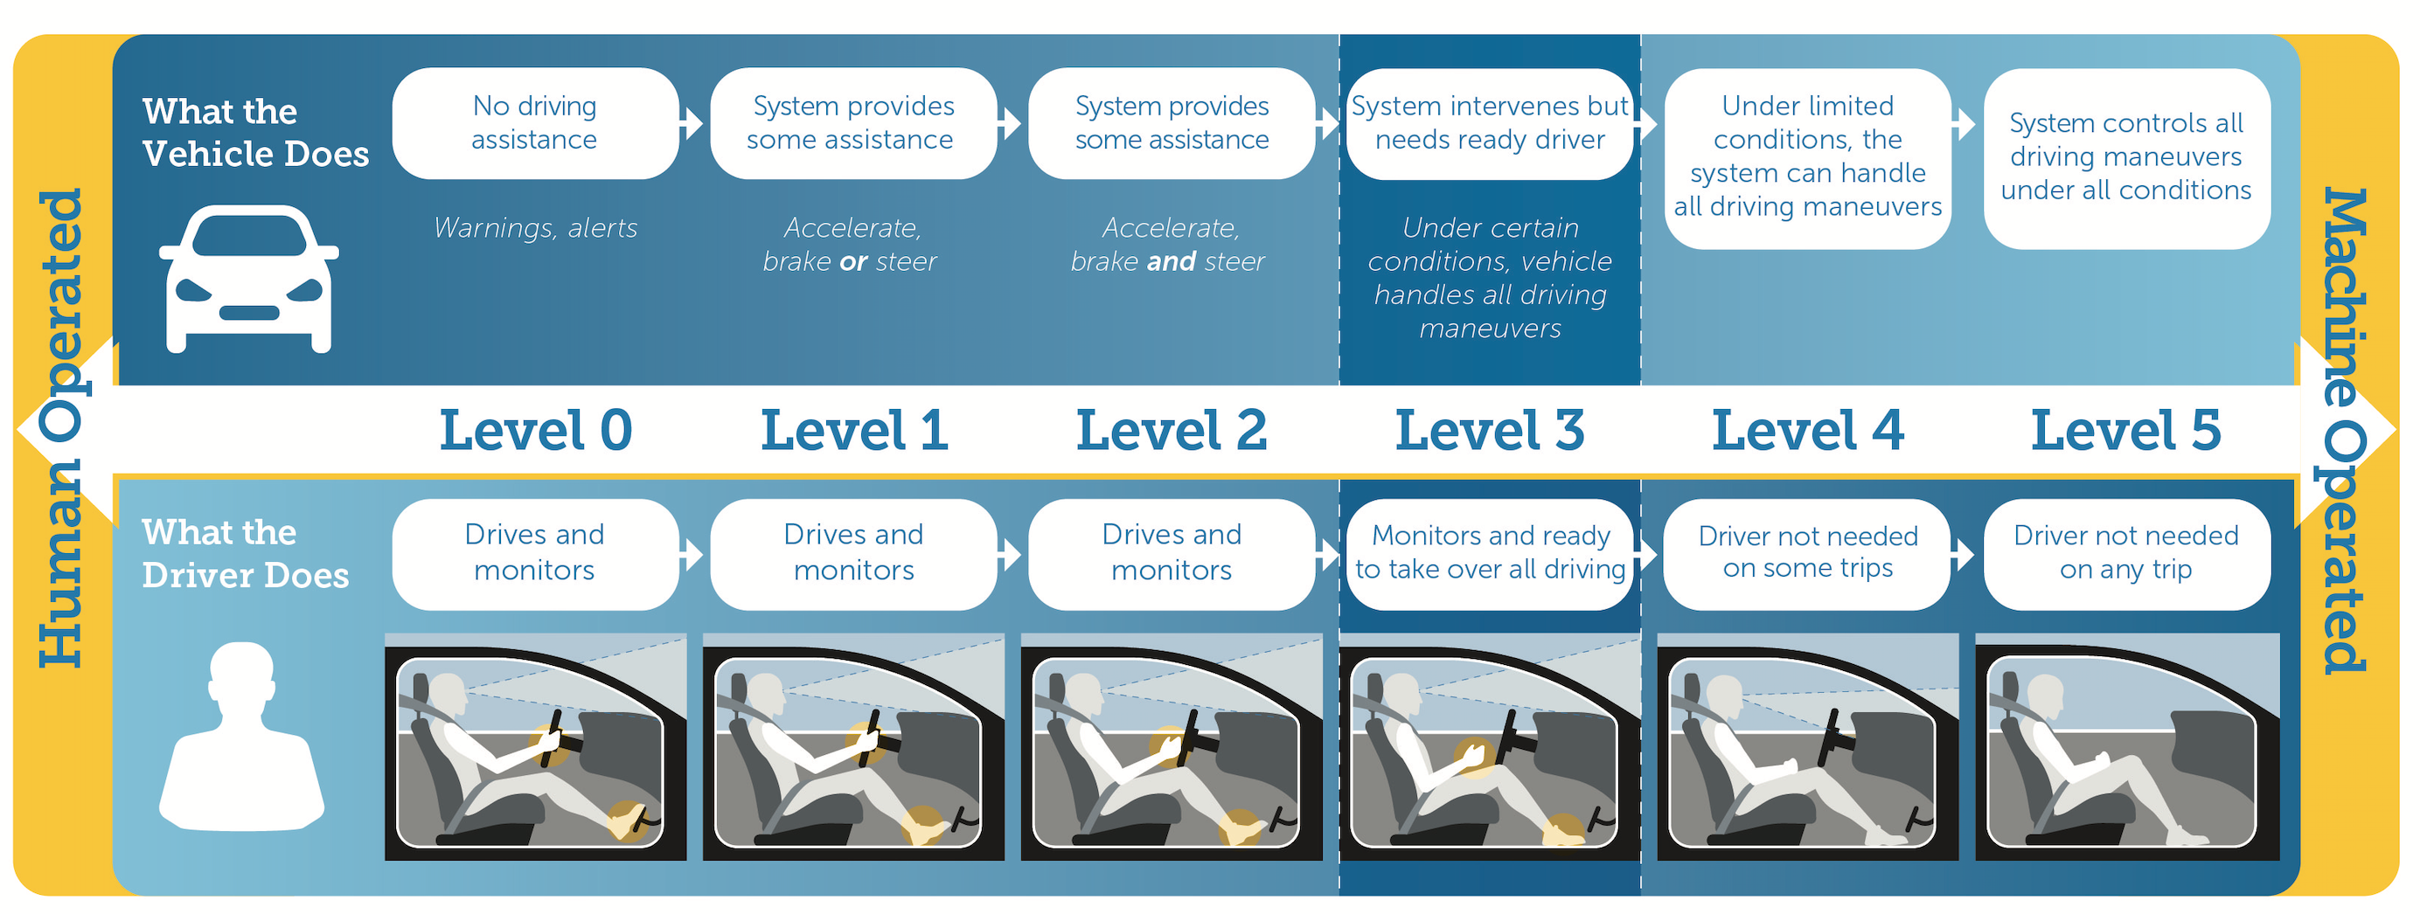

PAGE 13 IN WORKBOOK – ACTIVITY #4
  - When thinking about the different levels of automation, do you tend to A) think about your vehicle overall operating at a certain level or B) think about the different types of advanced driver assistance systems equipped in your vehicle that allow it to operate at a certain level? Why do you say that?

  - A vehicle can use multiple, different systems to provide driver assistance. Some of these systems work automatically while others needed to be activated, Individual systems may operate at one level, such as lane assist (level 1) but when combined with other systems such as adaptative cruise control (also level 1 on its own) can offer a higher level of automation (level 2 – assistance with steering, braking and acceleration at the same time). So, the level is related to more directly to the different types of advanced driver assistance systems equipped in your vehicle than directly to the vehicle. What are some ways to better communicate that idea to consumers?

- Wrap-up [10 minutes/90 minutes total]
  - As we wrap up tonight, I want to go back to one of the questions I asked you early on in our discussion. We started off by asking where you came down on two different perspectives about the impact of technology on safety. Thinking back about everything we discussed this evening, please turn to the last page in your workbook and indicate which of these two perspectives is closest to your own:

PAGE 14 IN WORKBOOK – ACTIVITY #5
    - [HUMANS ARE SAFER] Some people say that it’s safer when the human driver is in complete control of all the vehicle functions. They trust themselves more than technology, and say that technology software could be hacked, or that they can’t fully relax in a vehicle where the computer assists with certain driving tasks.

    - [TECHNOLOGY IS SAFER] Others say that vehicles in which drivers are assisted by a computer are safer. Technology can react more quickly and reliably than people can, technology can be rigorously tested in a wide range of situations before they are allowed on vehicles, and new and better technology is on the horizon.

Which of these statements comes closer to your own?

- DEFINITELY FEEL HUMANS ARE SAFER
- SOMEWHAT FEEL HUMANS ARE SAFER
- SOMEWHAT FEEL TECHNOLOGY IS SAFER
- DEFINITELY FEEL TECHNOLOGY IS SAFER
b. Did anyone’s answer change from the first time you answered? How? What did you read or hear tonight that helped to you change your response?

  - FOR THOSE SAYING HUMANS ARE SAFER:
    - What information would you need to know to get you to believe that vehicle technology that either assists or automates driver functions/tasks is safer and better for you than individual drivers?
    - At this time, is there any information that would make you feel more comfortable with automation technology? If so, how would you want that information provided?

  - FOR THOSE SAYING TECHNOLOGY IS SAFER:
    - What is the most important factor that makes you feel that technology is more reliable than individuals when it comes to safety on America’s roads?
    - What information have you received, either today or prior to today, that makes you believe that technology increases safety over human drivers? How did you learn that information? What made that source reliable/trustworthy?

On behalf of the Department of Transportation, we thank you for being so generous with your time and honest in your feedback throughout the course of this session.

