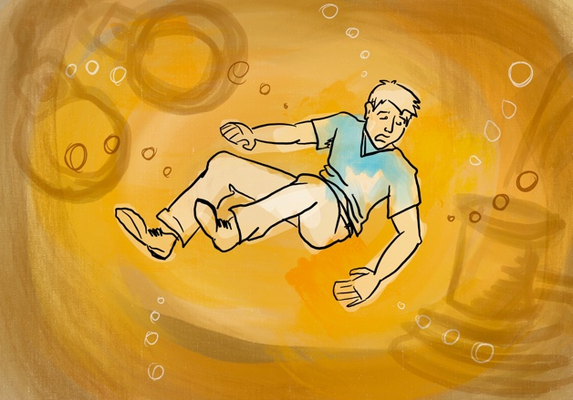
IN OVER YOUR HEAD
No matter what your worries, things can always get worse. Especially with the combination of drinking and driving. In this spot we see what happens when one man tries to drown his sorrows and then gets behind the wheel.

SCENE: We open on a man sitting by himself at a bar after a rough day at work, mumbling about his day over a beer (we will shoot different versions with different types of alcohol represented i.e. spirits and white wine). As he slumps further over the mug, our view switches to the bottom of the glass. We see his distorted face through the bottom of the mug, his eyes beginning to droop and slumping further down over the mug until he completely falls in.
He sinks further into an abyss of amber liquid as phantoms of life’s problems float around him. Initially its minor irritants of life, but as he sinks further, the consequences of a DUI and the issues are suddenly more desperate.

The issues in the abyss are represented by shadowy clips floating around him like liquid smoke – appearing transparent beside him and then quickly dissipating back into the beer – the audio is muffled and watery.

Example: Clips of a judge announcing his sentence as a shadowy image of a gavel slamming down appears beside him, stirring up bubbles and then whisking away.

Just when you think he’s given up, a knock sound pulls him back to reality. His body pulls backward, and the camera follows him back up through the beer.

He lands in the drivers seat of a car. The knock was a police officer on his window. He’s been pulled over. He looks completely shook and grasps the steering wheel to steady himself.
OFFICER: “Sir, have you been drinking?”
SUPER: Drive Sober Or Get Pulled Over PAID FOR BY NHTSA.

UNDERWATER SFX REFERENCE:
https://youtu.be/eJSik6ejkr0

TSUNAMI
Too much alcohol and getting behind the wheel is a bad idea that leads to really severe consequences. And, if you think you’re going to outrun the law, think again.

SCENE: Man, stumbles and knocks over a glass on a table as he leaves a bar. There is just a bit of beer in the glass (we will shoot different versions with different types of alcohol represented i.e. spirits and white wine) and we see the bubble form as it empties from the glass onto the counter. The bubble spills out onto the floor and starts to grow larger and moves towards the door following the man. As the narration continues the man has driven off in his car but the bubble is behind him and building into a raging tsunami.

MUSIC: Dramatic, epic music builds throughout the spot.

VO: It’s been a rough day at work and the next thing you know you’re putting back a few. A few becomes a few too many. The man behind the bar says, “You calling for a ride?” You mumble something that sounds like “Yea sure.” and you head to the door. Nahh. You live nearby.

SCENE: Man driving as wave builds behind him in the road.

VO: What are the odds you’ll get pulled over? And even if you did, what’s the worst that could happen? Your insurance goes up. You lose your license?

SCENE: We hear faints sirens as police lights begin to flash in the heart of the wave.

VO: You get into a wreck? You total your car? You’re paralyzed for life? You kill someone?

SCENE: The man’s car, appearing very tiny, is overtaken by the massive mountain of flowing beer. Instantly the wave is gone, and police car appears behind the man’s car.
SUPER: Drive Sober Or Get Pulled Over. PAID FOR BY NHTSA.

SPLIT SCREEN
When going out for an evening there are many choices to be made. Chose the right path and the result is a good time. Chose the wrong path and the outcome is entirely different.

VISUAL: Split screen shows the same man on both sides going through his evening out with jazzy upbeat music. We are choreographed through his night in a single take, smoothly following him into the bar, a quick spin around the dance floor with several beautiful ladies. Then he hops over the bar and pours a line of drinks down the bar, wowing his audience.
He heads out the back door, struts down the sidewalk and into the next bar. Again, he smoothly twirls through the bar, catching a drink and interacting with other patrons.

The scenes diverge suddenly when he leaves the bar. The left side shows the man getting into the back seat of a cab/uber, while the right side hops into the driver’s seat of his own car. Although at this point the stories are different, there will be similar visual cues on either side of the screen.

The music is winding down from the “night out” and while the man on the left arrives safely home, the man on the right is pulled over.

On the left: Man pays is ride and says goodnight through the driver’s window
On the Right: Cop approaches the man by the driver’s window after pulling him over

Left: Man stumbles down the hallway of his apartment building getting his keys out.
Right: Man stumbles through the sobriety test trying to walk a straight line.
Left: He arrives home and slumps down onto his couch.
Right: Man is slumped down in the back seat of the police car.

SUPER: Drive Sober Or Get Pulled Over. PAID FOR BY NHTSA.

THE PRICE YOU PAY (GENERAL MARKET VERSION)
Imagine we're in a bar. We drink. Enjoy. We numb our pain by making a toast. We keep drinking, and enjoying, and partying. In the end, we ask for the check. We're ready to go home but, when the check arrives, we realize that the total amount could be a little more expensive if the plan is to get home driving.

SCENE: Open on a bar where friends are having a good time. Time passes by and, after some drinks, one of them decides to ask for the check. He’s clearly had a few too many. Just like the rest. When the check arrives, we see that the total amount exceeds $10,000. We take a closer look and reveal a charge of $10,000 below their drinks and food. The man and his friends claim the amount to the waiter

MAN: Ten grand for a… D-U-I?

WAITER: Oh, yeah, that’s the DUI charge. Don’t worry about it. It’s just in case you’re thinking of driving home in that condition. You know, jail, the ticket, suspended license, insurance, the days you’ll miss at work. Cops are looking for drunk drivers, so we thought we might as well tell you in advance what it could cost you.

The man is visibly concerned.

FRIEND: I think a cab is a lot cheaper.

As they walk out of the bar onto the street, there’s a cop pullover with a male driver “walking the line” slightly tipsy and we cut back to our friends faces as they express a little surprise and relief.

FRIEND: Poor guy, he got the DUI charge on his tab.
Cut to everybody jumping in a cab and we see a cop on the other side of the street, arresting a drunk driver.

SUPER: Don’t pay the price of drinking and driving.
SUPER/LOGO: Drive Sober or Get Pulled Over. PAID FOR BY NHTSA.
THE PRICE YOU PAY (SPANISH VERSION)
Imagine we're in a bar. We drink. Enjoy. We numb our pain by making a toast. We keep drinking, and enjoying, and partying. In the end, we ask for the check. We're ready to go home but, when the check arrives, we realize that the total amount could be a little more expensive if the plan is to get home driving.

SCENE: Open on a bar where friends are having a good time. Time passes by and, after some drinks, one of them decides to ask for the check. He’s clearly had a few too many. Just like the rest. When the check arrives, we see that the total amount exceeds $10,000. We take a closer look and reveal a charge of $10,000 below their drinks and food. The man and his friends claim the amount to the waiter

MAN: ¿Diez mil dólares por… D-U-I?
MAN: Ten grand for a… D-U-I?

WAITER: Ah, sí, es el cargo en caso de que pienses manejar tomado. Ya sabes, cárcel, multa, licencia suspendida, seguro, días de trabajo perdido. Los policías están buscando, está bien que lo sepan desde antes.
WAITER: Oh, yeah, it’s the charge in case you’re thinking of driving drunk. You know… jail, ticket, suspended license, insurance, the days you’ll miss at work. Cops are looking for drunk drivers, so we might as well let you know in advance.

The expression of the men says it all. One of them adds:

FRIEND: Creo que un taxi es mucho más barato…
FRIEND: I think a cab is much cheaper…

As they walk out of the bar onto the street, there’s a cop pullover with a male driver “walking the line” slightly tipsy and we cut back to our friends faces as they express a little surprise and relief.

FRIEND: Pobre. Le llegó la cuenta del DUI.
FRIEND: Poor guy, he got the DUI charge on his tab.

SUPER: No pagues el precio de tomar y manejar.
Maneja borracho y serás multado. NHTSA.
SUPER: Don’t pay the price of drinking and driving.
SUPER/LOGO: Drive Sober or Get Pulled Over. NHTSA.

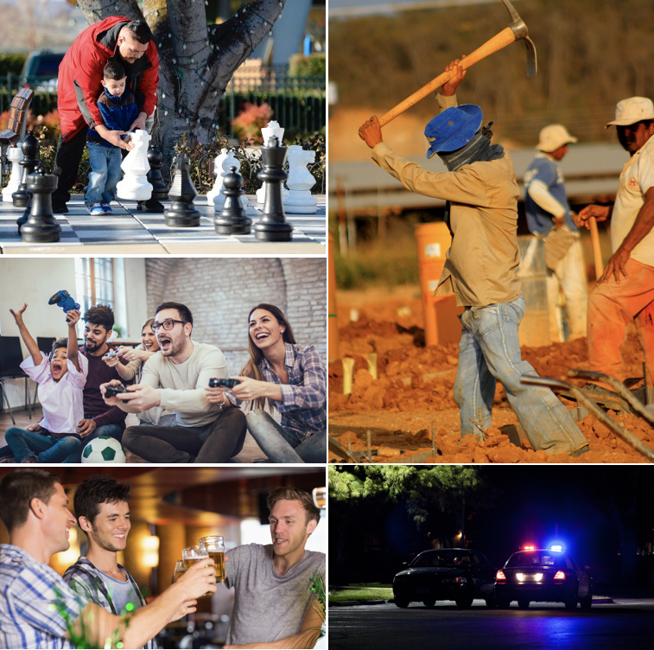

A STORY
We all have a story to tell, and a bad record can ruin the story. For Latinos, getting a DUI means more than just going to jail or losing a day of work.

We’ll see an inspiring life story of a young Latino in his 20s who came to this country without knowing the language or any friends to turn to. Different scenes will build up the emotion of him making it as a hard worker, good friend (toasting in a bar), loyal husband, caring father and even as a brave entrepreneur. A heartfelt narration will thread the story together. Then it all takes a turn.

VO: Todo lo que has trabajado. Todos los sueños que has cumplido
Everything you've worked for. All the dreams you have fulfilled.
Todo lo que le has enseñado a los tuyos. Y viceversa.
Everything you've taught those you love. And vice versa.
Todo lo que has pasado. Reído. Llorado. Y sobrepasado otra vez.
Everything you've been through. Cried. Laughed. And been through again.
Todo lo que sueñas.
Everything you’ve dreamed of.
Y todo lo que te ha costado llegar hasta donde has llegado.
And all that you’ve struggled for to get where you’ve gotten. (Please keep in mind the Spanish flows perfectly. There is no double “get” and “gotten” in Spanish)
Todo… ¿arruinado por un DUI?
Everything… so it could get ruined by a DUI?

SUPER/LOGO: Maneja borracho y serás arrestado. NHTSA.
SUPER/LOGO: Drive Sober or Get Pulled Over. NHTSA.

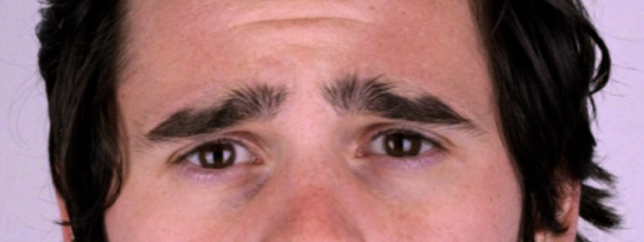

WRONG CONFESSION
We Latinos try to talk our way out of sticky situations. This is something we’re accustomed to doing back home, especially with law enforcement. Just one problem. Things don’t work that way here.

Open with a close-up of a drunk man in his 20s, explaining something to someone in front of him:

MAN: Nunca falté al trabajo. Siempre fui el primero en llegar y el último en irme. Madrugadas, fines de semana, ¡días festivos que sacrifiqué, por cinco años! ¿Sabes lo que se siente que te corran así? Es totalmente injusto. De verdad me merecía ese trago. Lo necesitaba.
I've never missed a day of work. I was always the first one to arrive and the last one to leave. Late nights, weekends, even holidays that I sacrificed for the last five years… Do you know how it feels to get fired this way? It’s totally unfair! I really deserved a drink. I needed it!

When we open up the scene, we unveil that the person who’s in front of our character is a policeman. Our driver was caught. The policeman nods and replies:

POLICEMAN: Quizás te merecía ese trago. Pero yo no soy un psicólogo, ni un cantinero. Soy un policía.
You may have deserved that drink, but I’m not a psychologist or a bartender. I’m a cop.

The face of our character says it all. The officer is right. Second cop handcuffs our driver.

SUPER: Tus problemas no necesitan un problema extra.
SUPER: Your problems don’t need an extra problem.

SUPER/LOGO: Drive Sober or Get Pulled Over. PAID FOR BY NHTSA.

