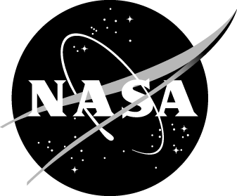
Study Overview for Parents of Students Participating in a
NASA Scientific Research Challenge Activity

This research seeks to support the mission of the NASA Office of Education by asking your child to take part in surveys pertaining to our interest in the ways in which NASA project activities impact outcomes for participants. The information we collect will help us to improve the nature of the project activity and the accuracy with which NASA Education can report to its community about the project activities it offers. The purposes of this research is to determine the degree to which the surveys accurately capture participant outcomes. There are two opportunities for completing surveys, before the activity and after the activity.

What it Means to Participate in the Surveys
Your child’s participation in the surveys is voluntary. The first survey will be administered [Month] [Year]. When your child completes a survey, he/she does not have to answer any question they do not want to. Also, if you do not want your child be part of the survey administration, you can call [insert number] (toll-free) or e-mail [insert email] to request that your child not be included; simply state that you do not what your child to participate in the surveys and provide your child’s name and the name of the school/center at which he/she participates in an afterschool program. Your child can take part in the program even if he/she does not take part in the surveys.

Protecting Your Information
Protecting your information is very important to us.

- NASA’s Office of Education, their collaborators, and the afterschool program providers will follow strict rules to protect the information you and your child provide.
- The research reports will not include your or your child’s names.
- Paper copies of your child’s responses and electronic copies of the data will be stored securely.
- We will not share information that identifies your child to anyone outside the research team and the afterschool program providers, except as required by law. A final dataset with survey responses will be prepared by NASA at the end of the study, but only after names and identifiers are removed from the data.

As with all data collection, there is a very small chance that someone will see your child’s answers without permission. The NASA Office of Education and the research collaborators have many procedures in place to protect the privacy of the data collected, so we do not think this will happen. However, if it does, all NASA Office of Education procedures will be followed to correct the situation.

Questions about the Survey Testing
For questions about the survey testing, please contact the Help Desk at 216-433-2017 or send an e-mail to: grc-21-cclc@mail.nasa.gov. For questions about your child’s rights as a participant in this survey testing, please call Ms. Elysia Oudemans, Director of Research Integrity and Compliance, Pacific Institute for Research and Evaluation, at 1-866-PIRE-ORG, extension 2757.

Paperwork Reduction Act Statement: This information collection meets the requirements of 44 U.S.C. §3507, as amended by section 2 of the Paperwork Reduction Act of 1995. You do not need to answer these questions unless we display a valid Office of Management and Budget (OMB) control number. The OMB control number for this collection is 2700-0159 and expires 04/20/2018. We estimate that it will take 10 minutes to read the instructions and answer the questions. Send only comments relating to this time estimate to: richard.l.gilmore@nasa.gov.

