**As a former NASA internship applicant and/or awardee, you have been randomly selected to participate in a pilot study that will help NASA understand the long-term outcomes of our internship program and help us improve the program for future researchers and explorers.**

**As a participant in this pilot study, we are asking you to complete this brief questionnaire. At the end the questionnaire, you will be asked to provide feedback about the clarity of the questions and the amount of time it took you to complete the survey. Therefore, please note the time you begin the survey in order to provide an accurate estimate of how long the survey took you to finish. Your responses to these questions will help us improve the questionnaire for future studies.**

**We sincerely appreciate your help!**

**If you wish to participate in this pilot study, please select “Yes, I agree to participate in this survey” below to continue to the next page.**

**Privacy Notice:** This is an official NASA application hosted on Google forms. Google forms is not a government application, the application is controlled and operated by a third party. NASA’s Web Privacy Policy does not apply to this application. NASA will not maintain, use, or share Personally Identifiable Information (PII) that becomes available through the use of this third party application unless expressly stated and consent is obtained from the user. For additional information on NASA’s Third-Party Privacy Notice please go to <http://www.nasa.gov/about/highlights/HP_Privacy.html>.

**Paperwork Reduction Act Statement:** This information collection meets the requirements of 44 U.S.C. §3507, as amended by section 2 of the Paperwork Reduction Act of 1995. You do not need to answer these questions unless we display a valid Office of Management and Budget (OMB) control number. The OMB control number for this collection is 2700-0159 and expires 06/30/2021. We estimate that it will take 10 minutes to read the instructions and answer the questions. Send only comments relating to this time estimate to: richard.l.gilmore@nasa.gov.

**Please enter your 6-digit survey response code:**

**___________________________________________**

1. **Were you working for pay or profit during the week of February 1, 2019?**

*Working includes being a student on paid work-study, self-employed and did not get paid that week, on vacation from work, traveling while employed, on personal leave, paid sick leave, or other temporary leave.*

|  |  |  |
| --- | --- | --- |
| 1 | 🞎 | Yes |
| 2 | 🞎 | No |

1. **Using the JOB CATEGORY list below, choose the code that best describes the last job you held prior to the week of February 1, 2019.**

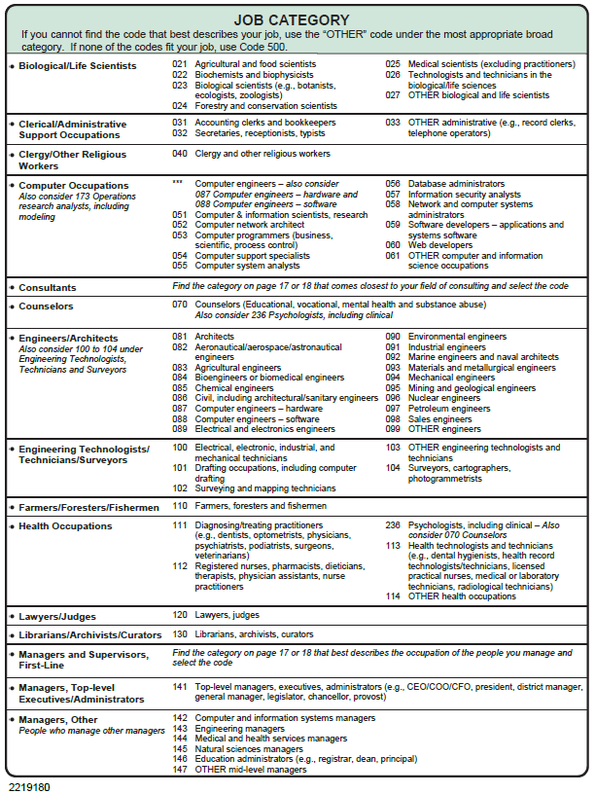

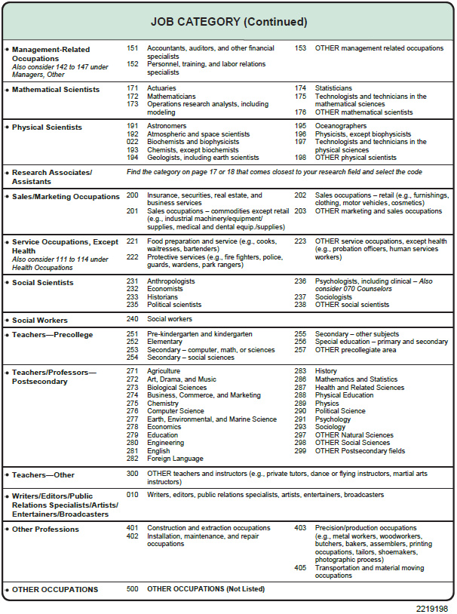

**Enter the job category code. If you were not working, or your job is not listed, please enter “500”. CODE**

**___________________________________________**

1. **Who was your principal employer during the week of February 1, 2019?**

*If you had more than one job, report the one for which you worked the most hours that week.*

*If your employer had more than one location report the location that employed you.*

*If you worked for a contracting or consulting company, report the name of that company, not the client organization.*

|  |
| --- |
| Employer Name |
| Department / Division |
| City / Town |
| State / Territory |
| Zip Code |

1. **What was that employer’s main business or industry – that is, what did that employer make or do?**

*If your principal employer had more than one type of business, report the type of business primarily performed at the location where you worked.*

*Example: Production of microprocessor chips*

EMPLOYER’S MAIN BUSINESS

|  |
| --- |
|  |

1. **Which one of the following best describes your principal employer during the week of February 1, 2019? Were you…**

*Mark one answer.*

|  |  |  |
| --- | --- | --- |
|  |  | SELF EMPLOYED or a BUSINESS OWNER |
| 1 | 🞎 | in a non-incorporated business, professional practice, or farm |
| 2 | 🞎 | in an incorporated business, professional practice, or farm |
|  |  | PRIVATE SECTOR employee |
| 3 | 🞎 | in a for-profit company or organization |
| 4 | 🞎 | in a non-profit organization (including tax-exempt and charitable organizations |
|  |  | GOVERNMENT employee |
| 5 | 🞎 | in a local government (e.g., city, county, school district) |
| 6 | 🞎 | in a state government (including state colleges / universities) |
| 7 | 🞎 | in the U.S. military service, active duty, or Commissioned Corps (e.g., USPHS, NOAA) |
| 8 | 🞎 | in the U.S. Federal Government (e.g., civilian employee) |
| 9 |  | OTHER type of employer – |
|  | Please specify “Other” type of employer: | |

1. **Did your duties on this job require the technical expertise of a bachelor’s degree or higher in:**

*Mark Yes or No for each item.*

|  |  |  |  |
| --- | --- | --- | --- |
|  |  | Yes | No |
| 1 | Engineering, computer science, math, or the natural sciences | 🞎 | 🞎 |
| 2 | The social sciences | 🞎 | 🞎 |
| 3 | Some other field (e.g., health, business, or education) | 🞎 | 🞎 |
|  | *If some other field, please specify:* | | |

1. **The next question is about your work activities on your principal job. Which of the following work activities occupied at least 10 percent of your time during a typical work week on this job?**

*Mark Yes or No for each item.*

|  |  |  |  |
| --- | --- | --- | --- |
|  |  | Yes | No |
| 1 | Accounting, finance, contracts | 🞎 | 🞎 |
| 2 | Basic research – study directed toward gaining scientific knowledge primarily for its own sake | 🞎 | 🞎 |
| 3 | Applied research – study directed toward gaining scientific knowledge to meet a recognized need | 🞎 | 🞎 |
| 4 | Development – using knowledge gained from research for the production of materials, devices | 🞎 | 🞎 |
| 5 | Design of equipment, processes, structures, models | 🞎 | 🞎 |
| 6 | Computer programming, systems or applications development | 🞎 | 🞎 |
| 7 | Human resources – including recruiting, personnel development, training | 🞎 | 🞎 |
| 8 | Managing or supervising people or projects | 🞎 | 🞎 |
| 9 | Production, operations, maintenance (e.g., chip production, operating label equipment) | 🞎 | 🞎 |
| 10 | Professional services (e.g., health care, counseling, financial services, legal services) | 🞎 | 🞎 |
| 11 | Sales, purchasing, marketing, customer service, public relations | 🞎 | 🞎 |
| 12 | Quality or productivity management | 🞎 | 🞎 |
| 13 | Teaching | 🞎 | 🞎 |
| 14 | *Other –* | 🞎 | 🞎 |
|  | *If you answered “Other” from the above answers, please specify here:* | | |

1. **Thinking about your principal job held during the week of February 1, please rate your satisfaction with that job’s…**

*Mark one answer for each item.*

|  |  |  |  |  |  |
| --- | --- | --- | --- | --- | --- |
|  |  | *Very satisfied* | *Somewhat satisfied* | *Somewhat dissatisfied* | *Very dissatisfied* |
| *1* | Salary | 🞎 | 🞎 | 🞎 | 🞎 |
| *2* | Benefits | 🞎 | 🞎 | 🞎 | 🞎 |
| *3* | Job security | 🞎 | 🞎 | 🞎 | 🞎 |
| *4* | Job location | 🞎 | 🞎 | 🞎 | 🞎 |
| *5* | Opportunities for advancement | 🞎 | 🞎 | 🞎 | 🞎 |
| *6* | Intellectual challenge | 🞎 | 🞎 | 🞎 | 🞎 |
| *7* | Level of responsibility | 🞎 | 🞎 | 🞎 | 🞎 |
| *8* | Degree of independence | 🞎 | 🞎 | 🞎 | 🞎 |
| *9* | Contribution to society | 🞎 | 🞎 | 🞎 | 🞎 |

1. **How would you rate your overall satisfaction with the principal job you held during the week of February 1, 2019?**

|  |  |  |
| --- | --- | --- |
| 1 | 🞎 | Very satisfied |
| 2 | 🞎 | Somewhat satisfied |
| 3 | 🞎 | Somewhat dissatisfied |
| 4 | 🞎 | Very dissatisfied |

1. **Thinking back now to 2018, was any of your work during 2018 supported by contracts or grants from the U.S. Federal Government?**

*Federal employees: Please answer “No.”*

|  |  |  |
| --- | --- | --- |
| 1 | 🞎 | Did not work in 2018 |
| 2 | 🞎 | Yes |
| 3 | 🞎 | No |
| 4 | 🞎 | Don’t Know |

1. **Which U.S. Federal Government agencies or departments were supporting your work?**

*Mark all that apply.*

|  |  |  |
| --- | --- | --- |
| 1 | 🞎 | Department of Defense (DOD) |
| 2 | 🞎 | Department of Education |
| 3 | 🞎 | Department of Energy (DOE) |
| 4 | 🞎 | National Institutes of Health (NIH) |
| 5 | 🞎 | Department of Health and Human Services |
| 6 | 🞎 | National Aeronautics and Space Administration (NASA) |
| 7 | 🞎 | National Science Foundation (NSF) |
| 8 | 🞎 | Other – |
|  |  | Specify: |
| 9 | 🞎 | DON’T KNOW SOURCE AGENCY |

1. **Which U.S. Federal Government agencies or departments have you completed an internship with?**

*Mark all that apply.*

|  |  |  |
| --- | --- | --- |
| 1 | 🞎 | Department of Defense (DOD) |
| 2 | 🞎 | Department of Education |
| 3 | 🞎 | Department of Energy (DOE) |
| 4 | 🞎 | National Institutes of Health (NIH) |
| 5 | 🞎 | Department of Health and Human Services |
| 6 | 🞎 | National Aeronautics and Space Administration (NASA) |
| 7 | 🞎 | National Science Foundation (NSF) |
| 8 | 🞎 | Other – |
|  |  | If you marked “Other” from the above answers, please specify here: |
| 9 | 🞎 | I HAVE NEVER participated in an internship with A U.S. Federal Government agencY or department. |

1. **PRIOR TO applying for the NASA internship program, did you participate in any NASA Out-of-School-Time (OST) Science Technology Engineering Mathematics (STEM) Programs?**

Out-of-School-Time (OST) programs are supervised programs young people attend when school is not in session. These include before- and after- school programs, summer programs, programs on a school campus or at a facility, academic programs (e.g., math focused programs), specialty programs (e.g., STEM enrichment), and multipurpose programs (e.g., 21st Century Community Learning Centers, Boys & Girls Clubs, YMCAs).

NASA OST STEM Programs can include:

1. NASA Challenges, Competitions, or Contests (e.g., Design Challenges, Moon to Mars, etc.)

2. NASA College STEM Experiences (e.g., GenHERation Discovery Days, MUREP, Space Grant, etc.)

3. NASA Fellowships (e.g., Summer Undergraduate Research Fellowships, etc.)

4. NASA Institutional Support Programs (e.g., NASA @ MyLibrary, etc.)

5. NASA Internships (e.g., GeneLab Summer Intern Program, STEM Enhancement in Earth Science

Summer High School Internship, etc.)

6. NASA Pre-College STEM Experience (e.g., HUNCH, NASA Academic Research Experience, High

School Aerospace Scholars, MUREP Aerospace Academy, etc.)

7. NASA Research and Development Opportunities (e.g., Summer REU, NASA High School Capstones,

MUREP, MIRO, EPSCoR, etc.)

8. Other NASA OST STEM programs

|  |  |  |
| --- | --- | --- |
| 1 | 🞎 | **No** |
| 2 | 🞎 | **Yes** |

**You've selected "Yes" in the previous section. Please list the names of any NASA OST STEM Programs you recall participating in PRIOR TO applying for the NASA internship:**

|  |
| --- |
|  |

1. **AFTER applying for the NASA internship program, did you participate in any NASA Out-of-School-Time (OST) Science Technology Engineering Mathematics (STEM) Programs?**

Out-of-School-Time (OST) programs are supervised programs young people attend when school is not in session. These include before- and after- school programs, summer programs, programs on a school campus or at a facility, academic programs (e.g., math focused programs), specialty programs (e.g., STEM enrichment), and multipurpose programs (e.g., 21st Century Community Learning Centers, Boys & Girls Clubs, YMCAs).

NASA OST STEM Programs can include:

1. NASA Challenges, Competitions, or Contests (e.g., Design Challenges, Moon to Mars, etc.)

2. NASA College STEM Experiences (e.g., GenHERation Discovery Days, MUREP, Space Grant, etc.)

3. NASA Fellowships (e.g., Summer Undergraduate Research Fellowships, etc.)

4. NASA Institutional Support Programs (e.g., NASA @ MyLibrary, etc.)

5. NASA Internships (e.g., GeneLab Summer Intern Program, STEM Enhancement in Earth Science

Summer High School Internship, etc.)

6. NASA Pre-College STEM Experience (e.g., HUNCH, NASA Academic Research Experience, High

School Aerospace Scholars, MUREP Aerospace Academy, etc.)

7. NASA Research and Development Opportunities (e.g., Summer REU, NASA High School Capstones,

MUREP, MIRO, EPSCoR, etc.)

8. Other NASA OST STEM programs

|  |  |  |
| --- | --- | --- |
| 1 | 🞎 | **No** |
| 2 | 🞎 | **Yes** |

**You've selected "Yes" in the previous section. Please list the names of any NASA OST STEM Programs you recall participating in AFTER applying for the NASA internship:**

|  |
| --- |
|  |

1. **PRIOR TO applying for the NASA internship program, did you participate in any NON-NASA Out-of-School-Time (OST) Science Technology Engineering Mathematics (STEM) Programs?**

OST programs are supervised programs young people attend when school is not in session. These include Before-School and After-School programs, summer programs, programs on a school campus or at a facility, academic programs (e.g., math focused programs), specialty programs (e.g., STEM enrichment), and multipurpose programs (e.g., 21st Century Community Learning Centers, Boys & Girls Clubs, YMCAs).

Non-NASA OST STEM programs can include:

1. Extended Day OST STEM Programs (STEM learning opportunities provided by teachers on school grounds outside of school time intended to help students improve academic achievement and standardized test scores)

2. Before-School or After-School OST STEM Programs (content-rich learning programs intended to provide opportunities for students to develop capacities and interests)

3. STEM Learning Opportunities at General OST Programs (e.g., STEM activities provided during 4-H Club, Boys & Girls Clubs of America, YMCA, etc.)

4. STEM OST Summer Programs (e.g., Cosmic Chemistry, Summer Science Program, Summer Research Program, etc.)

5. Specialty STEM OST Programs (e.g., NSF Advancing Informal Science Learning Program, Imagine Science, etc.)

6. STEM Academic Extracurricular OST Programs (e.g., Science club, Technology club, Engineering club, Math club, STEM club, Computer Science club, etc.); and STEM OST Programs sponsored by or offered at a library, museum, science center, business, college or university.

7. Other Non-NASA OST STEM Programs

|  |  |  |
| --- | --- | --- |
| 1 | 🞎 | **No** |
| 2 | 🞎 | **Yes** |

**You've selected "Yes" in the previous section. Please list the names of any Non-NASA OST STEM Programs you recall participating in PRIOR TO applying for the NASA internship:**

|  |
| --- |
|  |

1. **AFTER applying for the NASA internship program, did you participate in any NON-NASA Out-of-School-Time (OST) Science Technology Engineering Mathematics (STEM) Programs?**

OST programs are supervised programs young people attend when school is not in session. These include Before-School and After-School programs, summer programs, programs on a school campus or at a facility, academic programs (e.g., math focused programs), specialty programs (e.g., STEM enrichment), and multipurpose programs (e.g., 21st Century Community Learning Centers, Boys & Girls Clubs, YMCAs).

Non-NASA OST STEM programs can include:

1. Extended Day OST STEM Programs (STEM learning opportunities provided by teachers on school grounds outside of school time intended to help students improve academic achievement and standardized test scores)

2. Before-School or After-School OST STEM Programs (content-rich learning programs intended to provide opportunities for students to develop capacities and interests)

3. STEM Learning Opportunities at General OST Programs (e.g., STEM activities provided during 4-H Club, Boys & Girls Clubs of America, YMCA, etc.)

4. STEM OST Summer Programs (e.g., Cosmic Chemistry, Summer Science Program, Summer Research Program, etc.)

5. Specialty STEM OST Programs (e.g., NSF Advancing Informal Science Learning Program, Imagine Science, etc.)

6. STEM Academic Extracurricular OST Programs (e.g., Science club, Technology club, Engineering club, Math club, STEM club, Computer Science club, etc.); and STEM OST Programs sponsored by or offered at a library, museum, science center, business, college or university.

7. Other Non-NASA OST STEM Programs

|  |  |  |
| --- | --- | --- |
| 1 | 🞎 | **No** |
| 2 | 🞎 | **Yes** |

**You've selected "Yes" in the previous section. Please list the names of any Non-NASA OST STEM Programs you recall participating in AFTER applying for the NASA internship:**

|  |
| --- |
|  |

1. **How many college-level STEM classes did you complete PRIOR TO applying for the NASA internships program?**

*Enter the number of STEM classes below.*

|  |  |  |  |
| --- | --- | --- | --- |
| Number of STEM Classes: |  |  |  |

1. **How many college-level STEM classes did you complete AFTER applying for the NASA internships program?**

*Enter the number of STEM classes below.*

|  |  |  |  |
| --- | --- | --- | --- |
| Number of STEM Classes: |  |  |  |

Please provide feedback on your experience with this survey by answering the following questions.

1. **How many minutes did it take you to read the instructions and answer the questions?**

Indicate the number of minutes below.

|  |
| --- |
|  |

1. **Please indicate the level to which you agree or disagree with each statement.**

|  |  |  |  |  |  |
| --- | --- | --- | --- | --- | --- |
|  |  | *Strongly Disagree* | *Disagree* | *Agree* | *Strongly Agree* |
| 1 | The survey instructions were clear. | 🞎 | 🞎 | 🞎 | 🞎 |
| 2 | The questions were easy to understand. | 🞎 | 🞎 | 🞎 | 🞎 |

1. **As you went through the survey, did you think of any comments or feedback you can give us about the instructions or questions?**

________________________________________________________________________

________________________________________________________________________

________________________________________________________________________

________________________________________________________________________

**Thank you for participating in this survey!**